Quercetin-loaded Polycaprolactone Electrospun Nanofibers for Sustained Local Drug Delivery
Asyikin Sasha Mohd Hanif¹, Aryanny Nasir^{2,3}, Ahmad `Athif Mohd Faudzi⁴, Saravana Kumar Jaganathan⁵, and Mohamad Ikhwan Jamaludin^{6*}

¹ Malaysia-Japan International Institute of Technology, Universiti Teknologi Malaysia, 54100, Kuala Lumpur, Malaysia
² Newcastle University Medicine Malaysia (NUMed), Educity@Iskandar, Iskandar Puteri, 79200, Johor, Malaysia
³ Faculty of Medical Sciences, Newcastle University, Newcastle upon Tyne, NE1 7RU, United Kingdom
⁴ Department of Control and Mechatronics Engineering, Faculty of Electrical Engineering, Universiti Teknologi Malaysia, Johor Bahru, 81310, Johor, Malaysia
⁵ Biomedical Engineering Research Group, School of Engineering, University of Leicester, University Road, Leicester, LE1 7RH, United Kingdom
⁶ Bioinspired Device and Tissue Engineering Research Group, Department of Biomedical Engineering and Health Sciences, Faculty of Electrical Engineering, Universiti Teknologi Malaysia, Johor Bahru, 81310, Johor, Malaysia
mohamad.ikhwan@utm.my
Abstract. Quercetin (Que) is a type of flavonoid used as potential phytochemical in treating chronic diseases due to its anti-inflammatory, antioxidant and other therapeutic effects. It is commonly taken via oral and injection approaches. However, its curative efficacy is limited by its low aqueous solubility, extensive first pass metabolism and resultant low availability. In this study, quercetin-loaded polycaprolactone (PCL) electrospun nanofibers were fabricated at different Que concentrations (5, 10, and 15 wt%) to investigate their morphological, physicochemical, mechanical, drug release, and cytocompatibility properties for sustained local drug delivery. Scanning electron microscopy (SEM) showed smooth and bead-free nanofibers, with representative mean fiber diameters of 510 ± 77 nm for pristine PCL and 596 ± 177 nm for PCL/Que15. Mechanical testing demonstrated a reduction in tensile modulus from 0.60 ± 0.02 MPa for pristine PCL to 0.39 ± 0.03 MPa for PCL/Que15, indicating reduced mechanical stiffness following Que incorporation. The nanofibers exhibited an initial burst release followed by prolonged Que release over 21 days, with the highest early release approximately 25%. Cytocompatibility evaluation using the MTT assay demonstrated formulation- and time-dependent cellular metabolic responses, with PCL/Que10 exhibiting the highest relative metabolic activity. These findings highlight the importance of integrated structural-functional analysis in electrospun drug delivery systems and demonstrate the potential of PCL-based nanofibers for sustained flavonoid delivery.
Keywords: Quercetin, Polycaprolactone, Electrospinning, Nanofibers.
- Introduction
Quercetin (Que) (3,3′,4′,5,7-pentahydroxyflavone) is a naturally occurring flavonoid commonly found in fruits and vegetables such as walnuts, fig, capers, cranberry, asparagus, radish leaves, red onion, coriander, and broccoli. Studies showed that Que is widely recognized for its antioxidant, anti-inflammatory, and anticancer properties [1]. With all these pharmacological activities, Que is often taken as nutraceutical via oral and intravenous approaches. However, its clinical translation remains limited due to poor aqueous solubility, rapid systemic metabolism, and low oral bioavailability, which significantly restrict its therapeutic efficacy in conventional delivery systems [2].
To overcome these limitations, polymer-based drug delivery platforms such as liposomes, nanoparticles, nanoemulsion, micelles, solid dispersion, and nanofibers, have been extensively studied [3]. Particularly, electrospun nanofibers have garnered increasing interest in recent years due to their high surface area-to-volume ratio, tunable porosity, and ability to encapsulate bioactive compound within fibrous matrices [4].
Recent studies have reported Que-loaded polymeric nanofibers using polymers such as poly (lactic acid), gelatin, and polyvinyl alcohol [5,6]. While these systems demonstrated improved drug release when comparing with free Que, they often exhibited rapid degradation, limited mechanical stability, or uncontrolled burst release. Among polymers, polycaprolactone (PCL) has gained considerable attention due to its biocompatibility, biodegradability, mechanical flexibility, and regulatory approval for biomedical applications. Moreover, its hydrophobic nature and slow degradation rate also make it particularly suitable for sustained and long-term drug delivery applications [7].
In this context, electrospun PCL nanofibers provide a promising platform for sustained Que delivery, but the systematic studies addressing Que concentration-dependent effects, influence on fiber morphology, mechanical integrity, release kinetics, and cytocompatibility remain limited [8]. Previous PCL/ Que studies have generally incorporated quercetin within multifunctional scaffolds or investigated specific biomedical applications. In contrast, the present study systematically examines the effect of different Que concentrations within an otherwise consistent PCL electrospinning system, with particular emphasis on the relationship between formulation, fiber morphology, thermal/mechanical properties, release behavior and cytocompatibility.
Therefore, the present study aims to fabricate and evaluate Que-loaded PCL electrospun nanofibers with varying drug loadings of 5, 10, and 15%. The study focuses on (i) morphological and physicochemical characterization, (ii) mechanical and thermal property evaluation, (iii) in vitro drug release behaviour, and (iv) cytocompatibility assessment using fibroblast-like cells.
- Material and Methods
  - Materials
The materials used in this study are (Querc-CAS: 117-19-5, ≥95%), poly(ε-caprolactone) (PCL-average Mn = 80000-CAS: 24980-41-4), Tween® 80 (T80), phosphate buffered saline (PBS) tablets, Dulbecco’s Modified Eagle’s Medium - high glucose (DMEM), fetal bovine serum (FBS); glutamine, and penicillin were purchased from Sigma Aldrich (Sigma-Aldrich (M) Sdn Bhd, 47301 Petaling Jaya, Selangor, Malaysia).
  - Preparation of PCL/ Que Solution and Electrospinning of PCL/ Que Nanofibers
The preparation of PCL/ Que solution and synthesis of the PCL/ Que nanofibers were referred and adapted from previous study with a slight modification done [9,10]. PCL (22 wt%) was dissolved in 5 mL glacial acetic acid with a constant stirring at 50°C for about 4 h. Then 5 wt% of Que relative to PCL total weight was added and the solution was left stirred overnight. Distilled water (9%) was then added into the solution and further stirred for 1 h. The solution was ultrasonicated for 10 minutes at room temperature before it was used to fabricate nanofiber using electrospinning. The steps were repeated for pure PCL as control and variations of Que concentration (5, 10, and 15 wt% relative to PCL total weight).
To synthesize nanofibers using electrospinning, the prepared solution was loaded into a 3 mL syringe, which was driven by a peristaltic pump. The syringe was fitted with a 23-gauge steel needle connected to a positive voltage source. The needle was positioned 15 cm away from a metal collector, which was wrapped in aluminum foil and connected to negative voltage source. 18 kV high voltage DC power was supplied to the setup. The solution was dispensed at a controlled flow rate of 0.1 mL per h. This process was repeated for other prepared solutions with varying concentrations of Que. All electrospinning procedures were carried out under laboratory ambient conditions of 25 °C temperature. Relative humidity was not continuously monitored.
  - Physicochemical Characterization of Electrospun PCL/ Que Nanofibers
Scanning electron microscopy (SEM) was used to examined the morphology of the electrospun nanofibers. Before imaging, all nanofiber samples were coated with a thin layer of gold using an Agar Automatic Sputter Coater (Model B7341, Stansted, UK) at a current of 40 mA for 120 Sec. The fiber diameter distribution was analyzed using ImageJ software by randomly selecting 100 individual fibers for measurement [11].
To verify the existence of bioactive components in the electrospun nanofibers, Fourier transform infrared spectra (FTIR) was collected on an infrared spectrometer ranging from 4000 – 400 cm⁻¹ [12].
Thermogravimetric analysis (TGA) and derivative thermogravimetric analysis (DTGA) was done for the electrospun PCL and PCL/Que nanofibers using thermogravimetry analyser system under nitrogen atmosphere, with temperature ranging from 30-1000°C and heating rate 10 °C/ min [13,14].
  - Analysis of Structural Integrity and Mechanical Properties
Structural integrity and mechanical properties of the electrospun nanofibers were analysed using tensile tester machine by following the ASTM standard (ASTM D882-10). Nanofibers were cut into rectangular strips (10 x 40 mm) with thickness of 1 mm. The samples were put into two conditions: dry and wet before being tested. For dry condition, the nanofibers were kept in desiccator for 24 h while for wet condition, the nanofibers were immersed in phosphate-buffered saline (PBS) for 24 h. The tensile testing was repeated three times [15].
  - In Vitro Drug Release of Que
The release of Que from electrospun PCL/Que nanofibers was investigated by immersing 10 mg of PCL/Que nanofiber in 25 mL of PBS solution containing 2 % w/v T80 and the temperature was maintained at 37°C. T80 was added to the release medium PBS because of poor solubility of Que. To monitor the initial burst release, readings were taken at short period of time which are at 1 h, 3 h and 6 h. Then, readings were taken at day 1, day 9, day 14 and day 21 to monitor the delayed release of the Que. At mentioned time intervals, 1 mL sample was taken and the same volume of fresh PBS and T80 was added as substitution as the incubation continues. The samples were measured for its absorbance by UV-Vis spectrophotometer at 415 nm. The concentration of the drug release was calculated based on the calibration curve of the Que and the release percentage was calculated based on the actual determined amount of electrospun nanofibers. The experiments were repeated three times where the results will be reported as average values. Kinetic modeling was done to determine the mechanism of the release of Que from the electrospun PCL nanofiber [16,17].
  - Cell Viability Study of PCL/ Que Nanofibers
The cell viability of electrospun nanofibers was evaluated using an MTT assay with NIH-3T3 cells. The cells were cultured in Dulbecco’s Modified Eagle Medium (DMEM) supplemented with 10% (v/v) fetal bovine serum (FBS) and 1% (v/v) penicillin-streptomycin. They were maintained in a CO₂ incubator at 37°C. Meanwhile, 5 mg of the electrospun nanofiber was immersed in 2 mL of DMEM and incubated at 37°C for 48 h to prepare the extract solution. For the cytotoxicity assessment, approximately 4,000 cells were seeded into each well of a 96-well microplate and incubated for 24 h. After this initial incubation, the medium was replaced with the prepared extract solution from the nanofibers and incubated for another 24 h. Following this, the medium was removed and replaced with fresh medium containing the MTT reagent, and the cells were incubated for an additional 4 h. The absorbance of the MTT formazan product was then measured at 450 nm with a microplate reader [11].
  - Statistical Analysis
The results were presented as the mean ± standard deviation (SD). Statistical comparisons were done by applying one-way analysis of variance (ANOVA) followed by Tukey’s test. For cell viability assays, statistical significance between treated and untreated cells was determined using Student’s t-test. A p-value of less than 0.05 (p < 0.05) was considered statistically significant. Additionally, the coefficient of determination (R²) was used to assess the accuracy of the fitting process.
- Results
  - Morphological Analysis of Nanofibers by SEM
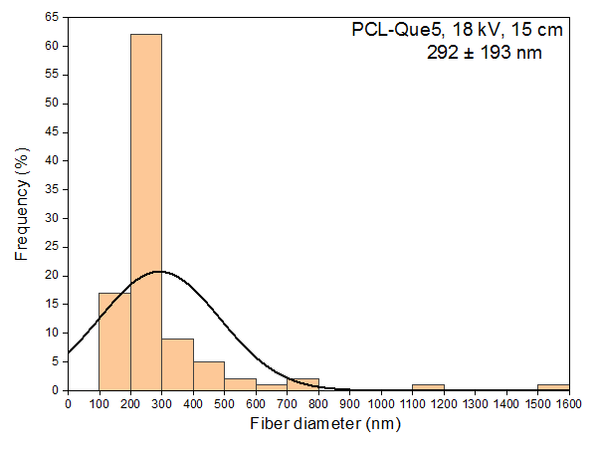
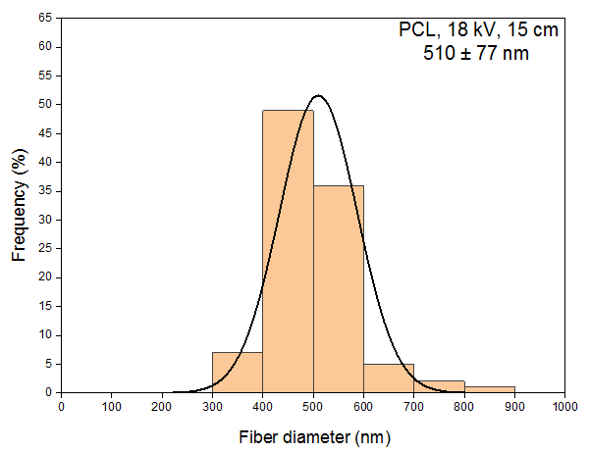
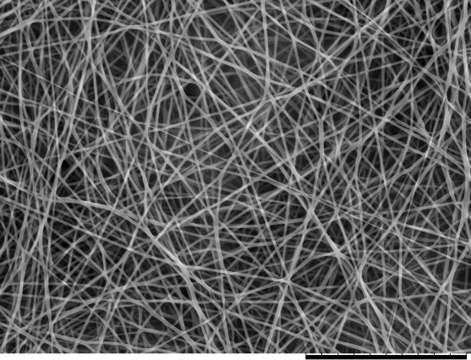
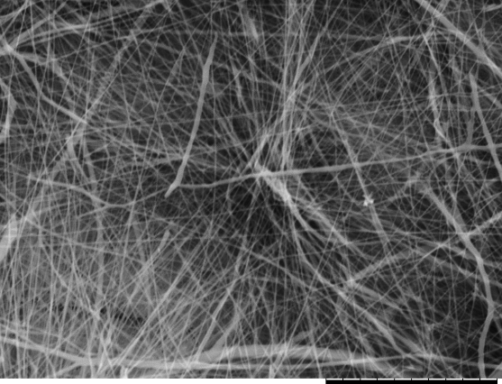
A successful electrospun nanofiber is determined by different factors such as the concentration of materials in polymer solution, the electrospinning parameters, and also the ambient conditions. When the optimal conditions are achieved, a defect-free fibrous membrane will be produced. Figure 1 shows the SEM images of successfully electrospun PCL and PCL/ Que nanofibers where they were smooth, randomly interconnected with uniform structure and porosity. As no phase separation was observed, this indicated fine dispersion of Que in polymer solution during electrospinning [18]. Distribution of fiber diameter is also shown in Figure 1, where the average diameters of PCL, PCL/ 5% Que, PCL/ 10% Que, and PCL/ 15% were 510±77 nm, 292±193 nm, 542±208 nm, 596±177 nm, respectively. Except for PCL/ 5% Que, the addition of Que into PCL solution has resulted in more viscous solution, producing thicker fiber and larger diameter due to stronger resistance of the viscoelastic force to the electric field force [10].
b)
a)

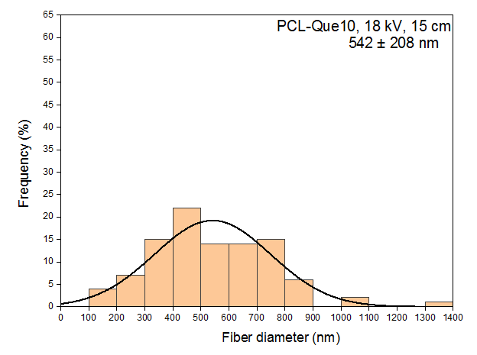
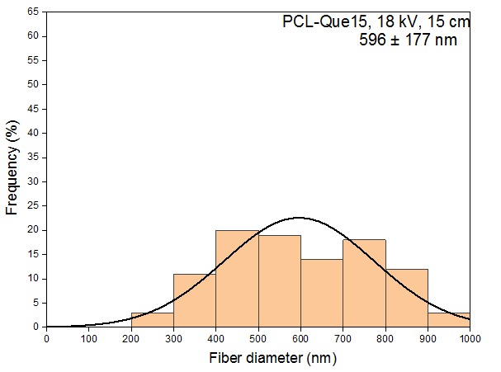
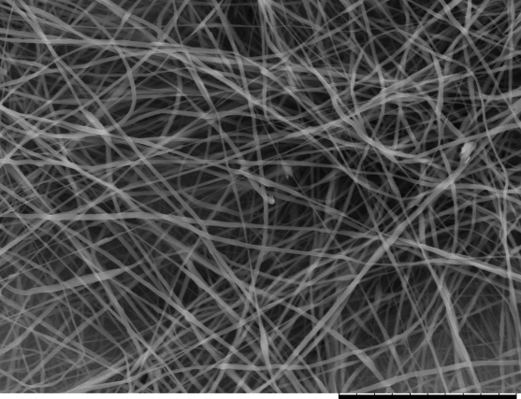
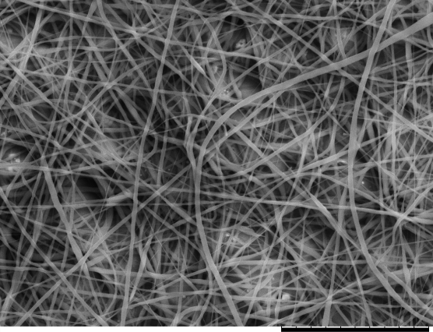
Fig. 1. SEM images and distribution of fiber diameter of (a) PCL, (b) PCL/ 5% Que, (c) PCL/ 10% Que, and (d) PCL/ 15% Que nanofibers. Black scale bars on SEM images represent 30 µm.
c)
d)
  - FTIR Analysis
The success of quercetin incorporation into PCL nanofibers was determined from FTIR spectroscopy where the presence of functional groups within PCL/ Que nanofibers can be ascertained. The Que molecular structure has several hydroxyl groups and a benzene ring. In Figure 2, stretching at 3406 and 1610 cm⁻¹ indicates the vibration of phenolic group (5 OH) and aryl ketone (C=O), while the stretching of C=C group and C-H group of Que were detected at 1510 and 883 cm⁻¹, respectively [15]. In PCL nanofibers, PCL peaks were detected at 2944 and 1721 cm⁻¹ which represents the vibration of CH₂ and C=O stretching of ester group. The FTIR spectra primarily confirmed the coexistence of characteristic PCL and Que functional groups.

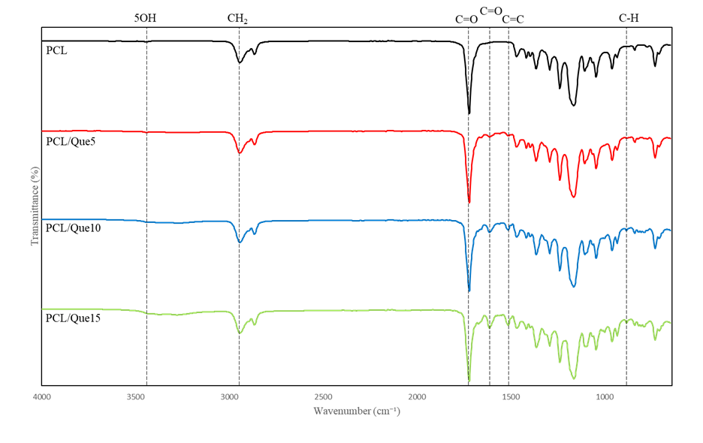
Fig. 2. FTIR spectrum of PCL and PCL/ Que incorporated nanofibers.

  - Thermal Analysis
Figure 3 (a) shows weight loss (%) curves of pure PCL and PCL loaded with varying Que concentrations which exhibited distinct thermal degradation patterns. The decomposition of pure PCL began around 350 °C and completed by approximately 450 °C, indicating a one-step degradation corresponding to the breakdown of the polymer. The Que-loaded samples exhibited earlier weight loss, starting slightly before 350 °C, and the residual weight increased with increased Que content. Higher residual weight at temperature beyond 450 °C was detected as the Que concentration increased.
Figure 3 (b) shows the rate of weight loss as a function of temperature, while the peaks highlighted the primary degradation events. For pure PCL, a sharp peak was observed around 410 °C, corresponding to the maximum degradation rate of PCL. While the curves for Que-loaded fibers showed slightly broader peaks with a small shift towards lower temperatures. The peak intensity decreased as the Que content increased, suggesting an interaction between Que and PCL during thermal decomposition. Additionally, small shoulders or secondary peaks might represent the decomposition of Que.
T_{onset} decreased with the increasing Que loading (~376 °C ~365 °C) indicating additional thermally labile organic components with the incorporation of Que, which might alter the intermolecular interactions and packing of the PCL chains. Que contains multiple hydroxyl groups and an aromatic polyphenolic structure, which can interact with PCL through hydrogen bonding and other intermolecular interactions. These interactions may disturb the relatively stable PCL matrix and facilitate the initiation of thermal degradation at somewhat lower temperatures.

Fig. 3. (a) TGA and (b) DTG curves of PCL, PCL/Que nanofibers.
  - Tensile Mechanical Properties
The mechanical properties of the electrospun nanofibers were determined by measuring the Young’s modulus, ultimate tensile strength and strain at break. Because the primary objective of the mechanical analysis was to evaluate the effect of Que incorporation at the highest loading, PCL/Que15 was selected as the representative drug-loaded formulation. The tensile properties are summarized in Table 1.
The provided data presents the tensile mechanical properties of electrospun PCL and PCL/Que nanofibers under both dry and wet conditions. The key properties measured include tensile modulus, tensile strength, and elongation at break.

Dry vs. Wet Conditions:

Tensile Modulus: The tensile modulus represents the stiffness of the material. In dry conditions, PCL shows a higher modulus (~0.6 MPa) compared to PCL/Que (~0.52 MPa), indicating that the PCL nanofibers are stiffer. When soaked in water, both PCL and PCL/Que experience a decrease in tensile modulus (PCL drops to ~0.39 MPa, and PCL/Que drops to ~0.35 MPa), suggesting that the presence of water reduces the material's stiffness.

Tensile Strength: This property indicates the maximum stress the material can withstand before breaking. Dry PCL exhibits the highest tensile strength (~0.75 MPa), followed by wet PCL (~0.62 MPa). Dry PCL/Que and wet PCL/Que both show lower tensile strength, with wet PCL/Que (~0.37 MPa) demonstrating the lowest value, which indicates that Que incorporation and wet conditions weaken the nanofibers' strength.

Elongation at Break: This measures the elongation before breaking. Wet PCL shows the highest elongation at break (~33%), suggesting it can stretch more before failure compared to dry conditions (~30.5%). In contrast, wet PCL/Que (~20.5%) and dry PCL/Que (~24 %) exhibit lower strain, indicating that the presence of Que reduces the fibers' ability to elongate under stress.

Table 1. Mechanical properties of electrospun PCL and PCL/ Que nanofibers in dry and wet conditions.
Sample | Tensile modulus (Mpa) | Tensile strength (Mpa) | Elongation at break (%)
Dry PCL | 0.60 ± 0.02 | 0.75 ± 0.03 | 30.5 ± 1.2
Wet PCL | 0.52 ± 0.01 | 0.62 ± 0.02 | 33.0 ± 1.5
Dry PCL/Que | 0.39 ± 0.03 | 0.45 ± 0.04 | 24.0 ± 0.8
Wet PCL/Que | 0.35 ± 0.02 | 0.37 ± 0.05 | 20.5 ± 1.1

  - In Vitro Drug Release
Figure 4 shows the in vitro drug release and cumulative release profile of Que from three different formulations (Que5, Que10, Que15) demonstrating distinct release behaviours over 21 days, highlighting the influence of polymer-drug interactions as in Table 2. In the initial burst release phase (1H–3H), Que5 exhibited the highest release (~25%), followed by Que10 (~20%) and Que15 (~15%), attributed to the rapid dissolution of surface-bound Que. The sustained release phase (6H–D9) showed a decline in the release rate for all formulations, with Que15 displaying the most controlled and gradual release, indicating strong polymer-Que interactions.
The secondary increase observe at Day 9 might reflect additional drug diffusion or redistribution within the fibrous matrix, with Que5 percentage release of ~18-20% while Que10 and Que15 maintained a more stable profile. During the long-term release phase (D14–D21), the release stabilized with minor fluctuations. Que5 and Que15 displayed a slight increase towards D21 (~17-18% and ~15-16%, respectively), likely due to polymer erosion, while Que10 exhibited the slowest release (~13-14%), indicating the strongest encapsulation. Que5 has the highest burst release (25%), followed by secondary fluctuations, making it suitable for applications requiring an initial high-dose release. Que10 shows the lowest release percentage at D21 (~13-14%), indicating a more sustained release, ideal for controlled drug delivery. Que15 maintains a more stable release (~15-16%), balancing initial burst and long-term release, which could be beneficial for prolonged therapeutic applications. The selection of the appropriate formulation depends on the intended drug delivery purpose. If a high initial release is needed, Que5 is preferable. If long-term controlled release is desired, Que10 or Que15 would be better candidates.

Fig. 4. Release and cumulative release of PCL and PCL/ Que nanofibers in PBS with Tween80

Table 2. In vitro drug release of electrospun PCL and PCL/ Que nanofibers for 21 days.
Time | Que5 Release (%) | Que10 Release (%) | Que15 Release (%)
1H | ~5% | ~4% | ~6%
3H | ~24-25% (Peak) | ~18-20% (Peak) | ~15-16% (Peak)
6H | ~17% | ~16% | ~15%
D1 | ~14-15% | ~15% | ~16%
D9 | ~18-20% (Secondary Peak) | ~15% | ~15-17%
D14 | ~15% | ~13-14% | ~15%
D21 | ~17-18% | ~13-14% (Lowest) | ~15-16% (Stable)

To further analyze the mechanism of the drug release, kinetic modeling was done where the release profile was fit into zero-order, first-order, Higuchi, and Korsmeyer-Peppas models. Based on Table 3, zero-order kinetics provided the best fit for all Que-loaded electrospun formulations, with R² values ranging from 0.9913 to 0.9940. This indicates that the release profiles were predominantly characterized by an approximately constant release rate over the investigated period. The comparatively high R² values obtained from the Higuchi model (0.8919-0.9153) further suggest that diffusion through the polymeric matrix contributed substantially to Que release.
Meanwhile, the progressively higher Korsmeyer-Peppas R² values with increasing Que loading suggest that drug loading may influence the contribution of diffusion and matrix-related transport mechanisms. Nevertheless, the release mechanism cannot be conclusively assigned based on R² values alone, and interpretation of the Korsmeyer-Peppas model requires consideration of the release exponent, n. Overall, the results indicate that the Que-loaded electrospun fibers exhibited sustained release characteristics, with the release behavior being most closely represented by the zero-order model.

Table 3. Kinetic modeling of drug release of electrospun PCL/ Que nanofibers.
Sample | Zero-order R² | First-order R² | Higuchi R² | Korsmeyer-Peppas R²
Que5 | 0.9913 | 0.6622 | 0.9153 | 0.6924
Que10 | 0.9917 | 0.7338 | 0.8919 | 0.7622
Que15 | 0.994 | 0.8184 | 0.9122 | 0.8476

  - Cell Viability of PCL/ Que Extract
The data in Figure 5 shows the cell viability of different nanofibers over three-time intervals (24 h, 48 h, and 72 h). The nanofibers being studied include PCL (Polycaprolactone), PCL Que5 (with 5% Que), PCL Que10 (with 10% Que), and PCL Que15 (with 15% Que). These nanofibers are used for evaluating the effects of varying concentrations of Que on cell viability. At 24 h, PCL Que10 shows the highest cell viability (117.31), followed by PCL Que5 (112.81). PCL Que15 (106.94) and PCL (96.19) both show lower viability, with PCL showing the least. This suggests that adding Que at both 5% and 10% concentrations positively affects cell viability, with a peak at 10% (PCL Que10). However, at 15%, the viability is slightly lower than at 10%, suggesting that higher concentrations of Que might not have a significantly better effect and could even be slightly detrimental at this stage.
At 48 h, PCL Que10 significantly increases cell viability to 180.03, showing an even stronger positive effect than at 24 h. PCL Que15 also has increased viability (151.83), though slightly lower than PCL Que10. PCL Que5 shows the second-highest value (137.52), suggesting that a higher concentration of Que continues to enhance cell viability. PCL shows a moderate increase from 24 to 48 h (109.15), but it is still the least effective. At 72 h, PCL Que10 remains the most effective with a cell viability of 133.75, followed by PCL with 125.02. PCL Que5 has a slight decrease to 117.84, and PCL Que15 shows the most significant drop, decreasing to 89.27. This suggests that after 72 h; the higher concentration of Que (PCL Que15) may start to have a negative impact on cell viability. The 10% concentration seems to maintain a relatively stable and high cell viability over time, while the 5% and 15% concentrations show more variation.

Fig. 5. Cell viability of PCL-Que extract of PCL, PCL/Que5. PCL/Que10 and PCL/Que15 nanofibers
- Discussion
The fiber diameter distribution for different formulations, including pure PCL and PCL-Que nanofibers, reveals significant variations influenced by Que incorporation. Pure PCL nanofibers exhibit a diameter of 510 ± 77 nm, with a narrow and normal distribution centered around 500 nm, indicating uniform electrospinning conditions. However, PCL-Que5 nanofibers show a significant reduction to 292 ± 193 nm, with a broader and skewed distribution, peaking at 100-300 nm but extending beyond 1000 nm, suggesting that a low Que concentration affects fiber uniformity due to polymer-drug interactions [18]. In contrast, PCL-Que10 nanofibers exhibit an increased diameter of 542 ± 208 nm, approaching pure PCL values, but with a wider size distribution ranging from 100 nm to 1300 nm, indicating some level of improved fiber formation despite inconsistencies. The PCL-Que15 nanofibers have the highest fiber diameter of 596 ± 177 nm, with a more uniform distribution centered around 600 nm, suggesting that higher Que concentrations lead to better fiber formation.
Overall, Que incorporation significantly impacts fiber morphology, with lower concentrations (Que5) resulting in thinner, more heterogeneous fibers, while higher concentrations (Que15) produce thicker, more uniform fibers similar to pure PCL. Que incorporation alters fiber morphology, with lower concentrations (Que5) leading to thinner and more heterogeneous fibers, whereas higher concentrations (Que15) yield thicker and more uniform fibers, comparable to pure PCL. The success of Que incorporation into PCL nanofibers was determined from FTIR spectroscopy where the presence of functional groups within PCL/ Que nanofibers can be ascertained. As functional groups for both PCL and Que were detected in the composite nanofibers, it was confirmed that Que was successfully incorporated into electrospun PCL fibers [19].
Among biopolymers, PCL has excellent mechanical properties which serve as an advantage in biomedical applications. With moderate strength and stiffness, electrospun PCL nanofibers have the extensibility and elasticity as tissue engineering scaffolds [20]. There was a reduction in tensile strength and elastic modulus when the nanofiber was in wet condition, although not significant. At molecular level, the fibers might be hydrolysed by water, suggesting more softening, or a more pronounced yield point [21]. The addition of Que has decreased the tensile strength and elasticity of the fibers. This might due to plasticizing effect of Que which act as a plasticizer within the PCL matrix. Although SEM images showed bead-less and uniform fibers, there is a possibility of structural defects and crystallinity reduction occurred within the nanofibers when incorporating Que. The disruption can act as points of weakness and reduce the mechanical integrity of the fibers. The data indicates that while the inclusion of Que slightly reduces the mechanical strength and flexibility of PCL fibers, both dry and wet conditions result in a general reduction in mechanical properties. However, wet conditions tend to increase strain, suggesting better flexibility but lower strength [22].
The addition of Que in PCL potentially introduce instability into the composite, which weakened the molecular bonds. As Que itself is a compound that can decompose at relatively low temperatures, its decomposition can catalyze the thermal degradation of the nanofiber, resulting in lower thermal stability of PCL/ Que composite compared to pure PCL nanofibers [13]. The incorporation of Que into PCL matrix might create interfacial defects or regional poor adhesion between polymer and additive, which can act as points of weakness for thermal degradation to start more readily.
Previous studies reported limited capability of Que to be released into various media. In in vitro drug release study, the initial burst release can be largely attributed from the surface desorption or pore diffusion, facilitated by Tween 80 as a surfactant that enhances Que solubility. The release rate was then decreasing as an effect from polymer hydrophobicity and the presence of intermolecular forces. Hydroxyl groups in the structure of hydrophobic polymers prevent the miscibility of Que in the polymer and its tendency to cluster together, resulting in lower mobility [11]. Thus, as shown in the drug release result, the first burst decreased when the concentration of Que increased. Although Que has an elimination half-life of 11-28 hours (oral) and 3.8-86 min (intravenous), the release of Que was detected until day 21 indicating continuous drug release from the electrospun fibers. The comparative analysis suggests that Que5, with its high burst release and fluctuating long-term release, may be suitable for applications requiring an initial high-dose release. Que10 demonstrated a moderate burst with a stable sustained release, making it ideal for controlled drug delivery. Que15 provided the slowest and most controlled release, suitable for prolonged therapeutic effects. Overall, the study confirms that Que release is influenced by formulation composition, likely due to polymer-drug interactions affecting diffusion and degradation rates. The selection of an optimal formulation should be guided by the desired release kinetics for specific biomedical applications [17].
The addition of Que to PCL nanofibers positively affects cell viability, especially at the 10% concentration (PCL Que10). At 24 and 48 h, higher concentrations (Que10 and Que15) seem to have a better effect, but at 72 h, the 15% concentration shows a significant decrease in viability. The reduction in metabolic activity observed for PCL/Que15 at 72 h might reflect a concentration- and exposure-dependent cellular response. However, the present MTT assay does not allow the specific mechanism underlying this reduction to be established. The 10% concentration of Que (PCL Que10) consistently demonstrates the best performance in terms of cell viability over time. The MTT assay showed higher metabolic activity relative to the untreated control for several Que-loaded formulations. However, values exceeding 100% should not be interpreted as direct evidence of enhanced proliferation, as MTT primarily reflects cellular metabolic activity under the experimental conditions. This could require further investigation into the ideal concentration for prolonged exposure. In conclusion, PCL Que10 nanofibers seem to offer the most favorable cell viability profile across the time points studied, suggesting that this concentration may be optimal for therapeutic or biomedical applications.
- Conclusion
In this study, Que-loaded PCL nanofibers have been synthesized using electrospinning method. The electrospun nanofibers were uniform and beadless. However, reduction of mechanical properties and thermal stability were exhibited after the incorporation of Que. This might be due to the instability of the nanocomposite after the addition of Que. The drug release study showed a continuous release of Que until 21 days. Overall, the quercetin-loaded PCL nanofibers demonstrated considerable potential as a sustained local drug-delivery platform. Further studies are warranted to optimize their physicochemical properties and evaluate their in vivo therapeutic performance.

References
1. Khursheed, R., Singh, S. K., Wadhwa, S., Gulati, M. & Awasthi, A. Enhancing the potential preclinical and clinical benefits of quercetin through novel drug delivery systems. Drug Discov. Today 25, 209–222 (2020).
2. Candragupta Jihwaprani, M., Choirur Rizky, W. & Mushtaq, M. Pharmacokinetics of Quercetin. in Quercetin - Effects on Human Health [Working Title] (IntechOpen, 2023). doi:10.5772/intechopen.1003172.
3. Salehi, B. et al. Therapeutic Potential of Quercetin: New Insights and Perspectives for Human Health. ACS Omega 5, 11849–11872 (2020).
4. Luraghi, A., Peri, F. & Moroni, L. Electrospinning for drug delivery applications: A review. Journal of Controlled Release 334, 463–484 (2021).
5. Visser, Z. B., Verma, S. K., Rainey, J. K. & Frampton, J. P. Loading and Release of Quercetin from Contact-Drawn Polyvinyl Alcohol Fiber Scaffolds. ACS Pharmacol. Transl. Sci. 5, 1305–1317 (2022).
6. Tomou, E.-M. et al. Recent Advances in Nanoformulations for Quercetin Delivery. Pharmaceutics 15, 1656 (2023).
7. Raza, M. A. et al. Recent trends on polycaprolactone as sustainable polymer-based drug delivery system in the treatment of cancer: Biomedical applications and nanomedicine. Int. J. Pharm. 666, 124734 (2024).
8. Mokhena, T. C. et al. Electrospun PCL‐Based Materials for Health‐Care Applications: An Overview. Macromol. Mater. Eng. 309, (2024).
9. Li, W. et al. Electrospinning of polycaprolactone nanofibers using H ₂ O as benign additive in polycaprolactone/glacial acetic acid solution. J. Appl. Polym. Sci. 135, (2018).
10. Zhou, L. et al. Electrospun chitosan oligosaccharide/polycaprolactone nanofibers loaded with wound-healing compounds of Rutin and Quercetin as antibacterial dressings. Int. J. Biol. Macromol. 183, 1145–1154 (2021).
11. Viscusi, G., Paolella, G., Lamberti, E., Caputo, I. & Gorrasi, G. Quercetin-Loaded Polycaprolactone-Polyvinylpyrrolidone Electrospun Membranes for Health Application: Design, Characterization, Modeling and Cytotoxicity Studies. Membranes (Basel). 13, 242 (2023).
12. Karamian, M. et al. Glucantime and quercetin electrospun nanofiber membranes: Fabrication and their evaluation as dressing for cutaneous leishmaniasis. Mol. Biochem. Parasitol. 261, 111663 (2025).
13. Tsioptsias, C. & Tsivintzelis, I. On the Thermodynamic Thermal Properties of Quercetin and Similar Pharmaceuticals. Molecules 27, 6630 (2022).
14. Bagheri, M. & Mahmoodzadeh, A. Polycaprolactone/Graphene Nanocomposites: Synthesis, Characterization and Mechanical Properties of Electrospun Nanofibers. J. Inorg. Organomet. Polym. Mater. 30, 1566–1577 (2020).
15. Bulbul, Y. E. & Uygun Oksuz, A. Cold atmospheric plasma modified polycaprolactone solution prior to electrospinning: A novel approach for improving quercetin-loaded nanofiber drug delivery systems. Int. J. Pharm. 651, 123789 (2024).
16. Vashisth, P., Singh, R. P. & Pruthi, V. A controlled release system for quercetin from biodegradable poly(lactide-co-glycolide)–polycaprolactone nanofibers and its in vitro antitumor activity. J. Bioact. Compat. Polym. 31, 260–272 (2016).
17. Eskitoros-Togay, Ş. M., Bulbul, Y. E. & Dilsiz, N. Quercetin-loaded and unloaded electrospun membranes: Synthesis, characterization and in vitro release study. J. Drug Deliv. Sci. Technol. 47, 22–30 (2018).
18. Karuppannan, S. K. et al. Quercetin functionalized hybrid electrospun nanofibers for wound dressing application. Materials Science and Engineering: B 285, 115933 (2022).
19. Jang, S. R., Kim, J. I., Park, C. H. & Kim, C. S. The controlled design of electrospun PCL/silk/quercetin fibrous tubular scaffold using a modified wound coil collector and L-shaped ground design for neural repair. Materials Science and Engineering: C 111, 110776 (2020).
20. Kim, H. H., Kim, M. J., Ryu, S. J., Ki, C. S. & Park, Y. H. Effect of fiber diameter on surface morphology, mechanical property, and cell behavior of electrospun poly(ε-caprolactone) mat. Fibers and Polymers 17, 1033–1042 (2016).
21. Afshar, S., Rashedi, S., Nazockdast, H. & Ghazalian, M. Preparation and characterization of electrospun poly(lactic acid)-chitosan core-shell nanofibers with a new solvent system. Int. J. Biol. Macromol. 138, 1130–1137 (2019).
22. Hu, Y. et al. A multifunctional quercetin/polycaprolactone electrospun fibrous membrane for periodontal bone regeneration. Mater. Today Bio 24, 100906 (2024).

