Non-thermal Oxygen Plasma Surface Treatment for Enhanced Silane-coupling on Interdigitated Gold Microelectrode
Possible Okikiola Popoola¹, Subash C. B. Gopinath^{2,3,4,*}, Tijjani Adam^{1,5}, Vikas Rathore⁶, Mudtorlep Nisoa^{6,7},
Makram A. Fakhri⁸, Evan T. Salim⁹

¹Institute of Nano Electronic Engineering, Universiti Malaysia Perlis (UniMAP), 01000 Kangar, Perlis, Malaysia (possibleokikiolapopoola@studentmail.unimap.edu.my)
²Department of Neonatology, Saveetha Medical College and Hospital, Saveetha Institute of Medical and Technical Sciences, Chennai 602 105, Tamil Nadu, India
³Department of Electrical and Electronics Engineering, Dogus University, Umraniye, Istanbul 34775, Türkiye
⁴Faculty of Chemical Engineering & Technology, Universiti Malaysia Perlis (UniMAP), 02600 Arau, Perlis, Malaysia (subash@unimap.edu.my)
⁵Faculty of Electronics Engineering Technology, Universiti Malaysia Perlis, Kampus Uniciti Alam Sg. Chuchuh, 02100 Padang Besar (U), Perlis, Malaysia (tijjani@unimap.edu.my)
⁶Futuristic Science Research Center, School of Science, Walailak University, Nakhon Si Thammarat, Thailand (vikasrathore9076@gmail.com)
⁷Functional Materials and Nanotechnology Center of Excellence, School of Science, Walailak University, Nakhon Si Thammarat, Thailand (nmudtorl@wu.ac.th)
⁸College of Laser and Optoelectronics, University of Technology-Iraq, Baghdad 10066, Iraq (Makram.A.Fakhri@uotechnology.edu.iq)
⁹College of Applied Sciences, University of Technology-Iraq, Baghdad 10066, Iraq (Evan.T.Salim@uotechnology.edu.iq)

*Correspondence to: subash@unimap.edu.my [0000-0002-8347-4687]

Abstract

Surface preparation of interdigitated gold microelectrodes (IDGMEs) is a prerequisite for further functionalization and reliable electrical characterization. A pilot study was performed to evaluate non-thermal oxygen plasma as a substitute for potassium hydroxide (KOH) pretreatment in the preparation of IDGME surfaces for (3-aminopropyl) triethoxysilane (APTES) functionalization. Bare IDGME chips were studied by high-power microscopy and scanning electron microscopy, and their electrical responses were characterized by current–voltage (I–V) measurements over −4 to +4 V. The electrolyte scouting was done with 20 µL of deionized water and solutions in the pH range 1–12. Separate chips were treated with oxygen plasma for 10, 20 and 60 s and followed by electrolyte scouting. For chemical pretreatment, a non-plasma-treated chip was treated with 20 μL of 1 M KOH for 5 min and rinsed with distilled water. Chips that were chemically pretreated and plasma treated were then functionalized with 0.5%, 1% and 2% APTES prepared in 30% ethanol for a 30-min incubation period. The electrical responses depended on the plasma exposure time and the concentration of APTES. Out of the exposure times tested, the 20 s exposure time demonstrated the best electrical response under the tested conditions and was therefore selected as the optimal plasma pretreatment time for subsequent APTES functionalization. Changes in current after APTES deposition were consistent with interfacial modification but not independently confirmed covalent silane attachment. These preliminary results support further investigation of controlled oxygen plasma as an alternative to KOH pretreatment, with additional surface characterization and repeat measurements required to establish comparative surface preservation and subsequent biosensing performance.

Keywords: Oxygen plasma, (3-Aminopropyl) triethoxysilane, Biosensor, Gold electrode
- Introduction
Interdigitated gold microelectrodes (IDGMEs) are commonly used for rapid detection of proteins, bacteria and clinical markers using electrochemical impedance spectroscopy (EIS) as signal enhancement. They are specific sensors with dual comb-like gold patterns interlocked into one another, these surfaces make them highly sensitive and increase electrochemical signals [1]. One of the major features of their unique surface structure is that it allows for redox recycling, which is an application of electrical potential that leads to diffusion of oxidized species on one electrode to the reduction of same species on the other electrode thereby resulting in the generation of high amplified feedback current [2]. IDGMEs performance is dependent on the functionality of their sensing surface which is why surface preparation is a crucial procedure for a stable and reliable electrical response; the surfaces must be free of contaminant, provide enough reactive site for recognition of biological element and show high wettability [3], [4].
Plasma treatment is a nondestructive procedure that is used to generate hydroxyl group, enhance surface wettability and remove traces of organic contaminants in order to activate sensor surface. Plasma exposures are considered non-destructive provided the time of exposure is not excessively long, which means exposure time must neither be too short or too long because too short exposure may not make any difference to sensor surface while longer exposure may alter or damage surface structure [5], [6]. On the other hand, 3-Aminopropyl)triethoxysilane (APTES) contains amino groups which provides a reactive interface for biomolecules like DNA, enzymes and aptamers to attach and hyrodxyl groups for interactions with saline groups making it serve as a molecular link between organic and inorganic materials [7], [8]. The current pilot experimental analysis provides a basis for identifying suitable IDGME surface preparation in order to get a highly sensitive interaction for biomolecular analysis by verifying the effect of non-thermal oxygen plasma exposure and APTES functionalization on electrical response on IDGME chips (Figure 1).

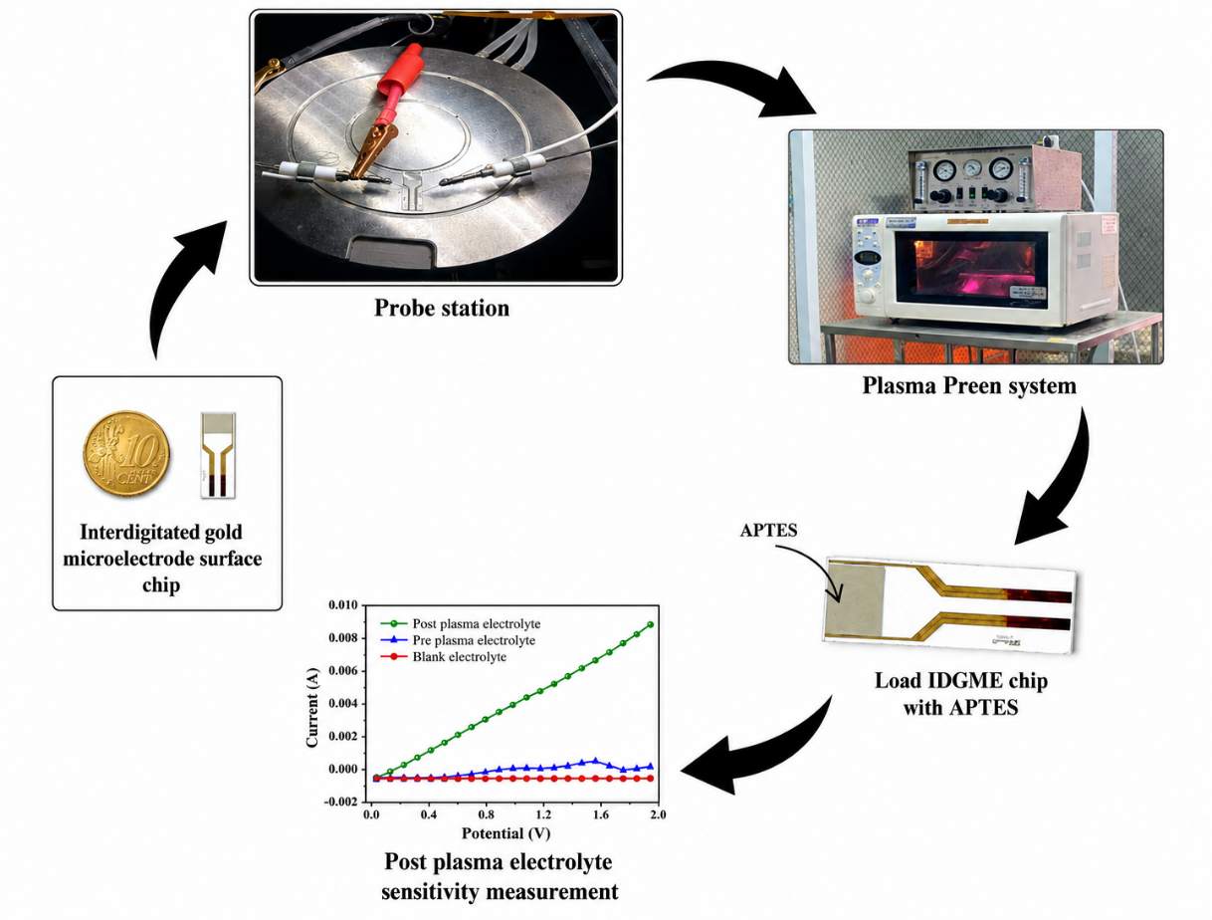

Figure 1: Schematic illustration of the methodology workflow

- Materials and Methods

  - Reagents

IDGME chips were commercially purchased in Metrohm, Malaysia and carefully stored on airtight plastics to avoid dust depositions. The buffer solutions were subsequently used for electrolyte scouting ranging from pH 1 to 12 were gotten from Hanna Instruments (M) Sdn Bhd,, Malaysia. The APTES (3-Aminopropyl) triethoxysilane and Potassium hydroxide (KOH) were availed from Sigma Aldrich, USA. The surface analysis of the IDGME chip was verified using a high-power microscopy to examine the surface morphology.
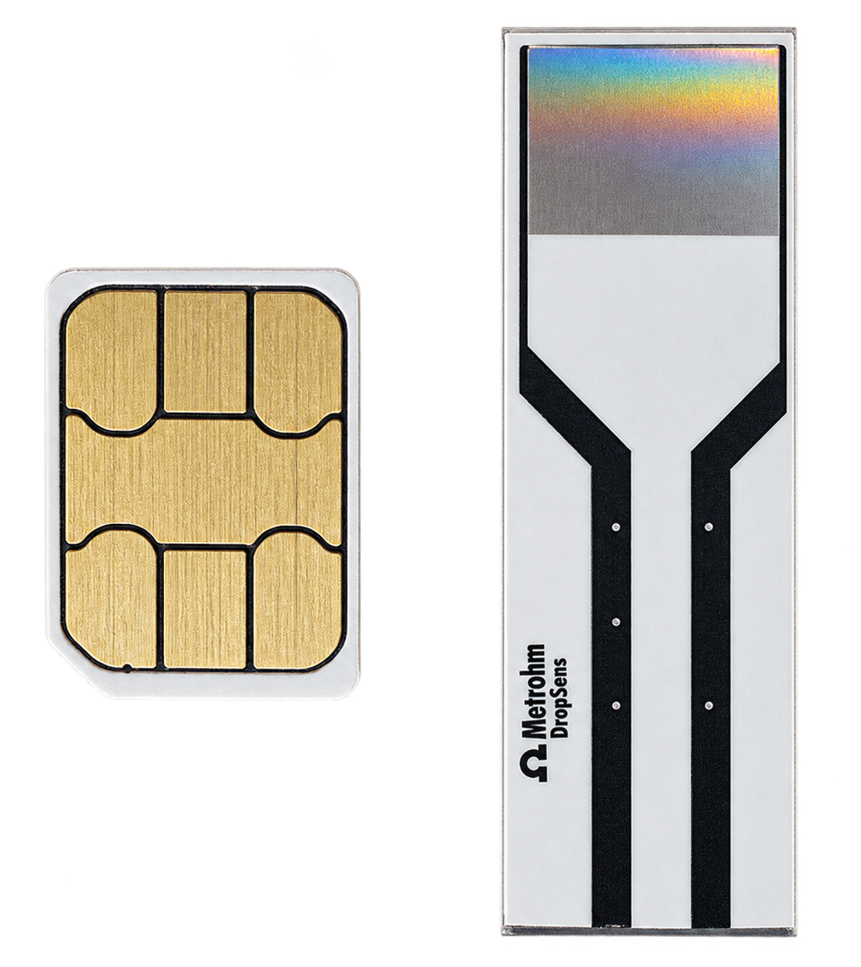

Figure 2: IDGME Chip and Sim card for standard measurement comparison.
  - Measurements on bare IDGME chip

An IDGME chip tagged ‘bare’ was cleaned under running distilled water, after which a baseline electrical characterization was performed by an I-V machine using a picoammeter connected to a probe station and a desktop for real time visualization. The voltage measurement was configured between -4 and +4 V, the real time capture was configured at 0.1 V interval to capture up to 80 points in order to get the baseline electrical response.

  - Initial electrolyte scouting

Electrolyte scouting was performed beginning with the deposition of 20 µL of distilled water on the sensing surface of the bare chip and measured with picoammeter voltage/current supply (Keithley 6487) with voltage source from -4 to +4 V. This was followed by the deposition of 20 µL pH 1 solution, and the electrical signal was measured; 200 µL of distilled water was used to wash the sensing surface of the chip before the deposition of 20 µL of pH 2 solution in order to keep chip surface free of previous pH solutions to allow for accurate independent electrical measurements [1]. The steps were repeated until pH 12, while each electrical signal was recorded.

  - Non-thermal Oxygen plasma surface activation

Non-thermal oxygen plasma is an energized oxygen gas consisting of reactive particles such as electrons, ions and radicals, capable of cleaning and modifying a material’s surface without excessively heating the material. Three new IDGME chips labelled as 10 sec, 20 sec and 60 sec were exposed to non-thermal oxygen plasma after being washed and cleaned with distilled water to ensure that there is no contaminant on the chip surface. The exposures were performed under the same pressure (100 Pa), power (250 W) and gas flow rate (50 sccm). pH scouting was carried out on the oxygen plasma exposed IDGME chips where distilled water, pH 1-12 were loaded sequentially while checking the respective electrical responses. The electrical performance data were analyzed using the Origin pro graphing and analysis software to compare the performance with the bare chip pH scouting.

  - Chemical hydroxyl activation and silane coupling

Chemical hydroxyl activation was carried out on the bare chip by loading 20 µL of 1 M potassium hydroxide (KOH) and was left for 5 minutes in order to generate hydroxyl groups; this procedure was followed by proper rinsing with distilled water in order to remove impurities. Following chemical hydroxyl activation of the bare chip, 0.5%, 1%, and 2% APTES solutions were prepared using 30% ethanol as solvent. APTES was deposited on the four IDGME chips (bare, 10 sec, 20 sec, 60 sec) and incubated for 30 minutes. After the 30 minutes was complete, post-functionalization electrical characterization was performed using the I-V machine over the voltage range of -4 V to +4 V. This procedure was repeated for 1% and 2% APTES.
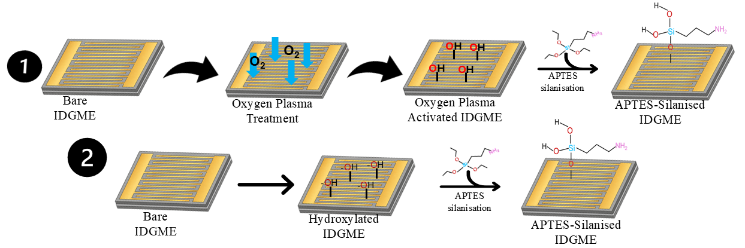
Figure 3: Schematic illustration of surface modification procedure. Performed with plasma and KoH treatments.

- Results and Discussion

  - APTES (3-Aminopropyl)triethoxysilane

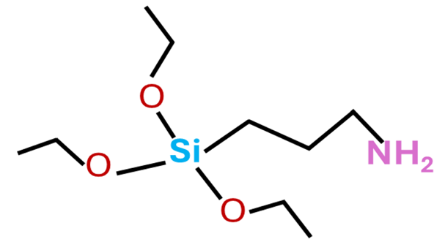
Figure 4: Chemical structure of 3-Aminopropyl)triethoxysilane (APTES)

  - Surface integrality and electrolyte scouting on IDGME

Initially, the visualization was performed on the chip to check the structure integrity, physical defect, surface alignment and measure microscopic dimensions and chip reliability (Figure 5 A-D). Figure 5A, 8.43 µm; Figure 5B, 10.08 and 10.62 µm; Figure 5C, 10.51 and 29.83 µm; Figure 5D, 11.03 µm. Most individual features are measured at ~10 µm, but the 29.83 µm cut across three electrodes. Local fabrication variation, uneven boundaries and surface residues can obscure the precise edges used for measurement and may be reasons for variation between comparable measurements. Differences in focus, illumination, and image resolution, along with differences in calibration at each magnification, may also contribute to measurement uncertainty.
The narrowness of these electrodes is a major contribution to increase the sensitivity and conductivity [7]. After this, the ‘bare’ chip was stored in a petri dish to prevent contamination and dust deposition. The sensitivity of the bare chip to the pH solutions was examined by using pH solutions from pH 1 to 12. pH scouting was carried out to determine the effect of background signal and ionic charge, irrespective of the surrounding conditions which could either be highly alkaline or acidic. The conductivity of the IDE chip is altered because the amount of the positively and negatively charges ions filling in between the electrodes are fluctuating [9]. pH scouting begins with distilled (deionized) water which serves as the control to examine the sensitivity of the chip to an electrolyte rich solution and a non-electrolyte solution like deionized water [10].
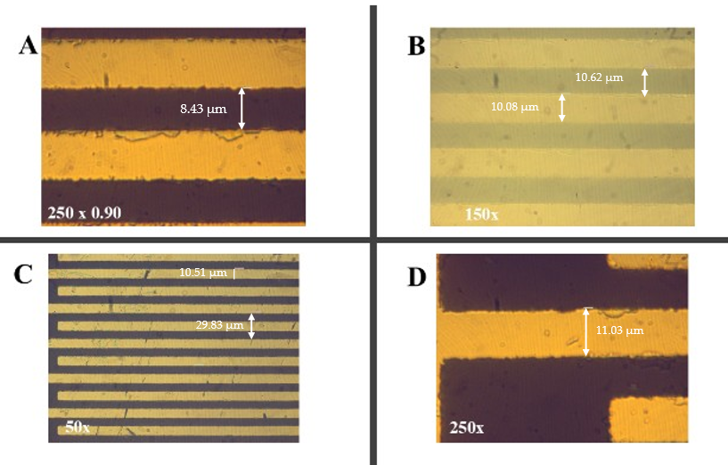

Figure 5 (A-D): High-power microscope images of bare IDGME chip at different magnifications

IDGME were viewed under Scanning Electron Microscope (SEM) for more definite visualization of the chip surface (Figure 6 A-C). At magnifications of ×500 (A), ×1000 (B) and ×5000 (C) revealed parallel electrode fingers separated by well-defined gaps with measured dimensions close to 10 µm. The lower-magnification images show a generally regular arrangement of the electrodes, whereas the x5000 image provides a closer view of the gap, labeled 10.0 µm, and reveals minor irregularities along the electrode boundaries. Small differences between measurements of equivalent features may be indicative of local fabrication variation, such as uneven patterning or etching. Measurement uncertainty can also be introduced through pixel resolution, magnification calibration, specimen tilt and the selection of measurement endpoints along irregular edges. Increased magnification improves the visibility of edges but does not, in itself, change the physical dimensions.

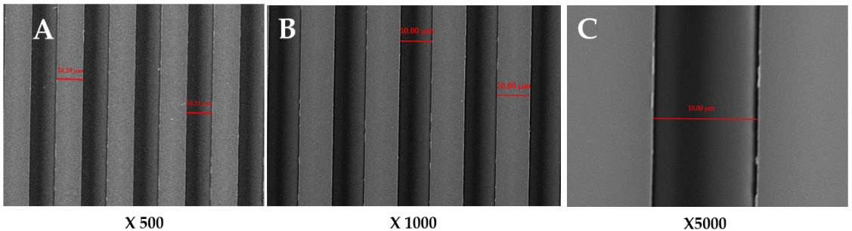

Figure 6 (A-C): Scanning Electron Microscope of bare IDGME images at different magnifications

The bare IDGME shows resistive electrical behavior by exhibiting an increase in current for pH solutions, especially pH 1 and 2 which shows an obvious difference and may indicate high effective conductivity because of their high acidity, high ionic concentration and increased hydrogen ion mobility (Figure 5). The current values during pH scouting of the bare chip are recorded in Table 1 alongside the standard deviation of (1.60×${10}^{-6}$).

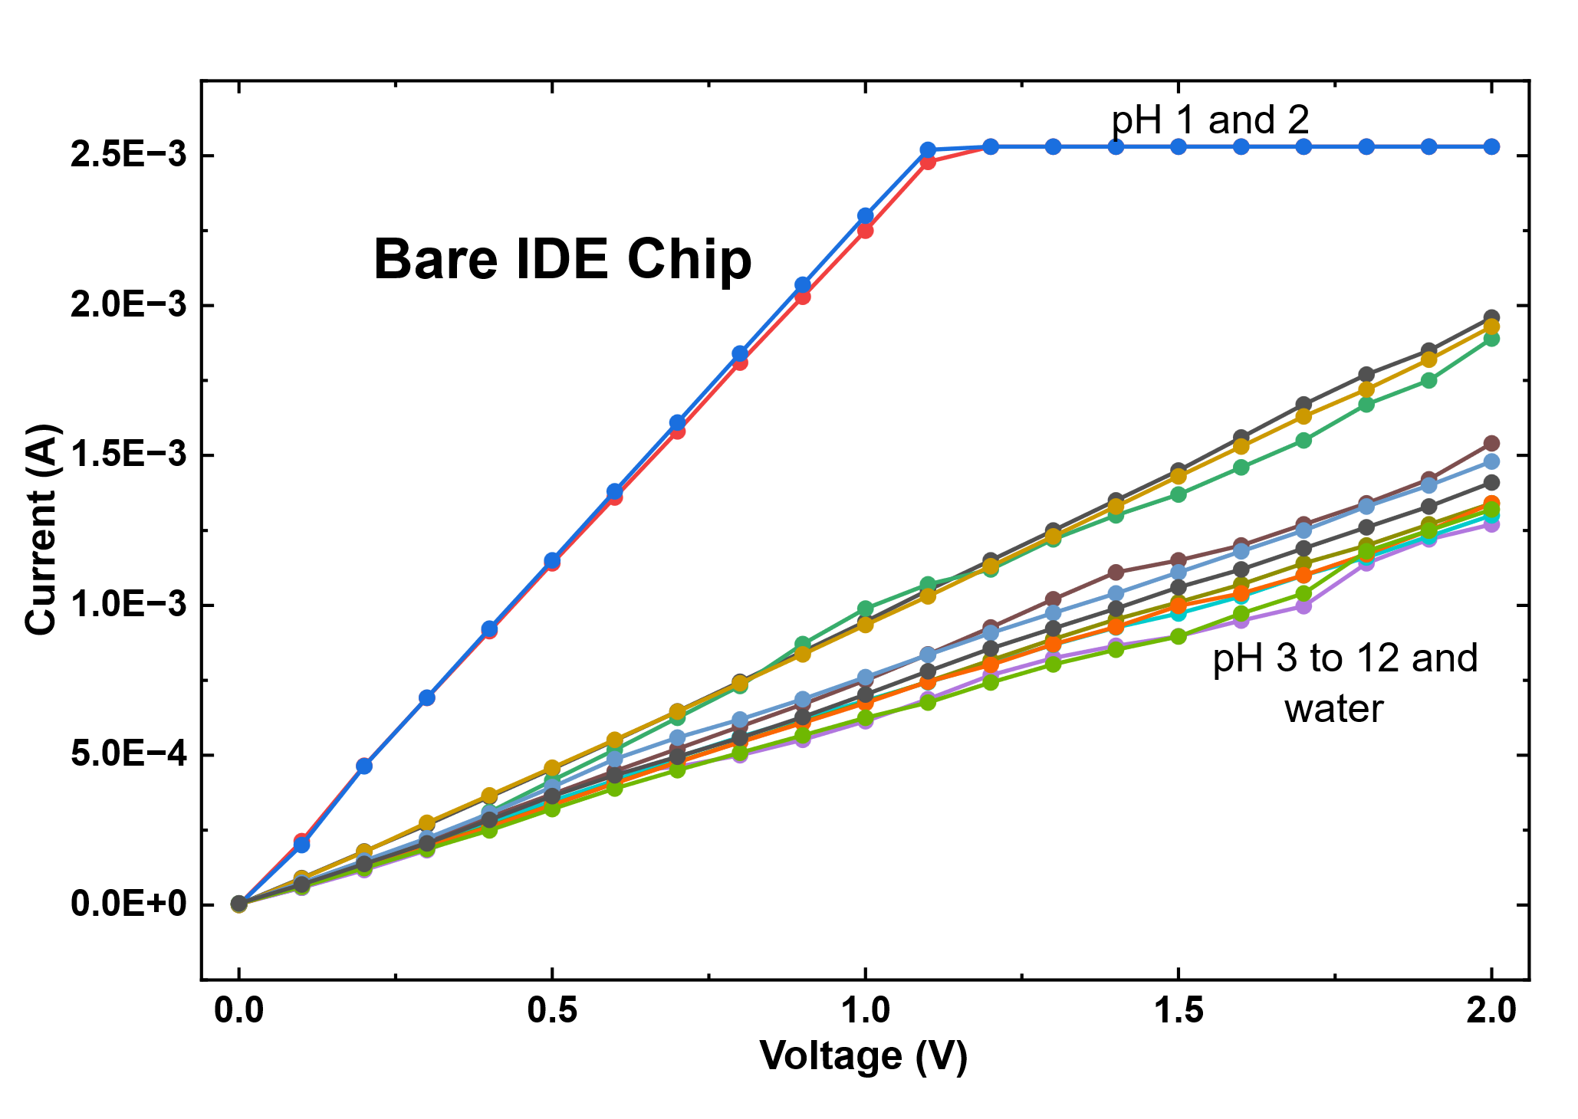

Figure 7: I-V measurement of a bare device with power supplied by an ammeter.

Table 1: Mean current values of the bare IDGME chip in electrolyte solutions at pH 1-12, extracted from the I-V curves at an applied voltage of 2 V.

Electrolyte solution | Current (A)
pH 1 | 9.03 × 10⁻⁷
pH 2 | 6.53 × 10⁻⁷
pH 3 | 4.95 × 10⁻⁶
pH 4 | 3.56 × 10⁻⁶
pH 5 | 8.87 × 10⁻⁸
pH 6 | 2.49 × 10⁻⁶
pH 7 | 2.95 × 10⁻⁶
pH 8 | 2.76 × 10⁻⁶
pH 9 | 3.12 × 10⁻⁶
pH 10 | 3.79 × 10⁻⁶
pH 11 | 4.48 × 10⁻⁶
pH 12 | 5.26 × 10⁻⁶
Standard deviation | 1.60 × 10⁻⁶

3.2. Oxygen plasma treated IDGME surface

The electrical response of IDGME chips exposed to plasma at different times is shown in figure 5 (A-C). The chip ‘A’ was exposed to plasma for 10 secs shows lower current response, when compared to ‘B and C’. There was a moderate increment in current response when plasma exposure was extended to 20 secs in chip ‘C’. Also, the exposure to plasma for 60 secs in chip ‘B’ produced the highest response with more pH solutions attaining 2.5 mA, although response showed that the limit of the picometer has been reached thereby displaying a plateau (Table 2). However, of all responses, the 20 seconds plasma treatment proves to have provided the most appealing response by balancing the current level and electrical response.

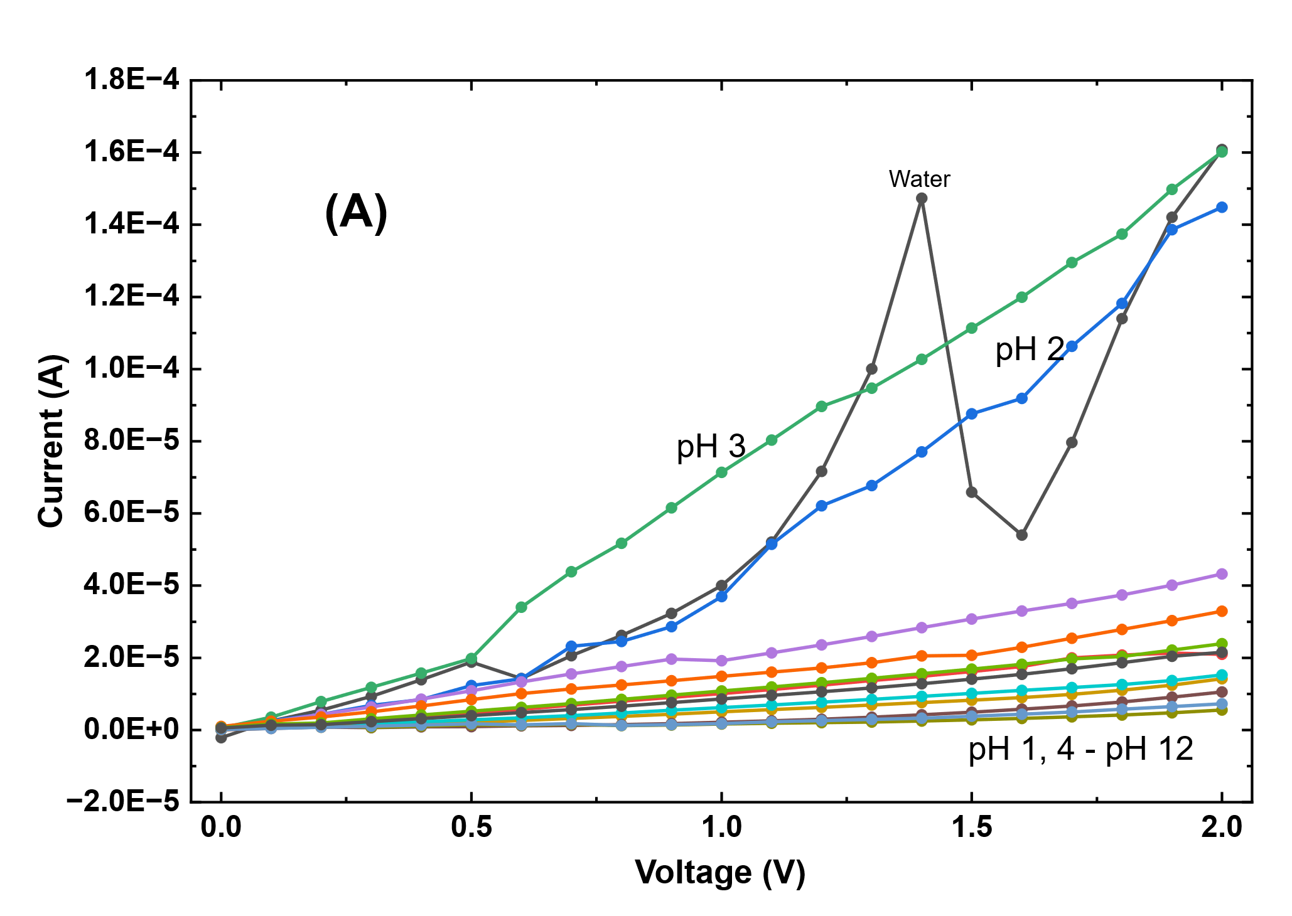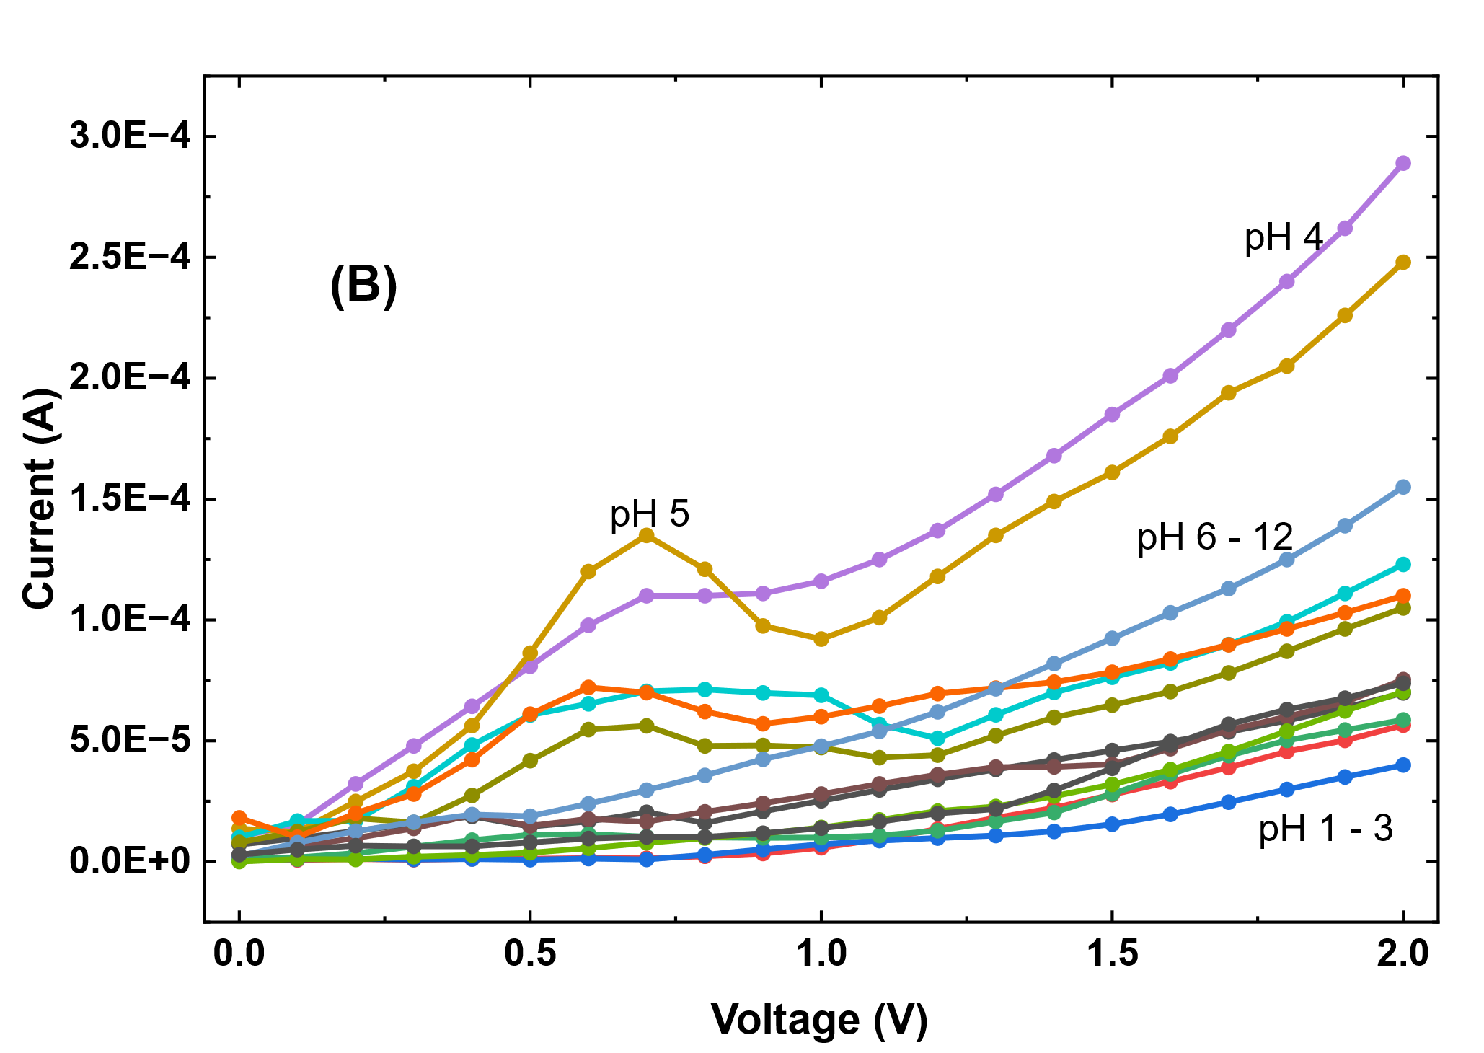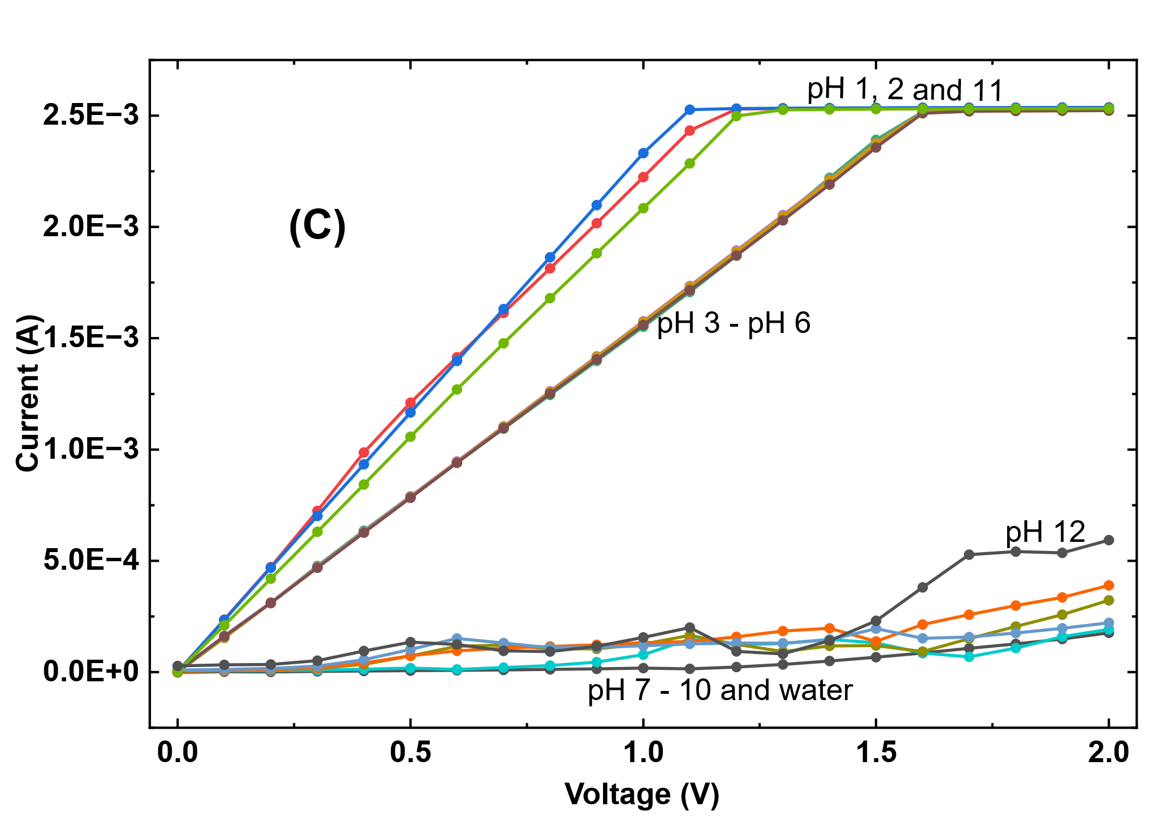

Figure 8: pH scouting on IDGME chips exposed to plasma for 10 sec (A), 20 secs (B) and 60 secs (C).

Table 2: Current values of IDGME chips exposed to oxygen plasma for 10, 20 and 60 secs at pH 1-12, extracted from curves at an applied voltage of 2 V.

Electrolyte solution | Current after plasma exposure
Electrolyte solution | 10 Sec (A) | 20 sec (A) | 60 sec (A)
pH 1 | 5.54 × 10⁻⁷ | 4.72 × 10⁻⁷ | −1.90 × 10⁻⁶
pH 2 | 7.43 × 10⁻⁷ | 8.46 × 10⁻⁷ | 2.23 × 10⁻⁶
pH 3 | 5.52 × 10⁻⁷ | 1.55 × 10⁻⁶ | −4.51 × 10⁻⁷
pH 4 | 1.33 × 10⁻⁷ | 1.04 × 10⁻⁵ | 4.89 × 10⁻⁶
pH 5 | 2.13 × 10⁻⁸ | 1.37 × 10⁻⁵ | 1.21 × 10⁻⁶
pH 6 | 1.18 × 10⁻⁷ | 1.01 × 10⁻⁵ | 3.13 × 10⁻⁶
pH 7 | 6.48 × 10⁻⁸ | 2.63 × 10⁻⁶ | 4.04 × 10⁻⁶
pH 8 | 5.64 × 10⁻⁷ | 7.93 × 10⁻⁶ | 5.00 × 10⁻⁶
pH 9 | 1.01 × 10⁻⁶ | 1.82 × 10⁻⁵ | 4.12 × 10⁻⁶
pH 10 | 1.54 × 10⁻⁷ | 2.26 × 10⁻⁶ | 9.00 × 10⁻⁶
pH 11 | 6.70 × 10⁻⁷ | 7.17 × 10⁻⁸ | 3.49 × 10⁻⁶
pH 12 | 5.47 × 10⁻⁷ | 2.95 × 10⁻⁶ | 2.81 × 10⁻⁵
Mean current | 4.27 × 10⁻⁷ | 5.93 × 10⁻⁶ | 5.24 × 10⁻⁶
Standard deviation | 3.04 × 10⁻⁷ | 5.73 × 10⁻⁶ | 7.38 × 10⁻⁶

3.3 Formation of silane coupling at different APTES levels on chip surface

APTES is an important synergistic compound that is used to functionalize sensor surfaces by reducing the gap between inorganic sensor surfaces such as silicon, gold or metal oxides and biological elements like DNA, enzymes or antibodies [8], [11]. The evidence gathered through pH scouting on IDGME chips shows that electrical activity on chips is influenced by oxygen plasma exposure. The results also indicated that pretreatment of IDGME chips with APTES preceded by controlled oxygen plasma exposure is a viable method of surface optimization. Indeed, 20 secs oxygen plasma exposure produced measurable electrical responses with considerable electrical adjustment after APTES. The electrical response of chip exposed to oxygen plasma for 20 sec was exposed to different levels of APTES (Figure 9) at 2 V. The 1% APTES showed the highest response and similar values for the other two. The observed variation indicates that the electrical properties of the plasma treated chip depend on the APTES concentration and therefore the subsequent silanisation conditions need to be optimized.

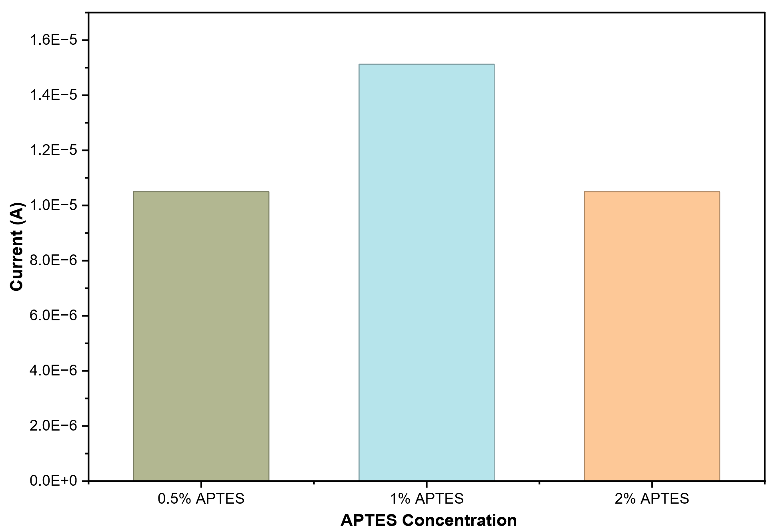
Figure 9: Electrical response of 20% plasma exposed chip under different concentrations of APTES at 2V

3.4 Discussion

Surface chemistry and formation of the APTES-functionalized interface

The surface functionalization of an interdigitated electrode is not only connected with the physical morphology but also with the chemical state of the solid-liquid interface [7], [8]. Prior to functionalization, reactive sites can be occupied by free-standing molecules, readily absorbed organic molecules and other impurities that hinder the surface wettability and restrict the homogeneous interaction of the electrode surface [12]. Strong oxygen-containing species in oxygen-plasma treatment modify the interfacial chemistry by removing weakly bound organic contaminants and increasing the polarity and surface energy of susceptible regions of the chip. Plasma treatment may increase the amount or availability of oxygen-containing functionalities (including surface hydroxyl groups) on surface domains [13]. This results in an increased affinity of the treated surface to polar solutions and an increased chemical suitability for subsequent silanization. This surface-activation step is important because organosilane deposition is highly dependent on surface cleanliness, availability of hydroxyl groups, wettability, silane level, and reaction time [8]. APTES (Figure 4) was selected as a coupling molecule owing to its multifunctional chemical structure; it has a triethoxysilane group that can undergo hydrolysis at one end and a terminal primary amine (-NH₂) at the other end. APTES does not start with three hydroxyl groups. Their ethoxy groups [-Si-O-CH₂CH₃] are readily hydrolyzed with water to give the chemically reactive silanol groups [-Si-OH] and ethanol the product.

The reaction can be reduced to:
≡ Si - (O CH₂ CH₃)₃ + 3H₂O → ≡ Si - (OH)₃ + 3CH₃ CH₂ OH

The newly formed silanol groups can condense with available hydroxyl groups on a hydroxylated surface, resulting in interfacial Si-O- surface bonds and the release of water. Lateral condensation of the surrounding hydrolyzed APTES molecules may also lead to the formation of Si-O-Si siloxane linkages [14]. These reactions give an organosilane layer with the propyl chains pointing away from the base surface, presenting terminal -NH₂ groups to the solution. This mechanism explains why surface activation prior to APTES treatment is necessary; because an improperly cleaned interface, or one that is poorly hydroxylated, can result in incomplete, heterogeneous, or poorly adhered silane coverage, whereas controlled activation leads to more reproducible functionalization [13], [14]. The terminal amine group is important biosensor application because upon the APTES silanization of the plasma activated IDGME surface, the remaining exposed -NH₂ groups are chemically measurable sites that can be used for further immobilization of biological molecules. Primary amines can be further coupled with aldehyde-, carboxyl- or other suitably activated functional groups, whereby antibodies, enzymes, nucleic acids, aptamers and related bioreceptors can be located at the sensing interface [15], [16]. Thus, APTES acts as a molecular bridge connecting the activated inorganic or oxide that contains surface domains of the sensing platform to a subsequent biological recognition layer. This is an advantage over the use of the untreated electrode itself, which provides electrical conduction but not necessarily a controlled density of chemically accessible functional groups for biomolecule immobilization [8], [14].

The concentration of APTES is also a key consideration in surface chemistry even though a low APTES concentration may not always show a corresponding improvement of the sensing interface. Surface-bound molecules at relatively low concentrations can form a comparatively thin silane layer. Excessive APTES or prolonged reaction can favor intermolecular silanol condensation and formation of oligomers or multilayers [14]. This can lead to greater heterogeneity of the surface, the appearance of loosely bound molecules and an increase in the distance between the electrode and the immobilized recognition element. Studies showed that the silane-layer thickness was influenced by the APTES concentration and reaction time while a thick APTES layer could reduce the electrical sensitivity of the biosensor [17]. Thus, by using 0.5%, 1% and 2% APTES in this study, it was possible to verify whether an increase in the silane concentration would result in corresponding changes in the electrical properties of the plasma-treated IDGME. The I-V results support the interaction of plasma activation and APTES deposition, rather than an effect due only to APTES concentration. Due to the gap between electrical conductivity of APTES and the underlying metallic electrode, silane layer deposition can limit direct charge transport and change interfacial capacitance, ion accessibility and electrical resistance [8], [17]. Therefore, a decrease in the current measured after functionalization should not be holistically interpreted as a reduction of the electrode performance. Rather, within a suitable range, it can be considered as the successful incorporation of a molecular interfacial layer, which can further host the subsequent immobilization of bioreceptors.

The results indicate that optimization of plasma exposure is important since the chemical state of the surface before silanization plays a larger role in the result than as well as increasing the concentration of APTES. However, the changes in I–V response are indirect evidence of the interfacial modification, but not definitive chemical proof of the covalent attachment of APTES. Therefore, the electrical variations reported in this study can be interpreted as being suitable for the formation of an APTES-modified surface [18]. Although there may be need for additional physicochemical characterization such as FTIR, XPAS or AFM that can directly confirm the molecular structure and organization [19], [20].

Conclusion.

In this pilot study, non-thermal oxygen plasma was investigated as an alternative to KOH pretreatment for the preparation of IDGME for APTES functionalization with the aim to decrease the dependence on chemical treatment while maintaining the sensing surface. The electrical measurements showed the effect of plasma exposure time and APTES concentration on the chip response and indicated 20 s exposure as a promising condition for further optimization. The observed changes in current upon APTES deposition were consistent with interfacial modification but did not independently confirm covalent silane attachment or improved biosensing performance. These results support the further development of controlled oxygen plasma pretreatment as an alternative to KOH activation. But superiority in preserving surface integrity has to be confirmed by direct comparison of plasma- and KOH-treated chips using post-treatment microscopy, surface chemical characterization and replicated electrical measurements. Further studies on bioreceptor immobilization and analyte detection are also required to demonstrate the functional benefit of the proposed treatment.
REFERENCES
[1] I. Letchumanan, M. K. Md Arshad, S. C. B. Gopinath, R. D. A. A. Rajapaksha, and S. R. Balakrishnan, “Comparative Analysis on Dielectric Gold and Aluminium Triangular Junctions: Impact of Ionic Strength and Background Electrolyte by pH Variations,” Sci. Rep., vol. 10, no. 1, pp. 1–10, 2020, doi: 10.1038/s41598-020-63831-w.
[2] J. López-Asanza, A. J. Martínez-García, J. V. Hernández-Tovar, J. González, A. Molina, and E. Laborda, “Redox Cycling in Two-Polarized Electrode Sensors: Diagnostic Insights Guided by Theory,” ACS Meas. Sci. Au, vol. 6, no. 2, pp. 553–563, 2026, doi: 10.1021/acsmeasuresciau.6c00024.
[3] R. D. A. A. Rajapaksha, U. Hashim, S. C. B. Gopinath, and C. A. N. Fernando, “Sensitive pH detection on gold interdigitated electrodes as an electrochemical sensor,” Microsyst. Technol., vol. 24, no. 4, pp. 1965–1974, Apr. 2018, doi: 10.1007/s00542-017-3592-5.
[4] T. S. Tejaswi and P. S. Devi, “Biogenesis of Copper Oxide Nanoparticles using Marine Bacteria Pseudomonas aeruginosa: In vitro Antimicrobial and Photocatalytic Activities,” J. Pure Appl. Microbiol., vol. 19, no. 1, pp. 210–226, 2025, doi: 10.22207/JPAM.19.1.12.
[5] A. U. Siddique and R. Warren, “Effect of Plasma Treatment on the Spontaneous Formation and Morphology of Surface Nanobubbles on Silicon.”
[6] X. Yuan, L. Ma, J. Zhang, and Y. Zheng, “Simple pre-treatment by low-level oxygen plasma activates screen-printed carbon electrode: Potential for mass production,” Appl. Surf. Sci., vol. 544, Apr. 2021, doi: 10.1016/j.apsusc.2020.148760.
[7] S. C. B. Gopinath, K. Awazu, M. Fujimaki, K. Shimizu, W. Mizutani, and K. Tsukagoshi, “Surface functionalization chemistries on highly sensitive silica-based sensor chips,” Analyst, vol. 137, no. 15, pp. 3520–3527, 2012, doi: 10.1039/c2an35159e.
[8] M. Sypabekova, A. Hagemann, D. Rho, and S. Kim, “Review: 3-Aminopropyltriethoxysilane (APTES) Deposition Methods on Oxide Surfaces in Solution and Vapor Phases for Biosensing Applications,” Biosensors, vol. 13, no. 1, 2023, doi: 10.3390/bios13010036.
[9] L. Cao, J. Kiely, M. Piano, and R. Luxton, “A copper oxide/zinc oxide composite nano-surface for use in a biosensor,” Materials (Basel)., vol. 12, no. 7, 2019, doi: 10.3390/ma12071126.
[10] S. Ramanathan et al., “Assorted micro-scale interdigitated aluminium electrode fabrication for insensitive electrolyte evaluation: zeolite nanoparticle-mediated micro- to nano-scaled electrodes,” Appl. Phys. A Mater. Sci. Process., vol. 125, no. 8, Aug. 2019, doi: 10.1007/s00339-019-2833-0.
[11] A. Miranda, L. Martínez, and P. A. A. De Beule, “Facile synthesis of an aminopropylsilane layer on Si/SiO2 substrates using ethanol as APTES solvent,” MethodsX, vol. 7, no. December 2019, 2020, doi: 10.1016/j.mex.2020.100931.
[12] C. Ibau, M. K. Md Arshad, G. Subash C.B., M. Nuzaihan, M. F. M. Fathil, and P. Estrela, “Gold interdigitated triple-microelectrodes for label-free prognosticative aptasensing of prostate cancer biomarker in serum,” Biosens. Bioelectron., vol. 136, pp. 118–127, 2019, doi: 10.1016/j.bios.2019.04.048.
[13] D. S. Moyo, G. Kleinhans, X. Wei, F. J. Doucet, and E. M. van der Merwe, “Parametric Study on APTES Silanization of Coal Fly Ash for Enhanced Rubber Composite Performance,” Minerals, vol. 15, no. 11, pp. 1–12, 2025, doi: 10.3390/min15111198.
[14] Y. Millot, A. Hervier, J. Ayari, N. Hmili, J. Blanchard, and S. Boujday, “Revisiting Alkoxysilane Assembly on Silica Surfaces: Grafting versus Homo-Condensation in Solution,” J. Am. Chem. Soc., vol. 145, no. 12, pp. 6671–6681, 2023, doi: 10.1021/jacs.2c11390.
[15] M. Antoniou, D. Tsounidi, P. S. Petrou, K. G. Beltsios, and S. E. Kakabakos, “Functionalization of silicon dioxide and silicon nitride surfaces with aminosilanes for optical biosensing applications,” Med. Devices Sensors, vol. 3, no. 5, pp. 1–11, 2020, doi: 10.1002/mds3.10072.
[16] F. Wieland, R. Bruch, M. Bergmann, S. Partel, G. A. Urban, and C. Dincer, “Enhanced protein immobilization on polymers-A plasma surface activation study,” Polymers (Basel)., vol. 12, no. 1, pp. 1–12, 2020, doi: 10.3390/POLYM12010104.
[17] P. Saengdee et al., “Optimization of 3-aminopropyltriethoxysilane functionalization on silicon nitride surface for biomolecule immobilization,” Talanta, vol. 207, no. August 2019, p. 120305, 2020, doi: 10.1016/j.talanta.2019.120305.
[18] B. Lu et al., “Detection of microRNA-335-5p on an Interdigitated Electrode Surface for Determination of the Severity of Abdominal Aortic Aneurysms,” Nanoscale Res. Lett., vol. 15, no. 1, 2020, doi: 10.1186/s11671-020-03331-y.
[19] Y. Alqaheem and A. A. Alomair, Microscopy and spectroscopy techniques for characterization of polymeric membranes, vol. 10, no. 2. 2020. doi: 10.3390/MEMBRANES10020033.
[20] J. H. Sliwowska, N. E. Woods, A. R. Alzahrani, E. Paspali, R. J. Tate, and V. A. Ferro, “Kisspeptin a potential therapeutic target in treatment of both metabolic and reproductive dysfunction,” Apr. 01, 2024, John Wiley and Sons Inc. doi: 10.1111/1753-0407.13541.

