Responses to the reviewer’s comments
We are deeply grateful to the reviewers for their thoughtful and constructive feedback, which significantly strengthened this manuscript. We have carefully updated the paper to address all suggestions. Below, you will find the reviewers' comments alongside our detailed replies. Our responses are marked in blue, and the corresponding changes in the revised manuscript are highlighted in yellow.

Reviewer 1
Comments
The manuscript presents a relevant DFT-based comparative investigation of four nanocage structures as potential anode materials for lithium-ion batteries. The comparative approach is useful, and the combination of adsorption energy, electronic properties, and theoretical voltage provides a reasonable basis for preliminary computational screening. The manuscript is suitable for conference proceedings after the following revisions:

Reviewer Comment point-1:
The novelty and specific contribution should be stated more explicitly at the end of the Introduction. The manuscript discusses previous applications of these nanocages, but the authors should clearly identify what is new about simultaneously comparing C24, B12N12, Be12O12, and Al12P12 for LIB anode screening using the selected descriptors.

Response to Reviewer
We thank the reviewer for this helpful comment. While our original manuscript outlined the rationale for selecting these four distinct material classes, we agree that the specific novelty—performing a direct, systematic comparative screening of C24, B12N12, Be12O12, and Al12P12 for lithium-ion battery anode applications—should be emphasized more explicitly.
To address this, we have revised the final paragraph of the Introduction to clearly state our specific contribution and clarify that, although individual nanocages have been studied separately, a unified comparative evaluation using these specific descriptors is lacking in the literature.

[Page 2: Line 19-30]
Besides structural engineering, selecting suitable nanocage materials is equally important for maximizing battery performance. Carbon (C₂₄), boron nitride (B₁₂N₁₂), beryllium oxide (Be₁₂O₁₂), and aluminum phosphide (Al₁₂P₁₂) nanocages were selected in this study because they represent different classes of materials, including pure carbon, nitride ceramics, oxide ceramics, and semiconductors. These materials exhibit attractive properties such as high structural stability, favorable electronic conductivity, excellent thermal stability, and sufficient internal cavities for lithium storage. Although previous studies have investigated these individual nanocages for various molecular interactions and storage applications [11-14], a direct and systematic comparative evaluation of their electrochemical performance as potential LIB anodes using a unified set of electronic and energetic descriptors remains scarce. Therefore, this work aims to bridge this gap by providing a comprehensive comparative screening to identify the structure-property relationships governing their lithium storage capabilities.

Reviewer Comment point-2:
The computational methodology requires slightly stronger justification. The authors employ the M06-2X functional with the 6-31+G(d) basis set. A brief explanation or supporting reference demonstrating the suitability of this computational level for lithium adsorption and nanocage systems would strengthen the reliability of the methodology

Response:
We thank the reviewer for this constructive suggestion. To address this, we have expanded our methodology section to provide a clearer justification for our choice of computational level. The M06-2X functional was selected because its parametrization incorporates empirical dispersion corrections, making it widely recognized and reliable for modeling non-covalent interactions, binding behaviors, and charge transfers in alkali metal adsorption for battery and energy storage systems [19–22]. Furthermore, the 6-31+G(d) basis set—equipped with essential diffuse and polarization functions—provides an accurate description of the flexible electron density distributions of the host nanocages and the electropositive lithium atoms. We have updated the text in the revised manuscript (page 3, lines 20–28) to reflect these details and added the appropriate supporting literature references.

. The M06-2X exchange-correlation functional combined with the 6-31+G(d) basis set was employed for all calculations. The M06-2X functional was chosen for its proven reliability in evaluating non-covalent interactions and medium-range electron correlation, making it a robust and widely adopted level of theory for investigating alkali metal adsorption in battery and energy storage applications [19-22]. Additionally, the inclusion of diffuse functions in the 6-31+G(d) basis set is essential for properly capturing the electronic properties and charge transfer behavior associated with electropositive lithium ions interacting with nanocage surfaces. Geometry optimization was performed without geometric constraints until the convergence criteria for energy and atomic forces were satisfied.

Reviewer Comment point-3:
The interpretation of Li and Li+ adsorption energies should be checked carefully. Table 1 reports substantially different adsorption energies for neutral and ionic lithium. The discussion should consistently distinguish Li from Li+ and ensure that statements regarding which species exhibits stronger adsorption correspond correctly to the numerical values reported in Table 1

Response:

We thank the reviewer for this important suggestion. We have carefully re-examined the discussion surrounding Table 1 to ensure that the distinction between neutral lithium ($\text{Li}$) and ionic lithium (${\text{Li}}^{+}$) is rigorous, consistent, and strictly aligned with the reported numerical values. In the revised manuscript, we explicitly clarify that the adsorption energies for the positively charged ${\text{Li}}^{+}$ ion are substantially more negative (indicating significantly stronger exothermic binding driven by Coulombic/electrostatic attraction) compared to those of the neutral $\text{Li}$ atom (which are governed by covalent contributions and charge transfer). We have verified that all comparative statements regarding adsorption strength precisely reflect the numerical data in Table 1.
(Page 4: Line 22-24): Negative E_{ads} indicate spontaneous adsorption, with more negative values corresponding to stronger binding interactions [15, 23].

Reviewer Comment point-4:
The authors should discuss whether excessively strong adsorption is always beneficial for an anode material. For example, Be12O12 exhibits a very strong interaction in one adsorption condition, whereas the manuscript later identifies C24 as the most promising candidate. A concise explanation connecting adsorption strength with reversible lithiation/delithiation would make this interpretation more convincing.

Response:
We thank the reviewer for this insightful question. We agree that exceptionally strong adsorption is not always beneficial for a practical battery anode, as it can hinder the reversibility of the charging and discharging cycles.
Although ${\text{Be}}_{12}{\text{O}}_{12}$ exhibits an extremely high binding energy under specific ionic conditions (e.g., ${\text{Li}}^{+}$ adsorption), its neutral lithium adsorption is weak ($-0.73\text{ eV}$) and its calculated theoretical voltage is negative ($-0.98\text{ V}$), which implies that sustained, reversible lithium insertion would be energetically unfavorable. Conversely, an ideal anode requires a balanced intermediate adsorption energy combined with a positive operating voltage—such as that demonstrated by ${\text{C}}_{24}$ ($0.65\text{ V}$) and ${\text{Al}}_{12}{\text{P}}_{12}$ ($0.30\text{ V}$). These materials provide sufficient retention without creating kinetic bottlenecks that impede delithiation. We have expanded Section 4.3 of the revised manuscript to explicitly address this balance between binding strength, theoretical voltage, and cycling reversibility.

(Page 8: Line 6-14):
It is worth noting that excessively strong adsorption—such as the massive ionic binding energy seen in ${\text{Be}}_{12}{\text{O}}_{12}$ (−12.79 eV)—is not always advantageous for rechargeable batteries. While high exothermic adsorption suggests high thermodynamic stability, overly strong local binding can create kinetic traps, hinder lithium-ion diffusion, and impede the extraction process during delithiation [7, 26]. Furthermore, combined with its negative theoretical voltage, ${\text{Be}}_{12}{\text{O}}_{12}$ fails to support spontaneous, reversible cycling. Therefore, an optimal anode material requires a delicate balance: strong enough adsorption to prevent clustering, yet moderate enough (coupled with a positive operating voltage, as observed in ${\text{C}}_{24}$ and ${\text{Al}}_{12}{\text{P}}_{12}$) to ensure high reversibility and practical battery performance.

Reviewer Comment point -5:
Figure 1 should be improved for clarity and readability. The HOMO-LUMO isosurfaces provide useful qualitative support for the calculated energy gaps, but several numerical labels and molecular structures are relatively small. Increasing the figure resolution, font size, and consistency of labels would improve presentation. The authors should also check the reference to “C12” in the discussion, which appears inconsistent with C24 used throughout the study. 6. The manuscript requires careful proofreading before final publication. There are several grammatical, formatting, punctuation, and terminology inconsistencies. Correcting these issues would significantly improve the professional presentation of the proceeding paper.
Response:
We sincerely thank the reviewer for their careful reading and constructive suggestions regarding the presentation and clarity of the manuscript.
- Figure 1: We have regenerated Figure 1 at a higher resolution, increased the font sizes for all labels, and ensured consistent formatting across all molecular structures and orbital surfaces to improve readability.
- Typo Correction ("C12"): We thank the reviewer for catching the typographical error. We have thoroughly proofread the text and corrected all accidental references from "C12" to the correct formula, ${\text{C}}_{24}$, ensuring total consistency throughout the manuscript.
- Proofreading: Following the reviewer's recommendation, we have thoroughly proofread the entire manuscript to correct grammatical errors, punctuation mistakes, and terminology inconsistencies, significantly improving the overall professional presentation.
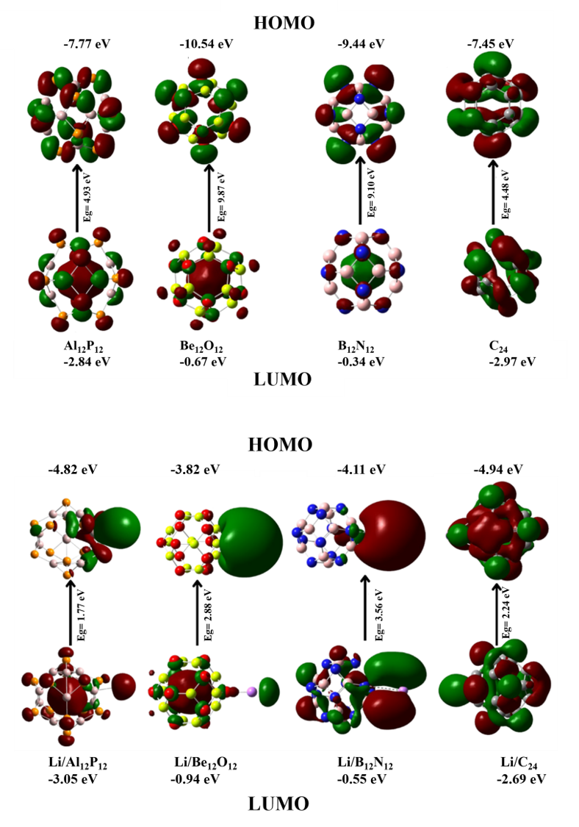
Fig. 1. HOMO and LUMO isosurfaces of pristine Al₁₂P₁₂. Be₁₂O₁₂. B₁₂N₁₂. and C₂₄ nanocages and their corresponding Li-adsorbed structures.

\
Reviewer #2
This manuscript investigates the potential application of C24, B12N12, Be12O12, and Al12P12 nanocages as lithium-ion battery anode materials using DFT calculations. The results provide useful preliminary theoretical insight, particularly the identification of C24 and Al12P12 as comparatively promising candidates.

Reviewer Comment point -1:
The reported work is entirely computational and uses Gaussian 16/GaussView rather than an experimental procedure.
Response:
We thank the reviewer for this observation. We have verified that the manuscript clearly reflects the purely computational nature of this study, utilizing Density Functional Theory (DFT) calculations via Gaussian 16 and GaussView 6.0 for structural screening and electronic property evaluation.

Reviewer Comment point-2:
It is currently written as “Effect of Potassium Adsorption on the Energy Gap,” whereas the study investigates lithium adsorption. This should be corrected to “Effect of Lithium Adsorption on the Energy Gap.”
Response:
We sincerely thank the reviewer for catching this oversight. We have corrected the subheading and text to accurately state “Effect of Lithium Adsorption on the Energy Gap” to maintain consistency with the rest of the manuscript, which focuses exclusively on lithium-ion battery applications.

Reviewer Comment point-3:
The heading “Application of Graphene Quantum Dots in Potassium-Ion Batteries (KIBs)” does not correspond to the actual study, which concerns nanocages for lithium-ion batteries. A suitable heading would be “Comparative Electrochemical Assessment of Nanocages for Lithium-Ion Battery Anodes.”
Response:
We sincerely thank the reviewer for pointing out this oversight. We agree that the previous heading was inconsistent with the scope of the study. We have updated Section 4.3 with the recommended heading, “Comparative Electrochemical Assessment of Nanocages for Lithium-Ion Battery Anodes,” to accurately reflect that the research investigates nanocages for lithium-ion (rather than potassium-ion) batteries.

Reviewer Comment point-4:
Equation (3) and the accompanying description should explicitly define every energy term and explain how the calculated energy is converted into theoretical voltage. This is particularly important because theoretical voltage is one of the main parameters used to rank the candidate materials.
Response:
We thank the reviewer for pointing this out. We have thoroughly revised the text and Equation (3) in the manuscript. We corrected the previous typographical error, removed the unintended reference, and replaced it with the standard thermodynamic equation used to calculate theoretical operating voltage for lithium-ion battery anodes. Furthermore, we have added explicit definitions for every energy term ($E_{\text{sys+Li}}$, $E_{\text{sys}}$, $E_{\text{Li}}$, $n$, and $F$) to ensure absolute clarity.

(Page 4: Line 7-16)

Finally, the theoretical average voltage ($V$) was calculated to evaluate the electrochemical feasibility of each nanocage as an anode material for lithium-ion batteries. The theoretical voltage is determined from the total energy change associated with the lithiation and delithiation processes, defined as:
$$V=-\frac{E_{\text{sys+Li}}-E_{\text{sys}}-nE_{\text{Li}}}{nF} \text{(3)}$$
where $E_{\text{sys+Li}}$ is the total electronic energy of the Li-adsorbed nanocage system, $E_{\text{sys}}$ is the total electronic energy of the pristine nanocage, $E_{\text{Li}}$ is the energy per atom of bulk lithium metal reference, $n$ is the number of transferred electrons, and $F$ is the Faraday constant. The adsorption energy (E_{ads}), energy gap (E_{g}), and theoretical voltage were then comparatively analyzed to determine the most promising nanocage structure for lithium-ion battery applications.

Reviewer Comment point-5:
The manuscript reports -0.63 V and -0.98 V, respectively, compared with positive values of 0.65 V for C24 and 0.30 V for Al12P12. The physical meaning and implication of these negative values for practical anode behavior should be briefly clarified.
Response:
We thank the reviewer for this insightful comment. To clarify the discussion, we have expanded the manuscript to explain the physical meaning and practical implications of the negative theoretical voltages ($-0.63\text{ V}$ for ${\text{B}}_{12}{\text{N}}_{12}$ and $-0.98\text{ V}$ for ${\text{Be}}_{12}{\text{O}}_{12}$).
Physically, a negative voltage indicates that the Gibbs free energy change for lithium insertion into the nanocage is positive relative to the lithium metal reference state, meaning lithiation is thermodynamically unfavorable. Practically, this implies that the material would fail to spontaneously insert lithium during discharge and would instead favor lithium dendrite formation or require an unrealistic external electrical penalty, thereby rendering it unsuitable for practical battery operation. We have integrated this clarification into Section 4.3 of the revised manuscript.

(Page 8: Line 20-31)

The calculated theoretical voltages further distinguish the electrochemical feasibility of the investigated nanocages. ${\text{C}}_{24}$ and ${\text{Al}}_{12}{\text{P}}_{12}$ exhibit positive theoretical voltages of $0.65\text{ V}$ and $0.30\text{ V}$, respectively, indicating thermodynamically favorable lithiation and delithiation processes. In contrast, ${\text{Be}}_{12}{\text{O}}_{12}$ and ${\text{B}}_{12}{\text{N}}_{12}$ produce negative theoretical voltages of $-0.98\text{ V}$ and $-0.63\text{ V}$, respectively. Physically, a negative theoretical voltage implies that the Gibbs free energy change for lithium insertion is unfavorable relative to the lithium metal reference state, meaning lithiation is endergonic under standard conditions. In practical battery operation, an anode with a negative voltage would fail to spontaneously insert lithium and would require a forced external overpotential, thereby increasing energy losses, elevating safety risks such as lithium plating or dendrite formation, and hindering reversible cycling. Consequently, these negative values significantly reduce the practicality of these materials as rechargeable lithium-ion battery anodes despite their other favorable adsorption characteristics [29-30].

Reviewer Comment point-6: The current study evaluates adsorption energy, HOMO-LUMO gap, and theoretical voltage, but does not report experimental cycling, specific capacity, diffusion barriers, or long-term structural stability. The conclusion should therefore acknowledge these limitations and recommend experimental validation as future work.

Response:
We thank the reviewer for this constructive observation. We fully agree that while this study provides a robust preliminary screening based on adsorption energy, electronic properties, and theoretical voltage, comprehensive evaluation would ultimately benefit from complementary data such as diffusion barriers, specific capacity, long-term structural stability, and experimental testing.
To address this, we have revised the Conclusion section of the manuscript to explicitly acknowledge these limitations and outline future work—including kinetic evaluations via nudged elastic band (NEB) calculations and subsequent experimental synthesis and testing—to validate the practical performance of ${\text{C}}_{24}$ and ${\text{Al}}_{12}{\text{P}}_{12}$ as advanced lithium-ion battery anodes.

(Page 9: Line 38 – Page 10: Line 3)
Finally, while this study provides a comprehensive computational screening based on adsorption energy, electronic properties, and theoretical voltage, several practical aspects—such as ionic diffusion barriers, specific capacity, and long-term structural stability during cycling—warrant further exploration. Future work should focus on kinetic evaluations, such as nudged elastic band (NEB) calculations, alongside complementary experimental synthesis and electrochemical testing to validate the practical viability of ${\text{C}}_{24}$ and ${\text{Al}}_{12}{\text{P}}_{12}$ as high-performance lithium-ion battery anodes.

Reviewer Comment point-7:
Chemical notation (Li/Li+), subscripts, punctuation, equation formatting, table headings, figure labels, and terminology should be standardized throughout. This will considerably improve readability and presentation quality.

Response:
We sincerely thank the reviewer for this helpful recommendation. We have conducted a thorough, manuscript-wide check to standardize all formatting elements. Specifically, we have ensured consistent formatting and proper subscripts for all chemical notations (e.g., ${\text{C}}_{24}$, ${\text{B}}_{12}{\text{N}}_{12}$, ${\text{Be}}_{12}{\text{O}}_{12}$, ${\text{Al}}_{12}{\text{P}}_{12}$, $\text{Li}$, and ${\text{Li}}^{+}$), uniform punctuation and equation styles, and standardized terminology, table headings, and figure labels across the entire document. These changes significantly enhance the overall readability and presentation quality of the manuscript.

