3D-Printed Carbon-Based Conductive PLA Insert for Embedded Vibration Sensing in Multicopter UAV Arm: Detection of Propeller ImbalanceDesign and Measurement Methodology for Propeller Imbalance Detection
Muhammad Aldo Setiawan^{1,*}, Ananta Adhi Wardhana¹, Joseph Raul Bagasta Nillan¹, Rizky Naufal Faruqi¹, Hisham Hanif¹, Tahta Amrillah²
¹ Robotics and Artificial Intelligence Engineering, Faculty of Advanced Technology and Multidiscipline, Universitas Airlangga, Surabaya, Indonesia ² Nanotechnology Engineering, Faculty of Advanced Technology and Multidiscipline, Universitas Airlangga, Surabaya, Indonesia
* Corresponding author: [m.aldo.setiawan@ftmm.unair.ac.id]
Propeller imbalance is a common fault in multicopter unmanned aerial vehicles, arising after a crash, a hard landing, or contact between a blade and an obstacle. Conventional detection adds accelerometers to the airframe, which increases mass and loads a flight controller that already handles navigation and control. This work presents the design method and the supporting analysis for an arm that senses its own vibration, using a replaceable sensing element rather than an added instrument. A stiff arm compatible with the F450 airframe class carries the structural load, while a slender central plate integrated along the arm acts as an interchangeable piezoresistive sensing flexure. The plate is produced by fused deposition modelling from carbon-based conductive polylactic acid (PLA), so the sensing region and the structure are formed in the same build. A rotating-unbalance model fixes the relationship between rotational speed, unbalance mass, and the alternating bending that the plate must transduce, and it sets the sampling rate and the safe operating envelope. Candidate sensing materials are analysed against the percolation behaviour that governs piezoresistive sensitivity, and practical methods for applying each material to the plate are described, including co-printed conductive PLA, a cast carbon black and epoxy strip with a controlled filler fraction, and a dip-cast carbon nanotube dispersion. A two-layer plate that separates the structural substrate from the sensing layer is proposed as the configuration best suited to a controlled material study. A fabricated conductive PLA specimen changed its resistance measurably and reversibly when bent by hand, which is encouraging, though instrumented motor testing is still to come. No motor-rig measurements are reported. What the paper contributes is the design method, the analysis behind it, and the measurement protocol now being used for validation.
Keywords: conductive PLA; piezoresistive sensing; fused deposition modelling; propeller imbalance; multicopter UAV; structural health monitoring
- Introduction
Multicopter unmanned aerial vehicles (UAVs) are used routinely in mapping, inspection, agriculture, and logistics, and their reliability depends strongly on the rotating subsystem. Among the faults that occur in service, propeller imbalance is one of the most frequent. It appears after a crash, after a hard landing, or when a blade clips an obstacle, and it can also develop gradually through erosion of the blade surface. The resulting rotating unbalance force excites the airframe at the rotational frequency of the rotor, degrades attitude control quality, accelerates bearing wear, and reduces the useful signal available to onboard estimators.
Vibration analysis is the established route for detecting this class of fault. In rotating machinery diagnostics, mass imbalance produces a dominant response at the first rotational harmonic, commonly written as 1×, and the amplitude at that frequency scales with the severity of the unbalance. The same principle has been applied to multicopters. Ghalamchi and Mueller used the accelerometer already present in the flight controller together with spectrum comparison to locate a damaged propeller [1]. Later work extended this to real-time operation and to richer fault sets, and recent studies using microelectromechanical system (MEMS) accelerometers at the arm tip have shown that the informative band for propeller and structural faults in small multicopters lies below roughly 200 Hz, which makes low-cost acquisition viable [2]. Datasets covering healthy, minor imbalance, severe imbalance, and loosened-screw conditions have also been published [3].
These approaches share an architecture in which the sensor is a discrete component attached to a passive structure. On a small airframe this costs twice. An accelerometer on every arm puts mass out on the arm, the worst place for it, and adds wiring that has to survive vibration. Sampling and transforming several channels then competes with navigation and control for a limited computing budget.
An alternative is to let the load-carrying structure itself sense its state. Additive manufacturing makes this attractive, because a conductive filament and a structural filament can be deposited in the same build, and the sensing region can be placed where the mechanical analysis says the strain is highest. Conductive polymer filaments based on carbon black or carbon nanofiller in a PLA matrix are commercially available and have been characterised as piezoresistive. Leigh et al. demonstrated early printed sensors from a carbon black loaded thermoplastic [4], and Kwok et al. reported printed conductive traces for circuits and sensing [5]. More recent work has quantified the electromechanical response of printed conductive PLA under bending, including the influence of infill pattern and ratio on gauge factor and cyclic stability [6], and has addressed temperature compensation for printed strain gauges [7]. Reported gauge factors for carbon-modified PLA vary widely with formulation and strain level, from near unity for coarse composites up to the range of 15 to 33 for carbon nanofiber modified PLA [8], with much higher values for elastomer matrices such as thermoplastic polyurethane loaded with multiwalled carbon nanotubes [9]. Geometry has recently been treated as a design variable, with trace width, spacing, thickness, and end-loop configuration optimised against gauge factor and stiffness penalty [10].
What has not been done is to apply this material class to a rotor-loaded UAV arm, and to work out how much load the sensing element actually shares with the structure and which materials and application methods are worth pursuing. Published characterisation of printed conductive PLA is dominated by coupon-level three-point bending, where the loading is slow, uniaxial, and free of the thrust and gyroscopic effects that act on a real arm. Coupon data cannot say how much load a compliant sensing element carries when it sits in parallel with a stiff structure, or what that does to the signal. Those are the questions an arm raises.
This paper takes up the design and analysis side of those questions. It contributes the following.
1. A system architecture for the F450 arm class in which a stiff arm carries the structural load and a slender central plate acts as an interchangeable piezoresistive sensing flexure, formed from carbon-based conductive PLA in the same build.
2. A rotating-unbalance model and a set of design calculations that fix the sampling rate, the filter corners, and the safe operating envelope, and that expose the load sharing between the sensing plate and the arm as a controllable design parameter.
3. An analysis of candidate sensing materials against the percolation behaviour that governs sensitivity, with practical methods for applying each material to the plate, including a two-layer plate that separates the structural and sensing functions.
The scope is a design and methods study. A conductive PLA sensing plate has been fabricated and its piezoresistive response confirmed by a preliminary manual test, and the full instrumented validation on the motor rig is ongoing and identified as future work. No in-flight demonstration and no full material characterisation are claimed. One distinction runs through the paper. Only the co-printed conductive PLA was actually made and tested. The cast carbon black strip, the dip-cast nanotube dispersion and the graphene coatings are candidates drawn from the literature, and the sensitivity figures given for them come from published work, not from measurements made here.

- Vibration Model and Design Calculations
  - Piezoresistive response of carbon-filled PLA
The sensing mechanism is the strain dependence of the conductive network formed by carbon filler dispersed in the PLA matrix. Above the percolation threshold the filler forms continuous and near-continuous paths, and conduction takes place both through direct contact and through tunnelling across thin polymer gaps between neighbouring particles [12]. Strain changes the average inter-particle separation and the number of conductive paths, so the bulk resistance changes with strain. The response is described by the gauge factor
$$GF=\frac{ΔR/R_{0}}{ε}$$
where $R_{0}$ is the unstrained resistance and $ε$ is the applied strain. Sensitivity is highest just above the percolation threshold, where the network is sparse and easily disrupted, but repeatability degrades there because small changes in filler distribution produce large changes in resistance. Section 4 comes back to this trade-off.
  - Excitation produced by propeller imbalance
A residual unbalance mass $m$ at radius $r$ on a rotor turning at angular velocity $ω$ produces a force that rotates with the rotor,
$$F=m r ω^{2}, ω=\frac{2πN}{60}$$
with $N$ in revolutions per minute. Two things follow from this. The force grows with the square of speed, so the same added mass gives very different loading at different throttle settings, and speed must be controlled and recorded for every run. The force vector rotates in the plane of the rotor disc, which for a level arm is the horizontal plane, so the dominant alternating bending of the arm is lateral. Thrust acts vertically and is quasi-static at fixed throttle.
Table 1 lists the unbalance force for the mass and speed levels considered in this study, at an application radius of 0.10 m.
Table 1. Rotating unbalance force for the considered combinations, calculated at $r=0.10$ m.
Added mass (g) | 3000 rpm (N) | 4500 rpm (N) | 6000 rpm (N)
0.05 | 0.49 | 1.11 | 1.97
0.10 | 0.99 | 2.22 | 3.95
0.20 | 1.97 | 4.44 | 7.90
Because the force scales with $ω^{2}$, testing is planned to begin at the lowest speed and the smallest mass, with each step upward taken only after inspection.
  - Strain at the sensing plate and its dependence on orientation
Bending strain varies linearly from zero at the neutral axis to a maximum at the outer fiber,
$$ε=\frac{M c}{E I}, I=\frac{b d^{3}}{12}$$
where $M$ is the bending moment, $c$ is the distance from the neutral axis, $E$ is the elastic modulus, and $I$ is the second moment of area of a rectangular section of breadth $b$ and depth $d$ in the bending direction. The central sensing plate has a rectangular section of nominal 3.0 mm by 8.0 mm (Section 3). Its behaviour depends on which face is presented to the lateral, imbalance-driven bending, so the model is written for both installed orientations.
Table 2. Section properties of the sensing plate for the two installed orientations. Lateral bending is the imbalance-driven direction; vertical bending is thrust-driven.
Orientation | Lateral $I$ (mm⁴) | Lateral $c$ (mm) | Vertical $I$ (mm⁴) | Sensing character
3 mm across arm width | 18.0 | 1.5 | 128 | Compliant laterally, sensitive to imbalance
8 mm across arm width | 128 | 4.0 | 18.0 | Stiff laterally, dominated by thrust response
The first orientation places the 3 mm dimension in the lateral direction, which makes the plate compliant to the imbalance force and stiff against thrust, and is the configuration intended for imbalance sensing. The second orientation reverses this and is reported for completeness. The remainder of the analysis assumes the first orientation and notes where the conclusion would change under the second.
  - Load sharing between the sensing plate and the arm
The arm and the sensing plate connect the same two points, the motor end and the root, so they form two load paths in parallel. Under a lateral force the two members deflect together, and the force divides between them in proportion to their lateral stiffness. The fraction carried by the plate is
$$ϕ=\frac{k_{\text{plate}}}{k_{\text{plate}}+k_{\text{arm}}}≈\frac{I_{\text{plate}}}{I_{\text{plate}}+I_{\text{arm}}}$$
for members of comparable span, where $k$ is the lateral bending stiffness. Using the plate lateral $I$ from Table 2 and an estimated lateral $I$ of the shelled arm body on the order of ${10}^{3}$ mm⁴, the plate carries only a small percentage of the lateral load, and the plate deflection is set mainly by the stiffness of the arm rather than by the plate itself.
This has a direct consequence for the material study of Section 4. In the parallel arrangement, changing the plate material changes the plate stiffness but has little effect on the imposed deflection, because the arm dominates. To give the plate material and thickness meaningful control over the signal, the arm must be made laterally compliant along the plate span, for example by relieving or slotting the arm body over that region so that the plate becomes the primary lateral load path. The ratio $ϕ$ is therefore something we set on purpose, not a fixed property of the assembly. Where $ϕ$ is small the plate reports the arm strain faithfully but weakly; where the arm is relieved and $ϕ$ approaches unity the plate governs both the compliance and the signal.
  - Structural safety
The arm is treated as a cantilever clamped at the center plate and loaded at the free end by the motor. Vertical bending from thrust is carried mainly by the arm, whose section is much deeper than the plate. Using an effective arm length of 0.17 m, a thrust of 3 N produces a root bending stress in the arm that stays below the yield stress of the structural polymers considered here, with the margin narrowing at full throttlestays below the tensile strength of the eSUN PLA listed in Table 4, which the data sheet puts at 64 MPa in the build plane. The arm is printed with its long axis lying in that plane, so the in-plane figure is the one that applies. Through the layers the same material is only about half as strong. The margin narrows at full throttle, so extended running at full throttle is avoided. The plate, oriented with its 8 mm depth vertical, is stiff enough in the thrust direction that it is not the limiting member. So the strength of the arm, not the strain available to the sensor, is what limits the design.
  - Resonance
For a cantilever carrying a concentrated tip mass, the first natural frequency can be estimated as [11]
$$f_{1}=\frac{1}{2π}\sqrt{\frac{3EI}{m_{\text{eff}}L^{3}}}, m_{\text{eff}}≈m_{\text{tip}}+0.236 m_{\text{beam}}$$
For the present assembly, in which the compliance is shared between the arm and the plate, this expression is an order-of-magnitude guide, and the tap test of Section 5.4 is treated as the authoritative value because it includes the real stiffness of the bolted joint. The relevant comparison is between $f_{1}$ and the 1× excitation, which is 100 Hz at 6000 rpm. When $f_{1}$ falls well below the operating 1×, the system runs above its first resonance and the steady-state response is not resonant, so the risk is concentrated in the spin-up and spin-down transients when the excitation sweeps through resonance. Run-up and run-down segments are therefore excluded from the steady-state analysis windows.

- System Architecture and Sensor Design
  - Arm and interchangeable sensing plate
The system separates the structural function from the sensing function into two co-located parts. A stiff arm, compatible with the F450 center plate at the root and carrying the motor mount at the free end, carries the primary load. A slender central plate runs along a channel in the arm, fixed at both ends, and serves as the sensing flexure. The plate is a replaceable specimen, so its material and thickness can be changed while the arm, the motor, the mounting, and the acquisition chain remain unchanged. This isolates the plate as the variable in a material study. Fig. 1 shows the assembled arm and plate; the plate runs lengthwise inside the arm channel. The corresponding dimensioned drawings of the arm and sensing plate are shown in Fig. 2, while the key dimensions are summarised in Table 3.
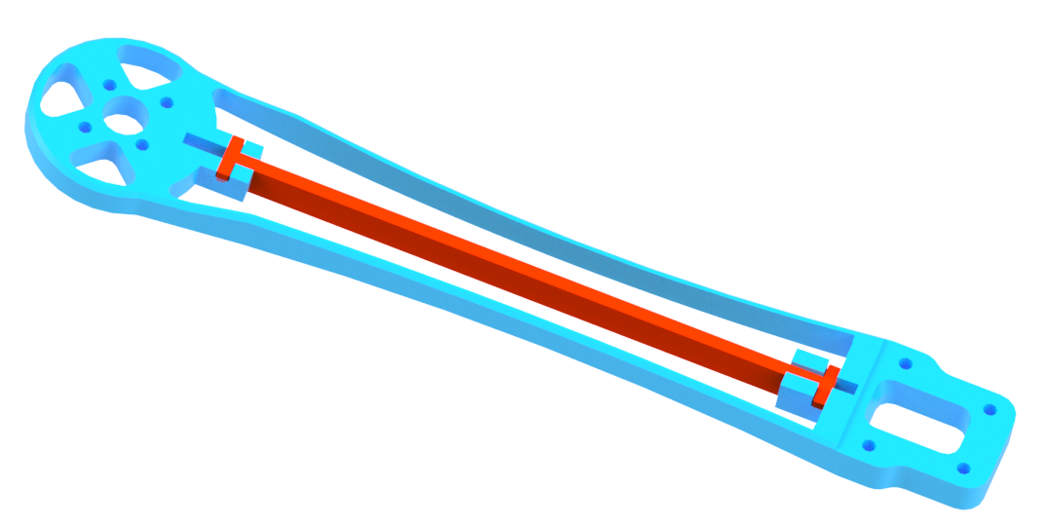
Fig. 1. Isometric assembly rendering of the UAV arm with the central sensing plate (red) installed along the internal channel.
Table 3. Measured geometry from the design drawings. Bracketed values are to be confirmed against the printed parts.
Part | Parameter | Value
Arm | Total length, tip to tip | 215.9 mm
 | Motor hub to root span | 169.9 mm
 | Thickness, motor end | 5.10 mm
 | Thickness, root end | 7.07 mm
 | Motor hub radius | R20.3 mm
 | Shell wall thickness | 1.49 mm
Sensing plate | Length between mounting holes | 130.0 mm
 | Total length with end tabs | 136.0 mm
 | Cross-section | 3.00 × 8.00 mm
 | End tab height | 10.38 mm
 | Installed orientation | [3 mm across arm width — confirm]3 mm across arm width (lateral)
 | Baseline resistance $R_{0}$ | [ ] kΩ4.7 kΩ
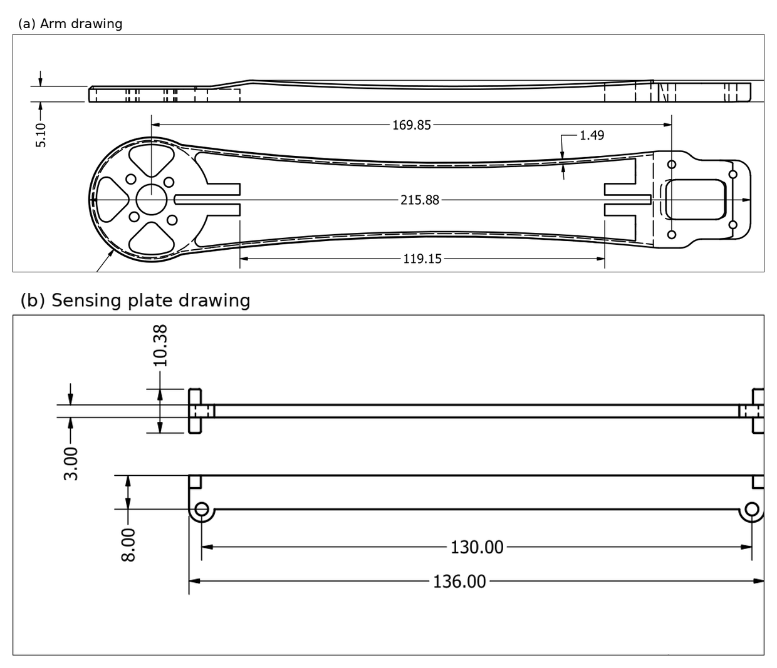
Fig. 2. Dimensioned drawings used to define the geometry: (a) arm drawing showing the overall length and motor-hub-to-root span; (b) sensing plate drawing showing the active span and the 3 × 8 mm cross-section.
  - Placement rationale
Two placement rules follow from Section 2. First, the sensing plate spans the region of highest bending near the root, so that the strain transduced by the plate is representative of the arm loading rather than of a lightly stressed tip region. Second, the plate is oriented so that its compliant face lies in the lateral, imbalance-driven direction, which for a level arm is horizontal, and the conductive path is placed at the outer fiber of that face where lateral strain is greatest. A conductive path placed on the centreline of the section would read close to zero, because bending strain vanishes at the neutral axis.
The load-sharing analysis of Section 2.4 adds a third consideration specific to this architecture. Because the plate sits in parallel with a much stiffer arm, the lateral relief of the arm over the plate span is what determines whether the plate governs the response or merely follows it. The design intent is to relieve the arm along the sensing span so that the plate carries a meaningful share of the lateral load, which is what gives the material study of Section 4 a measurable effect.
  - Electrical isolation
One constraint cannot be relaxed. The conductive plate must not contact any other conductive element of the structure. If a conductive arm material is used, such as a carbon-fiber-filled filament or an original carbon tube, an insulating layer is required between the plate and the arm, because a parallel conductive path shunts the sensing element and makes the measured resistance change depend on an uncontrolled division ratio. This is separate from the mechanical load sharing of Section 2.4 and must be checked independently.
  - Fabrication parameters
The arm and the sensing plate were printed separately. Table 4 gives the full specification for both. Two entries need comment. The first is raster orientation. Extruded conductive PLA does not respond to strain equally in every direction, so a gauge factor measured along the print path is not the same as one measured across it, and the number means little unless the orientation is stated. On this plate two perimeters at 0.42 to 0.45 mm take up most of the 3 mm width, so current travels mainly along perimeter traces that follow the long axis rather than through the sparse infill. The second is the infill itself. Pattern and density both change the gauge factor and how well the response holds up under repeated loading [6]. Electrodes were copper tape on the end tabs, painted over with silver conductive paint to bring the contact resistance down, and the four-wire connection of Section 5.1 keeps lead and contact resistance out of the reading. No volume resistivity is published for this filament. The figure in Table 4 is therefore an apparent value, worked out from the measured baseline of the printed plate, its gross cross-section and the 124 mm electrode spacing. The infill is sparse, so the conducting cross-section is smaller than the gross one, which puts the true material resistivity below the number quoted.
Table 4. Fabrication parameters for the conductive PLA sensing plate and the structural arm.
Parameter | Sensing plate (conductive PLA) | Structural arm
Printer | Bambu Lab H2D, 0.4 mm nozzle | Bambu Lab H2D, 0.4 mm nozzle
Slicer | Bambu Studio 2.7.1 | Bambu Studio 2.7.1
Filament | RepRapper Electrically Conductive PLA, 1.75 mm (base resin NatureWorks Ingeo 4032D); sliced with the generic PLA profile | eSUN PLA, 1.75 mm, 1.24 g/cm³
Volume resistivity | Not published by the manufacturer; apparent value measured on the printed plate, 92 Ω·cm (gross section) | Insulating (not applicable)
Nozzle temperature | 220 °C | 220 °C
Bed temperature | 55 °C, textured PEI plate | 55 °C, textured PEI plate
Layer height | 0.20 mm (first layer 0.20 mm) | 0.20 mm (first layer 0.20 mm)
Perimeters | 2 (5 top, 3 bottom solid layers) | 2 (5 top, 3 bottom solid layers)
Extrusion width | 0.42 mm outer, 0.45 mm inner and infill | 0.42 mm outer, 0.45 mm inner and infill
Infill pattern | Grid | Grid
Infill density | 15 % | 15 %
Infill direction | 45° | 45°
Build orientation | Long axis in the build plane; layers stack across the 3 mm thickness | Long axis in the build plane
Raster orientation | Perimeters follow the long axis (0°); infill at 45° | Perimeters follow the long axis (0°)
Print speed | 200 mm/s outer, 300 mm/s inner, 350 mm/s infill | 200 mm/s outer, 300 mm/s inner, 350 mm/s infill
Flow ratio | 0.98 | 0.98
Part cooling | 100 % | 100 %
Post-print treatment | None | None
Printed mass | 3.22 g (55 layers) | 14.58 g (60 layers)
Electrode contact | Copper tape at the end tabs, overpainted with silver conductive paint | Not applicable
Electrode cure | Air-dried at ambient temperature before measurement | Not applicable

  - Fabrication status and preliminary observation
A first sensing plate was fabricated from carbon-based conductive PLA by fused deposition modelling. Its baseline resistance was approximately 4.7 kΩ, well above the insulating regime and within the range the acquisition chain can accommodate, and a manual bending test produced a reversible relative resistance change of the order of two percent. This confirms qualitatively that the printed element is piezoresistive at the strain levels reached in this geometry and that the response is repeatable across manual load cycles. The observation motivates the measurement method of Section 5. Quantitative characterisation under controlled deflection and under motor excitation is future work. The fabricated specimen and the preliminary baseline resistance measurement are shown in Fig. 3.bending it by hand, with a handheld multimeter on the terminals and the room at ambient temperature, changed the resistance by roughly two percent. The reading returned to its starting value each time the load came off. Nothing measured the deflection, so the strain is unknown and no gauge factor follows from it. That is enough to say the printed element is piezoresistive, and it is what led to the measurement method of Section 5. It is not a calibration, and we do not present it as one. Proper characterisation under controlled deflection and under motor excitation is still to come. The specimen and the baseline reading are shown in Fig. 3.

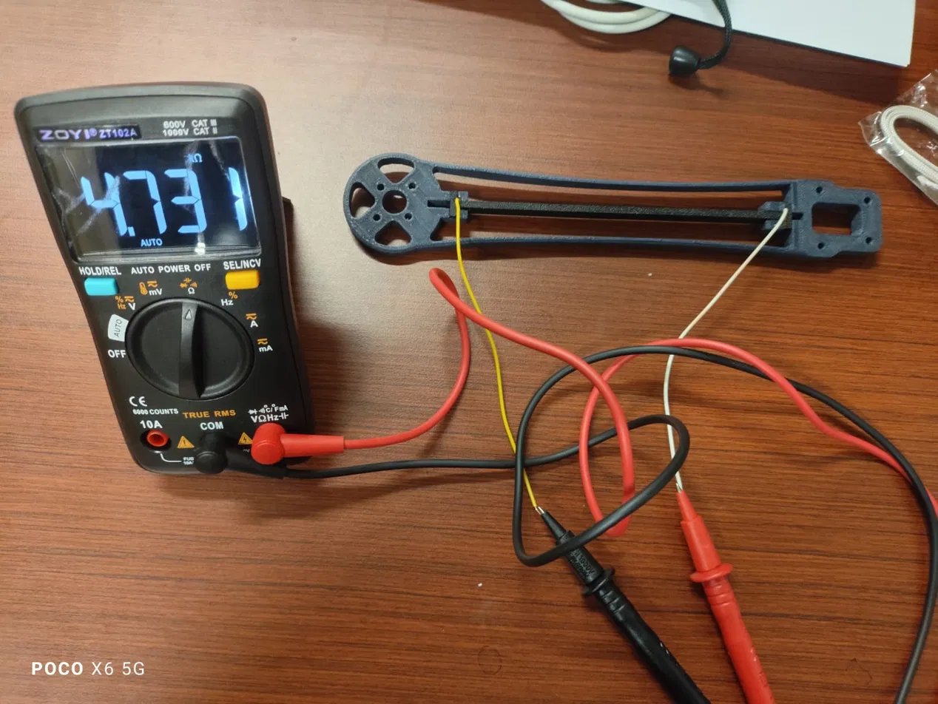
Fig. 3. Fabricated conductive PLA sensing plate mounted in the printed arm, with electrode wires attached for preliminary resistance measurement; the displayed reading indicates a baseline resistance of approximately 4.731 kΩ.
- Candidate Sensing Materials and Application Methods
  - The percolation trade that governs every choice
Piezoresistive sensitivity in a carbon-filled polymer is set by where the formulation sits relative to the percolation threshold. Just above the threshold the conductive network is sparse, so strain disrupts it strongly and the gauge factor is high, but the baseline resistance is noisy and varies from specimen to specimen. Well above the threshold, where commercial conductive filaments and shielding coatings are formulated, the network is dense and stable but insensitive. Every material and application method below amounts to picking a point on this curve. We want the most sensitive point that still gives a stable baseline. Table 5 sets out the candidates. The last column marks which of them we built. Only the co-printed conductive PLA was fabricated and measured here. The rest come from published work, and their sensitivity figures were obtained on coupons, under conditions unlike the arm geometry in question. None of them has been tested in this study.
Table 4.Table 5. Candidate sensing materials for the plate. Gauge factor values are indicative ranges from the literature and depend strongly on formulation and strain.
Material | Gauge factor potential | Modulus (GPa) | Fatigue and drift | Sourcing | Status in this work
Carbon black in PLA (commercial filament) | Low to moderate | 2 to 3.5 | Brittle, temperature drift | Commercial, easy | Fabricated and evaluated here
Carbon black in epoxy, cast | Moderate to high near percolation | 2 to 4 | Better than PLA, needs dispersion control | Cheap, locally available | Proposed; literature values
Carbon fiber filled PLA | Low | 4 to 5 | Stiff, brittle | Easy, nozzle wear | Proposed; literature values
MWCNT in epoxy or thermoplastic polyurethane | High | 0.01 to 3 depending on matrix | Excellent in elastomer, more lab work | Harder to source locally | Proposed; literature values
Graphene or graphite coating | Moderate | Coating only | Environmental sensitivity | Available, shielding grades insensitive | Proposed; literature values
  - Application methods
The candidate materials reach the plate by three practical routes, listed in order of rising sensitivity, and rising effort.
The first route is co-printing. A conductive PLA region is printed as part of the plate in the same build, either as the whole plate or as a layer on one face. This is the simplest route and the one already demonstrated on the bench. Its limitation is that the formulation is fixed by the commercial filament, so it sits well above percolation and its sensitivity cannot be tuned.
The second route is casting a carbon black and epoxy strip. The plate body is printed from a structural filament with a shallow groove along the sensing face, and a mixture of carbon black in epoxy at a chosen weight fraction is dispersed, cast into the groove, and cured. This is the route to build a material study around. The filler fraction is under our control, so the formulation can be placed deliberately near the percolation threshold and sensitivity reported as a function of loading, instead of taking whatever a filament gives. Its challenges are dispersion uniformity, since carbon black agglomerates, curing time, and specimen-to-specimen consistency, all of which must be reported.
The third route is dip or drop casting a carbon nanotube dispersion. A dispersion of multiwalled carbon nanotubes near a low loading of a few weight percent is applied to the plate surface and dried. This route reaches the highest gauge factors, particularly in an elastomer matrix, at the cost of more demanding preparation and less convenient local sourcing.
  - A two-layer plate for a clean material study
The recommended configuration for a controlled study separates the two functions the plate must serve. A structural substrate, printed from a tough filament such as PETG, polycarbonate, or a carbon-fiber-filled nylon, sets the stiffness and the fatigue life and can be varied in material and thickness. A thin sensing layer, applied by any of the three routes above, sits on the outer fiber of the substrate and transduces the strain. Splitting the two roles helps in three ways. Stiffness and thickness can be varied without touching the sensing chemistry, so a change in gauge factor does not confound the study. No single brittle material has to be both the spring and the gauge, which is better for fatigue life. And because the thin layer carries almost no load, the sensing formulation can be tuned for sensitivity alone.
  - Thickness as a tuning variable
The plate thickness is a structural tuning variable. With the plate oriented so that the 8 mm depth carries thrust and the 3 mm dimension sets lateral compliance, reducing the 3 mm dimension raises lateral compliance and increases the signal for a given unbalance force, at the cost of fatigue margin. This only works once the arm is relieved along the sensing span as described in Section 2.4, because otherwise the arm, not the plate, sets the lateral deflection.

- Measurement Method
  - Signal conditioning and data acquisition
The plate is connected in a quarter-bridge configuration, with completion resistors close to the nominal so that the bridge is near balance at rest, and a four-wire connection at the plate so that lead and contact resistance do not appear in the measurement. The bridge output is digitised by a 16-bit converter (ADS1115) read by an ESP32 microcontroller, with the converter’s programmable gain amplifier at gain 16 (full-scale range ±0.256 V) serving as the sole amplification stage. A discrete instrumentation amplifier is not used, which is acceptable here because the Thévenin source impedance of the bridge is only a few kilohms against the converter’s much higher differential input impedance. At the highest planned speed of 6000 rpm the 1× component is at 100 Hz, so the converter is operated at 860 samples per second, placing the Nyquist limit at 430 Hz and leaving room for the fourth harmonic. A first-order low-pass filter with a corner near 350 Hz precedes the converter to attenuate content above the Nyquist limit and the switching noise of the speed controller. The complete sensing and acquisition circuit is shown in Fig. 4: the conductive PLA strip forms the active arm of a 3.3 V quarter-bridge with three 4.7 kΩ completion resistors, followed by a differential anti-alias RC network, ADS1115 conversion at PGA gain 16 and 860 SPS, and I²C transfer to the ESP32. A four-wire Kelvin connection is used at the strip to separate excitation-current and voltage-sense leads.
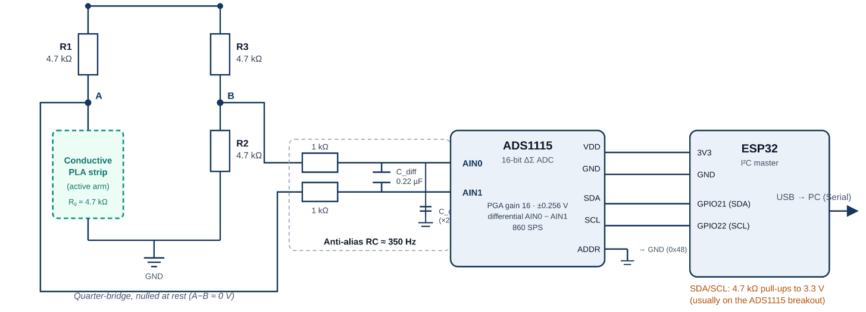
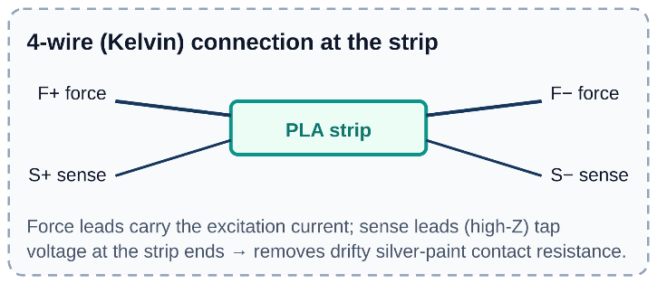
Fig. 4. Sensing and signal-acquisition circuit. The conductive PLA strip is the active arm of a quarter-bridge excited from a filtered 3.3 V rail. The differential bridge output is conditioned by an anti-alias RC network and digitised by the ADS1115 before I²C transfer to the ESP32; the inset shows the four-wire Kelvin connection at the sensing strip
Table 5.Table 6. Acquisition parameters.
Parameter | Value
Bridge configuration | Quarter bridge, four-wire connection at the plate
Excitation | 3.3 V filtered rail
Completion resistors | 3 × 4.7 kΩ metal film
Amplification | ADS1115 PGA at gain 16 as the sole stage; no discrete instrumentation amplifier (provisional until dynamic 1× amplitude measured)
Converter | ADS1115, 16 bit, differential input, PGA gain 16 (FSR ±0.256 V, LSB 7.8 µV)
Sampling rate | 860 samples per second
Anti-alias filter | First-order RC, corner near 350 Hz
Controller | ESP32, I²C
Record length per run | [30] s30 s
  - Test rig and imbalance protocol
The center plate is bolted to a rigid base so that the root approximates a clamp, and the instrumented arm carries the motor and propeller. A guard encloses the rotor plane and all runs are performed with the operator outside that plane. Imbalance is introduced in a controlled and reversible way by attaching a known mass to one blade at a fixed radius, rather than with a damaged propeller, whose mass, radius and aerodynamic change would all be unknown. The planned test matrix crosses three unbalance levels and a balanced reference against the speeds of Table 1, with each condition recorded for 30 s and repeated at least three times, and with rotational speed, ambient temperature, and running time recorded for every run.
Table 6.Table 7. Test rig configuration.
Item | Specification
Airframe | F450 class center plate
Motor | DJI 2212, 920 kV
Propeller | [1045]DJI-style 1045 (254 × 114 mm)
Speed controller | [ ] A, fixed PWM per runFixed PWM per run
Speed measurement | Optical tachometer
Reference sensor | MPU6050 accelerometer, near the root
Ambient temperature | Recorded per run
  - Signal processing
Raw converter counts are converted to relative resistance change $ΔR/R_{0}$ using the bridge relation and the measured baseline. Each record is detrended to remove the slow drift and thermal offset of the polymer, band-pass filtered between 5 Hz and 400 Hz, and reduced to a root mean square and a peak-to-peak amplitude in the time domain. A Hann window and a discrete Fourier transform then give the amplitude at the measured rotational frequency and its first three harmonics. The imbalance indicator is the ratio of the 1× amplitude in the test condition to the 1× amplitude in the balanced reference at the same speed. Reporting a ratio against the balanced reference cancels the sensitivity of the whole chain, including the gauge factor, the bridge gain, the slowly varying baseline, and the fixed load-sharing fraction of Section 2.4, and keeps the claim inside what a feasibility study can support.
  - Supporting characterisation
A quasi-static deflection test applies a known tip displacement to the mounted arm and records the resistance change, to confirm that strain at the plate is transferred to the sensing element and to give an assembly-level calibration. A static load test holds a mass equivalent to the expected thrust at the motor position, to confirm that the plate and arm do not crack before the motor is run. A tap test excites the mounted arm while the MPU6050 records the response, and the dominant peak in that spectrum is taken as the measured first natural frequency of the assembly. These three tests make up the characterisation procedure. They are still in progress.

- Discussion
Load sharing turned out to be the variable that governs this architecture. The plate sits in parallel with a much stiffer arm, so as drawn it reports the arm strain but carries little load, and its material has little effect on the signal. The arm has to be relieved along the sensing span before the plate governs the lateral compliance. Only then does a material or thickness study mean anything. Treating the load-sharing fraction as something to set, rather than something to accept, is what makes it a design choice.
The material analysis points to a two-layer plate as the configuration best suited to a controlled study, because it separates the structural role, which sets stiffness and fatigue life, from the sensing role, which sets gauge factor. Of the application methods, the cast carbon black and epoxy strip is the one where the filler fraction is under our control, so sensitivity can be reported against loading instead of taken as given from a commercial filament.
Some limitations need stating. The polymer exhibits creep and a temperature-dependent baseline, so the analysis relies on the amplitude of a periodic component rather than on an absolute level. The apparent gauge factor of the assembly includes the compliance of the interface and is not a material property. Fatigue behaviour has not been evaluated, and carbon-filled PLA is brittle, so baseline drift across repetitions should be monitored as a proxy for damage. The evaluation is a bench study on a single arm with a fixed boundary condition, which is not equivalent to a flying airframe. No measurement under motor excitation is reported at all. Telling balanced from unbalanced operation is set out here as a protocol and a set of design calculations, not as a result. The indicator of Section 5.3 has not yet been tried against recorded data.

- Conclusion
This work presented a design method and supporting analysis for a multicopter arm that senses its own vibration through an interchangeable central plate made of carbon-based conductive PLA. A rotating-unbalance model fixed the sampling rate and the safe envelope and exposed the load sharing between the sensing plate and the arm as a design parameter. Candidate sensing materials were analysed against the percolation behaviour that governs sensitivity, and three application methods were described, with a two-layer plate proposed as the configuration best suited to a controlled material study. A printed conductive PLA plate changed its resistance reversibly when bent by hand, which is a start, though instrumented testing is still to come.
Further work will complete the instrumented motor testing to discriminate balanced from unbalanced operation at the first rotational harmonic, relieve the arm along the sensing span so that the plate governs the lateral response, quantify the effect of plate material and thickness on the measured signal, and evaluate stability under extended cyclic loading. A finite element study, static and modal, is planned to measure the load-sharing fraction and the first natural frequency accurately, since the analytical estimates here are order-of-magnitude for a shelled, tapered arm. A separate direction is magnetoelastic sensing based on the Villari effect in magnetic materials, which would replace the resistive readout with an inductive one and remove the contact-resistance and drift issues of a printed carbon trace.

Acknowledgements
The authors gratefully acknowledge the Robotics and Artificial Intelligence Engineering Laboratory, Faculty of Advanced Technology and Multidiscipline, Universitas Airlangga, for providing the fabrication and testing facilities used in this work. This research received no external funding and was carried out with self-funded support from the authors.

References
- B. Ghalamchi and M. W. Mueller, “Vibration-based propeller fault diagnosis for multicopters,” in Proc. 2018 Int. Conf. Unmanned Aircraft Systems (ICUAS), Dallas, TX, USA, 2018, pp. 1041–1047.
- T. Sonmezocak, “Intelligent UAV health monitoring: detecting propeller and structural faults with MEMS-based vibration,” Engineering Science and Technology, an International Journal, vol. 69, art. 102130, 2025.
- A. Baldini, R. Felicetti, F. Ferracuti, A. Freddi, S. Iarlori, and A. Monteriù, “Real-time propeller fault detection for multirotor drones based on vibration data analysis,” Engineering Applications of Artificial Intelligence, vol. 123, art. 106343, 2023.
- S. J. Leigh, R. J. Bradley, C. P. Purssell, D. R. Billson, and D. A. Hutchins, “A simple, low-cost conductive composite material for 3D printing of electronic sensors,” PLoS ONE, vol. 7, no. 11, e49365, 2012.
- S. W. Kwok, K. H. H. Goh, Z. D. Tan, S. T. M. Tan, W. W. Tjiu, J. Y. Soh, Z. J. G. Ng, Y. Z. Chan, H. K. Hui, and K. E. J. Goh, “Electrically conductive filament for 3D-printed circuits and sensors,” Applied Materials Today, vol. 9, pp. 167–175, 2017.
- C. Rubio-González, J. J. Ku-Herrera, J. Wang, A. Patterson, J. A. Soto-Cajiga, and O. Olvera-Silva, “Effect of printing parameters on the mechanical and piezoresistive response of cellular structures manufactured with a conductive polylactic acid nanocomposite through a material extrusion process,” Journal of Manufacturing Processes, vol. 132, pp. 375–391, 2024.
- A. M. L. Lanzolla, F. Attivissimo, G. Percoco, M. A. Ragolia, G. Stano, and A. Di Nisio, “Additive manufacturing for sensors: piezoresistive strain gauge with temperature compensation,” Applied Sciences, vol. 12, no. 17, art. 8607, 2022.
- C. M. Maynard, J. A. Hernandez, A. Doak, B. Mardikis, M. Viz, B. Newell, J. Garcia, and T. N. Tallman, “A computational study of strain sensing via 3D-printed CNF-modified PLA strain gauges,” in Proc. ASME 2020 Conf. Smart Materials, Adaptive Structures and Intelligent Systems (SMASIS2020), Virtual Conf., Sep. 2020, Paper SMASIS2020-2236.
- J. F. Christ, N. Aliheidari, A. Ameli, and P. Pötschke, “3D printed highly elastic strain sensors of multiwalled carbon nanotube/thermoplastic polyurethane nanocomposites,” Materials & Design, vol. 131, pp. 394–401, 2017.
- I. U. Musa, R. A. Gomes, M. Sonego, and G. F. Gomes, “Design optimization of 3D-printed piezoresistive sensors for integrated structural health monitoring,” Smart Materials and Structures, vol. 35, no. 1, art. 015061, 2026.
- S. S. Rao, Mechanical Vibrations, 6th ed. Boston, MA, USA: Pearson, 2017.
- W. Bauhofer and J. Z. Kovacs, “A review and analysis of electrical percolation in carbon nanotube polymer composites,” Composites Science and Technology, vol. 69, no. 10, pp. 1486–1498, 2009.

