An Overview on ‘Waste-to-Functional Nanomaterials’

Thangavel Lakshmipriya¹, Subash C. B. Gopinath^{2,3,4,*}, Makram A. Fakhri⁵, Evan T. Salim⁶,
Renan Prasta Jenie⁷, Irzaman⁸

¹Institute of Nano Electronic Engineering, Universiti Malaysia Perlis (UniMAP), 01000 Kangar, Perlis, Malaysia (lakshmipriya50@gmail.com)
²Department of Neonatology, Saveetha Medical College and Hospital, Saveetha Institute of Medical and Technical Sciences, Chennai 602 105, Tamil Nadu, India
³Department of Electrical and Electronics Engineering, Dogus University, Umraniye, Istanbul 34775, Türkiye
⁴Faculty of Chemical Engineering & Technology, Universiti Malaysia Perlis, 02600 Arau, Perlis, Malaysia (subash@unimap.edu.my)
⁵College of Laser and Optoelectronics, University of Technology-Iraq, Baghdad 10066, Iraq (Makram.A.Fakhri@uotechnology.edu.iq)
⁶College of Applied Sciences, University of Technology-Iraq, Baghdad 10066, Iraq (Evan.T.Salim@uotechnology.edu.iq)
⁷Digital Business Department, Binawan University / Research, Development, and Innovation Directorate, Indonesia Artificial Intelligence Society, Indonesia (qwerty_user1983@yahoo.com)
⁸Physics Department, IPB University, Indonesia (irzaman@apps.ipb.ac.id)

*Correspondence to: subash@unimap.edu.my [0000-0002-8347-4687]

Abstract

This research highlights the preparation nanomaterials from resources, such as biomasses, by addressing ‘waste-to-functional nanomaterials’, and their ultimate downstream applications. Transforming biological wastes into functional nanomaterials sustains waste management and supports technological innovation and environmental protection. The strategies involve ‘green-technologies’ for large scale commercialization strategies to generate waste-derived nanomaterials. This study reveals the production of different particles at ‘nanoscale’ from different resources. Considering the biomasses from plants and animals/insects, they have been displayed for their applications involving nanomaterial utilization. With the residues of organic and inorganic compounds from these materials, work as reducing and capping agents and to be functional. Herein, different modified metallic and non-metallic functional nanomaterials were revealed with their high efficiency for their downstream applications in different industrial sectors. This overview provides insights on the production of different nanotmaterials from the natural resources and aligned the concept in converting wastes into useful products.

Keywords: Nanomaterial, Biowaste, Greener method, Carbon material.
- Introduction

The manipulation and control of matter on the nanoscale dimension using scientific knowledge in diverse industrial and biomedical applications were characterized as nanotechnology [1]. By controlling the nanoscale scale and making extensive use of their novel phenomena and properties, nanotechnology has been used to build and apply structured particles and devices. Scientists are interested in them because of their capacity to bridge the gap between bulk materials and atomic or molecular structures, which has given an impact on health care and associated businesses [2]. Nanoparticle applications are a fast-expanding field of study that brings up new possibilities for diagnosing and treating human ailments. The structure of nanoparticles is 1-100 nm in diameter, with a wide surface area and functional groups for conjugating diagnostic and therapeutic substances [3]. The quick rate of discoveries in nanotechnology has fueled innovation in all disciplines of science, including biosensors, where cutting-edge research for illness diagnostics is being undertaken. Nanoscale materials give value to current sensors, opening new sensing opportunities. They boost platform loading time, signal amplification, sensitivity, detection range, selectivity, interference resistance, specificity, stability, and cost-effectiveness [4]. Multifunctional nanomaterials are particularly significant in the development of multimodal sensing instruments and point-of-care devices [5]. Overall nanomaterial productions indeed follow two production lines, namely top-down and bottom-up to bring several applications (Figure 1).
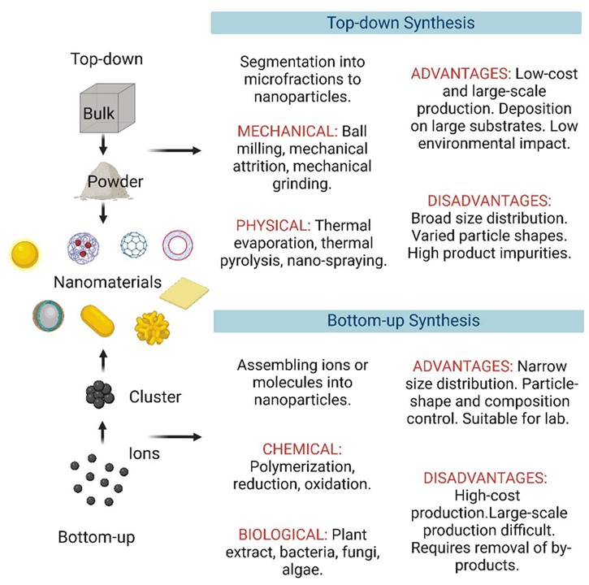
Figure 1: Two approaches with nanomaterials. Processes involved in top-down and bottom-up are displayed.

Nanoparticles can be classified as the hardness of nanoparticles and there are hard nanoparticles, semisoft nanoparticles, and soft nanoparticles. Usually, in hard nanoparticles, the worker will use clay nanoparticles as clay has strong and hard chemical bonding that can make the product long last and can be used for a long time period, while soft nanoparticles and semi-soft are usually used in medicine and agriculture [6] . Various types of liposomes are currently used in the clinically as delivery systems for anticancer drugs and vaccines. For agriculture, the researcher uses antifungal and antibacterial to prevent pesticide from damaging vegetables and fruits that can be sold around the world. Nanoparticles have active properties, which allow them to easily change their physicochemical properties based on their physical environment, synthesis, and processing history. As a result, morphology and structural analyses are used after nanoparticle synthesis to characterize the nanoparticles' structure, size, shape, surface area, and chemical properties. In the agriculture industry, nanoparticles will make crop production yield increase year by year [7]. This industry used gold nanoparticles to increase their crop production yield as gold nanoparticles have its own unique characteristics to produce a high amount of yield [8]. With the help of nanoparticles, the production of food also increases in the economic sector. The workers in the food industry processing used silver nanoparticles to maintain the quality of the products as silver nanoparticles will prevent microorganisms, such as bacteria and fungus cultivate in their food product. Besides, nanomaterials that are used in agriculture are aimed at the reduced amount of spray chemical products, which can lead to environmental possession. With the help of nanomaterials, the environment is free from being polluted by chemical and waste products.

- Nanomaterials and zero-waste challenge
High surface area, optical qualities, improved catalytic activity, customizable shape, and superior electrical and thermal potentials are the physicochemical traits that have made nanomaterials to be adaptable. Their extensive use in drug-delivery, biomedical diagnostics, energy storage, catalysis, environmental remediation, electronics, agriculture, and advanced manufacturing has been made possible with nanomaterials. The production of conventional nanomaterials frequently entails numerous processing stages, high energy consumption, dangerous compounds, organic solvents, and rigorous purifying processes. Significant amounts of liquid effluents, tainted process water, leftover chemicals, undesirable by-products, and solid trash can also be produced by these processes. Consequently, creating a high-value nanomaterial may cause the production process to bear a greater environmental burden. Indeed, a significant area of sustainable nanotechnology is the zero-waste challenge. The goal is to create production processes that maximize the utilization of waste materials, minimize process waste, and transform by-products into beneficial products rather than just producing nanoparticles efficiently. This necessitates switching from traditional linear production with raw material into nanoparticle, where resources and materials stay in the production line. The environmental impact can be significantly reduced by using green production methods, solvent-free processes, renewable reducing and stabilizing agents, and energy-efficient processing. To ascertain whether a suggested nanomaterial production method offers environmental benefits from raw material collection through manufacturing and applications. Transferring from laboratory-scale synthesis to industrial manufacturing is particularly focused and in this reviewer several laboratory productions of nanomaterials have been discussed (Table 1). By establishing laboratory methods or techniques, several knowingly and unknowingly man-made waste products can be recycled into useful nanomaterials [9], [10], [11] (Figure 2).
Table 1: Comparative table in recycling the wastes for potential applications.
Waste Source | Nanomaterial | Synthesis/Conversion | Characteristics | Application | Ref
Fish Scales | Hydroxyapatite nanoparticles | Calcination, hydrothermal | Bioactive, osteoconductive | Bone tissue engineering, dental materials | [12]
Shrimp/Crab Shells | Chitosan nanoparticles | Deacetylation, ionic gelation | Biodegradable, antimicrobial | Drug delivery, wound healing, biosensors | [13]
Tea Leaves | Carbon quantum dots | Hydrothermal | Fluorescent, low toxicity | Bioimaging | [14]
Coffee Grounds | Carbon dots, activated carbon | Hydrothermal,  pyrolysis | Fluorescent, porous | Sensors, energy storage | [15]
Banana Peel | Carbon nanospheres, activated carbon | Pyrolysis | High adsorption capacity | Water treatment, supercapacitors | [16]
Orange Peel | Carbon quantum dots | Hydrothermal | Strong photoluminescence | Fluorescence sensing, bioimaging | [17]
Citrus Peel | Silver nanoparticles | Green synthesis | Antimicrobial, eco-friendly | Biomedical, sensing | [18]
Waste Paper | Cellulose nanocrystals | Acid hydrolysis | Strong, renewable, lightweight | Packaging, nanocomposites | [19]
Textile Waste | Cellulose nanofibers | Mechanical fibrillation, acid hydrolysis | Flexible, biodegradable | Smart textiles, composites | [20]
Plastic Waste | Carbon nanotubes, graphene derivatives | Pyrolysis, catalytic conversion | High conductivity | Electronics, batteries | [21]
Polyethylene Waste | Carbon nanosheets | Catalytic pyrolysis | High carbon yield | Energy storage, catalysis | [22]
Red Mud | Iron oxide nanoparticles | Chemical precipitation | Magnetic properties | Wastewater treatment | [23]
Waste Glass | Silica nanoparticles | Alkali extraction and precipitation | High-purity amorphous silica | Coatings, catalysis, biosensors | [24]

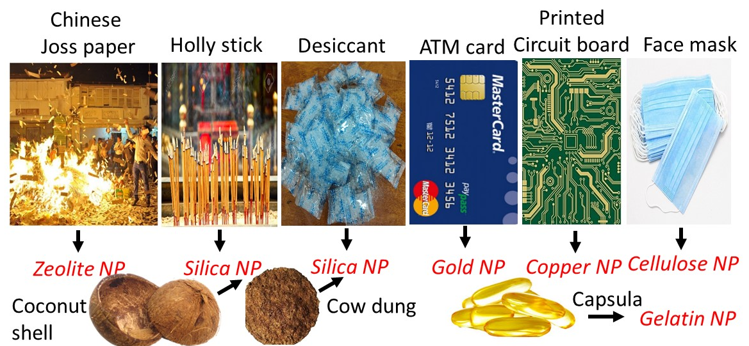

Figure 2: Man-made waste materials. Several wastes thrown into open environments are displayed with their possible conversion into nanomaterials.

- Importance nanomaterials produced from natural wastes
Agricultural residues, food waste, forestry by-products, and industrial biomass waste can be transformed into high-performance porous carbon materials through pyrolysis, hydrothermal carbonization, chemical activation, or physical activation. These processes generate hierarchical porous structures with interconnected micro-, meso-, and macropores that facilitate rapid ion transport and electrolyte accessibility. The electrochemical performance of biomass-derived carbon is strongly influenced by its pore architecture, graphitization degree, surface area, and surface chemistry. Naturally occurring heteroatoms such as nitrogen, oxygen, phosphorus, and sulfur present in biomass can be retained during carbonization, introducing additional pseudocapacitive behavior and enhancing electrical conductivity. These heteroatom-doped carbons often demonstrate higher specific capacitance and improved charge-transfer kinetics compared with conventional activated carbons. Recently focused on tailoring biomass-derived carbons through activation agents, pore engineering, and hybridization with graphene, MXenes, conducting polymers, and transition metal oxides. Such modifications improve energy density, rate capability, and cycling stability. Large-scale manufacturing, standardization of electrochemical testing, and long-term device reliability also require further investigation before widespread commercialization can be achieved.
The growing emphasis on sustainability has led to the widespread use of terms such as green synthesis, waste-derived synthesis, low-waste production, and zero-waste nanomanufacturing. Although these concepts are often used interchangeably in nanotechnology, they represent different levels of environmental sustainability and resource efficiency. Understanding these distinctions is important for accurately assessing the environmental impact and commercial viability of nanomaterial production processes. Green synthesis primarily focuses on replacing hazardous chemicals and energy-intensive procedures with environmentally benign alternatives. Biological resources such as plant extracts, algae, microorganisms, enzymes, and natural polymers are commonly employed as reducing, stabilizing, or capping agents during nanoparticle formation. Silver nanoparticles synthesized using tea leaf extract, neem extract, or citrus peel extract are often classified as green nanomaterials because the synthesis avoids strong chemical reducing agents. Consequently, green synthesis represents an important step toward sustainability but should not automatically be considered a zero-waste process.
  - Silica nanomaterials and their importance
Silica, often known as silicon dioxide, is a naturally occurring chemical found in the sand that forms massive covalent bonds [25]. It is among the hardest and most common substances, accounting for over two-thirds of the Earth's continental crust. Depending on the availability of oxygen molecules, a single silicon atom establishes a double bond (SiO₂) with oxygen before forming a stable tetrahedron (SiO₄)-4 with a crystalline structure such as quartz. Except for hydrofluoric acid, silica is a tasteless, colorless, and odorless substance that is insoluble in water and acids. Silica is a poor conductor of heat and electrons; moreover, silica has low thermal conductivity but is an excellent insulator material. Silica performs well in terms of chemical, physical, and thermal stability, compatibility with various materials, availability, and price. It is used in various industries, including chromatography, ceramics, catalysis, and anti-corrosion agent, and it focuses on silica nanoparticles. Agro-industrial waste has recently gained popularity as a source of cleaner fuels and compositions. A large amount of these wastes can produce crystalline nanoparticles from constrained pure silica. Thus, there is a growing interest in additional research into the creation of silica nanoparticles from various sources. Silica nanoparticles have been widely used in agriculture, food, medication delivery, and industrial applications due to their superiority over ordinary nanoparticles. Furthermore, silicon dioxide nanoparticles are frequently utilized in biosensors, catalysts, and aerogels. Silica nanoparticles are already widely utilized in nonmedical applications as additions in chemical cleaning, cosmetics, varnishes, and meals. Such particles have been used in biomedicine such as biomarkers, cancer therapies, and drug delivery vehicles. Rice husk is one of the most abundant agricultural wastes worldwide and contains approximately 15–25 wt% silica, making it an economically attractive precursor for high-purity SiO₂ nanomaterials. Through controlled combustion, acid leaching, sol-gel processing, and precipitation techniques, rice husk can be converted into silica nanoparticles, mesoporous silica, silica aerogels, and silica-carbon nanocomposites. The high purity, excellent thermal stability, large surface area, and chemical inertness of rice husk-derived silica have enabled its use in numerous device applications. Its excellent dielectric characteristics contribute to improved device reliability and reduced leakage currents. In sensor technology, rice husk-derived silica has attracted significant interest due to its high surface area and abundant silanol groups that facilitate chemical functionalization. Silica surfaces can be modified with biomolecules (antibodies, aptamers, enzymes) to create highly sensitive biosensing platforms. An additional advantage of rice husk-derived silica lies in its compatibility with carbon materials.

  - Gold nanomaterials and their importance
The gold nanoparticle is one of the nanoparticles that has been used in several industries such as biomedical, food and agriculture. It has many types of shapes such as gold nanohexapods, gold nanorods, and gold nanocages. These three types have their own size and properties for it owns. The researcher believes that Gold nanorods usually using in all industry as their function can maintain the products from damaged and produce high quality of the products. With gold nanoparticles, several applications have been applied to the industries [26]. One of the industries that use gold nanoparticles in their industry is agriculture. The workers and engineers in this industry believe that gold nanoparticles can prevent the insect from damaging the cell of the plant, fruit, and vegetables. Even though the gold nanoparticles are quite expensive compared to the other types of nanoparticles, the quality of the product that has used gold nanoparticles bring high quality to the products. Besides, gold nanoparticles are safe to environments and do not lead to the greenhouse effect and global warming that can make our earth become hotter day-by-day. For detection of gold nanoparticles characteristics, researchers always used FTIR, SEM, and UV-Vis in their experiment. Gold nanoparticles always show a positive result when they derive fungi and bacteria. However, waste-derived synthesis is welcome and emphasizes the utilization of discarded materials as feedstocks for nanomaterial production. Agricultural residues, food waste, industrial by-products, municipal solid waste, electronic waste, and biomass residues are transformed into functional nanomaterials.
  - Silver nanomaterials and their importance
Silver nanoparticles have their own unique properties that can be used in different ways, such as in medical procedures [27]. Silver is usually used to induce antimicrobial effect when it is transformed to nitrate form. When silver nanoparticles appear at the beginning, it gives impact to the space available. Besides, the usage of the silver nanoparticle can make antibacterial or antifungal growth increase and the size of the cell become bigger . In addition, silver nanoparticles do not harm the other cell such as animal cell when silver nanoparticles conjugate with the animal cell [28]. Silver nanoparticles also have the strong kinetic energy of interaction. The researcher believes that silver nanoparticles are also used in industry as their price is cheaper than gold nanoparticles. The farmers also can afford silver nanoparticles as give many advantages to them and can give them a high quality of product too. Besides, the silver nanoparticle is applied on the antimicrobial to eradicate bacterial infection could be considered. The farmers usually spray the silver nanoparticles to the infection part of the plants such as root, stem, and leaves. Silver nanoparticles also is a potential antimicrobial agent against drug resistance bacteria. The silver nanoparticles can induce pits and gaps in the bacterial membrane and then fragment the cell. Besides, silver nanoparticles have great potential for use in controlling spore-producing fungi plant pathogens as silver nanoparticles have a great effect on the plant pathogen effect. Silver nanoparticles are one of the highly studied nanomaterials, has been primarily synthesized by biomass waste. Apart from agricultural wastes, animal microbial wastes are also used to generate silver nanomaterials.
  - Copper nanomaterials and their importance
A printed circuit board (PCB) is a substrate medium frequently used in electrical and electronic engineering to link electronic devices using electrical and mechanical methods [29]. Usually, a bare PCB appears to be a flat, rigid, and insulating substance with a unique geometric pattern that serves as interconnections or connection points for components. Nowadays, PCBs are integral to nearly every electronic device, as they function to transmit electrical signals within the device. PCBs are composed of several conductive and insulating layers in the form of a laminated stack-up structure to create the physical connection between components. Every conductive layer is constructed with an artwork pattern of traces, planes, and other features etched from the copper layer, which will be laminated onto the sheet layers of an insulating substrate. Due to its high electrical and thermal conductivity for signal transmission and heat dissipation, copper is considered the most crucial component in PCB design and is employed as the conductive layer. In detail, copper can transmit the electrical signal without losing or slowing down the electricity along the PCB because it has a free mobile electron that can travel from one atom to another without slowing down. Moreover, the direct installation of heat sinks on the surface is possible due to copper's efficient heat transfer capability, thus improving the heat transfer across the PCB and preventing damaging stress to the board. The copper trace acts as a conductive interconnection to conduct signals on the surface of the PCB. Generally, PCBs comprise around 30 % of ceramics and polymeric materials, each together with 40 % of metallic material. PCB is one of the ignored wastes and affect the open environment, must be recycled with the possible strategies proposed in the past.
  - Strontium nanomaterial and their importance
The potential electrical, optical, catalytic, and biological features of strontium-based nanomaterials have brought plenty of interest. For utilize in environmental clean-up, energy storage, sensors, and bone tissue engineering, materials like strontium carbonate (SrCO₃), strontium titanate (SrTiO₃), strontium oxide (SrO), and strontium-substituted hydroxyapatite nanoparticles are being investigated. However, excessive energy consumption, harmful chemicals, and the production of toxic waste are the features of conventional synthesis. Consequently, environmentally friendly synthetic methods have become potential options for producing strontium nanoparticles (Figure 3). The primary advantage of waste-derived synthesis is resource valorization; whereby waste streams are diverted from landfills and converted into high-value products. However, many waste-to-nanomaterial processes still require significant chemical treatments, acid washing, activation reagents, purification steps, or high-temperature processing. In the creation of nanoparticles, phyto-extracts that contain flavonoids, polyphenols, organic acids and sugars, act as capping and reducing agents. Strontium-containing nanoparticles have been generated under mild conditions using several plant extracts including neem leaves, tea leaves, citrus peels, aloe vera, and agricultural wastes. Carbon materials can be utilized to immobilize strontium nanoparticles, creating multifunctional nanocomposites and be used for adsorption, energy, and catalysis. Replace the use of dangerous solvents, green sol-gel techniques can be utilized water-based systems and biodegradable organic additions. Strontium titanate and similar nanomaterials can be synthesized utilizing natural polymers including cellulose, starch, chitosan and pectin, as structural-directing reagents.
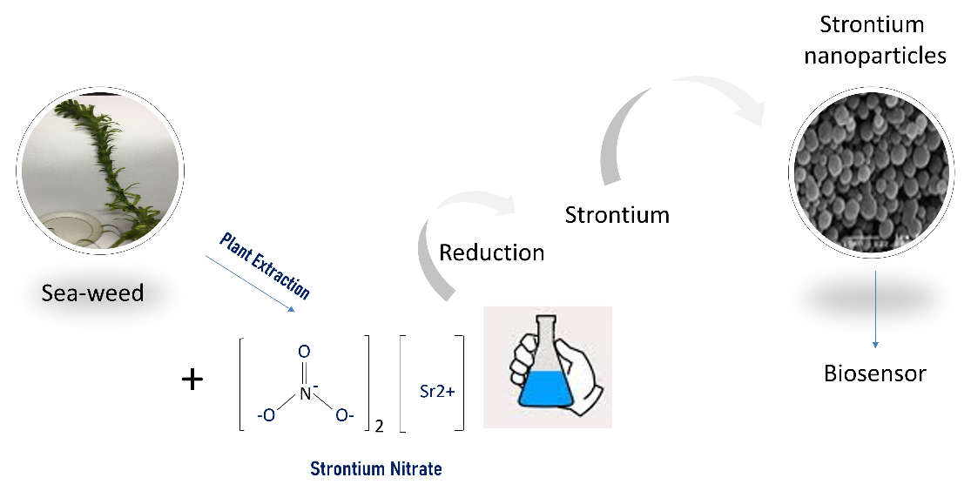
Figure 3: Greener production of strontium nanomaterial. Capping and reduction agents are from sea-weed.
- Production of nanomaterials

  - Synthesize of nanoparticles by using physical Methods

The method of synthesizing nanoparticles includes multiple approaches, including silica nanoparticles. First, there was evaporation-condensation, which was accomplished using a tube furnace to create nanoparticles (NPs) at atmospheric pressure. Using this condensation technique, Copper nanoparticle was synthesized by using a simple synthesis strategy for the manufacture of chitosan-coated silica nanocapsules with a double-shelled structure. Following that, laser ablation is a technique that concentrates a laser beam on a metal in order to release NP from the irradiated area. Because chemical reagents are scarce in NP synthesis, laser ablation is chosen over other approaches. An overview of this technology was utilized to synthesize silicon-based nanomaterials, the focus of which is on their advancements in the prevention of bacterial infections. Laser ablation enables the micromachining of materials by forming cuts or engravings on the surface or by generating nanomaterials from the ablation cloud.

  - Synthesize nanoparticles by using Chemical Methods

There are several types of processes and techniques in the chemical method, but the Stober method of the sol-gel process is widely used in many studies. The synthesis proposed by a group of scientists led by V. Stober in 1968 is the most widely used technique for obtaining silica particles. The Stober method entails hydrolysis of tetraethoxysilane (TEOS) in an alcohol-water solution, followed by condensation of the resulting silanols. The size of silica particles obtained using this method is typically between 20 and 800 nm. However, the chemical extraction method, which is the most common, efficient, and simple method, produces high-quality results in many research experiments. There are two types of extraction methods: alkalization and acid-leaching treatment. Both types were used in the sol-gel process. Alkalization synthesis required the use of an alkaline solution, such as sodium hydroxide. Centrifugation was used to remove the alkaline treated in the sample. The alkaline was then titrated with sulfuric acid until it reached neutral pH. After reaching pH 7, the solution was continuously stirred for 18 hours at room temperature before being centrifuged to separate the gel from the solution. Finally, after drying at 80°C, dried gel powder was formed as a silica nanocomposite. An acid-leaching treatment used acid to remove impurities via a chemical reaction between an acid and inorganic impurities. During filtration, the reacted metals were leached from the acidic solution. Following that, some white powder rich in silica was obtained, and the nanoparticles were obtained after the powder was milled for 3 hours at 600 rpm in a high-energy planetary ball mill.

  - Phytosynthesis of Nanomaterials
Synthesis of nanoparticles also can be done by using biological methods. According to [30], a biological method is friendly to the environment, and it is easy to use and can deal with bacteria, fungi and plant extract without using chemicals. Moreover, the biological methods are free from toxic, cheaper and most effective. In addition, different plant extraction also influences the synthesize of the silver nanoparticle [31] They claimed that different plants that need to extract were had, different antioxidant agent. Some plants have higher antioxidant, and some plants do not have antioxidants. Synthesis of gold and silver nanoparticles by the biological method, compared to chemical and physical gives many advantages. Nanoparticles are commonly synthesized via chemical methods using the chemicals as reducing agents (Figure 4). It is expensive and involves the use of toxic, hazardous chemicals, which may pose potential environmental and biological risks. Although the chemical method is cheaper for effective utilization it is not friendly with environmental and economic processes. Whereas in the physical method, nanoparticle preparation also involves expensive strategy and labourious. As the solution to prevent these hurdles, biological approaches are coming to fill the void through green synthesis. In which, biomaterial-based molecules undergo controlled assembly by making them suitable for silver and gold nanoparticles production. Gymnema sylvestre is a promising agent as an antimicrobial against the plant pathogens. The extraction from this plant expects to yield a great result when combining gold and silver nanoparticles. The incorporation of gold and silver nanoparticles with this plant extraction will clearly demonstrate enhanced microbial activity. Thus, the green synthesize of silver and gold nanoparticle conjugation is one of the good sources, which can be easier to produce, and it is friendly with environment.

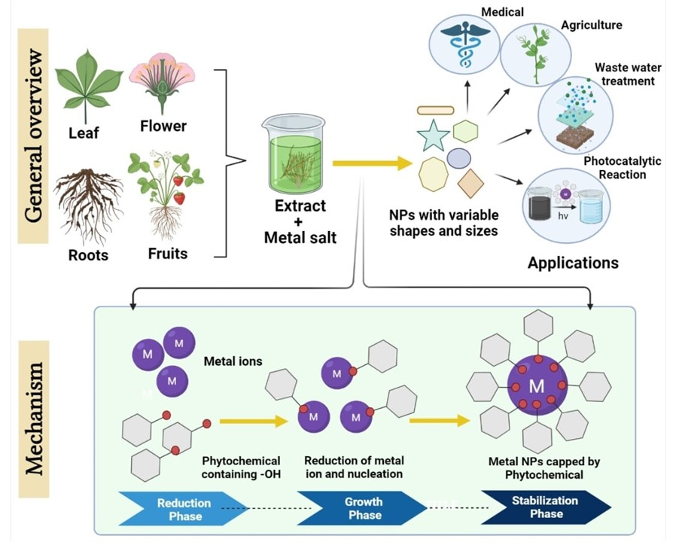

Figure 4：Greener production of nanomaterials. Using plant or biomass extract as the reduction and capping reagents are common as shown.

Green synthesis always is used with silver and nanoparticle in the different plant part extraction. This is because green synthesis method is cheap, low price and free from wasted chemical [32]. Green synthesis method gave benefit to the natural and living thing, thus they said that can prevent an accident when the researcher doing with green synthesis method compared to a chemical method where it can easily get an accident when using a high concentration of chemical [33]. High concentration of the chemical can corrode to the skin and eye. Green synthesis can be determined by using UV-Vis and FTIR methods. With green synthesis plant parts are usually used to produce silver and gold nanoparticles. The microorganism can be utilized or produced by the green synthesis, but the rate of the synthesis is slow and has limited sizes and shapes that are amenably compared to routes that are involving with plant-based materials. The main mechanism in the green synthesis of silver nanoparticle is a plant-assisted reduction due to the usage of phytochemicals. The function of the phytochemical is responsible for the immediate reduction of the ion and formation of nanoparticles. The green synthesis of the gold nanoparticle is also considered as good but lesser than the silver nanoparticle, based on the degree of the section.

- Application of Nanoparticles
The use of nanomaterials has grown dramatically in recent years, with applications ranging from agriculture to the food industry to medicine. Because of its biocompatibility, biodegradability, and low toxicity, nanomaterials have a wide range of applications in biomedical fields such as bioimaging, biosensors, and drug delivery. Nanomaterials are also thought to be the least toxic and safest particles for DNA conjugation and drug delivery . Several researchers have successfully used these nanocarriers to load a variety of cargo ranging from drugs to macromolecules such as DNA, proteins, and RNA . Different mechanisms have been proposed and implemented with the complex formation between nanomaterials and antimicrobial compounds. The mechanisms are, physical Adsorption, in which drug molecules are simply adsorbed onto the surface of nanomaterials through weak interactions such as van der Waals forces, hydrogen bonding, or hydrophobic interactions. On the other hand, covalent bonding involves the formation of chemical bonds between drug molecules and functional groups on the surface of nanomaterials. In a different approach, drug molecules are encapsulated within the core of nanomaterials, such as liposomes, polymeric nanoparticles, or dendrimers. Electrostatic interactions involve the attraction between oppositely charged molecules or groups (Figure 5).

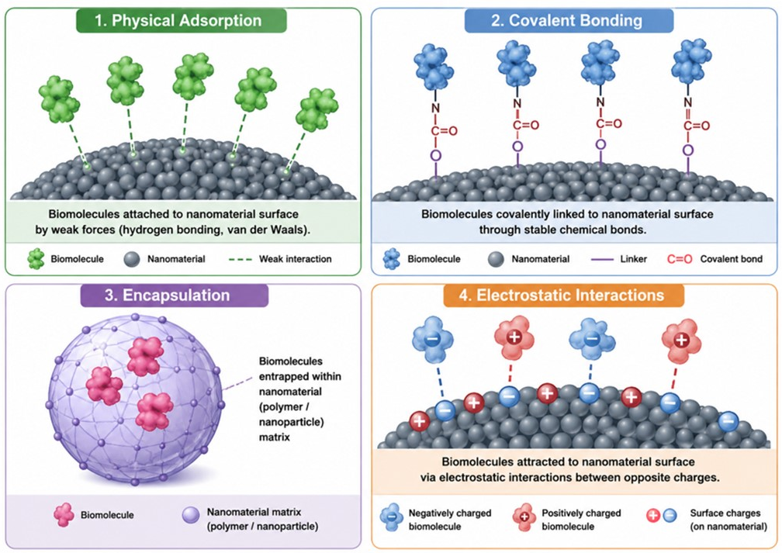

Figure 5：Mechanisms of drug or biomolecular complex formation with nanomaterials. Different approaches are displayed.
  - Nanoparticles in Antimicrobial Potentials: Involvement of Phytochemicals
With the silver nanoparticle, many researchers are doing research on the characteristics, mechanism, and synthesis. There are several silver nanoparticles on the microbes, it has own ability to penetrate the bacterial cell wall. When this happens, the structure of the cell membrane changes. There are also formations of free radical, where the cell dies, make these damage. Silver nanoparticles also changed the behavior and characteristics of antibacterial and antifungal. In the antibacterial show the positive control of antibacterial when its synthesis with silver nanoparticle [34]. Antimicrobial activity in plants always can be found in the extracted compounds from the plant, usually against E. coli, fungi, and yeast. The antimicrobial effect of silver nanoparticles is huge. Researchers evaluate the growth of the bacteria with silver nanoparticles because the method can be handled easily and cheaper. The antimicrobial activity of silver nanoparticles can be used by utilizing agar well distribution. He claimed that various silver nanoparticles can show different activities with different concentrations. Antimicrobial activities can be done by using agar well distribution. From the experiment, the bacterial inhibition can be seen with different bacteria. Phytochemicals are non-nutritive plant chemicals that have protective or disease preventive properties. Phytochemicals are non-essential nutrients; they are not required for the human body to sustain life.

Gymnema sylvestre is one of the plant herbs that can be found in the tropical forests around the world and people use this type of plant for medical treatment as they believed that it could cure the sickness of all walks of life in that country. This herb usually used for the pregnant woman, fever, and cough. They will eat this herb to decrease the body temperature. The plant is best known for its leaf extract to suppress the sweet receptors of the tongue. This plant herb has active ingredients that can cause physiological reactions such as gumarin and polypeptide that are made from 35 amino acids. The properties of the G. Sylvestre are firstly had a long been thought of as medical plant in Asia. Usually, in medicine, some doctors suggest that this herb to their patients to recover their diseases. Besides, this herb has a huge number of chemicals such as triterpenoids. Triterpenoids contain pharmacological properties that can cure the disease of humans and plants. Besides, these plants also has saponins will act to sweatiness the taste of the flavor. Usually, this kind of herb will use in the extraction experiment as it has higher potential to cure the disease and can prevent the plant cell died from pesticides. This plant also has high antimicrobial. High in antimicrobial can cause the plant easily to wilt and die.
- Current challenges in zero-waste nanomaterial production
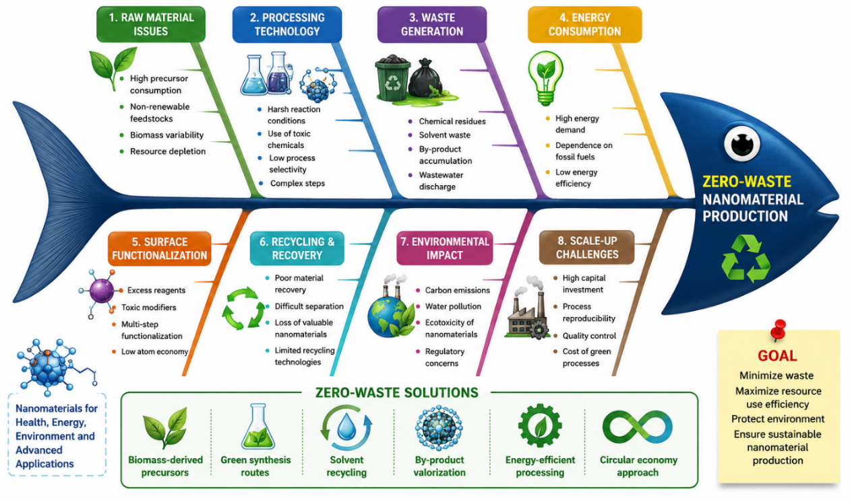
Figure 6：Fish diagram with current challenges in zero-waste nanomaterial production.

Zero-waste nanomaterial production is to minimize completely the waste creation during the stages of raw material synthesis, preparation, processing, purification, and application. Zero-waste nano manufacturing is still challenging, despite advancements in green synthesis and proposed strategies (Table 2). Recent studies highlight a process is automatically sustainable only by substituting a conventional chemical with biological agents. Figure 6 is with fish diagram that displays the current challenges with zero waste challenges and nanomaterial production. Green synthesis should be expanded to circular zero-waste nanomanufacturing in the generation of nanomaterials in near future. Waste-derived feedstocks, low-waste synthesis, renewable energy, solvent recovery, Artificial intelligence-controlled processing need to be included in the most promising model, and this integration might change the generation of nanomaterials from a linear, resource-intensive process into a high-performance manufacturing platform.

Zero-waste or circular nanomanufacturing represents the highest level of sustainability. In this model, all material and energy streams are continuously recycled, reused, or converted into useful products without generating landfill waste or environmentally harmful emissions. The principles are closely aligned with the circular economy framework. For instance, an agricultural biomass processing facility may convert rice husk into silica nanoparticles, transform residual carbon into activated carbon electrodes, recover process heat for energy generation, recycle all wash water, and reuse extraction chemicals within a closed-loop system. In such a scenario, nearly every material stream is valorized, and disposal requirements are minimized. However, true zero-waste nanomanufacturing remains challenging because many nanomaterial syntheses involve unavoidable losses associated with purification, separation, emissions control, equipment maintenance, and product end-of-life management. Consequently, many studies claiming “zero-waste synthesis” often describe highly efficient waste utilization rather than complete elimination of waste generation. Future developments in sustainable nanotechnology are expected to move beyond simply producing nanomaterials from waste. For reviews on “Waste-to-Functional Nanomaterials,” it is therefore important to distinguish between materials that are merely synthesized from waste and those produced through genuinely circular and near-zero-waste manufacturing frameworks. This distinction helps avoid overstating sustainability claims and provides a more accurate assessment of the environmental benefits associated with emerging nanomaterial production technologies.

Table 2: Comparative Overview on different levels of recycling the wastes
Aspect | Green Synthesis | Waste-Derived Synthesis | Low-Waste Production | Zero-Waste/Circular Nanomanufacturing
Main Goal | Reduce toxicity and environmental impact | Utilize waste as feedstock | Minimize process waste | Eliminate waste through circular resource use
Feedstock | Renewable biological materials | Waste streams and by-products | Any feedstock | Preferably waste or renewable resources
Chemical Usage | Reduced hazardous chemicals | Require  chemicals | Optimized chemical consumption | Closed-loop chemical recycling
Waste Generation | Reduced but present | Variable | Minimized | Near-zero or fully recycled
Resource Recovery | Limited | Feedstock valorization | Partial recycling | Complete resource circularity
Energy Efficiency | Often improved | Variable | Optimized | Integrated renewable and recovered energy
Industrial Maturity | High | High | Moderate to high | Emerging
Sustainability Level | Moderate | Moderate to high | High | Very high

Ethical and data declaration: None.

AI Tools：Used to enhance the resolution of figures.

References

[1] M. Mazaheri, H. Aashuri, and A. Simchi, “Three-dimensional hybrid graphene/nickel electrodes on zinc oxide nanorod arrays as non-enzymatic glucose biosensors,” Sens. Actuators B Chem., vol. 251, 2017, doi: 10.1016/j.snb.2017.05.062.
[2] Z. Qiu et al., “Zeolite nanomaterial-modified dielectrode oxide surface for diagnosing Alzheimer’s disease by dual molecular probed impedance sensor,” Turkish Journal of Biochemistry, vol. 48, no. 6, 2023, doi: 10.1515/tjb-2023-0079.
[3] A. Kushwaha, L. Goswami, and B. S. Kim, “Nanomaterial-Based Therapy for Wound Healing,” 2022. doi: 10.3390/nano12040618.
[4] C. Jiang, L. Lan, Y. Yao, F. Zhao, and J. Ping, “Recent progress in application of nanomaterial-enabled biosensors for ochratoxin A detection,” 2018. doi: 10.1016/j.trac.2018.02.007.
[5] J. Zhang, T. Lakshmipriya, and S. C. B. Gopinath, “Electroanalysis on an Interdigitated Electrode for High-Affinity Cardiac Troponin i Biomarker Detection by Aptamer-Gold Conjugates,” ACS Omega, vol. 5, no. 40, pp. 25899–25905, 2020, doi: 10.1021/acsomega.0c03260.
[6] Y. Jiang et al., “Electrochemical Biosensors for Oilseed Crops: Nanomaterial-Driven Detection and Smart Agriculture,” 2025. doi: 10.3390/foods14162881.
[7] A. Ditta, M. Arshad, and M. Ibrahim, “Nanoparticles in Sustainable Agricultural Crop Production: Applications and Perspectives,” in Nanotechnology and Plant Sciences, Cham: Springer International Publishing, 2015, pp. 55–75. doi: 10.1007/978-3-319-14502-0_4.
[8] H. Zhang et al., “Effect of ZnO nanoparticle application on crop safety and soil environment: a case study of potato planting,” Environ. Sci. Nano, vol. 11, no. 1, 2023, doi: 10.1039/d3en00680h.
[9] M. Kuddushi, C. Kanike, B. Bin Xu, and X. Zhang, “Recent advances in nanoprecipitation: from mechanistic insights to applications in nanomaterial synthesis,” 2025. doi: 10.1039/d5sm00006h.
[10] S. Ullah et al., “Mechanistic insights and therapeutic innovations in engineered nanomaterial-driven disruption of biofilm dynamics,” 2025. doi: 10.1039/d5ra01711d.
[11] J. Wang, U. Habiba, M. S. Reza, I. M. R. Fattah, A. Altaee, and T. M. I. Mahlia, “Nanomaterial-enhanced membranes for PFAS remediation: Mechanistic insights, technology performance, and pathways to scalable implementation,” 2026. doi: 10.1016/j.jwpe.2025.109341.
[12] C. Piccirillo et al., “Extraction and characterisation of apatite- and tricalcium phosphate-based materials from cod fish bones,” Materials Science and Engineering C, vol. 33, no. 1, 2013, doi: 10.1016/j.msec.2012.08.014.
[13] I. Younes and M. Rinaudo, “Chitin and chitosan preparation from marine sources. Structure, properties and applications,” 2015. doi: 10.3390/md13031133.
[14] S. Zhu et al., “Highly photoluminescent carbon dots for multicolor patterning, sensors, and bioimaging,” Angew. Chem. Int. Ed., vol. 52, no. 14, 2013, doi: 10.1002/anie.201300519.
[15] Y. Zhou et al., “Synthesis of carbon dots from spent coffee grounds: transforming waste into potential biomedical tools,” Nanoscale, vol. 17, no. 16, pp. 9947–9962, Mar. 2025, doi: 10.1039/d4nr05186f.
[16] P. D. Pathak, S. A. Mandavgane, and B. D. Kulkarni, “Fruit peel waste: Characterization and its potential uses,” Curr. Sci., vol. 113, no. 3, 2017, doi: 10.18520/cs/v113/i03/444-454.
[17] S. Sahu, B. Behera, T. K. Maiti, and S. Mohapatra, “Simple one-step synthesis of highly luminescent carbon dots from orange juice: Application as excellent bio-imaging agents,” Chemical Communications, vol. 48, no. 70, 2012, doi: 10.1039/c2cc33796g.
[18] S. Ahmed, M. Ahmad, B. L. Swami, and S. Ikram, “A review on plants extract mediated synthesis of silver nanoparticles for antimicrobial applications: A green expertise,” 2016. doi: 10.1016/j.jare.2015.02.007.
[19] Y. Habibi, L. A. Lucia, and O. J. Rojas, “Cellulose nanocrystals: Chemistry, self-assembly, and applications,” Chem. Rev., vol. 110, no. 6, pp. 3479–3500, Jun. 2010, doi: 10.1021/cr900339w.
[20] D. Klemm et al., “Nanocelluloses: A new family of nature-based materials,” 2011. doi: 10.1002/anie.201001273.
[21] L. Dai, O. Karakas, Y. Cheng, K. Cobb, P. Chen, and R. Ruan, “A review on carbon materials production from plastic wastes,” 2023. doi: 10.1016/j.cej.2022.139725.
[22] R. Miandad, M. A. Barakat, A. S. Aburiazaiza, M. Rehan, and A. S. Nizami, “Catalytic pyrolysis of plastic waste: A review,” 2016. doi: 10.1016/j.psep.2016.06.022.
[23] H. Sutar, “Progress of Red Mud Utilization: An Overview,” American Chemical Science Journal, vol. 4, no. 3, 2014, doi: 10.9734/acsj/2014/7258.
[24] A. M. de O. Lima, M. P. F. Graça, I. Hammami, and A. A. M. Macêdo, “Waste-Glass-Derived Porous Silica: Synthesis and Structural Characterization,” Materials, vol. 19, no. 3, Feb. 2026, doi: 10.3390/ma19030601.
[25] A. A. Nayl, A. I. Abd-Elhamid, A. A. Aly, and S. Bräse, “Recent progress in the applications of silica-based nanoparticles,” RSC Adv., vol. 12, no. 22, pp. 13706–13726, 2022, doi: 10.1039/d2ra01587k.
[26] Y. C. Chen et al., “Dual-functional gold-iron oxide core-satellite hybrid nanoparticles for sensitivity enhancement in biosensors: Via nanoplasmonic and preconcentration effects,” Analyst, vol. 146, no. 22, 2021, doi: 10.1039/d1an01334c.
[27] Z. Xiu, Q. Zhang, H. L. Puppala, V. L. Colvin, and P. J. J. Alvarez, “Negligible particle-specific antibacterial activity of silver nanoparticles.,” Nano Lett., vol. 12, no. 8, pp. 4271–5, 2012, doi: 10.1021/nl301934w.
[28] A. M. Abdelgawad, S. M. Hudson, and O. J. Rojas, “Antimicrobial wound dressing nanofiber mats from multicomponent (chitosan/silver-NPs/polyvinyl alcohol) systems,” Carbohydr. Polym., vol. 100, pp. 166–178, 2014, doi: 10.1016/j.carbpol.2012.12.043.
[29] M. Chen et al., “Copper Oxide Nanoparticles,” vol. 2014, no. Ii, pp. 1–7, 2014.
[30] C. Dipankar and S. Murugan, “The green synthesis, characterization and evaluation of the biological activities of silver nanoparticles synthesized from Iresine herbstii leaf aqueous extracts,” Colloids Surf. B Biointerfaces, vol. 98, pp. 112–119, 2012, doi: 10.1016/j.colsurfb.2012.04.006.
[31] A. Kumar, Y. Chisti, and U. Chand, “Synthesis of metallic nanoparticles using plant extracts,” Biotechnol. Adv., vol. 31, no. 2, pp. 346–356, 2013, doi: 10.1016/j.biotechadv.2013.01.003.
[32] O. V. Kharissova, H. V. R. Dias, B. I. Kharisov, B. O. Pérez, and V. M. J. Pérez, “The greener synthesis of nanoparticles,” Trends Biotechnol., vol. 31, no. 4, pp. 240–248, 2013, doi: 10.1016/j.tibtech.2013.01.003.
[33] U. B. Jagtap and V. A. Bapat, “Green synthesis of silver nanoparticles using Artocarpus heterophyllus Lam. seed extract and its antibacterial activity,” Ind. Crops Prod., vol. 46, pp. 132–137, 2013, doi: 10.1016/j.indcrop.2013.01.019.
[34] M. A. Radzig, V. A. Nadtochenko, O. A. Koksharova, J. Kiwi, V. A. Lipasova, and I. A. Khmel, “Antibacterial effects of silver nanoparticles on gram-negative bacteria: Influence on the growth and biofilms formation, mechanisms of action,” Colloids Surf. B Biointerfaces, vol. 102, pp. 300–306, 2013, doi: 10.1016/j.colsurfb.2012.07.039.

