Eco-Friendly Biosynthesis of Silver Nanoparticles Using Solanum melongena Leaf Extract: Physicochemical Characterization and Evaluation of Their Antibacterial Activity

Mohammed Khaleel Saeed, Saja Ayad Najm, Ammar moula Hmood, Ammar Radhi Obaid, Farah G. Jawad
Scientific Research Commission / Baghdad / Iraq

Abstract:
Background: Antibiotic resistance among pathogenic bacteria is a growing global health concern, propting the search for effective and environmentally friendly alternatives to antimicrobial. Silver has been used as an alternative, including in the synthesis of nanoparticles, to treat burns, wounds, and many infections caused by pathogenic bacteria. Objective: This study aimed to biosynthesis silver nanoparticles using Solanum melogena leaf extract and assess their antibacterial activity against selected human pathogens. Methods: Aqueous extracts of Solanum melogena leaves were prepared and reacted with silver nitrate (AgNO₃) solution. The formation of silver nanoparticles (AgNPs) was monitored by optical color change and characterized using scanning electron microscopy (SEM), X-ray diffraction (XRD) and Atomic force microscopy (AFM). The antibacterial activity of the synthesized nanoparticles against Escherichia coli and Staphylococcus aureus was tested using the agar well diffusion method. Results: the average size of the synthesized silver nanoparticles was verified to be 37.98 nm, confirming that the y were indeed nanoparticles. The antibacterial activity of the synthesized silver nanoparticles was evaluated against both Gram-positive and Gram-negative bacteria, and they were highly against these pathogens. Main Conclusions: S. melogena leaf extract is an effective green agent for synthesizing antibacterial silver nanoparticles with potential biomedical applications.
Keywords: Solanum melongena, Antimicrobial activity, Bacteria, Silver nanoparticles.
- Introduction:
Currently, the most important active research field in modern science is the development of nanotechnology. The next industrial revolution is focused on the development of nanomaterials and the manufacturing processes of nanomaterials particles which measure between 1 to 100 nm in one dimension [1,2]. Their antimicrobial properties, are ease of synthesis, good optical, electrical, catalytic, shape, mechanical stability, magnetically responsive, mercurial, chemically active, easy to engineer to the desired size, porous alongside having a large surface area makes composite silver nanoparticles very useful [3]. In tackling environmental issues, silver and gold nanoparticles (NPs) have proven useful in reducing dependence on herbicides. With special optical properties, these metals seem to be gaining prominence because of their ability to detect pollutants. Another interesting feature of these metals is their ability to exhibit surface plasmon resonance (SPR), which allows colorimetric detection and provides a visual indicator of environmental pollution [4]. In addition, they serve as bacterial disinfectants in medical instruments, for instance, catheters [5,6]. Furthermore, these silver containing medical products are widely utilized in hospital for medical and surgical dressings. Licences for the production of AgNPs have increased demand in the market for plastics, soaps, clothing and creams due to consumer's perception. It is used more by consumers than other nanomaterials due to its antimicrobial properties [7, 8, 9] .
Because the cost of green synthesis of nanoparticles is less than the cost of chemical and physical synthesis it has become the best option for synthesizing nanoparticles. So low-cost pathways of nanoparticles are made using plants and microorganisms. By using biologically modified nanomaterials, the natural research pathway is used to collect inorganic materials of small and infinite length [10]. The main reaction occurs is oxidation or reduction in biosynthesized nanoparticles, which is bottom up approach. The biological method is an alternative to the chemical and physical methods, as it is an environmentally friendly way to synthesize nanoparticles, in addition to that this method does not require expensive, toxic or harmful chemicals. There is great interest in the use of silver AgNP due to the unusual anti-bacterial properties as a special class of biocides [11, 12, 13]. Also, there are numerous Silver composite materials containing AgNP’s as an active antibacterial component [14, 15, 16, 17].
In one step can be done synthesis using biological organisms such as plants, actinobacteria, bacteria, yeasts, molds and algae, or their products. By reducing the molecules of plants and microscopic drugs, such as proteins, enzymes, phenolic compounds, amines, alkalis, and dyes that lead to the formation of nanoparticles [18, 19]. Because plants contain a large group of secondary metabolites that have the potential to oxidize and can be explored for biological synthesis of nanoparticles, where the nanoparticles produced by plants are more stable and the synthesis rate is faster compared to microorganisms. Therefore, plants and plant extracts were the best choice as biological alternatives [20].
In this study, Ag NP was obtained from AgNO₃ solutions by preferring the green synthesis method, and the results of the analyzes showed the morphological characteristics of nanoparticles and their anti-bacterial effect.

2. MATERIALS AND METHODS:
Silver nitrate (AgNO₃ 99.99%) was purchased from a local market. Fresh leaves of Solanum melogena obtained from Iraqi farms within the limits of the city of Baghdad / Iraq.
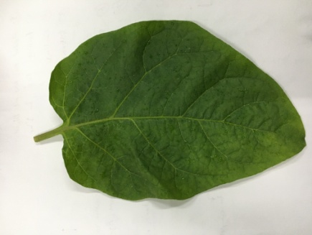
Figure 1: Photograph of Solanum melogena leaf
2.1. Preparation of Solanum melongena leaf extract :
Washed the leaves thrice with deionized water to avoid fine dust particles on its surface (Figure 2). After washing, leave the leaves to dry for about 15 minutes to remove residual moisture. About 20 grams of finely chopped leaves were boiled with 100 ml of deionized water for 1 hr at 60°C. After boiling, the leaf extract was cooled and filtered with Whatman paper No:1. The filtrate it was used for further analysis (Figure 3 –A).
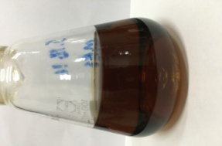A 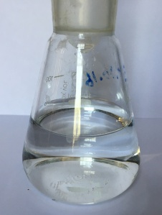 B 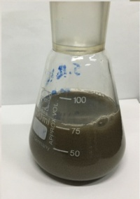 C
Figure 2: Synthesis of Silver nanoparticles from Solanum melongena leaf extract
A. Solanum melongena leaf extract; B. Silver nitrate.
C. After addition of silver nitrate.

2.2 Synthesis of Silver Nanoparticles:
To prepare the silver nanoparticles, silver nitrate (AgNO₃) 0.1M (1.698 gm of AgNO₃ in 100ml D.W.) aqueous solution was used (Fig. 3-B) for the bioreduction process 5 ml of Solanum melongena leaf extract was added to 45 mL of 0.1N AgNO₃ solution at room temperature. The solution was stored in a dark place at room temperature. After 24 hours, the solution changed from brown to gray-brown, (Fig. 3- A and C) indicating the formation of polymeric silver nanoparticles. The proposed mechanism for the biosynthesis of nanoparticles is the bioreduction mechanism of silver nanoparticles: plant extract mixed with silver dioxide (AgNO₃) [21].

2.3. Characterization of silver nanoparticles:
The silver nanoparticles synthesized from the plant extract were characterized using a number of different techniques to measure these scans, the most important of which were atomic force microscopy (AFM)-(NT-MDT, Ntegra, Rassian Federation), Scanning Electron Microscope (SEM) Tescan, Vega III, Czech Republic, (Serial No. VG 9021271 IQ). the generated nanoparticles' morphology was assessed, which yielded data on their size, shape, roughness, and size distribution. and X-ray diffraction (XRD) (6000 – Shimadzu, Japan) was used to analyze the nature of the nanoparticles.

2.4. Microorganisms’ Inoculation Procedure
Collection and Identification of Clinical Isolates.
Bacterial samples were collected from the laboratories of the Medical City Department, Baghdad, Iraq. Clinical isolates (Pseudomonas aeruginosa, Staphylococcus aureus and E. coli) are examined microscopically and subjected to standard biochemical tests. All isolates were grown in broth medium at 37°C and stored at −80°C until further analysis [22].

2.5. Antibacterial Activity
The disc diffusion technique on agar was used to evaluate the effectiveness of environmentally friendly, synthetic silver nanoparticles in inhibiting the growth of harmful bacteria [23, 24]. The potential of the synthetic silver nanoparticles as an antibacterial agent against selected pathogenic strains was assessed, focusing on three different bacterial species (Pseudomonas aeruginosa, Staphylococcus aureus, and Escherichia coli). Samples were cultured on nutrient agar, Mueller-Hinton agar (MHA), and LB agar media and incubated at 37°C for 24 hours. Subsequently, one colony was collected from each sample using a sterile swab and evenly distributed onto Mueller-Hinton agar plates, by (1 x 10⁸ CFU/mL). Ten microliters of silver nanoparticles were added to each 6-mm diameter disc. The impregnated discs containing the pellets. As negative control used as blank disc (impregnated with DMSO). These plates were incubated at 37 °C for 24 h. By measuring the diameter of the zone of inhibition expressed in millimetres the antibacterial activity of the test samples was determined.

2.6. Statistical Analysis
For every bacterial isolate and treatment, all antibacterial test were carried out in triplicate (n=3). The sizes of inhibition zones are given as mean ±standard deviation (SD). Using Microsoft Excel's Data analysis ToolPak, one-way analysis of variance (ANOVA) was used to compare treatment groups statistically; p<0.05 was deemed statistically significant.

3. RESULTS AND DISCUSSION

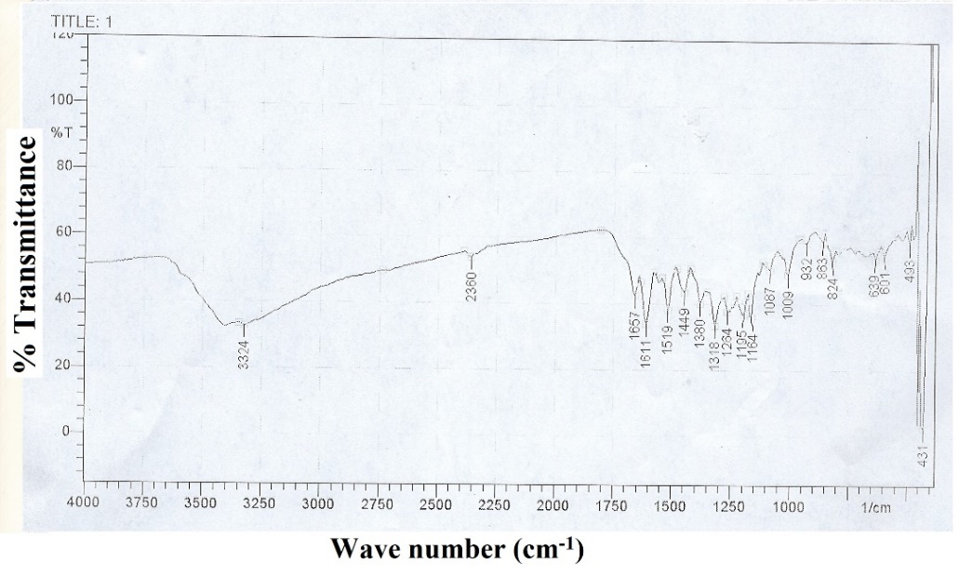

Figure 3: FTIR Solanum melongena Leaf Extract

3.1. FTIR Spectral Analysis of Solanum melongena Leaf Extract
The existence of phenolic acids and flavonoid compounds is supported by a number of distinctive absorption bands in the FTIR spectrum of the leaf extract from Solanum melongena. O-H stretching vibrations, which originate from the hydroxyl groups of phenolic compounds and perhaps intermolecular hydrogen bonding – a characteristic of polyphenolic extracts – are responsible for the board, strong band seen around 3334 cm⁻¹. The band about 1657 cm⁻¹ represents C=O stretching (carbonyl group), which is usually connected to the conjugated ketone or carboxylic acid functionality present in phenolic acid structures and flavonoid backbones. Aromatic C =C stretching vibrations of the benzene ring, a structural characteristic shared by phenolic acids and flavonoids, are responsible for the peak at about 1611-1519 cm⁻¹. The cluster of peaks between 1318 and 1164 cm⁻¹ indicates C-O stretching vibrations, which are frequently associated with ether, ester, or phenolic C-OH groups found in flavonoid glycosides and phenolic acid derivatives. Bands in the 1449-1380 cm⁻¹ region represent C-H bending (asymmetric and symmetric deformation). The peaks appearing in the fingerprint region below 1100 cm-1 (around 1087, 1009, 932, 863, and 824 cm-1) are generally associated with C-O-C and C-H out –of – plane bending vibrations of aromatic rings, further confirming the polyphenolic and flavonoid –rich composition of the extract. In line with earlier phytochemical reports on eggplant leaves, these spectral characteristics- especially the O-H, C=O, aromatic C=C, and C-O stretching bands – provide compelling evidence for the presence of flavonoid compounds (like quercetin or kaempferol derivatives) and phenolic acids (like caffeic, chlorogenic, or gallic acid derivatives) in the Solanum melongena leaf extract.

3.2. X-ray Diffraction:

Figure 3 shows the XRD pattern of the silver nanoparticles biosynthesized using Solanum melongena leaf extract, recorded over the range 2θ = 10–80°. Seven well-resolved Bragg reflections were observed at 2θ ≈ 27.8°, 32.2°, 46.2°, 54.5°, 57.3°, 67.5°, and 76.7°. To assign these reflections unambiguously, the observed peak positions were compared against two ICDD (International Centre for Diffraction Data) reference patterns: the standard pattern face –centred-cubic metallic silver, Ag⁰ (JCPDS 98 -004-4387; Fig. 3B), and the standard pattern for cubic silver chloride, AgCl (JCPDS 31-1238). The indexing results are summarized in Table 1.

Table 1. indexing of the diffraction peaks observed in Fig. 3 by comparison with the ICDD reference pattrens for Ag⁰ and AgCl.

Observed 2θ (°) | Ref. Ag⁰ (JCPDS 98-004-4387) | Ref. AgCl (JCPDS 31-1238) | (hkl) | Assigned Phase
27.8° | 38.11° | 27.8° | (111) | AgCl
32.2° | 44.3° | 32.2° | (200) | AgCl
46.2° | 64.4° | 46.2° | (220) | AgCl
54.5° | 77.4° | 54.8° | (311) | AgCl
57.3° | 81.5° | 57.4° | (222) | AgCl
67.5° | — | 67.5° | (400) | AgCl
76.7° | — | 76.7° | (420) | AgCl

As shown in Table 1, all seven observed reflections coincide, to within 0.3° in 2θ, with the (111), (200), (220), (311), (222), (400), and (420) plans of cubic AgCl whereas none match the five characteristic reflections metallic Ag at 38.11° (111), 44.3° (200), 64.4° (220), 77.4° (311), 81.5° (222), (Fig. 3B). As a result, the AgCl (420) plane is more consistent with the reflection at 76.7° which was previously attributed to the Ag (311) plane. This suggests that silver chloride, not metallic Ag⁺² , is the predominant crystalline phase in the sample. Remaining chloride species in the plant extract or reaction medium, which react with Ag⁺ ions produced from the silver precursor during synthesis, are most likely the source of chloride [25].

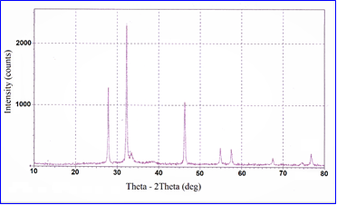
Figure 3: XRD of biosynthesized silver nanoparticles using extract of Solanum melongena leaves.
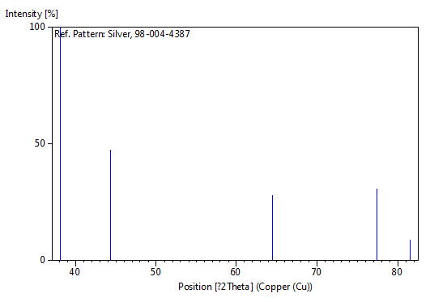
Figure 3 B: XRD of Standard silver nanoparticles

This observation is consistent with previous reports on plant-mediated silver nanoparticle synthesis, in which extra or shifted diffraction peaks have been attributed not only to lattice distortion of metallic silver but also to the co-formation of silver chloride, silver oxide, or surface-bound organic phases [26].
The average crystallite size of the sample was calculated from the full width at half maximum (FWHM) of the most intense reflection (2θ ≈ 32.2°) using the Debye–Scherrer equation:
τ = Kλ / (β cos θ)
where τ is the average crystallite size, K is the shape factor, λ is the X-ray wavelength, β is the FWHM (in radians), and θ is the Bragg angle. The calculated average crystallite size was 37.98 nm. This value corresponds to the size of the coherently diffracting crystalline domain, as determined from XRD line broadening, and should be distinguished from the physical particle size obtained by imaging techniques such as AFM (Section 3.4). The additional non-specific peak observed at 45.85° is attributed to the presence of an amorphous or low-crystallinity organic coating layer — likely proteinaceous or phytochemical in nature — derived from the Solanum melongena leaf extract and adsorbed on the nanoparticle surface [27]. Findings from multiple investigations on plant-mediated silver nanoparticle synthesis are consistent with slight shifts in the diffraction peaks and the occasional appearance of additional reflections during the formation of silver nanoparticles by Solanum melongena leaf extract. Such changes are usually attributed to surface-bound protein, substrate residues, agglomeration stress, or small variations in the crystal lattice rather than a failure of nanoparticle formation [26, 27, 28]. The most likely explanation is that plant extracts often cause shifts in the XRD pattern of silver nanoparticles due to surface coating, plant-dependent crystallinity, stress or lattice distortion, and particle-size effects; additional peaks may originate from silver chloride, oxide phases, or surface-bound chemical species rather than from silver lattice distortion alone [28]. No single mechanism is consistently supported by the literature. Since phytochemicals function concurrently as reducing, coating, and stabilizing agents, varied plant chemical composition is equally associated with varying crystallite size in similar green-synthesis processes [29, 30, 31].

3.3. Atomic Force Microscopy (AFM)
Figure 4 shows high-resolution 2D and 3D AFM images of the biosynthesized silver nanoparticles, revealing scattered aggregates of varying nanometre size distributed across the substrate. The corresponding size-distribution histogram (Fig. 5) and diagram (Fig. 6) show that particle sizes range from approximately 30 to 770 nm, indicating a broad and heterogeneous size distribution rather than a single uniform particle population.
This AFM-derived size range is markedly broader than, and its upper bound substantially exceeds, the 37.98 nm average crystallite size obtained from XRD (Section 3.2). This is discussed in detail in Section 4.
3.4. Atomic force microscopy (AFM):
The images below show AFM analysis of the presence of scattered aggregates of silver nanoparticles with various nanometer sizes. (Fig. 4).
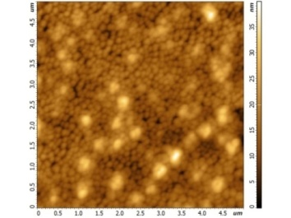2D 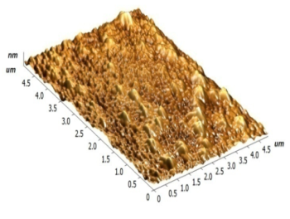 3D
Figure 4: High-resolution AFM 2D and 3D images for synthesis AgNPs using extract of Solanum melongena leaves.
Figure 5: Histograms of size distribution of AgNPs synthesized with extract of Solanum melongena leaves.
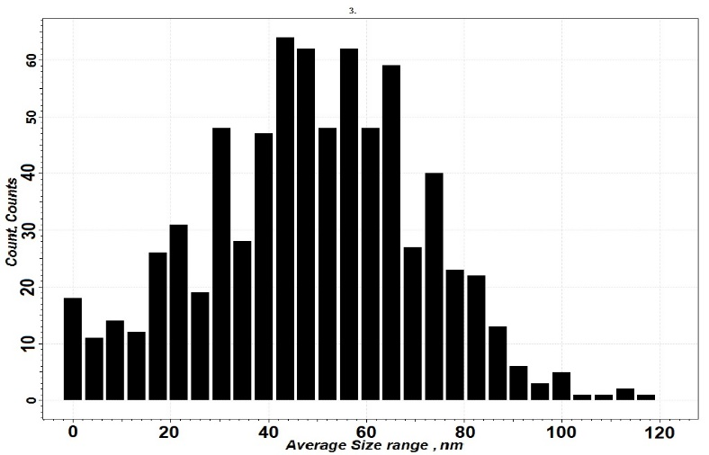
Figure 5 shows Size distribution diagram of silver nanoparticles biosynthesized using Solanum melongena leaf extract. The distribution shows that the majority of particles fall within the 30-770nm range, reflecting the efficiency and effectiveness of the biosynthesis method in producing relatively uniformly sized nanoparticles.

3.5. Morphological Analysis:
Scanning electronic microscope (SEM):
Figure 7 shows a sample of silver nanoparticles synthesized from the plant extract. The SEM images show that the silver nanoparticles had a smooth, spherical surface and were well-distributed in a tightly packed arrangement. The average particle size was 37.98 nm, which is identical to the values recorded using X-ray diffraction.
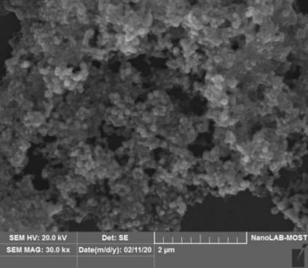 A 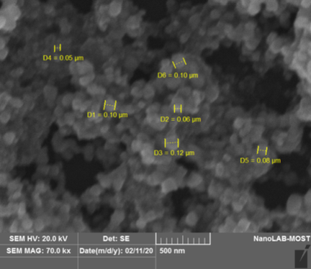 B
Figure 6: SEM image of synthesized AgNPs using extract of Solanum melongena leaves. (A) SEM image at (2µm), (B) SEM image at (500nm).
3.6. Antibacterial activity of synthesized silver nanoparticles:
Silver nanoparticles synthesis from plant extract had an inhibitory effect on the isolated bacteria. The antibacterial activity was evaluated using the disc diffusion method. Our findings were of antibacterial activity against three different bacteria (Pseudomonas aeruginosa, Staphylococcus aureus and E. coli) As a standard antibiotic (100 µg/mL), levofloxacin (lev. 5) and Tigecycline (TGC 15), Cefoxitin (FOX 30) was used as a control, and the results are described in Figs. 8 and 9.
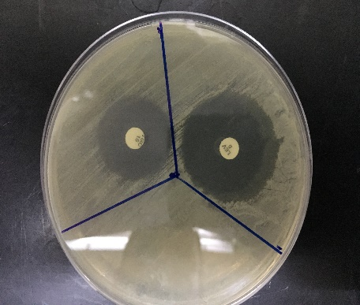 A 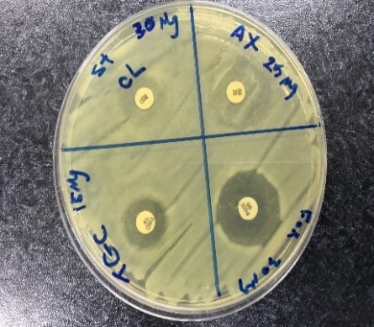 B 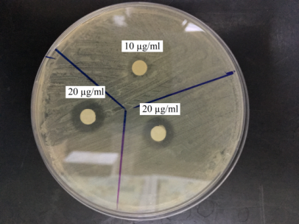 C
Figure 7: Antibacterial activity Samples: A) Antibiotic (Levo, TGC), B) Antibiotic (TGC, FOX), C) AgNOPs (10, 20) µL

Figure 8: Silver nanoparticles' antibacterial activity against infections is compared to that of (lev 5), (TGC 15) and (FOX 30), a common medication.
The test was performed against three pathogenic reference strains including Gram-positive and Gram-negative bacteria, the effect of silver particles derived from S. melongena extract (14 mm) was inhibitory against the pathogen (Fig. 9). Whereas the standard antibiotics used was (lev 5), (TGC 15) and (FOX 30), as a positive control showed a zone of )10-33 mm (inhibition against the tested bacteria. Hence, it was observed that AgNPs biosynthesized by Solanum melongena leaf extract had good inhibitory effect compared to the standard antibiotic. Which is also in accordance with data of, [32, 33] it was demonstrated that the NPs agglomerate on the membrane and have the ability to penetrate the cells, damaging the cell walls; the cell membrane presented a clear-cut zone of inhibition. In the whole, silver was utilized directly as nitrate for an early antimicrobial effect (when AgNPs are numerous, the stable interaction of positively supercharged NPs and negatively charged bacterial membrane causes cell permeability, leading to death of cells). So there was a significant effect on microbes due to exposure of a larger area of the microbial surface to silver nanoparticles manufactured using plant extract [34]. The biosynthesized AgNPs showed a moderate antibacterial effect (14 mm inhibition zone) when compared to the standard antibiotics. This was less than that of some antibiotics (up to 33mm) but comparable to, or even greater than, others (as low as 10 mm) in some strain-antibiotic combinations (Fig. 8). These findings support the AgNPs potential as promising, environmentally friendly complementary antimicrobial agent and show that they did not consistently outperform the reference antibiotics used in this study. Instead, they showed a consistent antibacterial effect against both Gram-positive and Gram-negative bacteria [32, 33].
3.7. 1. Mechanism of plant-mediated synthesis of AgNPs:
The trapping of positive silver ions on the protein surface as a results of electrostatic interaction between the protein and silver in the plant extract was thought to be the cause of the bio-reduction of silver. Silver nuclei are produced and the secondary structure shifts as a result of proteins lowering Ag+ ions. On the other hand, as Ag+ ions build up, silver cores enlarge and produce AgNPs, which then group together to form oligomer clusters (Figure 1). Metallic silver colloidal particles may be produced by these clusters. Several surfactants and polymers are used to prevent particles from sticking together even more and to maintain their structure. AgNPs morphology can be controlled by mixed surfactant solutions that combine cationic and anionic surfactant, resulting in high crystallinity and decreased aggregation [35].

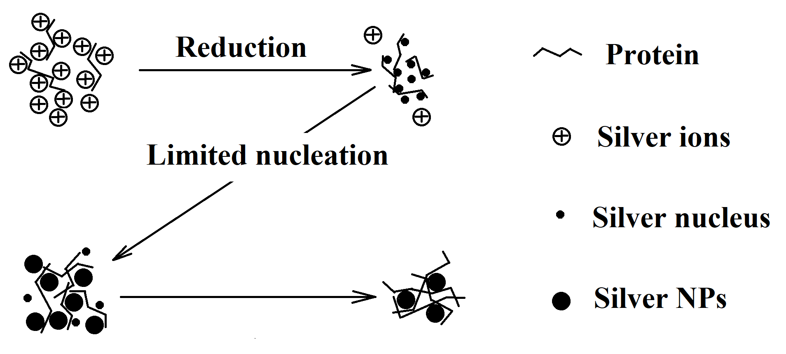

Figure 9: Schematic representation for the formation process of silver NPs.

According to a different study, the containment of primary phytochemicals such flavones, carboxylic acids, aldehydes, amides, ketons, and terpenoids is the key mechanism behind AgNPs-mediated plant synthesis [36]. Silver ions in the reaction mixture are immediately reduced by these water-soluble phytochemicals. Additionally, dry plants that contain anthraquinone and emodin and go through a stress phase have been shown to produce AgNPs.

3.7.2. The toxicity mechanisms of NPs against bacteria:

It is yet unknown exactly how AgNPs interact with bacteria. The bacterial outer membrane is essentially asymmetric and primarily composed of lipopolysaccharides, while the bacterial inner membrane is made up of narrow semipermeable chains of phospholipids [37]. Proteins and lipopolysaccharide molecules are released as a result of cytoplasmic leakage brought on by its rupture. AgNPs may adhere to the cell wall, changing the membrane's permeability and ultimately causing bacterial cells to breathe.
AgNPs attach to cell wall proteins, which are mostly made up of macromolecules like DNA, which contains phosphorus and sulphur, after passing through the cell wall [38, 39]. According to certain studies, NPs may cause harm to the bacterial membrane by attaching to its surface through an electrostatic reaction [40], based on the cell's composition, functions, and structure. The strength and stiffness of the bacterial cell wall shielded the cell against mechanical and osmotic harm. Gram positive cells have a thick coating of 20-50 nm –thick peptidoglycan (PG) that makes up their cell wall.

This layer attaches to teichoic acids, which are specific to gram-positive cell walls. The interaction between peptidoglycan and teichoic acids is crucial for preserving the cell wall's structural integrity, which affects the bacterial physiology and reactions to environmental stressors [41]. Gram-negative cell walls, on the other hand, have more complicated chemical and structural makeup. The cell wall is composed of a thin layer of PG found in the outer membrane that sits on top of the surface membrane. In addition to having lipopolysaccharides, which raise the cell membrane's negative charge and are physically and physiologically significant for Gram-positive bacteria, this outer membrane is renowned for its resistance to hydrophobic substances like detergents [37, 42, 43].

3.7.3. Comparative summary of the proposed formation and antibacterial mechanisms:

Table 2 compares the plant/source material, the suggested reducing and capping phytochemicals, particle size, proposed formation mechanism, bacteria tested, and proposed antibacterial mechanism reported in this study with those of closely related plant-mediated AgNPs studies cited above [35, 36, 37] in order to provide stronger, more structured evidence in support of the mechanism proposed in sections 3.4, 3.5, and 3.5.1. The comparison demonstrated that the membrane-disruption mode of antibacterial action and bioreduction/electrostatic-capping mechanism suggested for the current Solanum melongena-derived AgNPs are generally consistent with mechanisms reported for other Solanum species and other plant-mediated synthesis. It also highlights areas where direct comparison is limited by methodological differences (e.g., callus vs leaf extract, chemical vs phytochemical capping).

Table 2. Comparion of proposed AgNPs formation and antibacterial mechanisms in this study and related plant-mediated synthesis.

Reference / Study | Plant / source used | Proposed reducing / capping phytochemicals | Particle size (nm) | Proposed formation mechanism | Bacteria tested | Proposed antibacterial mechanism
This study  (Saeed et al.) | Solanum melongena leaf extract | Proteins/phenolics implicated via electrostatic Ag⁺-trapping mechanism (not directly assayed) | XRD: 37.98 nm; AFM: 30–770 nm | Ag⁺ electrostatically trapped on protein surface → silver nuclei → oligomeric AgNP/AgCl clusters capped by phytochemicals | P. aeruginosa, S. aureus, E. coli | NP adsorption/aggregation on membrane; electrostatic NP–membrane interaction increases permeability, leading to cell death (ZOI = 14 mm)
[21] Lashin et al., 2021 | Solanum incanum callus extract | Callus metabolites (proteins/phenolics per FT-IR) | 15–60 nm (TEM) | Bioreduction/capping of Ag⁺ by callus-extract metabolites | S. aureus, B. subtilis, E. coli, K. pneumoniae, P. aeruginosa, C. albicans | Dose-dependent growth inhibition; MIC 6.25–12.5 µg/mL
[51] Pushparaj et al., 2023 | Solanum melongena leaf extract (same species) | Leaf phytocompounds (not itemised in the abstract) | Not reported in the accessible abstract | Phytocompound-mediated reduction of Ag⁺ to Ag⁰ | Bacterial isolates (species not specified in the abstract) | Antibacterial, pesticidal and anticancer activity reported; mechanism not detailed in the abstract
[29] Gowda et al., 2024 | Santalum album (sandalwood) leaf extract | Polyphenols, proteins, lipids (FT-IR) | 10–32 nm (SEM/TEM/AFM); 49.53 nm hydrodynamic (DLS) | Phytochemical bioreduction/capping; FCC crystal structure | Not tested (study evaluated plant and cancer-cell proliferation, not bacteria) | N/A — cited here for XRD/crystallinity comparison only, not antibacterial mechanism
[32] Nalini et al., 2016 | Five Solanum species (leaf extracts) | Not detailed in the available title/abstract | Not reported | Plant-mediated bioreduction (species-dependent) | Not specified in the accessible summary | Antibacterial activity reported; cited in Section 3.4 as consistent with the present inhibitory effect
[33] Rajalakshmi et al., 2019 | Solanum nigrum | Not detailed in the accessible abstract | Not reported | Plant-mediated bioreduction | Not specified (antioxidant/antibacterial/anticancer tested) | Antibacterial activity reported alongside antioxidant and anticancer activity
[34] Saqib et al., 2022 | Aspergillus fumigatus extract (fungal, bimetallic NPs) | Fungal-derived metabolites | Not reported in the accessible summary | Bimetallic nanoparticle assembly | Bacterial membrane (species not specified) | Direct damage to bacterial membrane surface with release of cellular contents (as cited in Section 3.4)
[35] Mohamed et al., 2022 | Not plant-based — chemical mixed-surfactant synthesis | Cationic/anionic surfactants (not phytochemicals) | Not reported | Mixed surfactant system controls AgNP morphology, crystallinity and aggregation | Not tested | N/A — cited here for formation-mechanism/morphology control only
[36] Shaikh et al., 2021 (review) | Review across multiple plant species | Flavones, carboxylic acids, aldehydes, amides, ketones, terpenoids (review synthesis) | Varies across reviewed studies | Phytochemical-mediated reduction (general mechanism synthesised from the literature) | Varies across reviewed studies | Varies across reviewed studies

Overall, the mechanistic picture suggested for the current S. melogena-derived AgNPs-phytochemical bioreduction/capping of Ag⁺ followed by electrostatic NP-membrane interaction and permeabilization of the bacterial cell envelope-is in line with the larger plant-mediated AgNP literature compiled in Table 2. However, the size and phase (AgCl-dominant) results of this study go beyond that literature by emphasizing the impact of the particular extract chemistry and reaction medium on the final nanoparticle composition.
4. Discussion:
The traditional FTIR signature of polyphenol-rich extract consists of several aromatic C=C bands (1611-1519 cm⁻¹), a strong O-H band (3324 cm⁻¹), and a carbonyl stretch (1657 cm⁻¹). Since sugar-ring C-O vibrations usually occur in this area, the dense cluster of C-O stretching bands (1318-1009 cm⁻¹) provides additional evidence of the existence of glycosylated flavonoids [44, 45]. This pattern is in line with published FTIR profiles of leaf extracts from eggplant (Solanum melongena) that are high in falvonol glycosides (such as derivatives of quercetin and kaempferol), caffeic acid, chlorogenic acid.
The peak-indexing analysis presented in Section 3.2 (Table 1) indicates that the dominant crystalline phase in the biosynthesized sample is silver chloride (AgCl) rather than metallic silver (Ag⁰). This finding refines the interpretation of the XRD data relative to earlier plant-mediated silver nanoparticle studies, which have similarly reported the co-formation of AgCl, silver oxide, or organic surface phases alongside — or instead of — metallic Ag⁰ [26, 46]. One possible explanation is that during the reduction process, chloride ions that are either naturally in the laef extract of Solanum melongena or introduced through the aqueous reaction medium react with Ag⁺ ions, causing partial or total precipitation of AgCl in competition with the reduction of Ag⁺ to Ag⁰ [47]. This process is in line with high phytochemical content of plant extracts, which has been demonstrated to significantly affect the size distribution, phase composition, and crystallinity of biosynthesized nanoparticles based on the ratio of stabilizing to reducing activity [29, 30, 31]. A crystalline or semi-crystalline organic coating layer is further supported by the non-specific reflection seen at 45.85°, which is accordance with publications that attribute extra low-intensity peaks in plant-synthesized nanoparticles to bioorganic capping agents [27, 28, 48].
The apparent discrepancy between the XRD-derived crystallite size (37.98 nm) and the much broader AFM particle-size range (30–770 nm; Figs. 4–5) is attributable to the fact that the two techniques probe fundamentally different physical quantities rather than to a measurement error. XRD line-broadening analysis (Debye–Scherrer equation) reports the size of the coherently diffracting crystalline domain, whereas AFM reports the apparent topographic footprint of whatever is deposited on the substrate — which may be a single nanocrystal, a polycrystalline particle, or an agglomerate of several crystallites bound together by residual phytochemical or proteinaceous material from the leaf extract [29]. Such capping-mediated aggregation is a well-documented feature of plant-mediated nanoparticle synthesis and is consistent with the wide size range and scattered aggregates observed in the AFM images (Fig. 4). In addition, AFM is known to overestimate the lateral dimensions of nanoscale features due to tip-convolution effects, in which the finite radius of curvature of the probe geometrically broadens the apparent footprint of small particles, an effect that is proportionally most pronounced for particles below ~50 nm [49, 50]. Lastly, AFM captures the entire heterogeneity of the deposited sample, including relatively uncommon large aggregates that extend the upper bound of the observed range without necessary reflecting the mofal particle size, whereas the Scherrer method yields a single intensity-weighted average dominated by the most intense reflection. When combined, these factors show that the XRD and AFM results are complementary rather than contradictory, and that primary crystalline units (~38 nm) are primarily present on the substrate in an agglomerated state rather than as discrete particles of the size suggested by the AFM range alone.

Conclusion:

Seven diffraction peaks that consistently index to the (111), (200), (220), (311), (222), (400), and (420) plans of cubic AgCl were found by XRD analysis of the sample synthesized using Solanum melongena leaf extract. This suggests that silver chloride, rather than metallic silver, is the dominant crystalline phase formed under the synthesis condition used, most likely due to chloride species in the reaction with Ag⁺ ions. The Debye-Scherrer equation yield an average crystalline size 37.98 nm, which is not a directly observed particle dimension but rather the size of the coherently diffracting crystalline domain. These crystalline units are primarily found as aggregates between 30 and 770 nm, according to AFM research. This distribution can be attributed to both intrinsic AFM tip-convolution effects and phytochemical-mediated agglomeration rather than inconsistency between the two methods. Overall, these results highlight the significance of integrating XRD phase indexing with imaging-based size analysis for evaluation plant-mediated nanomaterials and improve the structural and morphological characterization of the biosynthesized nanoparticles. The biosynthesized AgNPs potential as antibacterial agents is further supported by the antibacterial results obtained in this study; however, this potential is reported as such and broader biomedical applications are not claimed because they would need additional validation through cytotoxicity and in vivo studies.

Acknowledgments
The authors extend their sincere thanks to the Scientific Research Commission / Baghdad, and the Center for Industrial Applications and Materials Technology Research for providing the necessary laboratory facilities to conduct this research. The authors also express their sincere gratitude to the reviewers who contributed to the evaluation of this research for presentation at this conference.

References:
- ASTM E2456-06, Standard terminology relating to nanotechnology (2012).
- Kumar, S., Khan, S. I., Neidhe, MM.R., Islam, M. and Hasan, MM.: Nanomaterials in Industry: A Review of Emerging Applications and Development. Control Systems and Optimization Letters. 2(3), 342–348. https://doi.org/10.59247/csol.v2i3.135 (2024).
- Sharma, C.: Nanoparticles: applications in modern technology. Iterative International Publishers (IIP). 2:138–145. https://doi.org/10.58532/v2bs14p2ch4 (2023).
- De, A. and Kalita, D.: Bio-Fabricated Gold and Silver Nanoparticle Based Plasmonic Sensors for Detection of Environmental Pollutants: An Overview. Critical Reviews in Analytical Chemistry. 1–17 (2021).
- Jain, N., Waidi, YO., Vannaladsaysy, V., Pathote, D., Sharma, U. and Datta, S.: Application of Nanoparticles on Biomedical Devices. Advances in Medical Diagnosis, Treatment, and Care (AMDTC) Book Series. 315–340. https://doi.org/10.4018/979-8-3693-3065-4.ch012 (2024).
- Arya, A. and Yashan, N.: The Nanorevolution in Medicine: Advancing Drug Delivery Systems with Nanomaterials and Nanodevices. Engineering Archive. https://doi.org/10.31224/4266 (2024).
- Devi, R., Sriram, R., Ali, MMA., Akash, MSH. and Srinivasan, R.: Silver nanoparticals for tissue engineering and regenerative medicine. Iterative International Publishers (IIP). 67–80. https://doi.org/10.58532/v3bkpn16p1ch7 (2024).
- Kameswaran, S., Ramesh, B., Gopal, N.O. and Reddy, A.S.: Plant-Based Nanoparticle Synthesis. 20–29. https://doi.org/10.1201/9781003477730-3. (2025).
- Sharma C. Tripathi P. and Wadhwa N. Nanoparticles emerging through microbial routes. Iterative International Publishers (IIP). 3(1),127–139. https://doi.org/10.58532/v3bfbt1p1ch8 (2024).
- Iqbal, J., Ijaz, S., Ijaz, N. Abbasi, BH., Yaseen, T., Ullah, Z., Iqbal, R., Murtaza, G., Ashraf, Z., Mahmood, T., Kanwal, S., Ali, I., Ullah, I. and Kazi, M.: Microbial Synthesis of Metal Nanoparticles for Nanomedicinal and Catalytic Applications. 88–124. https://doi.org/10.1201/9781003378563-5 (2025).
- Fouad, A., Hegazy, AE., Azab, E., Khojah, E. and Kapiel, T.: Boosting of Antioxidants and Alkaloids in Catharanthus roseus Suspension Cultures Using Silver Nanoparticles with Expression of CrMPK3 and STR Genes. Plants, 10, 2202 (2021).
- Bharathi, C., Rajeswari, R., Janaki, P., Sivamurugan, AP., Govindan, SK., Sengodan, R., Priya, RS., Sangeetha, M., Thenmozhi, S., Chiranjeevirajan, N., Sharmila, R., Ramya, B. and Balamurugan, R.: Bio-mediated synthesis of nanoparticles: A new paradigm for environmental sustainability. Plant Science Today, 12(sp1). https://doi.org/10.14719/pst.5192 (2025).
- Singh, V., Pandit, C., Pandit, S., Roy, A., Rustagi, S., El‐kott, AF., Ibrahium, HA., Anand, J., Malik, S., Yadav, KK. and Tambuwala, MM.: Deciphering the Mechanisms and Biotechnological Implications of Nanoparticle Synthesis Through Microbial Consortia. Journal of Basic Microbiology. https://doi.org/10.1002/jobm.202400035 (2024).
- Vanlalveni, Ch., Lallianrawna, S., Biswas, A., Selvaraj, M., Changmai, B. and Rokhum, SL.: Green synthesis of silver nanoparticles using plant extracts and their antimicrobial activities: a review of recent literature. RSC Advances. 11, 2804-22837. (2021).
- Audtarat, S. and Dasri, T.: Preparation and antibacterial property of silver nanoparticles loaded into bacterial cellulose. Materials Research Express, 10. https://doi.org/10.1088/2053-1591/acd991 (2023).
- Liu, T.Y., Pang, Q., Mai, K.-S., He, X., Xu, L.Q., Zhou, F. and Li, Y.: Silver nanoparticle@carbon quantum dot composite as an antibacterial agent. RSC Advances. 12(16), 9621–9627. https://doi.org/10.1039/d2ra00561a (2022).
- Dridi, D., Vu, N., Singh, J., Eesaee, M., Saïdi, A., Elkoun, S. and Nguyen‐Tri.: Recent advances on engineering of silver related nanocomposites toward antibacterial applications. Nano-Structures and Nano-Objects. 38, 101195. https://doi.org/10.1016/j.nanoso.2024.101195 (2024).
- Bruna, T., Maldonado-Bravo, F., Jara, P. and Caro, N.: Silver Nanoparticles and Their Antibacterial Applications. Int. J. Mol. Sci., 22, 7202 (2024).
- Khan, M., Khan, AU., Bogdanchikova, N. and Garibo, D.: Antibacterial and Antifungal Studies of Biosynthesized Silver Nanoparticles against Plant Parasitic Nematode Meloidogyne incognita, Plant Pathogens Ralstonia solanacearum and Fusarium oxysporum. Molecules. 26, 2462 (2021).
- Khan, N. Ali S. Latif S. and Mehmood A. Biological Synthesis of Nanoparticles and Their Applications in Sustainable Agriculture Production. Natural Science. 14(06),226–234. https://doi.org/10.4236/ns.2022.146022 (2022).
- Lashin, I., Fouda, A., Gobouri, AA., Azab, E., Mohammed, saleh, ZM. and Makharita, RR.: Antimicrobial and In vitro cytotoxic efficacy of biogenic silver nanoparticles (Ag-NPs) fabricated by callus extract of Solanum incanum L. Biomolecules.11, 341 (2021).
- Bharadwaj, V. G., Suvvari, T. K., Kandi, V., P, C. R., and Dharsandia, M. V.: Molecular Characterization of Pseudomonas aeruginosa Clinical Isolates Through Whole-Genome Sequencing: A Comprehensive Analysis of Biotypes, Sequence Types, and Antimicrobial and Virulence Genes. Cureus. https://doi.org/10.7759/cureus.71118 (2024).
- Saied, E., Doghish, A.S., Soliman, M.K., El-Dakroury, W.A., Aloufi, A.S., Kiani, B.H., Hashem, A.H.: Onion peel-mediated biosynthesis of TiO2-ZnO bimetallic nanoparticles: Antimicrobial, antibiofilm, and anticancer activities. Elec. Biot. 77:12–23. https://doi.org/10.1016/j.ejbt.2025.06.001 (2025).
- Balouiri, M., Sadiki M., Ibnsouda SK.: Methods for in vitro evaluating antimicrobial activity: A review. Phar. Ana. 6(2),71–79. https://doi.org/10.1016/j.jpha.2015.11.005 (2016).
- Eltayeb, B.M., Elshazly, E.H., Aboelmagd, H.A. et al. Sustainable production of silver chloride nanoparticles from desert flora for biomedical applications with multifunctional biological activities. Sci Rep 15, 32674. https://doi.org/10.1038/s41598-025-20170-y. (2025).

- Al-Zahrani, S., Astudillo-Calderón, S., Pintos, B., Pérez-Urria, E., Manzanera, J., Martín, L., and Gómez-Garay, A.: Role of Synthetic Plant Extracts on the Production of Silver-Derived Nanoparticles. Plants, 10. https://doi.org/10.3390/plants10081671 (2021).
- Getachew, A., Bacha, E. G., and Geleta, W. S.: Statistical optimization of eco-friendly synthesized silver nanoparticles using Discopodium penninervium Hochst leaf extract for enhanced antimicrobial efficacy. Scientific Reports, 15. https://doi.org/10.1038/s41598-025-29253-2 (2025).
- Dashora, A., Rathore, K., Raj, S., and Sharma, K.: Synthesis of silver nanoparticles employing Polyalthia longifolia leaf extract and their in vitro antifungal activity against phytopathogen. Biochemistry and Biophysics Reports, 31. https://doi.org/10.1016/j.bbrep.2022.101320 (2022).
- Gowda, A., C, S. T., Anil, V. S., and Raghavan, S.: Phytosynthesis of silver nanoparticles using aqueous sandalwood (Santalum album L.) leaf extract: Divergent effects of SW-AgNPs on proliferating plant and cancer cells. PLOS ONE, 19. https://doi.org/10.1371/journal.pone.0300115 (2024).
- Riaz, M., Sharafat, U., Zahid, N., Ismail, M., Park, J., Ahmad, B., Rashid, N., Fahim, M., Imran, M., & Tabassum, A.: Synthesis of Biogenic Silver Nanocatalyst and their Antibacterial and Organic Pollutants Reduction Ability. ACS Omega, 7, 14723 - 14734. https://doi.org/10.1021/acsomega.1c07365 (2022).
- Nayem, S. M. A., Sultana, N., Haque, M. A., Miah, B., Hasan, M., Islam, T., Hasan, M., Awal, A., Uddin, J., Aziz, M. A., & Ahammad, A.: Green Synthesis of Gold and Silver Nanoparticles by Using Amorphophallus paeoniifolius Tuber Extract and Evaluation of Their Antibacterial Activity. Molecules, 25. https://doi.org/10.3390/molecules25204773 (2020).
- Nalini, Mabela, GDN., Gracelin, DHS., Clarina, T. and Ramab, V.: Bio synthesis of Silver Nanoparticles from Five Solanum Species and their anti-bacterial Activity. New Advances in Chemistry and Materials. 38-45 (2016).
- Rajalakshmi, A., Sreelatha, S. and Jayachitra A.: Synthesis and Characterization of Solanum Nigrum Derived Nanoparticles and Exploration if Its Antioxidant, Antibacterial and Anticancer Potentials in in Vitro. SSRG International Journal of Agriculture & Environmental Science, 6(1): 29-36 (2019).
- Saqib, S., Faryad, S., Afridi, MI., Arshad, B., Younas, MS., Naeem, M., Zaman, W., Ullah, F., Nisar, M., Ali, S., Elgorban, AM., Syed, A., Elansary, HO. and Zin, El-Abedin, TK.: Bimetallic Assembled Silver Nanoparticles Impregnated in Aspergillus fumigatus Extract Damage the Bacterial Membrane Surface and Release Cellular Contents. Coatings, 12(10), 1505. https://doi.org/10.3390/coatings12101505 (2022).
- Mohamed, D., Mohamed, AS. and El-Dib, F. I.: Role of mixed surfactants system in preparation of silver nanoparticles. Tenside Surfactants Detergents. 59(5), 400–408. https://doi.org/10.1515/tsd-2022-2421 (2022).
- Shaikh WA. Chakraborty S. Owens G. and Islam RU.: A review of the phytochemical mediated synthesis of AgNP (silver nanoparticle): the wonder particle of the past decade. Applied Nanoscience, 11(11), 1–36. https://doi.org/10.1007/S13204-021-02135-5 (2021).
- Yeow, J., Luo, M. and Chng, S.: Molecular mechanism of phospholipid transport at the bacterial outer membrane interface. Nature Communications. https://doi.org/10.1038/s41467-023-44144-8 (2023).
- Pinheiro, SK., de, P. Rangel, Miguel, TBA., Chaves, M., de M., Barros, FC., de F. Farias, CP., Moura, TA., de Ferreira, OP., Paschoal, AR. Filho, AGS. and Miguel, E de C.: Silver nanoparticles (AgNPs) internalization and passage through the Lactuca sativa (Asteraceae) outer cell wall. Functional Plant Biology. 48(11), 1113–1123. https://doi.org/10.1071/FP21161 (2021).
- Rzheussky, SE.: Silver nanoparticles in medicine. Vestnik of Vitebsk State Medical University.: 21(2), 15–24. https://doi.org/10.22263/2312-4156.2022.2.15 (2022).
- Hussien, AM., Taher, HS. and Abdulla, H.: Biosynthesized Silver Nanoparticles as Promising Antimicrobial Agents and Their Mode of Action. Advances in Environmental and Life Sciences, 6(2). Pag. 1-11. https://doi.org/10.21608/aels.2024.291232.1057 (2024).
- Barber, F., Yuan, Z., Akbary, Z., Biboy, J., Vollmer, W. and Rojas, E.: Wall teichoic acids regulate peptidoglycan synthesis by paving cell wall microstructure. https://doi.org/10.1101/2024.09.02.610702 (2024).
- Lundstedt, EA., Kahne, D. and Ruiz, N.: Assembly and Maintenance of Lipids at the Bacterial Outer Membrane. Chemical Reviews,121(9), 5098–5123 (2021).
- Schumann, A. Gaballa, A. and Wiedmann, M.: The multifaceted roles of phosphoethanolamine-modified lipopolysaccharides: from stress response and virulence to cationic antimicrobial resistance. Microbiology and Molecular Biology Reviews, 88: e00193-23. https://doi.org/10.1128/mmbr.00193-23 (2024).
- Shahwar, D., K. Zafar, M. Abbas, et al. 2026. “ Unveiling the Antioxidant Profiling, Cytotoxicity and Wound Healing Potential of Biocompatible Silver Nanoparticles Synthesized Using Solanum melongena.” Food Science & Nutrition 14, no. 2: e71569. https://doi.org/10.1002/fsn3.71569

- Añibarro-Ortega M., Dias M. I., Petrović J., Núñez S., Calhelha R. C., Costa E. M., Machado M., Pintado M., Soković M., López V., Barros L., Pinela J. Valorization of Solanum melongena L. crop by-products: Phenolic composition and in vitro antioxidant, antidiabetic, anti-inflammatory, cytotoxic, and antimicrobial properties. Process Biochemistry. 153, 315-324, https://doi.org/10.1016/j.procbio.2025.04.002. (2025)
- Bayik, D. G., and Baykal, B.: Impact of Plant Species on the Synthesis and Characterization of Biogenic Silver Nanoparticles: A Comparative Study of Brassica oleracea, Corylus avellana, and Camellia sinensis. Nanomaterials, 14. https://doi.org/10.3390/nano14231954 (2024).
- Kota, S., Dumpala, P., Anantha, R. K., Verma, M. K., & Kandepu, S. (2017). Evaluation of therapeutic potential of the silver/silver chloride nanoparticles synthesized with the aqueous leaf extract of Rumex acetosa. Scientific reports, 7(1), 11566. https://doi.org/10.1038/s41598-017-11853-2
- Jemel, I., Krayem, N., Jlidi, H., Bacha, A. B., Alonazi, M. A., Charguia, R., Alzahrani, A., Aifa, S., and Mnif, S.: Structural insights and biomedical potential of biosynthesized silver nanoparticles: antibacterial activity, anti-biofilm and cancer cell inhibition. PeerJ, 13. https://doi.org/10.7717/peerj.19608 (2025).
- Dhir R, Chauhan S, Subham P, Kumar S, Sharma P, Shidiki A and Kumar G (2024) Plant-mediated synthesis of silver nanoparticles: unlocking their pharmacological potential–a comprehensive review. Front. Bioeng. Biotechnol. 11:1324805. doi: 10.3389/fbioe.2023.1324805.

- Canet-Ferrer, J., Coronado, E., Forment-Aliaga, A., & Pinilla-Cienfuegos, E. (2014). Correction of the tip convolution effects in the imaging of nanostructures studied through scanning force microscopy. Nanotechnology, 25(39), 395703. https://doi.org/10.1088/0957-4484/25/39/395703.

- Pushparaj, K., Balasubramanian, B., Kandasamy, Y., Arumugam, V. A., Kaliannan, D., Arumugam, M., Alodaini, H. A., Hatamleh, A. A., Pappuswamy, M., and Meyyazhagan, A.: Green synthesis, characterization of silver nanoparticles using aqueous leaf extracts of Solanum melongena and in vitro evaluation of antibacterial, pesticidal and anticancer activity in human MDA-MB-231 breast cancer cell lines. Journal of King Saud University - Science. https://doi.org/10.1016/j.jksus.2023.102663 (2023).

