Energy Storage Performance of Upcycled Coffea arabica Coffee-Pulp-Derived Carbon Quantum Dots
Iman Aris Fadzallah¹[0000-1111-2222-3333], Amirul Muttaqin Naharudin² and H.K Jun ^{1,2,3}[1111-2222-3333-4444]*
¹ Centre for Sustainable Mobility Technologies, Universiti Tunku Abdul Rahman, Sungai Long Campus, Bandar Sungai Long, 43000 Kajang, Malaysia.
² Department of Mechanical and Materials Engineering, Lee Kong Chian Faculty of Engineering and Science, Universiti Tunku Abdul Rahman, Sungai Long Campus, Jalan Sungai Long, Bandar Sungai
³ Centre for Advanced and Sustainable Materials Research, Universiti Tunku Abdul Rahman, Sungai Long Campus, Bandar Sungai Long, 43000 Kajang, Malaysia
*Corresponding author: junhk1@gmail.com, junhk@utar.edu.my
Abstract. The development of sustainable electrode materials from abundant biomass waste is important for advancing environmentally responsible electrochemical energy-storage technologies while reducing dependence on conventional carbon precursors. In this study, coffee-pulp-derived carbon quantum dots (CQDs) were synthesized via a one-step hydrothermal method and evaluated as electrode additives for electrical double-layer capacitors (EDLCs) applications. SEM analysis confirmed a porous and fragmented morphology favourable for electrolyte access. Electrochemical evaluation of the CQD-based electrodes exhibited nearly rectangular cyclic voltammetry (CV) profiles, achieving a maximum specific capacitance of 133 F/g at 5 mV/s. Galvanostatic charge-discharge (GCD) measurements yielded a specific capacitance of 51.5 F/g, an energy density of 10.3 Wh/kg, and a power density of 309.8 W/kg at a current density of 0.5 A/g. These findings demonstrate the potential of coffee pulp as a viable and sustainable precursor for producing CQDs with promising electrochemical energy-storage performance.
Keywords: Carbon Quantum Dots, Coffee Pulp, Biomass Upcycling, Supercapacitors, Energy Storage.
- Introduction

Electric double-layer capacitors (EDLCs) are a key class of energy storage devices because they deliver very fast charge-discharge cycles and excellent long-term stability. Unlike batteries that rely on faradaic redox reactions, EDLCs store energy electrostatically at the electrode-electrolyte interface, enabling high power density and long cycle life for applications such as regenerative braking, grid stabilization, and short-term buffering [1-4]. Electrode material properties with high accessible surface area, good electrical conductivity, and an appropriate pore network are therefore decisive for EDLC performance [5-7]. Carbon materials (activated carbon, graphene, carbon nanotubes) remain dominant choices because of their tunable morphology and chemical stability, but they can be costly or require complex processing to achieve optimal pore architectures [8,9].
Nanostructured carbons, particularly carbon quantum dots (CQDs), offer a complementary route to improve EDLC electrodes. CQDs combine sp²/sp³ carbon cores with abundant surface functional groups (–COOH, –OH, –NH₂, etc.), quantum confinement effects, and high surface-to-volume ratios; these features can enhance wettability, provide redox-active sites, and facilitate ion transport when integrated into composite electrodes [10-14]. This study focuses on coffee‑pulp CQDs and compares device performance under identical conditions to our prior spent‑coffee‑groundwork, contributing data that may help clarify precursor‑dependent effects.
Coffee processing generates large volumes of by-products (pulp, husk, spent grounds) that are attractive, low-cost precursors for CQDs [15-17]. Coffee pulp’s distinct biochemical makeup consist of cellulose, hemicellulose, lignin, sugars and phenolics can steer hydrothermal carbonization toward different core sizes, defect densities, and surface oxygenation patterns, which in turn affect porosity, conductivity, and pseudocapacitive behaviour [18,19]. This work synthesizes CQDs from Coffea arabica coffee pulp via a one‑step hydrothermal route followed by dialysis, freeze‑drying and evaluates them as 0.5 wt.% additives in activated‑carbon electrodes assembled with a PVA‑based gel polymer electrolyte. SEM‑EDX confirms a porous, fragmented morphology with substantial oxygen content, while electrochemical testing (cyclic voltammetry at 5-100 mV/s and galvanostatic charge-discharge at 0.5 A/g) assesses capacitive behaviour and rate response. By comparing these results with prior spent‑coffee‑ground benchmarks under identical device conditions [20], the study aims to clarify which precursor‑derived features most strongly influence EDLC performance and to identify practical directions for optimizing biomass‑derived CQDs for scalable, polymer‑electrolyte supercapacitors.
- Materials and Methodology
Coffee pulp (Coffea arabica) was obtained commercially. Electrode components: activated carbon, carbon black (Super P), poly(vinylidene fluoride) (PVdF, M_{w} ~534,000 g/mol, Sigma Aldrich), 1-methyl-2-pyrrolidone (NMP, Supelco), and battery-grade aluminium foil (0.25 mm), were used as received.

  - Preparation of biomass-derived CQDs
Coffee pulp was pulverized and milled to a fine powder, then hydrothermally treated in an autoclave at 200 °C for 4 h, following the procedure of Arora, G. et al. [20]. The resulting suspension was dialyzed for 48 h, washed, filtered, and freeze-dried to yield brown CQD powder (Fig. 1). Synthesis was repeated to confirm reproducibility.
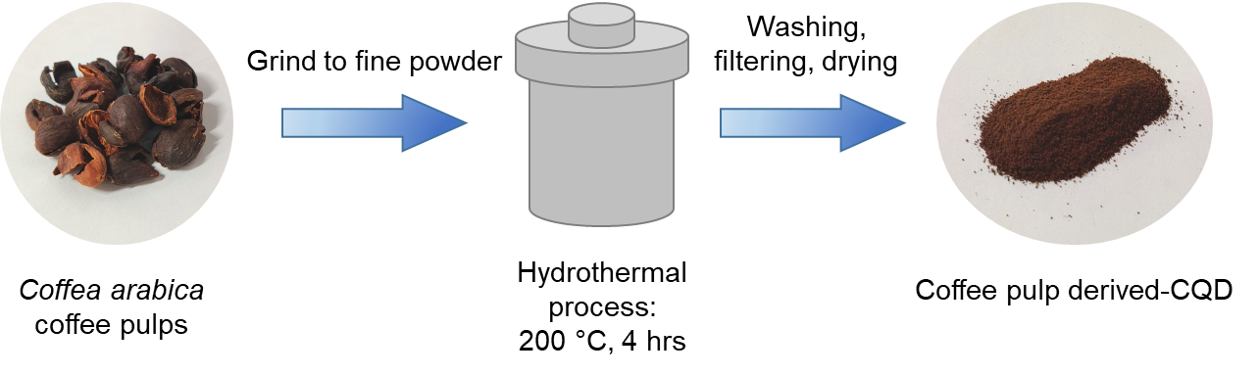
Fig. 1. Synthesis of CQD from Coffea arabica coffee pulps
  - Fabrication of EDLCs
Electrodes were prepared as previously reported [21]. In brief, 10 wt.% PVDF was dissolved in NMP at 60 °C, followed by addition of 80 wt.% activated carbon, 5 wt.% carbon black, and 5 wt.% synthesized CQDs. The slurry was stirred at 60 °C for 24 h, coated onto aluminium foil, and then dried at 120 °C for 4 h. EDLC cells were assembled by sandwiching a PVA-based gel polymer electrolyte film between two identical electrodes.
  - Characterizations
SEM-EDX (Hitachi S-3400N, 15 kV) was used to examine CQDs morphology and elemental composition. Cyclic voltammetry (CV) (ZIVE SPI potentiostat) was performed at 5, 30, 50, and 100 mV/s to assess capacitive behaviour and rate capability, with specific capacitance calculated from Eqn. 1 [22]:
$C_{sp}= \frac{1}{m × s × ∆v}\int_{V1}^{V2}{I dV}$ (1)
where $\int_{V1}^{V2}{I dv}$ represents the area under the CV curve, m is the mass of the active electrode material, $∆v$ is the potential window (in V), and s is the scan rate (in V/s). Galvanostatic charge-discharge (GCD) measurements gave specific capacitance, C_{sp} from the linear portions of the charge-discharge plots as estimated from Eqn. 2:
$C_{sp}= \frac{i\left(\frac{Δt}{ΔV}\right)}{m }$ (2)
where i is the constant current, Δt/ΔV is the gradient from the linear parts of the charge-discharge curves, and m is the mass of the active electrode material. The energy density (E_{d}) and power density (P_{d}) of the device were then calculated using Eqn. 3:

$E_{d}=\frac{C_{sp}V}{2m}, P_{d}=\frac{V}{4m^{2}ESR}$ (3)

where V is the operating window voltage and ESR is the equivalent series resistance that was determined from ESR=V_{d}/i (V_{d} and i are the voltage drop from GCD and applied current, respectively).
- Results and Discussions
The morphology analysis of the CQDs is shown in Fig. 2. From Fig. 2(a-b), a highly porous, fragmented structure with irregular and well-defined edges is observed, indicating significant carbonization and a high surface area beneficial for energy storage [23]. EDX (Fig. 2c) confirms 53.5% carbon, 44.4% oxygen, and 2.2% nitrogen. Based on the findings of our previous study [20], the physical characteristics of the synthesized CQDs are expected to be comparable to those reported previously [20]. Nevertheless, the presence and morphology of the CQDs will be further confirmed using TEM analysis in future work.

(a) | (b) | (c)
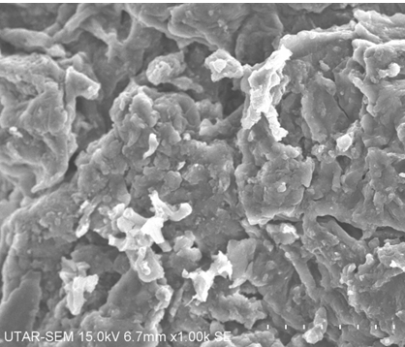 | 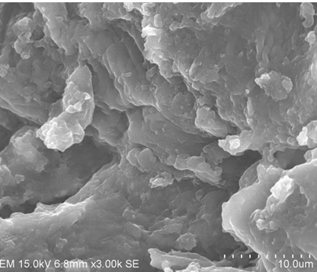 | 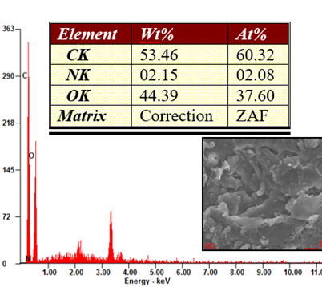
Fig. 2. Morphological study using SEM-EDX: (a) image at 500x magnification, (b) image at 3000x magnification, and (c) corresponding EDX spectrum showing elemental composition of CQDs.
Fig. 3(a) shows CV curves of the assembled EDLCs at 5-100 mV/s with typical EDLC shape. There are no observable Faradaic peaks, confirming the electrolyte stability without redox reactions [24]. Using Eqn. (1), specific capacitance (C_{sp}) reached a maximum of 133 F/g at 5 mV/s and decreased progressively with increasing scan rate (Fig. 3b). This trend is consistent with diffusion-limited ion access at higher rates [25,26]. Minor deviation from ideal rectangular CV shape reflects electrode porosity and internal resistance, in line with de Levie's penetration-depth concept [27]. For comparison, our earlier PVA-based EDLC system reached only 0.75 F/g (reference electrode) and 3.66 F/g (spent-coffee-ground CQD electrode) at 5 mV/s [20,21].
(a)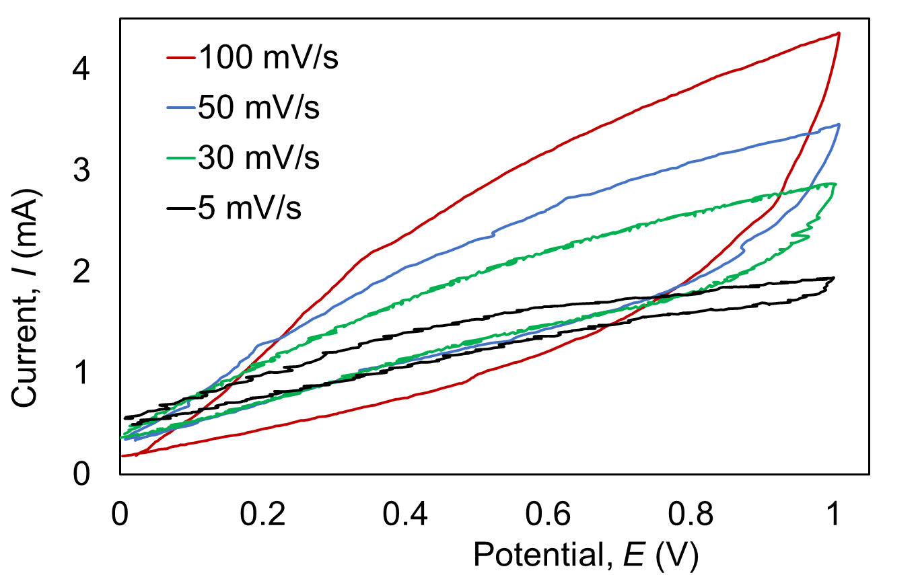 | (b)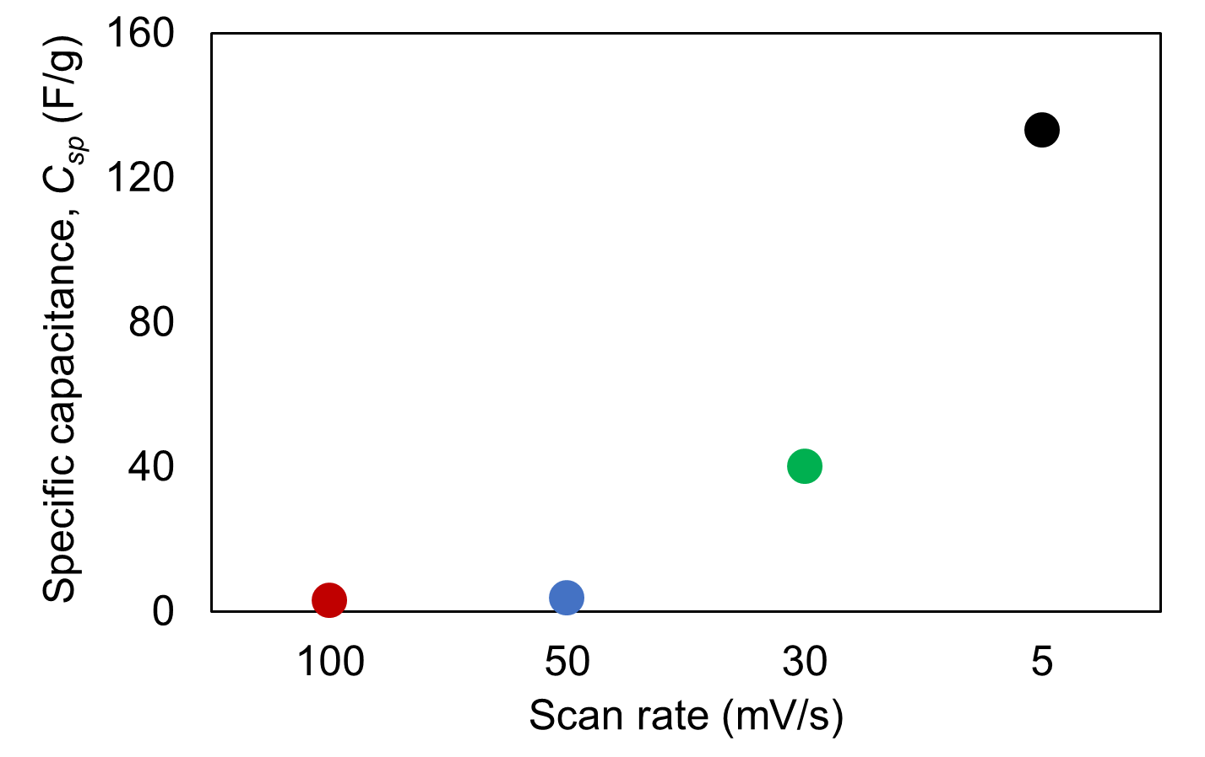
Fig. 3. Electrochemical studies of EDLC: (a) CV responses at various scan rate (b) specific capacitance (C_{sp}) at different scan rate (mV/s).
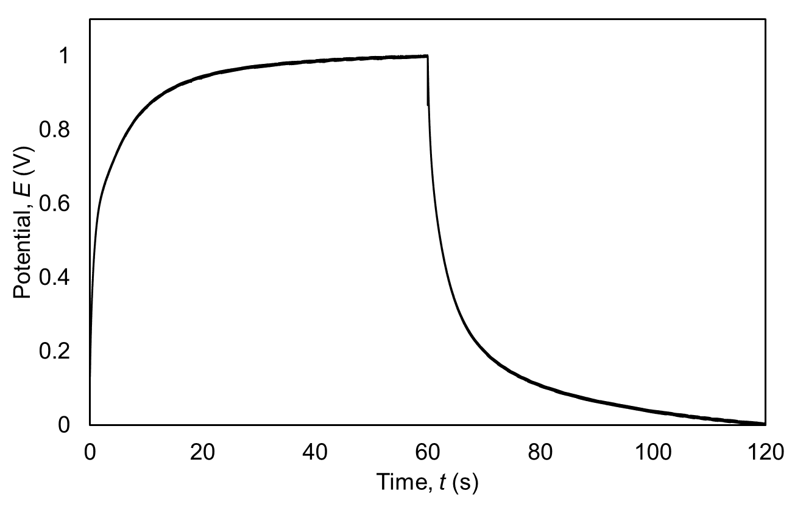
Fig. 4. GCD plot of EDLC with CQD-added electrodes.
The galvanostatic charge-discharge (GCD) profile for the assembled EDLC composed of CQD derived from coffee pulps is presented in Fig. 4. GCD measurements at current density of 0.5 A/g gave a C_{sp} of 51.5 F/g, an energy density (E_{d}) of 10.3 Wh/kg, and a power density (P_{d}) of 309.8 W/kg. This nearly doubles our previous result (E_{d} = 4.3 Wh/kg, P_{d} = 130 W/kg)[20], confirming that CQD incorporation enhances charge storage. Notably, despite literature suggesting coffee pulp's richer surface functionality should outperform spent grounds, our spent-coffee-ground CQDs achieved higher capacitance (C_{sp} = 97.5 F/g). This outcome likely reflects the differences in lignin/ cellulose content and carbonization behavior between different precursors. Coffee pulp nonetheless remains a promising, underexploited feedstock with room for optimization.
The discrepancies in C_{sp} values obtained from CV and GCD arise from the inherent differences in the measurement techniques. CV is strongly dependent on the applied potential scan rate, where higher sweep rates limit ion diffusion into micropores and reduce the apparent capacitance, while lower sweep rates allow more complete ion transport and yield higher values. In contrast, GCD is performed under constant current density, and the calculation of C_{sp} explicitly considers the IR drop, thereby providing a more realistic evaluation of device performance under practical operating conditions. Although the two techniques yield different capacitance values, both are complementary: CV highlights ion diffusion behaviour and rate capability at varying scan rates, whereas GCD reflects charge storage and resistive effects under constant current operation, thus together offering a comprehensive understanding of the electrochemical behaviour of supercapacitors [28].
The SEM images reveal a rough and fragmented electrode morphology with visible voids and irregular surface features. These structural characteristics may facilitate electrolyte penetration and increase the accessibility of electrochemically active surfaces, which is beneficial for charge storage in EDLCs. Similar morphological features have been associated with improved electrochemical performance in our previous studies using spent coffee grounds-derived materials [29-31]. However, the present study does not include BET analysis; therefore, the relationship between the observed surface morphology, pore characteristics, and electrochemical performance cannot be quantitatively established. Future work will include BET characterization to provide quantitative information on the specific surface area and pore structure and to further clarify their contribution to the observed charge-storage performance.

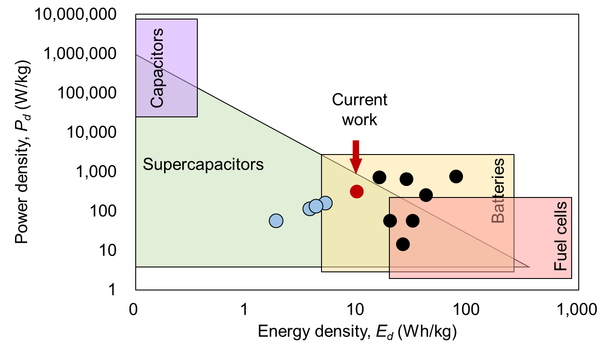
Fig. 5. Ragone plot of the previously reported energy density and power density across biomass derived carbon electrodes in EDLC systems. Blue circular markers represent the authors’ earlier work (spent coffee grounds CQDs with the same polymer electrolyte systems), while the red circular marker corresponds to the present work. The black circular markers represent biomass-derived CQDs with aqueous electrolytes and biomass-derived activated carbon (AC) with polymer electrolytes.
Because most reported hydrothermal biomass-derived CQD-based EDLC studies use aqueous electrolytes, direct comparison with our polymer-electrolyte system is limited. To contextualize the electrochemical performance, Fig. 5 presents a Ragone plot benchmarking the coffee-pulp-derived CQD electrodes developed in this work against spent-coffee-ground-derived CQD electrodes from our previous studies [32,20,21], biomass-derived CQD electrodes using aqueous electrolytes, and biomass-derived activated carbon (AC) electrodes using solid polymer electrolytes. The use of comparable electrode configurations and electrolyte environments provides a basis for evaluating the effect of CQD incorporation on EDLC performance. Although the aqueous-electrolyte CQD systems and solid polymer-electrolyte AC systems exhibit higher performance, as indicated by the black circular markers, they have certain limitations, including safety and stability concerns associated with aqueous electrolytes such as KOH and H₂SO₄) [33,34] and the relatively complex activation processes required for producing AC [35-38]. In contrast, the hydrothermal synthesis of CQD offers a greener and milder route without the need for toxic reagents [39-41]. Importantly, the present study demonstrates a marked improvement over our previous work using spent coffee grounds, achieving higher energy and power densities under the same polymer-electrolyte framework. Therefore, the proposed approach provides a potentially safer and greener pathway for biomass-derived EDLC electrodes compared with conventional aqueous-electrolyte and activated carbon systems.
- Conclusion
Coffee-pulp-derived CQDs, synthesized hydrothermally, were demonstrated as effective EDLC electrode materials. SEM-EDX confirmed a porous, carbon-rich, fragmented morphology. Electrochemical testing gave a maximum specific capacitance of 133 F/g (CV, 5 mV/s) and 51.5 F/g (GCD), with an energy density of 10.3 Wh/kg and power density of 309.8 W/kg. These results nearly double our previous spent-coffee-ground result. These results nearly double our previous spent‑coffee‑ground benchmark, underscoring the promise of coffee pulp as a sustainable CQD precursor for energy storage. Nonetheless, the present study did not include pore‑size/BET analysis or long‑term cycling data, which are essential to establish structure–property correlations and lifetime stability. A key take‑home message is that future optimization should focus on tailoring pore size distribution, enhancing accessible surface area, and validating ion transport pathways through BET and TEM analyses, alongside durability testing. These parameters will be critical to surpass the performance of spent coffee grounds and fully unlock the potential of coffee‑pulp‑derived CQDs for practical supercapacitor applications.

Acknowledgment

This research was supported by the Ministry of Higher Education (MOHE) through the Fundamental Research Grant Scheme (FRGS/1/2025/TK08/UTAR/02/1).

References
1. Chand, B., Phogat, P., Shreya, & Kant, C. R. Materials and mechanisms in electrochemical double-layer capacitors: bridging high power with energy storage efficiency. Materials Science and Engineering: B, 324(2026).
2. Kumagai, S., Kanamoto, Y., Chng, C. J., Abe, Y., Kabir, M., Eguchi, T., et al. Accelerated aging of electric double-layer capacitor cells under increased cell voltage and temperature. Journal of Energy Storage, 137(2025).
3. Sikiru, S., Olutoki, J. O., Musa, S. A., Afolabi, L. O., & Mahat, M. M. The projection role of surface charge density in electric double-layer capacitance for enhanced energy storage. Journal of Energy Storage, 138(2025).
4. Dissanayake, K., & Kularatna-Abeywardana, D. A review of supercapacitors: Materials, technology, challenges, and renewable energy applications. Journal of Energy Storage, 96, 112563(2024).
5. Xu, Y., Yu, S., Johnson, H. M., Wu, Y., Liu, X., Fang, B., et al. Recent progress in electrode materials for micro-supercapacitors. iScience, 27(2), 108786(2024).
6. Abimana, C., Bello, A., Machunda, R., Chande Jande, Y. A., & Bhuyar, P. Understanding the Factors Influencing the Properties of Biomass‐Derived Porous Carbon and Their Impacts on Electrical Double‐Layer Capacitor Electrodes: A Comprehensive Review. Journal of Renewable Energy, 2024(1), 1343256(2024).
7. Ngidi, N. P. D., Koekemoer, A. F., & Ndlela, S. S. Recent advancement in the electrochemical performance of electrochemical capacitors based on biomass-derived porous carbon: A review. Journal of Energy Storage, 89, 111638(2024).
8. Gurten, I., II. Scalable activated carbon/graphene based supercapacitors with improved capacitance retention at high current densities. Turk J Chem, 45(3), 927-941(2021).
9. Li, C., Yue, Q., Gao, Y., Li, Z., Zhang, J., Zhang, M., et al. Toward Rational Design of Carbon-Based Electrodes for High-Performance Supercapacitors. ACS Appl Mater Interfaces, 17(17), 24675-24700(2025).
10. Jin, Y., Wang, Y., Ren, P.-G., Zhang, B., Zhao, Z., Hou, X., et al. Recent advances of carbon dots based emerging materials for supercapacitors applications. Journal of Energy Storage, 85, 111118(2024).
11. Wu, M., Zhan, J., Geng, B., He, P., Wu, K., Wang, L., et al. Scalable synthesis of organic-soluble carbon quantum dots: superior optical properties in solvents, solids, and LEDs. [10.1039/C7NR04718E]. Nanoscale, 9(35), 13195-13202(2017).
12. Mondal, T. K., Kapuria, A., Miah, M., & Saha, S. K. Solubility tuning of alkyl amine functionalized carbon quantum dots for selective detection of nitroexplosive. Carbon, 209(2023).
13. Liu, N., Yu, J., Li, Y., Liu, Y., Jabeen, S., Cheng, Y., et al. Multifunctional Carbon Dots for Electrochemical Capacitors Reviewed: Their Opportunities and Challenges. Adv Sci (Weinh), 12(41), e08000(2025).
14. Sead, F. F., Makasana, J., Saraswat, S. K., Rekha, M. M., Kundlas, M., Saini, S., et al. Electrochemical behavior of carbon quantum dots as electrolyte additives for enhanced battery and supercapacitor performance. Materials Technology, 40(1), 2500524(2025).
15. Ramírez Sanabria, A. E., Urbano Narváez, S., Gutiérrez Portilla, J. V., & Torres Rodríguez, G. A. Sonochemical synthesis of CQDs from coffee husk: Insights in aggregation mechanism, optimization and sustainability analysis. Heliyon, 11(1), e41000(2025).
16. Crista, D. M. A., El Mragui, A., Algarra, M., Esteves da Silva, J. C. G., Luque, R., & da Silva, L. P. Turning Spent Coffee Grounds into Sustainable Precursors for the Fabrication of Carbon Dots. Nanomaterials 2020, Vol. 10, Page 1209, 10(6), 1209(2020).
17. Ali, M. A., & Bhowmik, S. Bioactive compounds in coffee husk: extraction, functional properties, applications, and sustainable approach in circular economy. RSC Sustainability, 3(10), 4410-4425(2025).
18. Piotrowicz, A., Fabiszewska, A., Jasinska, K., & Wierzchowska, K. The Use of Coffee Residues as Sustainable Cultivation Substrates in Microbial Biotechnology: Up-to-Date Review and Future Perspectives. Molecules, 31(13)(2026).
19. Ramirez, N., Sardella, F., Deiana, C., Schlosser, A., Muller, D., Kissling, P. A., et al. Capacitive behavior of activated carbons obtained from coffee husk. Rsc Advances, 10(62), 38097-38106(2020).
20. Arora, G., Sabran, N. S., Liew, C.-W., Ng, C. Y., Low, F. W., Singh, P. K., et al. Characterization of green-synthesized carbon quantum dots from spent coffee grounds for EDLC electrode applications. Chemical Physics Impact, 9, 100767(2024).
21. Arora, G., Sabran, N. S., Liew, C.-W., Ng, C. Y., Low, F. W., & Jun, H. K. Development study of proton conductor: poly(vinyl alcohol)-based gel electrolyte for energy storage devices. Ionics, 30(12), 8073-8085(2024).
22. Kumar, S., Singh, P. K., Punetha, V. D., Singh, A., Strzałkowski, K., Singh, D., et al. In-situ N/O-heteroatom enriched micro-/mesoporous activated carbon derived from natural waste honeycomb and paper wasp hive and its application in quasi-solid-state supercapacitor. Journal of Energy Storage, 72(2023).
23. Cheng, Q., Chen, W., Dai, H., Liu, Y., & Dong, X. Energy storage performance of electric double layer capacitors with gradient porosity electrodes. Journal of Electroanalytical Chemistry, 889(2021).
24. Aziz, S. B., Dannoun, E. M. A., Murad, A. R., Mahmoud, K. H., Brza, M. A., Nofal, M. M., et al. Influence of scan rate on CV Pattern: Electrical and electrochemical properties of plasticized Methylcellulose: Dextran (MC:Dex) proton conducting polymer electrolytes. Alexandria Engineering Journal, 61(8), 5919-5937(2022).
25. Soltani, H., Bahiraei, H., Ghasemi, S., & Hashempour, M. Rate capability and electrolyte concentration: Tuning MnO<sub>2</sub> supercapacitor electrodes through electrodeposition parameters. Heliyon, 11(1)(2025).
26. Mishra, N., Shinde, S., Vishwakarma, R., Kadam, S., Sharon, M., & Sharon, M. (2013). MWCNTs synthesized from waste polypropylene plastics and its application in super-capacitors.
27. Niu, J., Pell, W. G., & Conway, B. E. Requirements for performance characterization of C double-layer supercapacitors: Applications to a high specific-area C-cloth material. Journal of Power Sources, 156(2), 725-740(2006).
28. Helseth, L. E. Comparison of methods for finding the capacitance of a supercapacitor. Journal of Energy Storage, 35(2021).
29. Kado, Y., Soneda, Y., Hatori, H., & Kodama, M. Advanced carbon electrode for electrochemical capacitors. Journal of Solid State Electrochemistry, 23(4), 1061-1081(2019).
30. Pan, Z., Yu, S., Wang, L., Li, C., Meng, F., Wang, N., et al. Recent Advances in Porous Carbon Materials as Electrodes for Supercapacitors. Nanomaterials (Basel), 13(11)(2023).
31. Surya, K., & Michael, M. S. Hierarchical porous activated carbon prepared from biowaste of lemon peel for electrochemical double layer capacitors. Biomass and Bioenergy, 152, 106175(2021).
32. Arora, G., Sabran, N. S., Zhang, B., & Jun, H. K. Enhanced energy storage in electric double-layer capacitors using boron-doped graphene and upcycled carbon quantum dots derived from spent coffee grounds as electrode materials. Chemical Physics Impact, 10, 100838(2025).
33. Taneja, N., Kumar, A., Gupta, P., Gupta, M., Singh, P., Bharti, et al. Advancements in liquid and solid electrolytes for their utilization in electrochemical systems. Journal of Energy Storage, 56, 105950(2022).
34. Chen, X., & Holze, R. (2024). Polymer Electrolytes for Supercapacitors. Polymers, 16(22), 3164. doi:10.3390/polym16223164
35. Mohit, Yadav, N., & Hashmi, S. A. High energy density solid-state supercapacitors based on porous carbon electrodes derived from pre-treated bio-waste precursor sugarcane bagasse. Journal of Energy Storage, 55, 105421(2022).
36. Singh, K., Kumar, R., & Kaur, A. Novel hierarchical porous carbon derived from biomass Citrus limetta pulp for high-performance quasi-solid-state supercapacitor electrodes. Journal of Energy Storage, 71, 108121(2023).
37. Bhat, M. Y., Yadav, N., & Hashmi, S. A. Pinecone-derived porous activated carbon for high performance all-solid-state electrical double layer capacitors fabricated with flexible gel polymer electrolytes. Electrochimica Acta, 304, 94-108(2019).
38. Momodu, D., Bello, A., Oyedotun, K., Ochai-Ejeh, F., Dangbegnon, J., Madito, M., et al. Enhanced electrochemical response of activated carbon nanostructures from tree-bark biomass waste in polymer-gel active electrolytes. [10.1039/C7RA05810A]. Rsc Advances, 7(59), 37286-37295(2017).
39. Rastgar, S., & Elboughdiri, N. Environmentally friendly synthesis of carbon quantum dots (CQDs) to enhance photocatalytic activity for the photodegradation of various organic dyes and the evolution of hydrogen and oxygen. J Fluoresc, 35(12), 13497-13543(2025).
40. Abu, N., Chinnathambi, S., Kumar, M., Etezadi, F., Bakhori, N. M., Zubir, Z. A., et al. Development of biomass waste-based carbon quantum dots and their potential application as non-toxic bioimaging agents. [10.1039/D3RA05840A]. Rsc Advances, 13(40), 28230-28249(2023).
41. Usman, M., & Cheng, S. (2024). Recent Trends and Advancements in Green Synthesis of Biomass-Derived Carbon Dots. Eng, 5(3), 2223-2263. doi:10.3390/eng5030116

