Band Gap and Urbach Energy Analysis of Mn-Doped Ba₀.₅Sr₀.₅TiO₃ Thin Films (0.0, 0.5, and 1.0 wt.%)
Aep Setiawan^{1,2}, Dea Widiawati³, Naila Nur Alifa³, Renny Apriani Dwika Saputri³, Sayidina Ali², Aulia Rahmawati², Ane Siti Jahra², Ridwan Siskandar², Muhammad Mahyiddin Ramli⁴, Irzaman³
¹Doctoral Program, Department of Physics, Faculty of Mathematics and Natural Sciences, IPB University, Bogor, Indonesia
²Computer Engineering Technology, IPB University Vocational School, Bogor, Indonesia
³Department of Physics, Faculty of Mathematics and Natural Sciences, IPB University, Bogor, Indonesia
⁴Institute of Nano Electronic Engineering, Universiti Malaysia Perlis, Kangar, Perlis 01000, Malaysia

ABSTRACT
Ba₀.₅Sr₀.₅TiO₃ (BST) thin films have drawn a lot of interest for use in devices and sensors because of their ability to change optical properties. This study looks at how adding manganese (Mn) affects the features of BST thin films. The Mn concentrations tested were 0.0, 0.5 and 1.0 wt.%. The films were made using the Chemical Solution Deposition (CSD) method. Placed on p-type Si(100) substrates. The thickness and optical behavior of the films were measured to see how Mn changes the structure of the BST films. The average thickness went up from 12.70 nm for the BST film to 17.29 nm for the 0.5 wt.% Mn-doped film and then to 31.28 nm for the 1.0 wt.% Mn-doped film. All films were made under the spin-coating conditions and with three coating cycles. Optical tests showed that the band gap energy rose from 2.50 ± 0.51 eV in the film to 3.15 ± 0.10 eV at 0.5 wt.% Mn.. At 1.0 wt.% Mn the band gap dropped to 2.29 ± 0.25 eV. In contrast the Urbach energy went down from 0.16 ± 0.04 eV to 0.13 ± 0.04 eV at 0.5 wt.% Mn. Then increased to 0.24 ± 0.07 eV at 1.0 wt.% Mn. The Urbach pre-exponential absorption coefficient (α₀) dropped from about 1.69 × 10⁻⁴ a.u. In the film to 2.66 × 10⁻¹⁰ a.u. At 0.5 wt.% Mn. Then it went back up to around 7.60 × 10⁻⁴ a.u. At 1.0 wt.% Mn. These results suggest that adding an amount of Mn leads to a sharper absorption edge and less energetic disorder in the film.. When the Mn concentration is higher the absorption in the band tails becomes stronger. In general the data shows that the amount of Mn greatly changes the features of BST thin films. The best performance, in terms of optical band gap and Urbach energy was seen at 0.5 wt.% Mn.

Keywords: Band gap ; Ba₀.₅Sr₀.₅TiO₃ thin film; Chemical Solution Deposition; Manganese doping; Urbach energy.

- Introduction
Perovskite-based ferroelectric materials, Barium Strontium Titanate (Ba₀.₅Sr₀.₅TiO₃, BST) have drawn a lot of interest in the last ten years because they have great dielectric properties, good heat stability and very small leakage current [1,2]. These qualities make them strong candidates for electronics and light-based devices. The chemical and physical traits of BST depend a lot on how Barium is replaced by Strontium [2,3]. When Barium ions are partially substituted by Strontium ions, the size of the crystal lattice changes and the temperature where the material moves from ferroelectric to shifts. This allows control of the electrical and optical behaviour of BST. Among all the mixes Ba₀.₅Sr₀.₅TiO₃ has been studied the most because it gives an excellent mix of ferroelectricity tunability of the dielectric constant and stable structure. This mix is very useful for sensors, high-density capacitors, devices that tune microwaves and integrated parts, for light-based technology [1,3].
Transition-metal elements can be added to BST films to further enhance their optical and electrical characteristics. These components alter the number of oxygen vacancies, the degree of structural distortion, and the movement of charges. Manganese (Mn) is regarded as one of the best elements used. Manganese can have charges such as Mn²⁺, Mn³⁺, and Mn₄⁺. It can function as either an acceptor or a donor, depending on how it is created. This helps manage the flaws, increase the material's resistance to electricity, prevent a lot of current from flowing, and improve the material's stability when heated [4,5]. Additionally, by introducing new energy levels and altering the way the orbitals function, a tiny quantity of manganese can alter the structure. This influences the band gap's width and the material's ability to absorb light [4,6]. The Chemical Solution Deposition method with spin coating is a common technique for creating these films. This is due to the fact that it is inexpensive, allows for mix control, is simple to apply for large areas, and produces uniform films at lower temperatures [5,6].
Understanding the electronic structure of semiconductor and ferroelectric thin films requires optical characterisation utilizing UV–UV–Vis spectroscopy. The Tauc plot and the Kubelka-Munk function are typically used to determine the optical band gap (Eg). This provides information on how electrons flow between the conduction and valence bands [7,8]. The Urbach energy (Eu) is another important metric in addition to the optical band gap. The exponential absorption tail's width is indicated by this value. Localized states at the band boundaries are associated with the absorption tail [9,10]. The quantity of oxygen vacancies and the states brought about by the addition of dopants to the crystal lattice can be measured using Urbach energy [10]. The Urbach energy typically increases as the optical band gap decreases. This indicates that there are more electronic disorders and faulty states. This occurs as a result of dopants being added or structural issues [9,10].
There isn't much study that links the optical band gap with Urbach energy in Mn-doped BST films when the amount of Mn is very low, despite the fact that numerous studies have discussed how various additives alter BST's appearance, how it functions with electricity, and how it interacts to light. This work is unusual in that it examines the optical band gap and Urbach energy in Mn-doped BST films in order to closely examine the electrical band structure and the disorder in the material. This study aims to determine the optimal doping level that significantly improves optical qualities without altering the inherent ferroelectric capabilities of BST using a range of Mn concentrations. Additionally, this work demonstrates the relationship between the Urbach energy, Urbach pre-exponential absorption coefficient, optical band gap, and film thickness. This gives an idea of how defects affect the band-tail states and how they influence the way light is absorbed. The results should help create strategies for making BST-based thin films for future uses, in optoelectronics, photonics and ultraviolet sensing.

- Research Method
Mn-doped Ba₀.₅Sr₀.₅TiO₃ (BST) thin films were made by using Chemical Solution Deposition (CSD) with spin coating. This approach is simple and inexpensive. It gives very good control of the chemical balance keeps the material uniform and works well each time you make a film. I have seen many researchers use this technique to build devices from Mn-doped Ba₀.₅Sr₀.₅TiO₃ (BST) and BaTiO₃ because it lets you process the solution at room air and still produce crystal films that are very high quality, after heating [11,12,13].
The first solution was made using barium acetate (99%) strontium acetate (99.95%) titanium isopropoxide (97%) and 2-methoxyethanol (99.8%) as the liquid that holds everything together. Manganese dioxide (MnO₂) was added as an ingredient at amounts of 0, 0.5 and 1.0 percent by weight. Since manganese dioxide does not mix well with 2-methoxyethanol the mixture with dioxide was stirred gently using a magnetic stirrer at 40 degrees Celsius and 500 revolutions per minute for two hours. The final solution was then passed through a 0.45 micrometer PVDF filter to get rid of any particles that did not mix well before it was used. This step was taken to make sure the solution was even and ready, for spinning and to reduce the number of particles during the making of the film [12].
Commercial p-type Si(100) wafers were cut into 1.2 × 1.2 cm substrates using a diamond cutter. The substrates were sequentially cleaned with distilled water, methanol and acetone in a cleaner for five minutes each. After cleaning the substrates were dried before deposition. This substrate preparation removes particulate contaminants. As a result film adhesion. Defect formation during thin-film growth decreases [12,13].
The BST precursor solution was applied to the cleaned Si(100) substrates using spin coating at 3000 rpm for 30 seconds for each layer. Three separate coating cycles were carried out to reach the required film thickness. After coating the films were heated at 550 °C for 8 hours in an oxygen atmosphere. This heating was done in a PPF-1600 muffle furnace to help the material crystallize connect the grains reduce defects and improve both the ferroelectric and optical features of the BST thin films. The method of spin coating followed by annealing has been shown to create dense and even ferroelectric oxide films that are good for use, in optoelectronic devices [11,12,13].
Film thickness was measured with a Bruker Dektak profilometer. Optical properties were studied with an Ocean Optics UV–Vis spectrometer. The spectrometer produced reflectance data for the Mn-doped Ba₀.₅Sr₀.₅TiO₃ films. We processed the reflectance data with the Kubelka–Munk function to get an absorption-related parameter. From that absorption-related parameter we deduced the optical band gap using the Tauc plot. We also found the Urbach energy and the Urbach pre-exponential absorption coefficient by fitting a line to the plot of ln(α) versus photon energy. Therefore all optical parameters in this study come from reflectance data not from transmission tests, on the p-type Si(100) substrates [11,12].
Optical Band Gap and Urbach Energy Calculation. The measured reflectance (R) data were converted using the Kubelka–Munk function [7,8]:
$F\left(R\right)=\frac{{\left(1-R\right)}^{2}}{2R}$ (1)
where $R$is the measured diffuse reflectance and $F\left(R\right)$is the Kubelka–Munk function, which is used as an absorption-related parameter for the optical analysis. The direct optical band gap was then estimated using the Tauc relation:
${\left[F\left(R\right)hν\right]}^{2}=A\left(hν-E_{g}\right)$ (2)
where $hν$is the photon energy, $A$is a proportionality constant, and $E_{g}$is the optical band gap energy. The value of $E_{g}$was obtained by extrapolating the linear portion of the Tauc plot to ${\left[F\left(R\right)hν\right]}^{2}=0$.
The Urbach energy was determined from the exponential absorption edge according to:
$ln⁡\left(α\right)=ln⁡\left(α_{0}\right)+\frac{hν}{E_{u}}$ (3)
where $α$is the absorption coefficient or absorption-related parameter obtained from the optical analysis, $α_{0}$is the Urbach pre-exponential absorption coefficient, $hν$is the photon energy, and $E_{u}$is the Urbach energy. The Urbach energy was determined from the reciprocal of the slope of the linear region of the $ln⁡\left(α\right)$versus $hν$plot, while $α_{0}$was obtained from the intercept of the linear fit.

For the four measurements (Tests 1–4) reported for each composition, the values in Table 4 are arithmetic means with sample standard deviations (n = 4). The four tests were retained separately in Tables 2 and 3 to make the point-to-point variation transparent.

- Results
Table 1 Thickness values ​​of undoped and Mn-doped Ba_{0.5}Sr_{0.5}TiO₃ thin films
No | Compound | Thickness Value (nm)
1 | Ba_{0.5}Sr_{0.5}TiO₃ | 12.7
2 | Ba_{0.5}Sr_{0.5}Ti_{0.995}Mn_{0.05}O₃ | 17.29
3 | Ba_{0.5}Sr_{0.5}Ti_{0.99}Mn_{0.01}O₃ | 31.28

Table 1 presents the thickness values of Mn-doped Ba₀.₅Sr₀.₅TiO₃ (BST) thin films. The undoped BST thin film shows a thickness of 12.70 nm. When Mn is added the thickness rises to 17.29 nm for the 0.5 Mn-doped sample and to 31.28 nm for the 1.0 wt.% Mn-doped sample. All three compositions were processed with the nominal spin-coating conditions: 3000 rpm, 30 s, per layer and three successive coating cycles. So the different thicknesses were not produced by using a number of coating cycles. Instead the measured thickness difference indicates that Mn incorporation changes the film-formation behavior under identical nominal deposition conditions.
The thickness increases with the addition of Mn. This could be linked to changes in how the precursor flows and gels during spin coating. Adding more Mn might change the viscosity how well the particles are dispersed how the solvent interacts with the precursor and how quickly the material dries or forms a gel. A thicker or faster-gelling precursor may not flow outward much during spinning so it keeps more material on the substrate. That leads to a layer after heating. Also adding Mn might influence how crystals form and grow when heated. In this study viscosity and gelation time were not measured directly. So these ideas are explanations, not proven causes. Because of that the thickness values should be taken into account when looking at the results. Still thickness alone is not assumed to be the reason behind the -monotonic changes, in Eg and Eu
.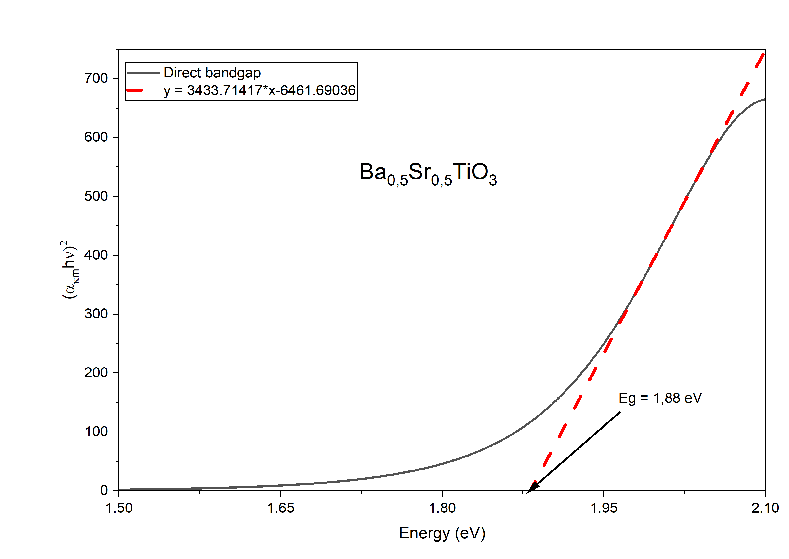

Fig. 1 Representative Tauc plot used to determine the direct optical band gap of Ba₀.₅Sr₀.₅TiO₃ using diffuse reflectance and the Kubelka–Munk function.

Table 2 Summary of direct optical band-gap values (eV) for Ba₀.₅Sr₀.₅TiO₃ thin films.
Mn concentration (wt.%) | Test 1 | Test 2 | Test 3 | Test 4
0.0 (undoped) | 1.88 | 2.28 | 2.87 | 2.97
0.5 | 3.16 | 3.27 | 3.02 | 3.13
1.0 | 2.50 | 2.50 | 2.13 | 2.04

Figures 1 through 3 and Table 2 show the optical band-gap values of undoped and Mn-doped Ba₀.₅Sr₀.₅TiO₃ (BST) thin films. These values were obtained from the Kubelka–Munk/Tauc analysis. The undoped BST film has E_g values ranging from 1.88 to 2.97 eV. The 0.5 wt.% Mn-doped film has E_g values from 3.02 to 3.27 eV. The 1.0 wt.% Mn-doped film has E_g values from 2.04 to 2.50 eV. The spread in the four tests is large for the sample. The spread is still noticeable for the 1.0 wt.% Mn sample. The four test positions did not have a thickness map. So thickness non-uniformity cannot be confirmed as the reason for the variation. Differences between points may come from thickness, surface shape, precursor coverage, reflectance or local defect density. Therefore the individual test values are in Table 2. The mean plus standard deviation in Table 2 is used to show the response at the composition level. The 0.5 wt.% Mn sample has the Eg range. This range is 3.02 to 3.27 eV. This shows that the optical behavior is more consistent, across the tests.
The rise in Eg at 0.5 wt.% Mn is linked to a drop in disorder, which shows up as a lower Eu as Table 2 tells us. These optical tests do not point straight to the defect layout on the atomic level so we see the widening of Eg as a sign that there are fewer localized band-tail states, not as a sure proof of a specific Mn spot. The Eg decreases and the Eu increases when the Mn level rises to 1.0 weight percent, which fits a distribution of localized states and higher absorption below the band gap. We would need additional chemical or structural tests, such XPS or EPR, to corroborate the picture and determine the oxidation state mix and the number of oxygen vacancies.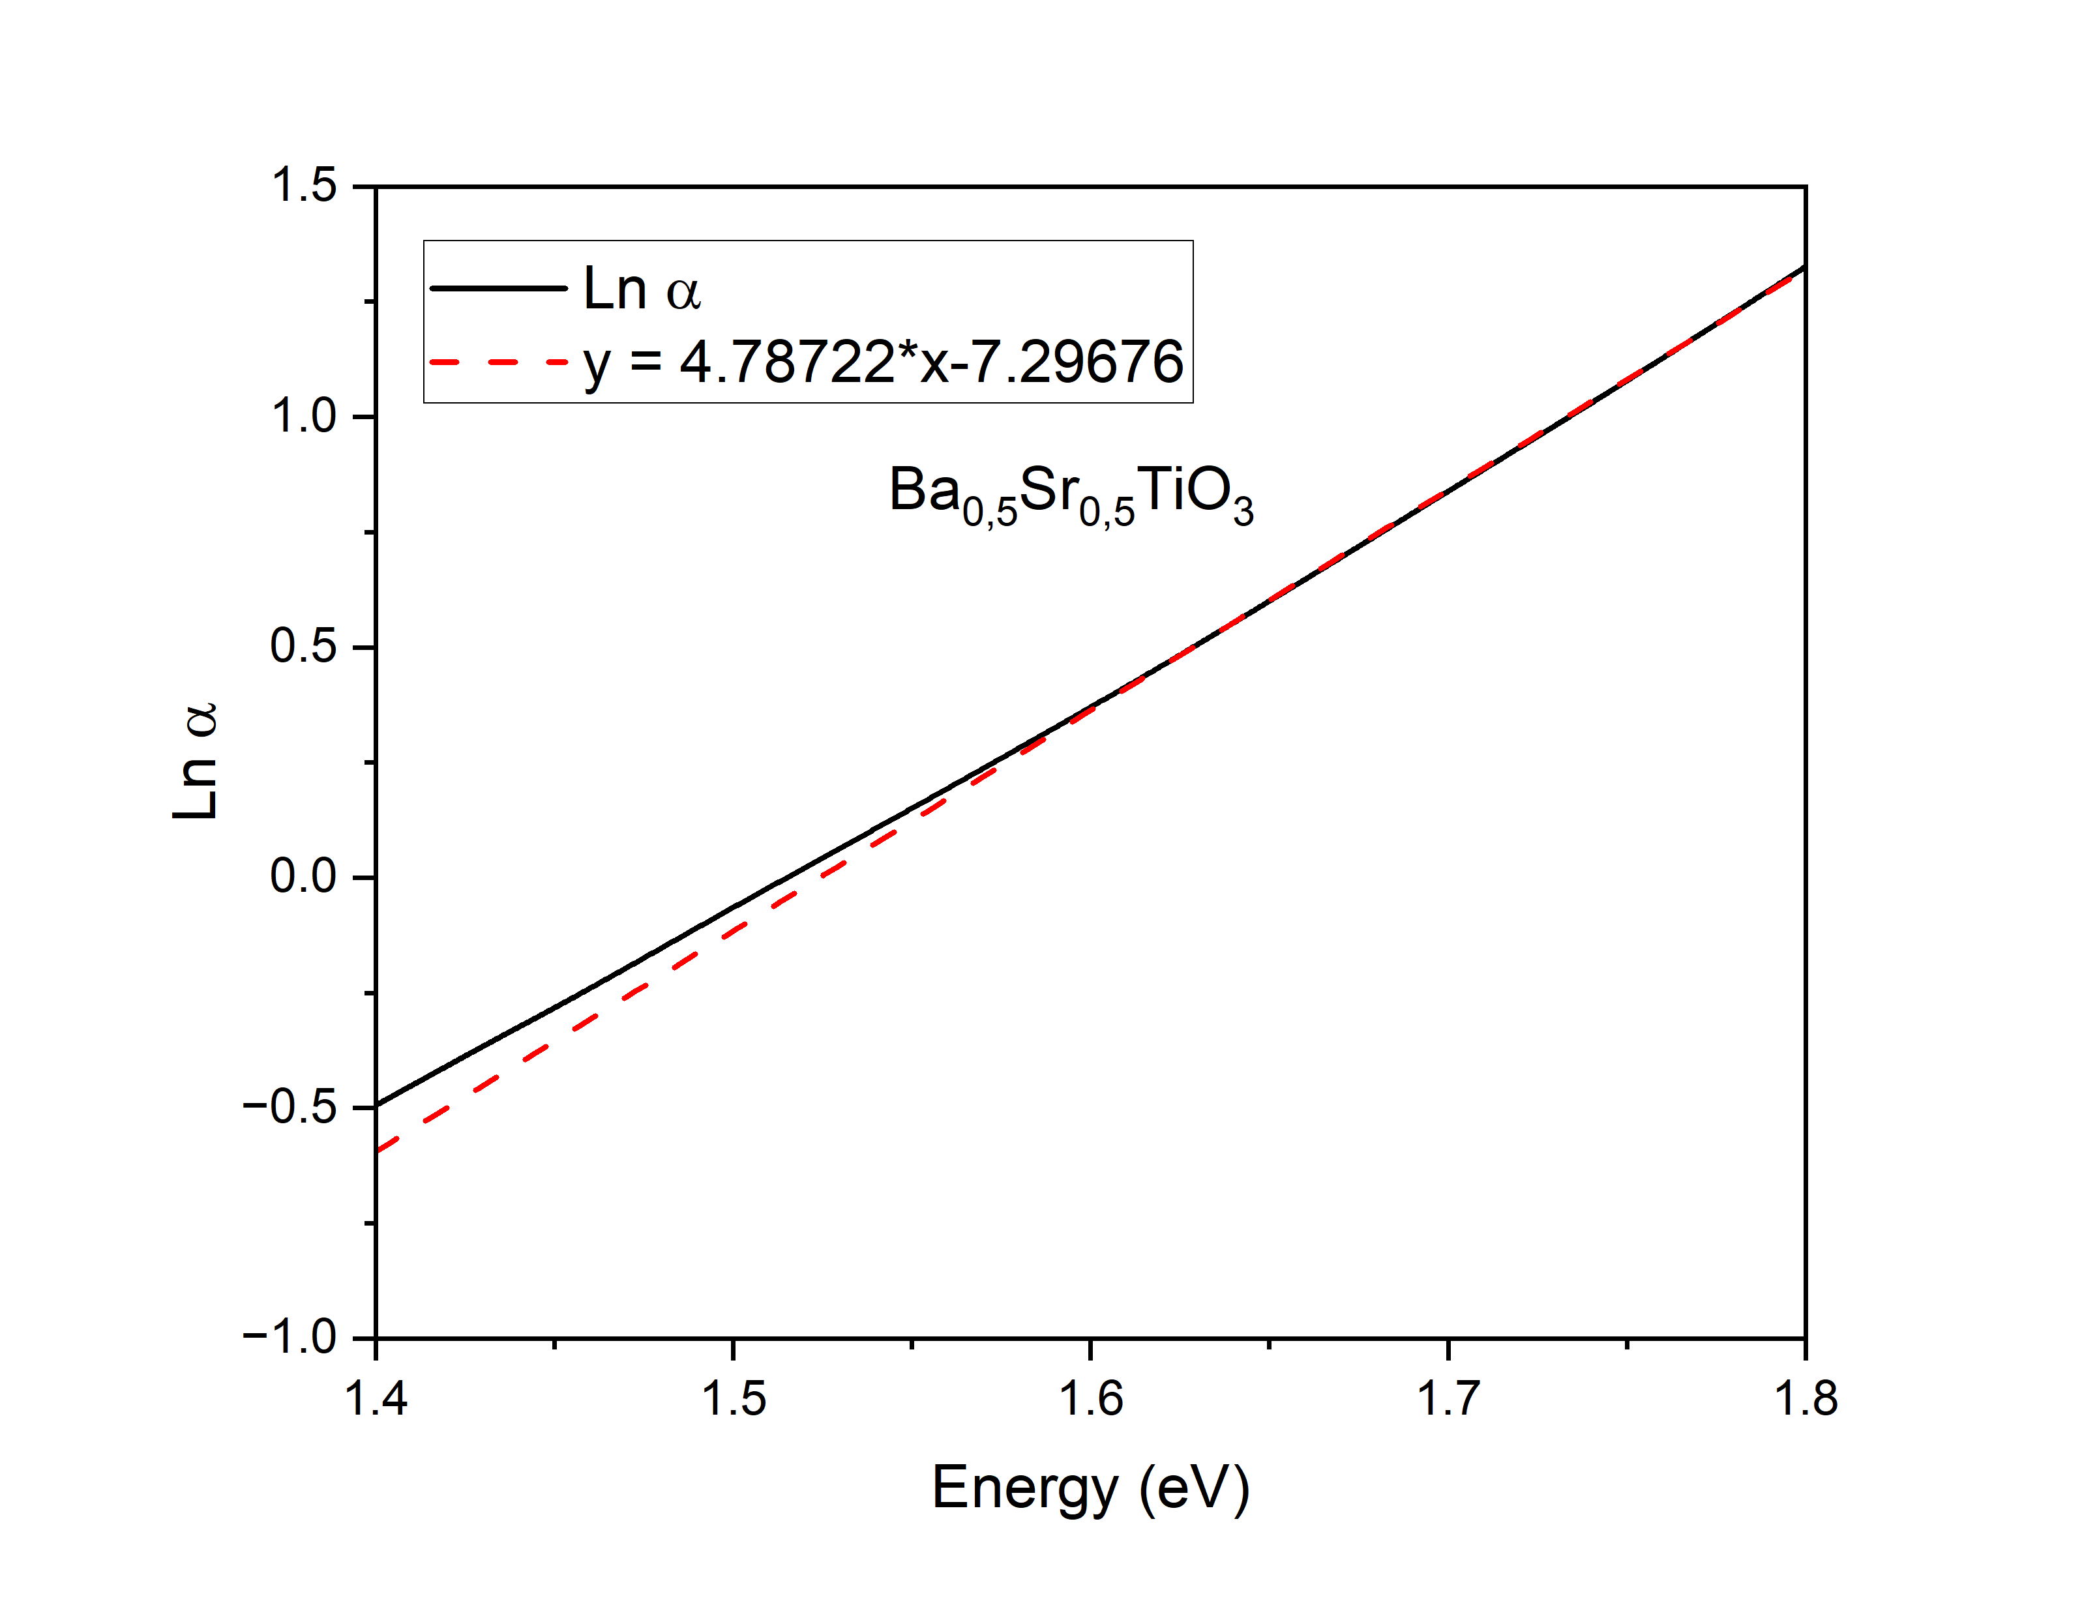
Fig. 2 Representative ln(α) versus photon-energy plot used to determine the Urbach energy of Ba₀.₅Sr₀.₅TiO₃ using the Kubelka–Munk-derived absorption coefficient.
Table 3 Summary of Urbach energy and absorption coefficient constant (α₀) values for Ba₀.₅Sr₀.₅TiO₃ thin films.

Dopant Concentration (Mn) | Slope | Coefficient | Urbach Gap (eV) | α₀ (a.u)
0 | 4.78722 | -7.29676 | 0.21 | 6.778 x 10⁻⁰⁴
0 | 7.53059 | -17.78329 | 0.13 | 1.892 x 10⁻⁰⁸
0 | 6.50667 | -19.59769 | 0.15 | 3.082 x 10⁻⁰⁹
0 | 7.92716 | -24.43491 | 0.13 | 2.444 x 10⁻¹¹
0.5 | 9.71376 | -30.59836 | 0.10 | 5.144 x 10⁻¹⁴
0.5 | 11.46138 | -34.89687 | 0.09 | 6.99 x 10⁻¹⁶
0.5 | 6.43492 | -22.99138 | 0.16 | 1.035 x 10⁻¹⁰
0.5 | 6.17611 | -20.764 | 0.16 | 9.601 x 10⁻¹⁰
1 | 5.58128 | -15.67167 | 0.18 | 1.563 x 10⁻⁰⁷
1 | 5.4152 | -15.46765 | 0.18 | 1.916 x 10⁻⁰⁷
1 | 3.14829 | -6.61548 | 0.32 | 1.339 x 10⁻⁰³
1 | 3.52945 | -6.378 | 0.28 | 1.699 x 10⁻⁰³

Figures 2 and Table 3 show the Urbach energy (E_u) values that we calculated from the part of the ln(α) versus photon-energy graphs. For the BST film the E_u values lie between 0.13 and 0.21 eV. For the film doped with 0.5 wt.% Mn the E_u values are lower between 0.09 and 0.16 eV. In contrast for the film doped with 1.0 wt.% Mn the E_u values are higher ranging from 0.18 to 0.32 eV. The α₀ values also change a lot between the samples. The average α₀ goes down from 1.6946 × 10⁻⁴ a.u. For the film to 2.6591 × 10⁻¹⁰ a.u. For the 0.5 wt.% Mn film and then goes up again to 7.5959 × 10⁻⁴ a.u. For the 1.0 wt.% Mn film. These averages form the numbers that appear in the Abstract, Discussion and Conclusion (1.69 × 10⁻⁴ 2.66 × 10⁻¹⁰ and 7.60 × 10⁻⁴ a.u. respectively). The wide spread among the tests shows that α₀ is especially sensitive to how we fit the local absorption edge so we should look at α₀ together, with E_u and E_g instead of using α₀ alone to prove a particular defect species.
The variation in Urbach energy observed in the samples reflects how energetic disorder changes with the amount of manganese added. At 0.5 wt.% Mn the Urbach energy is lower which matches an absorption edge and less energetic disorder. In contrast at 1.0 wt.% Mn the Urbach energy is higher indicating a broader band tail and more disorder. These optical findings suggest that the disorder depends on the concentration. However the current measurements do not directly measure oxygen vacancies. Identify the oxidation states of manganese. As a result any claims that tie the observed trends to factors like oxygen vacancies or to the proportions of Mn²⁺, Mn³⁺ or Mn⁴⁺ or to a specific defect-compensation process should be seen as hypotheses. These ideas need to be tested and confirmed using methods such, as XPS, EPR, XRD or other structural and chemical analysis techniques.

Table 4 Mean ± sample standard deviation of optical band gap (E_g) and Urbach energy (E_u) for Ba₀.₅Sr₀.₅TiO₃ films (n = 4).

Mn concentration (wt.%) | Optical band gap, Eg (eV) | Urbach energy, Eu (eV)
0 | 2.50 ± 0.51 | 0.16 ± 0.04
0.5 | 3.15 ± 0.10 | 0.13 ± 0.04
1 | 2.29 ± 0.25 | 0.24 ± 0.07

Table 4 shows the mean plus or minus the sample standard deviation of Eg and Eu for the four tests at each Mn concentration. The undoped BST film has an Eg of 2.50 plus or minus 0.51 eV and an average E_u of 0.16 plus or minus 0.04 eV. At 0.5 wt.% Mn Eg goes up to 3.15. Minus 0.10 eV while Eu goes down to 0.13 plus or minus 0.04 eV. At 1.0 wt.% Mn Eg drops to 2.29 plus or minus 0.25 eV while E_u rises to 0.24 plus or minus 0.07 eV. These changes show that the composition with the mean band gap also has the lowest mean Urbach energy. Since the four measurements at each composition have amounts of spread the mean plus or minus standard deviation is given to separate the composition-level trend from the variation, between individual points.
- Discussion
The thickness of Ba₀.₅Sr₀.₅TiO₃ (BST) films increased in a clear way as the Mn concentration went up as seen in Table 1. The BST film that had no doping had a thickness of 12.70 nm. This went up to 17.29 nm when there was 0.5 wt.% Mn. It kept increasing to 31.28 nm when the Mn was 1.0 wt.%. The steady rise in thickness shows that adding Mn changes how the material is built up during the chemical solution deposition process. Replacing Ti⁴⁺ with Mn ions is likely to change the way the chemical parts react when they break apart and join together. This can alter the number of tiny bits that begin to form and how they expand when heated. The chemical solution might become thicker and more stable with the addition of Mn. This results in films because more of the material remains on the surface after spinning. An instrument known as optical profilometry was used in this investigation to measure the thickness numbers. It is well known that this instrument can precisely measure the thickness of thin films [14,15]. Studies of perovskite oxide films produced using solution methods have already demonstrated the impact of adding Mn to the films and how it alters their growth and appearance [16].
The optical characteristics do not exhibit the pattern, despite the fact that the film thickness continues to increase as the concentration of Mn increases. The length of the optical path and the likelihood that incoming photons will strike the substance are often altered by film thickness. The Beer-Lambert law states that because photons travel farther, thicker layers exhibit optical absorption. However in oxide semiconductors the optical response is mainly set by the electronic band structure, not thickness. So while film thickness makes light absorption bigger film thickness does not automatically make the optical band gap wider. Instead the electronic structure depends a lot on crystallinity, lattice distortion, oxygen vacancies, impurity-induced electronic states and how many localized states sit near the band edges. Recent work on diffuse reflectance spectroscopy shows that the optical band gap mainly tells us about changes in electronic transition energy not about thickness as long as the model is used correctly [17,18]. Therefore the big increase in film thickness seen in the 1.0 Mn film comes with worse optical quality showing that defect chemistry matters far more, than geometrical thickness when deciding how BST thin films behave optically.
The optical band gap does not change in a line as Mn concentration changes. The undoped BST thin film had an optical band gap of 2.50 ± 0.51 eV. When 0.5 wt.% Mn was added the optical band gap rose to 3.15 ± 0.10 eV.. If the Mn concentration was raised to 1.0 wt.% the optical band gap fell to 2.29 ± 0.25 eV. I find the trend of the optical band gap interesting. The increase of the optical band gap at Mn levels indicates that adding a small amount of Mn helps to eliminate defect states close to the band edges. When Mn ions replace Ti sites they partly fix oxygen vacancies. Lower the number of localized electronic states inside the forbidden band. Consequently the absorption edge becomes sharper. Moves toward higher photon energies, which makes the optical band gap appear larger. I think the sharper absorption edge shows how Mn helps. Other studies of BST films have found similar optical improvements when the right dopant is added. Those studies show that dopant addition changes the structure and shifts the optical transition energy measured with UV–Vis spectroscopy. Theoretical calculations for Mn-containing BaTiO₃ also show that adding Mn changes the density of states, near the valence and conduction bands, which strongly alters the optical band structure [19]. I see that the same effect has been observed elsewhere. Other reports of transition-metal-doped titanates also describe a widening of the optical band gap when the dopant concentration is moderate because the lattice becomes more ordered and fewer structural defects remain.
At 1.0 wt.% Mn a different mechanism takes over. The high concentration of dopant brings in extra electronic defects. When a lot of Mn gets added it leads to valence states. Specifically Mn²⁺, Mn³⁺ and Mn⁴⁺. Along with oxygen vacancies. These vacancies are needed to balance the charge. Together these defects create energy levels within the forbidden gap. This allows transitions that happen below the band gap effectively making the measured optical band gap smaller. Even though the film at 1.0 wt.% Mn is the thickest it shows the band gap. That’s because absorption caused by these defects starts to dominate. Intrinsic band-to-band transitions become less important. This view matches up with studies. Those studies show that Mn-related states greatly change the density of states near the Fermi level. Consequently, in oxides, the effective energy required for transitions decreases [20]. Additionally, Landi et al. noted that in oxide materials, structural disorder and band-tail states resulting from impurities and compositional changes directly reduce the optical band gap. Doped perovskite oxides frequently exhibit this type of behavior. The distortion of the crystal lattice increases with the amount of transition metal supplied. The band gap narrows as a result of an increase in electronic disorder.
The addition of Mn causes the structure to become more disordered, as evidenced by the shift in Urbach energy. The width of the absorption tail below the optical band edge is measured using Urbach energy. It is frequently used to observe the degree of localized electronic states caused by structural flaws. The Urbach energy of the pure BST thin sheet was 0.16 ± 0.04 eV. At 0.5 weight percent Mn, this decreased to 0.13 ± 0.04 eV. Then, at 1.0 weight percent Mn, it increased significantly to 0.24 ± 0.07 eV. The decrease in Urbach energy at a level of Mn indicates a decrease in both the number of faults and the disorder. This implies that Mn aids in defect reduction. A lower Urbach energy indicates a sharper absorption edge and improved electronic order inside the crystal [21].
The study unequivocally demonstrates the negative relationship between Urbach energy and the optical band gap. The material with the lowest Urbach energy of 0.13 eV also has the optical band gap of 3.15 eV. On the other hand, the film with the largest Urbach energy of 0.24 eV had an optical band gap of 2.29 eV. This inverse correlation shows that the appearance of localized electronic states causes the Urbach tail to spread and the effective optical band gap to decrease as structural disorder grows. The exponential broadening of the absorption edge comes from lattice strain, compositional variations, oxygen vacancies, impurity-induced disorder and defect-induced band-tail states. Recent work shows that Urbach energy quantitatively measures the amount of disorder that creates localized exponential-tail states near the band edges making Urbach energy one of the most sensitive optical parameters for judging disorder in semiconductor materials [22]. Therefore the Urbach energy data in this work strongly suggest that the optical behavior of Mn-doped BST films is mainly controlled by defect density rather than by simple geometrical factors such, as film thickness.
The Urbach pre-exponential absorption coefficient (α₀) also changes in a way as the Mn concentration changes. The average α₀ drops a lot from about 1.69 × 10⁻⁴ in the film without any Mn to 2.66 × 10⁻¹⁰ when there is 0.5 wt.% Mn. Then it goes up quickly to 7.60 × 10⁻⁴ for the film with 1.0 wt.% Mn. Since α₀ is the absorption coefficient at the start of the exponential absorption part smaller α₀ means absorption from defects and a clearer optical absorption edge. On the hand the higher α₀ in the 1.0 wt.% film shows more absorption of light through defect states that come from too much Mn in the material. This same kind of behavior has been seen in BaTiO₃ films. There the optical properties got worse. New absorption bands appeared because of defect-related changes in the electronic structure [23]. Also defects linked to the amounts of cations and problems with oxygen are known to change the optical absorption edge and make more absorption below the band gap in perovskite oxides [23]. This matches the increase in Urbach energy and the drop, in the optical band gap. It shows that α₀ can be another way to check for disorder in Mn-doped BST thin films.
The results show a link between how thick the film is, its optical band gap, Urbach energy and the Urbach pre-exponential absorption coefficient. Even though adding more Mn makes the film thicker going from 12.70 nanometers to 31.28 nanometers the optical properties are mostly affected by how the structure of the film changes not by its thickness. The film with 0.5 weight percent of Mn has the optical properties. It has a thickness of 17.29 nanometers, the optical band gap of 3.15 electron volts, the lowest Urbach energy of 0.13 electron volts and the smallest α₀ of 2.66 times 10 to the minus 10. This suggests the number of localized electronic states and the most ordered structure. On the hand the film with 1.0 weight percent of Mn is the thickest but it has the lowest band gap of 2.29 electron volts, the highest Urbach energy of 0.24 electron volts and the largest α₀ of 7.60 times 10 to the minus 4. This shows that much Mn causes defects related to oxygen vacancies spreads out the band-tail states and increases optical absorption caused by defects. These findings match studies that say the bad optical quality in BaTiO₃-based thin films comes from defects, not from the thickness. Also recent research on disorder says that more disorder makes the Urbach tail wider. This leads to absorption, below the gap and a smaller apparent optical band gap. So the findings here show that the optical performance of Mn-doped BST films is mainly controlled by how the defects are handled. The best amount of Mn to use is 0.5 weight percent. This gives the optical quality, less energetic disorder and better electronic order.

- Conclusion
This study shows that adding Mn makes a difference in how the optical properties of Ba₀.₅Sr₀.₅TiO₃ (BST) thin films behave, when those films are made by the Chemical Solution Deposition (CSD) method. When Mn is added the thickness of the film goes up. The undoped BST film is 12.70 nm thick. With 0.5 wt.% Mn the film is 17.29 nm thick. With 1.0 wt.% Mn the film reaches 31.28 nm. These changes show that Mn changes how the film starts and grows during deposition.. Making the film thicker does not directly make the optical properties better. This confirms that the way BST thin films respond to light is mainly governed by changes, in the structure and the chemistry of defects. The shape and size of the film do not control the optical response.
The optical band gap showed a non-monotonic change when Mn was added. The average band gap grew from 2.50 ± 0.51 eV in the film that had no Mn to 3.15 ± 0.10 when 0.5 wt.% Mn was present proving that a moderate amount of Mn can reduce local defect states and make the crystal lattice more ordered. The band gap decreased to 2.29 ± 0.25 eV when the Mn content was increased to 1.0 weight percent. This indicates that a significant amount of Mn contributed additional impurity levels, mixed valence Mn species, and oxygen vacancy defects that assisted light in falling into the band gap. These findings demonstrate that while an excess of Mn degrades the quality by producing defect-induced band tail states, a modest amount of Mn benefits the electrical band structure.
The evolution of disorder in the BST thin films was further confirmed by the Urbach energy analysis. The average Urbach energy dropped from 0.16 ± 0.04 eV in the film to 0.13 ± 0.04 eV at 0.5 weight percent Mn, suggesting a sharper absorption edge, less energetic disorder, and a smaller density of localized electronic states. On the other hand, with the 1.0 Mn film, the Urbach energy dramatically increased to 0.24 ± 0.07 eV, indicating that excessive Mn incorporation causes lattice deformation and widens the exponential absorption tail. Increasing structural disorder immediately lowers the optical band gap by introducing defect-assisted electronic transitions, as shown by the inverse link between optical band gap and Urbach energy.
The Urbach pre-exponential absorption coefficient (α₀) provided information on the material's changes in flaws. At 0.5 weight percent Mn, the average α¹ decreased significantly from around 1.69 × 10⁻¹ in the film to 2.66 × 10⁻¹². This drop exhibits a sharper optical absorption edge and defect-assisted absorption. The manganese level rapidly increased to about 7.60 × 10⁻² when it reached 1.0 weight percent. This increase indicates increased sub-band-gap absorption and photon absorption via localized defect states. In Mn-doped BST thin films, α₀ can be utilized as a measure of optical disorder due to the close correlation between Eg, Eu, and α₀. Overall the optical behavior of Mn-doped BST films depends more on defect engineering than on film thickness. Out of all the samples studied the 0.5 wt.% Mn-doped BST thin film showed the mix of properties. It had a thickness of 17.29 nm, the highest optical band gap (3.15 ± 0.10 eV) the lowest Urbach energy (0.13 ± 0.04 eV) and the smallest α₀ value (approximately 2.66 × 10⁻¹⁰). These values point to a ordered structure and very low defect density. Because of these qualities the 0.5 wt.% Mn-doped BST thin film stands out as the promising choice, for future ferroelectric photonic devices, ultraviolet photodetectors, optoelectronic sensors, optical switching devices and other BST-based electronic applications where low energetic disorder and high optical quality are key.

- Acknowledgements

This research was financially supported by the Directorate of Downstreaming and Partnership, Directorate General of Research and Development, Ministry of Higher Education, Science, and Technology of the Republic of Indonesia through the Research Program for Fiscal Year 2026 under Contract No. 136/SPK/C.C4/PPK.DHK/IV/2026. The authors sincerely appreciate this support, which made this research possible. All AI-generated suggestions were reviewed, revised, and approved by the authors, who take full responsibility for the accuracy and integrity of the work.

- References
- Irzaman, R. Siskandar, R. P. Jenie, et al., "Ferroelectric sensor integrated with android smartphone for controlling and monitoring smart street lighting," Journal of King Saud University – Science, vol. 34, no. 102180, (2022).
- W. D. Mesquita, M. C. de Oliveira, M. Assis, et al., "Unraveling the relationship between bulk structure and exposed surfaces and its effect on the electronic structure and photoluminescent properties of ," Materials Research Bulletin, vol. 143, p. 111442, (2021).
- S. Mukherjee, D. Phuyal, C. U. Segre, et al., "Structure and Electronic Effects from Mn and Nb Co-doping for Low Band Gap Ferroelectrics," The Journal of Physical Chemistry C, vol. 125, pp. 14910-14923, (2021).
- S. Lahiry. "Optical Properties of Sol-Gel Deposited Barium Strontium Titanate Films," Trends in Sciences, vol. 20, no. 6, p. 5147, (2023).
- A. Ismangil, R. P. Jenie, Irmansyah, dan Irzaman. "Development of lithium tantallite for automatic switch on LAPAN-IPB Satellite infra-red sensor. " Procedia Environmental Sciences, vol. 24, pp. 329-334, (2015).
- A. Setiawan, I. Noor, Irmansyah, et al. "Effect of manganese (0%, 0.5% and 1%) doping on the optical and crystal properties of Barium Titanate synthesised by Chemical Solution Deposition (CSD) method. " BIO Web of Conferences, vol. 234, p. 02016, (2026).
- S. Landi Jr., I. R. Segundo, E. Freitas, et al. "Use and misuse of the Kubelka-Munk function to obtain the band gap energy from diffuse reflectance measurements," Solid State Communications, vol. 341, p. 114573, (2022).
- P. R. Jubu, K. M. Chahrour, A. Muhammad, et al. "Considerations About the Determination of Optical Bandgap from Diffuse Reflectance Spectroscopy Using the Tauc Plot. " Research Square (Preprint), (2023).
- N. Mozaffari, V. Vambol, Y. Hamzah, et al. "Influence of Thickness on the Structural, Morphological and Optical Properties of Co-doped Thin Films Prepared by Sol-Gel Method. " Biointerface Research in Applied Chemistry, vol. 12, no. 1, pp. 718-731, 2022.
- D. EL-Said Bakeer, A. H. Sakr, H. A. Motaweh, dan W. El-Sokary. "An Efficient Co-Precipitation Synthesis of Nanoparticles: Structural, Optical and Magnetic Properties,". Journal of Nanostructures, vol. 9, no. 3, pp. 414-428, (2019).
- Irzaman, R. Siskandar, R. P. Jenie, H. Syafutra, M. Iqbal, B. Yuliarto, M. Z. Fahmi, F. Ferdiansjah, and Khairurrijal, "Ferroelectric sensor BaₓSr₁₋ₓTiO₃ integrated with android smartphone for controlling and monitoring smart street lighting," Journal of King Saud University – Science, 34 102180. https://doi.org/10.1016/j.jksus.2022.102180 (2022)
- Irzaman, M. Dahrul, M. Rahmani, A. M. Rukyati, Samsidar, N. Nurhidayah, F. Deswardani, M. Peslinof, R. P. Jenie, J. Iskandar, Y. Wahyuni, K. Priandana, and R. Siskandar, "Design and fabrication of photovoltaics based on MFS (Ag/BaTiO₃/silicon p-type) structure," Materials Science for Energy Technologies, 7 (2024), 29–34. https://doi.org/10.1016/j.mset.2023.06.002. (2023).
- M. A. Santi, N. P. Har, R. P. Jenie, R. Siskandar, H. Syafutra, E. Pratama, T. P. Negara, A. A. Setiawan, H. Alatas, and Irzaman, "Effect of Cupric-Doped SrTiO₃ Films on Optical Properties Using Spectrophotometry Method," IOP Conference Series: Earth and Environmental Science, 1359 012015. https://doi.org/10.1088/1755-1315/1359/1/012015. (2024).
- Liao, H.-S., Cheng, S.-H., & Hwu, E.-T. Method for Film Thickness Mapping with an Astigmatic Optical Profilometer. Sensors, 22(8), 2865. https://doi.org/10.3390/s22082865. (2022)
- Greenall, H., Carey, B. J., Bulla, D., Gotardo, F., Harris, G. I., Bennett, J. S., Foster, S., & Bowen, W. P. Quantitative profilometric measurement of magnetostriction in thin-films. Applied Surface Science, 662, 160105. https://doi.org/10.1016/j.apsusc.2024.160105. (2024).
- J. W. Kim, C. M. Raghavan, J. Y. Choi, W. J. Kim, S. S. Kim*, T. K. Song. Effects of Mn-doping on the electrical and the ferroelectric properties of Bi₆Fe₂Ti₃O₁₈ thin films prepared by using chemical solution deposition. Pages 1344-1349, Number of pages 6, Volume 66, issue 9, Journal of the Korean Physical Society, Doi : 10.3938/jkps.66.1344. (2015).
- Landi, S., Jr., Segundo, I. R., Freitas, E., Vasilevskiy, M., Carneiro, J., & Tavares, C. J. Use and misuse of the Kubelka–Munk function to obtain the band gap energy from diffuse reflectance measurements. Solid State Communications, 341, 114573. (2022).
- Jubu, P. R., Chahrour, K. M., Muhammad, A., Landi, S., Obaseki, O. S., et al.. Considerations About the Determination of Optical Bandgap from Diffuse Reflectance Spectroscopy Using the Tauc Plot. Research Square. DOI: 10.21203/rs.3.rs-2654236/v1. (2023).
- Setiawan, A., Palupi, E. K., Umam, R., Alatas, H., and Irzaman. Optical characterization of Ba₀.₅Sr₀.₅TiO₃ material grown on a p-type silicon substrate (111) doped niobium oxide and chlorophyll. Ferroelectrics, 568, 62–70. (2020).
- Kang, Z., Wu, M., Li, J., Zhang, J., Tian, H., Wu, Y., & Wang, X. Theoretical study of (La, Mn) co-doping on the modification of photonic performance in BaTiO₃ materials. (Supplementary/Theoretical study).
- Biwas Subedi, Chongwen Li, Cong Chen, Dachang Liu, Maxwell M. Junda, Zhaoning Song, Yanfa Yan, Nikolas J. Podraza; Urbach Energy and Open-Circuit Voltage Deficit for Mixed Anion–Cation Perovskite Solar Cells. ACS Appl. Mater. Interfaces 16 February; 14 (6): 7796–7804. https://doi.org/10.1021/acsami.1c19122. (2022).
- Kaiser, C., Sandberg, O. J., Zarrabi, N., Li, W., Meredith, P., & Armin, A. A universal Urbach rule for disordered organic semiconductors. Nature Communications, 12, 3988. https://doi.org/10.1038/s41467-021-24202-9. (2021).
- Yalcin, B. F., Suceava, A., Kuznetsova, T., Wang, K., Gopalan, V., & Engel-Herbert, R. Stoichiometric Control and Optical Properties of BaTiO₃ Thin Films Grown by Hybrid M.

