Seven-Month Precursor Aging Induces Changes in the Bandgap and Urbach Energy of Ruthenium-Doped Ba₀.₇₅Sr₀.₂₅TiO₃ Thin Films
Tala’la Sapata¹, Annisa Palupi Trisasongko¹, Dea Widiawati², Naila Nur Alifa², Kinanthi Freda Bhanuwati², Ardian Arif Setiawan², Irmansyah², Setyanto Tri Wahyudi², Voon Chun Hong³, Rofiqul Umam⁴, Hirotaka Takahashi⁵, Irzaman²
¹ Biophysics Study Program, Department of Physics, Faculty of Mathematics and Natural Science, IPB University, 16680, Bogor, Indonesia
² Department of Physics, Faculty of Mathematics and Natural Science, IPB University, Bogor, 16680, Indonesia
³ Institute of Nano Electronic Engineering (INEE), Universiti Malaysia Perlis (UniMAP), 02600 Arau, Perlis, Malaysia
⁴ Institute of Life and Environmental Sciences, University of Tsukuba, Japan
⁵ Faculty of Design and Data Science, Tokyo City University, Japan
Abstract. Thin films of Ba₀.₇₅Sr₀.₂₅TiO₃ doped with di uthenium (0.0 mol% and 0.5 mol%) were deposited on p-type Si (100) substrates via the Chemical Solution Deposition (CSD) method along with spin coating. A 0,5 M precursor solution was systematically aged for seven months under controlled ambient conditions prior to deposition. The structural, morphological, and optical properties of the deposited films were characterized using profilometry, UV-Visible spectroscopy, and X-ray diffraction (XRD). Film thickness measurements revealed that Ru incorporation in the aged precursor decreased the average film thickness from 26.792 nm (undoped) to 24.400 nm (0.5 Ru). Optical analysis via Tauc plots demonstrated a substantial narrowing of the direct bandgap ($E_{g}$) from 3.09 cV for the undoped film to 1.48 eV for the 0.5 mol Ru-doped film. Concurrently, the Urbach energy ($E_{U}$) increased from 0.13 eV to 0.66 eV, confirming an increase in localized defect states and structural disorder near the band edges. XRD analysis indicated that both films retained a cubic perovskite crystal structure, with a subtle lattice parameter expansion from $α=3.830 Å$ to $3.832 Å$upon Ru doping. These findings demonstrate that prolonged precursor aging combined with Ru incorporation provides a viable pathway to engineer the optical bandgap and defect structure of BST thin films for photoresponsive and optoelectronic applications.
Keywords: Aging; Cubic; Ruthenium – doped Barium Strontium Titanate; Thickness; Urbach.

- Introductions
Barium strontium titanate (Ba₀.₇₅Sr₀.₂₅TiO₃, Ba₀.₇₅Sr₀.₂₅TiO₃ or BST) is a material that has been studied a lot. It is a perovskite oxide. It has properties that make it useful. BST has a high dielectric constant and low dielectric loss. It also lets light pass through it clearly. It is good, for making many devices. The material can be used in photodetectors, optical sensors, electro‑optical modulators, DRAM cells, microwave‑tunable components and non‑volatile memory devices [1,2].
The physical properties of BST films the crystallographic properties of BST thin films and the optoelectronic properties of BST thin films are controlled by many processing parameters. These parameters include the chemical composition of BST films, the dopant selection, for BST thin films the deposition technique used for BST thin films and the thermal annealing regimes applied to BST thin films. Transition metal doping, such as ruthenium (Ru) incorporation, has attracted substantial interest because Ru ions can substitute into the perovskite lattice (predominantly at the $Ti^{4+}$ B-site). This change affects the electronic band structure it adds states that are not spread out and it changes how many oxygen holes are present. Because of this adding Ru can adjust the bandgap it makes the material better, at absorbing visible light and it controls the disorder in the thin films [3].
In addition to incorporation the long-term aging of sol-gel precursor solutions before deposition is an important processing factor that has not been studied as thoroughly. Over time these solutions go through physicochemical changes. These include hydrolysis, polycondensation, loss of solvent through evaporation and changes, in viscosity. Minimal chemical changes affect nucleation, aggregation and spreading of liquid films during spin-coating, and finally, post-annealing crystallization [4,5].
While prior literature has largely focused on dopant concentrations or post-deposition annealing temperatures, the combined influence of multi-month precursor aging and Ru doping on the optoelectronic band structure and Urbach energy of BST films warrants detailed investigation [6]. Therefore, this study investigates the structural, crystallographic, and optical changes induced by a seven-month precursor aging process combined with Ru incorporation (0.0 mol\% and 0.5 mol%) in BST thin films fabricated via chemical solution deposition on p-type Si (100) substrates.
- Methods
  - Precursor Preparation and Aging Conditions
Ba₀.₇₅Sr₀.₂₅TiO₃ (BST) precursor solustions (0.5 M) containing 0.0 mol% and 0.5 mol% ruthenium (Ru) were formed by means of the Chemical Solution Deposition (CSD) method. Barium and strontium acetates as well as titanium isopropoxide, and ruthenium (III) chloride as the dopant source, in glacial acetic acid and ethylene glycol, were the raw materials for the study.
To establish controlled aging conditions, the precursor solutions were stored in a desiccator maintained at a controlled temperature of $30.3℃$ and a relative humidity of approximately 30% RH, under an ambient light exposure of 225 lux measured with a digital lux meter. The solutions were kept undisturbed for a period of seven months. During the storage period there was no large‑scale precipitation, gelation or phase separation. However a small rise, in viscosity was seen because of slow oligomerization. Before depositing the thin film the aged solutions were filtered through a 0.22 µm PTFE syringe filter to remove microaggregates.
  - Film Deposition and Heat Treatment
Prior to deposition, precursor solutions were aged for a period of seven months and further deposited on p-type Si (100) substrate via spin coating at 3000 rpm for thirty seconds. The films were heat treated at 550 °C for 8 hours to allow for crystal formation.
Film thickness was carried out through a profilometer at three different points and the average value was utilized for the purpose of further analysis. Optical characteristics of the films were determined through the instrument of UV-Visible spectroscopy in order to acquire the absorption coefficient, band gap energy and Urbach energy using Tauc plot technique and Urbach relation respectively.
  - Characterization Methods
- Film Thickness: Surface profilometry was performed across three distinct regions on each substrate to assess film thickness and uniformity.
- The films were then analyzed for their optical properties using the spectrum range of 200 to 900 nm.
- Crystal structure and phases of the films were analyzed using X-ray diffraction (XRD).
- Result and Discussion
  - Film Thickness Analysis
The thickness of the film is one of the main factors influencing the optical performance of thin films, as this parameter is responsible for the absorption coefficient of the film, its transmittance, optical bandgap, and Urbach energy. Thus, the precise measurement of the film thickness is important to the optical assessment utilizing UV–Visible spectroscopy [1,2]. For each sample, the film thickness was measured at three different locations to reduce the effect of uneven film due to spin coating. The average of the three values was considered as the film thickness for every Ru concentration shown in Table 1[9].
Table 1. Thickness measurements of seven-month aged Ru-doped Ba₀.₇₅Sr₀.₂₅TiO₃ thin films.
Sample | Ru Dopant (%) | Film Thickness (nm)
Ba_{0,75}Sr_{0,25}TiO₃ | 0.0 | 13.657
Ba_{0,75}Sr_{0,25}TiO₃ | 0.0 | 122.080
Ba_{0,75}Sr_{0,25}TiO₃ | 0.0 | 54.512
Ba_{0,75}Sr_{0,25}TiO₃ | Average | 26.792
Ba_{0,75}Sr_{0,25}TiO₃ | 0.5 | 14.501
Ba_{0,75}Sr_{0,25}TiO₃ | 0.5 | 30.238
Ba_{0,75}Sr_{0,25}TiO₃ | 0.5 | 28.461
Ba_{0,75}Sr_{0,25}TiO₃ | Average | 24.400
The undoped film exhibited an average thickness of 26.792 nm, whereas the 0.5 mol% Ru-doped film showed an average thickness of 24.400 nm, corresponding to an 8.9\% reduction in film thickness. [10].
Precursor Aging and Reaction Mechanism:
During seven months of storage, the metal alkoxides and metal-organic complexes undergo continuous, slow ambient hydrolysis and polycondensation:
- Hydrolysis:
$$M-OR+H_{2}O→M-OH+ROH$$
- Condensation:
$$M-OH+HO-M→M-O-M+H_{2}O$$
$$M-OH+RO-M→M-O-M+ROH$$
where M represents Ba, Sr, Ti, or Ru. Over an extended seven-month timeframe, these continuous condensation reactions expand the polymer network, converting small monomeric species into larger cross-linked M-O-M oligomeric clusters. This structural growth increases the dynamic viscosity of the liquid precursor. During spin coating at 3000 rpm, higher viscous drag alters the liquid radial flow rate and thinning dynamics. Furthermore, during thermal annealing at 550$℃,$pre-condensed polymeric cluster networks consolidate into a denser inorganic backbone, yielding thinner yet densely packed ceramic films. The slight decrease in thickness upon Ru addition (24.400 nm) indicates that $R_{u}$ ions act as catalytic centers or cross-linking nodes during aging, slightly accelerating condensation [4,5].
Film thickness measurements are accounted when performing optical characterization, because changes in film thickness may modify the interaction of light with the thin films and therefore affect the results of the optical bandgap and Urbach energy calculations. These results show that precursor aging, with Ru doping changes the structural characteristics of the films. The same precursor aging and Ru doping also help in a way to improve the optical properties of the films.
  - UV–Visible Spectroscopic Analysis and Optical Bandgap Determination
The optical characteristics of Ru doped Ba₀.₇₅Sr₀.₂₅TiO₃ (BST) thin films were studied by UV-Visible spectroscopy to determine the effects of 7-month old precursor material. Optical bandgap is one of the important characteristics for determining the minimum energy required to excite electrons from the valence region to the conduction region. This energy level directly affects how light is absorbed. The absorption of light governs properties, in materials especially in semiconductors and photovoltaic devices [11].
The optical bandgap $(E_{g})$ is the energy needed to move an electron from the valence band to the conduction band. This energy threshold is important, for understanding how materials absorb light. $E_{g}$ was calculated using the Tauc relation, which is used for allowed optical transitions:
$${\left(αhv\right)}^{2}=A\left(hv-E_{g}\right)$$ | (1)
where α is the absorption coefficient, $hv$ is photon energy, and $A$ is a material-dependent proportionality constant. Extrapolating the linear segment of ${\left(αhv\right)}^{2}$ versus $hv$ to the energy axis (${\left(αhv\right)}^{2}$ = 0) yields $E_{g}$[11,12].
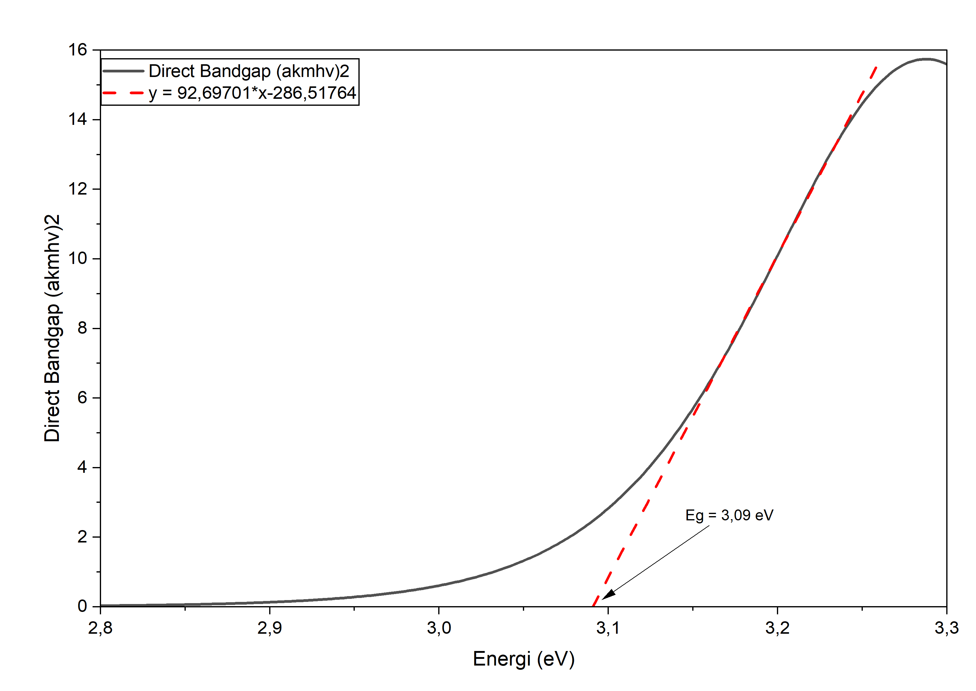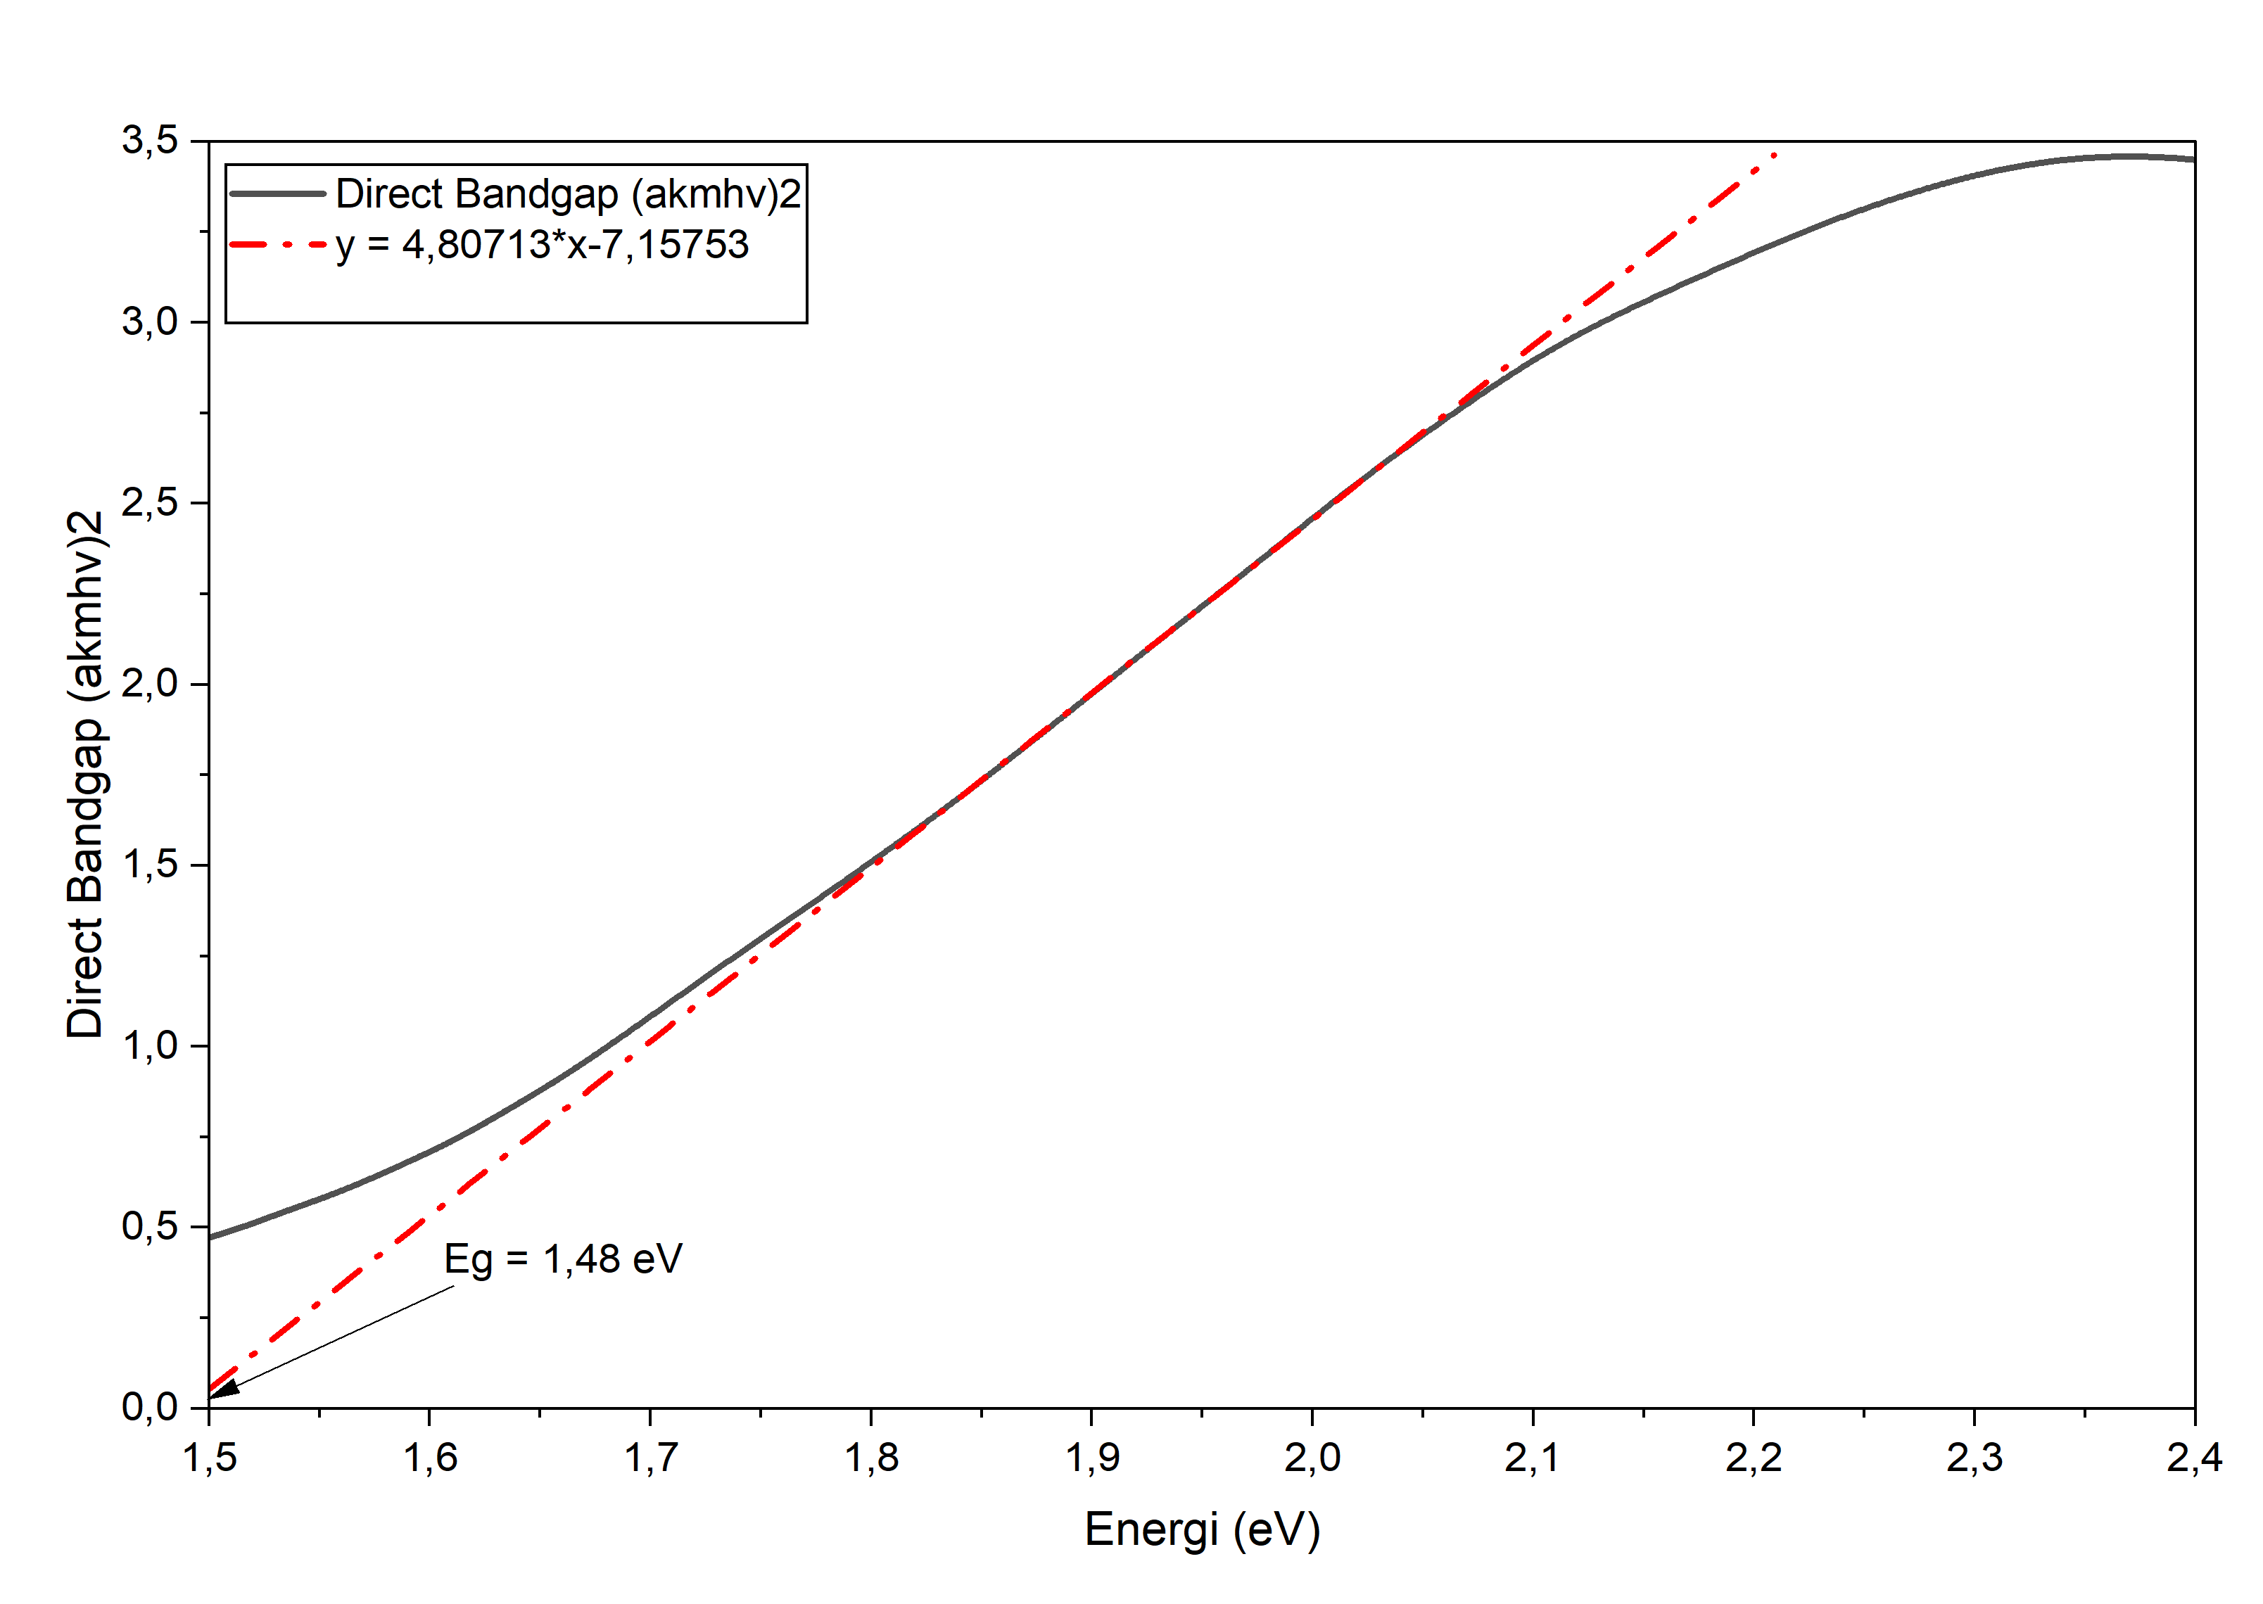
(a) Undoped BST (Aged 7 Months Eg=3.09 eV | (b) 0,5 mol% Ru-Doped BST (Aged 7 Months) Eg=1.48 eV
Fig. 1. Tauc plots of ${\left(αhv\right)}^{2}$ versus photon energy $(hv)$ for (a) undoped and (b) 0.5 mol% Ru-doped Ba₀.₇₅Sr₀.₂₅TiO₃ thin films after seven months of precursor aging.
The Tauc plots of ${\left(αhv\right)}^{2}$against photon energy for the undoped and Ru-doped Ba₀.₇₅Sr₀.₂₅TiO₃ thin films synthesized using 7-month-old precursor solutions are shown in Figure 1. The optical bandgap was obtained by extanding the linear regions of the plots into the photon-energy axis, where ${\left(αhv\right)}^{2}=0$. This is one of the common ways to obtain the direct optical bandgap of semiconductor and ferroelectric oxide thin films [11].
For the BST film, which does not contain any dopants (in Figure 1a), the linear region is seen to occur at a relatively higher photon energy value, quite far in the energy scale from the intersection with the x-axis, at around 3.09 eV. On the contrary, in the case of the Ru-doped BST film, as shown in Figure 1b, the linear region is observed to have moved much lower down the photon energy scale, obtaining the value of the intercept around 1.48 eV.
As can be inferred from the shift of the absorption edge to lower values, Ru doped film decreases the energy needed to excite electrons from the valence to conduction band. This behavior is ascribed to the emergence of defect states in the energy band gap that enable the excitations at lower energy levels [12,13]. Table 2 shows calculated optical band gap values while Figure 1 presents corresponding Tauc plots.
Table 2. Optical bandgap values of seven-month-aged Ru-doped Ba₀.₇₅Sr₀.₂₅TiO₃ thin films.
Sample | Dopant Concentration (mol%) | Direct BandGap (eV)
Ba_{0,75}Sr_{0,25}TiO₃ | 0 | 3,09
Ba_{0,75}Sr_{0,25}TiO₃ : Ru | 0,5 | 1,48
As shown in Table 2 and Figure 1, the undoped aged film exhibits an optical bandgap of 3.09 eV. Incorporation of 0.5mol% Ru causes a substantial shift of the absorption edge toward lower energies, reducing $E_{g}$ to 1.48 eV.
This bandgap narrowing is driven by two main factors:
- Dopant-Induced Defect States: According to Mott-Davis electronic models for disordered systems, substituting Ru (ionic radii $\sim$0.62 $Å$) into Ti B-sites $(\sim$0.605 $Å$) generates localized d-band defect states within the energy bandgap. Additionally, charge compensating oxygen vacancies (V𝑂̈) are also included in this work. These defects, located near the top of the valence band, create an energy band gap and reduce the energy needed for optical excitation (optical gap) with respect to the band gap created solely by free carrier absence (band gap obtained by charge transport) [12,13].
According to Brinker and Scherer [4], extended precursor aging modifies the optics of the deposit films. It has been documented that extended aging (7 months or more) promotes continuous condensation and hydrolysis, residual solvent evaporation, and modification of the viscosity of the precursor solution. Modifications in the rheology of the precursor solution result in variations during the spin-coating process. Variations in the rheology also influences the final structure of the deposit films. Modifications in the density and structure of the deposit films promotes the removal of defects (i.e. rearrangement and densification) when the deposit films are heated at high temperatures (i.e. annealed) [5]. Consequently, precursor aging acts as an indirect yet critical driver in tailoring the electronic band structure of the resulting BST thin films.
- Precursor Aging Contribution: Extended precursor aging promotes non-uniform local cation distribution and micro-strains during sol-gel network formation. When thermal processing is used with this structural disorder it increases the number of localized electronic states. This leads to an absorption of light, across the visible spectrum. The improved ability to absorb light helps photoresponsive sensors and optoelectronic devices perform better [14].
  - UV–Visible Spectroscopic Analysis and Urbach Energy
The Urbach energy ${(E}_{U})$can be defined as a significant optoelectronic parameter that assists analysts in determining the level of structural disorder and finds out the existence of localized electronic states in the forbidden energy gap. In the case of ferroelectric thin films, the Urbach energy has an increase pertaining to higher density of crystal defects, structural disturbances due to the presence of oxygen vacancy effects, and local potential fluctuations [15,13].
The Urbach energy $(E_{U})$ quantifies the extent of structural disorder, dynamic/static lattice distortion, and localized state density in the forbidden band gap. It is determined using the empirical Urbach relationship:
$$α=α_{0} exp \frac{hv}{E_{U}}$$ | (2)
Taking the natural logarithm yields,
$$In \left(α\right)=In \left(α_{0}\right)+\frac{hv}{E_{U}}$$ | (3)
Where $E_{U}$ is the reciprocal of the linear slope drived from the plot of In $α$ versus photon energy $\left(hv\right)$ in the low-energy absorption tail region [15,16].
The calculated Urbach energy values are summarized in Table 3, while the corresponding $In \left(α\right)$ versus photon energy plots are presented in Figure 2.
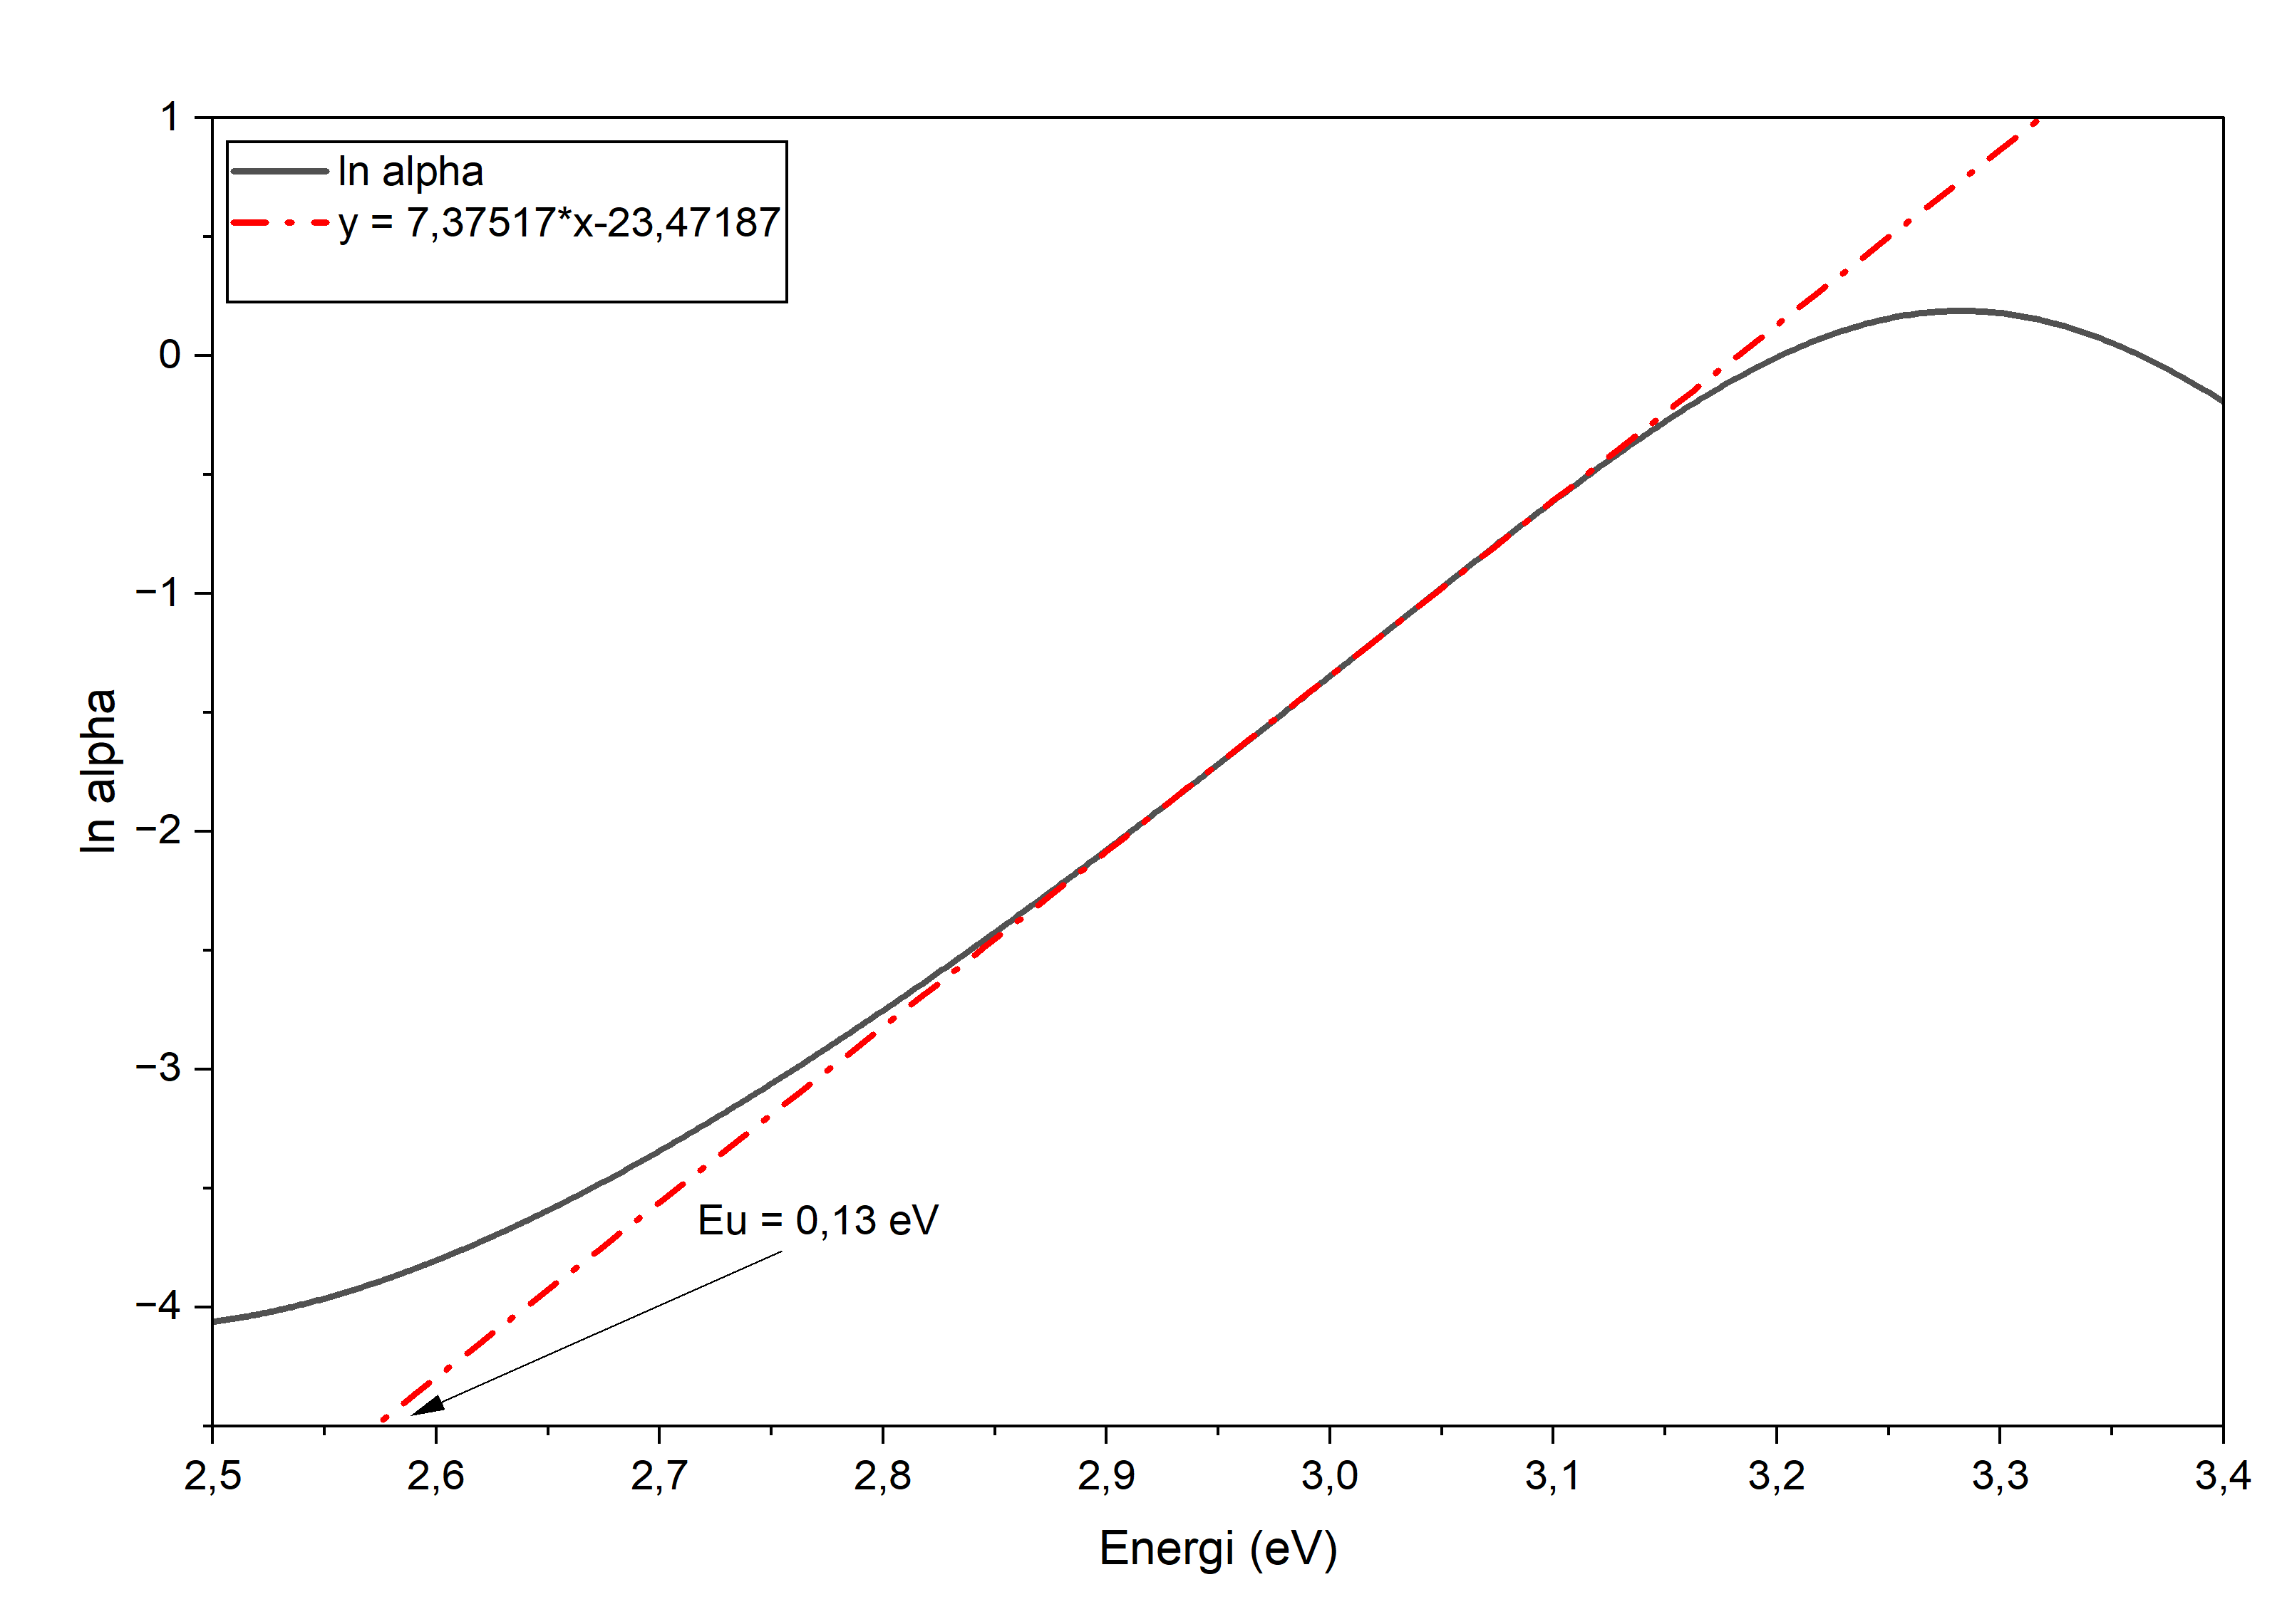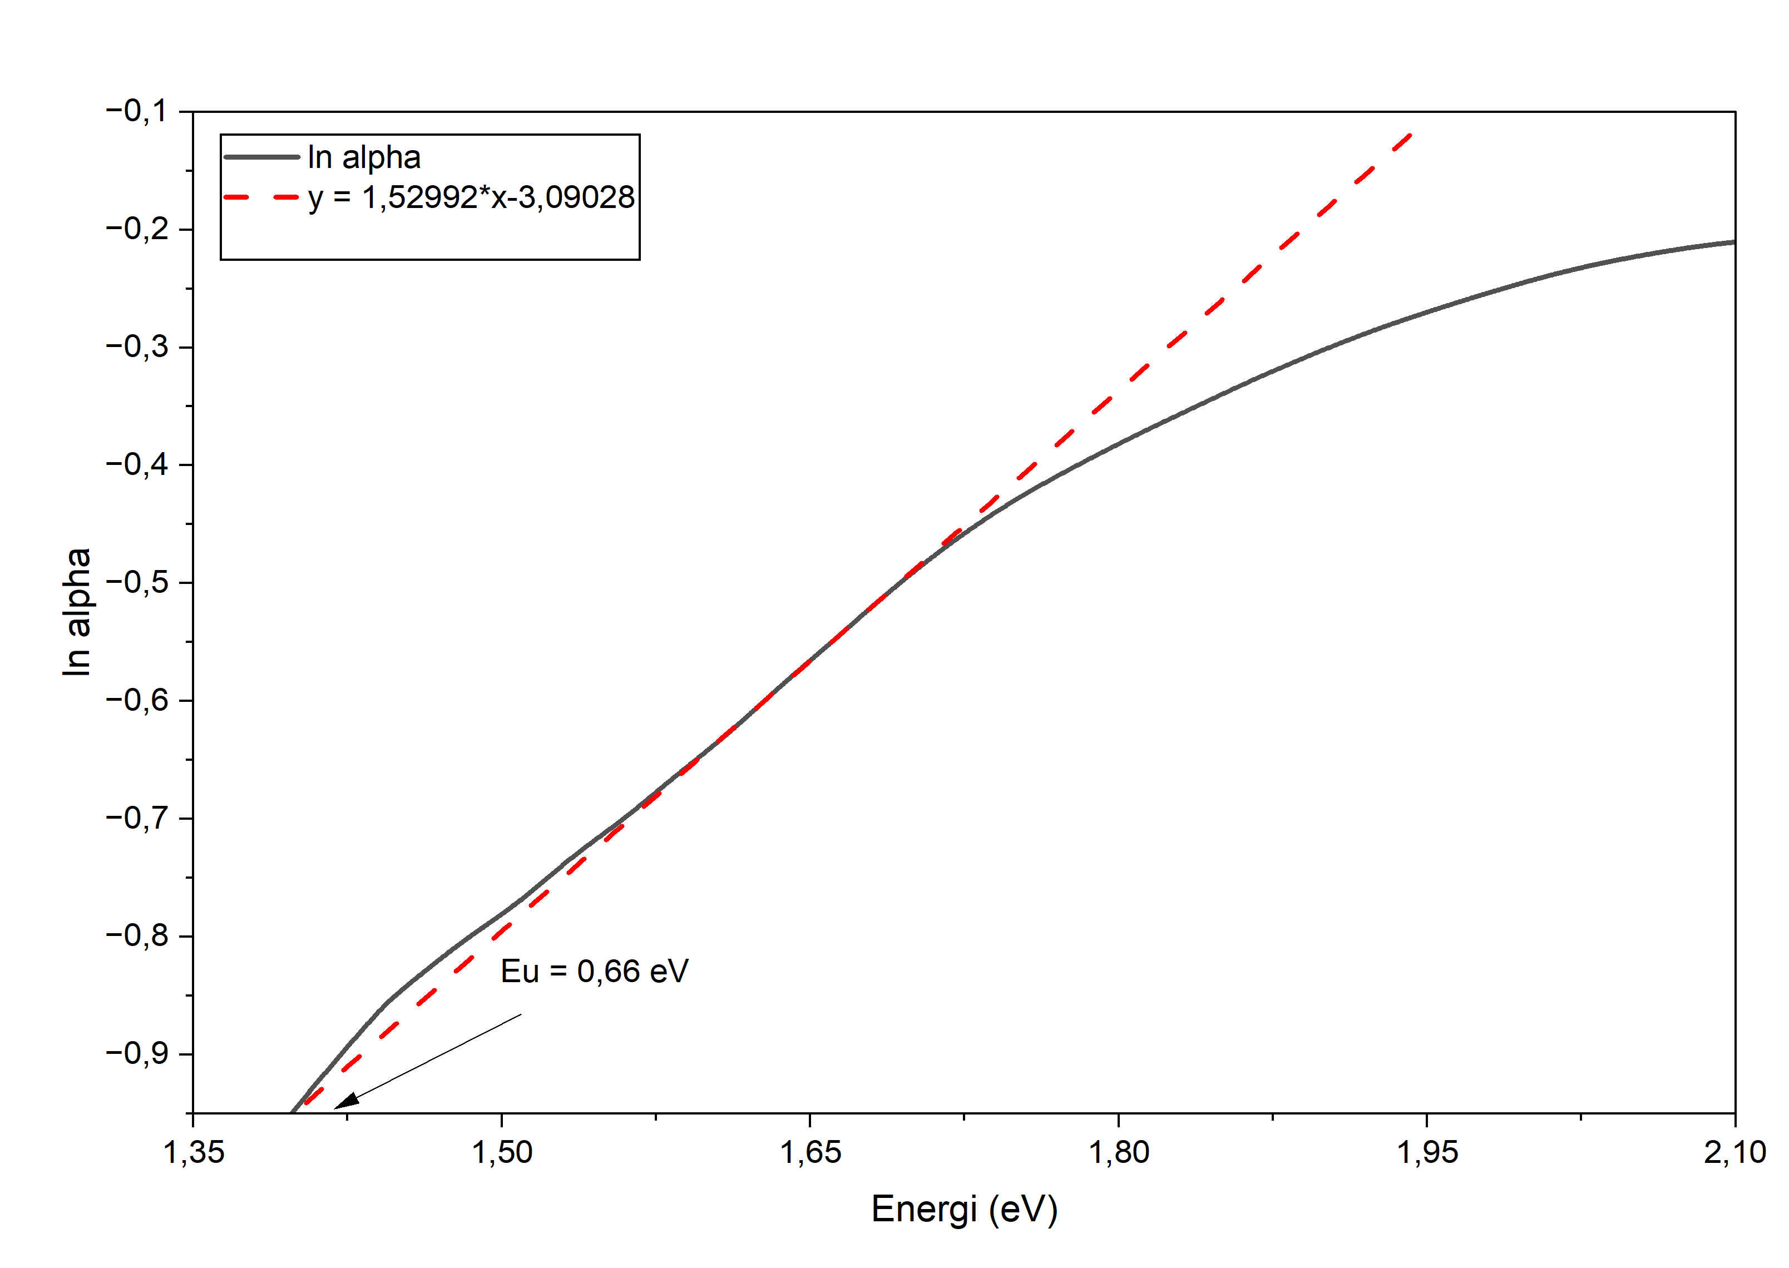
(a) Undoped BST (Eu = 0.13 eV) | (b) 0.5 mol% Ru-Doped BST 0.66 eV

Fig. 2. $In\left(α\right)$ versus photon energy $(hv)$ plots used to derive the Urbach energy ${(E}_{U})$for (a) undoped and (b) 0.5 mol% Ru-doped Ba₀.₇₅Sr₀.₂₅TiO₃ thin films after seven months of precursor aging.
Table 3. Urbach energy values of seven-month-aged Ru-doped Ba₀.₇₅Sr₀.₂₅TiO₃ thin films.
Sample | Dopant-Concentration (mol%) | Urbach Energy (eV)
Ba_{0,75}Sr_{0,25}TiO₃ | 0 | 0,13
Ba_{0,75}Sr_{0,25}TiO₃ : Ru | 0,5 | 0,66

The calculated $E_{U}$ values are summarized in Table 3. The undoped film displays a low Urbach energy of 0.13eV, corresponding to a sharp absorption edge and minimal structural disorder. Upon introducing 0.5 mol% Ru into the seven-month-aged precursor, $E_{U}$ increases significantly to 0.66 eV.
The increase in Urbach energy confirms an increased density of localized state tails extending into the forbidden gap. During seven months of precursor aging, continuous oligomerization generates structural non-uniformities that alter grain boundary evolution and crystallite orientation during annealing. Ru substitution at the B-site, coupled with oxygen vacancy creation, introduces local strain and electric field fluctuations that distort the $TiO_{6}$ octahedra. The inverse relationship between $E_{g}$ (3.09 eV $→$1.48 eV) and $E_{U}$ (0.13 eV $→$ 0.66 eV) aligns with the Mott-Davis model, confirming that increased structural disorder directly induces optical bandgap narrowing.
From a physical perspective, the primary cause of the increase in Urbach energy is the formation of various types of crystal defects in the material. These defects are specifically divided into three categories: the first is oxygen vacancies, which means the positions originally occupied by oxygen atoms in the crystal are left empty; the second is lattice distortion, which refers to the twisting and deformation of the regular atomic framework that forms the crystal; the third is localized electronic states, which are small-range electronic states that only emerge after ruthenium ions replace the original ions at the lattice sites of the BST perovskite. The introduction of these defects broadens the distribution of electronic states near the edge of the band gap. Optical transitions, in the presence of these defects, no longer involve the direct hopping of an electron across the band gap of the material. Instead, optical transitions occur by hopping of an electron from a filled state to an unoccupied state through a defect state. The optical transition may also occur in the reverse direction. Because of the presence of these defects, the optical transitions become better understood by considering hopping of electrons through localized states as opposed to band-to-band transitions [15,12,13].
The aging of the precursor solution used in the experiment also affects the final film-forming process. Following the aging process for a period of seven months changes the final thickness and the microstructure of the deposited film. The reason why the precursor stored for seven months produces this effect is that during the storage period, changes never stop inside the precursor solution: two chemical reactions, hydrolysis and condensation, keep occurring; the solvent in the solution slowly volatilizes; and the viscosity of the entire solution, that is, its consistency, also keeps changing accordingly. These internal changes are ultimately transmitted to the deposited thin film, altering its microstructure. These physicochemical changes may modify the nucleation and grain-growth processes during deposition and promote structural rearrangement and densification during annealing, thereby increasing the degree of structural disorder and broadening the Urbach tail [4,5].
Reduction in the optical bandgap and increase in Urbach energy. Band structure of BST thin films is related to structural disorder. Localized states in BST are attributed to structural defects. The band edge states can be expressed by Urbach energy. This results in a lowered excitation energy needed for electron transitions and the Optical Bandgap is decreased accordingly. This was in line with the Mott–Davis model that gives an explanation for the electronic transitions in amorphous and disordered semiconductors [13].
Overall, the results show that the aging of precursor for seven months and incorporation of Ru facilitate not only the enhanced disorder in Ba₀.₇₅Sr₀.₂₅TiO₃ thin films but also provide important contribution to changes in their optical properties, primarily the Urbach energy and Optical Bandgap reduction.
  - X-Ray Diffraction (XRD) Analysis and Lattice Parameter Determination
Crystallographic analysis was conducted via XRD to evaluate structural modifications induced by Ru doping and seven-month precursor aging. Interplanar d-spacing ($d$) and unit-cell lattice parameters ($a$) for the cubic structure were calculated using Bragg’s Law and the cubic plane equation:
$$nλ=2dsinθ$$ | (4)
where λ is the Cu Kα wavelength (1.5406 Å), while the lattice parameter was subsequently calculated using
$$a=d\sqrt{h^{2}+k^{2}+l^{2}}​$$ | (5)
where $h, k, and l$ are the Miller indices corresponding to the diffraction plane [17].
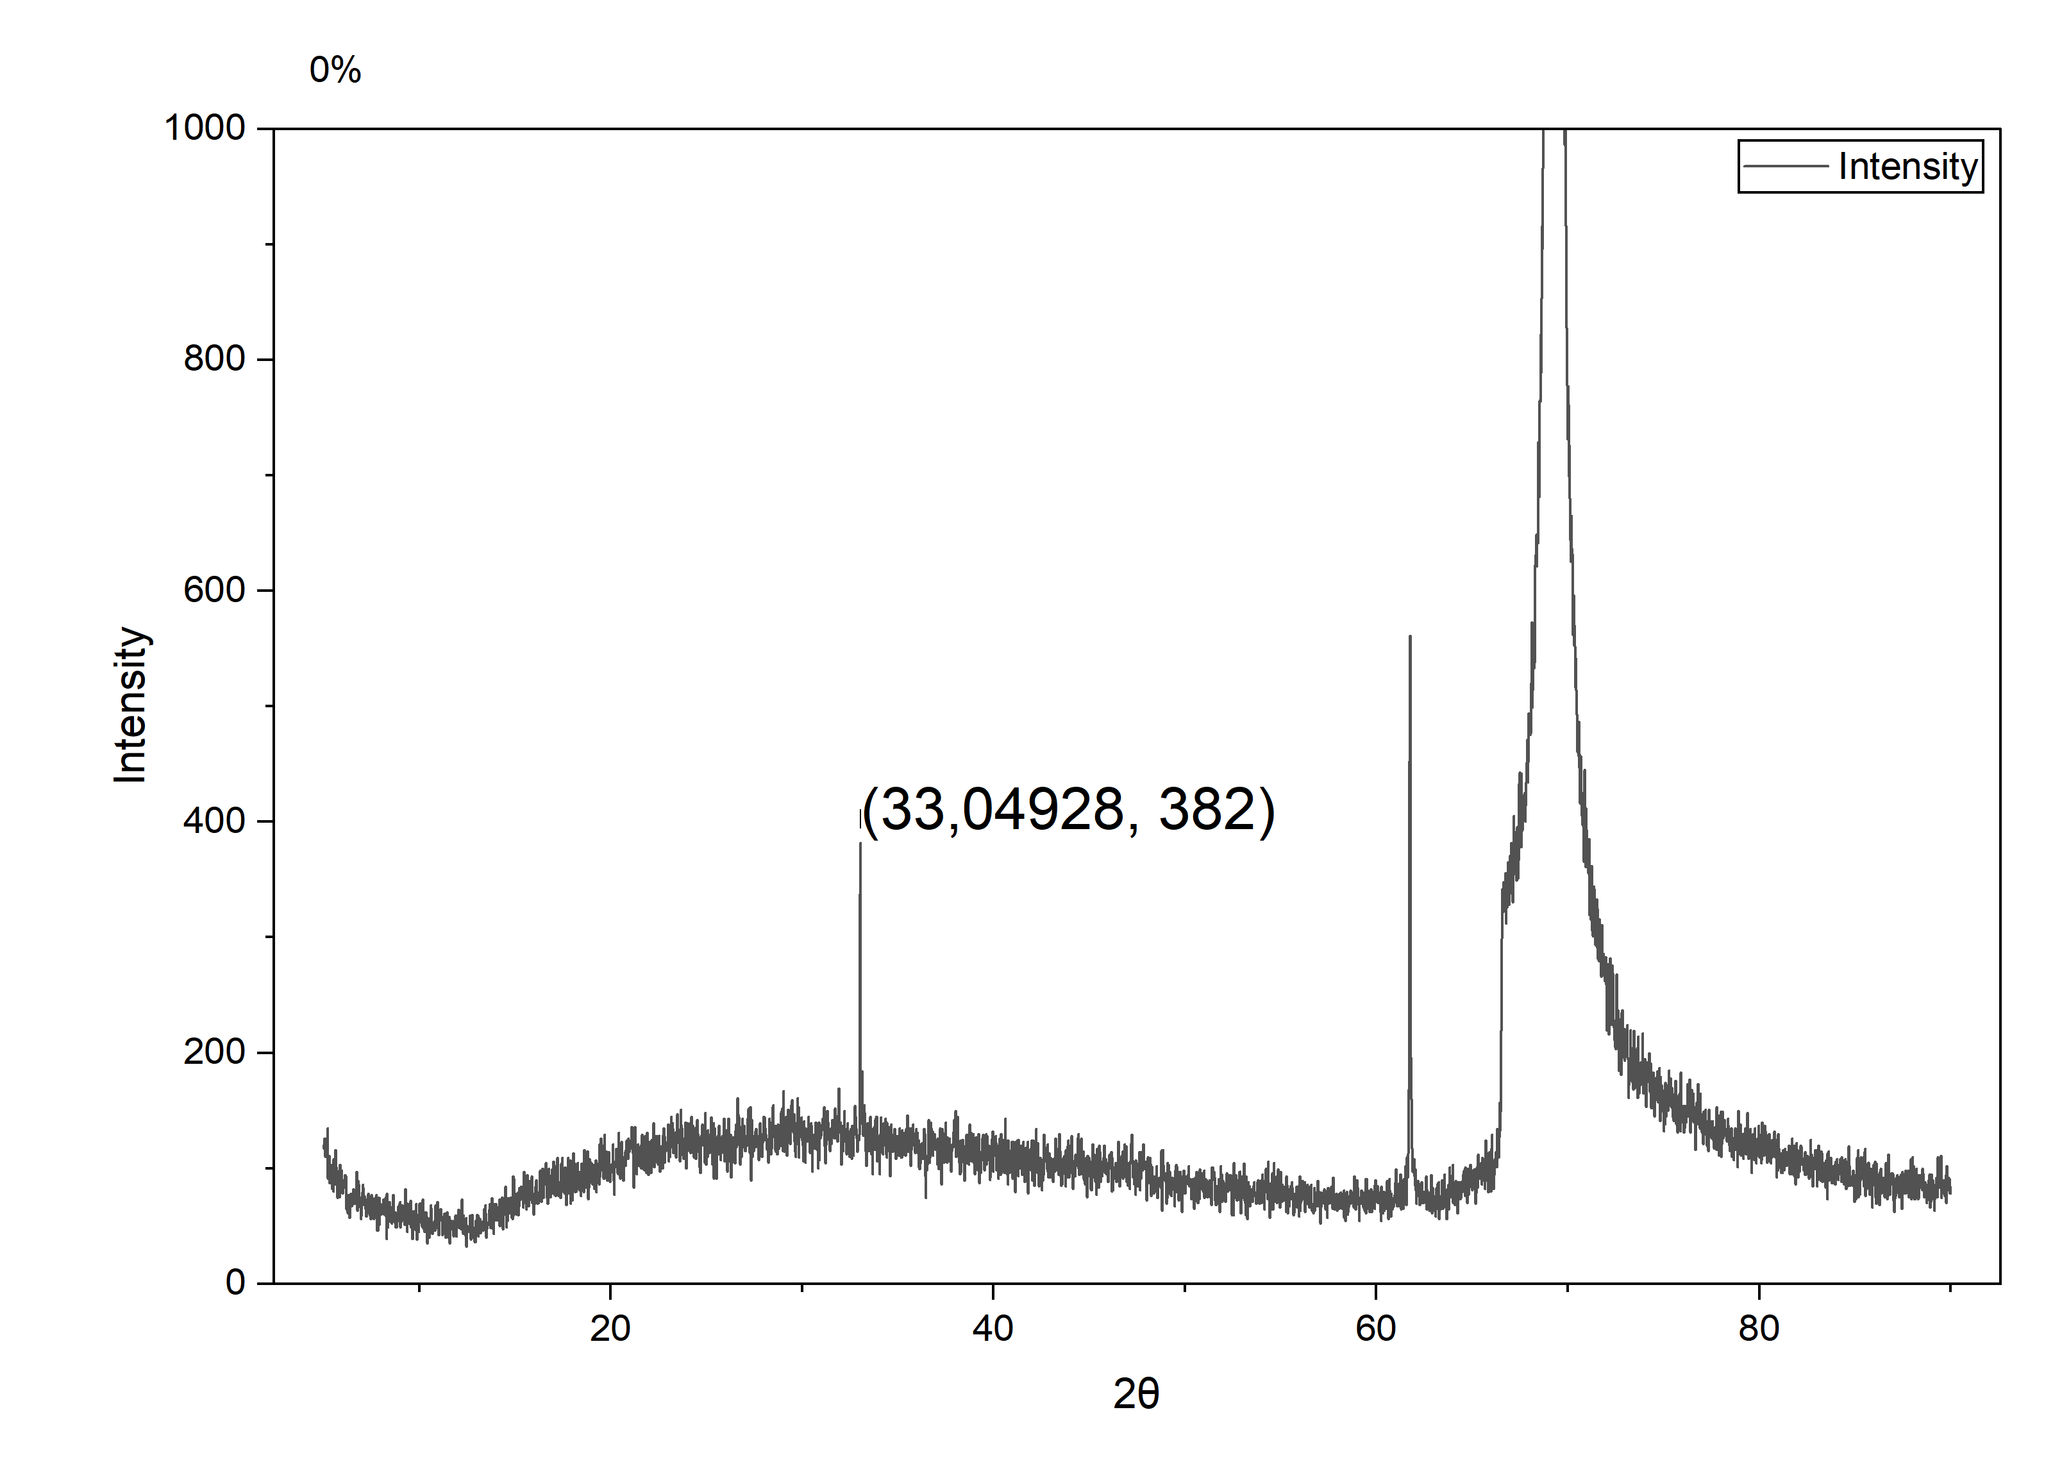
(a) Undoped BST (2$θ$ = 33.049$°$) | (b) 0.5 mol% Ru BST ($θ$= 33.027$°$)
Fig. 3. High-resolution XRD spectrum centered at the (200) diffraction peak for (a) undoped and (b) 0.5 mol% Ru-doped BST thin films prepared from seven-months-aged precursor.
Table 4. XRD diffraction angle, d-spacing, and cubic parameter of seven-month-aged Ru-doped Ba₀.₇₅Sr₀.₂₅TiO₃ thin films.
Sample | Ru concentration (mol%) | 2θ (°) | d-spacing (Å) | Lattice parameter (Å)
Ba₀.₇₅Sr₀.₂₅TiO₃ | 0.0 | 33.049 | 2.708 | 3.830
Ba₀.₇₅Sr₀.₂₅TiO₃ : Ru | 0.5 | 33.027 | 2.710 | 3.832

Both samples exhibit a primary peak corresponding to the (200) crystallographic plane of the cubic perovskite phase. As detailed in Table 4, introducing 0.5 mol% Ru causes a minor shift in the (200) peak toward lower 2θ angles, moving from 33.049∘ to 33.027∘.
According to Bragg's Law, this shift to a lower diffraction angle reflects an increase in interplanar d-spacing from 2.708 $Å$ to 2.710$Å$, resulting in a slight expansion of the lattice parameter from $a$ = 3.830$Å$ to 3.832$Å$. This lattice expansion ($∼$ 0.05%) is attributed to the substitution of $Ti^{4+}$ ions (0.605$Å$) by slightly larger Ru ions (0.62$Å$) within the B-site sub-lattice, as well as electrostatic repulsion near oxygen vacancies [18,1]. Furthermore, long-term precursor aging alters cation distribution uniformity prior to crystallization, contributing to slight lattice relaxation. While the calculated lattice constants (3.830 - 3.832 $Å$) remain smaller than the bulk BST value ($∼$3.974$Å$) due to thermal expansion mismatches and compressive substrate stress from the underlying silicon, the observed lattice expansion correlates with the increased Urbach energy and bandgap narrowing. [17,19].
The structural evolution revealed by the XRD analysis is consistent with the optical characterization. When ruthenium is doped into the material, a subtle lattice expansion occurs. This change coincides with two other observed outcomes: one is the narrowing of the optical band gap that originally existed in the material, and the other is the increase in Urbach energy. These concurrent changes converge to point to the same core conclusion: not only has crystal structure distortion occurred inside the material, but unintended defects have also formed. These issues give rise to localized electronic states confined only to local regions of the material near the band edges. With these localized electronic states, electrons in the material require only a lower energy to complete transitions, and the optical response of the original BST thin film is consequently altered. All current experimental results confirm that the two operations—storing the precursor for seven months and doping it with ruthenium—will not only change the crystallographic characteristics of the Ba₀.₇₅Sr₀.₂₅TiO₃ thin film, but also alter its electronic and optical properties.
- Conclusion
Thin films of Ba₀.₇₅Sr₀.₂₅TiO₃ (BST) doped with ruthenium (0.0 mol% and 0.5 mol%) were synthesized on p-type Si (100) substrates using chemical solution deposition with a seven-month-aged precursor solution. Analysis of the films showed that averaged precursor films thickness was 26.792 ± 0.341 nm. After aging and Ru doping the average thickness became 24.400 ± 0.464 nm. Optical absorption spectra of BST films have direct bandgap energies (Eg) of 3.09 eV and 1.48 eV, respectively. The Urbach energy (Δ) increased from 0.13 eV to 0.66 eV, after aging and Ru doping. X-ray diffraction (XRD) pattern of the BST films shows that the (cubic) perovskite structure films has a lattice parameter (a) of 3.830 Å, which increased slightly to 3.832 Å, after aging and Ru doping. It is established that Ru doping together with prolonged aging has a positive effect on the tail state of defects, and absorption of visible light, in BST thin films.
Acknowledgment
This research was funded by Direktorat Hilirisasi dan Kemitraan, Direktorat Jenderal Riset dan Pengembangan Kementerian Pendidikan Tinggi, Sains, dan Teknologi under contract No. 134/SPK/C.C4/PPK.DHK/IV/2026.
References
1. Lines, M.E., Glass, A.M.: Principles and Applications of Ferroelectrics and Related Materials. Oxford University Press. (1977).
2. Scott, J.F.: Ferroelectric Memories. Springer, Berlin Heidelberg (2007).
3. Kurniawan, A., Irzaman, Yuliarto, B., Fahmi, M.Z., Ferdiansjah: Application of barium strontium titanate (BST) as a light sensor on led lights. Ferroelectrics. 554, 160–171 (2020).
4. Brinker, C.J., Scherer, G.W.: Sol–Gel Science: The Physics and Chemistry of Sol–Gel Processing. Academic Press. (1990).
5. Hench, L.L., West, J.K.: The Sol-Gel Process. Chemical Reviews. (1990).
6. Schlom, D.G., Chen, L.-Q., Eom, C.-B., Rabe, K.M., Streiffer, S.K., Triscone, J.-M.: Strain Tuning of Ferroelectric Thin Films. Annu. Rev. Mater. Res. 37, 589–626 (2007).
7. Swanepoel, R.: Determination of the thickness and optical constants of amorphous silicon. J. Phys. E: Sci. Instrum. 16, 1214–1222 (1983).
8. Poelman, D., Smet, P.F.: Methods for the determination of the optical constants of thin films from single transmission measurements: a critical review. J. Phys. D: Appl. Phys. 36, 1850–1857 (2003).
9. Norrman, K., Ghanbari-Siahkali, A., Larsen, N.B.: Studies of spin-coated polymer films. Annual Reports Section “C” (Physical Chemistry). 101, 174–201 (2005).
10. Irzaman, I., Syafutra, H., Darmasetiawan, H., Hardhienata, H., Erviansyah, R., Huriawati, F., Akhiruddin, A., Hikam, M., Arifin, P.: Electrical Properties of Photodiode Ba_{0.25}Sr_{0.75}TiO₃ (BST) Thin Film Doped with Ferric Oxide on p-type Si (100) Substrate using Chemical Solution Deposition Method. Atom Indo. 37, 133 (2011).
11. Tauc, J., Grigorovici, R., Vancu, A.: Optical Properties and Electronic Structure of Amorphous Germanium. Physica Status Solidi. 15, 627–637 (1966).
12. Davis, E.A., Mott, N.F.: Conduction in non-crystalline systems V. Conductivity, optical absorption and photoconductivity in amorphous semiconductors. Philosophical Magazine. 22(179), 903–922 (1970).
13. Mott, N.F., Davis, E.A.: Electronic Processes in Non-Crystalline Materials. Oxford University Press. (1979).
14. Irzaman, Siskandar, R., Jenie, R.P., Syafutra, H., Iqbal, M., Yuliarto, B.: Ferroelectric Sensor BaₓSr₁₋ₓTiO₃ Integrated with Android Smartphone for Controlling and Monitoring Smart Street Lighting. IEEE Access. (2022).
15. Urbach, F.: The Long-Wavelength Edge of Photographic Sensitivity and of the Electronic Absorption of Solids. Physical Review. 92, 1324 (1953).
16. Cody, G.D., Tiedje, T., Abeles, B., Brooks, B., Goldstein, Y.: Disorder and the optical-absorption edge of hydrogenated amorphous silicon. Physical Review Letters. 47(20), 1480–1483 (1981).
17. Cullity, B.D., Stock, S.R.: Elements of X-Ray Diffraction. Prentice Hall. (2001).
18. Shannon, R.D.: Revised Effective Ionic Radii and Systematic Studies of Interatomic Distances in Halides and Chalcogenides. Acta Crystallographica Section A. 32, 751–767 (1976).
19. Warren, B.E.: X-Ray Diffraction. Dover Publications. (1990).

