Design and Fabrication of a Casing for a Thin-Film Barium Strontium Titanate (BST)-Based Light Sensor
Ridwan Siskandar^{1*[0000-0003-2911-3108]}, Indi Jaka Nugraha¹, Muhammad Habiburrahman¹, Muhammad Rizky Caesar¹, Wuliddah Tamsil Barokah¹, Roma Juliana Arios¹, Annisa Raihanah Maimun¹, Muhammad Raka Faqihhudin¹, Muhammad Mahyiddin Ramli^{2[0000-0001-5833-8037]}, and Irzaman Irzaman^{3[0000-0002-6447-3726]}
¹ Computer Engineering Technology Study Program, Vocational School, IPB University, 16151, Bogor, Indonesia
² Department of Physics, Faculty of Mathematics and Natural Science, IPB University, 16680, Bogor, Indonesia
³ Institute of Nano Electronic Engineering (INEE), Universiti Malaysia Perlis, 02600 Arau, Perlis, Malaysia
*ridwansiskandar@apps.ipb.ac.id
Abstract. One of many developed thin-films, Barium Strontium Titanate (BST) is one of the popular materials in optical detection systems, because of their excellent characteristics in dielectric and photoresponsive properties. The main focus on the many developments of this thin film is in many but the mechanical aspects. To minimize the risk of damage from impact, dust, humidity, and mishandling to unprotected sensor, this study designed with considerate measurements in the sensor’s dimensions, electrical interconnection paths, ease of assembly, and light access to the sensor surface, fabricated using Polylactic Acid (PLA) via Fused Deposition Modeling (FDM) technology and evaluated a protective housing for BST thin-film light sensors without obstructing optical line-of-sight to the sensor's area while also protecting the mechanical aspects of the sensors. The simple square housing then, successfully fabricated with high dimensional accuracy, straightforward assembly, rigid build, and reliable compatibility with the sensor’s system, which enhances mechanical protection and supports the integration of thin-film BST integration in light sensors in various optoelectronic application.
Keywords: Barium Strontium Titanate (BST), Thin-film-based Light Sensor, Protective Housing, Fused Deposition Modeling (FDM Fused Deposition Modeling (FDM), PLA, Sensor Packaging
- Introduction
Over the past two decades, many of the advances in technology, especially in optoelectronic, have increased interest in high sensitivity, fast response time, low power consumption, and good reliability, as they are now essential components in a wide range of field, including industrial automation, environmental monitoring systems, biomedical devices, optical communications, precision agriculture, and Internet of Things (IoT) systems. As the complexity of these applications increases, sensor development is no longer focused solely on improving sensitivity but is also directed toward the ability to integrate with electronic systems that are more compact, portable, and offer long-term stability. Therefore, various functional thin-film materials continue to be developed because they can provide good optical response while supporting device miniaturization. Compared to bulk materials, thin-film-based sensors offer several advantages, including smaller device dimensions, lower material consumption, faster response times, and ease of integration with modern microelectronic systems [1–3].
Among the various functional materials developed for optical sensors, Barium Strontium Titanate (Ba_{x}Sr_{1-x}TiO₃ or BST) is a ferroelectric material with excellent prospects due to its high dielectric constant, tunable permittivity, low dielectric loss, and excellent electro-optical properties [4–11]. As a perovskite-structured material, BST’s electrical and optical characteristics can be modified by adjusting the composition of barium and strontium, enabling its use in various electronic devices, such as capacitors, dynamic random-access memory, microwave filters, electro-optical modulators, and thin-film-based light sensors [12]. Furthermore, BST exhibits good thermal stability, is compatible with silicon substrates, and is capable of providing a stable photoelectric response, leading to its increasing use as an active material in next-generation optoelectronic devices [13]. These various characteristics make BST a highly promising material for supporting the development of high-performance light sensors across diverse environmental and analytical monitoring applications. [14–20].
The significant potential of BST has spurred numerous studies focused on improving the quality of thin films and sensor performance through various deposition techniques, such as radio frequency magnetron sputtering, pulsed laser deposition, chemical solution deposition, and sol-gel spin coating [21]. These studies generally aim to optimize crystal structure, surface morphology, dielectric constant, photoresponsivity, leakage current, optical transmittance, and sensor response time through modifications to material composition, elemental doping, deposition conditions, annealing processes, and substrate selection [13, 22–25]. The results of these studies indicate that BSTs are capable of delivering increasingly superior optoelectronic characteristics and hold great potential for application in various light detection systems [26]. However, most published research remains focused on material development and sensor performance characterization at the laboratory scale, while engineering aspects that would enable these sensors to be implemented as deployable devices have received relatively little attention.
Research focused on improving the characteristics of these materials has not been fully complemented by research on device engineering aspects that support the implementation of sensors under actual operational conditions. Most BST-based light sensors are still evaluated on a laboratory scale using temporary holders or simple test setups that serve only as characterization tools. These conditions leave sensor elements—particularly thin-film layers that are only a few micrometers thick—vulnerable to mechanical impact, dust contamination, exposure to moisture, and handling errors during installation and measurement. In addition to potentially reducing measurement reliability, these conditions can also affect sensor positional stability, the quality of electrical connections, and the overall lifespan of the device. In the development of modern sensor devices, mechanical aspects are no longer viewed as supplementary components but rather as integral parts that determine the success of the integration between active materials, electronic systems, and their operational environments [27, 28].
In the fields of microelectronics and sensor systems, packaging, or protective housing, plays a far broader role than simply protecting electronic components from physical damage. Protective housing serves to maintain the sensor’s positional stability, preserve alignment between the light path and the sensor’s active area, protect electrical interconnections, and facilitate assembly, maintenance, and integration with other supporting devices. In thin-film-based optical sensors, housing design becomes more complex because it must provide mechanical protection without obstructing the light path to the sensor surface. In other words, the housing design must simultaneously integrate mechanical integrity, optical alignment, and electrical interconnection requirements [29, 30]. Various studies have shown that sensor system failures in field applications are not always caused by poor material performance but are often influenced by inadequate packaging design, which leads to reduced device stability and reliability during operation [28, 31]
Although the importance of sensor packaging has been widely discussed in the context of microelectronic devices and flexible optoelectronics, research on custom protective housings specifically engineered for thin-film optical and ferroelectric sensors remains scarce. While additive manufacturing has increasingly been employed to fabricate rapid sensor enclosures and optical component mounts [32, 33], most existing solutions target off-the-shelf packaged sensor modules rather than fragile, unencapsulated thin films. Most previous research on BST thin films has focused predominantly on material synthesis, optimization of deposition parameters, and improvement of the sensor’s optoelectronic characteristics, while the mechanical design aspects that support the implementation of the sensor as a ready-to-use device have not received adequate attention. In fact, without a specially designed housing system, the sensor performance achieved under laboratory conditions may not necessarily be maintained when the sensor is used in actual operational environments. This situation highlights a research gap: the lack of protective housing designs that systematically consider mechanical protection, optical access, dimensional accuracy, ease of assembly, and compatibility with BST-based thin-film light sensors.
Based on this gap, this study proposes a protective housing design for a BST thin-film-based light sensor developed through an additive manufacturing approach using Fused Deposition Modeling (FDM) technology. Unlike previous studies, which generally used 3D printing solely as a fabrication method, this study treats the housing as an integral part of the sensor system, ensuring that the entire design process simultaneously considers optical, mechanical, and electrical requirements. The novelty of this study lies in the development of a protective housing architecture specifically designed for BST thin-film-based light sensors by integrating aspects of light access to the sensor’s active area, structural stability, dimensional accuracy, protection of electrical interconnection paths, and ease of assembly into a single comprehensive mechanical design. Based on that, this study not only produces a protective component, but also supports the transition of the sensors from laboratory prototypes to devices that are more ready for implementation.
As this study’s expectations to serve as a contribution, and as a foundation for further development of an easier, accessible, and more reliable BST sensors, this study aims to design a suitable protective housing for the BST light sensor, where it then gets fabricated using PLA via FDM technology, and lastly, evaluate the complete mechanical performance of the housing.
- Materials and Methods
  - Materials
The main material used for the design process of the protective housing in this study is a thin-film Barium Strontium Titanate (BST) light sensor, measuring 2 mm × 2 mm × 1 mm and is mounted on a silicon substrate, which is supported on a precision-diced glass slide carrier measuring 5.6 mm × 5.6 mm × 1.0 mm. A measured base housing of 6.00 × 6.00 mm is used to ensure secure positioning without lateral compressive stress, while also accommodating this glass carrier with a nominal of 0.20 mm clearance per side. This configuration was chosen to support the optical characterization process while maintaining the mechanical stability of the sensor elements during testing. Given the sensor’s relatively small dimensions and the BST active layer’s sensitivity to mechanical disturbances, the housing design was developed to provide protection against impacts, dust, moisture, and mishandling without obstructing the path of light to the sensor’s active area [34].
The material used to fabricate the protective housing was 1.75 mm diameter Polylactic Acid (PLA) filament (eSUN, Shenzhen eSUN Industrial Co., Ltd., China). PLA was chosen because it offers good dimensional stability, low shrinkage, ease of printing, and sufficient mechanical strength for prototyping and laboratory devices. Additionally, this material is widely used in Fused Deposition Modeling (FDM) technology because it can produce components with complex geometries, high dimensional accuracy, and relatively short fabrication times. These characteristics allow for efficient design iteration during the housing development phase [35].
The 3D modeling process was performed using Autodesk Fusion 360 software (Autodesk Inc., USA). The resulting design model was then exported in Standard Tessellation Language (STL) format and processed using Bambu Studio software to generate the printing toolpath. Next, the protective housing was fabricated using a Bambu Lab X1 Carbon 3D printer (Bambu Lab, China), which employs Fused Deposition Modeling (FDM) technology. This printer was selected for its ability to achieve high dimensional accuracy, printing process stability, and the capability to print small components with a good surface finish, making it suitable for fabricating micro-sized sensor housings.
After the fabrication process was complete, the housing was cleaned of any remaining support material and visually inspected to ensure there were no printing defects such as warping, stringing, or layer delamination. Next, the dimensions of the printed part are measured using a digital vernier caliper with a resolution of 0.01 mm to evaluate the conformity between the actual dimensions and the design model. The entire process of design, fabrication, and evaluation is carried out at the Computer Engineering Technology Program Laboratory, Vocational School, IPB University.
  - Design of the Protective Housing
The protective housing was designed to provide a mechanical protection system capable of maintaining the physical integrity of the BST thin-film light sensor while preserving direct optical access to the active thin-film region. Unlike conventional electronic housings, which generally serve only to protect components, the housing developed in this study was designed as an integral part of the sensor system. Therefore, the design process simultaneously considered mechanical, optical, and electrical requirements to ensure the sensor remains protected while maintaining its measurement performance. The entire modeling process was carried out using Autodesk Fusion 360 software before fabrication using Fused Deposition Modeling (FDM) technology [36, 37].
The initial design phase began with identifying the physical characteristics of the BST sensor assembly, which comprises the active thin-film sensor (2 mm × 2 mm × 1 mm), a silicon substrate, and an underlying glass slide carrier (5.6 mm × 5.6 mm). These relatively small dimensions make the sensor highly susceptible to impact and mechanical stress during the mounting and testing processes. Given these conditions, the housing design was developed to provide a stable sensor seat, ensuring that the sensor remains in a consistent position throughout the measurement process. while providing a nominal 0.20 mm clearance per side to accommodate FDM fabrication tolerances and allow stress-free manual assembly. Precisely placed sensor is the key to maintaining perfect alignment between the active sensor’s area and the incoming light path. To minimize optical variations during reinstallation, the exact position needs to be locked at all times.
A dedicated optical aperture is incorporated into the housing that is used to direct light straight into the BST thin-film active surface. Placed exactly above the sensor, this window matches the active sensor’s dimensions to ensure there are no disturb the light reception. To also minimize dust and contaminants, the aperture’s footprint is restricted to these baseline measurements. The crafted design of the measurements successfully balances clear optical access with rigid mechanical shielding.
Other than the optics improvement, the physical design manages electrical interconnections between the sensor and the data gathering system. Proper routing on the cables is designed to exclusively route each cable through the rear of the unit, keeping wiring out of the light and preventing tension on physical connections when the device moves. This configuration simplifies sensor installation, calibration, and replacement without risking cable damage.
For the enclosure, a two-part modular design is used, starting with a base mount for the sensor and a primary protective cover. This split design not only allows rapid assembly, but when assembling, no pressure is applied to the fragile sensor substrate, at the same time granting immediate access to internal components for routine cleaning or inspection. All dimensions for the enclosure include specific tolerances to the FDM 3d printing process to allow the components to fit together, and eliminating the need for any post-print process
Before moving to the physical prototype, multiple visual simulations evaluated wall thicknesses, aperture placements, mounting mechanisms, and cable routing paths, ensuring the final model protects all of its hardware, maintains the optical path, and streamlines integration with the measurement system. These multiple design operations successfully optimized structural strength, material efficiency, and 3D printing feasibility.
Combined, the custom housing shields sensitive electronics from minor impacts while securing optical alignment, serving as a core mechanical stabilizer that streamlines assembly and ensures consistent sensor operation across multiple measurement cycles.
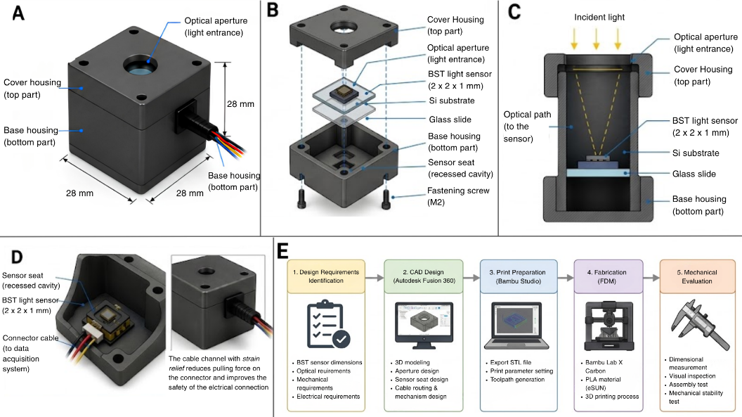
Fig. 1. Design architecture of the BST thin-film protective housing: (A) Closed, fully built visualization of the housing. (B) Opened viewing, exposing the base, glass slide, silicon substrate, BST sensor, the seat, and cover. (C) Side viewing, illustrating the optical aperture aligned perfectly above the sensor’s active area. (D) Detail of the sensor seat and rear cable channel providing mechanical strain relief. (E) Complete workflow covering CAD modeling, FDM slicing, fabrication, and mechanical evaluation.
  - Fabrication of the Protective Housing via FDM
Once the design process is complete, the three-dimensional (Computer-Aided Design/CAD) model of the protective housing is exported in Standard Tessellation Language (STL) format for further processing using Bambu Studio software. At this stage, the slicing process takes place, which involves converting the 3D model into a print path (toolpath) that can be read by a 3D printer. In addition to generating the print path, the slicing process is also used to determine the printing parameters that affect the dimensional accuracy, mechanical strength, and fabrication time of the housing [38, 39].
The protective housing was fabricated using a Bambu Lab X1 Carbon 3D printer with Fused Deposition Modeling (FDM) technology. The material used was eSUN brand Polylactic Acid (PLA) filament with a diameter of 1.75 mm. PLA was chosen because it offers good dimensional stability, low shrinkage, ease of printing, and the ability to produce a high-quality surface finish for small components. Additionally, PLA has sufficient mechanical strength for laboratory prototyping needs, making it suitable as the material for the protective housing of the BST thin-film light sensor [40].
The printing parameters were determined based on the printer specifications and the filament manufacturer’s recommendations to achieve optimal print quality. The printing process was carried out using a 0.4 mm diameter nozzle with a layer height of 0.20 mm. The nozzle temperature is set to 210°C, while the build plate temperature is maintained at 60°C to improve the adhesion of the first layer during the printing process. The internal structure of the housing is printed using a gyroid pattern with an infill density of 20%, thereby achieving a balance between mechanical strength, material efficiency, and fabrication time. Details of the printing parameters used in this study are shown in Table 1.
Table 1. FDM Printing Parameters Used for Housing Fabrication
Parameter | Specification
3D Printer | Bambu Lab X1 Carbon
Printing Technology | Fused Deposition Modelling (FDM)
Filament Material | eSUN PLA
Filament Diameter | 1.75 mm
Nozzle Diameter | 0.40 mm
Layer Height | 0.20 mm
Nozzle Temperature | 210 °C
Bed Temperature | 60 °C
Infill Density | 20%
Infill Pattern | Gyroid
Build Orientation | Vertical
Slicing Software | Bambu Studio
After the printing process is complete, the housing is allowed to cool naturally to room temperature before being removed from the build plate. Next, a post-processing step is performed, consisting of support removal and cleaning the surface of the printed part. A visual inspection is conducted to ensure there are no printing defects such as warping, layer separation, stringing, or imperfections in material deposition that could affect the housing’s mechanical function. Housings that meet visual quality standards are then used in the dimensional testing and mechanical evaluation stages.
  - Mechanical and Functional Evaluation Methodology
A mechanical evaluation was conducted to determine the protective housing’s ability to shield the BST thin-film light sensor and to ensure that the developed design could optimally support the sensor’s installation and operation. Four parameters were selected, from the dimensional accuracy, ease of assembly, structural stability, and functional compatibility, because of the reliability of the housing as both a protective system and a support for sensor operations all four directly affects.

Dimension Accuracy. Three repeated trials (n = 3) for each parameter of the printed part’s height, length, and width of the housing were done using a digital caliper with a resolution of 0.01 mm to ensure measurement consistency in dimension and verify tolerances, while comparing the results with the design dimensions in the CAD model. The percentage of dimensional deviation was calculated using Equation (1).
$$\begin{aligned}Dimensional Deviations \left(\%\right)=\frac{D_{CAD}- D_{Actual}}{D_{CAD}} x 100\#\left(1\right)\end{aligned}$$

Where D_{CAD} is the dimension resulting from the CAD design, and D_{Actual} is the dimension resulting from the housing measurement.

Assembly Evaluation. An assembly evaluation was conducted to determine the ease of installing the BST sensor into the housing. The aspects observed included the dimensional fit of the sensor seat, the ease of installing the glass substrate, access to the cable routes, and the ease of the disassembly and reassembly process. The assembly process is considered successful if the sensor can be installed properly without applying excessive pressure to the substrate or electrical connections.

Structural Stability. Structural stability testing was conducted by performing 10 consecutive manual assembly and disassembly cycles to evaluate the structure’s ability to maintain the sensor’s position during use. Observations were made regarding the possibility of deformation, sensor displacement, cracks in the housing, or a reduction in the strength of the joint between the base and the housing cover. Visual inspections were performed after each assembly cycle to ensure there was no structural damage that could affect the housing’s function.

Functional Compatibility. Functional compatibility is evaluated to ensure that the protective housing is capable of supporting the sensor’s operation in accordance with its intended function. The evaluation includes the alignment of the optical aperture with the sensor’s active area, access to electrical connections, the presence of an unobstructed light path through the housing structure, and the overall dimensional compatibility with the sensor system. The housing is deemed to meet compatibility requirements if the sensor can be properly installed, the light path to the sensor surface remains unobstructed, and electrical connections can be made without encountering mechanical obstacles.
Table 2. Mechanical Evaluation Parameters for Protective Housing
Evaluation Aspects | Testing Methods | Indicators of Success
Dimensional accuracy | Three repeated measurements (n = 3) using a digital vernier caliper | Minor dimensional deviations from the CAD design
Ease of assembly | Manual sensor installation | The sensor installed easily without causing any damage
Structural stability | Repeated assembly and visual inspection | There was no deformation, cracking, or shifting
Functional compatibility | Inspection of sensor position and light path | The sensor is aligned with the optical aperture, and the light path is unobstructed
- Results and Discussion
  - Configuration of the Protective Housing
After conducting the design process using Autodesk Fusion 360, a final design was successfully made in two-part configuration, which consists the base housing and the cover housing, formed together making a complete mechanical protection system. This specific configuration was chosen to simplify installation process, facilitate easier inspection and maintenance, and also reduce the risk of damage to the inside during assembly.
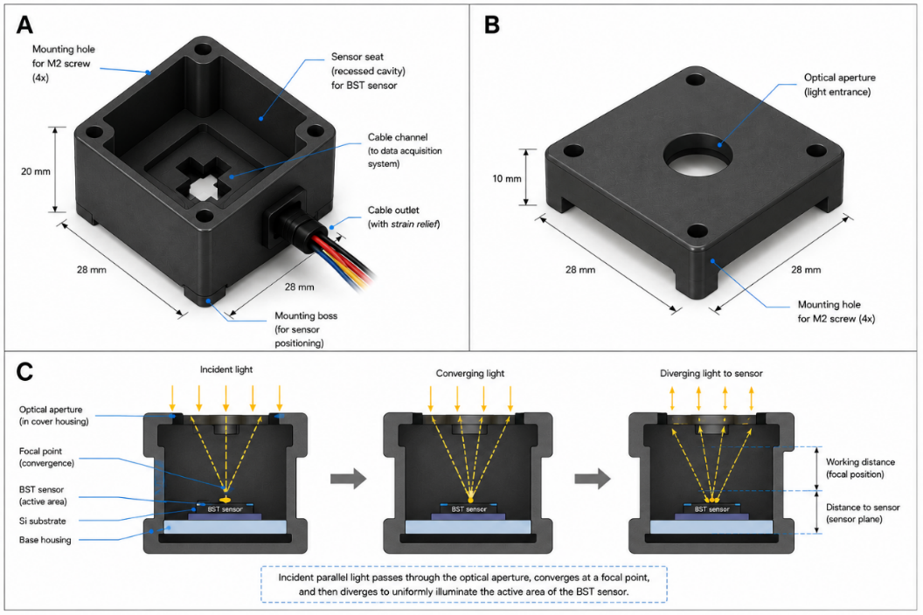
Fig. 2. CAD illustrated design: (A) Base housing; (B) Cover housing; and (C) Conceptual incident sunlight access through the optical aperture on the cover housing to the sensor’s active surface (not to scale; illustrative ray path only).
The main mounting that holds the BST sensor and the glass side are served on the base housing, measured in a fixed position. To limit positional shifts without pressuring the silicon substrate, the dimensions of the mount are tailored to the actual size of the sensor. Avoiding light path obstruction to the sensor’s surface, the base is equipped with electrical interconnection paths for the cables to exit the housing neatly.
An 8 mm wide optical aperture is placed directly above the 2 x 2 mm sensor’s area with roughly 2.83 mm diagonal size, and through the cover, providing an ample radial clearance margin of roughly 2.58 mm, serving as a light path to ensure the sensor receives optimal light intensity, shielding the surrounding wire bonds and minimize the dust and contaminants from the external environment without restricting the sensor’s field of view under varying sunlight angles. and provides clear pathway for solar radiation to reach the surface without internal vignetting or shadowing as illustrated in Figure 2(C); note that this schematic is strictly qualitative for illustration.
As illustrated on Figure 1(B), the final design shows all mechanical components have been integrated to each part with each corresponding features, making a single, compact housing system that work together for easy assembly without requiring any special handling of the sensor.
  - Additive Manufacturing Results and Prototype Assembly
Any production of housing made using Fused Deposition Modeling (FDM) technology with eSUN’s PLA material on a Bambu Lab X1 Carbon proceeded smoothly as planned, with key geometric features retaining their shapes as designed in the CAD model, resulting in a sharp definition and a uniform surface finish.
Through visual inspection, consistent layer deposition is found with no observable defects such as warping, layer delamination, or under-extrusion while good dimensional accuracy is reached together with uniform texture housing surface, indicating all printing parameters used were capable of producing fabrication quality suitable for small mechanical components. Performing post-processing steps such as removing the support material and cleaning the surface were easily done without causing any damage to the housing’s structure, proofing the use of PLA material with selected printing parameters is more than enough to manufacture the perfect quality for the needs of thin-film-based sensor prototypes.
Sensor placement, along with its assembly, including the active BST film, silicon substrate, and glass carrier, results in proper seating, stably on the measured base housing dimensions, without shifting during the mounting process, while being protected by the housing cover and provided by the optical aperture that is located at the cover and aligned above the sensor’s active area. This whole configuration successfully provides perfectly aligned light path that enters through the top, while at the same time protecting the components without obstructing line-of-sight to the sensor surface.
For the cables, proper routes on the side of the housing have been configured to avoid interference with optical path, while reducing direct tensile stress on the cable connections, and easier integration between the sensor and the data acquisition system.
Beyond good matches between the CAD model and the printed components are found in the fabrication results with no additional or post-print modifications. These findings indicate that FDM technology using PLA material is capable of producing a protective housing with sufficient geometric and functional quality to serve as a protective system for the BST thin-film-based light sensor. Documentation of the fabrication results for the base housing, cover housing, and the sensor assembly process is shown in Figure 3.
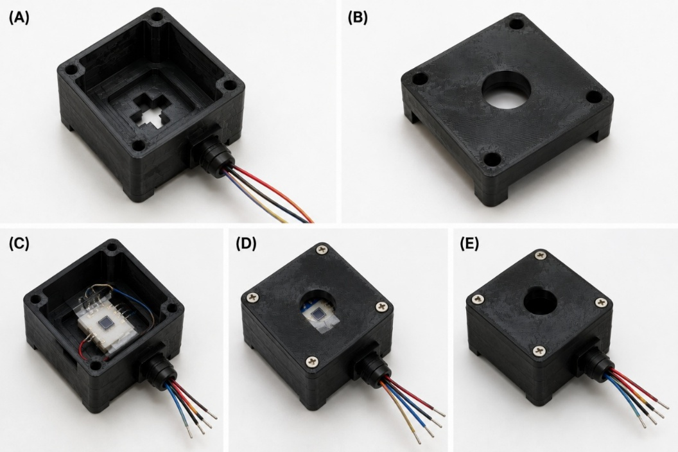
Fig. 3. Documentation of Fabrication Results: (A) Printed base housing. (B) Printed cover housing. (C) Base housing with the BST sensor installed. (D) Cover housing attached to the base housing. (E) Final view of the assembled protective housing.
  - Evaluation of Dimensional Accuracy
Dimensional accuracy is one of the key indicators in evaluating the quality of fabricated parts using Fused Deposition Modeling (FDM) technology. In this study, an evaluation was conducted to determine the degree of conformity between the printed dimensions and the design dimensions (Computer-Aided Design/CAD) and to ensure that the protective housing has sufficient geometric tolerances to precisely position the BST thin-film-based light sensor. Dimensional accuracy is critical because it affects the sensor’s position relative to the optical aperture, stability during the measurement process, and compatibility among the housing’s components. Excessive dimensional deviations could potentially cause misalignment of the sensor, thereby reducing the consistency of optical measurements.
Measurements were taken of six key geometric features considered to have the greatest impact on the housing’s mechanical function: overall length, overall width, base height, optical aperture diameter, sensor seat width, and screw hole diameter. Each parameter was measured three times using a digital caliper with a resolution of 0.01 mm. The mean and standard deviation were calculated to characterize the measurement consistency and precision of the evaluation, while the percentage deviation was calculated based on the difference between the printed dimensions and the CAD model.
Table 3. Dimensional evaluation parameters of the fabricated protective housing based on repeated caliper measurements (n = 3)
Parameter | CAD (mm) | Measurement 1 | Measurement 2 | Measurement 3 | Mean ± SD (mm) | Deviation (mm) | Error (%)
Housing Length | 28.00 | 27.93 | 27.91 | 27.92 | 27.92 ± 0.01 | 0.08 | 0.29
Housing Width | 28.00 | 27.96 | 27.95 | 27.94 | 27.95 ± 0.01 | 0.05 | 0.18
Height of Base Housing | 20.00 | 19.94 | 19.93 | 19.92 | 19.93 ± 0.01 | 0.07 | 0.35
Width of Optical Aperture | 8.00 | 7.95 | 7.94 | 7.93 | 7.94 ± 0.01 | 0.06 | 0.75
Width of Sensor Seat | 6.00 | 5.97 | 5.96 | 5.96 | 5.96 ± 0.01 | 0.04 | 0.67
Diameter of Screw Hole | 3.00 | 2.98 | 2.97 | 2.97 | 2.97 ± 0.01 | 0.03 | 1.00
All measured dimensions of the fabricated prototype exhibited close conformity with the nominal CAD specifications, maintaining deviations between 0.03 mm and 0.08 mm, with error percentages ranging from 0.18% to 1.00%. The largest deviation was found in the screw hole diameter, while the main dimensions of the housing, such as length, width, and height, exhibited errors of less than 0.5%. The relatively small standard deviation (±0.01 mm) indicates high measurement consistency and dimensional stability across repeated evaluations of the fabricated prototype, confirming minimal measurement error. Specifically, the sensor seat was fabricated at 5.96 ± 0.01 mm against the nominal 6.00 mm CAD target. This dimension is designed to house the 5.6 mm × 5.6 mm glass carrier slide supporting the active 2 mm × 2 mm BST thin-film sensor, thereby maintaining an effective assembly clearance of ≈ 0.18 mm per side to prevent lateral strain on the sensor elements.
The dimensional accuracy obtained indicates that the combination of the Bambu Lab X1 Carbon printer, eSUN PLA material, and the printing parameters used is capable of producing components with good geometric quality. The high precision of the printer’s motion system, along with the low shrinkage characteristics of PLA, contribute to minimal dimensional changes during the cooling process. In addition, using a layer height of 0.20 mm and a 20% gyroid infill pattern provides a balance between mechanical strength, material efficiency, and the dimensional accuracy of the printed parts.
Nevertheless, some small features, particularly the optical aperture and screw holes, exhibit slightly greater deviations compared to the housing’s main dimensions. This phenomenon is a common characteristic of the FDM process, as it is influenced by the nozzle diameter, the flow behavior of the molten material, and the cooling process after extrusion. Nevertheless, all deviation values remain within acceptable tolerance limits for laboratory prototyping purposes, so they do not affect the sensor installation process or the mechanical function of the housing.
Overall, the evaluation results show that the fabrication method used is capable of producing protective housings with high dimensional accuracy and reliable conformance to the design specifications. The degree of conformity between the CAD model and the fabricated results indicates that the design and manufacturing processes used have met the geometric requirements for supporting the integration of BST thin-film-based light sensors.
  - Assembly and Functional Compatibility Evaluation
In addition to having good dimensional accuracy, the protective housing must also support the sensor installation process and maintain optical functionality during the measurement process. Therefore, an evaluation of the assembly performance and functional compatibility was conducted to ensure that all designed mechanical components could work together as intended for the research objectives. The evaluation was conducted through the installation of the BST sensor into the base housing, the installation of the housing cover, testing of the optical aperture alignment, and inspection of the electrical interconnection paths.
Physical trial mounting confirmed that the BST sensor seated stably within the recessed cavity without requiring filing, trimming, or force-fitting. The dimensions of the sensor mount, which have been adapted to the size of the silicon substrate and glass specimen, ensure that the sensor remains in its intended position throughout the assembly process. No gaps were found that could cause the sensor to shift, nor was there any excessive pressure that could potentially damage the BST thin film layer. These results indicate that the sensor seat design has successfully fulfilled its primary function as a mechanical support for the sensor while maintaining the position of the active area relative to the light path.
The installation of the housing cover also went smoothly. The four screw holes on the cover were properly aligned with the housing base, allowing the two components to be assembled without difficulty. After all the screws were tightened, no gaps between the components or misalignments that could cause the housing structure to shift were found. Furthermore, across 10 consecutive assembly and disassembly cycles, the housing met all established acceptance criteria: no thread wear, screw hole enlargement, or layer delamination was detected, and the sensor remained securely seated without positional displacement. These results indicate that the fabrication process was able to achieve sufficiently good dimensional tolerances, thereby ensuring compatibility between the components.
One of the key aspects of this study is the alignment between the optical aperture and the active area of the BST sensor. Direct optical alignment verified that the aperture centered precisely above the sensor’s active surface, preserving an unobstructed line-of-sight across the incident light path. This is critical because any misalignment of the optical aperture could cause part of the light beam to miss the sensor’s active area, potentially reducing measurement sensitivity. Based on the observations, the developed housing configuration is able to maintain consistent optical alignment after the assembly process is complete. The results of the Assembly and Functional Compatibility Evaluation are shown in Table 4.

Table 4. Results of the Assembly and Functional Compatibility Evaluation
Evaluation Parameters | Observation Results | Status
Installation of the Seat Sensor | The sensor is securely mounted without any shifting. | Successful
Fit of the Base and Housing Cover | All screw holes are aligned. | Successful
Optical Aperture Alignment | The optical aperture is directly above the sensor’s active area. | Successful
Electricity Interconnection Lines | The cable does not obstruct the light path. | Successful
Ease of Assembly | All components can be assembled without modification. | Successful
Structural Stability After Assembly | No deformation or looseness was found. | Successful
An evaluation was also conducted on the electrical interconnection system to ensure that the cable routes do not interfere with the light path or the sensor installation process. Cable routes positioned on the side of the base housing allow the cables to exit the housing neatly and do not exert direct tension on the sensor during handling. In addition to improving the system’s neatness, this configuration also simplifies the process of removing or replacing the sensor should maintenance or calibration be required in the future.
Overall, the fabricated housing successfully provided mechanical protection and direct optical alignment while maintaining clear routing paths for the sensor wiring. Resulting in a housing that meets the operational requirements of the BST thin-film light sensor, all combined properties including precisely made sensor mount, centered optical aperture above the active area, with a stable locking system, and integrated cable routing, were integrated into a compact, ruggedized enclosure.
  - General Discussion and Engineering Implications
Based on the results of the design, fabrication, and mechanical evaluation conducted, this study successfully developed a suitable protective housing for a BST thin-film light sensor using a CAD approach and fabrication with FDM technology, fulfilling the basic requirements as both a mechanical protection system and a sensor integration platform. With high level of dimensional accuracy, the success of the assembly and great compatibility between the housing and the sensor itself proofs that the carefully made design has been successfully realized from 2D visualization to 3D printed prototype ready for use in laboratory testing, indicating that the engineering approach applied produces and provides a platform that support the integration of thin-film-based sensor into a better, more structured measurement system.
Multiple mentioned findings, differentiating from conventional electronic housings, show that a special targeted sensor must be tightly coupled to its operational characteristics, in order to serve not only to protect the sensor, but also to consider the position of the sensor’s active area, the direction of incoming light, electrical interconnection paths, and ease of assembly. One of the critical aspects is covered with this approach by maintaining alignment between the optical aperture and the active area of the BST sensor, making the consistency of light intensity received by the sensor during measurement process stable, proofing the key to maintaining the sensor’s position relative to the optical path is in the housing design itself, demonstrating it directly contributes to the overall reliability of the sensor system.
The success of the fabrication using the Bambu Lab X1 Carbon printer also demonstrates that FDM technology is capable of producing mechanical components with good geometric quality for thin-film-based sensor applications. The relatively small dimensional deviations indicate that the printing parameters used were able to achieve high dimensional accuracy and close conformity to the CAD design. Although the FDM process generally has limitations in producing micro-features with very tight tolerances, the results of this study show that the level of precision achieved is still within acceptable limits for laboratory prototyping needs. Thus, FDM technology can be an efficient manufacturing alternative in the development of custom housings because it allows for rapid design, modification, and fabrication at a relatively low cost.
Compared to previous research, most studies on BST-based sensors still focus on material development, composition optimization, deposition techniques, and the characterization of their electrical and optical properties.
Different from previous studies which have succeeded in improving functional characteristics, this study focuses on the mechanical characteristics by focusing on sensor packaging, designed to provide mechanical protection, ensure optical alignment, and sensor integration facilitation. With this in mind, based on this study approach, it complements previous research by contributing to the device implementation stage for ready-for-use device purpose rather than to the optimization of the sensor.
This specially made protective housing for BST light sensor are different from conventional housing, because it consists of three main contribution key aspects, which includes mechanical protection, optical access, and ease of system integration. In this study, the sensor seat configuration, optical aperture, electrical interconnection paths, and assembly system were developed simultaneously, resulting in a housing that not only protects the sensor from physical disturbances but also supports a more stable and consistent measurement process. Therefore, the results of this study can be viewed as a first step toward the development of more integrated sensor packaging for thin-film-based sensor devices.
Although it yielded good results, this study still has several limitations. The evaluation focused on the mechanical characteristics and functional compatibility of the housing, relying primarily on dimensional measurements, manual assembly, and visual inspection rather than direct quantitative mechanical testing. Because this investigation centered on physical housing design and prototyping, a quantitative evaluation of the sensor's optoelectronic response (such as photocurrent and responsivity) with and without the housing under calibrated illumination was not performed. Furthermore, testing of the housing’s durability under more complex environmental conditions, such as temperature fluctuations, high humidity, vibration, and long-term mechanical loading, has not yet been conducted. These factors have the potential to affect the housing’s performance when used outside the laboratory.
Given these limitations, future research could focus on developing protective housings using materials with superior mechanical and thermal properties, such as PETG, ABS, or engineering resins, as well as evaluating the effect of housing design on the light distribution received by the sensor. In addition, the integration of the housing with a data acquisition system and a wireless communication module can also be developed to produce a more compact BST-based light sensor device that is ready for implementation in various real-time optical monitoring applications.
- Conclusion
Developed, and integrated several key aspects to the protective housing for a BST thin-film light sensor using CAD and FDM technology is proven to be successful in design, fabrication and evaluation. The proofs of the success come from the results of the fabrication process which show that all housing components were produced correctly according to the design using eSUN’s PLA material; the mechanical evaluation process which resulted in a high-level dimensional accuracy, with good structural stability; and the perfectly aligned light path through the housing cover straight into the sensor’s area.
Not only this research’s success comes from the successful fabrication of the housing, but also in the approach of mechanical integration, optical, and electrical aspects. Unlike previous studies, which largely focused on optimizing BST materials and characterizing sensor performance, this research demonstrates that housing engineering plays a crucial role in supporting the implementation of sensors as more ready-to-use devices. The approach developed is capable of maintaining the sensor’s position relative to the optical aperture, providing protection for the active elements, and facilitating the integration of the sensor into measurement systems. Thus, this study contributes to the development of sensor packaging technology for thin-film-based optoelectronic devices.
Nevertheless, this study is still limited to evaluating the mechanical characteristics and functional compatibility of the housing. Further research is needed to quantitatively evaluate the housing’s impact on the sensor’s optical performance—including the distribution of light intensity across the active area—as well as the housing’s resistance to more complex environmental conditions, such as temperature fluctuations, humidity, and long-term mechanical loading. In addition, exploring other manufacturing materials with better mechanical and thermal characteristics also presents an opportunity to improve the housing’s performance in sensor applications across a wider range of operational environments.

References
1. Yuan, Z., Sun, Y., Wang, D., Chen, K.-Q., Tang, L.-M.: A review of ultra-thin ferroelectric films. Journal of Physics: Condensed Matter. 33, 403003 (2021). https://doi.org/10.1088/1361-648X/ac145c.
2. Abdhul Rahuman, M.A., Kahatapitiya, N.S., Amarakoon, V.N., Wijenayake, U., Silva, B.N., Jeon, M., Kim, J., Ravichandran, N.K., Wijesinghe, R.E.: Recent Technological Progress of Fiber-Optical Sensors for Bio-Mechatronics Applications. Technologies (Basel). 11, 157 (2023). https://doi.org/10.3390/technologies11060157.
3. Wu, L., Yang, Y.: Narrow Bandgap Inorganic Ferroelectric Thin Film Materials. Adv. Mater. Interfaces. 9, (2022). https://doi.org/10.1002/admi.202201415.
4. Syafutra, H., Siskandar, R., Jenie, R.P., Pratama, E., Ramli, M.M., Umam, R., Sumaryada, T.I., Irzaman: Potential of Ru-doped Ba_{0.5}Sr_{0.5}TiO₃ thin film for acetone gas detection as diabetes biomarker. Next Materials. 12, 102249 (2026). https://doi.org/10.1016/j.nxmate.2026.102249.
5. Nurhidayah, Samsidar, Deswardani, F., Peslinof, M., Anggraini, R.M., Afrianto, M.F., Irzaman, Dahrul, M., Rahmani, M., Rukyati, A.M., Siskandar, R.: Synthesis and Characterization of Lithium-doped BaTiO₃/Si(100) Thin Films with Variations of 0 %, 0.5 %, 1 % and 1.5 % as Potential Forerunners of Solar Cells. International Journal of Nanoelectronics and Materials. 17, 141 – 151 (2024).
6. Siskandar, R., Mandang, T., Hermawan, W., Irzaman, I.: Thin Film Potential Ba_{0.5}Sr_{0.5}TiO₃ (BST) doped with RuO₂ 6% as a Light Detecting Sensor at Solar Tracker ALSINTAN System in Microcontroller-Based. Biointerface Res. Appl. Chem. 13, (2023). https://doi.org/10.33263/BRIAC136.545.
7. Irzaman, Siskandar, R., Jenie, R.P., Syafutra, H., Iqbal, M., Yuliarto, B., Fahmi, M.Z., Ferdiansjah, Khairurrijal: Ferroelectric sensor Ba_{x}Sr_{1-x}TiO₃ integrated with android smartphone for controlling and monitoring smart street lighting. J. King Saud Univ. Sci. 34, 102180 (2022). https://doi.org/10.1016/j.jksus.2022.102180.
8. Siskandar, R., Dio, F.C., Alatas, H., Irzaman, I.: Application of Ba_{0.5}Sr_{0.5}TiO₃ (bst) film doped with RuO₂ (0%, 2%, 4% and 6%) on a rice-stalk cutting robot model based on a line follower with hc-05 bluetooth control. Biointerface Res. Appl. Chem. 12, 2138 – 2151 (2022). https://doi.org/10.33263/BRIAC122.21382151.
9. Irzaman, Rahmawaty, V., Palupi, E.K., Patonah, N., Sumaryada, T., Siskandar, R., Alatas, H., Iqbal, M., Yuliarto, B., Fahmi, M.Z., Rusydi, F., Nugroho, W.S.: The effect of photoconductive mole fraction based on thin film Ba_{x}Sr_{1-x}TiO₃ (X = 0.000; 0.125; 0.250; 0.375; 0.500) on electrical properties and diffusivity coefficient. Biointerface Res. Appl. Chem. 11, 14956 – 14963 (2021). https://doi.org/10.33263/BRIAC116.1495614963.
10. Irzaman, Siskandar, R., Yuliarto, B., Zakki Fahmi, M., Ferdiansjah: Application of Ba_{0.5}Sr_{0.5}TiO₃ (Bst) Film Doped with 0%, 2%, 4% and 6% Concentrations of RuO₂ as an Arduino Nano-Based Bad Breath Sensor. Chemosensors. 8, 3 (2019). https://doi.org/10.3390/chemosensors8010003.
11. Irzaman, Siskandar, R., Aminullah, Irmansyah, Alatas, H.: Characterization of Ba_{0.55}Sr_{0.45}TiO₃ films as light and temperature sensors and its implementation on automatic drying system model. Integrated Ferroelectrics. 168, 130–150 (2016). https://doi.org/10.1080/10584587.2016.1159537.
12. Irzaman, Siskandar, R., Nabilah, N., Aminullah, Yuliarto, B., Hamam, K.A., Alatas, H.: Application of lithium tantalate (LiTaO₃) films as light sensor to monitor the light status in the Arduino Uno based energy-saving automatic light prototype and passive infrared sensor. Ferroelectrics. 524, 44–55 (2018). https://doi.org/10.1080/00150193.2018.1432842.
13. Wang, L., Zhu, M., Shao, Y., Zhao, Y., Wei, C., Gao, L., Bao, Y.: Smart Sensing Multifunctionalities Based on Barium Strontium Titanate Thin Films. Sensors. 22, 7183 (2022). https://doi.org/10.3390/s22197183.
14. Prastowo, B., Jenie, R.P., Hardyanto, I., Dahrul, M., Iskandar, J., Kurniawan, A., Siskandar, R., Nurdin, N.M., Suryana, Y., Pambudi, S., Widayanti, T., Aridarma, A., Rahayu, M.S.K., Riadhie, T.S., Irzaman, Alatas, H.: Determination of light source modules on blood glucose biomimetics using the reflectance method. AIP Conf. Proc. 2320, 050003 (2021). https://doi.org/10.1063/5.0037485.
15. Hardyanto, I., Pambudi, S., Suyarna, Y., Ardidarma, A., Kurniawan, A., Iskandar, J., Siskandar, R., Jenie, R.P., Alatas, H., Irzaman: Non-invasive hemoglobin blood level measurement system. AIP Conf. Proc. 2320, 050005 (2021). https://doi.org/10.1063/5.0037659.
16. Irzaman, Suryana, Y., Pambudi, S., Widayanti, T., Jenie, R.P., Prastowo, B., Zaheri, R., Hardyanto, I., Nurdin, N.M., Dahrul, M., Iskandar, J., Kurniawan, A., Siskandar, R., Aridarma, A., Rahayu, M.S.K., Riadhie, T.S., Alatas, H.: Review: Non-invasive blood haemoglobin level measurement. AIP Conf. Proc. 2320, 050002 (2021). https://doi.org/10.1063/5.0037477.
17. Alatas, H., Prastowo, B., Jenie, R.P., Dahrul, M., Hardyanto, I., Iskandar, J., Kurniawan, A., Siskandar, R., Nurdin, N.M., Suryana, Y., Pambudi, S., Widayanti, T., Aridarma, A., Rahayu, M.S.K., Riadhie, T.S., Irzaman: Non-invasive measurement of blood glucose biomimetics with the reflectance method on near-infrared light source. AIP Conf. Proc. 2320, 050004 (2021). https://doi.org/10.1063/5.0037894.
18. Jenie, R.P., Suryana, Y., Pambudi, S., Widayanti, T., Irzaman, Nurdin, N.M., Dahrul, M., Iskandar, J., Kurniawan, A., Siskandar, R., Aridarma, A., Rahayu, M.S.K., Riadhie, T.S., Alatas, H.: General protocol for ethical conforming development for non-invasive blood biomarker measurement optical device. AIP Conf. Proc. 2320, 050023 (2021). https://doi.org/10.1063/5.0037469.
19. Irzaman, Suryana, Y., Pambudi, S., Widayanti, T., Jenie, R.P., Prastowo, B., Har, N.P., Rahmawaty, V., Dahrul, M., Aminullah, Kurniawan, A., Siskandar, R., Hardyanto, I., Iskandar, J., Nurdin, N.M., Ardidarma, A., Rahayu, S.K., Alatas, H.: Development of blood hemoglobin level early detection device based on a noninvasive optical platform. Heliyon. 8, e11260 (2022). https://doi.org/10.1016/j.heliyon.2022.e11260.
20. Siskandar, R., Wiyoto, W., Santosa, S.H., Sari, J.E., Darmawangsa, G.M., Hidayat, A.P., Dardanella, D., Kusumah, B.R.: Potential Readings of Water Turbidity Values Based on Optical Sensors on Fish-Rearing Biofloc Media. Photonics Lett. Pol. 15, 1–3 (2023). https://doi.org/10.4302/plp.v15i1.1176.
21. Irzaman, F. Mufarrohah, P. Handayani, M. A Santi, V. Rahmawaty, N. F. Har, A. A. Setiawan, R. Siskandar, H. Syafutra, E. Pratama, R. P. Jenie, Tony Sumaryada: Crystal properties analysis using the Cramer-Cohen method and the MAUD software in SrTiO₃ ceramic doped with ruthenium oxide (RuO₂). International Journal of Nanoelectronics and Materials (IJNeaM). 18, 619–623 (2025). https://doi.org/10.58915/ijneam.v18i4.2665.
22. Sun, X., Jia, Y., Chen, F.: Thin-film lithium niobate-based detector: recent advances and perspectives. Opto-Electronic Science. 4, 250028 (2025). https://doi.org/10.29026/oes.2025.250028.
23. Aftab, S., Li, X., Kabir, F., Mukhtari, M., Hussain, I., Jehanzaib Aslam, M., Hegazy, H.H., Yewale, M.A., Rajpar, A.H., Akman, E.: Recent advancements in perovskite thin film technology: From solar cells to optoelectronic devices. Materials Today. 92, 952–995 (2026). https://doi.org/10.1016/j.mattod.2025.12.032.
24. Irzaman, Dahrul, M., Rahmani, M., Rukyati, A.M., Samsidar, Nurhidayah, Deswardani, F., Peslinof, M., Jenie, R.P., Iskandar, J., Wahyuni, Y., Priandana, K., Siskandar, R.: Design and fabrication of photovoltaics based on MFS (Ag/BaTiO3/silicon p-type) structure. Mater. Sci. Energy Technol. 7, 29–34 (2024). https://doi.org/10.1016/j.mset.2023.06.002.
25. Santi, M.A., Har, N.P., Jenie, R.P., Siskandar, R., Syafutra, H., Pratama, E., Negara, T.P., Setiawan, A.A., Alatas, H., Irzaman: Effect of Cupric-Doped SrTiO ₃ Films on Optical Properties Using Spectrophotometry Method. IOP Conf. Ser. Earth Environ. Sci. 1359, 012015 (2024). https://doi.org/10.1088/1755-1315/1359/1/012015.
26. Li, H., Cao, Y., Wang, Z., Feng, X.: Flexible and stretchable inorganic optoelectronics. Opt. Mater. Express. 9, 4023 (2019). https://doi.org/10.1364/OME.9.004023.
27. Santagata, F., Zaal, J.J.M., Huerta, V.G., Mele, L., Creemer, J.F., Sarro, P.M.: Mechanical Design and Characterization for MEMS Thin-Film Packaging. Journal of Microelectromechanical Systems. 21, 100–109 (2012). https://doi.org/10.1109/JMEMS.2011.2170817.
28. Wang, Y., Yang, X., Overmeyer, L.: Simulative Investigations of the Mechanical Reliability of the Flexible Optoelectronic Packaging Using Optodic Bonding. In: 2016 IEEE 66th Electronic Components and Technology Conference (ECTC). pp. 1977–1983. IEEE (2016). https://doi.org/10.1109/ECTC.2016.216.
29. Liang, M., Fang, J., Chen, D., Chen, L., Peng, L., Zhang, C., Chen, Y., Lu, X.: Development Status of Key Technologies for Optoelectronic Integrated Circuit Manufacturing. Applied Sciences. 14, 8073 (2024). https://doi.org/10.3390/app14178073.
30. Bosman, E., Missinne, J., Hoe, B. Van, Steenberge, G. Van, Kalathimekkad, S., Erps, J. Van, Milenkov, I., Panajotov, K., Gijseghem, T. Van, Dubruel, P., Thienpont, H., Daele, P. Van: Ultrathin Optoelectronic Device Packaging in Flexible Carriers. IEEE Journal of Selected Topics in Quantum Electronics. 17, 617–628 (2011). https://doi.org/10.1109/JSTQE.2010.2096407.
31. Niedermayer, M., Guttowski, S., Thomasius, R., Polityko, D., Schrank, K., Reichl, H.: Miniaturization platform for wireless sensor nodes based on 3D-packaging technologies. In: Proceedings of the fifth international conference on Information processing in sensor networks - IPSN ’06. p. 391. ACM Press, New York, New York, USA (2006). https://doi.org/10.1145/1127777.1127836.
32. Jiang, Y., Islam, Md.N., He, R., Huang, X., Cao, P., Advincula, R.C., Dahotre, N., Dong, P., Wu, H.F., Choi, W.: Recent Advances in 3D Printed Sensors: Materials, Design, and Manufacturing. Adv. Mater. Technol. 8, (2023). https://doi.org/10.1002/admt.202200492.
33. Hossain, M.J., Tabatabaei, B.T., Kiki, M., Choi, J.-W.: Additive Manufacturing of Sensors: A Comprehensive Review. International Journal of Precision Engineering and Manufacturing-Green Technology. 12, 277–300 (2025). https://doi.org/10.1007/s40684-024-00629-5.
34. Irzaman, Mayfarah, K.R., Zuhri, M., Syafutra, H., Darmawan, N., Pratama, E., Siskandar, R.: Composing and characterization of barium strontium titanate film doped with carbon dot. AIP Conf. Proc. 3027, 050003 (2024). https://doi.org/10.1063/5.0206903.
35. Ngo, T.D., Kashani, A., Imbalzano, G., Nguyen, K.T.Q., Hui, D.: Additive manufacturing (3D printing): A review of materials, methods, applications and challenges. Compos. B Eng. 143, 172–196 (2018). https://doi.org/10.1016/j.compositesb.2018.02.012.
36. Chua, C.K., Leong, K.F.: 3D Printing and Additive Manufacturing. WORLD SCIENTIFIC (2017). https://doi.org/10.1142/10200.
37. Gibson, I., Rosen, D., Stucker, B., Khorasani, M.: Additive Manufacturing Technologies. Springer International Publishing, Cham (2021). https://doi.org/10.1007/978-3-030-56127-7.
38. Ali, S., Deiab, I., Pervaiz, S.: State-of-the-art review on fused deposition modeling (FDM) for 3D printing of polymer blends and composites: innovations, challenges, and applications. The International Journal of Advanced Manufacturing Technology. 135, 5085–5113 (2024). https://doi.org/10.1007/s00170-024-14820-0.
39. Cano-Vicent, A., Tambuwala, M.M., Hassan, Sk.S., Barh, D., Aljabali, A.A.A., Birkett, M., Arjunan, A., Serrano-Aroca, Á.: Fused deposition modelling: Current status, methodology, applications and future prospects. Addit. Manuf. 47, 102378 (2021). https://doi.org/10.1016/j.addma.2021.102378.
40. Ekşi, S., Karakaya, C.: Effects of Process Parameters on Tensile Properties of 3D-Printed PLA Parts Fabricated with the FDM Method. Polymers (Basel). 17, 1934 (2025). https://doi.org/10.3390/polym17141934.

