Dye-Contaminant Detection at Semiconductor Surfaces via Nonlinear Optical Spectroscopy and Bond Models: A Critical Review

Hendradi Hardhienata [⁰⁰⁰⁰⁻⁰⁰⁰¹⁻⁹¹²³⁻⁴⁵³⁹]
Theoretical Physics Division, Department of Physics, Bogor Agricultural University, Jl. Meranti, Gedung Wing S, Kampus IPB Darmaga, Bogor 16680, Jawa Barat, Indonesia
hendradi@apps.ipb.ac.id

Abstract. This critical review includes nonlinear optical spectroscopy and the Simplified Bond Hyperpolarizability Model (SBHM) as a physically interpretable model of detection and understanding of dye adsorption on semiconductor sur-faces. The scope is deliberately review-oriented: established analytical methods for dye determination are first compared to surface-sensitive second- and third-harmonic generation (SHG/THG), followed by an evaluation of the development, capabilities and current limitations of SBHM across silicon, ZnO, and metal-halide perovskites. Particular attention is paid to rotational-anisotropy SHG/THG (RA-SHG/RA-THG) where adsorption-induced changes in crystallographic symmetry, bond orientation, and electronic redistribution lead to angular optical fingerprints. A critical comparison with HPLC, LC-MS, Raman/SERS, fluorescence and electrochemical sensing shows that established methods usually provide more powerful validated analytical figures of merit, while nonlinear harmonic spectroscopy offers unique benefits for label-free, non-destructive, in-situ interrogation of interfaces. At present, there are no standardized limits of detection, selectivity metrics, and inter-laboratory reproducibility for SBHM based dye sensing. In this context, recent developments in density functional theory and physics-informed machine learning are presented as a route toward quantitative calibration, contaminant classification, and improved interpretability. The review identifies more extensive experimental validation, benchmarking with reference analytical methods, and standardized sensing protocols as priorities for translation of nonlinear bond-model sensing from proof-of-concept studies toward practical environmental and food-safety applications.
.
Keywords: food contamination, nonlinear optics, simplified bond hyperpolarizability model, second-harmonic generation, optical sensing, machine learning.

- Introduction
1.1 Food Dye Contamination and Conventional Analytical Techniques

Synthetic organic dyes still represent an important analytical challenge for the contamination of food and environmental matrices as hazardous colorants may enter products during processing, packaging, storage, transportation or by unauthorized use. Recent nonlinear optics studies have examined triphenylmethane and xanthene dyes at semiconductor interfaces, such as malachite green and rhodamine B [1,2]. Adsorbed molecules can persist on food-contact and sensing surfaces following cleaning, and there is a strong need for analytical methods that can directly and non-destructively interrogate interfaces, complementing conventional bulk assays . This analytical context is summarized in Figure 1, where surface sensitive harmonic generation is presented as a complementary, not alternative, technique to established chemical analysis.

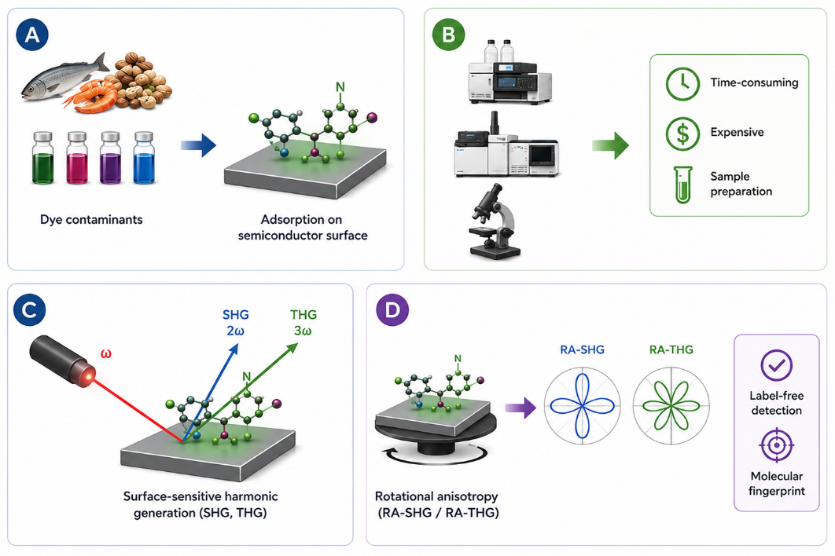
Fig. 1. Schematic of surface sensitive nonlinear optical spectroscopy for detection of dye contaminants adsorbed on semiconductor surfaces. (A) Food processing, packaging, and transport generate hazardous synthetic dyes that can adsorb onto food-contact materials and semiconductor substrates. (B) High analytical sensitivity is offered by conventional analytical methods such as HPLC, LC–MS/GC–MS, Raman spectroscopy, fluorescence spectroscopy, and electrochemical sensing, but these are generally not suitable for real-time in situ interfacial analysis and require extensive sample preparation and complex instrumentation. (C) Surface-sensitive SHG and THG selectively probe the outermost atomic layers where molecular adsorption breaks locally the inversion symmetry. Therefore, interfacial molecular adsorption can be detected without labels. (D) RA-SHG/RA-THG probes angular optical fingerprints encoding crystallographic symmetry, bond orientation and electronic redistribution upon adsorption, providing a sensitive platform for the identification of dye contaminants at semiconductor interfaces.

The classical analytical methods such as high-performance liquid chromatography (HPLC), liquid chromatography-mass spectrometry (LC-MS), gas chromatography-mass spectrometry (GC-MS), Raman/SERS, fluorescence and electrochemical sensing [3-5,27,28] provide the matured routes for trace level dye determination. Their analytical performances are strongly dependent on the matrix, extraction and pre-concentration procedure, calibration strategy and instrument configuration. Chromato-graphic and mass-spectrometric techniques are particularly powerful for confirmatory identification and quantitative analysis but generally require sampling and pre-treatment. SERS, fluorescence and electrochemical platforms may be faster and more portable, but their performance is often reliant on engineered substrates, recognition elements or electrode conditioning. Conversely, surface nonlinear optical techniques are inherently interface sensitive and can be performed nondestructively and in situ if the interface is optically accessible [29]. Thus, the main trade-off is not only sensitivity: nonlinear spectroscopy provides direct access to symmetry and bond-polarization changes occurring during adsorption, but conventional analytical procedures have a better track record for standardized limits of detection, recovery, precision, and validation in complex samples. The difference is summarized quantitatively and qualitatively in Table 1.

1.2 Surface-Sensitive Nonlinear Optical Spectroscopy

Nonlinear optical spectroscopy is an attractive alternative, as harmonic generation is intrinsically sensitive to symmetry breaking occuring at surfaces and interfaces. Second-harmonic genera-tion (SHG) and third-harmonic generation (THG) are nonlinear optical processes resulting from the induced higher-order nonlinear polariza-tion under intense electromagnetic fields [6]. In the electric-dipole approximation, SHG is vanishingly small for centrosymmetric bulk materials, but the surfaces and interfaces remain optically active because of the broken inversion symmetry [7]. Thus the measured harmonic signal is mainly a reflection of the structural and electronic properties of the outermost atomic layers where the contaminant adsorption first occurs [8]. This inherent surface sensitivity makes harmonic generation particularly well suited for studying molecular adsorption on semiconductor substrates without the need for fluorescent labels or chemical probes [9].
Rotational-anisotropy harmonic generation (RA-SHG and RA-THG) increases the analytical power of nonlinear optical spectroscopy by rotating the sample azimuthally and continuously recording the harmonic intensity . The resulting angular patterns are unique optical fingerprints, which are determined by the crystallographic symmetry, the bond orientation, the molecular ordering and the local electric-field distribution [10]. Very small changes in the electronic structure induced by adsorption can be very effective in distorting the rotational anisotropy patterns, so that nonlinear optics can detect surface perturbations that would be almost invisible to conventional optics [11]. This sensitivity has resulted in extensive research on the characterization of semiconductor surfaces, thin-films, oxide growth, molecular adsorption and interface engineering [12].

2. Simplified Bond Hyperpolarizability Model for Semiconductor Surface Analysis

The harmonic generation measurements are rich in structural information, but their inter-pretation requires a proper microscopic theoretical framework. The nonlinear polarization is usually described within the standard theory of nonlinear optics using phenomenological susceptibility tensors, constrained by the crystal symmetry and Neumann's principle [13]. Although the tensor formalism provides a successful prediction of symmetry allowed polarization components, it generally offers limited physical insight into the contribution of individual chemical bonds to the experimentally observed nonlinear response [14]. With the increasing complexity of semiconductor interfaces due to reconstruction, oxidation, nanostructuring and molecular adsorption microscopic descriptions at the level of bonds are much more informative than purely phenomenological tensor models.

Fig. 2 summarizes the microscopic reasoning for SBHM. A physically intuitive framework to relate nonlinear optical responses to chemical bonds directly, the Simplified Bond Hyperpolarizability Model (SBHM), was developed to overcome this limitation. Instead of adding independent tensor elements, SBHM considers each covalent bond as a non-linear oscillator driven anharmonically, where the radiation from all the oscillators is coherently added to obtain the total harmonic signal [15]. The macroscopic nonlinear polarization can then be written as a vector sum of all bond contributions according to the crystal symmetry with the corresponding bond orientations [16].

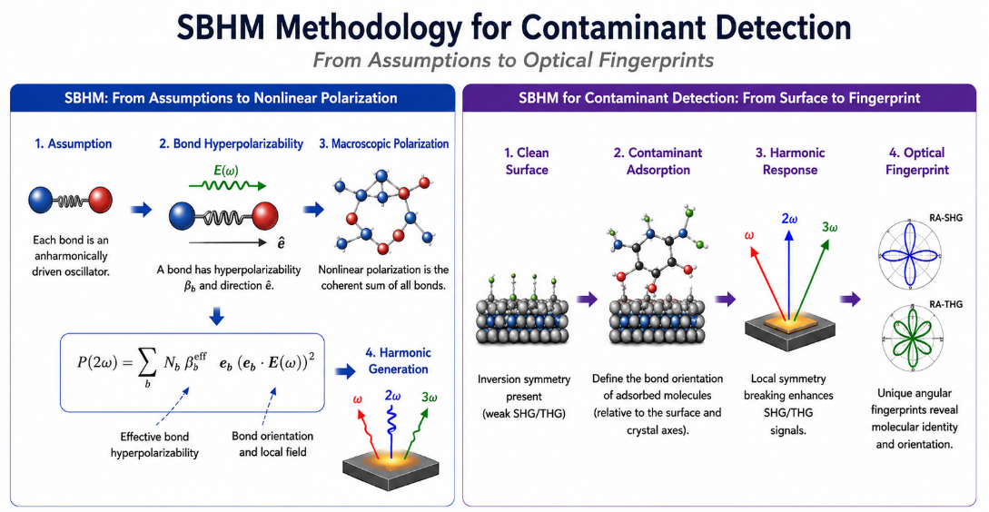
Fig. 2 Scheme of the simplified bond hyperpolarizability model (SBHM) for the detection of contaminants based on semiconductors. The model first proposed by Aspnes [15] relates microscopic bond hyperpolarizabilities to SHG/THG optical fingerprints by means of molecular adsorption at semiconductor surfaces.

The nonlinear optical signals can be directly correlated to bond polarization, charge redistribution, adsorption geometry and molecular orientation [17] because the fitted parameters are effective bond hyperpolarizabilities rather than empirical tensor coefficients. Since its birth, SBHM has been able to describe the nonlinear optical response of many semiconducting systems. Early studies showed good correspondence between theoretical and experimental SHG signals for Si(001), Si(111) and Ge interfaces [18]. Later works showed that the same theoretical framework can be used for electric-field induced SHG, isotropic THG and fourth harmonic generation, being perfectly consistent with crystallographic group theory and Neu-mann's principle [19,20]. More recently, the model has been generalized to wurtzite ZnO and other hexagonal semiconductors where bond-oriented descriptions reproduce experimentally observed non-linear anisotropy patterns with only a few physically meaningful parameters [21].
The rapid development of advanced semiconductor materials also broadened the applicability of the nonlinear bond models. The hybrid organic-inorganic perovskites, layered semiconductors, dielectric metasurfaces and two-dimensional materials have very strong nonlinear optical responses due to tunable electronic structures and reduced crystal symmetry [22]. Thus the bond-based modeling has been applied to tetragonal and orthorhombic perovskites and allows a quantitative description of second and higher harmonic generation in combination with density functional theory calculations [23,24]. These results indicate that nonlinear bond models are not confined to traditional silicon surfaces, but constitute a general theoretical framework for the interpretation of nonlinear optical phenomena in modern semiconductor systems.
.

3. Recent Advances in Nonlinear Optical Contaminant Sensing

One particularly promising application of nonlinear bond models is contaminant sensing. The adsorption of dye molecules results in a change of the local charge density, the bond polarization, the surface electric fields and the molecular orientation, and thus in a change of the effective bond hyperpolarizability responsible for harmonic generation. Thus, concentration-dependent variations of SHG and THG signals are quantitatively related to physically meaningful microscopic parameters instead of empirical calibration curves [2]. Compared with conventional intensity-based sensing approaches [3], the physics-based approach provides much richer information on adsorption mechanisms.
In a recent study, the capability of SBHM combined with nonlinear optical spectroscopy to detect malachite green on silicon substrates was shown. The measured rotational-anisotropy SHG patterns systematically change with increasing concentration and these changes are directly correlated with changes in the bond hyperpolarizability upon adsorption of molecules [1]. These results provide a promising platform for label-free detection of contaminants based on nonlinear bond modeling, and demonstrate the potential of semiconductor surfaces as optical sensing interfaces [2].

But the proof of concept should be taken with caution. The reported RA-SHG/SBHM studies show concentration-dependent changes in angular fingerprints and effective bond hyperpolarizabilities, but do not yet provide the same range of analytical validation typically expected for HPLC/LC-MS or established sensor platforms, such as matrix-matched limits of detection and quantification, recovery, interference testing, long-term stability, and inter-laboratory reproducibility. Hence, the current strength of the approach lies in mechanistic and interface-specific sensing, while the quantitative analytical performance of the approach has yet to be systematically benchmarked [1,2,27-30].

The successful application of SBHM to dye adsorption has stimulated increasing interest in the development of nonlinear optical sensing for a wider range of hazardous contaminants . Besides malachite green, many organic molecules like rhodamine B, crystal violet, methylene blue, bisphenol A, endocrine disrupting compounds and pharmaceutical residues adsorb strongly on semiconductor surfaces and can be potential targets for harmonic generation spectroscopy [2]. Each molecule perturbs the local electronic structure by specific adsorption mechanisms and the nonlinear optical response contains characteristic fingerprints that can be used to distinguish different molecular species without the need of chemical labels [1]. This capability provides a sub-stantial advantage over conventional optical measurements, which are usually based on intensity changes and therefore lack chemical selectivity.

The evolution from adsorption and bond-level modeling to sophisticated semiconduc-tor platforms, computation and machine learning are summarized in Fig. 3. Recent developments in semiconductor materials are further broadening the sensitivity and utility of nonlinear optical sensing platforms. One of the most studied substrates is conventional silicon due to its well understood crystallography and mature fabrication technology [25]. However, the emergence of wide-bandgap semiconductors, III-V compounds, hybrid organic-inorganic perovskites, two-dimensional materials and dielectric metasurfaces has paved a new way to enhance nonlinear optical conversion efficiency [23]. The reduced dimensionality, the possibility to tune the electronic band structures and the enhanced local electro-magnetic fields give these materials very strong light-matter interactions [17]. Thus, the harmonic generation from such advanced materials often exceeds those from conventional semiconductor surfaces while maintaining excellent compatibility with micro- and nano-fabrication technologies [19].
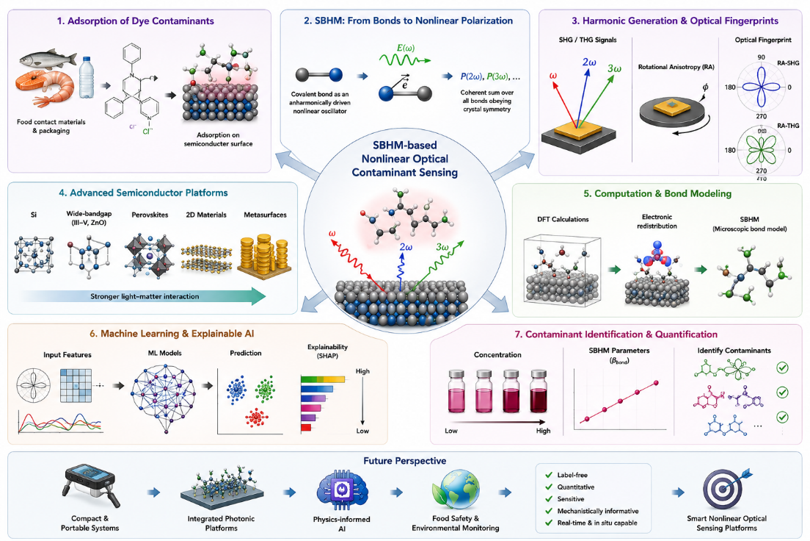

Fig. 3 Recent advances and future directions in SBHM based nonlinear optical contaminant sensing with emphasis on semiconductor platforms, computational modeling and explainable machine learning for label-free contaminant detection.

Progress has also been made in computational modeling of non-linear optical phenomena. Density functional theory-based first principles calculations can be used to test the microscopic assumptions of the bond models and to clarify the electronic redistribution at the semiconductor interfaces [23]. However, for realistic sensing systems involving large supercells, defects, solvents, and multiple adsorbates, full quantum-mechanical calculations are computationally demanding. Thus SBHM represents a useful middle ground, being physically meaningful in the bond descriptors while remaining efficient enough for routine fitting and interpretation. Table 1 presents a critical comparison between SBHM-based nonlinear optical sensing and existing dye-detection methods in terms of analytical performance and practical limitations.

There has also been progress in materials, and in the computational modeling of nonlinear optical phenomena. The first principles calculations based on the density functional theory revealing the electron distributions in Si(111) have greatly improved the understanding of the validity of SBHM assumption that charge motion is mainly along the bonds in Si surfaces [23]. However, pure quantum mechanical calculations are often computationally demanding for realistic sensing systems that may contain large supercells, surface defects, solvent effects, and multiple adsorbed molecules. Thus, microscopic bond models provide a desirable intermediate description that captures important physical information, yet is computationally efficient enough to allow routine interpretation of experimental measurements [6]. Table 1 summarizes the recent trend of the main findings and limitations of the sensing methods discussed and future directions.

Tabel 1. Summary of recent advances in contaminant sensing and SBHM-based nonlinear optical spectroscopy.
Method | Representative analytical performance | Selectivity / reproducibility | Response, preparation, instrumentation & in-situ suitability
HPLC | MG LOD 1.7 µg L⁻¹ (representative) [30]. | High chemical selectivity; mature QA/QC. | Extraction/cleanup often required; minutes per run [27,28]. Laboratory instrument; mainly ex-situ.
LC-MS/MS | Trace-level confirmatory analysis; matrix dependent [27,28]. | Very high molecular selectivity; mature QA/QC. | Sampling and extraction usually required. High-cost laboratory instrument; mainly ex-situ.
Raman/SERS | MG LOD 2.4 × 10⁻¹⁶ M; ~200 s reported [31]. | Molecular fingerprint; substrate reproducibility can limit precision. | Rapid; engineered substrate/preconcentration may be needed. Portable formats and on-site analysis are possible.
Fluorescence | MG LOD 3.7 nM (representative platform) [30]. | High with aptamer/MIP; probe/matrix dependent. | Fast; recognition chemistry may be required. Moderate instrumentation; in-situ use is platform-dependent.
Electrochemical | MG/LMG LOD 4.95 pg mL⁻¹ reported [30]. | Good with modified electrodes; fouling affects repeatability. | Seconds-minutes; electrode contact/conditioning required. Compact, portable, field-capable.
SHG/THG + SBHM | No standardized dye LOD/LOQ; concentration-dependent fingerprints demonstrated [1,2]. | Potential selectivity from symmetry/bond fingerprints; broader validation needed. | Rapid, label-free; alignment/calibration required. Pulsed-laser optics; intrinsically interface-sensitive and in-situ capable [29,32].

4. Future Directions

The rapid development of artificial intelligence in recent years has brought new possibilities to nonlinear optical sensing. Machine learning algorithms like support vector machines, random forests, artificial neural networks, gradient boosting, and deep learning have demonstrated impressive capability in recognizing complex multidimensional datasets obtained from optical spectroscopy. However, the classical machine learning algorithms are typically black boxes with predictions that are difficult to interpret from a physical point of view. In contrast, applying SBHM-derived parameters in machine learning provides a physics-informed learning approach, where bond hyperpolarizabilities, symmetry descriptors, nonlinear polarization components and rotational-anisotropy features can be used as physically meaningful predictors rather than abstract numerical variables. This method not only enhances the prediction accuracy but also the scientific interpretability, by explicitly associating the statistical inference with the microscopic chemical bonding.

Despite these advances, several challenges remain. Much of the SBHM literature has focused on validating bond-level descriptions for clean semiconductor surfaces or relatively simple adsorption systems, and the dye-sensing evidence base is still concentrated in a limited number of studies [1,2,13-16]. Future work should therefore broaden participation across independent research groups and adopt shared benchmark samples, blinded contaminant sets, common reporting of LOD/LOQ, sensitivity, selectivity, response time, repeatability/reproducibility, and direct comparison against HPLC/LC-MS or other reference methods. Such cross-laboratory validation is essential before claims of analytical superiority can be made. A particularly promising direction is to combine RA-SHG/RA-THG with SBHM-derived physical descriptors, DFT calculations, and physics-informed or explainable machine learning, while preserving external validation on semiconductor platforms beyond silicon.

In this critical review we have reviewed nonlinear optical spectroscopy and the Simplified Bond Hyperpolarizability Model (SBHM) as a surface-sensitive framework for probing dye adsorption at semiconductor interfaces. The main benefit of SBHM-based SHG/THG is its mechanistic interpretability; variations in harmonic response can be tied to crystallographic symmetry, bond orientation, charge redistribution, and effective bond hyperpolarizability, as opposed to simply being considered empirical signal variations. Studies of silicon, ZnO, and metal-halide perovskites show the wider physical applicability of bond-based nonlinear models, and early work on malachite green shows their potential for label-free contaminant sensing. A clear translational gap is also seen when comparing with HPLC, LC-MS, SERS, fluorescence and electrochemical sensing; conventional techniques are currently more mature in validation of detection limits, selectivity, recovery, reproducibility and performance in complex samples. Thus, the most plausible short-term function of RA-SHG/RA-THG is as a supplementary in-situ interface probe; future advancement hinges on standardized analytical benchmarking, wider independent validation, and coupling with DFT and physics-informed machine learning. This is necessary for nonlinear bond-model sensing to move from promising proof-of-concept demonstrations to robust environmental and food-safety applications.

References

- Ahyad, M., Hardhienata, H., Hasdeo, E.H., Wella, S.A., Handayasari, F., Alatas, H., Birowosuto, M.D.: A novel sensing method to detect malachite green contaminant on silicon substrate using nonlinear optics. Micromachines 15(10), 1227 (2024). https://doi.org/10.3390/mi15101227
- Hardhienata, H., Ahyad, M., Nabilah, F., Alatas, H., Handayasari, F., Kartono, A., Sumaryada, T., Birowosuto, M.D.: Nanoscale organic contaminant detection at the surface using nonlinear bond model. Surfaces 8(1), 11 (2025). https://doi.org/10.3390/surfaces8010011
- Hamode, M., Ron, R., Krause, A., Klimovsky, H., Haleva, E., Zar, T., Salomon, A.: 3D nanoporous metallic networks for SERS-based detection of water contaminants. ACS Applied Nano Materials 7(15), 18056–18064 (2024). https://doi.org/10.1021/acsanm.4c03899
- Aquino de Queiroz, J.L., Medeiros, L.G., Augusto da Silva, K., Fontes Galvão, F.M., Oliveira do Nascimento, J.H., Martínez-Huitle, C.A., Castro, P.S.: Development of recycled and miniaturized electroanalytical sensor: Probing isoniazid determination in environmental water matrices. Chemosphere 341, 140030 (2023). https://doi.org/10.1016/j.chemosphere.2023.140030
- Dolati, S., Ramezani, M., Nabavinia, M.S., Soheili, V., Abnous, K., Taghdisi, S.M.: Selection of specific aptamer against enrofloxacin and fabrication of graphene oxide based label-free fluorescent assay. Analytical Biochemistry 549, 124–129 (2018). https://doi.org/10.1016/j.ab.2018.03.021
- Alejo-Molina, A., Hingerl, K., Hardhienata, H.: Model of third harmonic generation and electric-field-induced optical second harmonic using simplified bond-hyperpolarizability model. Journal of the Optical Society of America B 32(4), 562–570 (2015). https://doi.org/10.1364/JOSAB.32.000562
- Peng, H.J., Adles, E.J., Wang, J.-F.T., Aspnes, D.E.: Relative bulk and interface contributions to optical second-harmonic generation in silicon. Physical Review B 72(20), 205203 (2005). https://doi.org/10.1103/PhysRevB.72.205203
- Ehlert, R., Kwon, J., Downer, M.C.: Optical second-harmonic and reflectance-anisotropy spectroscopy of molecular adsorption at Si(001) step-edges. Physica Status Solidi C 5(8), 2551–2555 (2008). https://doi.org/10.1002/pssc.200779124
- Ehlert, R., Kwon, J., Loumakos, L., Sharia, O., Demkov, A.A., Downer, M.C.: Optical second-harmonic and reflectance-anisotropy spectroscopy of clean and hydrogen-terminated vicinal Si(001) surfaces. Journal of the Optical Society of America B 27(5), 981–989 (2010). https://doi.org/10.1364/JOSAB.27.000981
- Kwon, J., Downer, M.C., Mendoza, B.S.: Second-harmonic and reflectance-anisotropy spectroscopy of vicinal Si(001)/SiO₂ interfaces: Experiment and simplified microscopic model. Physical Review B 73(19), 195330 (2006). https://doi.org/10.1103/PhysRevB.73.195330
- Reitböck, C., Stifter, D., Alejo-Molina, A., Hardhienata, H., Hingerl, K.: Nonlinear ellipsometry of Si(111) by second harmonic generation. Applied Surface Science 421, 761–765 (2017). https://doi.org/10.1016/j.apsusc.2016.10.131
- Hardhienata, H.: How nonlinear optics can be simplified to study molecular deposition and surface vicinality of a Si(001) interface. IOP Conference Series: Earth and Environmental Science 31(1), 012017 (2016). https://doi.org/10.1088/1755-1315/31/1/012017
- Alejo-Molina, A., Hardhienata, H., Sánchez-Mondragón, J.J., Hingerl, K.: Simplified Bond Hyperpolarizability Model of Second Harmonic Generation, Group Theory and Neumann's Principle. Journal of the Optical Society of America B 31(11), 2777–2787 (2014). https://doi.org/10.1364/JOSAB.31.002777
- Alejo-Molina, A., Hardhienata, H., Sánchez-Mondragón, J.J., Hingerl, K.: Group theory description of the simplified bond-hyperpolarizability model. In: Latin America Optics and Photonics Conference (LAOP 2014) (2014). https://doi.org/10.1364/LAOP.2014.LM4A.16
- Powell, G.D., Wang, J.-F.T., Aspnes, D.E.: Simplified bond-hyperpolarizability model of second harmonic generation. Physical Review B 65 (2002).
- Wang, J.-F.T., Powell, G.D., Aspnes, D.E.: Simplified bond-hyperpolarizability model of second harmonic generation: Application to Si-dielectric interfaces. Journal of Vacuum Science and Technology B 20, 1699–1705 (2002) https://doi.org/10.1116/1.1493783
- Hardhienata, H., Priyadi, I., Nurjanati, B., Alatas, H.: Third harmonic generation in ZnO semiconductor using the simplified bond hyperpolarizability model. Journal of Nonlinear Optical Physics and Materials 27(3) (2018). https://doi.org/10.1142/S021886351850025X
- Hardhienata, H., Priyadi, I., Nurjanati, B., Alatas, H.: Bond model of second-harmonic generation in wurtzite ZnO(0002) structures with twin boundaries. Journal of the Optical Society of America B 36(10), 2760–2767 (2019). https://doi.org/10.1364/JOSAB.36.002760
- Hardhienata, H., Alejo-Molina, A., Reitböck, C., Prylepa, A., Stifter, D., Hingerl, K.: Bulk dipolar contribution to second-harmonic generation in zincblende. Journal of the Optical Society of America B 33(2), 195–201 (2016). https://doi.org/10.1364/JOSAB.33.000195
- Reitböck, C., Stifter, D., Alejo-Molina, A., Hingerl, K., Hardhienata, H.: Bulk quadrupole and interface dipole contribution for second harmonic generation in Si(111). Journal of Optics 18(3), 035501 (2016). https://doi.org/10.1088/2040-8978/18/3/03550121. Hardhienata, H., et al.:
- Bond model of second harmonic generation in tetragonal and orthorhombic perovskite structures. Journal of the Optical Society of America B 40(11), 2773–2781 (2023). https://doi.org/10.1364/JOSAB.499753
- Hardhienata, H., et al.: Third-harmonic generation in tetragonal methylammonium lead iodide (MAPbI3) perovskite. Journal of the Optical Society of America B 42(9), 2103–2115 (2025). https://doi.org/10.1364/JOSAB.566006
- Hardhienata, H., et al.: Spatial dispersion contribution to second harmonic generation in inversion-symmetric materials. Physical Review B 103(12), 125410 (2021). https://doi.org/10.1103/PhysRevB.103.125410
- Aspnes, D.E., Hansen, J.-K., Peng, H.-J., Powell, G.D., Wang, J.-F.T.: Simplified bond-hyperpolarizability model of second- and fourth-harmonic generation: Application to Si–SiO₂ interfaces. Physica Status Solidi B: Basic Research 240(3), 509–517 (2003). https://doi.org/10.1002/pssb.200303825
- Hardhienata, H., et al.: Generation, Reflection and Transmission of Nonlinear Harmon-ic Waves by Direct Superposition of Anharmonic Dipoles. Journal of Optics 23(5), 055601 (2021). https://doi.org/10.1088/2040-8986/abeb2d
- Gokce, B., Adles, E.J., Aspnes, D.E., Gundogdu, K.: Measurement and control of in-plane surface chemistry during the oxidation of H-terminated (111) Si. Proceedings of the Na-tional Academy of Sciences of the United States of America 107(41), 17503–17508 (2010). https://doi.org/10.1073/pnas.1011295107
- 27. Long, C., Mai, Z., Yang, Y., Zhu, B., Xu, X., Lu, L., Zou, X.: Review of methods for the detection and determination of malachite green and leuco-malachite green in aquaculture. Critical Reviews in Analytical Chemistry 49(1), 1-20 (2019). https://doi.org/10.1080/10408347.2018.1456314
- 28. Chen, Z.-Y., He, B.-L., Bian, Y., Zhang, Y., Feng, X.-S.: Malachite green and related substances in environmental samples: Updates on pretreatment and analysis methods. Journal of Environmental Chemical Engineering 12, 113812 (2024). https://doi.org/10.1016/j.jece.2024.113812
- 29. Tran, R.J., Sly, K.L., Conboy, J.C.: Applications of surface second harmonic generation in biological sensing. Annual Review of Analytical Chemistry 10, 387-414 (2017). https://doi.org/10.1146/annurev-anchem-071015-041453
- 30. Seekaew, Y., et al.: Carbon dot-modified silver nanoparticle electrochemical sensors for the ultrasensitive detection of total malachite green and leucomalachite green residues in fish. RSC Advances (2026). https://doi.org/10.1039/D6RA01261B
- 31. Xu, K.-X., Guo, M.-H., Huang, Y.-P., Li, X.-D., Sun, J.-J.: Rapid and sensitive detection of malachite green in aquaculture water by electrochemical preconcentration and surface-enhanced Raman scattering. Talanta 180, 383-388 (2018). https://doi.org/10.1016/j.talanta.2017.12.079
- 32. Heinz, T.F.: Nonlinear optical effects at surfaces and interfaces. In: Ponath, H.-E., Stegeman, G.I. (eds.) Nonlinear Surface Electromagnetic Phenomena, pp. 353-416. North-Holland, Amsterdam (1991).

