Dear Dr. Mohamad Faris Bin Mohamad Fathil,

We are grateful for the opportunity to resubmit our revised work. Thank you for the reviewers' in-depth suggestions and comments, which have greatly helped us improve our manuscript.
Here we send you the revised manuscript. All suggestions and comments have been considered carefully and fully addressed. The changes in the revised manuscript are highlighted in yellow background.
We hope that the changes are sufficient to make our paper acceptable for publication.
Sincerely yours,
Faozan Ahmad
Physics Department, IPB University, Bogor, West Java, Indonesia

Reviewer #1
The manuscript applies dispersion-corrected DFT (B3LYP-D4/def2-SVP) and long-range-corrected TD-DFT (CAM-B3LYP/def2-SVP with CPCM ethanol solvation) calculations to model the optoelectronic parameters of galangin derivatives for dye-sensitized solar cell (DSSC) applications. The manuscript is generally well-structured and clearly presented; however, critical methodologies, energy alignment evaluations, and physical interpretations require fundamental revision before publication can be considered.
Comment #1: Omission of TiO₂ Conduction Band Alignment:
Evaluating DSSC sensitizers solely on the basis of frontier orbital gap (ΔE_HL) and theoretical light-harvesting efficiency (LHE) is insufficient. To demonstrate feasible electron injection capability, the authors must calculate and report the LUMO energy levels relative to the conduction band edge of TiO₂ (~ -4.0 eV vs. vacuum). Without proving that E_LUMO lies sufficiently above the TiO₂ conduction band minimum to drive injection, the working mechanism of the proposed sensitizers cannot be established.
Comment #2: Missing Dye Regeneration Alignment:
The authors must report the ground-state oxidation potential (or E_HOMO) relative to the redox potential of standard electrolytes (e.g., I⁻/I₃⁻ at -4.8 eV or Co²⁺/³⁺ redox complexes) to verify that a sufficient thermodynamic driving force exists for sensitizer regeneration by the electrolyte.
Response to Comment #1 & #2:
We thank the reviewer for this suggestion. The calculated HOMO energies (−5.408 to −5.688 eV) lie below the I−/I3− redox level (−4.8 eV), with offsets of 0.608–0.888 eV, indicating feasible dye regeneration. This energy-level alignment has been added as figure 4 and discussed in the revised manuscript as follows:
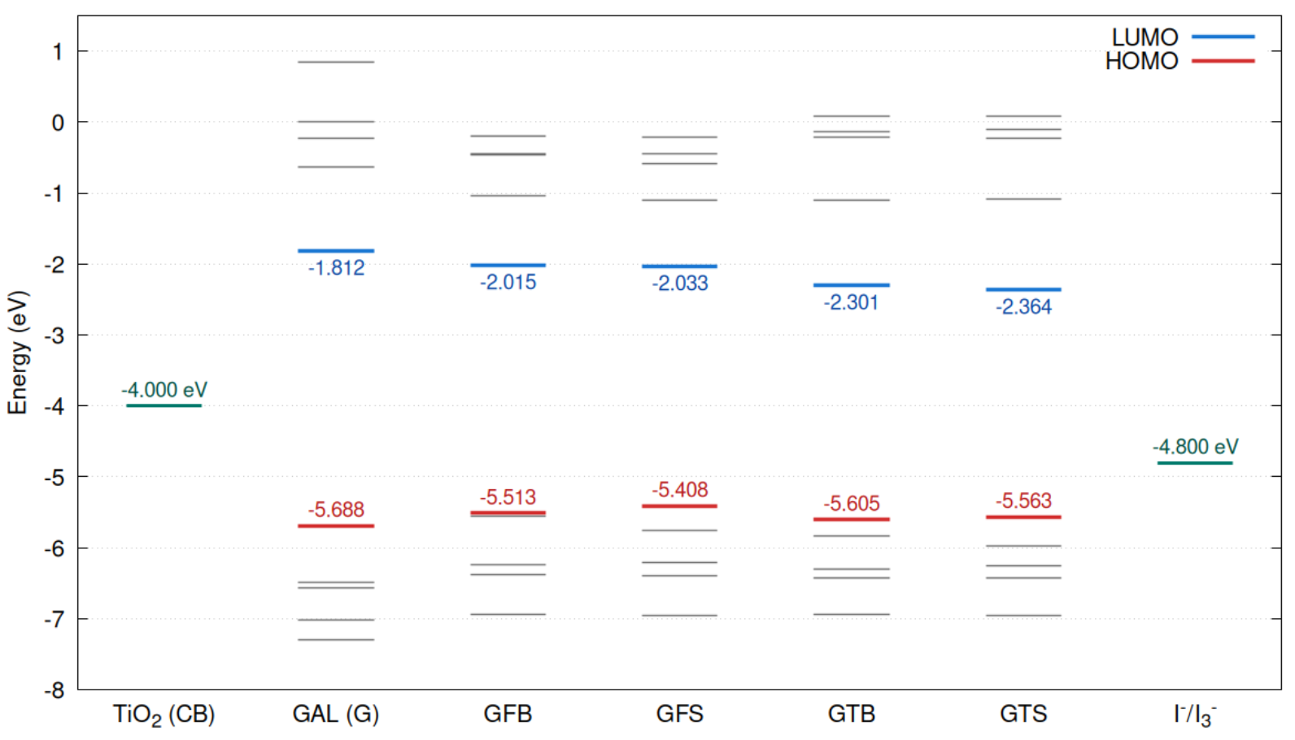
Fig 4. Frontier molecular orbital energy-level diagram of pristine galangin (G) and the designed galangin-based sensitizers GFB, GFS, GTB, and GTS. The HOMO and LUMO levels are highlighted in red and blue, respectively, while the corresponding HOMO–LUMO energy gaps are indicated by the dashed lines.
Energy-level alignment with TiO2 and the I⁻/I₃⁻ redox electrolyte was further examined to evaluate the feasibility of the designed sensitizers for DSSC application. The LUMO energies of G, GFB, GFS, GTB, and GTS range from −1.812 to −2.364 eV, all located above the TiO2 conduction-band edge (−4.0 eV), with LUMO–CB offsets of 1.636 – 2.188 eV. This indicates that electron injection from the excited sensitizer into the TiO2 conduction band is energetically favorable for all five molecules. The HOMO energies, in the range of −5.408 to −5.688 eV, lie below the I⁻/I₃⁻ redox potential (−4.8 eV), with offsets of 0.608 – 0.888 eV, indicating that dye regeneration by the redox electrolyte is thermodynamically feasible.

Comment #3: Basis Set Nomenclature / Verification:
Section 2.1 states the use of 'def2-SVP', whereas standard ORCA quantum chemical nomenclature uses 'def2-SVP'. The authors should verify and maintain consistent notation throughout the computational details to ensure scientific accuracy and reproducibility.
Response to Comment #3
The basis-set notation has been verified and standardized as def2-SVP throughout the manuscript, consistent with standard ORCA nomenclature.

Comment #4: Overextended Claims on Solar Spectrum Coverage:
All calculated absorption maxima (λ_max) remain within the ultraviolet-A region (328.8–345.1 nm). The manuscript framing overstates the red-shift achievement, as these molecules do not achieve meaningful visible light harvesting. The text should be revised to reflect that these modifications shift absorption deeper into the near-UV, rather than enabling broad solar spectrum harvesting.
Response to Comment #4
The following sentence in the introduction has been revised from:
"Therefore, structural modification of the galangin framework is an attractive strategy to regulate its electronic and optical properties, its optical absorption to the visible spectrum."
to:
"Therefore, structural modification of the galangin framework is an attractive strategy to regulate its electronic and optical properties, thereby shifting its optical absorption toward longer wavelengths."
In addition, the following sentence has been added to the conclusion:
"Further molecular engineering would be required to extend the absorption into the visible region."

Comment #5: Figure 2 Molecular Geometry:
In Figure 2, several structures display severe steric hindrance and non-planar dihedral angles between the galangin core, spacer, and acceptor moieties. The authors should report key inter-ring dihedral angles to evaluate the degree of conjugation disruption.
Response to Comment #5
We thank the reviewer for this important suggestion. The key galangin–spacer and spacer–acceptor dihedral angles have now been quantified and added to Table 1:
Table 1. Interfragment dihedral angles (θ) and deviations from planarity (Δθ) of the optimized galangin-based sensitizers.
Molecules | G–π-spacer, θ₁ (°) | Δθ₁ (°) | π-spacer–acceptor, θ₂ (°) | Δθ₂ (°)
GFB | 136.6 | 43.4 | −13.4 | 13.4
GFS | −104.4 | 75.6 | 176.4 | 3.6
GTB | 143.6 | 36.4 | 157.2 | 22.8
GTS | −105.2 | 74.8 | 179.9 | 0.1

The optimized structures exhibit different degrees of torsional distortion at the galangin–π-spacer and π-spacer–acceptor junctions (Table X). The galangin–spacer dihedral angles are 136.6°, −104.4°, 143.6°, and −105.2° for GFB, GFS, GTB, and GTS, corresponding to deviations from planarity of 43.4°, 75.6°, 36.4°, and 74.8°, respectively. In contrast, the spacer–acceptor junctions are generally more planar, particularly for GFS (176.4°) and GTS (179.9°), with deviations of only 3.6° and 0.1°, respectively. These results indicate that the major conformational distortion occurs mainly at the galangin–spacer junction, especially in the S-containing derivatives GFS and GTS. Such torsional distortion can reduce π-orbital overlap between adjacent fragments and partially disrupt effective conjugation. Nevertheless, the FMO distributions in Fig. 3 show that electronic communication between the molecular fragments is retained, indicating that the optoelectronic response is governed by the combined effects of molecular conformation and the electronic nature of the spacer–acceptor units.

Comment #6: Table 1 Formatting and Units:
Ensure that dipole moment units (Debye, D) in Table 1 are explicitly formatted and consistent with standard Physical Chemistry notation across all tables and text.
Response to Comment #6 Table 1 Formatting and Units:
The dipole-moment unit in Table 1 has been explicitly specified as (Debye, D), and the column heading has been revised to μ (Debye, D).”

Reviewer #2
The manuscript investigates galangin as a basis for optoelectronic sensitizers. The study systematically explores the effect of furan and thiophene spacers alongside two terminal acceptors. The methodology is sound, and the conclusions are supported by the calculated data.
Major Comments:
Comment #1:
Justify the specific selection of 4-ethynylbenzoic acid and ethyl cyanoacetate as terminal acceptors.
Response to Comment #1
We thank the reviewer for requesting clarification regarding the selection of the terminal acceptors. The rationale has already been added to the Introduction
The terminal acceptor further stabilizes the unoccupied states and extends conjugation toward the molecular terminus. In this study, 4-ethynylbenzoic acid and ethyl cyanoacetate were selected as two electronically distinct acceptors: the former provides an extended ethynyl–phenyl conjugated pathway with a carboxylic acid group, while the latter offers strong electron-withdrawing carbonyl and cyano functionalities. Their comparison therefore enables systematic evaluation of acceptor effects on LUMO stabilization, energy-gap modulation, and optical excitation

Comment #2:
Clarify the number of excited states calculated in the TD-DFT procedure, as this detail is missing.
Response to Comment #2
The number of excited states included in the TD-DFT calculations has now been explicitly stated in Section 2.1. The lowest 100 excited states (NROOTS = 100) were calculated for each molecule.
“Excitation energies were calculated using the long-range-corrected CAM-B3LYP functional [21] with the def2-SVP basis set, including the lowest 100 excited-state roots to provide sufficient coverage of the simulated UV–Vis spectra.”

Minor Comments:
Comment #3:
In Figure 4, ensure the numerical labels on the energy levels are perfectly aligned for readability.
Response to Comment #3
Figure 4 has been revised, and the numerical energy labels have been carefully realigned to improve readability.
Fig 4. Frontier molecular orbital energy-level diagram of pristine galangin (G) and the designed galangin-based sensitizers GFB, GFS, GTB, and GTS. The HOMO and LUMO levels are highlighted in red and blue, respectively, while the corresponding HOMO–LUMO energy gaps are indicated by the dashed lines.

Comment #4:
Briefly discuss if the def2-SVP basis set is sufficient or if polarization functions from a larger basis set might significantly alter the absolute energies.
Response to Comment #4
We thank the reviewer for this important comment. The def2-SVP basis set was selected as a computationally efficient double-ζ basis for the present organic sensitizers, which consist of main-group elements (C, H, N, O, and S). The def2-SVP basis already incorporates polarization functions and provides a reasonable balance between computational cost and accuracy for geometry optimization and comparative electronic-structure calculations. We have added the reason for using def2-SVP basis set as follows:
The def2-SVP basis set was considered appropriate for the present systems, which are composed predominantly of light main-group elements (C, H, N, O, and S), while providing a reasonable balance between computational accuracy and cost. Moreover, def2-SVP includes polarization functions and is suitable for geometry optimization and comparative electronic-structure analysis.

