Interdigitated Electrode Biosensor Chip Technology: Proof-of-concept on gold tetraelectrode
Jiaojiao Yu^{1,2}, Subash C. B. Gopinath^{3,4,5,*}, Ying Gao^{1,2}, Jie Ai ^{1,2}, M.N.A. Uda ^{1,6,7}, Adilah Ayoib^{1,5}

¹Institute of Nano Electronic Engineering, Universiti Malaysia Perlis (UniMAP), 01000 Kangar, Perlis, Malaysia (yujiaojiao@studentmail.unimap.edu.my)
²Affiliated Hospital of Yan’an University, 716000 Yan’an, Shaanxi, China.
³Department of Neonatology, Saveetha Medical College and Hospital, Saveetha Institute of Medical and Technical Sciences, Chennai 602 105, Tamil Nadu, India
⁴Department of Electrical and Electronics Engineering, Dogus University, Umraniye, Istanbul 34775, Türkiye
⁵Faculty of Chemical Engineering & Technology, Universiti Malaysia Perlis (UniMAP), 02600 Arau, Perlis, Malaysia (subash@unimap.edu.my)
⁶Faculty of Mechanical Engineering & Technology, Universiti Malaysia Perlis, Kampus Tetap Pauh Putra, 02600 Arau, Perlis, Malaysia
⁷Centre of Excellence for Biomass Utilization, Universiti Malaysia Perlis, Arau 02600, Perlis, Malaysia.

*Correspondence to: subash@unimap.edu.my [0000-0002-8347-4687]

Abstract

Recently, the demand for miniaturized and rapid detection equipment in medical diagnosis, food safety and environmental monitoring has driven increasing interests in developing electrochemical biosensor chips. Interdigitated electrodes (IDEs) possess compact structure which is suitable for integration with miniaturized detection systems. Herein, we firstly reviewed the IDEs in terms of their structural parameters, electrode and substrate materials, detection methodologies, surface functionalization, performance characteristics and biosensing applications. Then, we reviewed the gold interdigitated tetraelectrodes (AuIDTEs) as a literature-based proof-of-concept of biosensor chips. Several published works have used such chips and incorporated them with antibodies, aptamers and functional nanomaterials for the detection of disease biomarkers and allergen proteins. Voltammetry and electrochemical impedance spectroscopy (EIS) were employed to obtain current and impedance responses, respectively. Field-effect detection was realized through graphene and reduced graphene oxide channels. High sensitivity and low detection limit were reported in these works, which supports the application of AuIDTEs in biosensing. Nevertheless, practical application continues to need additional investigation of biofouling in complicated samples, uniformity of chip fabrication and surface modification, and clinical and environmental sample performance. This review provides a basis for future AuIDTE biosensor design and experimental validation.

Keywords: Interdigitated electrodes, Gold interdigitated tetraelectrodes, Electrochemical biosensors, Surface functionalization, Analytical performance
1. Introduction
A biosensor is a device comprising biological recognition element that binds a target and a transducer that translates this interaction into a detectable signal. Electrochemical biosensors are employed to detect the target analytes qualitatively or quantitatively using electrical signals (Thévenot, et al. 2001). The enzyme-linked immunosorbent assays, polymerase chain reaction, and optical detection methods are well established; however, certain ones need complicated equipment, time-consuming detection, or multiple sample preparation steps. The necessity of fast, inexpensive, on-site testing in medical diagnosis, food safety, and environmental monitoring has led to the creation of miniaturized electrochemical biosensors (Brosel-Oliu, et al. 2019).
Interdigitated electrodes (IDEs) are made up of fingers of the electrode that do not touch each other. It is possible to arrange the micrometer or nanometer scale electrodes in a small area through such an arrangement. The electric-field distribution, mass transport and electrical response are determined by finger width, spacing, length and number. IDEs have applications on impedance, capacitance, and conductance, which can be combined with microfluidic chips as well as portable detection equipment. These properties enable them to serve as electrodes of biosensors in miniature sizes (Varshney and Li 2009) (Brosel-Oliu, et al. 2019). Gold is also conductive and chemically stable and its surface has the ability to bind sulfur containing molecules with gold-sulfur bonds. This will give some ground for the self-assembled monolayers and immobilization of biological recognition element. When the structure of the IDE and the chemistry of the gold surface are joined together, it enables the device to measure the signal and form a recognition interface(Kosri, et al. 2022).
The gold interdigitated tetraelectrode (AuIDTE) is a chip that has two working electrodes, one counter electrode and one reference electrode on a glass substrate, allowing electrochemical detection. The research published on this chip has developed recognition layers based on antibody or aptamer in order to measure disease-related biomarkers and allergen proteins such as α-synuclein, N-terminal pro-B-type natriuretic peptide (NT-proBNP) and Bet v 1 (Adam, et al. 2024) (Adam, et al. 2025) (Jarić, et al. 2024a) (Jarić, et al. 2024b). These works give an empirical basis to determine the possibility of using AuIDTEs in biosensing. The performance of the detection process is also influenced by the modification of the surface, the molecules used in the recognition, sample condition and the signal measurement techniques thus it should be analyzed according to each work.
This review firstly introduces the structural parameters, materials, detection approaches, surface functionalization, performance characterization and biosensing applications of IDEs. Then a literature based proof-of-concept is developed based on the representative AuIDTE studies. The feasibility of using AuIDTEs as biosensor chips is evaluated by relating the chip structure, the recognition interfaces and the detection response. The challenges related to biofouling with complex samples, repeatability in fabrication and surface modification, and clinical validation are discussed to offer a reference for the future chip design and experiments.

2. IDE Biosensors and Proof of Concept for AuIDTEs

2.1. Structure and Geometrical Parameters of IDEs and AuIDTEs

2.1.1. Basic Structure of IDEs
The IDE is an electrically isolated pair of comb-shaped electrodes, which are interleaved. The primary parameters that define the geometry of an IDE are the width of the finger, gap, length of fingers, number of fingers and area of electrode. Such parameters influence the movement of charge, diffusion, capacitance and impedance (Kosri, et al. 2022). Electrode spacing is one of the design parameters. At a fixed potential difference, a reduced gap can enhance the local electric field and affect the electrical response to biomolecular adsorption or binding in the sensing region (Mazlan, et al. 2017). The effect of electrode spacing, finger width, and electrode height on the impedance response of IDE biosensors has also been demonstrated through finite element studies (Jiang, et al. 2024). Nonetheless, smaller gap is not always desirable. Narrower gaps demand more fabrication accuracy and the variation of the distance between chips can cause variations in sensor response. A longer finger or an increased number of fingers increases the area of the electrode and may alter capacitance, resistance, and distribution of electric-field. IDE design should thus strike a balance between sensitivity, fabrication complexity, and device stability (Silva, et al. 2025).
2.1.2. Structural Features of AuIDTEs

AuIDTE is a system with two working electrodes, one counter electrode and a reference electrode. For measurements requiring a counter electrode and a reference electrode, this four-electrode configuration simplifies experimental connections.The AuIDTE combines the chip-based electrodes of the electrochemical measurement into one chip making it easy to make connections during experiments. The substrate material used in the device is glass and gold is used as electrode. The finger width and gap are both 10 μm, and the number of interdigitated electrode fingers is 52 pairs (Basavaraj Banakar, et al.). Its surface area on the working electrode is 1.54 mm ² (Adam, et al. 2024). In terms of the structure of the device, the distance between the two working electrodes which are interdigitated can be reduced so that the mass transfer path between the adjacent electrodes can be shortened and the diffusion layers can be superimposed(Kosri, et al. 2022) (Adam, et al. 2024). Figure 1 shows the shape of an AuIDTE chip and its electrode configuration.

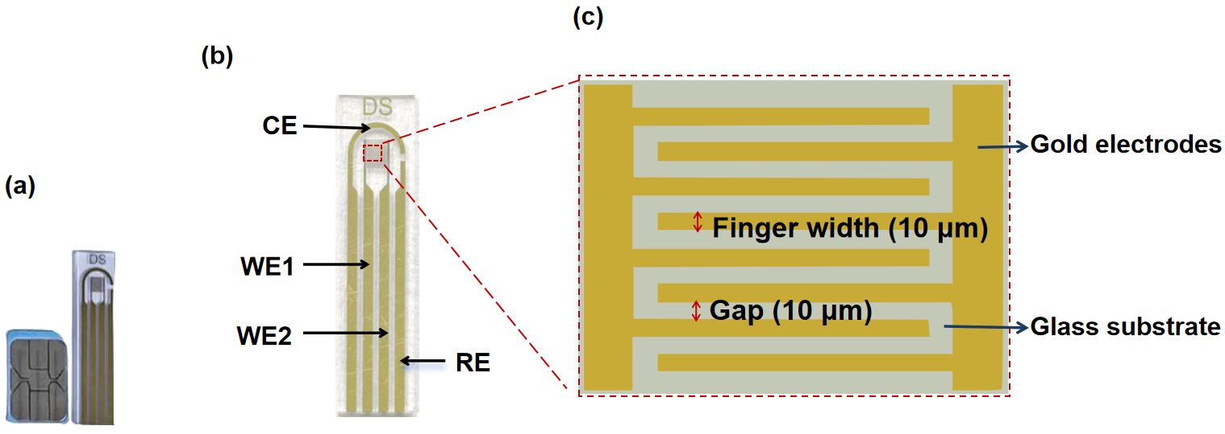

Figure 1: AuIDTE chip. (a) the SIM card and a chip; (b) Electrode layout; (c) The width/gap is of 10 μm.

2.2. Electrode Materials and Substrate Materials

2.2.1. Common Electrode and Substrate Materials for IDEs

Gold is a very popular material for the biosensor electrode due to its high conductivity, chemical stability and surface functionalization possibilities (Kosri, et al. 2022). Sulfur containing molecules can form stable self-assembled monolayers on gold via gold-sulfur interactions (Oberhaus, et al. 2020). Other materials are platinum, carbon and indium tin oxide. Platinum exhibits good chemical stability and electrochemical activity. Carbon products are inexpensive and chemically stable. Indium tin oxide has been used as a transparent and conductive material that can be employed in systems where optical and electrical detection should be combined. The selection of electrode materials should be based on a thorough consideration of conductivity, electrochemistry and chemical stability, biocompatibility, surface modification possibilities and cost of production. It should not be dictated by the conductivity aspect alone. Interdigitated electrodes are typically fabricated on substrates such as glass, silicon, ceramics or polymers. Glass is smooth, chemically stable and a good electrical insulator and thus highly appropriate to electrochemical chip. Silicon can be used with microfabrication technology and formed into more complex microstructures. Polymer is light-weighted, relatively inexpensive and simple to form flexible shape (Kosri, et al. 2022).
2.2.2. Roles of Gold and Glass in AuIDTEs
AuIDTE is a glass substrate that has gold electrodes. The two substances are the transmitting and supporting substance of the device in terms of electrochemical signal transmission. One of such electrode types is gold. It is very conductive, chemically stable to a certain degree which would be sufficient to fulfill the demand of electron transfer in the process of electrochemical detection. At the same time, the gold surface can form the self-assembled layer that is stable with the help of the sulfur-based molecules, which make it possible to immobilize the biological recognition agents (antibodies and aptamers) on its surface (Oberhaus, et al. 2020). AuIDTE contains the insulating material of the glass which is mechanical and electrical. In addition, the chemical stability of the glass is not so bad as well as the smoothness of the surface, which helps to stabilize the interdigitated structure of micrometer scale (Jarić, et al. 2024a).

2.3. Electrochemical Detection Using IDEs and AuIDTEs

2.3.1. Electrochemical detection principles of IDEs
IDEs can transduce biological recognition events into detectable electrical signals, which include current, potential, resistance, conductance, capacitance, and impedance among others. In general, one can describe the process as follows: if a given bio-recognition element binds to some molecule of interest at the electrode surface, then the occurring changes at the electrode surface cause a change in the signal output. For example, it has been observed that the charge distribution, electron transfer, or interfacial capacitance of the electrode surface varies after the target protein is bound when an antibody is immobilized on the gold electrode surface, thus appearing as a variation in the electric signal. The two most prominent categories of detection methods are voltammetry and electrochemical impedance spectroscopy (EIS) of IDE biosensors (Kosri, et al. 2022).
Voltammetry is a technique for characterising the electrochemical behaviour of the electrode interface whereby the electrode potential is controlled and the resulting current measured. One such method, cyclic voltammetry (CV) changes the electrode potential at a defined rate and measures the resulting change in current to obtain a current-potential curve. It can be employed to study redox reactions, modification of the electrode surface, adsorption of biomolecules and changes in the electrochemical response following binding of target molecules. Thus, it can be utilised both as a detection method and as a means of assessing the success of modification of the electrode surface. In differential pulse voltammetry (DPV) pulses are added during the scan of the potential, reducing the influence of background current and increasing sensitivity to small changes in current (Adam, et al. 2024).
In the case of current-based detection, IDEs are also able to be used in generator - collector mode so as to enhance the response by means of redox cycling. By proper control of potential and appropriate redox species, the oxidation or reduction product that is produced at one working electrode can go to the adjacent electrode and take part in a reverse reaction. The regenerated species can diffuse back again, creating a generator - collector redox cycle. This makes it possible for the same redox species to engage in multiple electron transfers, and thus improve the current response under suitable conditions (Kosri, et al. 2022).
EIS is the process of applying a small alternating current signal to the electrode and changing the frequency at which the response of the electrode system is measured. This provides information on solution resistance, charge transfer resistance, double-layer capacitance, overall impedance, and change of phase (Mazlan, et al. 2017). EIS can be classified as faradaic or non-faradaic based on the type of redox reaction that is involved. Faradaic detection often involves the presence of redox species and attachment of the target molecules to the electrode can prevent the movement of electrons; thus, there is a change in the charge transfer resistance (Rct). One of the parameters that are applied in the analysis of the ease of electron transfer at the surface of the electrode is Rct. In other words: binding of target molecule - alteration of the interface of an electrode - alteration of the transfer of electrons - alteration of the impedance. Rct may also be enhanced by blocking layers and nonspecific adsorption. Thus, increased Rct cannot demonstrate specific target binding by itself. Non-faradaic detection does not rely on redox reactions, and it focuses on the capacitance, dielectric behavior of the surface of the electrode and the interfacial dynamics of the electrode (Brosel-Oliu, et al. 2019) (Adam, et al. 2025). Figure 2 gives an overview of the electrochemical biosensors with IDEs.
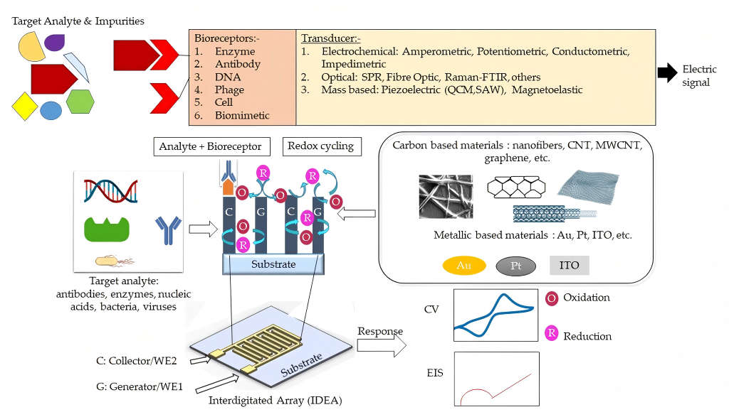

Figure 2: Schematic representation of IDE-based amperometric and impedimetric detection. Reprinted from
Kosri et al. (2022) under CC BY 4.0.

2.3.2. Electrochemical Detection Using AuIDTEs

Adam et al. (2024)(Adam, et al. 2024) employed AuIDTEs with DPV and CV to identify normal and aggregated α-synuclein. The detection signal was given by the change in current after the target protein bound to antibodies on the electrode surface. DPV overlays pulses on a staircase potential and measures the difference between the current immediately before each pulse and close to its end to get the peak current. CV documents current-potential curves during forward and reverse potential scans to examine redox peaks changes. Within the concentration range of 1 aM–1 pM, the calibration results of both methods exhibited a linear relationship between the peak current and the logarithm of the target concentration, enabling quantitative detection of α-synuclein. The paper observed that CV is usually applied to qualitative analysis whereas DPV minimizes the background current contribution and weak signals can be more easily identified. DPV is thus better suited to quantitative detection at low concentrations of targets where high sensitivity is required.
Adam et al. (2025) (Adam, et al. 2025) were able to identify the normal and aggregated forms of α-synuclein with the help of AuIDTEs by faradaic and non-faradaic EIS. They looked at their answers through Nyquist plots, impedance magnitude-frequency curves, and capacitance-frequency curves. Rct was found to generally increase with the concentration of the target as it was fitted using equivalent circuit fitting in the mode of faradaic, which indicated that there is a difficulty of transferring charge between the interface after the binding of targets. In the absence of redox reactions, the non-faradaic mode involved the detection of electrical properties of the interface change. The level of difference in the impedances and the capacitance among the concentrations of the target was usually higher at lower frequencies, which could be used as an indicator of frequency of measurements and analysis of the amount of the target.
AuIDTEs are able to identify target binding by detecting current or interfacial impedance changes, and the chip can be used with voltammetry as well as EIS.

2.4. Surface Modification and Biofunctionalization of IDEs and AuIDTEs

2.4.1. Surface Modification and Biofunctionalization of IDEs

Once the IDE is fabricated, photoresist, organic residues and other contaminants can be left on the surface. The surface is thus generally required to be cleaned and activated prior to additional modification(Kaushik, et al. 2018). These are solvent cleaning, sonication, piranha solution, potassium hydroxide (KOH) treatment, and oxygen plasma treatment(Ramanathan, et al. 2022) (MacKay, et al. 2017). The method of modification may be chosen depending on the material of the surface after pretreatment. As an illustration, molecules with thiols can be immobilized onto gold by Au-S bonds(Oberhaus, et al. 2020). Aminopropyltriethoxysilane (APTES) can be used to silanize glass or oxide surfaces that provide functional groups to immobilize antibodies, aptamers, enzymes or DNA probes in the next step(MacKay, et al. 2017).
Bifunctional linkers can form a self-assembled monolayer (SAM) on gold. One side is linked to the gold by a thiol and another one is an active group that binds biorecognition molecules. As an example, the terminal carboxyl groups are able to form amide bonds with amino groups of biomolecules using carbodiimide coupling. The DNA probes can also be immobilized directly onto the surface of the gold in which the probe has been modified by thiols. Following this immobilization, 6-mercapto-1-hexanol (MCH) may be introduced as a gap filler between probes, nonspecific interactions between the DNA and gold, and orientation of the probes. It is possible to add 1,6-hexanedithiol (HDT) to generate a ternary mixed layer, which can prevent displacement of the probes by MCH and stabilize the recognition layer. But it is not good to have thicker modification layers because they might interfere with electron transfer and therefore, both the stability of immobilization and signal transfer must be taken into consideration(Suni 2021). The main steps in IDE surface modification and biofunctionalization, from surface preparation to bioreceptor immobilization and blocking, are summarized in Figure 3.

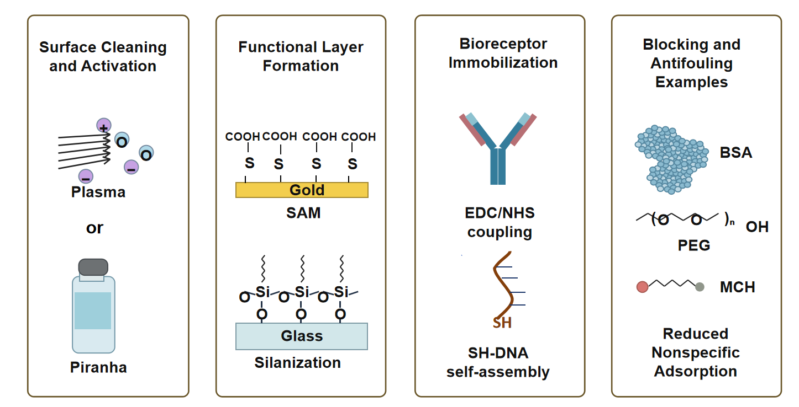

Figure 3： Schematic overview of surface modification and biofunctionalization strategies for IDEs.

Ramanathan et al. (2022) (Ramanathan, et al. 2022) treated the gold IDE with KOH, and then reacted it to the (3-glycidoxypropyl) trimethoxysilane (GOPTS) solution in which they immobilized the anti-spike protein antibodies on the surface of the IDE. The rest of the reactive sites were blocked by ethanolamine. In one of their previous studies, the authors attached the biomolecules to the nanomaterials through carbonyldiimidazole (CDI). They also modified a device based on gold electrode/silicon substrate using CDI-nanomaterial complexes. These instruments have been used to detect various types of target molecules. To purify the gold electrodes, Ding et al. (2017) (Ding, et al. 2017) applied piranha solution and sonicated the gold electrode in ethanol and water. They later coated the gold with a 5′-thiolated RNA aptamer capture probe (ACP), HDT, and MCH. ACP was able to identify interferon-gamma (IFN-γ) and the mixed layer minimized nonspecific adsorption of proteins.
These surface modification and biofunctionalization approaches assist in the immobilization of recognition molecules and the reduction of nonspecific adsorption, forming the basis for target detection.

2.4.2. Biofunctionalization and Surface Modification of AuIDTEs

The AuIDTE can be modified in both the gold electrodes and the glass gaps. Gold surface modification enables immobilization of antibodies and other recognition molecules, silanization of the glass gaps may assist in anchoring functional layers. The following studies explain the pretreatment, immobilization, and blocking processes that are applied to each approach and their use in antibody- and aptamer-based detection(Adam, et al. 2025; Adam, et al. 2024; Jarić, et al. 2024a; Jarić, et al. 2024b).
Adam et al. (2024) (Adam, et al. 2024) pretreated the AuIDTEs with diluted sulfuric acid. It was observed in the study that gold pretreatment has the potential to enhance interfacial electron transfer and minimize nonlinear drift in Rct. They then activated the surfaces by CDI, immobilized anti-α-synuclein antibodies and blocked the remaining sites using ethanolamine. Adam et al. (2025) (Adam, et al. 2025) soaked the AuIDTEs in a solution of diluted sulfuric acid and covered them with zinc oxide (ZnO). They subsequently functionalized the electrode surfaces with hexacyanoferrate and CDI, immobilized antibody on the surface treated with CDI and blocked the rest of the reactive sites with 1 M ethanolamine.
The G-IDE222 glass gaps were modified by Jarić et al. (2024a) (Jarić, et al. 2024a) with APTES and the gold electrodes in cysteamine. They have put a graphene oxide (GO) on IDE, which was reduced to make it a channel of reduced graphene oxide (rGO). The aptamer N20a, amino-modified, was bound to rGO using 1-pyrenebutyric acid N-hydroxysuccinimide ester (PBASE). Surface blocking was achieved by means of ethanolamine and bovine serum albumin (BSA). The aptasensor obtained was used to detect NT-proBNP.
In the other experiment, monolayer graphene was placed over the G-IDE222 chip to create a graphene field-effect transistor (GFET) channel. PBASE was used to modify the surface of the graphene and two monoclonal antibodies against Bet v 1 were immobilized on different sensors. To block the surface and minimize nonspecific interactions, BSA and Tween were employed (Jarić, et al. 2024b).
Combining these studies, it can be demonstrated that AuIDTEs have the potential to facilitate antibody-based and aptamer-based detection using various surface modification and biofunctionalization techniques.

2.5. Performance of IDE- and AuIDTE-Based Biosensors

2.5.1. Key Performance Metrics of IDE Biosensors
The performance of the IDE biosensor depends on electrode size, material, surface modification and biological recognition process and signal detection. The main parameters that are used to measure the performance of a biosensor are sensitivity, selectivity, specificity and limit of detection. Sensitivity is an indicator of how much the signal of the sensor is affected by the concentration of the target. Limit of detection (LOD) refers to the minimum amount of target which can be detected. In IDEs, finger width, gap, length, and number affect the electric-field distribution and mass transport, which can influence sensitivity. In generator–collector amperometric detection, a smaller electrode gap shortens the diffusion distance for redox species and promotes redox cycling. This will also enhance the current response and the signal-to-noise ratio, and this will aid in enhancing the sensitivity and reducing the LOD. Selectivity involves the ability of a sensor to differentiate between the target and interferents. When the potential conditions are favorable, the reversible redox species can be cycled multiple times in the generator-collector mode but not the irreversible ones, which may aid in differentiation between the two. Specificity is largely dependent on the biorecognition entity immobilised onto the IDE e.g. an antibody or aptamer. Binding of the target to the recognition element causes an interfacial change which the IDE transduces into an electrical signal. Therefore, specificity is an attribute of the functionalised sensor and is indicative of the ability of its recognition layer to identify the target (Kosri, et al. 2022).

2.5.2. Reported Performance of AuIDTEs

Adam et al. (2024)(Adam, et al. 2024) applied the AuIDTEs and DPV, CV to find normal and aggregated α-synuclein. The sensitivity was measured by means of the calibration equation between peak current and the logarithm of the target concentration. There are some things that can be done in order to enhance the sensitivity. The resistance of charge transfer was decreased and the electron exchange at the interface was improved after pretreatment with dilute sulfuric acid. More antibody probes would have been accommodated on the larger surface area available which would lead to a higher probability of capturing targets. DPV minimized the background current contribution so that weak signals could be detected easily. The LOD of the reported DPV was 10 aM and the linear range of the same was 1aM -1pM. The LOD of the CV of the aggregated α-synuclein was 100 aM. It was also found that the sensor reacted more to α-synuclein than tau protein as it could differentiate the target protein against the control protein. Electroactive surface area measurement had a relative standard deviation of less than 2% and voltammetric responses of 6.6%. The response measurements after storage also indicated that the sensors were stable during the tested time.
Adam et al. (2025) (Adam, et al. 2025) indicated that the sensitivity of α-synuclein was high with an EIS sensor on AuIDTEs. This can be attributed to the intense local electric field generated by the interdigitated design and modification of electrical characteristics of the interface following target binding. The impedance response was modified by binding the target to surface antibodies, which depended on the concentration of targets and was capable of measuring concentration. LODs of normal and aggregated α-synuclein in faradaic mode were 2.39 fM and 1.82 fM respectively. In non-faradaic mode, the LODs for normal and aggregated α-synuclein were 2.22 fM and 2.40 fM, respectively. Consistency of repeated EIS measurements was also reported to be good in the study. The sensor demonstrated significantly a stronger response to α-synuclein than to tau protein as a control, which confirms its selectivity and specificity under the given conditions.
Jarić et al. (2024a) (Jarić, et al. 2024a) constructed an rGO field-effect transistor (rGO-FET) based aptasensor to measure the NT-proBNP. It is possible that it was more sensitive because of the roughness and less charge screening on diluted phosphate-buffered saline (PBS). The LOD in artificial saliva without dilution was 41 fg/mL (about 4.6 fM). The control reaction of cardiac troponin I (cTnI) was at the noise level, and the sensor had been able to be regenerated and reused. Kudriavtseva et al. (2024) (Kudriavtseva, et al. 2024) have done a comparison of both the rGO and chemical vapor deposition (CVD) graphene aptasensors to the same target. The sensitivity of the rGO-FET was found to be higher due to its larger bandgap and roughness than CVD graphene sensor which exhibited less variation in parameters. They indicated their respective limits of detection in artificial saliva as 100fg/ml and 1pg/ml. Jarić et al. (2024b) (Jarić, et al. 2024b) designed a graphene immunosensor for Bet v 1 detection. The immersible sensor exhibited higher response than the drop-based sensor with reported LOD of 10 pg/mL and detection time of 12 min.

2.6. Biosensing Applications of IDEs and AuIDTEs

2.6.1. General Applications of IDE Biosensors

IDEs can be applied in the area of nucleic acid and protein detection, pathogen detection, food safety and environment monitoring as well as point-of-care testing. During the process of identifying nucleic acids, proteins or pathogens, the nucleic acid probes, antibodies or aptamers may be attached to the surface of the electrode. The electrochemical properties of the surface of the electrode will change when the recognition molecules attach themselves to their respective nucleic acid targets, proteins or pathogens. It could be mentioned that IDE impedance sensors have been used in bacterial identification and the application of electrochemical biosensors has also been common in the field of the identification of pathogens (Varshney and Li 2009) (Brosel-Oliu, et al. 2019) (Cesewski and Johnson 2020). Food and environmental samples can contain bacteria, proteins, toxins and other impurities in food safety and environmental monitoring. IDEs are miniaturizable and able to generate electrical signals rapidly and this makes them applicable in similar detections.The existing reviews have been a systematic summary of the application of electrochemical impedance biosensors in food safety detection (Chai and Oh 2020). In point-of-care testing, the goal is to detect as soon as possible at the patient side, on site or outside of the laboratory. IDEs are miniature, with low sample volume requirements and can be readily coupled to miniature electrochemical instruments. By way of example, research on a gold interdigitated electrode sensor that detects Zika virus protein has indicated that it may be possible to combine a sensing chip with a portable electrochemical detection device (Kaushik, et al. 2018).

2.6.2. Biosensing Applications of AuIDTEs

AuIDTEs have been applied to the identification of various proteins. Adam et al. (2024) (Adam, et al. 2024) also employed CV and DPV in order to identify the normal and aggregated α-synuclein, which is a way of determining the protein aggregation associated with Parkinson disease. The faradaic and non-faradaic EIS were used by Adam et al. (2025) (Adam, et al. 2025) to identify the presence of the α-synuclein and its aggregates. It can be seen that these studies demonstrate that there are two types of electrochemical techniques that can be used to detect the same protein associated with a disease. Jarić et al. (2024a) (Jarić, et al. 2024a) developed an rGO-FET aptasensor based on the chip in order to measure NT-proBNP as a heart failure biomarker in artificial saliva not diluted. The comparison between the use of rGO and CVD graphene aptasensors in the detection of NT-proBNP was also performed by Kudriavtseva et al. (2024) (Kudriavtseva, et al. 2024). Another experiment has been conducted by Jarić et al. (2024b) (Jarić, et al. 2024b)where they designed a graphene immunosensor to test Bet v 1, one of the allergens of birch pollen.
In general, AuIDTEs coupled with various recognition layers and detection techniques could sense disease-biomarkers and allergen proteins with good sensitivity. These outcomes offer experimental evidence for the further development of protein biosensors. These exemplary works are summarized in Table 1.

Table 1: Representative biosensing studies with AuIDTEs.
Reference | Target analyte | Detection method | Functionalization | Representative performance
Adam et al., 2024 | α-synuclein | CV, DPV | CDI; anti-α-synuclein antibodies; ethanolamine | DPV: range, 1 aM –1 pM; LOD,10 aM. CV: aggregated target LOD, 100 aM
Adam et al., 2025 | α-synuclein | EIS | ZnO; hexacyanoferrate; CDI; antibodies; ethanolamine | LODs (normal/aggregated): faradaic, 2.39/1.82 fM; non-faradaic, 2.22/2.40 fM
Jarić et al., 2024a | NT-proBNP | rGO-FET | APTES; cysteamine; rGO; N20a aptamer linked to PBASE;ethanolamine; BSA | LOD in undiluted artificial saliva: 41 fg/mL (approximately 4.6 fM)
Kudriavtseva et al., 2024 | NT-proBNP | rGO-FET and GFET | rGO or CVD graphene; N20a aptamer on PBASE. | LODs in artificial saliva: rGO-FET, 100 fg/mL; GFET, 1 pg/mL.
Jarić et al., 2024b | Bet v 1 | GFET | graphene; PBASE; anti-Bet v 1 antibodies; BSA and Tween | LOD: 10 pg/mL; detection time: 12 min

3 Problems and Future Outlook

3.1. Challenges of IDE Biosensors
The low target concentration, the interference resistance, long-term stability and mass production are still a problem to be solved by IDE biosensors. The electrode geometry should be optimized, nanomaterials introduced and surface modification enhanced in order to enhance the signal of detection but it has to be compatible with the device. The cross-reactivity of the recognition layer and slow loss of the biological activity may interfere with the detection process as well as the accuracy (Kumar, et al. 2024). Proteins, cells, lipids can be attached to the electrode in complex samples like urine, blood, sweat or saliva. This will also result in preventing the binding of the target or electron transfer and thus increase the background signal and reduce the target signal. Such a reduction in the signal-to-noise ratio can decrease the sensitivity and cause the response of the target to become difficult to distinguish against the noise. It is necessary to provide blocking treatments that are suitable and antifouling treatment to minimize interference(Saxena, et al. 2024).
The practicality is also restricted by the materials and manufacturing processes. Gold has a high conductivity, however it needs to be bonded on glass or silicon substrates with an adhesion layer of titanium (Ti) or chromium (Cr). Galvanic corrosion may occur in certain metal constructions, e.g., Ti Au or Cr Au, when they are put in contact with an electrolyte. The conditions of fabrication, surface residue, as well as variation in surface modification can influence electrode performance. It is necessary to regulate the width, spacing, and thickness of fingers during large-scale production, as well as modify the surfaces of the chips to minimize variations between the chips (Kosri, et al. 2022). The future research should ensure that the process of fabrication and treatment of the surfaces will be standardized, reagents would be dispensed automatically, and the detection quality will be verified in clinical or environmental samples. The IDE biosensors must also be connected with portable instruments and procedures which must be simplified so that the device could be used easily in practice (Kumar, et al. 2024) (Kosri, et al. 2022).

3.2. Challenges in AuIDTE-Based Biosensing
AuIDTEs have been demonstrated to be able to detect disease related proteins and allergens, however, further validation is required before practical application. Firstly, the functional layer on the chip can influence the measurement consistency. Jarić et al. (2024a) (Jarić, et al. 2024a) observed that small GO flakes might cause increased variation in sensor parameters. Thus, the material coverage and channel formation should be controlled during construction of an rGO channel on AuIDTEs. Kudriavtseva et al. (2024) (Kudriavtseva, et al. 2024) reported that rGO sensors were more sensitive whereas CVD graphene sensors exhibited better electrical properties consistency. Therefore, both sensitivity and consistency should be taken into account when selecting the channel material. Secondly, for antibody-modified AuIDTEs, pre-treatment, antibody immobilization and blocking conditions should also be standardised. Batch-to-batch differences should be evaluated for both bare chips and modified sensors to separate the manufacturing effects from the surface treatment effects.
The current sample tests are not free of flaws. The results of the experiments conducted by Adam et al. (2025) (Adam, et al. 2025)revealed that they could find α-synuclein amyloid protofibril in human serum, but the serum tests did not include monomers or other aggregated forms of α-synuclein. Jarić et al. (2024a) (Jarić, et al. 2024a) also made an experiment on the detection of NT-proBNP in artificial saliva. The association between salivary and blood concentration of NT-proBNP has to be determined before it is used in clinical practice as well as the influence of the rest of diseases like periodontal disease. In the case of Bet v 1 analysis, pollen extracts include other proteins, lipids and carbohydrates which might interfere with the signal. This would need more testing to be done using various samples of pollen to determine whether the allergen monitoring can be relied upon in practical use (Jarić, et al. 2024b). Another point mentioned by Adam et al. (2024) (Adam, et al. 2024)was that some physiological factors such as pH, temperature, and crowding of molecules could have been involved in the process of forming a fibril of α-synuclein and its interaction with other molecules, and these aspects should be further confirmed.
These limitations indicate that the reported high sensitivity of AuIDTE-based sensors should be considered together with performance in complex samples and between batches. Further studies are needed to investigate the influence of non-specific adsorption on background levels and target responses in real clinical and environmental samples, to test the efficacy of blocking and antifouling treatments and to compare batches of chips under standardised modification conditions. Only then can one obtain a stronger proof for their practical use with reliable results.

4 Conclusion

On the whole, AuIDTEs are interdigitated and have a small size, gold electrodes that are conductive and their surface chemistry is appropriate to immobilize biomolecules. They may be used in biorecognition systems with antibodies, aptamers, and nanoscale functional materials. It has been shown that voltammetry, EIS and field-effect detection can detect allergen proteins and disease-related biomarkers. The reviewed studies support the potential of AuIDTEs as biosensor chips in terms of structural design, choice of materials, surface treatment and signal transduction. Additional experiments should be conducted to determine sensitivity, selectivity, repeatability, and stability on complicated samples, the performance of different batches of chips, and the use of the device in clinical and environmental conditions.

REFERENCES

Adam, H., et al.
2025 Selective detection of alpha synuclein amyloid fibrils by faradaic and non-faradaic electrochemical impedance spectroscopic approaches. Bioelectrochemistry 161:108800.
Adam, Hussaini, et al.
2024 Cyclic and differential pulse voltammetric measurements on fibrils formation of alpha synuclein in Parkinson’s disease by a gold interdigitated tetraelectrodes. Process Biochemistry 136:212-220.
Basavaraj Banakar, Vijay, et al.
Structural plasticity of a dissipative neuromorphic material enables temporal information processing. ChemRxiv 2026(0326).
Brosel-Oliu, S., et al.
2019 Impedimetric transducers based on interdigitated electrode arrays for bacterial detection - A review. Anal Chim Acta 1088:1-19.
Cesewski, E., and B. N. Johnson
2020 Electrochemical biosensors for pathogen detection. Biosens Bioelectron 159:112214.
Chai, C., and S. W. Oh
2020 Electrochemical impedimetric biosensors for food safety. Food Sci Biotechnol 29(7):879-887.
Ding, S., et al.
2017 Rapid and Label-Free Detection of Interferon Gamma via an Electrochemical Aptasensor Comprising a Ternary Surface Monolayer on a Gold Interdigitated Electrode Array. ACS Sens 2(2):210-217.
Jarić, Stefan, et al.
2024a Femtomolar detection of the heart failure biomarker NT-proBNP in artificial saliva using an immersible liquid-gated aptasensor with reduced graphene oxide. Microchemical Journal 196:109611.
Jarić, Stefan, et al.
2024b Development of a graphene field effect transistor-based immersible biosensor for immunodetection of the birch pollen allergen Bet v 1 in air samples. Heliyon 10(20).
Jiang, Tianxiang, et al.
2024 Sensitivity studies and optimization of an impedance-based biosensor for point-of-care applications. Biosensors and Bioelectronics: X 18:100479.
Kaushik, Ajeet, et al.
2018 A sensitive electrochemical immunosensor for label-free detection of Zika-virus protein. Scientific Reports 8(1):9700.
Kosri, Elyana, et al.
2022 Micro and Nano Interdigitated Electrode Array (IDEA)-Based MEMS/NEMS as Electrochemical Transducers: A Review. Nanomaterials 12(23):4171.
Kudriavtseva, Anastasiia, et al.
2024 Comparative Study of Field-Effect Transistors Based on Graphene Oxide and CVD Graphene in Highly Sensitive NT-proBNP Aptasensors. Biosensors 14(5):215.
Kumar, Vikas, et al.
2024 Interdigitated Electrodes (IDEs)-Supported Biosensing for Efficient Point-of-Care Applications. ECS Sensors Plus 3(4):043401.
MacKay, Scott, et al.
2017 Using Impedance Measurements to Characterize Surface Modified with Gold Nanoparticles. Sensors 17(9):2141.
Mazlan, N. S., et al.
2017 Interdigitated electrodes as impedance and capacitance biosensors: A review. AIP Conference Proceedings 1885(1):020276.
Oberhaus, F. V., D. Frense, and D. Beckmann
2020 Immobilization Techniques for Aptamers on Gold Electrodes for the Electrochemical Detection of Proteins: A Review. Biosensors (Basel) 10(5).
Ramanathan, S., et al.
2022 Nanodiamond conjugated SARS-CoV-2 spike protein: electrochemical impedance immunosensing on a gold microelectrode. Mikrochim Acta 189(6):226.
Saxena, Survanshu, et al.
2024 Anti-Fouling Polymer or Peptide-Modified Electrochemical Biosensors for Improved Biosensing in Complex Media. Advanced Sensor Research 3(5):2300170.
Silva, H. D., et al.
2025 Interdigitated Capacitive Biosensors as Accessible Sensors: A Literature Review. IEEE Access 13:202315-202339.
Suni, II
2021 Substrate Materials for Biomolecular Immobilization within Electrochemical Biosensors. Biosensors (Basel) 11(7).
Thévenot, D. R., et al.
2001 Electrochemical biosensors: recommended definitions and classification. Biosens Bioelectron 16(1-2):121-31.
Varshney, Madhukar, and Yanbin Li
2009 Interdigitated array microelectrodes based impedance biosensors for detection of bacterial cells. Biosensors and Bioelectronics 24(10):2951-2960.

