The Title Goes Here with Each Initial Letter Capitalized: (Use the Microsoft Word template style: Title) or (Use Cambria Font: 14 pt, Bold, Centered)
Author¹, Author^{2*} and Author³ (Cambria, 10pt)
¹Affiliation (Cambria, 10pt)
²Affiliation (Cambria, 10pt)
³Affiliation (Cambria, 10pt)

Received XX August 2026, Revised XX September 2026, Accepted XX November 2026 (Cambria, 10pt)

ABSTRACT

These instructions give you the basic guidelines for preparing papers for ICoTriCE 2026 format. Submissions that do not comply with these requirements may be returned for revision. To avoid delays in the publishing process, you must strictly follow the conference’s guidelines and format. Your abstract should state the principal objectives and scope of the research, describe the methodology employed, summarize results, conclusions. The abstract should contain a maximum of 200 words. To format your abstract, use the Microsoft Word template style: Abstract Template or Use Cambria Font: 9 pt, Indent: left 0.5 cm, Right: 0.5 cm, Justified. Each paper must include an abstract.

Keywords: 3-5 keywords, separated by commas (Cambria 9 pt, Indent: left 0.5 cm, Right: 0.5 cm, Justified)

INTRODUCTION (First-level heading, Cambria, 11pt, Uppercase, Bold)
This document was prepared for Microsoft Word. It provides a simple example of a paper and offers guidelines for preparing your article. Here we introduce the paragraph styles for Level 1 and Level 2 headings. To format a paragraph, use the Microsoft Word template style: Normal or Cambria Font: 10 pt, no indentation and justified. In this template, we note each heading is First, Second and Third Levels; for example, “INTRODUCTION.” We have also highlighted in yellow, which font style to use – for example, “(Cambria 10pt, Justified)” for Normal Text. Again, those notes are not part of the headings or normal text. Their purpose is to advise you of the name of the style defined in this Word template. Use this for primary headings for Methodology, Results, or specific thematic breaks. Note that while it is only one point larger than the body text, the Bold weight provides the necessary visual hierarchy to guide the reader's eye.

The paper must include the following: (1) Introduction, (2) Theoretical Background, (3) Methodology, (4) Data Collection and Analysis, (5) Discussion and Results, (6) Conclusions and (7) References. Supplementary data and other sections are optional. You will usually want to divide your article into (numbered) sections and subsections (perhaps even sub-subsections). Code section headings using the options in the ‘Styles’ menu. Headings should reflect the relative importance of the sections. Note that text runs on after a 4th order heading. Use the heading style for the whole paragraph, but remove the italic coding except for the actual heading.

Within the introduction, the authors should follow a logical structure, beginning with the scientific motivation to establish the technical importance of the research. Authors must then transition into a literature review that highlights current advancements in areas, specifically identifying a knowledge gap that existing studies have failed to address. This leads to a clear statement of the proposed solution or hypothesis, defining the system boundaries and the novelty of the methodology used. Finally, the section should conclude with a concise list of research objectives. (Cambria 10pt, justified).

MAIN TEXT

Introduction (Second-level heading, Cambria, 10pt, Sentence case, Bold)
To format a paragraph, use the Microsoft Word template style: Normal or Cambria Font: 10 pt, No indentation, Justified. The subheading sits at 10-pt. You need to Bold these subheadings to make them pop against the body text.

Tables, Figures and Equations
To format a paragraph, use the Microsoft Word template style: Normal or Cambria Font: 10 pt, No indentation, Justified. Figures, tables, and equations must be inserted in the text and may not be grouped at the end of the paper. Important: A miscount of figures, tables, or equations may result in revisions. Please double check the numbering of these elements before you submit your paper to your proceeding’s editor. If you need to arrange many figures, a good tip is to place them in a table, which gives you additional control of the layout. Leave a line space between your figure and any text above it, and the figure description and any text below it, like Table 1 and Figure 1.

Table 1: To format a table caption, use the Microsoft Word template style: Table Caption. The text “Table 1,” which labels the caption, should be bold. Center this text above the Table. Tables should have top and bottom rules, and rules separating all rows.
Column Header Goes Here | Column Header Goes Here | Column Header Goes Here
Row Name Here | x | x
Row Name Here | x | x
Row Name Here | x | x

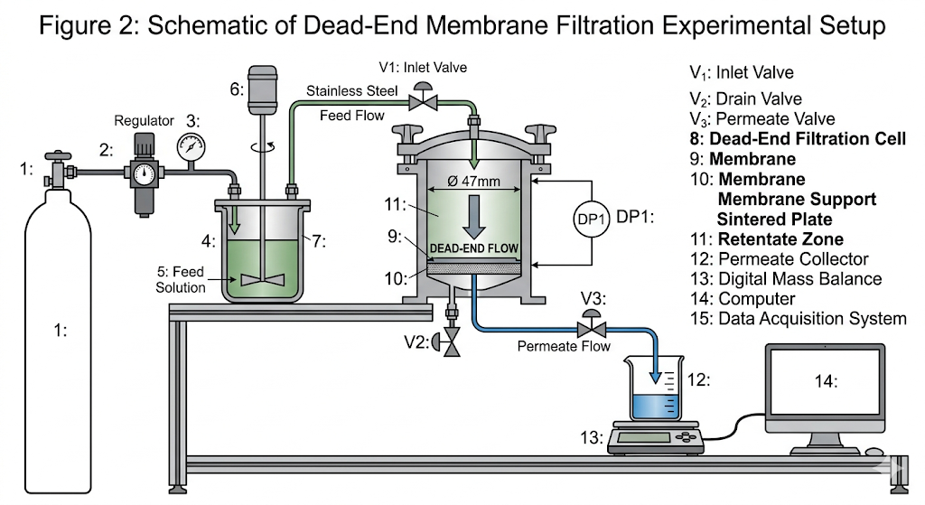
Figure 1: To format a figure caption, use the Microsoft Word template style: Figure Caption. The text “Figure 1,” which labels the caption, should be bold. Center this text below the Figure. Figures should be centered. Example of Figure Caption; Schematic of dead-end membrane filtration setup (AI generated for the purpose of manuscript template)
Conventionally, in mathematical equations, variables and anything that represents a value appear in italics, while chemical equations are displayed in roman, except for positional prefixes. You may choose to number equations for easy referencing. In that case the number should appear at the right margin. You can type your equations and use the symbols in the Word® equation editor. The equations should be labelled as Equation [1] and Equation [2].

(1)
$A=πr^{2}$ (2)

References
References must be numbered consecutively in the order in which they are first mentioned in the text. Use Arabic numerals in square brackets, such as [1] or [2–5]. These numbers should be placed inside punctuation if they refer to a specific statement, for example: "The catalytic efficiency was found to increase with surface area [6]." When citing multiple sources, separate them with commas [7, 8] or use a dash for a continuous range [9–12]. At the end of the manuscript, provide a full list of references in 10-pt Cambria. This list must match the numerical order established in the text. A standard format for a chemical engineering journal article is as shown in the references section.

MAIN CONTENT
Authors should be as concise as possible in their experimental descriptions. The Experimental section must contain all information necessary to ensure reproducibility. An introductory paragraph should be included, providing details on solvents, sources of less common starting materials, special equipment, and related information. This section should also specify the type of elemental analyser used and the name of the analytical laboratory. Procedures must be written in the past tense and should include the weight, volume, and other relevant quantities in parentheses following the names of the substances or solvents. General reaction conditions should be reported only once. The title of each experiment should include the chemical name and compound number of the product prepared; thereafter, the compound should be referred to by its assigned number.

The Results and Discussion section should present findings clearly and concisely, followed by critical interpretation and analysis. Data should not be repeated unnecessarily between text, tables, and figures; instead, the most relevant results should be highlighted and discussed. All figures and tables must be properly labelled, numbered, and referenced in the text. The discussion should interpret the significance of the results rather than merely restating them. Comparisons with previously reported studies should be included where appropriate to contextualize the findings. Any observed trends, relationships, or anomalies must be explained with sound scientific reasoning. Where applicable, mechanistic insights, theoretical considerations, or supporting calculations should be provided. Uncertainty, limitations, and potential sources of error should be acknowledged. The discussion should remain focused, avoiding speculation that is not supported by the data.

The Conclusion section should briefly summarize the key findings of the study and their significance. It should not simply repeat statements from the Results and Discussion but instead provide a concise synthesis of the main outcomes. The conclusion should highlight the contribution of the work to the field and may include implications, potential applications, or recommendations for future research. New data or extensive discussion should not be introduced in this section.

CONCLUSION

ACKNOWLEDGMENTS
The Acknowledgements section should recognize individuals, institutions, and funding bodies that contributed to the work but do not meet the criteria for authorship. This may include technical assistance, laboratory support, or valuable discussions. All sources of financial support must be clearly stated, including the funding agency name(s) and grant number(s), where applicable. Authors should ensure that all individuals acknowledged have given permission to be named. The wording should be concise and professional. Personal dedications or overly informal statements should be avoided. The wording should be concise and professional, and written as a single paragraph following the standard manuscript template format. Personal dedications or overly informal statements should be avoided.

REFERENCES
- I. E. Alguindigue, A. Loskiewicz-Buczak, and R. E. Uhrig, "Monitoring and diagnosis of rolling element bearings using artificial neural network," IEEE Transactions on Industrial Electronics, vol. 40, no. 2, pp. 209-217, 1993.
- R. Aiordachioaie D., R. Teodorescu, and G. Puscasu, "Fault Detection in Electrical Machines with Neural Networks," in Proc. ELECTROMOTION'95 Symposium, Cluj-Napoca, Romania, 1995.
- S. A. Al-Araimi, R. K. Al-Balushi, and B. Samanta, "Bearing Fault Detection Using Artificial Neural Networks and Genetic Algorithm," EURASIP Journal on Advances in Signal Processing, vol. 2004, no. 3, pp. 366-377, 2004.
- K. F. Al-Raheem, A. Roy, K. P. Ramachandran, D. K. Harrison, and S. Grainger, "Application of the Laplace-Wavelet combined with ANN for Rolling Bearing Fault Diagnosis," International Journal of IJNeaM, vol. 11, no. 4, pp. 19-24, 2008.

