Detecting Running Status of The Infusion Pump

To detect The infusion pump working status we can detect the electromagnetic field generated by the electronic circuit or by the electrical motor. A simple circuit implemented to detect the electromagnetic field generated by the electronic circuit. This circuit (Figure 1) consists of Arduino, resistor and piece of wire as antenna.

By using analog input in the Arduino board we can get the voltage value that generated by the electromagnetic field crossing the antenna. Figure 2 shows the output if the infusion pump is of where the output is zero.

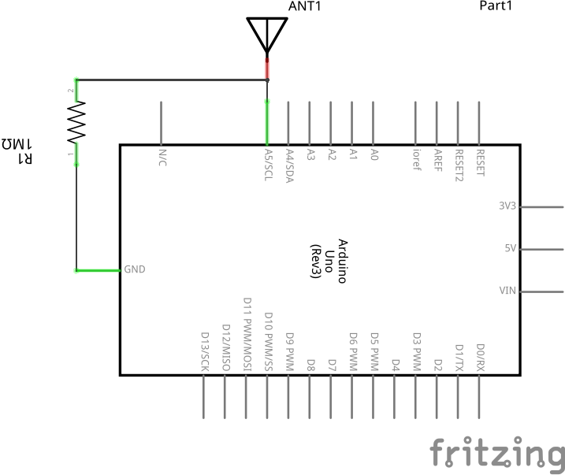Figure 1: Circuit diagram

If the infusion pump turned on, we can see some spikes in the output plot in Figure 3.

Figure 2: Output when the infusion pump is of

When the infusion pump start pumping, we can see the output spikes in the plot increase and become more close to each other as in Figure 4.

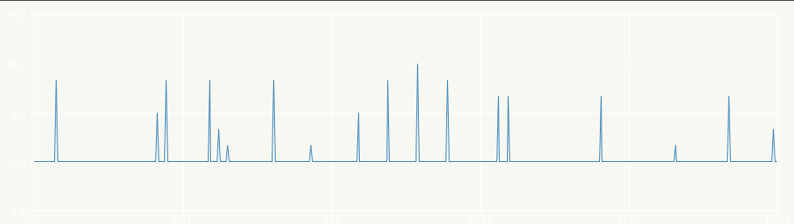Figure 3: The output when the infusion pump turned on

The best place to put the antenna of the circuit for best detection is shown in figure 5. Also this method for detecting the running status may be working with other devices.

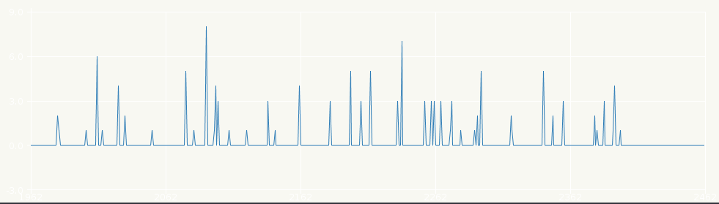Figure 4: The output after the infusion pump start pumping

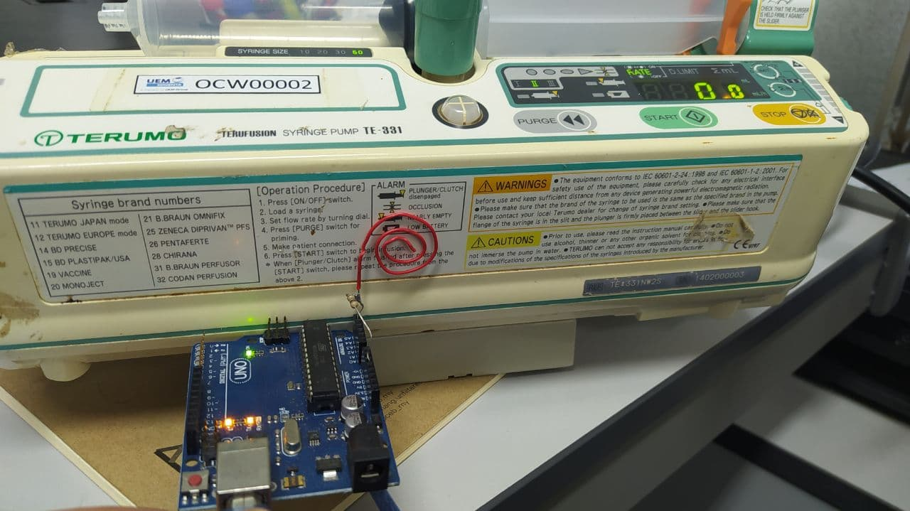Figure 5: Placement of the detector on the infusion pump