**Numerical Optimization of Injection-Moulded Recycled Plastic Honeycomb Bricks via Integration of the Taguchi Method and Grey Relational Analysis Approach**

**Nik Mizamzul Mehat*, Jeevan Raj Rajah1 and Shahrul Kamaruddin,2**

1 Faculty of Mechanical Engineering Technology, Universiti Malaysia Perlis, Kampus Tetap Pauh Putra, 02600 Arau, Perlis, Malaysia

2 Mechanical Engineering Department, Universiti Teknologi PETRONAS, 32610, Bandar Seri Iskandar, Perak, Malaysia

*E-mail: nikmizamzul@unimap.edu.my

**Abstract.** This study explores the production of plastic honeycomb bricks using the injection moulding process, emphasizing the importance of using recycled plastic to minimize environmental impact. Using the Taguchi L18 orthogonal array and Grey Relational Analysis (GRA), the study identifies the optimal and significant factors that influence the structural properties of these bricks made of recycled polypropylene. The main effect analysis revealed that the optimal factor combination for minimizing deflection and volumetric shrinkage is A2B1C1D3E1F3G2. ANOVA results indicated that reinforcement material is the most significant factor in enhancing the multi-quality characteristics of the honeycomb bricks. These findings can benefit the construction industry by improving the quality of plastic honeycomb bricks through the use of various fillers and thermoplastic reinforcements. By integrating the Taguchi method and GRA, the study optimizes the injection moulding process to address multiple quality issues, with a specific focus on challenges related to brick production.

**Keywords:** Injection Moulding, Optimization, Taguchi Method, Grey Relational Analysis

1. **Introduction**

The increasing environmental concerns associated with plastic waste have driven the need for innovative solutions that can mitigate its impact. One promising approach is the recycling of plastics for use in construction materials. Bricks for instance, are widely used in construction due to their functionality, durability, availability, strength, and low cost. They are commonly used in wall construction, paving, and retaining walls in both residential and commercial buildings, providing load-bearing strength and durability. Traditional brickmaking, known as the soft mud process, involves pressing moist clay into rectangular moulds by hand [1-2]. The construction industry has long relied on traditional bricks, made from clay and other natural materials, for their durability, strength, and cost-effectiveness. However, the production of these bricks involves significant environmental impacts, including the depletion of natural resources and the emission of greenhouse gases. In response to these challenges, the use of recycled plastic materials has emerged as a promising alternative, offering a sustainable solution to reduce environmental footprints. Plastic honeycomb bricks have emerged as a viable option due to their lightweight nature, structural integrity, and potential for incorporating recycled materials [1]. Plastic honeycomb bricks, can be produced through advanced manufacturing processes such as injection moulding, present an innovative substitute for traditional bricks. The use of recycled plastics, such as polypropylene (PP) helps in mitigating the issue of plastic waste [3]. The honeycomb structure on the other hand, not only reduces the weight of the bricks but also enhances their structural integrity, making them suitable for various construction applications. Plastic injection moulding is a versatile manufacturing process used to produce intricate and precise plastic parts in large quantities. It involves injecting molten plastic material into a mould cavity under high pressure. The process begins with the design of the mould, which determines the final shape and features of the part. During injection moulding, the plastic material is fed into a heated barrel and then forced into the mould cavity, where it cools and solidifies. Plastic injection moulding offers significant benefits such as high efficiency, consistent quality, and versatility in using various plastic materials customized for specific needs, allows for the mass production of complex shapes with tight tolerances and smooth surfaces [4-5].

However, achieving successful injection moulding entails meticulous attention to several critical factors particular in producing recycled plastic honeycomb bricks. These include selecting the appropriate material suited for the intended application of the honeycomb bricks, designing a mould that aligns with the part's specifications, meticulously controlling processing parameters like temperature and pressure, and implementing rigorous quality control measures throughout the production process of the plastic honeycomb bricks. The design of the injection mould and the plastic part significantly impacts the quality of the final product. The mould design, including factors such as the placement and size of cooling channels, directly influences the cooling rate and uniformity, which affects the part's dimensional accuracy and surface finish. For instance, conformal cooling channels can reduce warpage and shrinkage by ensuring even cooling throughout the mould, thereby improving part quality [6]. Part design elements, such as wall thickness and rib placement, also play crucial roles. Uneven wall thickness can lead to differential cooling rates, causing internal stresses and warpage. Properly designed ribs can enhance structural integrity without introducing defects like sink marks [7]. Additionally, the placement of gates and runners affects the flow of molten plastic into the mould cavity. Optimized gate locations can minimize weld lines and air traps, which are critical for maintaining part strength and aesthetics [8]. The injection moulding process parameters on the other hand, such as temperature, pressure, and cooling rate, significantly influence the quality and properties of the final plastic parts. Key parameters like melt temperature, mould temperature, injection speed, and holding pressure directly affect the material's flow behavior, cooling rate, and shrinkage, which in turn impact the mechanical properties, dimensional accuracy, and surface finish of the moulded part [9-10]. For instance, higher injection temperatures can enhance material flow and reduce viscosity, but excessive temperatures may lead to degradation of the polymer. Similarly, increased injection pressure can improve the packing of the material into the mould, but excessive pressure might cause part warpage or flash. Cooling rate is critical as well; rapid cooling can lead to internal stresses and potential part deformation, while slower cooling may result in better dimensional stability but longer cycle times. Mould temperature affects the surface finish and crystallinity of the part, where higher mould temperatures can improve surface gloss but may also extend the cycle time. Therefore, balancing these parameters is crucial to achieving high-quality, defect-free plastic parts with desired mechanical properties and aesthetic appearance [11-12]

Comprehending to all the facts, this study aims to explore the potential of plastic honeycomb bricks as a viable substitute for traditional bricks. By optimizing the injection moulding process through the integration of the Taguchi method and Grey Relational Analysis (GRA), the research seeks to enhance the quality and performance of these innovative bricks. The focus will be on identifying the optimal material combinations, part and mould design, and processing parameters to ensure minimal defects and maximum structural integrity of the honeycomb bricks. The findings from this study are expected to provide valuable insights for the construction industry, promoting the adoption of recycled plastic bricks as a sustainable alternative. By demonstrating their practicality and benefits, this research contributes to the advancement of eco-friendly construction materials, aligning with global efforts to achieve sustainable development goals and reduce environmental impacts. The integration of the Taguchi method and GRA not only improves product performance but also contributes to cost savings and increased production efficiency. This approach systematically addresses material selection, design considerations, and processing parameters, offering valuable insights for producing high-quality honeycomb bricks with superior structural characteristics and minimal defects.

1. **Methodology**

*2.1 Development of 3D part and simulation model of honeycomb brick*

In this work, the part to be studied is honeycomb brick. Honeycomb bricks are innovative construction part known for their lightweight structure and high strength-to-weight ratio [13]. The dimensions of the honeycomb are 7.87 mm in length, 2.0 mm in wall thickness, 2.56 mm in width, and 3.15 mm in height. Figure 1 illustrates the dimensions and specifications of the 3D model for the honeycomb brick. Meanwhile, the simulation model of a plastic honeycomb brick with a mesh geometry featuring a maximum aspect ratio of 4.10, 93.3% matching, and 92.5% reciprocity is illustrated in Figure 2.

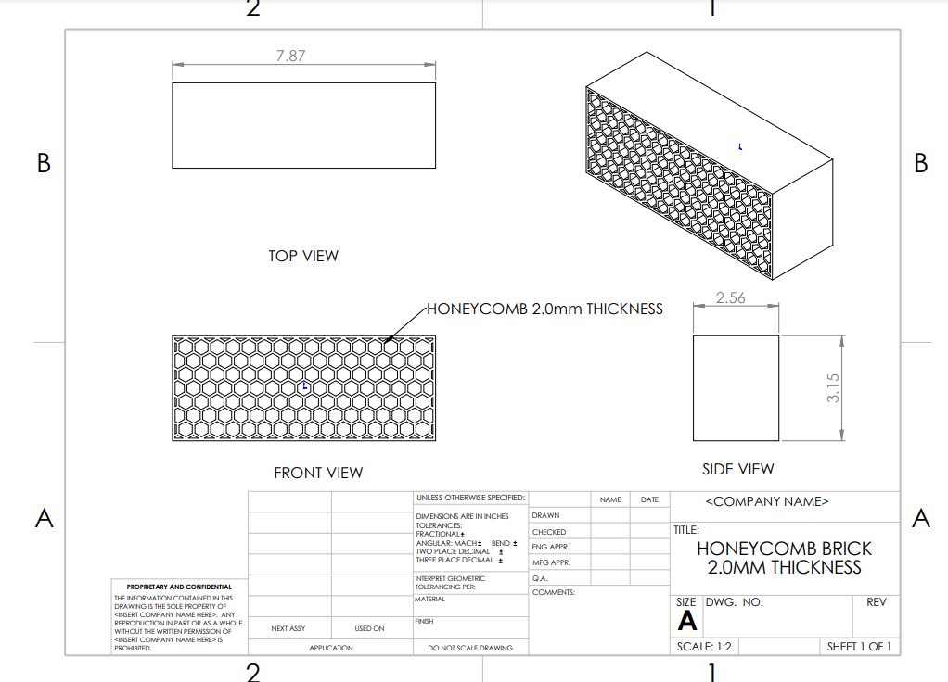

**Figure 1.** Geometry and specification of honeycomb brick

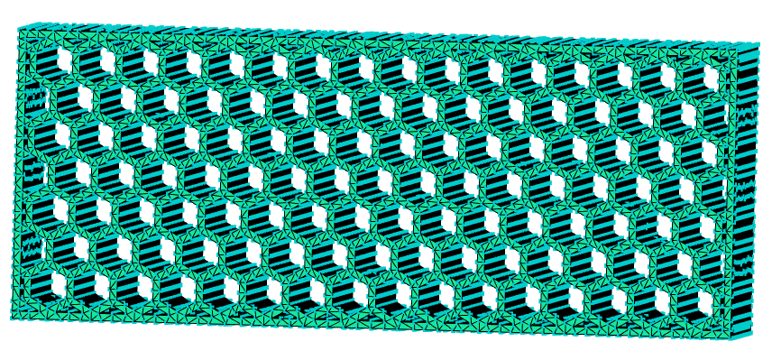

**Figure 2.** Mesh model of honeycomb brick

*2.2 Optimization method*

In this research, Mouldflow Plastic Insight (MPI) was employed to numerically simulate the 3D mesh honeycomb brick model. The Taguchi method's robust parameter design, in conjunction with GRA, was applied to conduct this simulation. The Taguchi method and GRA are integrated to identify the optimal and significant factors influencing the quality of honeycomb bricks made from recycled polypropylene. The Taguchi method, developed by Dr. Genichi Taguchi in the 1950s, is a powerful statistical technique used extensively in engineering and manufacturing disciplines. It aims to improve the quality and performance of products and processes by systematically optimizing design parameters. Unlike traditional experimental methods that require a large number of tests to identify optimal settings, the Taguchi method employs orthogonal arrays to efficiently explore multiple variables with a minimal number of experiments[14]. On the other hand, GRA is originally developed by Deng Julong in the 1980s, primarily used for solving problems involving multiple conflicting objectives or criteria. It operates on the principle of evaluating relationships between variables in a less precise or uncertain environment, often characterized by incomplete or limited information[15]. The overall methodology flowchart is shown in Figure 3.

*2.2.1 Determination of quality characteristics*

In this study, deflection, volumetric shrinkage, and sink marks were chosen as quality characteristics to investigate how material selection, part design, and injection moulding process parameters influence the simulation model of honeycomb bricks. Deflection or warpage in plastic honeycomb bricks refers to the bending or distortion of the brick from its intended shape or position. Warpage can cause dimensional inaccuracies, where the brick may not meet specified tolerances or dimensions required for proper fit and assembly. This can lead to difficulties during installation and may require additional adjustments or corrections [16]. Warpage can also impact the mechanical properties of the honeycomb bricks, such as reducing their load-bearing capacity or increasing susceptibility to damage under stress. Uneven warpage across multiple bricks can lead to uneven stress distribution within the structure, potentially compromising its long-term durability. On the other hand, in plastic honeycomb bricks, volumetric shrinkage refers to the reduction in volume that occurs as the molten plastic solidifies and cools inside the mould during the injection moulding process. Volumetric shrinkage directly influences the final dimensions of the honeycomb bricks. If not controlled properly, excessive shrinkage can lead to dimensional inaccuracies where the bricks do not meet specified tolerances. This can result in difficulties during assembly and affect the overall appearance and functionality of the structure[17]. Meanwhile, sink marks in plastic honeycomb bricks refer to depressions or indentations on the surface of the brick caused by uneven cooling during the injection moulding process. These marks typically occur when the outer surface of the brick cools and solidifies faster than the inner core, leading to shrinkage and inward pulling of the material. Depending on the severity and location of sink marks, this defect can weaken the structural integrity of the honeycomb bricks. Concentrated sink marks may indicate areas of internal stress or reduced material density, potentially compromising the brick's load-bearing capacity or durability [18].

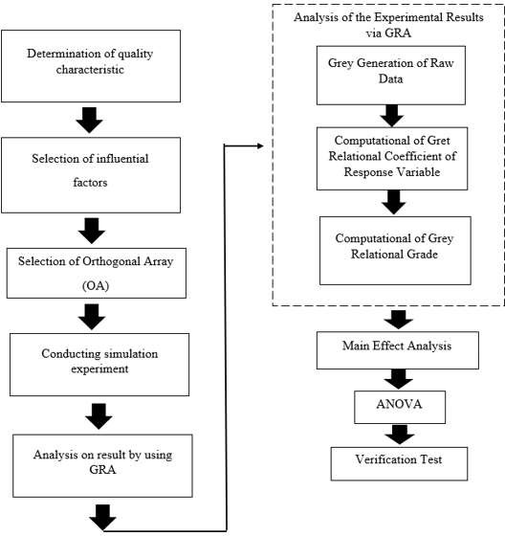

**Figure 3:** Overall Methodology Flow Chart

*2.2.2 Selection of influential factors*

This study selected a range of control factors, including reinforcing material and various injection moulding processing parameters. The research encompasses multiple injection moulding processing parameters such as melt temperature, injection pressure, filling pressure, injection time, filling time, and cooling time. Table 1 presents the chosen control parameters along with their respective levels. As depicted in Table 1, factor A pertains to the reinforcement material, with three specific materials chosen for this study: recycled PP with no filler, recycled PP with 20% glass fiber, and recycled PP with 20% calcium carbonate. Additionally, the study includes various processing parameters: melting temperature (factor B), injection pressure (factor C), filling pressure (factor D), injection time (factor E), filling time (factor F), and cooling time (factor G). Each factor was set at three levels to encompass a range of values that significantly impact the experimental outcomes.

**Table 1**. Floating-point operations necessary to classify a sample.

|  |  |  |  |  |
| --- | --- | --- | --- | --- |
| Column | Factor | Level 1 | Level 2 | Level 3 |
| A | Reinforcement material | Recycle PP with no filler | Recycle PP + 20% glass fibre | Recycle PP + 20% calcium carbonate |
| B | Melt Temperature (°C) | 230 | 240 | 250 |
| C | Injection Pressure (MPa) | 140 | 150 | 160 |
| D | Filling pressure (%) | 60 | 80 | 100 |
| E | Injection time (s) | 1 | 2 | 3 |
| F | Filling time (s) | 1.4 | 1.6 | 1.8 |
| G | Cooling time (s) | 30 | 40 | 50 |

*2.2.3 Selection of Orthogonal Array (OA)*

In Taguchi Orthogonal Arrays (OA), "DOF" stands for "Degrees of Freedom," referring to the total number of independent parameters or factors that can be varied in the experiment. The selection of an appropriate OA depends on the total DOF of the selected factors. In this study, there are seven factors, each at three levels. Each three-level factor has two DOF (DOF = number of levels - 1), resulting in a total DOF of 14. The total DOF of the selected OA should be at least equal to the total DOF of the studied factors. Therefore, an L18 OA was chosen, as it accommodates all seven factors at three levels with only 18 simulation runs.

**3. Result And Discussion**

*3.1 Analysis of experimental results via Grey Relational Analysis (GRA)*

GRA is a multi-objective optimization method that effectively addresses discrete data issues with multiple inputs, yielding positive outcomes. The first step in the GRA process is pre-processing. During this stage, the original data sequences are compared. This involves normalizing, scaling, and sorting the data into comparable sequences. Quality attribute data, such as deflection, volumetric shrinkage, and sink marks of the honeycomb brick, must be normalized to a range between 0 and 1. Table 2 lists the normalized data for these attributes for each trial, using the "lower-the-better" characteristic as defined by Eq. (1).

(1)

* + 1. *Determination of deviation sequence*

The deviation sequence ∆0𝑖 (𝑘) is the absolute difference between the reference sequence $x_{\begin{aligned}* \\ 0\end{aligned}}$* (𝑘) and the comparability sequence $x_{\begin{aligned}* \\ i\end{aligned}}$* (𝑘𝑘) after normalization. It is determined using Eq. (2) and listed in Table 3.

${xi}^{*} \left(k\right)=\frac{{xi}^{0}(k)}{{xi}^{0} (1)}$ (2)

**Table 2**. The normalization data for deflection, volumetric shrinkage, and sink mark

|  |  |  |  |  |
| --- | --- | --- | --- | --- |
| Trial no |  | Deflection | Volumetric shrinkage | Sink mark |
| 1 |  | 0.0000 | 0.4109 | 0.5749 |
| 2 |  | 0.0928 | 0.2453 | 0.4171 |
| 3 |  | 0.1713 | 0.1327 | 0.2494 |
| 4 |  | 0.9394 | 1.0000 | 0.8792 |
| 5 |  | 0.9668 | 0.9229 | 0.7569 |
| 6 |  | 1.0000 | 0.5525 | 0.5731 |
| 7 |  | 0.0312 | 0.5449 | 0.2989 |
| 8 |  | 0.1134 | 0.1315 | 0.5876 |
| 9 |  | 0.1838 | 0.1024 | 0.4315 |
| 10 |  | 0.0050 | 0.4412 | 0.6500 |
| 11 |  | 0.4392 | 0.2099 | 0.1171 |
| 12 |  | 0.1695 | 0.0000 | 0.1384 |
| 13 |  | 0.9801 | 0.8142 | 1.0000 |
| 14 |  | 0.9958 | 0.6941 | 0.6216 |
| 15 |  | 0.9934 | 0.7977 | 0.5152 |
| 16 |  | 0.1452 | 0.5322 | 0.5805 |
| 17 |  | 0.1290 | 0.1530 | 0.7178 |
| 18 |  | 0.1688 | 0.0632 | 0.0000 |

**Table 3.** Deviation Sequence

|  |  |  |  |
| --- | --- | --- | --- |
| Trial no | Deflection | Volumetric shrinkage | Sink mark |
| 1 | 1.0000 | 0.5891 | 0.4251 |
| 2 | 0.9072 | 0.7547 | 0.5829 |
| 3 | 0.8287 | 0.8673 | 0.7506 |
| 4 | 0.0606 | 0.0000 | 0.1208 |
| 5 | 0.0332 | 0.0771 | 0.2431 |
| 6 | 0.0000 | 0.4475 | 0.4269 |
| 7 | 0.9688 | 0.4551 | 0.7011 |
| 8 | 0.8866 | 0.8685 | 0.4124 |
| 9 | 0.8162 | 0.8976 | 0.5685 |
| 10 | 0.9950 | 0.5588 | 0.3500 |
| 11 | 0.5608 | 0.7901 | 0.8829 |
| 12 | 0.8305 | 1.0000 | 0.8616 |
| 13 | 0.0199 | 0.1858 | 0.0000 |
| 14 | 0.0042 | 0.3059 | 0.3784 |
| 15 | 0.0066 | 0.2023 | 0.4848 |
| 16 | 0.8548 | 0.4678 | 0.4195 |
| 17 | 0.8710 | 0.8470 | 0.2822 |
| 18 | 0.8312 | 0.9368 | 1.0000 |

*3.1.2* *Determination of Grey Relational Coefficient (GRC) and Grey Relational Grade (GRG)*

The relationship between the ideal (optimal) and actual normalized deflection, volumetric shrinkage, and sink marks is expressed by GRC for all sequences. If the two sequences agree at all points, then their GRC is 1. The GRC 𝛾 ( $x_{0}$ (𝑘), $x_{i}$ (𝑘𝑘)) as expressed by Eq. (3).

 (3)

where ∆𝑚in is the smallest value of ∆0𝑖 (𝑘𝑘) = $\min_{i}$ $\min_{k}$ $x_{\begin{aligned}* \\ 0\end{aligned}}$ (𝑘) − $x_{\begin{aligned}* \\ i\end{aligned}}$ ∗ (𝑘)| and ∆𝑚ax is the largest value of ∆ $0_{i}$ (𝑘) = | (𝑘) − $\max_{k}$ ∗ (𝑘)|, ∗ (𝑘) is the ideal normalized deflection, volumetric shrinkage, and sink marks, $x_{\begin{aligned}* \\ 1\end{aligned}}$ ∗ (𝑘) is the normalized comparability sequence, and 𝜁 is the distinguishing coefficient. The value of 𝜁 can be adjusted with the systematic actual need and defined in the range between 0 and 1; here it is chosen as 0.5. The GRG provides the foundation for the overall assessment of the many performance aspects. The GRG, which is defined as the average of the GRC, is shown in Eq. (4). Table 4 shows the results of GRC and GRG.

$γ_{i}=\frac{1}{n}\sum_{k=1}^{n}{ε_{i}\left(k\right)}$ (4)

**Table 4.** Grey Relational Coefficient (GRC) and Grey Relational Grade (GRG)

|  |  |  |  |  |  |
| --- | --- | --- | --- | --- | --- |
| Trial no |  | GRC |  | | GRG |
| Deflection | Volumetric shrinkage | | Sink mark |  |
| 1 | 0.3333 | 0.4591 | | 0.5405 | 0.4443 |
| 2 | 0.3553 | 0.3985 | | 0.4617 | 0.4052 |
| 3 | 0.3763 | 0.3657 | | 0.3998 | 0.3806 |
| 4 | 0.8920 | 1.0000 | | 0.8054 | 0.8991 |
| 5 | 0.9377 | 0.8664 | | 0.6729 | 0.8257 |
| 6 | 1.0000 | 0.5277 | | 0.5395 | 0.6890 |
| 7 | 0.3404 | 0.5235 | | 0.4163 | 0.4267 |
| 8 | 0.3606 | 0.3654 | | 0.5480 | 0.4246 |
| 9 | 0.3799 | 0.3578 | | 0.4680 | 0.4019 |
| 10 | 0.3344 | 0.4722 | | 0.5882 | 0.4650 |
| 11 | 0.4714 | 0.3876 | | 0.3616 | 0.4068 |
| 12 | 0.3758 | 0.3333 | | 0.3672 | 0.3588 |
| 13 | 0.9617 | 0.7290 | | 1.0000 | 0.8969 |
| 14 | 0.9916 | 0.6204 | | 0.5692 | 0.7271 |
| 15 | 0.9870 | 0.7120 | | 0.5077 | 0.7356 |
| 16 | 0.3690 | 0.5167 | | 0.5438 | 0.4765 |
| 17 | 0.3647 | 0.3712 | | 0.6392 | 0.4584 |
| 18 | 0.3756 | 0.3480 | | 0.3333 | 0.3523 |

* 1. *Determination of Optimal Factors via Main Effect Analysis*

In experimental design and optimization, identifying the optimal factors influencing a desired outcome is crucial for efficiency and effectiveness. Main effect analysis is a statistical method used to identify and prioritize these influential factors within a complex system or process. In this study, the goal of main effect analysis is to assess how variations in individual factors affect the overall performance or quality characteristics of the honeycomb brick. Seven factors have been selected: reinforcement material, melt temperature, injection pressure, filling pressure, injection time, filling time, and cooling time, each with three levels. Table 5 shows the results of the main effect analysis for multi-quality characteristics of the honeycomb brick, using GRG results from Table 4.

**Table 5.** Main effects analysis for multiple quality characteristics

|  |  |  |  |  |  |  |
| --- | --- | --- | --- | --- | --- | --- |
| Factors | Symbol | Level 1 | Level 2 | Level 3 | Max-Min | Rank |
| Reinforcement material | A | 0.4101 | 0.7956 | 0.4234 | 0.3855 | 1 |
| Melting temperature | B | 0.6014 | 0.5413 | 0.4863 | 0.1151 | 2 |
| Injection pressure | C | 0.5577 | 0.5443 | 0.5271 | 0.0305 | 4 |
| Filling pressure | D | 0.5077 | 0.5499 | 0.5714 | 0.0637 | 3 |
| Injection time | E | 0.5453 | 0.5418 | 0.5419 | 0.0036 | 7 |
| Filling times | F | 0.5390 | 0.5299 | 0.5600 | 0.0301 | 5 |
| Cooling times | G | 0.5412 | 0.5460 | 0.5418 | 0.0048 | 6 |

For better understanding of the main effect analysis, the Taguchi Method introduces a visual graph that can be plotted using the results from Table 5. In this study, three quality characteristics namely deflection, volumetric shrinkage, and sink mark were examined for the honeycomb brick. Figure 4 shows the main effect analysis graph for these multi-quality characteristics.

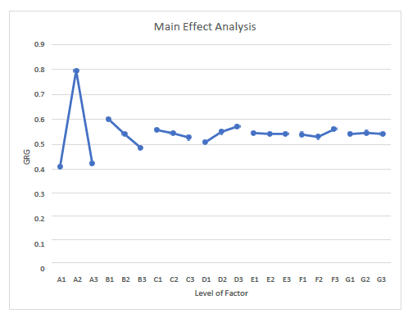

**Figure 4.** Main Effect Analysis Graph

Referring to Figure 4, it is clearly shown that the reinforcement material has a great impact on the deflection, volumetric shrinkage and sink mark of the honeycomb brick. The addition of 20% glass fibre seems to improve the quality of the honeycomb brick which in this case are deflection, volumetric shrinkage and sink mark. Reinforcement materials such as glass fibers or calcium carbonate can enhance the stiffness and rigidity of the honeycomb bricks compared to the honeycomb brick without any filler or fibre. Bricks reinforced with materials like glass fibers tend to have lower deflection because the fibers provide structural support and reduce the tendency of the brick to bend or deform under load. This improves the overall structural integrity of the bricks, making them more suitable for applications where minimal deflection is critical, such as load-bearing structures in construction [19]. Different reinforcement materials have varying coefficients of thermal expansion and contraction. Materials with lower coefficients, such as calcium carbonate on the other hand, can help minimize volumetric shrinkage during the cooling phase of injection moulding. This results in honeycomb bricks with more consistent dimensions and reduced internal stresses, leading to improved dimensional stability and less variation in size between individual bricks [20]. Meanwhile, reinforcement materials that facilitate uniform cooling and reduce shrinkage gradients, such as glass fibers, can help mitigate sink marks. Sink marks are depressions or indentations on the surface of the bricks caused by uneven cooling rates during moulding The fibers improve the overall flow properties of the molten plastic, resulting in a smoother surface finish and fewer visible defects on the brick surface.

Regarding injection moulding processing parameters, melt temperature ranked second, with a difference between the maximum and minimum values of 0.1151 (refer Table 6). The variation in melt temperature during the injection moulding process significantly influences the quality characteristics of honeycomb bricks, including deflection, volumetric shrinkage, and sink marks. Melt temperature affects the cooling rate of the plastic material inside the mould. Higher melt temperatures can lead to faster cooling times, which may result in insufficient material flow or uneven distribution within the mould cavity. This uneven cooling can cause internal stresses and uneven shrinkage, leading to deflection or warpage in the honeycomb brick. Conversely, lower melt temperatures might prolong cooling times excessively, affecting material flow consistency and potentially causing similar defects [21]. Higher melt temperatures also can exacerbate sink marks by accelerating cooling rates and creating internal stresses that manifest as depressions on the surface of the brick. Lower melt temperatures may mitigate sink marks by allowing for more controlled and uniform cooling, reducing the likelihood of localized shrinkage variations. The optimal combination of influential factors and levels can be obtained from the main effect analysis graph (Figure 4) by selecting the level of each factor with the highest GRG. Referring to Figure 4, the main effects analysis identifies the optimal factors as A2, B1, C1, D3, E1, F3, and G2. Table 6 details these optimal factors for the injection-moulded honeycomb bricks in this study.

**Table 6.** The optimal factors of Honeycomb brick

|  |  |  |  |
| --- | --- | --- | --- |
| Column | Factors | Level | Description |
| A | Reinforcement material (%) | 2 | PP + glass fibre |
| B | Melt Temperature (°C) | 1 | 220 |
| C | Injection Pressure (MPa) | 1 | 140 |
| D | Filling Pressure (%) | 3 | 100 |
| E | Injection time (s) | 1 | 1 |
| F | Filling time (s) | 3 | 1.8 |
| G | Cooling time (s) | 2 | 50 |

*3.5 Analysis of Variance (ANOVA)*

ANOVA is a statistical method used to evaluate the significance of differences among means of two or more groups. In optimization and experimental design, ANOVA identifies which factors significantly impact the variability of a response variable. This study used ANOVA to analyse the factors affecting the quality of honeycomb bricks. The results showed the percentage contribution of each factor to the quality characteristics. ANOVA was applied to the Taguchi method using 18 orthogonal arrays to assess GRG sequences. Table 7 shows the computed degrees of freedom (DOF), sum of squares, variance, F-ratio, and percentage contributions (%).

**Table 7.** Results of the ANOVA

|  |  |  |  |  |  |  |
| --- | --- | --- | --- | --- | --- | --- |
| Column | Factor | DOF | Sum Square | Variance | F-Ratio | % |
| A | Reinforcement material (%) | 2 | 0.5745 | 0.2873 | 1260.7043 | 90.7116 |
| B | Melt temperature (°C) | 2 | 0.0397 | 0.0199 | 87.2053 | 6.2747 |
| C | Injection Pressure (MPa) | 2 | 0.0028 | 0.0014 | 6.1679 | 0.4438 |
| D | Filling Pressure (%) | 2 | 0.0126 | 0.0063 | 27.6489 | 1.9894 |
| E | Injection times (s) | 2 | 0.0000 | 0.0000 | 0.1061 | 0.0076 |
| F | Filling times (s) | 2 | 0.0029 | 0.0014 | 6.2779 | 0.4517 |
| G | Cooling time (s) | 2 | 0.0001 | 0.0000 | 0.1828 | 0.0132 |
|  | **ERROR** | 3 | 0.0007 | 0.0002 |  | 0.1079 |
|  | **TOTAL** | 17 | 0.6333 |  |  | 100 |

Referring to Table 7, reinforcing material is the most crucial variable, contributing 90.7116% to the total variance, with a very high F-Ratio of 1260.7043, indicating a significant impact on the response variable. Its dominance is also shown by its large sum square of 0.5745. Melt temperature and filling pressure contribute 6.2747% and 1.9894%, respectively. Injection pressure, filling time, cooling time, and injection time are less important, with lower F-Ratios, percentages of variance, and sum squares. According to Roy's [14] Taguchi's 10% rule, any component contributing less than 9.07116% (10% of the highest possible contribution) is considered insignificant. Therefore, reinforcement material is consistently highlighted as the most influential factor in the experiment.

*3.6 Verification Test*

Once the optimal levels of the influential factors are identified, the next step is to validate the improvements in the quality characteristics using this optimal combination. The verification test assesses the effectiveness of integrating the Taguchi method and GRA. An experimental verification test is conducted using the same procedures as previous runs under optimal factor conditions (A2, B1, C1, D3, E1, F3, and G2, as shown in Table 6 to produce optimized injection moulded honeycomb bricks. Table 8 presents the deflection, volumetric shrinkage, and sink marks of the optimized injection moulded honeycomb bricks before and after optimization.

**Table 8.** Difference (%) before and after optimization

|  |  |  |  |  |  |  |  |  |  |  |
| --- | --- | --- | --- | --- | --- | --- | --- | --- | --- | --- |
|  | A | B | C | D | E | F | G | Deflection | Volumetric  shrinkage | Sink mark |
| Before  optimization | PP +20% calcium carbonate | 280 | 150 | 60 | 2 | 1.8 | 40 | 1.689 | 18.65 | 5.280 |
| After  optimization | PP + 20%  glass fibre | 220 | 140 | 100 | 1 | 1.8 | 50 | 0.4428 | 10.17 | 1.183 |
| Difference (%) | | | | | | | | 73.78 | 45.47 | 77.59 |

Referring to Table 8, after implementing optimization strategies via integration of Taguchi method and GRA, significant improvements were observed in the quality characteristics of the honeycomb bricks. The deflection decreased by 73.78%, indicating a substantial reduction in bending or deformation under load. This improvement enhances the structural integrity and dimensional stability of the bricks. In addition, volumetric shrinkage decreased by 45.47%, reflecting better control over the material's cooling and solidification process. Minimizing shrinkage helps maintain dimensional accuracy and reduces the risk of defects in the moulded bricks. On the other hand, sink marks reduced by 77.59%, indicating fewer depressions or dimples on the surface of the bricks. This improvement enhances the aesthetic appearance and surface smoothness of the bricks, contributing to their overall quality. The optimized honeycomb bricks exhibit improved performance characteristics, making them more suitable for various construction and industrial applications. Enhanced dimensional stability, reduced defects, and improved aesthetics contribute to their usability in load-bearing structures, decorative elements, and other architectural uses. Overall, the optimization process has successfully enhanced the quality characteristics of honeycomb bricks, as evidenced by significant reductions in deflection, volumetric shrinkage, and sink marks. These improvements not only enhance product performance but also contribute to operational efficiencies and customer satisfaction in construction and manufacturing sectors.

# 4. Conclusion

The analysis shows that reinforcement materials greatly impact honeycomb brick quality, particularly deflection, volumetric shrinkage, and sink marks. Adding 20% glass fiber improves brick stiffness, reducing deflection and enhancing structural integrity. The analysis identifies optimal factors for brick production as A2, B1, C1, D3, E1, F3, G2 and highlights that reinforcement material is the most significant factor, contributing 90.7% to the variance with a high F-Ratio of 1260.7. In comparison, melt temperature and filling pressure contribute 6.3% and 2.0% respectively, while other factors like injection pressure and filling time are less significant. By applying optimization strategies with the Taguchi method and Grey Relational Analysis (GRA), significant improvements in honeycomb bricks have been achieved. Deflection was reduced by 73.78%, showing a notable enhancement in structural integrity. Volumetric shrinkage dropped by 45.47%, indicating better control over cooling and solidification, which improves dimensional accuracy. Sink marks were minimized by 77.59%, resulting in smoother, more aesthetically pleasing surfaces. The Taguchi method and GRA were crucial in this process, as they systematically identified and optimized key factors affecting the bricks' quality. GRA, in particular, helped determine the best combinations of factors by evaluating their impact on deflection, shrinkage, and sink marks.

# References

[1] Gopu C, Mathew M J, Ninan J, John K, Moolayil T, and Sreekumar E 2016 *Int J Innov Res Sci Eng Technol* **2** 2349

[2] Tulashie S K, Dodoo D, Abdul‑Wadud Ibrahim A, Mensah S, Atisey S, Odai R, Mensah D 2022

*Innov Infrastruct Solut* **7** 265

[3] Islam Md. J , Niaz Md. S, Haque Md A 2022 *J. Build. Eng.* **54** 104597

[4] Nguyen D T, Yu E, Barry C, Chen W T 2024 *J. Clean. Prod*. **452** 142229

[5] Gaspar-Cunha A, Covas J A, Sikora J *Material* **15** (3) 1138

[6] Rahim S Z A, Sharif S, Mohd Saad R, Nasir S M and Zain A M 2016 *Adv. Polym. Technol*. **35**(1) 21524

[7] Solanki B, Singh H and Sheorey T 2022 *Int J Interact Des Manuf.* **16** 1653

[8] Masato D, Sorgato M and Lucchetta G 2016 *Mater. Des* **95** 219

[9] Karagöz, İ 2020 *Polym. Bull.* **78** 2627

[10] Kitayama S 2022 Int. J. Adv. Manuf. Technol.**121** 7117

[11] Sahani K, Joshi B R, Khatri K, Magar A T, Chapagain S, and Karmacharya N 2022 1 *Adv. Civ. Eng*. **1** 1

[12] Pachorkar P, Singh G, Agarwal N, and Srivastava A 2023 *Mater Today Proc*. **72** 1089

[13] Hao J, Wu X, Oporto G, Liu W and Wang J 2020 *Eur. J. Wood Wood Prod*. 78 1195

[14] Roy R K 2001 *Design of experiments using the Taguchi approach: 16 steps to product and process improvement (*John Wiley & Sons)

[15] Mehat N M, Noor H M, Kamaruddin S 2020 *IOP Conference Series: Materials Science and Engineering* **932** (1), 012122

[16] Mourya A, Nanda A, Parashar K, Sushant, Kumar R 2023 *Materials Today: Proceedings* **78** 656

[17] Chopade D, Metkar R, Sinha N, and A. Panchal A 2021 *Lecture Notes in Mechanical Engineering*, Springer Science and Business Media Deutschland GmbH, 53

[18] Pachorkar P, Singh G, Agarwal N and Srivastava A 2023 *Materials Today: Proceedings* **72** 1089

[19] Khandelwal S, Chandra Sharma R and Kumar R 2024 *Materials Today: Proceedings XXX*

[20] Agustang A, Oruh S, and Agustang A D M P, 2022 *SHS Web of Conferences*, 149 02005

[21] Srikhumsuk P, Butdee S and Nitnara C 2024 *Materials Today: Proceedings XXX*