|  |  |  |  |  |
| --- | --- | --- | --- | --- |
|  | |  | |  |
|  | |
|  | | | | |
| CI Engine Performance run with Emulsified Biodiesel from Refined Palm Oil | | | | |
|  | | | | |
| Muhamad Azman Miskam1, Mohd Fadzli Hamid1, Mohamad Yusof Idroas1,*, Mazlan Mohamed2, Yew Heng Teoh1, Sharzali Che Mat3, Mohd Hafif Basha4 | | | | |
| 1 | School of Mechanical Engineering, Universiti Sains Malaysia, Engineering Campus, Seri Ampangan, 14300 Nibong Tebal, Pulau Pinang, Malaysia | | | |
| 2 |  | | | |
| 3 | School of Mechanical Engineering, College of Engineering, Universiti Teknologi MARA, Cawangan Pulau Pinang, kampus Permatang Pauh, 13500, Permatang Pauh, Pulau Pinang, Malaysia. | | | |
| 4 | Faculty of Mechanical Engineering and Technology, Universiti Malaysia Perlis, Pauh Putra Campus, 02600, Arau, Perlis, Malaysia. | | | |
|  |  | | | |
| **ARTICLE INFO** | | | **ABSTRACT** | |
| ***Article history:***  Received  Received in revised form  Accepted  Available online | | | Diesel engine have found extensive application in various sectors such as agriculture, marine, automobile, and locomotives over time, owing to their exceptional efficiency and high-capacity torque. Nevertheless, using a diesel engine increase the number of dangerous pollutants like NOx and Soot. This study investigated the effect of several product of emulsified biodiesel compared to the CI engine fueled by baseline diesel. For the preparation of the test fuel B (5,10,15 and 20) biodiesel + (95,90,85, and 80%) Diesel were used in this experiment. Furthermore, for the preparation of surfactant (1,2, v/v%) and HLB ratio for SPAN 80 and TWEEN 80 (4.3 and 15) varies in the given range, respectively. From the result, EB5 shows the significant result closes with diesel fuel performance curve. Therefore, emulsified biodiesel has the potential to serve as a viable alternative fuel in the near future and is among the potential options for renewable energy in transportation. | |
| ***Keywords:*** | | |
| Engine, Biodiesel, Alternative Fuels, Emulsified Fuel, | | |

**1. Introduction**

Diesel engine also known as compression ignition (CI) engines, are very efficient and provide a lot of power, making them fit for use in the transportation sector[1], [2]. The elevated dependence on these fuel sources contributes to the accumulation of atmospheric contaminants, including NOx, CO, Sox, HC, PM and Pollution[3], [4]. Alternative fuels have the potential to mitigate the intensity of these impacts. Numerous researchers have worked to find a more environmentally friendly alternative to conventional diesel that may still be used in the current engine without requiring significant modifications[5]. The “biodiesel” has recently gained popularity candidate for use in CI engines as an alternative fuel. This is due to the fact that biodiesel is the most oxygenated renewable fuel[6], and it has low levels of sulfur and carboniferous emissions[7]. The advantages of utilizing biodiesel are their compatibility with baseline diesel in any proportion as a diesel-biodiesel blend. Despite with these advantages, it is unable to comply with BS (Bharat stage Emission Standard/ EURO Emission Standard) for NOx Emissions.

Fuel blend emulsified in water is classified as either oil-in-water (O/W) or water-in-oil (W/O)[8]. The surfactant agent's hydrophilic-lipophilic balance (HLB) value determines whether the dispersed phase is oil-soluble or water-soluble, also known as W/O and O/W. The difference in volatility between the water and oil causes the large fuel droplets to split into smaller droplets as a result of the combined effects of "micro-explosion" and "secondary atomization" phenomena[9]. The micro explosion occurred because of the instantaneous evaporation of accessible water in the emulsified fuel. In W/O, water droplets subjected to high pressure and temperature in the combustion chamber quickly absorb heat and explode through oil due to a lower boiling point[10]. This phenomenon is known as micro-explosion. Following that, a phenomenon known as secondary emulsion occurs, which fines the secondary fuel droplets, improving the air-fuel ratio and lowering engine emissions. Shanmughasundramet.al [11] discovered during their review that increasing the amount of water in fuel increases BTE while decreasing NOx and PM emissions by 45% and 80%, respectively, due to the micro-explosion phenomenon.

The emulsification technique is preferable because it is a low-cost method that does not require modifications to the original engine design or the use of specialized and sophisticated equipment. The available literature, on the other hand, is extremely limited in terms of its coverage of engine performance. The current paper aims to investigates the performance of CI engine run with emulsified biodiesel to improve knowledge of different techniques and methods related to their formulation and application directly to the diesel engine.

**2. Methodology**

*2.1 Engine Selection*

The engine utilized in this research is Yanmar generator engine model L70AE-DTM. This engine is a compression engine, air cooled, vertical cylinder, one cylinder, a four stroke direct injection engine. The specification of engine was tabulated at Table 3.1. Yanmar engine uses diesel as a primary fuel and is also able operate using biodiesel. It runs on one cam profile, one exhaust valve and one intake valve.

**Table 3.1**

Yanmar Engine Specification

|  |  |
| --- | --- |
| Specification | Description |
| Type | Yanmar L70AE-DTM |
| Bore | 84mm |
| Stroke | 62mm |
| Number of cylinder | 1 |
| Engine Weight | 36kg |
| Type of Injection | Direct Inject |
| Fuel Injection Pressure | 19.6 Mpa |
| Displacement | 0.296L |
| High Idle Speed | 3600 rpm |
| Max.rated power | 4.9 kW @ 3600 rpm |
| Injection Timing | 14° $±$ 1° BTDC |
| Intake | Naturally aspirated |
| Cooling | Forced air |
| Lubrication | Forced Lubrication with Trochoid Pump |
| Compression Ratio | 19.1 |

*2.2 Ultrasonic Homogenizer*

Ultrasonic homogenizer (UH) as shows in Figure 1 is an equipment that uses mechanical process and is very efficient for the reduction of soft and hard particles (dispersed phase). Particles are formed by ultrasonic wave vibration and only frequencies ranging around 20 KHz and a few MHz produce cavitation. When liquids are exposed to intense ultra-sonication, sound waves propagate through the liquids causing alternating high pressure and low-pressure cycles.

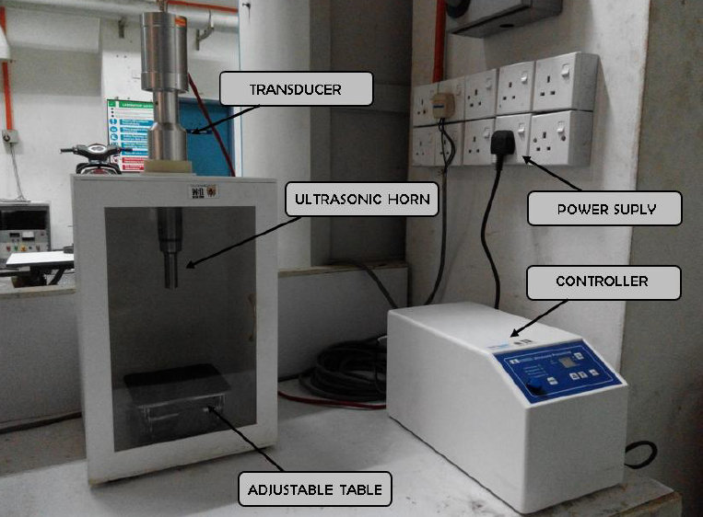

**Fig.1.** Ultrasonic Homogenizer

*2.3 Dynamometer controller*

The dynamometer was coupled with Focus Applied Technologies dynamometer controller (model: DC2AP). The controller receives speed and load cell signal as input signal and manipulates the current to the dynamometer to apply torque. The inductive speed sensor reads changes in magnetic flux from a gear mounted to the dynamometers shaft. The gear has teeth which provide changes in magnetic flux and hence produces a sinusoidal wave signal. It is equipped with an internal strain gauge amplifier to conditioning to the lower voltage signal from the load cell. A serial port of data logging is function which uses a computer to record the data from the controller (Focus Applied Technologies, 2009). The dynamometer controller is shown in Figure 2. The speed controller mode was used throughout the engine testing with wide open throttle (WOT).

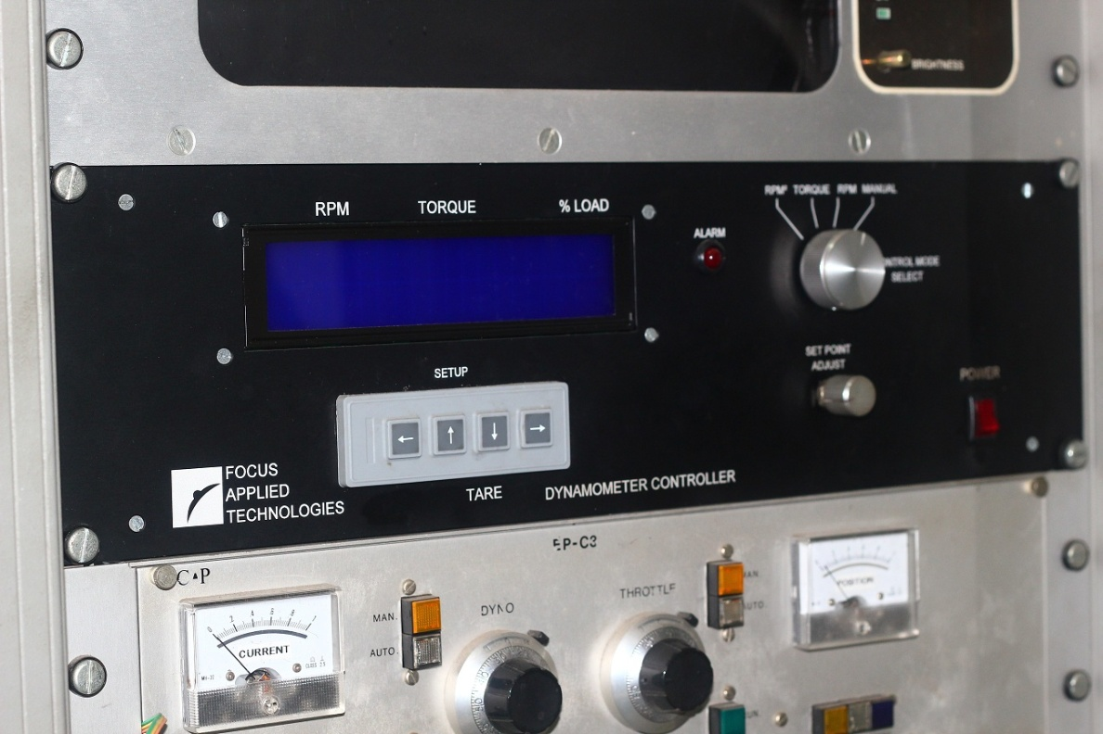

**Fig.2.** Dynamometer Controller

**3. Results and Discussion**

*3.1 Engine Torque*

The effects of diesel, pure biodiesel, and EB on engine torque are presented in this section under variable condition and variable speed. Figure 3 shows that diesel fuel produced higher torque performance curve compared to that of other biofuels. The higher torque generated via diesel is due to its lower viscosity and more complete combustion. Higher engine torque can be initially observed and it consistently decrease due to friction losses (negative torque). From the results, EB5 shows the higher torque producer compared to the others fuels and the other EB’s also shows the highest result. It is due to the when EB is sprayed into the combustion chamber, the heat is transferred via convection and radiation on the surface of fuel droplet. As biodiesel and water have different boiling temperatures, the evaporation of these two medium conditions were different. As a result, water evaporates initially due to water molecules reaching its superheated stage faster than biodiesel.

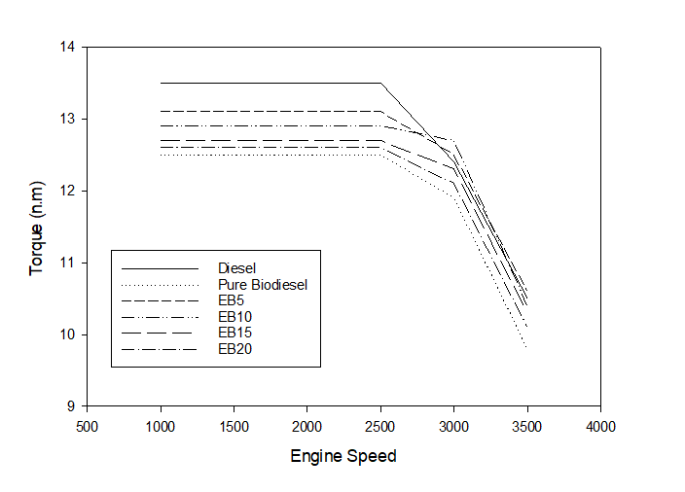

***Fig.3.*** *Engine Torque against engine speed*

*3.2 Engine Brake Power*

The brake power produced by the engine using pure diesel, pure biodiesel and EB with different percentage mixtures present in this section under variable conditions and speeds. Figure 4 shows that brake power gradually increases with the increasing of engine speed. Diesel fuel produced the maximum result compared to EB. EB5 is much closer to diesel performance curve compared to the others EB’s. This result is in line with researcher [12] which stated that the influence of the composition of water volume in biodiesel consequently improve combustion efficiency, improve the retardation of flame propagation, prolong the ignition delay and lower the rate of pressure increase in combustion. Initially during start-up. Diesel brake power diesel is approximately 9.3% higher that that of EB5. It is EB required less compression due to extended ignition delay in the compression stroke.

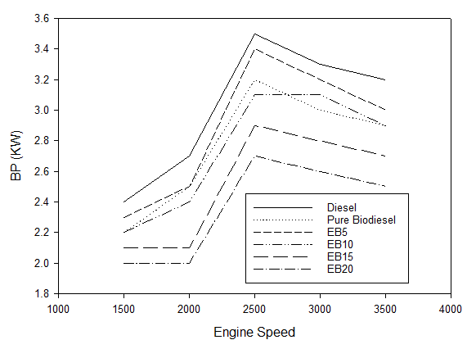

**Fig.4.**Engine brake power against engine speed

**4. Conclusions**

The performance and emission of diesel, pure biodiesel and emulsified biodiesel (EB5, EB10, EB15 and EB20) were compared using an internal combustion engine. The results showed that EB5 has the closest performance curve to diesel engine, while pure biodiesel has the lowest performance. This could be attributed to the lower energy content and higher viscosity of pure biodiesel compared to diesel and emulsified biodiesel. Despite emulsified biodiesel had the advantage of reducing some of the greenhouse gas emission such as carbon dioxide, carbon monoxide and Sulphur dioxide, it also aids to improve performance of engine due to the micro-explosion effect phenomenon that contributed to the complete combustion. Therefore, emulsified biodiesel can be considered as a promising alternative to diesel fuel, especially at low blend ratios, as it can improve the combustion efficiency and reduce the environmental impact of diesel engines.

**Acknowledgement**

This research was funded by the USM Fellowship RU (1001/CIPS/AUPE001) and Short-Term Grant (304/PMEKANIK/6315556).

**References**

[1] S. Mekhilef, S. Siga, and R. Saidur, “A review on palm oil biodiesel as a source of renewable fuel,” *Renewable and Sustainable Energy Reviews*. 2011.

[2] M. F. Hamid *et al.*, “Methods for improving the in-cylinder airflow characteristics for sustainable transportation using fuels with higher viscosity: A review,” *Renewable and Sustainable Energy Reviews*, vol. 155. 2022.

[3] Y. Chen *et al.*, “Effects of intake swirl on the fuel/air mixing and combustion performance in a lateral swirl combustion system for direct injection diesel engines,” *Fuel*, vol. 286, 2021.

[4] A. N. Abdalla *et al.*, “Effect of swirl at intake manifold on engine performance using ethanol fuel blend,” *Energy Sources, Part A: Recovery, Utilization and Environmental Effects*, vol. 42, no. 1, 2020,

[5] N. M. Taib, M. R. A. Mansor, and W. M. F. W. Mahmood, “Modification of a direct injection diesel engine in improving the ignitability and emissions of diesel–ethanol–palm oil methyl ester blends,” *Energies (Basel)*, 2019.

[6] S. Chozhavendhan, M. Vijay Pradhap Singh, B. Fransila, R. Praveen Kumar, and G. Karthiga Devi, “A review on influencing parameters of biodiesel production and purification processes,” *Current Research in Green and Sustainable Chemistry*, vol. 1–2, 2020.

[7] D. Singh, D. Sharma, S. L. Soni, S. Sharma, P. Kumar Sharma, and A. Jhalani, “A review on feedstocks, production processes, and yield for different generations of biodiesel,” *Fuel*, vol. 262. 2020.

[8] T. Stepišnik Perdih, M. Zupanc, and M. Dular, “Revision of the mechanisms behind oil-water (O/W) emulsion preparation by ultrasound and cavitation,” *Ultrason Sonochem*, vol. 51, 2019, doi: 10.1016/j.ultsonch.2018.10.003.

[9] G. R. Kannan, “Experimental Studies of Diestrol-Micro Emulsion Fuel in a Direct Injection Compression Ignition Engine under Varying Injection Pressures and Timings,” *Journal of The Institution of Engineers (India): Series C*, vol. 99, no. 1, 2018.

[10] P. Dinesha, S. Kumar, and M. A. Rosen, “Combined effects of water emulsion and diethyl ether additive on combustion performance and emissions of a compression ignition engine using biodiesel blends,” *Energy*, vol. 179, 2019.

[11] P. Shanmughasundaram, V. Gopinath, and P. Suresh, “Performance and emission characteristics of a diesel engine runs with corn oil biodiesel blends and air pre-heater,” *Mechanika*, vol. 23, no. 3, 2017.