THE EFFECT OF INFILL PATTERNS IN 3D PRINTED PLA PARTS ON THE MICRO AND MACRO PROPERTIES USING HOMOGENIZATION METHOD

Aisyah Allias¹, Khairul Salleh Basaruddin^{1*}, Nor Amalina Muhayudin¹, Shah Fenner Khan Mohamad Khan¹, Tien-Dat Hoang²
¹Faculty of Mechanical Engineering & Technology, Universiti Malaysia Perlis, 026000 Arau, Perlis, Malaysia.
²School of Mechanical and Automotive Engineering, Ha Noi University of Industry, Hanoi, Vietnam.

Abstract

This study employed the homogenization method in VOXELCON to examine how the infill patterns affect the micro and macro properties of 3D printed parts. Polylactic acid (PLA) is a material that is widely used in 3D printing technologies across different industries. Nevertheless, only a few research has been done on how infill patterns affect the micro and macro characteristics of 3D printed PLA, despite its widespread used. Because of factors including material utilization, infill density, and mechanical behaviour, choosing the best infill pattern can be difficult. Multiple 3D printed PLA sample pieces are needed to conduct reliable analysis, however the procedure takes time and can cause major delays. To solve this, finite element analysis (FEA) is used to reduces the need for actual 3D printed parts while also saving time and procedure. With this technique, different design can efficiently be examined without the requirement for actual prototyping. Investigating the effect of these infill patterns on the micro-properties of the PLA models, and analyze how the influence of infill patterns in the micro model impacted the macro-properties of the 3D printed PLA parts are the goal of this study. Homogenization method is used to analyse the micro model. With the result from the method, the micro model data from the homogenized material properties are imported as material properties for the macro model, and the constraint and pressure of the macro model is assigned. For the result, the octet design displays the lowest von Mises stress at 48 MPa, showing superior stress distribution, while the gyroid pattern displays the maximum stress at 56 MPa. The gyroid (850 MPa), octet (400 MPa), and line pattern (430 MPa) have the highest stiffness in the E₁₁ direction, E₂₂ direction, and E₃₃ direction, respectively, according to the stiffness analysis. Shear moduli and Poisson's ratios for various infill patterns are also examined in the paper, with notable differences found. Because of their balanced stiffness and stress distribution, octet patterns display superior mechanical performance over the concentric pattern, which is characterized by low stiffness and high stress. The study emphasizes how porosity and infill pattern design affect von Mises stress, which helps choose the right patterns for certain mechanical needs. Further research should investigate materials and patterns more broadly, improve computational precision, and take dynamic load circumstances into account.

1. Introduction

3D printing has emerged as an innovative technology in modern manufacturing processes, offering unprecedented flexibility in creating complex geometries and custom designs. Among the materials used in additive manufacturing, Polylactic Acid (PLA) stands out due to its biodegradability, ease of use, and favorable mechanical properties, making it popular in industries such as automotive, aerospace, and biomedical fields. The properties of 3D printed PLA parts are influenced by several factors, with the infill pattern being a crucial variable affecting both micro and macro properties. Infill patterns determine the internal structure and are essential for achieving desired mechanical characteristics like strength, stiffness, and weight. Choosing the optimal infill pattern depends on the intended function of the 3D printed part, making it a key consideration in the design process. Finding the best infill patterns and understanding how they influence the mechanical properties of 3D printed PLA parts is vital for enhancing performance across various applications. In this study, the VOXELCON software employs a homogenization method to evaluate the micro and macro properties of 3D printed PLA parts. This voxel-based finite element method allows for a detailed analysis of the microstructure and mechanical properties of different infill patterns, providing insights into optimizing the design and performance of 3D printed components. By investigating the effects of various infill patterns on the mechanical properties of PLA, this research aims to contribute to more efficient and effective 3D printing practices, advancing the capabilities of additive manufacturing in numerous industries.

3D printing, or additive manufacturing, revolutionizes the production of three-dimensional objects by building them layer by layer [1] using CAD software. Unlike traditional subtractive methods, it offers exceptional design flexibility and customization. The process starts with a digital 3D model sliced into layers to guide the printer, which comprises components like the build platform, extruder, filament, print head, and controller. Technologies such as Fused Deposition Modelling (FDM), Stereolithography (SLA), Selective Laser Sintering (SLS), Binder Jetting, and Poly Jet Printing are used, each with unique advantages [2]. A variety of materials, including plastics, metals, ceramics, and composites, are utilized based on application needs [1]. 3D printing is widely applied in manufacturing, healthcare, aerospace, and automotive industries, enhancing rapid prototyping, customized medical implants, and complex component production [3]. Despite challenges like material limitations and speed concerns, 3D printing is transforming manufacturing by offering unprecedented production and design opportunities across diverse industries.

Material such as Polylactic acid (PLA) filament has significantly impacted the 3D printing industry due to its unique characteristics and wide-ranging uses. As a biodegradable thermoplastic derived from agricultural products like corn and sugar beets, PLA is an eco-friendly alternative to petroleum-based polymers [4]. Its low melting point makes it easy to print, ensuring smooth extrusion, improved layer bonding, and high-quality prints, which are ideal for both beginners and experts. PLA's versatility in colors and finishes enhances design creativity and personalization, and it can be easily post-processed through methods like sanding, painting, and polishing. PLA is extensively used in rapid prototyping, educational settings, personalized home goods, and ornamental components. In the medical and dental sectors [5], PLA's biocompatibility makes it suitable for creating prototypes and antibacterial items. Overall, PLA's adaptability, environmental friendliness, and diverse applications underscore its crucial role in advancing additive manufacturing.

Infill pattern refers to the design or structure used to fill the interior space of a printed object. This internal framework is crucial as it determines the object's weight, strength, material usage while influencing the overall print time and quality [6]. The selection of an infill pattern is based upon the desired strength, material efficiency, and specific requirements of the intended printed object, often tailored by using 3D printing software to achieve the optimal balance. Here are some example of infill pattern, the grid pattern, utilizing perpendicular lines, balances strength and efficiency [7]. While the rectilinear pattern, similar to the grid but with lines in a single direction, is straightforward and material-efficient [8]. The triangle pattern, known for its interconnected triangles, enhances strength and structural integrity. The honeycomb or hexagon pattern adopts a hexagonal shape, providing both strength and material efficiency[8]. The gyroid pattern, with its complex, organic structure, excels in distributing stresses evenly, making it ideal for lightweight yet strong applications [9]. The line pattern features parallel lines printed layer by layer, offering simplicity but potentially sacrificing strength. Additionally, the octet infill pattern, characterized by its three-dimensional lattice structure, provides superior mechanical performance by optimizing stress distribution and stiffness, making it suitable for applications requiring high strength-to-weight ratios.

These are some examples of the previous studies based on different infill patterns. Based on both tensile and bending tests in a study to find the suitable infill pattern used for exoskeleton application, the cubic type of infill pattern with 70% infill density was determined to be the best design for 3D printing exoskeleton sections. The primary explanation for this is that exoskeleton structures can be made using cubic designs since the exoskeleton elements will frequently be subjected to bending and flexural loads because of body movements [8]. According to Patel [6], the lines infill pattern with a density of 60% has the best surface roughness and the maximum tensile strength, but it takes the longest to print. While the concentric infill pattern has the lowest tensile strength and the most surface roughness, but it has the fastest printing time. The paper indicates that infill patterns and densities have substantial effects on the mechanical qualities and printing time of 3D printed things and proposes picking the optimal parameters according to the intended usage of the model. From Eryildiz [10], honeycomb pattern showed the maximum tensile strength (29.43 MPa) and elongation (2.04 mm) because to the enhanced strength of the strut connections and the minimised air gaps. The pattern of the Hilbert curve exhibited the lowest elongation (1.39 mm) and tensile strength (16.66 MPa) because of the huge air gaps and stress concentration zones. The mechanical characteristics of PLA parts that are 3D printed are greatly impacted by the infill pattern. The honeycomb pattern holds great promise for attaining both low production costs and excellent strength. The triangle infill pattern shows the best tensile strength at 40 mm/sec printing speed and 100% infill density, according to the data. Conversely, the gyroid infill pattern exhibits the lowest manufacturing time [11]. According to a study, PLA with a grid infill pattern has the maximum hardness, while PLA using a zigzag design has the highest tensile strength. The best tensile strength and elongation at break for cPLA are found in grid infill pattern, whereas the highest hardness is found in concentric infill pattern. The study concludes that infill pattern is a crucial 3D printing parameter and that PLA and cPLA can be used in a variety of industries, including tissue engineering, biomedical, and packaging [12].

The study in influence of infill patterns on macro properties in 3D printing highlights the significant effect of internal structural configurations on overall printed object performance. Various research has explored relationships between infill patterns and key macro properties such as tensile strength, flexural strength, and thermal conductivity [13]. Notably, the choice of infill pattern significantly affects tensile strength, with patterns like honeycomb demonstrating enhanced load-bearing capabilities [10]. But in other study, honeycomb structure has low tensile properties, but it can be change with infill density [8]. The researcher compared different infill patterns (Grid and Honeycomb) and sizes at a fixed infill ratio of 75% and evaluate the effectiveness through tensile test. Honeycomb has the highest tensile strength compared to grid. To conclude, reducing the pattern's size can shorten the print time at a specific infill ratio while preserving the same stiffness but the process of layer formation affects the mechanical resistance [14]. Infill density or infill ratio can conclude that more density means stronger infill but longer printing time [15], reducing porosity. Moreover, studies highlight the role of infill patterns in impact resistance, thermal conductivity, weight reduction by porosity [16], compressive strength and material efficiency, providing valuable insights for applications prioritizing lightweight design without compromising strength.

By using a finite element-based numerical method, such as the representative volume element (RVE) homogenization method, to forecast the effective elastic characteristics of composites because it is more precise and is quickly becoming the accepted method for composite materials. RVE homogenisation is also one of the homogenization concepts that numerically impose uniform strains to compute the 12 effective elastic properties of a composite model [17]. The terms "E₁₁," "E₂₂," and "E₃₃" denote a material's stiffness along the x, y, and z directions, respectively, as represented by its Young's moduli. Poisson's ratios of ν₁₂, ν₂₃, and ν₃₁, indicate how much transverse strain there is in relation to axial strain when a material is stretched along one of its primary axes. To be more precise, ν₁₂ represents the ratio of strain in the y direction to the strain in the x direction when stretched along x, ν₂₃ represents the ratio of strain in the z direction to the strain in the y direction when stretched along y, and ν₃₁ represents the ratio of strain in the x direction to the strain in the z direction when stretched along z. The shear moduli, represented by the symbols G₁₂, G₂₃, and G₃₁, indicate how resistant the material is to shear deformation in the planes that are perpendicular to these axes. When it comes to characterizing the anisotropic elastic behaviour of composite materials, a situation in which the mechanical properties vary in multiple directions, these factors taken together are essential.

In summary, significantly impacts various industries by providing advanced customization and environmentally friendly options. Beyond simple layer-by-layer fabrication, 3D printing explores complex micro and macro properties. The choice of infill patterns is crucial, affecting weight, strength, material consumption, and overall quality of printed items. Studies emphasize the importance of selecting infill patterns tailored to specific needs, as they significantly impact mechanical properties. Homogenization methods enhance the efficiency of 3D printing by elucidating the connections between microscale characteristics and macroscale behavior. Tensile testing ensures the performance and reliability of 3D-printed parts, maintaining consistency and industry standards. As the field progresses, integrating advanced materials, strategic infill patterns, and comprehensive analysis techniques will drive technological advancements, opening new opportunities in manufacturing, design, and beyond.

Polylactic Acid (PLA) is widely used in 3D printing across various industries, but there is a lack of research on how infill patterns affect its micro and macro properties. Identifying the best infill pattern involves multiple factors like mechanical behavior, infill density, and material usage, and requires several 3D printed samples, which is time-consuming. To address this, Finite Element Analysis (FEA) is used to reduce reliance on physical parts, saving time and simplifying the experimental process by allowing efficient examination of designs and material properties without physical prototyping. Hence, this study was carried out to investigate the effect of infill patterns on the micro properties of 3D printed PLA model, and also to analyse the influence of infill patterns in micro model to the macroscopic responses of 3D printed PLA parts.

2. Materials & Methods

The overall flow of this study can be summarized as the following flow chart in Figure 1.

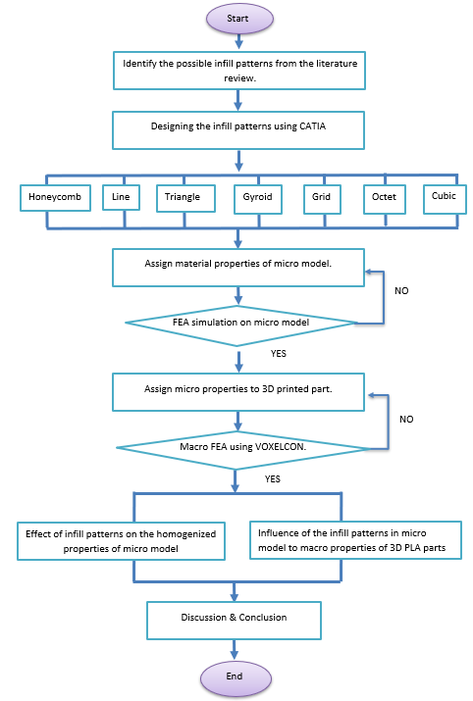

Figure-1: The flow chart of this study

2.1 Development of 3D model

The creation of the 3D model began in CATIA, where the "Pad" tool was used to extrude a cube with dimensions of 20mm x 20mm x 20mm. The workbench was then exited, and the sketch icon was selected to draw the geometry shape on the 3D model. The geometry design was flexible, allowing the creator to apply their creativity to determine the region. In this instance, a square shape was chosen. After sketching the shape on the selected 3D surface, the "Pocket" tool was used to create a hole with the drawn shape's depth. The rectangular pattern tool was employed to duplicate the selected pocket shape or feature, maintaining equal spacing between pockets. A dialog box appeared to define the location of the duplicated element. The pocket was selected, and a reference element was chosen to determine the direction of duplication. This process was repeated by changing the reference element to duplicate the pocket in other directions. Some geometries, such as the rectilinear, did not utilize the rectangular pattern tool. These are the example of 3D model as shown in Table 1.

Table 1 : The infill pattern designed in CATIA
Infill pattern | Isometric view | Front view
Rectilinear | 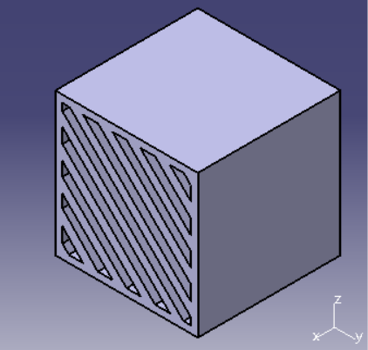 | 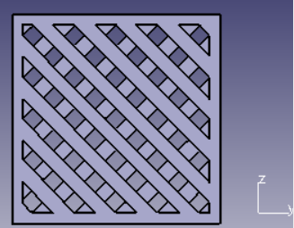
Gyroid | 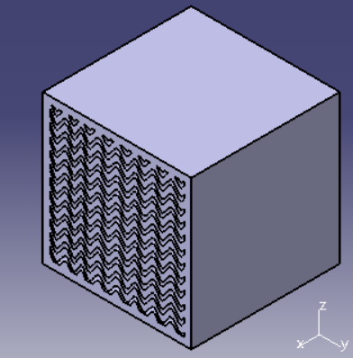 | 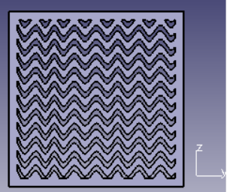
Octet | 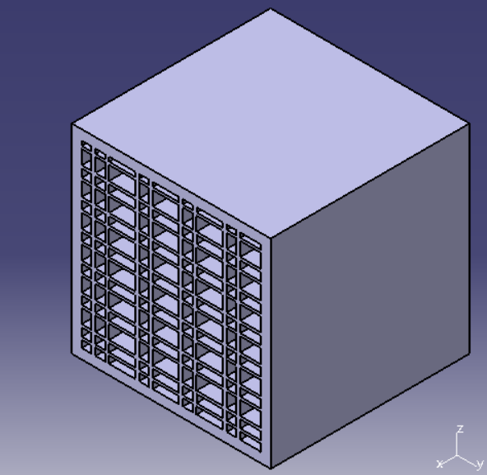 | 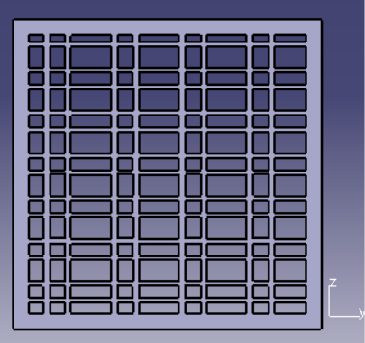
Triangle | 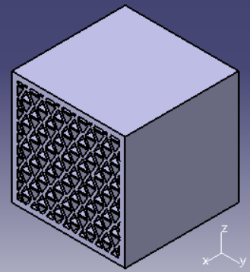 | 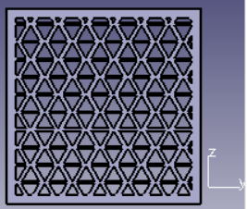
Grid | 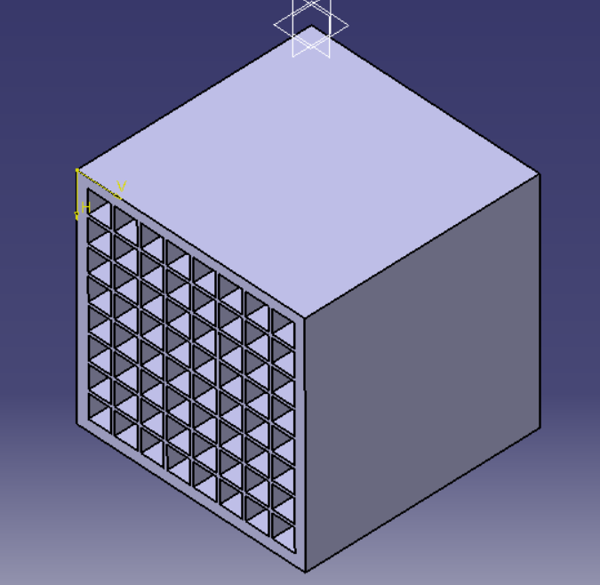 | 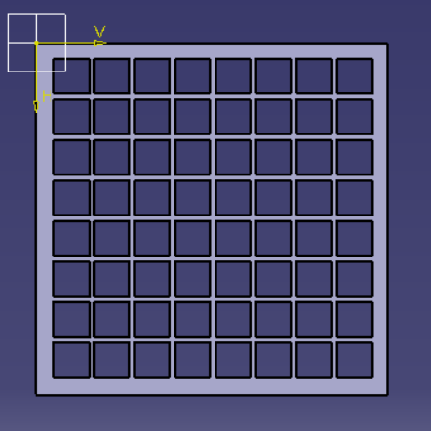
Line | 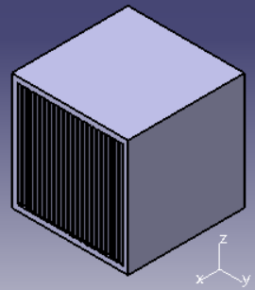 | 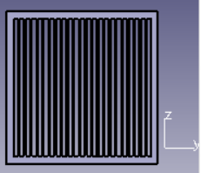
Honeycomb | 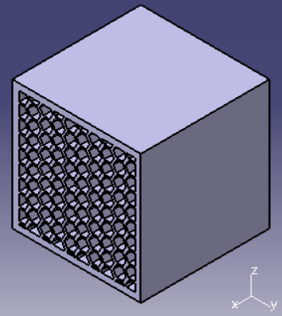 | 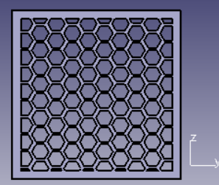

2.2 Assign Material Properties of Micro Model

After developing 3D models for infill pattern, next material selected is applied. The material properties such as Young’s modulus, thermal conductivity and yield strength are put with the value referred from the PLA properties in [18]. The material's stiffness is determined by its Young's modulus, which is 1.28×109 N/m². Poisson's ratio, which represents the relationship between transverse and axial strain, is 0.36. The mass of the material per unit volume is indicated by its density, which is 1240 kg/m³. The stress at which the material starts to distort plastically is known as the yield strength, and it is 70 N/m².

2.3 Homogenization Method

The models from CATIA are converted to STL files and imported into VOXELCON software to analyze the equivalent material properties and stress distribution of both micro and macro models. In VOXELCON, the micro model is updated with the material properties of PLA, including Young’s modulus and Poisson’s ratio. The voxel size for meshing is set to 0.1, providing higher accuracy for smaller models. After the analysis is finished, the result is imported automatically in the homogenized material property. During homogenization analysis, the chosen voxel size represents the entire model to determine the mechanical behavior of the material. According to [15], a material with microscopic heterogeneity has been designed to be composed of a macroscopic structure called the homogenization process. One way to establish a microscopic unit cell structure |Y| that can be utilized to depict global heterogeneity is to use the volumetric average of the microscopic attributes in the unit cell. The unit cell is repeatedly performed until the heterogeneous material can be replaced with an equivalent homogenized model. The equation from [15] for two scale singular perturbation theory.
$u_{i}(x,y) = {u }_{i}^{0}(x) + {εu}_{i}^{1}(x,y)$ (1)

In this equation, $u_{i}^{0}$ microscopic or homogenized displacement and $u_{i}^{1}$ is a perturbed term due to the microscopic heterogeneity. Suppose that the traction $t_{i}$ is applied on the boundary Г and the body force is neglected. An elasticity tensor is denoted as $E_{ijkh}$. By taking the limit of ε → 0 for homogenization, we finally obtain the decoupled microscopic and macroscopic equations. In this derivation, $u_{i}^{1}$ in Eq. (1) is assumed to be written by the following:
$u_{i}^{1}$(x, y) = -$X_{i}^{kh}$(y) $\frac{∂u_{k(x)}^{0}}{∂x_{h}}$ (2)

Where $X_{i}^{kh}$ is a characteristic displacement that, with relation to the microscale, is a periodic function. The microscopic equation for the unit cell Y, under the periodic boundary condition,
$\int_{Y}{(E_{ijkh}- E_{ijmn }\frac{∂X_{m}^{kh}}{∂y_{n}})}\frac{∂v_{i}^{1}}{∂y_{j}} dY=0$ for $∀v_{i}^{1}$ (3)

Due to the solution in Eq. (3.3), it can be derived as below:
$\int_{Ω}{E_{ijkh}^{H}\frac{∂u_{k}^{0}}{∂x_{h}}}\frac{∂v_{i}^{1}}{∂x_{j}}$dΩ = $\int_{Г}{t_{i}v_{i}^{0}}dГ$ for $∀v_{i}^{0}$ (4)

Where $E_{ijkh}^{H}$ is the homogenized elasticity tensor that is also symmetric defined by
$E_{ijkh}^{H}=\frac{1}{\left|Y\right|}\int_{Y}{(E_{ijkh}}- E_{ijmn}\frac{∂X_{m}^{kh}}{∂y_{n}}) dY$ (5)

where |Y| is the volume of the unit cell. Due to this, the calculation in VOXELCON utilizing the homogenization theory. After homogenization, the number of voxels is known.

Porosity, often referred to as volume fraction, can affect the infill pattern's mechanical performance, weight, and material consumption. Increased porosity causes the infill to have more empty spaces, which lowers material density and makes it more prone to deformation under stress. Due to the reduced number of solid material channels for load distribution, this typically leads to lower mechanical strength and low stiffness. Conversely, reduced porosity will result in fewer voids, which will boost material stiffness and density, improving mechanical strength and resistance to deformation. This is a result of the presence of additional material to support and distribute loads. The division of micro model is $200×200×200$, the calculated porosity is shown in Table 2.

Table 2: Calculated porosity of micro model
Meshed micro model | Number of voxels | Porosity %
Grid | 2,880,000 | 64.0%
Honeycomb | 3,473,000 | 56.6%
Line | 3,032,000 | 62.1%
Octet | 3,737,600 | 53.3%
Rectilinear | 4,704,705 | 41.2%
Triangle | 4,341,000 | 45.7%
Gyroid | 5,409,800 | 32.4%

2.4 Finite Element Analysis on Macro Model

To execute the macro model, the voxel map file is imported into the VOXELCON software. Micro model data from the homogenized material properties was imported as material properties of the macro model. The next step was to assign the constraints and pressure of 50 MPa applied at Y axis for boundary condition. The dimension of the beam is $190cm×36cm×6cm$. Same for micro model, the admissible error is 0.0001 as the repeated calculation is done to reduce error and get accurate result with small error. The constraint and pressure will mimic on how real-life application such as bedroom, kitchen cabinet shown in Figure 2, is used to see whether the macro model can withstand it.

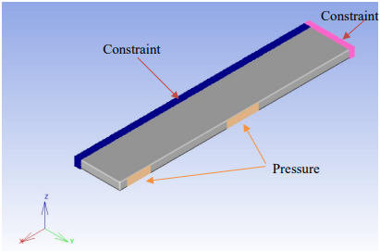
Figure 2: The constraints and pressure applied on the beam
3. Results and Discussion

3.1 Homogenization Results

As shown in table 1, the study compares various infill patterns in 3D printed models based on their homogenization result. In terms of stiffness, the gyroid pattern consistently exhibits the highest values across multiple directions (E11, E22, and E33), indicating its suitability for applications requiring high rigidity. Regarding Poisson's ratio, most patterns exhibit similar values around 0.36, except for the rectilinear pattern which shows a slightly lower ratio of 0.345. The gyroid pattern stands out with its high shear modulus in the G12 plane, while the rectilinear and triangle patterns excel in the G23 and G31 planes respectively, making them suitable for applications requiring high shear strength in specific directions. In Table 2, stress distribution analysis reveals significant variations among infill patterns. Patterns like gyroid show higher von Mises stress levels (56 MPa respectively), indicating strong load-bearing capacity but also a higher risk of failure under extreme conditions. In contrast, patterns like octet demonstrate lower stress (48 MPa) due to their efficient stress distribution despite higher porosity. The results of the investigation show that the mechanical characteristics of 3D printed objects are highly dependent on the choice of infill pattern. With the highest stiffness in the E11 and E22 directions, respectively, favourable Poisson's ratios, and an effective stress distribution as demonstrated by their lower von Mises stress values, the gyroid and octet patterns outperform the other patterns under study in terms of mechanical performance. The octet pattern, with a porosity of 53.28%, obtains the lowest von Mises stress (48 MPa), whereas the gyroid pattern, with a porosity of 32.28%, gets a relatively high von Mises stress (56 MPa) due to its efficient construction. A balanced proportion of material consumption and moderate von Mises stress (about 50 MPa) is provided by the grid, honeycomb, and triangular patterns. These results highlight the related impacts of porosity and infill pattern design on mechanical performance and stress distribution. Therefore, it is essential to choose the right infill patterns based on mechanical requirements in order to maximize the structural integrity and functionality of 3D printed components.

Table 3:The result from homogenization analysis of micro model
 |  | Young’s Modulus (MPa) |  |  | Poisson’s Ratio |  |  | Shear Modulus (MPa)
Infill pattern | Porosity % | E₁₁ | E₂₂ | E₃₃ | ν₁₂ | ν₂₃ | ν₃₁ | G₁₂ | G₂₃ | G₃₁
Grid | 64.0% | 460.80 | 285.34 | 285.34 | 0.36 | 0.22 | 0.04 | 3.58 | 101.24 | 101.24
Line | 62.1% | 485.12 | 144.07 | 426.01 | 0.36 | 0.02 | 0.32 | 48.64 | 0.75 | 154.64
Honeycomb | 56.6% | 555.68 | 258.99 | 243.61 | 0.36 | 0.31 | 0.16 | 117.27 | 16.07 | 129.23
Octet | 53.3% | 598.02 | 407.47 | 373.65 | 0.36 | 0.08 | 0.22 | 146.61 | 8.85 | 133.12
Triangle | 45.7% | 694.56 | 339.83 | 383.47 | 0.36 | 0.24 | 0.20 | 145.19 | 93.07 | 175.82
Rectilinear | 41.2% | 701.33 | 243.82 | 243.17 | 0.35 | 0.46 | 0.12 | 92.62 | 172.44 | 92.50
Gyroid | 32.3% | 865.57 | 253.37 | 153.39 | 0.36 | 0.07 | 0.06 | 182.08 | 1.74 | 53.31

3.2 Stress Distribution on Macro Model

As shown in Table 4, the stress is distributed across the beam. The maximum limit is set to be 40 MPa while the minimum limit is 0 Pa. Greater stress is indicated by yellow and red spots while lesser stress represents by blue and green. Every infill pattern has a von Mises stress value more than 45.5 MPa, this causes the red spot to enlarge after contouring because it surpasses the 40 MPa limit set for the macro model. Due to increased risk of material failure under load, these high stress locations are vital. The inconsistent design of the infill pattern and material properties of inserted PLA may cause these factors. For grid macro model, the stress focus in a rectangular spot rather than surrounding spot of the applied pressure, this is maybe due to the design of the infill pattern which is in Z axis while others infill pattern are in X axis. Inconsistent infill density or patterns that do not adequately support load distribution can lead to localized high-stress regions. Redesign the infill pattern to be more symmetry so that the load can be distributed evenly, and beam design need to smooth out sharp corners and transitions can help in reducing stress concentrations.The stress distribution analysis provides valuable insights into the mechanical performance of the macro model. The identification of high-stress regions exceeding the 40 MPa beam underscores the need for careful consideration of infill patterns, geometric design, and material properties. By addressing these factors through targeted design improvements and rigorous quality control, the structural integrity and performance of 3D printed components can be significantly enhanced, ensuring safety and reliability in practical applications.

Table 4: Stress distribution on macro model
Infill pattern at micro level |  | Scale
Grid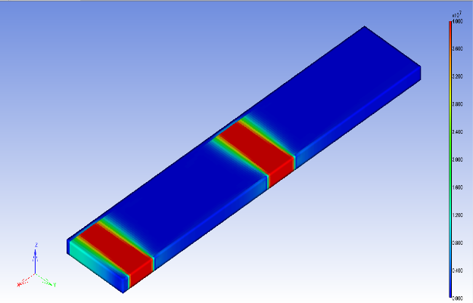 | Honeycomb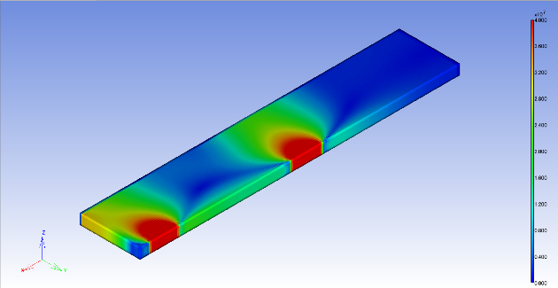
Line 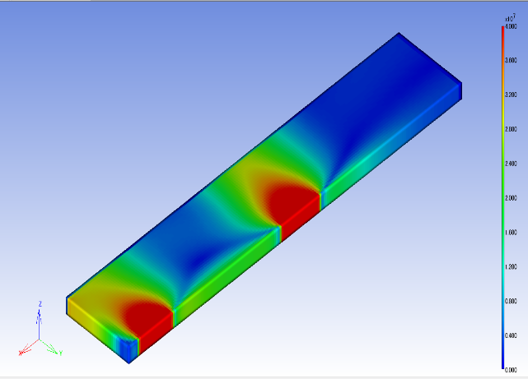 | Octet 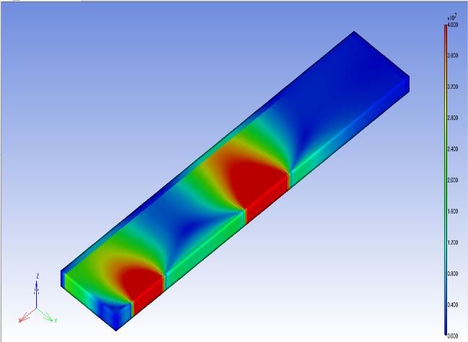
Rectilinear 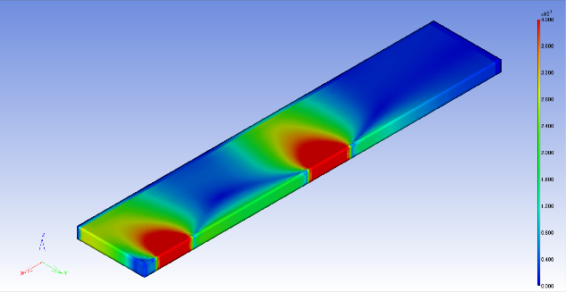 | Triangle 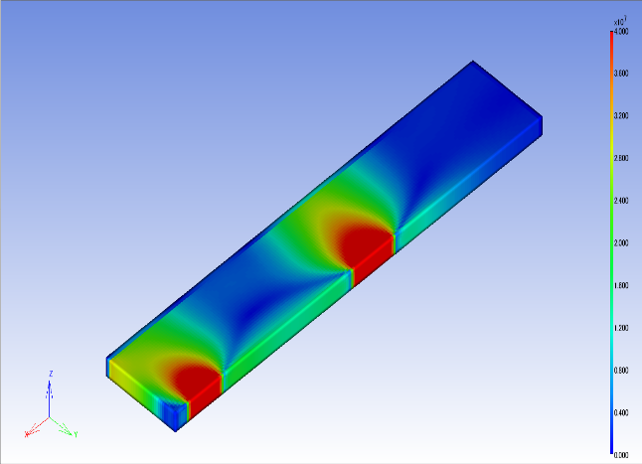
Gyroid
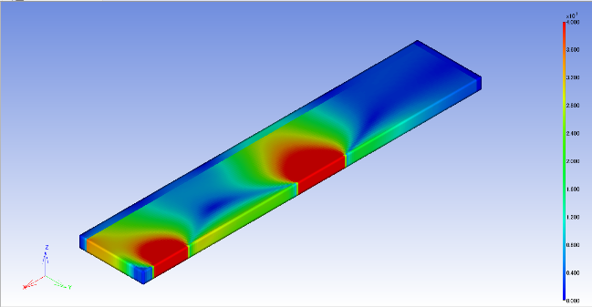

3.3 Maximum Von Mises Stress on Macro Model

In Figure 3, various infill patterns exhibit differing von Mises stress levels and porosity, influencing their load-bearing capacity and likelihood of material yielding. The gyroid pattern shows a high von Mises stress of 56 MPa with a balanced material presence and effective stress distribution, coupled with a porosity of 32.28%. The triangle, grid, and honeycomb patterns display moderate von Mises stress levels around 50 MPa, offering a good balance of strength and material consumption. The line and rectilinear patterns have slightly higher von Mises stress at 53 MPa and 51 MPa, respectively, indicating sufficient load-bearing capacity but a higher chance of yielding, with porosities of 62% and 64%. Notably, the octet pattern demonstrates excellent stress distribution and the lowest von Mises stress of 48 MPa despite its relatively high porosity of 53.28%, making it ideal for high-strength applications. These findings highlight the significant impact of infill pattern selection on the mechanical performance of 3D printed objects.

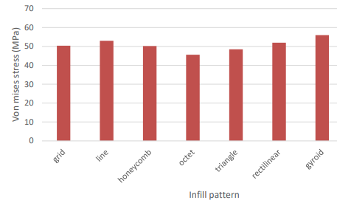
Figure 3: Von Mises Stress of macro model

3.4 Discussion

The study reveals that the mechanical properties of 3D printed objects are significantly influenced by the choice of infill pattern. The gyroid and octet patterns, with high stiffness in the E₁₁ and E₂₂ directions, favorable Poisson's ratios, and efficient stress distribution, outperform other patterns. The octet pattern, with a porosity of 53.28%, achieves the lowest von Mises stress (48 MPa), while the gyroid pattern, with a porosity of 32.28%, shows a higher von Mises stress (56 MPa) due to its efficient construction. Grid, honeycomb, and triangular patterns provide a balanced proportion of material consumption and moderate von Mises stress (about 50 MPa). These results emphasize the importance of selecting appropriate infill patterns based on mechanical requirements to optimize the structural integrity and functionality of 3D printed components. The study has some limitations - it focuses solely on PLA, does not explore other materials or a wider range of infill patterns and densities, simplifies geometries for analysis, and relies on theoretical calculations and simulations rather than comprehensive experimental validation. Additionally, it considers mainly static load conditions, whereas real-world applications may involved dynamic loads. The accuracy of the results is also dependent on the computational models and tools used, which may introduce numerical errors or simplifications.

4. Conclusion

The study successfully developed micro finite element models of 3D printed PLA parts with various infill patterns, analyzing their behavior at a microscopic level. It revealed significant variations in stress distribution, load-bearing capacities, and other microstructural characteristics based on the chosen infill pattern. These findings were effectively translated to the macro-properties of 3D printed PLA parts, demonstrating how microstructural changes impact overall strength, durability, and material efficiency. The macro model stress distribution and von Mises stress analysis revealed that the gyroid pattern had a high stress (56 MPa), indicating a strong load-bearing capacity but a higher failure risk. Grid, honeycomb, and triangle patterns offered balanced strength (50 MPa), while line and rectilinear patterns had slightly higher stress (53 MPa and 51 MPa), indicating good load-bearing capacity but a higher yielding risk. The octet pattern exhibited the lowest stress (48 MPa), showing effective stress distribution and a lower yielding risk, making it ideal for high-strength applications. All patterns were within the yield strength limit of 70 MPa, but the choice should be based on specific mechanical requirements. The analysis highlighted that both porosity and infill design affect von Mises stress, with efficient designs like gyroid and octet managing lower stress levels despite higher porosity. The study emphasizes the importance of detailed design to ensure symmetrical model designs with consistent axis orientations for accurate and clear results. More thorough and trustworthy outcomes can be achieved by broadening the scope of materials and infill patterns investigated, experimentally validating results alongside simulations, and improving computer models by considering dynamic load circumstances.

Acknowledgements

The authors would like to acknowledge the support from the Fundamental Research Grant Scheme (FRGS) under grant number FRGS/1/2019/TK03/UNIMAP/02/3 from the Ministry of Education Malaysia and the Faculty of Mechanical Engineering & Technology, Universiti Malaysia Perlis.

References

[1] A. Bhatia and A. K. Sehgal, “Additive manufacturing materials, methods and applications: A review,” in Materials Today: Proceedings, Elsevier Ltd, 2021, pp. 1060–1067. doi: 10.1016/j.matpr.2021.04.379.
[2] A. El Moumen, M. Tarfaoui, and K. Lafdi, “Additive manufacturing of polymer composites: Processing and modeling approaches,” Compos B Eng, vol. 171, 2019, doi: 10.1016/j.compositesb.2019.04.029.
[3] J. R. C. Dizon, A. H. Espera, Q. Chen, and R. C. Advincula, “Mechanical characterization of 3D-printed polymers,” Mar. 01, 2018, Elsevier B.V. doi: 10.1016/j.addma.2017.12.002.
[4] A. K. Trivedi, M. K. Gupta, and H. Singh, “PLA based biocomposites for sustainable products: A review,” Advanced Industrial and Engineering Polymer Research, vol. 6, no. 4, pp. 382–395, Oct. 2023, doi: 10.1016/J.AIEPR.2023.02.002.
[5] R. A. Ilyas et al., “Polylactic acid (Pla) biocomposite: Processing, additive manufacturing and advanced applications,” 2021. doi: 10.3390/polym13081326.
[6] D. M. Patel, “Effects of infill patterns on time , surface roughness and tensile strength in 3D Printing,” International Journal of Engineering Development and Research, vol. 5, no. 3, 2017.
[7] B. Aloyaydi, S. Sivasankaran, and A. Mustafa, “Investigation of infill-patterns on mechanical response of 3D printed poly-lactic-acid,” Polym Test, vol. 87, Jul. 2020, doi: 10.1016/j.polymertesting.2020.106557.
[8] V. M. Akhil, S. L. Aravind, R. Kiran, S. P. Sivapirakasam, and S. Mohan, “Experimental investigations on the effect of infill patterns on PLA for structural applications,” in Materials Today: Proceedings, Elsevier Ltd, 2022, pp. 636–639. doi: 10.1016/j.matpr.2022.10.292.
[9] S. Akhondi, C.-D. Matte, and T. H. Kwok, “A Study on Mechanical Behavior of 3D Printed Elastomers with Various Infills and Densities” Manufacturing Letters, vol 35, pp. 592-602, Aug. 2023, doi: 10.1016/j.mfglet.2023.08.035.
[10] M. Eryildiz, “THE EFFECTS OF INFILL PATTERNS ON THE MECHANICAL PROPERTIES OF 3D PRINTED PLA PARTS FABRICATED BY FDM.” Ukrainian Journal of Mechanical Engineering and Material Science, vol. 7, No. 1, 2021, doi: 10.3390/jmmp2040064.
[11] F. Yilan, İ. B. Şahin, F. Koç, and L. Urtekin, “The Effects of Different Process Parameters of PLA+ on Tensile Strengths in 3D Printer Produced by Fused Deposition Modeling,” El-Cezeri Journal of Science and Engineering, vol. 10, no. 1, 2023, doi: 10.31202/ecjse.1179492.
[12] C. K. Yeoh, C. S. Cheah, R. Pushpanathan, C. C. Song, M. A. Tan, and P. L. Teh, “Effect of infill pattern on mechanical properties of 3D printed PLA and cPLA,” IOP Conf Ser Mater Sci Eng, vol. 957, no. 1, p. 012064, Oct. 2020, doi: 10.1088/1757-899X/957/1/012064.
[13] C. Dudescu and L. Racz, “Effects of Raster Orientation, Infill Rate and Infill Pattern on the Mechanical Properties of 3D Printed Materials,” ACTA Universitatis Cibiniensis, vol. 69, no. 1, 2017, doi: 10.1515/aucts-2017-0004.
[14] M. T. Birosz and M. Andó, “Effect of infill pattern scaling on mechanical properties of FDM-printed PLA specimens,” Progress in Additive Manufacturing, 2023, doi: 10.1007/s40964-023-00487-8.
[15] J. Suteja, “Effect of Infill Pattern, Infill Density, and Infill Angle on the Printing Time and Filament Length of 3D Printing,” Jurnal Rekayasa Mesin, vol. 12, no. 1, p. 145, May 2021, doi: 10.21776/ub.jrm.2021.012.01.16.
[16] A. Y. Al-Maharma, S. P. Patil, and B. Markert, “Effects of porosity on the mechanical properties of additively manufactured components: a critical review,” Dec. 01, 2020, IOP Publishing Ltd. doi: 10.1088/2053-1591/abcc5d.
[17] S. L. Omairey, P. D. Dunning, and S. Sriramula, “Development of an ABAQUS plugin tool for periodic RVE homogenisation,” Eng Comput, vol. 35, no. 2, pp. 567–577, Apr. 2019, doi: 10.1007/s00366-018-0616-4.
[18] S. Farah, D. G. Anderson, and R. Langer, “Physical and mechanical properties of PLA, and their functions in widespread applications — A comprehensive review,” Adv Drug Deliv Rev, vol. 107, pp. 367–392, Dec. 2016, doi: 10.1016/j.addr.2016.06.012.

