**FINITE ELEMENT ANALYSIS ON IMPLANT ROD-SCREW WITH SPINE DEFORMITY**

Kavita Gunasekaran1, Nur Afrina Maisarah Khairil Anuar1, Khairul Salleh Basaruddin1*, Nor Amalina Muhayudin1, Fauziah Mat1, Tien-Dat Hoang2

1Faculty of Mechanical Engineering & Technology, Universiti Malaysia Perlis, 026000 Arau, Perlis, Malaysia.

2School of Mechanical and Automotive Engineering, Ha Noi University of Industry, Hanoi, Vietnam.

**Abstract**

This study employs finite element analysis (FEA) to investigate the mechanical behaviour of implant rod-screw systems in the correction of spinal deformities, specifically focusing on scoliosis. The research aims to assess the influence of different spine deformity angles on the mechanical stress distribution of implant rod-screw and correlate with the influence of correction rate. A finite element model was developed, combining realistic geometry and material properties to simulate the interaction between the rod and screw where the force was applied. Various deformity angles that are representative of scoliotic conditions are considered, and the mechanical stress distribution was quantitatively evaluated. The study further explores the correlation between deformity angles and the mechanical stress study experienced by the implant rod-screw system. By systematically varying the deformity angles, the seeks to investigate how alterations in rod curvature affect the load distribution across the implanted construct. Additionally, the investigation also looked into the influence of correction rates on mechanical stress. Different correction scenarios are simulated to analyze the mechanical response of the implant rod-screw system under varying degrees of correction then providing insights into optimal correction strategies for minimizing stress concentrations. The outcomes of this research contribute to a deeper understanding of the biomechanics involved in the implant-rod correction of scoliosis and offer valuable data as a guide for surgeons to apply force during the implementation of rod-screw. Based on the results, when the correction rate is maximum for each deformity angle, the corrective force increases as deformity angles increase. This results in a constant value range for von Mises stress which is below 790 MPa. For the effect of deformity angles on mechanical stress, it shows that von Mises stress increases when deformity angles increase. The same goes for the influence of correction rate to mechanical stress, the von Mises stress increases when the correction rate increases. The outcomes of this study can potentially provide clinical decision-making processes and contribute to the development of more effective spinal deformity correction strategies without any failure such as rod fracture.

**1. Introduction**

This study uses finite element analysis (FEA) to examine the mechanical behaviour of implant rod-screw systems in scoliosis correction, focusing on the thoracic vertebrae region. It evaluates how different scoliosis deformity angles affect stress distribution and corrective force within the implant. By simulating various deformity angles with realistic geometry and material properties, the study investigates changes in rod deformation and load distribution. The findings provide valuable data for surgeons to optimize force application, improve spinal deformity correction strategies and reduce risks like rod fractures. This research aims to ensure safer surgical outcomes by considering factors like material choice and geometry.

The middle segment of the spinal column is made up of the thoracic vertebrae, which are a group of 12 vertebral bones [1]. They are located between the lumbar vertebrae and the neck's cervical vertebrae which is the longest section of the spine. The thoracic vertebrae are numbered T1 through T12 [2].T1 is the first thoracic vertebra and T12 is the last thoracic vertebra before the lumbar vertebrae start. The rib cage, lungs, diaphragm and breathing muscles are controlled by nerves at T1 and T2, while the chest, arms and hands are controlled by nerves at T3 through T5 [3]. The abs and back muscles are influenced by the T6 through T12 nerves, which help with coughing, balance, and posture. Thoracic scoliosis is a sideways curve in the middle of the spine. It is more common in the thoracic area and can cause changes in the rib cage and shoulder blades, as well as uneven shoulder height. The condition produces a 'C' shaped curve in the thoracic vertebrae like and can develop independently producing an 'S' shape in the spine due to the formation of two curves in different directions.

If bracing is ineffective and the scoliosis worsens during growth, surgery might be taken into consideration. The spinal fusion using a rod and screw and instrumentation devices is the typical surgical technique called implant rod-screw. Thus, curve progression can be avoided by placing rod and screws into vertebrae. This is advised as the curvature approaches 45 to 50 degrees to prevent issues with growing trunk imbalance that could arise as an adult. Kids require surgery every six to twelve months to extend the rods to match the growing spine. This process continues until the kid approaches adulthood, at which point a spinal fusion can be carried out. The rods are bent to the desired coronal contour before implantation [4]. Because these intraoperative corrective manoeuvres put a lot of stress on the rods, their success heavily depends on rod biomechanics. The diameter, shape, and material properties of a rod will influence the rod's biomechanical profile.

Yield strength and Young’s modulus or stiffness a typical biomechanical properties of spinal rods. Stiffness is the extent to which an object resists deformation when force is applied. Yield strength is the maximum stress a material can handle before plastic deformation begins. These biomechanical properties are essential as spinal rods need low stiffness to easily deform when low force is applied but need high yield strength to avoid permanent deformation when high force is applied [5]. The most frequent materials utilised as spinal rods for corrective surgery are titanium alloy (Ti), cobalt chromium (CoCr), and stainless steel (SS) or ultrahigh strength stainless steel (UHSS). Ti has the highest yield strength and the lowest stiffness among other materials [4]. It also has high biocompatibility, corrosion resistance and magnetic resonance imaging (MRI) compatibility. Ti can be 90% retained to its original shape after being removed from the construct due to high yield strength while UHSS, SS and CoCr only 77%, 63% and 54% [5]. Due to lower stiffness, Ti also has 42% lower corrective forces than UHSS and CoCr. Ti also has the highest “spring back” as it can respond to repetitive bending proving that Ti can handle higher strains and yield before failure occurs after bending compared to SS that relatively brittle. So, the nearly nonexistent risk of rod fracture could be lessened with titanium. It can prevent the screws from pulling out of the vertebra and show greater distortion of the implant rod with less correction force [6]. There are many types of Titanium Alloy and Titanium Alloy Grade 23 (Ti AL – 4V ELI) is the most referred to as surgical titanium because it is more pure than Titanium Alloy Grade 5 (Ti 6Al-4V). It can be easily molded and cut. Similar to Ti 6AL-4V, it is strong and has a high level of corrosion resistance. It is very resistant to damage from other alloys and is lightweight. Due to these qualities and the special surgical qualities Ti 6AL-4V ELI has, its application in complicated surgical operations is greatly desired in the medical and dental fields. Due to its excellent biocompatibility, the human body may easily take it and graft it in, attaching it to bone.

The design of the rod and screws will influence the results. When the rod radius is increased, the bending stiffness of the rod will increase .5.5 mm rod diameter has a 5.17 EI (Nm2) bending stiffness and a 6.35mm diameter has a 9.18 EI (Nm2) bending stiffness [4]. For scoliosis cases, a 5.5 mm diameter has a better curve correction compared to a 6.35 mm. The pedicle screw with the trapezoidal thread profile, tapered geometry, lower pitch length (1 mm), and higher diameter (7.6 mm) has a lower maximum von Mises stress within pedicle screws, lower von Mises strain within the vertebral bone [7]. For lower von Mises stress within the vertebral bone, it is better to the pedicle screw with the triangular thread profile, cylindrical geometry, higher pitch length, and lower major diameter. The number of screws will not affect the degree of correction [8]. However, a larger degree of correction can be achieved by increasing screw density. This will result in a force increase. The maximal force did not correspond with screw density or degree of correction. In addition to corrective forces, screw placement design is crucial for scoliosis treatment since it affects forces.

For finite element analysis of implant rod-screw,ten-node tetrahedral solid elements were used to create the rod's finite element model [9]. Tetrahedral elements are four-faced polyhedra that are suitable for complex geometries but they can have less accuracy compared to hexahedral elements. Boundary condition was established taking into consideration how the rod was fixed during the surgical procedure. Initial values of forces were set as the loading condition. Since the implant rod was composed of titanium alloy, a common elastoplastic material, an elastoplastic analysis was conducted. Pedicle screw heads transmit three-dimensional correction forces to the implant rod. Forces are generated in response to the deformation of a metal rod. The lesser Cobb angle before surgery and the longest rod will result in a lesser Cobb angle after surgery. Finite Element Analysis (FEA) is used to determine von Mises stress distributions along deformed implant rods after scoliosis surgery to identify potential fracture sites [10]. High corrective forces can lead to implant or bone fractures and increase the risk of screw pullout from the vertebra. Analyzing stress distributions with FEA helps identify and prevent rod breakage, enhancing the safety and efficacy of scoliosis surgery. The analysis shows that fractures typically occur in high-stress regions, with results indicating that fractures often happen in the middle of the rod. Additionally, the postoperative rod curvature can be predicted based on the correlation between the degree of rod deformation and preoperative rod curvature [11]. The force exerted on the device can be uncontrolled and can lead to excessive reactive forces [12]. Thus, force should be controlled while reducing the malalignment of the rod to avoid excessive force and stress.

Patients with severe scoliosis (over 45°) need spinal fusion surgery with a rod-screw implant to realign the spine. Proper alignment requires manual control using a reduction device, but there are no clear guidelines or data on the optimal correction force leaving it up to the doctor's experience. Uncontrolled forces can lead to excessive corrective forces, resulting in rod fracture, permanent deformation, bone fracture or screw pullout. Because of these risks, surgeons often use less force, leading to lower correction rates. To avoid these problems, it is crucial to determine the maximum safe force to achieve the best correction without causing damage. Hence, the objective of this study is to analyse the effect of implant rod deformity angle on corrective forces, correction rate and mechanical stress.

**2. Materials and Methods**

Based on Figure 1, the methodology involves creating a detailed 3D model of the spine, including implant components like rods and screws, and assigning realistic material properties. The model then undergoes meshing and applies corrective force for each deformity angle. Finite element analysis is conducted to simulate the mechanical behaviour of the implant rod-screw focusing on stress distribution. Correction rates are systematically varied to assess their impact. Results were quantitatively analyzed. Figure 2 shows the implant rod-screw model developed using Catia V5 with various spine deformity angles.

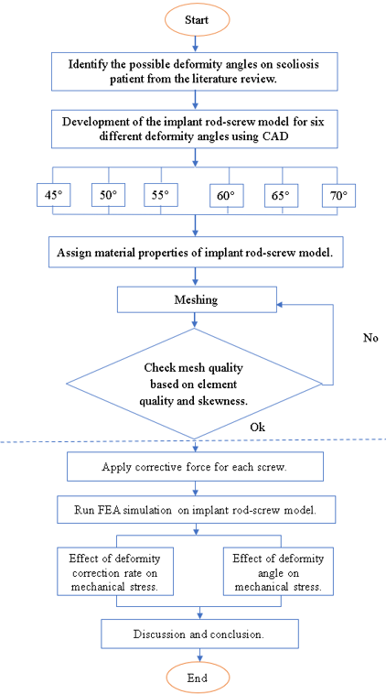

Figure 1 Flowchart for the research methodology.

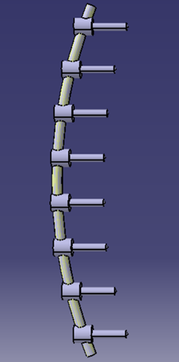 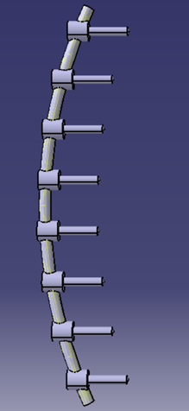 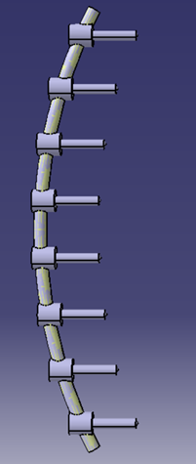

(a) (b) (c)

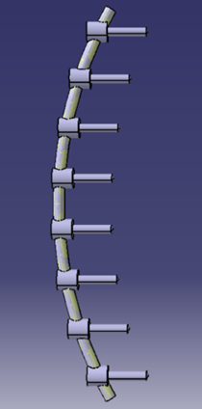 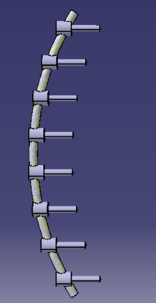 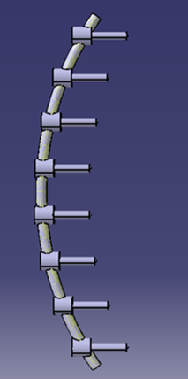

(d) (e) (f)

Figure 2 Geometrical model of implant screws with deformity of (a) 45°, (b) 50°, (c) 55°, (d) 60°, (e) 65° and (f) 70°.

**2.1 Finite Element Model**

The implant rod-screw was then analyzed using ANSYS to investigate the mechanical stress from different deformity angles. The static structural analysis system is chosen for this analysis. titanium alloy grade 23 was used for the finite element model and material properties were assigned manually in engineering data based on Table 1. Auto-meshed was used with tetrahedral elements (Tet10). The number of elements was different for different deformity angles as shown in Table 2.

Table 1 Material properties of Titanium Alloy Grade 23.

|  |  |
| --- | --- |
| Material Properties | Value |
| Density | 4430 kg/m3 |
| Young’s Modulus | 113.8 MPa |
| Poisso’s Ratio | 0.342 |
| Yield Strength | 790 MPa |
| Compressive Yield Strength | 860 MPa |
| Ultimate Tensile Strength | 860 MPa |

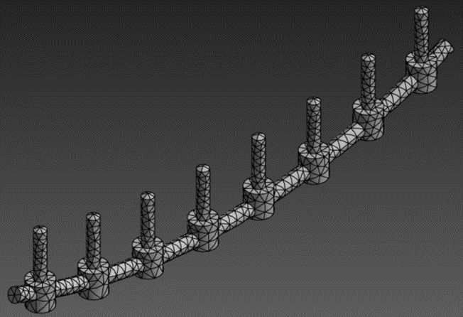

Figure 3 Mesh on finite element model.

Table 2 Number of elements for each deformity angle.

|  |  |
| --- | --- |
| Deformity Angle | Number of Elements |
| 45° | 3565 |
| 50° | 3662 |
| 55° | 3795 |
| 60° | 3958 |
| 65° | 3813 |
| 70° | 4031 |

There are eight screws were developed in this model as shown in Figure 4.1 which shows the numbering of screw positions from one to eight where force will be applied.

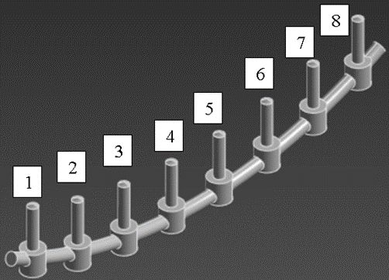

Figure 4 Numbering of screw position.

The boundary conditions for this analysis are fixed support and force. Fix support was applied at both ends of the rod which was labelled as A. A non-uniform distributed force is applied at all screws' heads in the y-axis direction to push the rod to reduce the deformity angle but the von Mises stress cannot exceed 790 MPa. The forces were labelled as B, C and D. The rod will undergo tension and compression load along the rod.

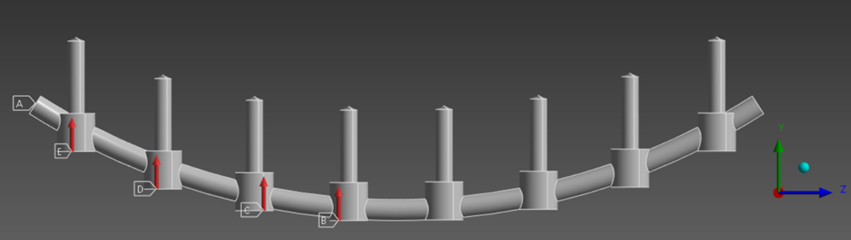

Figure 5 The location of boundary condition.

The force that was applied is a symmetry which is the force at screw 1 equal to screw 8, screw 2 equal to screw 7, screw 3 equal to screw 6 and lastly screw 4 equal to screw 5.

**3. Results and Discussion**

Based on the simulation, force analysis for all possible angles can be made and it will come out with a maximum correction rate and mechanical stress for each angle. At the end of this study, increased deformity angles of the rod will increase the corrective force exerted on each screw thus increasing the correction rate and mechanical stress.

**3.1 Effect of Implant Rod-Screw Deformity Angle on Corrective Force.**

The corrective forces applied on the heads of the screws are the maximum force and it is different for each screw and deformity angle. The difference in corrective force between each screw for one angle is fixed to 20 N. Based on Table 3, it shows that corrective force applied on each screw is increasing from the end of the rod toward the centre region of the rod. Thus, the location of screw play a major role in obtaining the value of corrective force. The corrective force applied is increased when the deformity angle increases because a higher angle needs a higher force to deform. When the force is applied, it will result in mechanical stress but should not exceed the yield strength value which is 790 MPa. So, the force applied is the force that can be applied before mechanical stress exceeds 790 MPa to avoid plastic deformation.

Table 3 Corrective force applied on each screw for different deformity angles.

|  |  |  |  |  |
| --- | --- | --- | --- | --- |
| Deformity Angle | Screw 1,8 | Screw 2,7 | Screw 3,6 | Screw 4,5 |
| 45° | 1780 N | 1800 N | 1820 N | 1840 N |
| 50° | 2175 N | 2195 N | 2215 N | 2235 N |
| 55° | 2540 N | 2560 N | 2580 N | 2600 N |
| 60° | 2805 N | 2825 N | 2845 N | 2865 N |
| 65° | 3170 N | 3190 N | 3210 N | 3230 N |
| 70° | 3300 N | 3320 N | 3340 N | 3360 N |

**3.2 Effect of Implant Rod-Screw Deformity Angle on Correction Rate**

The correction rate decreases over the deformity angle for all screws because the corrective force applied is not enough although it increases when the deformity angle is increasing. Each screw does not have the same correction rate in the same deformity angle, but it has the same difference of correction rate and trend for different deformity angles. A larger deformity angle needs a larger corrective force to increase the correction rate because the value of deformation for 100% correction rate is higher. But it is impossible as the corrective force has its limit to make sure stress does not exceed 790 MPa.

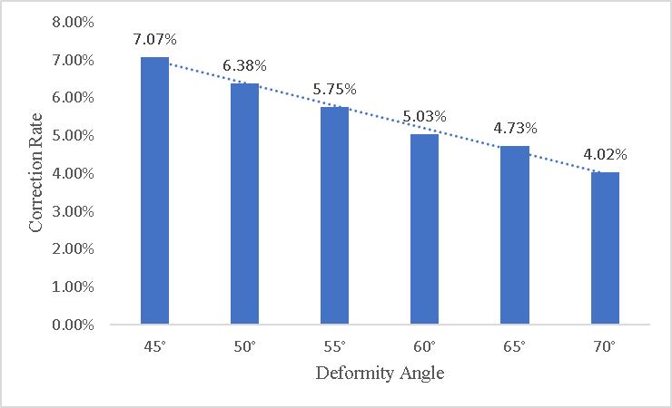

Figure 6 Graph of correction rate against deformity angle.

**3.3 Effect of Implant Rod-Screw Deformity Angle on Stress Distribution**

The results for von Mises stress are at the constant value range when the deformity angle is increased. This is because the corrective force for each deformity angle results in different correction rates. For larger deformity angles, a greater force is typically needed to achieve straightening, but this force must be carefully controlled to avoid exceeding the 790 MPa stress limit. The varying magnitude of this corrective force can lead to different stress distributions. The Von Mises stress that needs to be below 790 MPa can be assumed as a constant value range. The possible breakage location can be observed from the stress distribution of this analysis which is the highest stress located at the middle of the rod. The area of concentrated stress was increased gradually from 45° to 70° deformity angle. There also has the highest stress located at the end of the rod where the area of concentrated stress was increased gradually from 45° to 70°. As the area increases, the location of stress moves closer toward the middle of the rod.

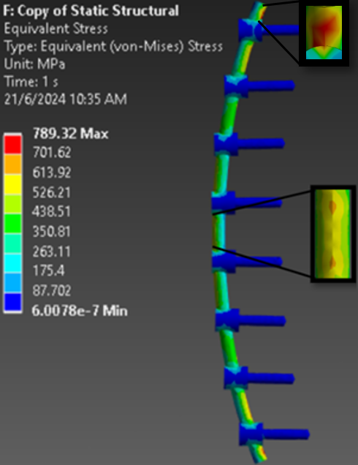 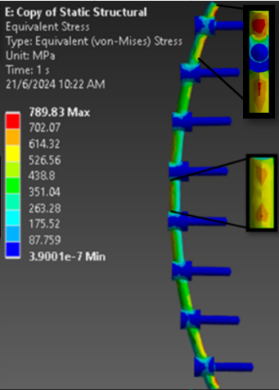 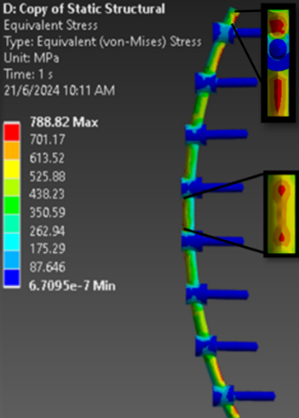

(a) (b) (c)

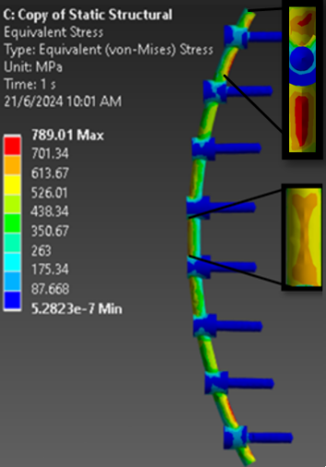 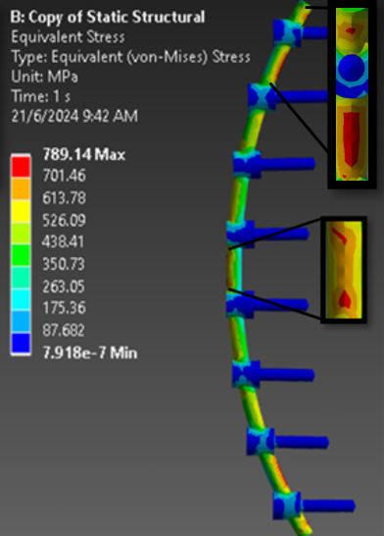 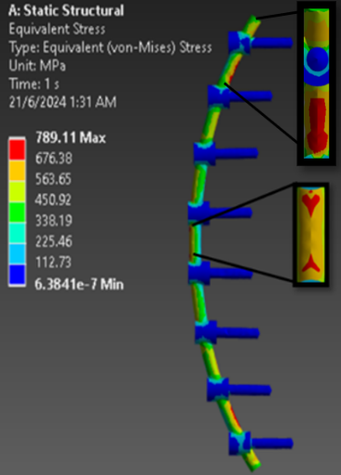

(d) (e) (c)

Figure 7 Von Mises stress distribution due to different deformity angle of (a) 45°, (b) 50°, (c) 55°, (d) 60°, (e) 65° and (f) 70°.

**3.4 Discussion**

The analysis of implant rod screws in scoliosis treatment demonstrates that both the deformity angle and the correction rate significantly impact the mechanical stress experienced by the implant rod. As the deformity angle increases from 45° to 70°, the corrective force required for maximum deformation also increases, thereby elevating the mechanical stress on each rod. This relationship indicates that higher deformity angles necessitate greater corrective forces, leading to increased mechanical stress. However, this stress must be carefully managed to avoid exceeding the yield strength of 790 MPa for titanium alloy grade 23, beyond which plastic deformation of the rods would occur. This careful balancing act is critical to ensure maximum correction rate while maintaining the integrity of the implant.

In practical terms, the force applied to the heads of the screws is adjusted to achieve the maximum correction rate without surpassing the yield strength limit. The study finds that maintaining a 20 N difference in corrective force between each screw helps to achieve an even deformation distribution between the rods with various deformity angle. A higher difference of corrective force between screws will result in higher deformation but the difference of deformation between screws will be higher too. So, this should be avoided as the difference of deformation between each screw should not be high as it will make the deformation nearer the end of the rod smaller but at the centre is larger and it will make the difference in correction rate between each screw larger. Even if the force is constant or larger for each screw, the correction rate for each screw still not going to be the same.

As the deformity angle increases, a higher corrective force is necessary to achieve maximum deformation. Higher deformity angle has the higher value of displacement for rod straightening from its initial position. So, this is one of the reason higher deformity angles need higher corrective force. Applied force will results on mechanical stress and deformation where the mechanical stress needs to be below than 790 MPa to avoid fracture or plastic deformation of the rod. The increment of corrective force between deformity angle is in decreasing trend. The corrective force is increasing just because the deformity angle is higher but the increment of corrective force is decreasing because the corrective force is enough to get maximum of correction rate below 790 MPa von Mises stress for each deformity angle which is not same.

The deformation of the rod from this analysis shows the maximum deformation the deformity angles can reach which resulting in the maximum correction rate. The maximum deformation that influence maximum correction rate is compared to deformation for 100% correction rate. The deformation for screws 4 and 5 does not have so much different and shows slightly decreasing trend from 1.348 mm until 1.172 for deformity angle from 45° to 70°. For higher deformity angle, the deformation is getting smaller. Thus, the maximum correction rate is decreasing with the increasing of deformity angle. The increment of correction rate between screws is the same for each deformity angles because of the constant 20 N difference of corrective force between each screws. For the higher deformity angle, higher correction rate need higher corrective force as it will have higher deformation for 100% correction rate.

From the results of analysis, the von Mises stress, maximum principal stress and minimum principal stress distribution can be observed. The possible location of breakage on the rod can be determined by checking this stress distribution which is the maximum stress as mentioned by [8]. For von Mises stress, the maximum stress is at the middle of the rod where the fracture is possible. The maximum stress at the end of the rod are because of the fix supports. For maximum principal stress, the maximum stress is located at the head of 4 and 5 screws where tension happened. Minimum principal stress has the maximum value at the middle of the rod where the compression was happened. The analysis is continued with comparison of maximum von Mises stress between each deformity angle where it is the stress achieved from maximum corrective force while keep the von Mises stress below 790 MPa. So, the maximum von Mises stress value is the maximum value before it exceeds 790 MPa which causes the maximum von Mises stress has a constant value range. The varying corrective force lead to varying value of stress distribution because it is for different correction rate. Even when the corrective force is increasing over the deformity angle, the von Mises stress is not increasing because a higher deformity angle has a larger displacement of the rod involved in deformation. This will spread the applied corrective force over a greater length and reduce the stress experienced on the rods.

**4. Conclusion**

The finite element model for implant rod-screw with various deformity angles has been developed. The analysis of the implant rod-screw for scoliosis correction shows that as the deformity angle increases from 45 to 70 degrees, the corrective force required also increases from 1840 N to 3360 N. When applying corrective force within the yield strength limit, the difference in corrective force between deformity angle increments decreases, indicating a smaller rate of force increase for larger angles. The correction rate decrease likely from 7.07% to 4.02% but have constant range value in maximum von Mises stress. Optimizing correction strategies is crucial to balance the corrective force and mechanical stress. Future work should incorporate patient-specific factors like bone quality, anatomy, age, and health into biomechanical models for more accurate results. Validating simulations with in vivo studies and clinical trials would provide more relevant data. Additionally, exploring different materials and designs for rods and screws could reduce stress and improve implant longevity.

**Acknowledgements**

The authors would like to acknowledge the support from the Ministry of Higer Education Malaysia under Fundamental Research Grant Scheme (FRGS) with grant number FRGS/1/2020/TK0/UNIMAP/02/20.

**References**

[1] Robert Bohinski and Zachary Tempel, “Spinal Deformity: Adult Degenerative Scoliosis,” OH Mayfield Brain & Spine. [Online]. Available: https://mayfieldclinic.com/pe-scoliosis.htm

[2] Richard L. Drake, A. Wayne Vogl, Adam W. M, and Mitchell, *Gray’s Atlas of Antomy*. Philadelphia, PA: Churchill Livingstone/Elsevier, 2015.

[3] Keith L. Moore, Anne M. R. Agur, and Arthur F. Dalley, *Critically Oriented Anatomy*. Philadelphia: Wolters Kluwer Health/Lippincott, 2014.

[4] S. Ohrt-Nissen, B. Dahl, and M. Gehrchen, “Choice of rods in surgical treatment of adolescent idiopathic scoliosis: What are the clinical implications of biomechanical properties? – A review of the literature,” *Neurospine*, vol. 15, no. 2. Korean Spinal Neurosurgery Society, pp. 123–130, Jun. 01, 2018. doi: 10.14245/ns.1836050.025.

[5] Serhan H, Mhatre D, and Newton P, “Would CoCr rods provide better correctional forces than stainless steel or titanium for rigid scoliosis curves?,” *J Spinal Disord Tech*, 2013, doi: 26:E70-4.

[6] Noshchenko A, Xianfeng Y, and Armour GA, “Evaluation of spinal instrumentation rod bending characteristics for in situ contouring.,” *J Biomed Mater Res B Appl Boimater*, 2011, doi: 98:192-200.

[7] J. K. Biswas *et al.*, “Design factors of lumbar pedicle screws under bending load: A finite element analysis,” *Biocybern Biomed Eng*, vol. 39, no. 1, pp. 52–62, Jan. 2019, doi: 10.1016/j.bbe.2018.10.003.

[8] R. Salmingo, S. Tadano, K. Fujisaki, Y. Abe, and M. Ito, “Corrective force analysis for scoliosis from implant rod deformation,” *Clinical Biomechanics*, vol. 27, no. 6, pp. 545–550, Jul. 2012, doi: 10.1016/j.clinbiomech.2012.01.004.

[9] Hwang SW, Samdani AF, and Cahill PJ, “The impact of segmental and en bloc derotation maneuvers on scoliosis correction and rib prominence in adolescent idiopathic scoliosis.,” *Neurosurg Spine*, 2012, doi: 16:345-50.

[10] D. Jayaswal, M. Kodigudla, A. Kelkar, V. Goel, and V. Palepu, “Validation of a patient-specific finite element analysis framework for identification of growing rod-failure regions in early onset scoliosis patients,” *Spine Deform*, Mar. 2024, doi: 10.1007/s43390-024-00846-7.

[11] R. A. Salmingo, S. Tadano, Y. Abe, and M. Ito, “Influence of implant rod curvature on sagittal correction of scoliosis deformity,” *Spine Journal*, vol. 14, no. 8, pp. 1432–1439, Aug. 2014, doi: 10.1016/j.spinee.2013.08.042.

[12] N. Nichols, D. Chou, A. Jamieson, and L. A. Tan, “P13. ACDF fusion rates,” *The Spine Journal*, vol. 20, no. 9, pp. S153–S154, Sep. 2020, doi: 10.1016/j.spinee.2020.05.411.