**Assessment of Bone Model using Finite Element Modelling for Prediction of Osteoporotic Fracture.**

Nur Izzati Md Radzi1, Nor Amalina Muhayudin1*, Khairul Salleh Basaruddin1,2, Nur Liyana Tajul Lile1

1 Faculty of Mechanical Engineering and Technology, Universiti Malaysia Perlis, 02600, Pauh Putra Campus, Perlis, Malaysia

2 Sports Engineering Research Centre, Centre of Excellence (SERC), Universiti Malaysia Perlis, Perlis, 02600, Malaysia

*E-mail: noramalina@unimap.edu.my

**Abstract**

Osteoporosis, characterized by low bone density and deterioration, poses significant fracture risks, typically in older adults but also affecting children. Pediatric osteoporosis is a serious concern, requiring unique approaches distinct from adult treatments. This study addresses the gap in finite element analysis (FEA) models for pediatric bones by developing and validating a detailed model of the pediatric femur for children under 12 years old. Using scaled models to represent pediatric bones, this research demonstrates the unique biomechanical properties and fracture risks in children. The findings reveal that 2-year-old children's bones, with a higher density of 237.5 kg/m³ and a Young's modulus of 8.67 GPa, exhibit better stress management, resulting in lower deformation (8.31 mm) and von Mises stress  
 (53.96 MPa), compared to 11-month-old bones. The results align closely with published data, with less than a 6% variance, highlighting FEA's accuracy in predicting stress patterns. The study concludes that pediatric osteoporosis significantly increases fracture risk, emphasizing the need for early detection and tailored treatment strategies.

*Keywords: pediatric femur, osteoporotic fracture, finite element modelling*

1. **Introduction**

Osteoporosis is a condition characterized by weakened bones due to low density and deterioration, occurring when bones lose minerals faster than the body can replace them, thus disrupting the normal bone renewal process. Commonly observed in older adults and often referred to as a "silent" disease due to its asymptomatic nature until fractures occur, osteoporosis also poses a serious risk in pediatric populations. Healthy bones are crucial for a child's growth, and weakened bones significantly increase the risk of fractures during developmental stages. While most research is focused on adult osteoporosis, pediatric cases require distinct approaches, as applying adult treatment methods to children often results in higher failure rates [1].

A significant challenge in addressing pediatric osteoporosis is the absence of a comprehensive finite element model of pediatric bone. Unlike adults, children's bone properties differ markedly, influencing fracture patterns and treatment outcomes. Current methodologies, which primarily adapt adult-based approaches, fail to adequately consider the unique biomechanical characteristics of pediatric bone. A dedicated finite element model tailored to pediatric bone would provide essential insights into bone strength, fracture risk, and the efficacy of treatment strategies specific to children, potentially reducing the high failure rates associated with the application of adult-based approaches in pediatric cases.

Since Galileo's early observations [2], it has been recognized that mammalian limb bones scale closely to geometrical similarity with body size [3]. Despite this, only a limited number of studies have explored the allometric relationship of body measures in humans [4–7], with even fewer focusing on growing children [8,9]. Understanding the distinct growth patterns of bone length and cross-sectional area in children is essential for accurate interpretation of bone health assessments. The presence of smaller bone mass compared to adults does not necessarily indicate a physiological concern in young children, as scaling effects can play a significant role. To adjust for these scaling effects, 'unscaled' raw data is converted into 'scaled' data by raising two-, three-, and four-dimensional variables to powers of half, third, and fourth, respectively [7].

Dimensional scaling has a positive impact on analysis. When dimensionally scaled, children's measurements align proportionally with adult values, demonstrating the effectiveness of this approach in normalizing data across different ages [10]. This scaling facilitates accurate comparisons of bone and muscle variables by adjusting for size and developmental stage, revealing clear patterns of sex differences post-puberty [10]. Before puberty, growth in femur bone mass and strength does not substantially lag behind bone growth in length once geometrical scaling effects are considered. When adjusted dimensionally or functionally, prepubertal girls and boys exhibit similar bone geometry and muscle size [10]. Although males show greater bone and muscle metrics in absolute terms, young adult women demonstrate greater bone area relative to femur length, weight, and muscle size when adjusted [10]. Therefore, dimensional scaling enhances the ability to make meaningful comparisons by accounting for size differences and developmental changes.

Numerical models are invaluable for studying femur behavior under different loads, aiding in understanding fracture processes and assessing fracture risk from imaging. Accurately predicting bone fractures using these models presents challenges due to variability in bone properties influenced by factors such as age, disease, and nutrition [11-13]. The reliability of predictions depends on how realistically bone behavior is represented in the models. Research conducted by Marco et al. [14] has explored the influence of these varying factors on fracture load. Advances in computer modeling now enable the analysis of bone fractures at both micro- and macro levels [15]. The proximal femur, where hip fractures frequently occur, is a focal point of interest. Linear finite element models have proven effective in predicting the elastic response and fracture load of the human femur, achieving approximately 90% accuracy in predictions [16]. Artificial or composite femurs are commonly used in research to simulate real bone, as they replicate the biomechanical properties of young, healthy femurs [17-19]. These composite bones are tested for stiffness and failure strength using methods such as axial compression, bending, and torsion. Offering advantages like consistency in properties and reduced variability compared to biological tissues, composite bones are useful for controlled analyses and model validation [17,18]. Published studies indicate that their failure modes closely resemble those of human bones [18].

This study aims to develop an accurate and realistic finite element model of the pediatric femur bone, focusing specifically on children under 12 years old. By creating a detailed computational model tailored to pediatric bone properties, the research seeks to enhance the understanding of bone mechanics and fracture behavior in pediatric osteoporosis cases.

1. **Materials and Methods**

The initial phase of this study involved the development of a pediatric femur model, with careful consideration given to the scaling process due to the existing lack of a comprehensive finite element model for pediatric bones. To address this gap, three distinct pediatric femur models were developed, each representing different sizes, to facilitate a thorough analysis. To ensure the accuracy and reliability of these models, the analysis was conducted in a systematic manner. The first step involved conducting validation studies to confirm that the three-dimensional (3D) models were accurate, reliable, and suitable for detailed analysis. The final phase of the study focused on comparing osteoporotic and normal pediatric bone conditions and predicting the likelihood of osteoporotic fractures.

**2.1 Scaling of pediatric femur**

A critical aspect of developing the pediatric femur models was determining the appropriate size relative to an adult femur model. Assuming the adult femur model represents 100% size, scaling was applied to create pediatric models at 50%, 33%, and 25% of the adult femur's dimensions.

The rescaling technique employed in this study follows the methodology outlined in the referenced work [10], ensuring consistency with established procedures for adjusting model dimensions and properties. By adhering to these best practices, the study ensures that the scaling is accurate and that the subsequent analysis remains valid.

The scaled-down bone models were evaluated against anthropometric data, confirming that they fall within acceptable ranges on the anthropometric graph [20]. Specifically, the model scaled to 50% corresponds to the anthropometric measurements of a pediatric population approximately 2 years of age. The model scaled to 33% aligns with measurements typical of a 1-year-old pediatric population, and the model scaled to 25% corresponds to the measurements of an 11-month-old pediatric population as presented in Figure 1. This scaling approach ensures that the pediatric femur models are representative of the target age groups.

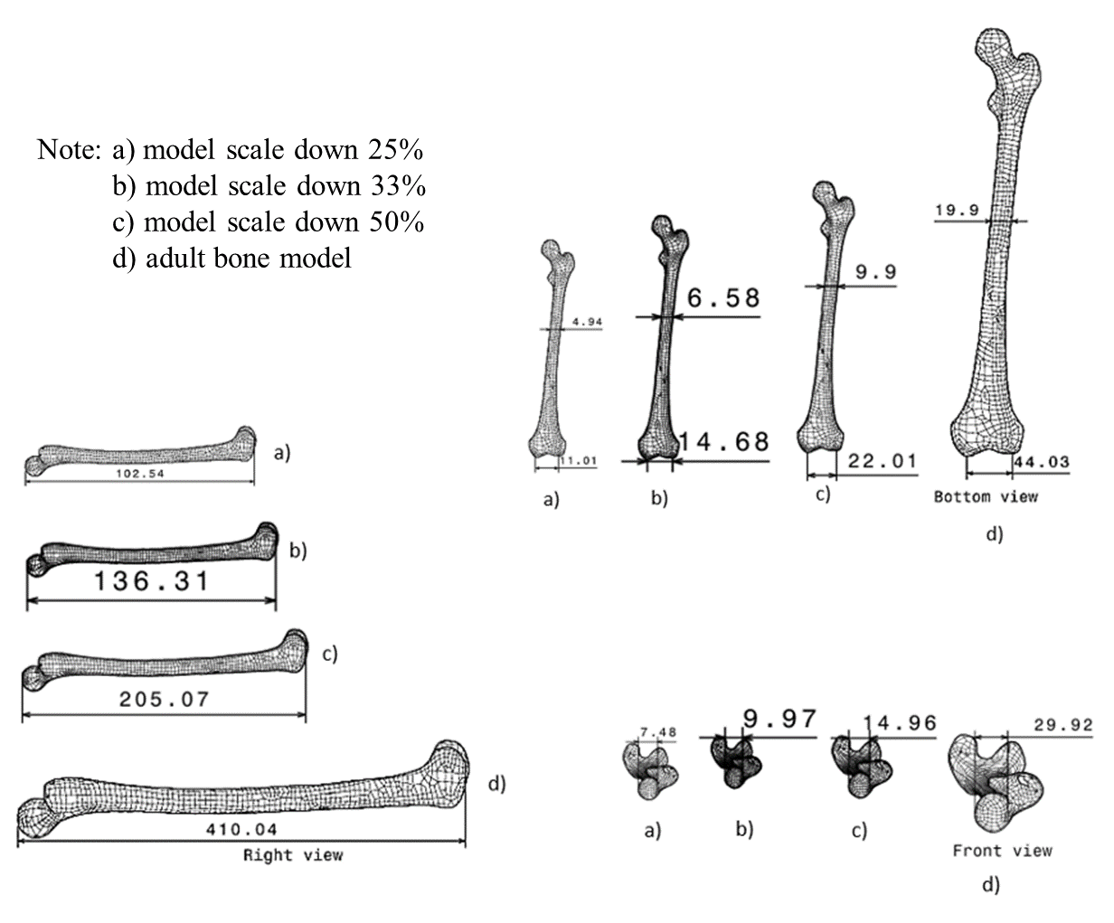

Figure 1: Dimensional scaling

**2.2 Materials**

Human bone is heterogeneous and exhibits non-linear properties, making it challenging to assign different material characteristics along each direction. The analysis becomes more manageable by assuming isotropy where the material properties are considered uniform in all directions. This assumption strikes a practical balance between accuracy and computational efficiency. Table 1 summarised bone material properties assigned in the analysis.

Table 1: Material properties of 3 different pediatric ages in normal conditions [26].

|  |  |  |  |
| --- | --- | --- | --- |
| Age | Bone Density  (kg/ $m^{3}$) | Young’s Modulus  (GPa) | Poisson’s Ratio |
| 11-month-old | 346.6 | 17.25 | 0.342 |
| 1-year-old | 346.6 | 18.48 | 0.342 |
| 2-year-old | 480 | 19.09 | 0.342 |

**2.3 Simulation setup**

Static structural analysis is a strong tool for simulating the behavior of structures under static loads. Its goal is to forecast how a structure will deform and the stresses it will encounter under these loads. This will assist predict failure points. A convergence test is required for determining the size of components in infinite element modeling. In this study, the mesh size was reduced from 5 mm to 2 mm, where 2 mm element size seems suitable. Increasing mesh density does not significantly change the results.

The mesh uses triangular elements, which are better suited for fitting complex shapes than other elements like quadrilaterals. This is helpful for accurately modeling the detailed features of the femur. The "medium" smoothing quality means the mesh is reasonably smooth, offering a good balance between detail and computational efficiency.

Figure 2 shows boundary conditions were applied as free-fixed boundaries for the analysis of the femur bone. A uniformly distributed force is placed at the top section of the femur bone, and the femur bone is limited in all directions. This shows that the bone will undergo a compression load at 500 N for all ages. The applied force will act in a downward z direction. This setup simulates real-world loading conditions to observe changes in stress and deformation. The 500 N load is commonly used in biomedical studies to understand how bones and tissues respond to stress and to evaluate their mechanical properties, elasticity, and strength.

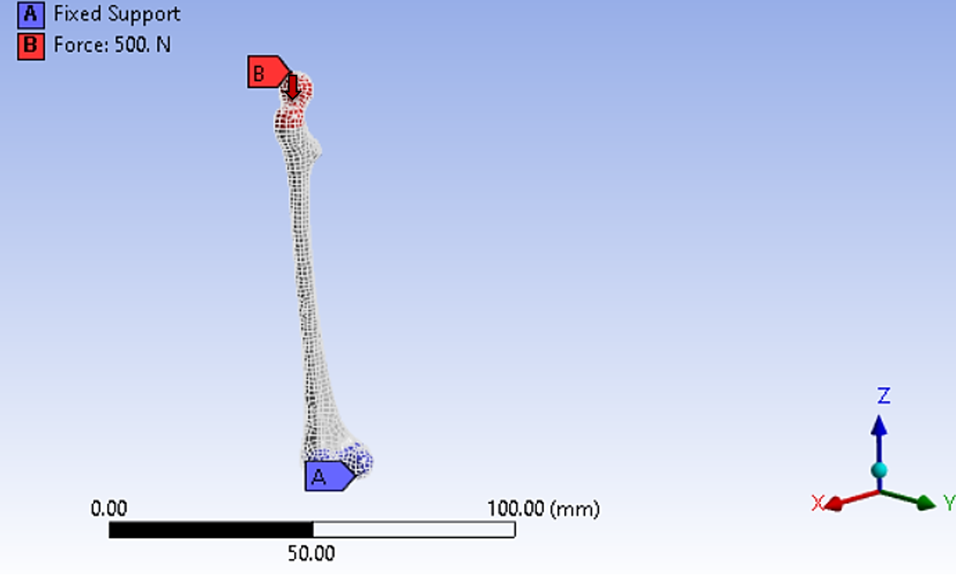

Figure 2: Boundary condition

**2.4 Validation of 3D bone model**

The first method involves conducting a static structural analysis of the femur bone using different plate materials, based on the investigation by Kirthana et al. [21]. The analysis utilized plate material properties including a density of 1750 kg/m³, a Young's modulus of 16.7 GPa, and a Poisson's ratio of 0.3. The femur was meshed with 5 mm triangular elements, and boundary conditions involved fixing the bone and applying a 2500 N load downward. The results showed maximum deformation at the femoral head and maximum stress at the shaft. The maximum equivalent stress was 51.862 MPa, with a 5% difference from literature values, and maximum deformation was 10.732 mm, with less than a 2% difference. These discrepancies fall within the acceptable 10% range, indicating consistency with published data [21].

The second method validates the model using finite element analysis to examine bone properties, such as isotropic qualities and density, with the femur meshed with 2 mm triangular elements and a 1471 N force applied downward by Fathima [22]. The maximum equivalent stress was found to be 35.913 MPa, with a difference of 0.697 MPa, or less than 2%, also within the 10% threshold, confirming compatibility with published data [22].

1. **Results and Discussion**

**3.1 Analysis of Pediatric Normal Bone**

Under compression, the femoral head and greater trochanter region of the 11-month-old, 1-year-old and 2-year-old femora were subjected to compressive stresses. The femoral shaft underwent compression due to the orientation of the lower supports and loading points. Table 2 shows the analysis results of von Mises stress and maximum total deformation under compression.

Table 2: Table of pediatric normal bone conditions.

|  |  |  |  |
| --- | --- | --- | --- |
| Age | Bone density  (kg/ $m^{3}$) | Total Deformation Maximum  (mm) | Von Mises stress  (MPa) |
| 11-month-old | 346.6 | 8.35 | 244.10 |
| 1-year-old | 346.6 | 5.85 | 136.16 |
| 2-year-old | 480.0 | 3.77 | 53.96 |

The study observed a decrease in the magnitude of von Mises stress in response to applied stresses from the 11-month-old femur to the 2-year-old femur. This decrease was anticipated due to the increase in both the bone's cross-sectional area and the elastic modulus as the femur matures from 11 months to 2 years of age. These findings suggest that younger children are more prone to fractures, as their bones are less developed and more susceptible to stress.

Under the applied conditions, which included a free-fixed boundary setup, the compression analysis revealed that pediatric femora reach their maximum total deformation under relatively small loads. For children aged 1 to 2 years, the maximum deformations were recorded at 5.85 mm and 3.77 mm, respectively. The percentage difference in deformation between the 1-year-old and 2-year-old femurs was 43.2%, indicating that the deformation increases by 43.15% as the child's age decreases. In contrast, the femur of an 11-month-old exhibited a greater deformation of 8.35 mm, which is significantly higher than that observed in the femurs of 1- and 2-year-olds. The percentage difference in deformation between the 11-month-old and the 1-year-old femurs was 35.2%, reflecting a 35.2% increase as age decreases from 1 year to 11 months.

These results suggest that both von Mises stress and total deformation are higher in the femurs of 11-month-old children compared to those of 2-year-olds, likely due to differences in growth and development, physical activity, body proportions, and environmental factors. The smaller size and less developed bones and tissues of 11-month-olds make them more vulnerable to deformation under stress. Moreover, as physical activity and muscle development increase with age, they provide better support to bones and joints, thereby reducing stress and deformation during daily activities. The distinct body proportions of 11-month-olds, including larger heads and shorter limbs, also contribute to the distribution of forces, leading to higher equivalent stress in specific areas. Environmental factors, such as nutrition and exposure to physical activity, further influence bone density and strength, impacting how stress is distributed and managed in the pediatric population.

**3.2 Analysis of Pediatric with Osteoporotic Bone**

According to Table 3, there are no significant changes in von Mises stress among the three pediatric age groups. However, slight variations in total deformation were observed when the bones were subjected to compressive forces, compared to normal conditions. The femoral head experienced compression due to the orientation of the loading points. The amplitude of the maximum total deformation decreased as the age of the femur increased.

Table 3: Table of pediatric with osteoporotic bone.

|  |  |  |  |  |
| --- | --- | --- | --- | --- |
| Age | Bone density  (kg/ $m^{3}$) | Total Deformation Maximum  (mm) | | Von Mises stress  (Mpa) |
| 11-month-old | 170.2 | 18.402 | 244.10 | |
| 1-year-old | 171.5 | 12.885 | 136.16 | |
| 2-year-old | 237.5 | 8.3151 | 53.96 | |

This reduction was anticipated, given the increase in bone cross-section and elastic modulus in the 2-year-old femur compared to the 11-month-old femur. These findings may suggest potential issues related to changes in bone structure, such as increased stress or strain on certain components, raising concerns about the possibility of failure or excessive deformation under load.

**3.3 Comparison between osteoporosis and normal conditions**

When subjected to mechanical loading, normal bones typically undergo elastic deformation, meaning they can bend and return to their original shape without sustaining permanent damage. The total deformation under physiological loading is relatively small. In contrast, osteoporotic bones exhibit significantly increased total deformation under similar loading conditions due to their weakened structure, making them less capable of withstanding mechanical stresses. This leads to more pronounced deformations, even during normal activities, and increases the likelihood of permanent deformation, which further compromises the structural integrity of the bone. As shown in Table 4, bones affected by osteoporosis are much more prone to fracture than normal bones.

Table 4: Comparison between normal and osteoporosis conditions.

|  |  |  |
| --- | --- | --- |
| Age | Maximum total deformation (mm) | |
| Normal | Osteoporosis |
| 11-month-old | 8.3583 | 18.402 |
| 1-year-old | 5.8523 | 12.885 |
| 2-year-old | 3.7766 | 8.3151 |

At 11 months old, osteoporotic bones exhibit a maximum total deformation of approximately 18 mm, compared to around 8 mm for normal bones. This indicates that osteoporotic bones are already significantly weaker at the onset of analysis. As both bones are subjected to stress over time, the osteoporotic bone deforms much more rapidly. By the age of 2 years, the osteoporotic bone reaches a maximum total deformation of approximately 8 mm, while the normal bone only shows around 3 mm of deformation.

These findings conclude that osteoporotic bones experience higher total deformation, reflecting a decline in structural strength and durability compared to normal bones. This heightened deformation suggests that osteoporotic bones are far more susceptible to fractures under stress. The differences in deformation underscore the physical weakness of osteoporotic bones and emphasize the importance of maintaining bone density and strength through a balanced diet, regular exercise, and appropriate medical supervision.

**3.4 Prediction of osteoporotic fracture**

Predicting fracture risk in osteoporosis often involves advanced stress analysis techniques. Von Mises stress analysis, in particular, provides insights into how stress is distributed within bone structures under load, helping to identify areas most likely to fail. By pinpointing where cracks might initiate and propagate, this analysis enhances understanding of bone strength and informs risk assessments, preventive strategies, and treatment plans aimed at reducing fracture risk. Figure 3 illustrates the crack patterns in an 11-month-old pediatric femur, which are more pronounced compared to those in 1- and 2-year-olds.

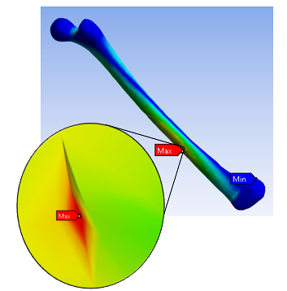 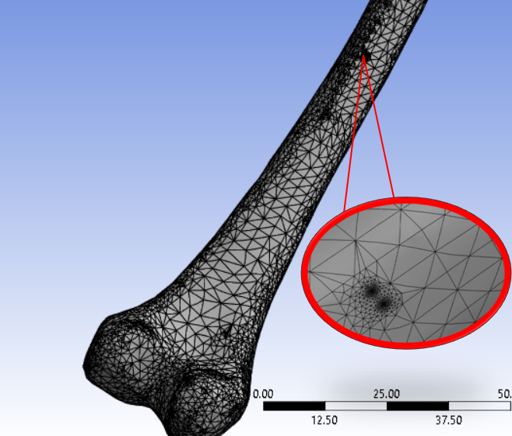 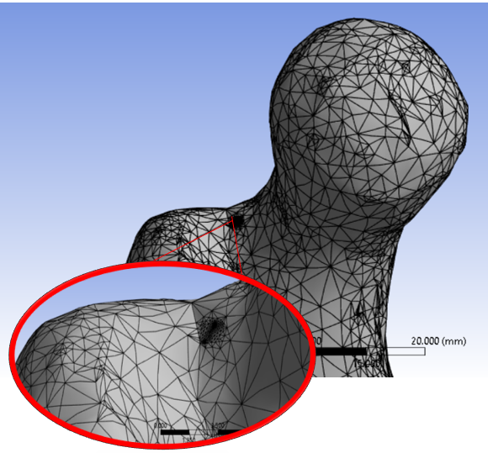

Figure 3: Crack on the femoral shaft and head in shading view and mesh view

This is attributed to the decreased bone strength and increased fragility observed in younger bones. In severe cases of osteoporosis, fractures can occur with minimal trauma or even spontaneously. The larger and more localized nature of the cracks suggests that the femoral region experienced higher stress concentrations, making it particularly prone to fracture once the maximum von Mises stress and total deformation thresholds are exceeded. The crack patterns identified in this study align with the findings of M. Marco et al. [23], who reported similar fracture patterns. This agreement reinforces the validity of the applied force regions used in this study and suggests that when trabecular bone is compromised by osteoporosis, the fracture path typically traverses the central zone of the femoral neck [24]. In cases where cortical bone is affected, fractures tend to occur in the central zone of the femoral neck, leading to an extracapsular fracture [24].

As crack growth progresses, the likelihood of fracture increases, as the expanding crack further weakens the bone. Eventually, the crack may grow large enough to cause the bone to break. Thus, it can be inferred that osteoporotic bones will develop larger cracks compared to normal bones due to differences in bone properties and cross-sectional geometry.

Overall, pediatric femurs at 2 years old demonstrate better stress management by more evenly distributing stress and benefiting from stronger bone structure due to a higher Young's modulus. Consequently, any small cracks that form may serve as early warning signs, allowing for timely intervention before a complete fracture occurs. This understanding can assist healthcare professionals in predicting the risk of future fractures and tailoring prevention strategies accordingly.

1. **Conclusion**

The study effectively demonstrated that the diaphyseal region of pediatric femora responds distinctly to axial stress, a factor often overlooked in favor of adult bone deformation studies. By applying a scaling technique to adapt adult bone attributes for pediatric models, the research provided a validated finite element analysis (FEA) model that aligns closely with published data, showing a discrepancy of less than 6%. This validation underscores the accuracy of FEA in predicting stress patterns in pediatric bones, offering valuable insights for medical professionals in forecasting femur fractures in children. The FEA model successfully accounted for variables such as age, material properties, and bone geometry, accurately predicting fracture risk in pediatric patients. The findings reveal that children with osteoporotic bone conditions are significantly more susceptible to fractures compared to those with normal bone density. This emphasizes the critical need for early detection and intervention in pediatric osteoporosis to minimize fracture risk and improve the quality of life for affected children.

**Acknowledgements**

The authors would like to acknowledge the financial support from the Ministry of Higher Education Malaysia under Fundamental Research Grant Scheme (FRGS) with grant number FRGS/1/2020/TK0/UNIMAP/02/20.

**References**

[1] S. D. Sakka, “Osteoporosis in children and young adults,” Best Practice &amp; Research Clinical Rheumatology, vol. 36, no. 3, p. 101776, 2022. doi:10.1016/j.berh.2022.101776.

[2] Galileo G. Discorsi e dimonstrazioni matematiche, intorno a due nuove scienze altenenti alla meccanica ed a muovementi locali. Opere, ed. Favoro, VIII 169 seq. transl. by H. Carew and A. de Salvio (1914). 1638.

[3] Alexander R, Jayes A, Maloiy G, Wathuta E. Allometry of the limb bones of mammals from shrew (Sorex) to elephant (Loxodonta). J Zool (Lond) 1997;189:305–14.

[4] Marx JO, Olsson MC, Larsson L. Scaling of skeletal muscle shortening velocity in mammals representing a 100,000-fold difference in body size. Pflugers Arch 2006;452:222–30.

[5] Mattfeldt T, Mall G. Statistical methods for growth allometric studies. Growth 1987;51:86–102.

[6] Heymsfield SB, Gallagher D, Mayer L, Beetsch J, Pietrobelli A. Scaling of human body composition to stature: new insights into body mass index. AmJ Clin Nutr 2007;86:82–91.

[7] Ruff CB. Allometry between length and cross-sectional dimensions of the femur and tibia in Homo sapiens sapiens. Am J Phys Anthropol 1984;65:347–58.

[8] Ruff C. Growth in bone strength, body size, and muscle size in a juvenile longitudinal sample. Bone 2003;33:317–29.

[9] Ruff C. Growth tracking of femoral and humeral strength from infancy through late adolescence. Acta Paediatr 2005;94:1030–7.

[10] W. Högler et al., “Sex-specific developmental changes in muscle size and bone geometry at the femoral shaft,” Bone, vol. 42, no. 5, pp. 982–989, 2008. doi:10.1016/j.bone.2008.01.008

[11] Doblaré M, Garcıa JM, Gómez MJ. Modelling bone tissue fracture and healing: a review. Eng Fract Mech 2004;71(13):1809–40.

[12] Giner E, Arango C, Vercher A, Fuenmayor FJ. Numerical modelling of the mechanical behaviour of an osteon with microcracks. J Mech Behav Biomed Mater 2014;37:109–24.

[13] Marco M, Rodríguez-Millán M, Santiuste C, Giner E, Miguélez MH. A review on recent advances in numerical modelling of bone cutting. J Mech Behav Biomed Mater 2015;44:179–201.

[14] Marco M, Giner E, Larraínzar-Garijo R, Caeiro JR, Miguélez MH. Numerical modelling of femur fracture and experimental validation using bone simulant. Ann Biomed Eng 2017;45(10):1–14.

[15] Ural A, Mischinski S. Multiscale modeling of bone fracture using cohesive finite elements. Eng Fract Mech 2013;103:141–52.

[16] Schileo E, Balistreri L, Grassi L, Cristofolini L, Taddei F. To what extent can linear finite element models of human femora predict failure under stance and fall loading configurations? J Biomech 2014;47(14):3531–8.

[17] Cristofolini L, Viceconti M, Cappello A, Toni A. Mechanical validation of whole bone composite femur models. J Biomech 1996;29(4):525–35.

[18] Gardner MP, Chong ACM, Pollock AG, Wooley PH. Mechanical evaluation of large-size fourth-generation composite femur and tibia models. Ann Biomed Eng 2010;38(3):613–20.

[19] Basso T, Klaksvik J, Syversen U, Foss OA. A biomechanical comparison of composite femurs and cadaver femurs used in experiments on operated hip fractures. J Biomech 2014;47(16):3898–902.

[20] Rawal B, Malhotra R, Ribeiro R, Bhatnagar N. Anthropometric measurements to design best-fit femoral stem for the Indian population. Indian J Orthop. 2012;46(1):46

[21] S. Kirthana, M. Bindhu Supraja, A. S. N. Vishwa, and N. Mahalakshmi, “Static structural Analysis on Femur Bone Using Different Plate Material,” Materials Today: Proceedings, vol. 22, pp. 2324–2333, 2020

[22] T. Fathima, “Finite Element Analysis of Stress in Femur Bone,” International Journal of Progressive Research in Science and Engineering, no. 1, 2020, Accessed: May. 27, 2024.

[23] Dath, D. Ebinesan, K. M. Porter, and W. Miles, “Anatomical measurements of porcine lumbar vertebrae,” *Clin. Biomech. (Bristol, Avon)*, vol. 22, no. 5, pp. 607–13, Jun. 2007.

[24] M. Marco, E. Giner, J. R. Caeiro-Rey, M. H. Miguélez, and R. Larraínzar-Garijo, “Numerical modelling of hip fracture patterns in human femur,” Computer Methods and Programs in Biomedicine, vol. 173, pp. 67–75, May 2019,

[25] M. Marco, E. Giner, R. Larraínzar-Garijo, J. R. Caeiro, and M. H. Miguélez, “Modelling of femur fracture using finite element procedures,” Engineering Fracture Mechanics, vol. 196, pp. 157–167, Jun. 2018,

[26] E. F. Morgan, G. U. Unnikrisnan, and A. I. Hussein, “Bone Mechanical Properties in Healthy and Diseased States,” Annual Review of Biomedical Engineering, vol. 20, no. 1, pp. 119–143, Jun. 2018