**A review of implementation extended producer responsibility for construction waste management in Malaysia**

**Mohamed Fuad Shahariman1,a , Muhammad Azizi Azizan2,b, Zuradzman Mohamad Razlan3,c , Nur Amierah Harun2,d**

1Postgraduate Studies, Faculty of Civil Engineering & Technology, Universiti Malaysia Perlis, Kampus Tetap Pauh Putra,02600, Arau, Perlis, Malaysia

2Faculty of Civil Engineering & Technology, Universiti Malaysia Perlis, Uniciti Alam Campus, 02100, Padang Besar, Perlis, Malaysia

3Faculty of Mechanical Engineering & Technology, Universiti Malaysia Perlis, Kampus Tetap Pauh Putra,02600, Arau, Perlis, Malaysia

a[fuadshahariman@studentmail.unimap.edu.my](mailto:fuadshahariman@studentmail.unimap.edu.my), b[aziziazizan@unimap.edu.my](mailto:aziziazizan@unimap.edu.my), c[zuradzman@unimap.edu.my](mailto:zuradzman@unimap.edu.my), d [nuramierah@unimap.edu.my](mailto:nuramierah@unimap.edu.my)

**Abstract.** The construction industry generates wealth and advances a nation's social and economic growth. Improper waste management associated with construction activities in Malaysia substantially contributes to environmental deterioration. This paper provides a comprehensive literature analysis on construction waste management in Malaysia, focusing on implementing extended producer policy (EPR) within the Malaysian construction industry. The research suggests that the Malaysian government's current construction waste management strategies are inadequate in addressing the growing volume of construction waste, particularly inert landfill capacity. Moreover, the adopted efforts appear inefficient primarily because of inadequate enforcement and implementation. Therefore, addressing the deficiencies through enhanced activities and advancements in current practices is essential to manage construction waste efficiently.

**Keywords:** Construction waste, waste management, extended producer policy (EPR).

1. **Introduction**

There has been a notable rise in construction waste resulting from inadequate waste management practices in construction industries [1]. In addition to contributing to waste, construction waste in Malaysia also has significant implications for environmental concerns. Furthermore, the construction sector in Malaysia plays a substantial part in generating economic prosperity, as evidenced by its consistent contribution to the increase of the Gross Domestic Product (GDP). According to Murtagh et al. [2] it impacts the advancement of social and economic infrastructures and architectural constructions.

Buildings, tunnels, roads, bridges, and airport development are only a few examples of the diverse variety of projects under the construction operations umbrella. Often perceived as being driven by profit, the construction industry lacks cognizance concerning its ecological consequences [3]. Waste from construction has been increasing over time. This may be connected to the construction activities [4] and the noticeable increases in reaction to quick developments and urbanization [5]. According to Taha [6], the Solid Waste and Public Cleansing Management Corporation of Malaysia has verified that construction projects produce approximately 8 million tonnes of waste annually.

Based on the facts mentioned earlier, the Malaysian government must address this issue by making changes to the current plans and implementing specific measures aimed at decreasing construction waste. Asia has a few policies for the handling of construction waste, for example, Basic Law for Establishing a Recycling-based Society (Japan), Sustainable Singapore Blueprint (Singapore), Enhancing Public Construction Quality and Safety Act (Thailand), and National Solid Waste Management Policy (Malaysia). EPR is a widely acknowledged idea that transfers the obligation of waste disposal from consumers to manufacturers, hence promoting a more sustainable product life cycle [7]. The objective of this study is to evaluate the present condition of construction waste management in Malaysia, pinpointing areas that are lacking and potential prospects for enhancement, and to gain a thorough understanding of the possible adaptation of EPR within Malaysia's construction waste management system. This will be accomplished by evaluating the practicality of such integration and investigating its potential influence.

Incorporating EPR into construction practices presents a feasible approach for Malaysia to pursue sustainable development and commitment to environmental stewardship. This section will examine the methodology, primary objectives, and anticipated outcomes of the research, offering valuable perspectives on the imperative to redefine construction waste management for Malaysia's sustainable and resilient future.

This paper studies the literature review on construction waste management and Malaysia's EPR policy. The purpose is to find gaps in the current programmers and practices.

1. **Extended Producer Responsibility for Construction Waste Management**
   1. *Construction waste*

One of the primary contributors to environmental and health issues, including asbestos production during demolition, is thought to be construction waste. According to Soni et al. [8] building materials constitute the primary construction waste source. The definition of construction waste given by various authors in table 1 is as follows.

In conclusion, table 1 lists three authors' definitions of building waste. Overall, most countries have not provided adequate management of construction waste. There is a requirement that encourages all parties involved to take part in formulating more proactive actions.

**Table 1.** Construction waste definition.

|  |  |
| --- | --- |
| **Authors** | **Definitions** |
| Da Silva *et al.* [9] | Construction wastes encompass any surplus building materials, such as steel, concrete, wood, and other materials, that remain after various construction operations. |
| Gedik *et al.* [10] | Construction and demolition waste refers to the waste produced during remodeling, demolition, and construction activities. This pertains to additional or damaged resources and provisional items utilized in these activities. |
| Chen *et al.* [11] | Any undesirable materials left over from building, remodeling, and demolition projects are considered construction waste. |

* 1. *EPR based on a collective responsibility*

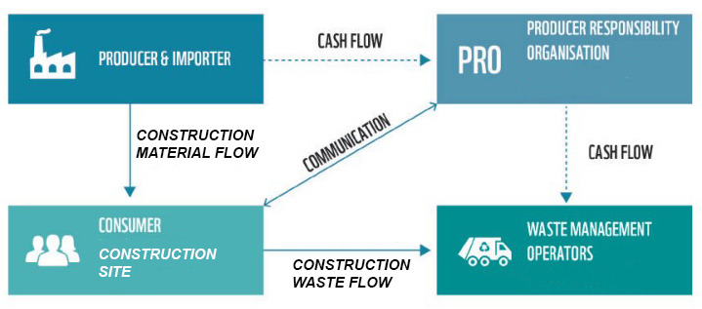In global comparison, most effective EPR schemes are built upon a mandatory obligation for producers and importers. These schemes are based on collective responsibility, where a central organization takes over the take-back responsibilities of all producers and importers. This organization is called the Producer Responsibility Organisation (PRO) ‘Figure 1’. Having a mandatory system in place requires enforcing a corresponding legal basis.

**Figure 1.** EPR based on a collective responsibility

* 1. *Classification of EPR in Construction and Demolishing Waste*

Few cases explicitly highlight specific categories of construction and demolition (C&D) waste materials to demonstrate how EPR is being applied in the C&D waste sector. Data on EPR software explicitly designed to manage and recycle waste materials from construction and demolition projects are included in table 2.

**Table 2.** C&D waste EPR schemes

|  |  |  |
| --- | --- | --- |
| Material | Ref | Summary |
| Brick and concrete | [12 -14] | Since its inception in 2007, BGC's Brickmakers has effectively incorporated all waste produced during the manufacturing of clay bricks into the final combination. Furthermore, it utilizes waste produced from its concrete and fiber cement manufacturing procedures to create its concrete paver and backing block goods. Furthermore, the Austral Bricks factory in Victoria has successfully reduced the frequency of deformed or non-standard green (unfired) bricks. It is clearly specified that any of these units are rapidly reintegrated into the clay mixture for recycling, rather than being discarded in a landfill. |
| Carpet | [15] | Ontera Modular Carpets, established in 1985, provides the Earth Plus environmental program, guaranteeing that the product will be collected for reuse or recycling at no cost to the customer after it reaches the end of its initial lifespan. This program operates without any harmful processes or measurable increases in energy input. Ontera claims that this strategy has successfully built a positive reputation and market position, resulting in higher financial profits and reduced costs associated with utilities and landfill usage. |
| Gypsum | [15] | CSR Gyprock offers a service that involves collecting leftover pieces of gypsum board and materials from demolition projects. According to the instructions in this plan, after the gypsum boards are installed, the contractor in charge of fitting the boards will work together with the recycling contractor from CSR Gyprocks to schedule the collection of the boards. The recycling contractor will levy a reasonable price on the contractor for this service. Implementing such a system is believed to have the ability to reduce expenses related to cleaning up sites and using landfills, enhance waste management on-site, and lead to time and cost savings for structures. |
| PVC | [15] | Since 2002, the Vinyl Council of Australia has voluntarily pledged to adopt EPR principles and comply with the criteria set forth under the Product Stewardship Act of 2011. Armstrong Australia, a prominent international manufacturer of resilient PVC flooring solutions, collects old and worn materials that would otherwise be disposed of in a landfill. Subsequently, these materials undergo recycling and further conversion into a novel product. |
| Timber | [16] | The National Timber Product Stewardship Group was formed in 2007 by the timber industry to reduce the environmental impact of disposing of timber products and improve their recovery after consumers have used them. |
| Waffle pod | [15] | EPS Australia and its Pod Group members are working together to reduce the quantity of expanded polystyrene (EPS) waste produced by waffle pod offcuts at construction sites. To achieve this goal, they want to implement a product stewardship initiative known as the Pod Scrap Bag program. This program offers contractors specialized bags designed to isolate EPS waste from other materials. Afterward, the bags are collected and sent to the EPS producer, who claims to produce new EPS using 40% recycled materials. |

* 1. *Consideration in the development of EPR policy*

The formulation of EPR and similar legislation is complex because of its intricate nature and the wide range of participants involved in product creation, trade, distribution, consumption, and waste management [12]. Furthermore, the implementation strategies of EPR policies can vary. Previous research endeavors have attempted to construct models to improve the efficacy of EPR regulations in practical situations [17]. The results section explicitly examines a specific group of these models. Dubois et al. [18] introduced a set of five criteria to evaluate the appropriateness of EPR for managing C&D waste:

* The level of control in the end-of-life stage
* The environmental scope for improvement
* Existing incentives for end-of-lie treatment
* The availability of alternative policy instruments
* Political priorities

Examining upon analyzing the waste stream of the Netherlands related to C&D, the researchers found that the adoption of EPR was primarily driven by two factors: the environmental scope and political priorities. Acree Guggemos et al. [19] established a regulatory framework aimed at enhancing waste management of construction and demolition activities and accomplishing the goals of EPR. The framework, based on the paradigm put forth by Thorpe et al. [20] includes three types of policy instruments: regulatory, economic, and information-based.

Prior studies have presented models that demonstrate specific similarities and differences [21 - 23]. In addition, targeted research investigating the variables that impact EPR performance has yielded valuable insights on how to optimize the effectiveness of EPR and related waste management efforts. Gupt et al. [24] conducted a comparative analysis of twenty-six case studies from both industrialized and developing nations. Their objective was to determine the fundamental components of EPR creation and implementation, as well as the factors that contribute to its effective implementation. The results indicated that the "financial responsibility of the manufacturers," "unique assortment," and "recycling entities" play a significant impact on the efficacy of EPR. The main constituents of EPR were categorized as "regulatory provisions," "take-back responsibility," and "financial flow." In 2016, a study assessed the effectiveness of various environmental regulations in Maine, United States [25]. The study utilized a method of assigning weights and making comparisons to evaluate the policies. The data indicate that EPR policies are very successful. However, their acceptability is still unclear [25].

* 1. *Impact of using EPR in the construction waste management*

Implementing EPR can result in numerous benefits for the environment and the wider community. Through the implementation of EPR, societies can embrace a more sustainable and responsible approach to effectively managing the life cycles of products. This includes offering support for environmental conservation, minimizing the production of extra materials, and advocating for the adoption of a circular economy. The EPR has been used for several types of waste and streams [26 - 27]. This technology can enable the building industry and the C&D waste recovery sector to effectively adapt to significant disruptions, including pandemics, climate crises, trade wars, and natural disasters [17][28].

* 1. *Challenges and barriers to EPR implementation in Malaysia*

Several barriers have been recognized that hinder the widespread implementation of EPR and comparable initiatives in the construction sector [29 - 31]. Hence, it is important to acknowledge that the EPR instruments vary in their ability to effectively handle C&D waste. The implementation of EPR in Malaysia may have undergone adjustments. An all-encompassing and well-organized strategy involving the government, corporations, and the general population is crucial to tackling these difficulties. Regular and ongoing communication, education, and thorough evaluation of the efficacy of EPR policies are essential for the successful implementation of these policies.

Discovered multiple obstacles in the implementation and enforcement of EPR policies [32]. These factors encompass the financial and temporal consequences, the participation of various parties, the necessity to take into account the complete lifespan of construction goods, the obligations of manufacturers, the intricacy of implementing EPR regulations, the need to adapt existing facilities, and apprehensions regarding health and safety. To acquire the most up-to-date and precise information regarding the implementation of EPR, it is advisable to refer to Malaysia's current progress and regulations. Nevertheless, drawing from prevalent patterns and the problems encountered by several countries in executing EPR initiatives, the subsequent hurdles and impediments are expected to be confronted by Malaysia or any other nation

* 1. *Policy instrument that facilitates EPR implementation*

EPR is a policy strategy that imposes responsibility on producers for the ecological consequences of their products from creation to disposal. To successfully implement EPR, it is necessary to utilize many policy instruments that provide incentives to producers, regulate their actions, and guarantee adherence to environmental goals. ‘Figure 2’ by Acree Guggemos et al. [19] three policy instruments that support the adoption of EPR.

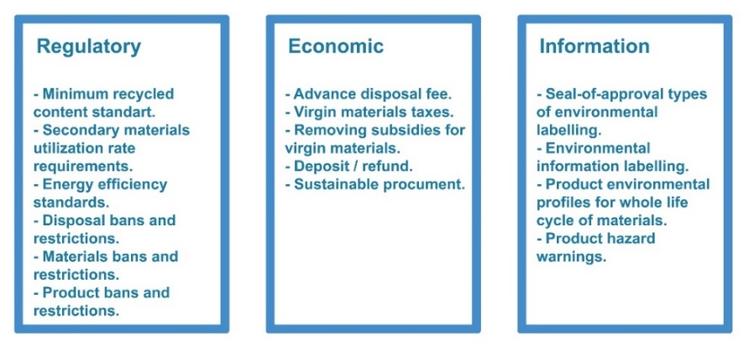

**Figure 2.** Three policy instruments that facilitate EPR implementation. Source: Adopted from Acree Guggemos et al. [19].

* 1. *Developing innovative operational measures for improving sustainability with the EPR system*

EPR schemes are environmental policies designed to hold producers accountable for the complete life cycle of their products, encompassing disposal and recycling. Enhancing sustainability across the product lifetime in EPR systems requires the implementation of novel ideas and practices to develop unique operational metrics. Here are some possibilities depicted in ‘Figure 3’.

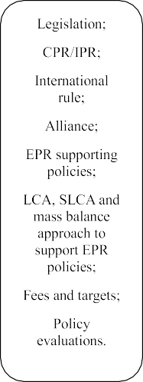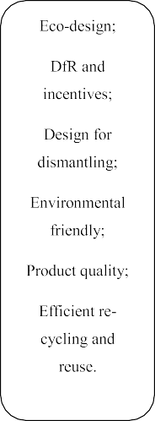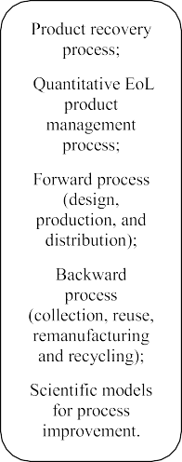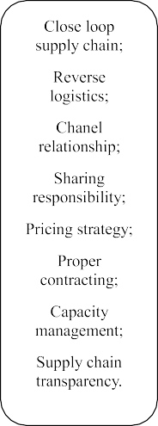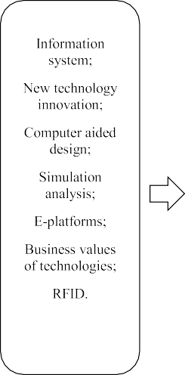

**Figure 3.** Developing innovative operational measures for improving sustainability with EPR systems.

1. **Conclusion**

Implementing the EPR policy at the national level is typically the most efficient strategy since the majority of firms affected by EPR operate on a national scale [33]. Currently, only a restricted number of programs have been implemented on a national scale. However, this issue must be promptly resolved.

As per the suggestions of many stakeholders in waste and resource recovery, it is necessary to shift the policy approach to EPR from voluntary to mandatory arrangements [34 - 35].

Before implementation, it is essential to establish the EPR policy by soliciting input from diverse stakeholders. Implementing an EPR strategy that is widely accepted would guarantee the ongoing execution of the program and its achievement of desired results. Moreover, due to the numerous distinctive and intricate elements involved in C&D waste management, the EPR approach that was established should be customized to meet the specific demands of this industry. An effective strategy can be formulated to tackle the existing difficulties in handling C&D waste. Therefore, it is crucial to actively engage in research institutions, such as colleges, to comprehend the exact methodologies required to tackle these particular issues.

The summary of the article contains a comprehensive description of the EPR approach for managing construction waste in Malaysia. Not all initiatives are undertaken by the parties involved in building. Hence, it is imperative to adopt a holistic strategy to safeguard the economic, social, and environmental dimensions. The Malaysian government should offer vital support to build a more effective framework for controlling construction waste, particularly by implementing EPR.

1. **References**
2. Aslam, M. S., Huang, B., & Cui, L. (2020). Review of construction and demolition waste management in China and USA. *Journal of Environmental Management*, *264*, 110445.
3. Murtagh, N., Scott, L., & Fan, J. (2020). Sustainable and resilient construction: Current status and future challenges. *Journal of Cleaner Production*, *268*, 122264.
4. Bailey, M., Booth, C. A., Horry, R., Vidalakis, C., Mahamadu, A. M., & Awuah, K. G. B. (2020). Opinions of small and medium UK construction companies on environmental management systems. *Proceedings of the Institution of Civil Engineers-Management, Procurement and Law*, *174*(1), 23-34.
5. Jalaei, F., Zoghi, M., & Khoshand, A. (2021). Life cycle environmental impact assessment to manage and optimize construction waste using Building Information Modeling (BIM). *International Journal of Construction Management*, *21*(8), 784-801.
6. Xu, F., Wang, Z., Chi, G., & Zhang, Z. (2020). The impacts of population and agglomeration development on land use intensity: New evidence behind urbanization in China. *Land Use Policy*, *95*, 104639.
7. Taha, M. P. (2015). *What a Waste: Solid Waste Management and The Malaysian Perspective on Construction Waste Generation and Management.* Kuala Lumpur: Solid Waste and Public Cleansing Management Corporation. Retrieved from <http://www.swcorp.gov.my/index.php/en/>
8. Liang, Y., Tan, Q., Song, Q., & Li, J. (2021). An analysis of the plastic waste trade and management in Asia. *Waste Management*, *119*, 242-253.
9. Soni, A., Das, P. K., Hashmi, A. W., Yusuf, M., Kamyab, H., & Chelliapan, S. (2022). Challenges and opportunities of utilizing municipal solid waste as alternative building materials for sustainable development goals: A review. *Sustainable Chemistry and Pharmacy*, *27*, 100706.
10. da Silva, T. R., de Azevedo, A. R. G., Cecchin, D., Marvila, M. T., Amran, M., Fediuk, R., ... & Szelag, M. (2021). Application of plastic wastes in construction materials: A review using the concept of life-cycle assessment in the context of recent research for future perspectives. *Materials*, *14*(13), 3549.
11. Gedik, A. (2020). A review on the evaluation of the potential utilization of construction and demolition waste in hot mix asphalt pavements. *Resources, Conservation and Recycling*, *161*, 104956.
12. Chen, Z., Feng, Q., Yue, R., Chen, Z., Moselhi, O., Soliman, A., ... & An, C. (2022). Construction, renovation, and demolition waste in landfill: a review of waste characteristics, environmental impacts, and mitigation measures. *Environmental Science and Pollution Research*, *29*(31), 46509-46526.
13. Shooshtarian, S.; Caldera, S.; Maqsood, T.; Ryley, T. Using Recycled Construction and Demolition Waste Products: A Review of Stakeholders’ Perceptions, Decisions, and Motivations. Recycling 2020, 5, 31.
14. Scarvaci, V.; General Manager at Brickmakers, Perth, Australia; Barrett, C.; Energy and Environment at BGC, Perth, Australia. Personnal Communication, 2019.
15. Brickworks Building Products. Build for Living: Building a Platform of Commitment and Responsibility; BrickWorks: Melbourne, Australia, 2012.
16. Edge Environment. Construction and Demolition Waste Guide—Recycling and Reuse across the Supply Chain; The Department of Energy and Environment: Canberra, Australia, 2012.
17. Taylor, J.; Warnken, M. Wood Recovery and Recycling: A Source Book for Australia, Forest & Wood Products; CMSE: East Lansing, MI, USA, 2008.
18. Xu., J., Ye, M., Lu, W., Bao, Z., Webster, C. A Four-Quadrant Conceptual Framework for Analysing Extended Producer Responsibility in Offshore Prefabrication Construction. J. Clean. Prod. 2020, 282, 124540. [A four-quadrant conceptual framework for analyzing extended producer responsibility in offshore prefabrication construction - PubMed (nih.gov)](https://pubmed.ncbi.nlm.nih.gov/33052174/).
19. Dubois, M.; de Graaf, D.; Thieren, J. Exploration of the Role of Extended Producer Responsibility for the Circular Economy in the Netherlands; EY: London, UK, 2016.
20. Acree, G.A.; Horvath, A. Strategies of Extended Producer Responsibility for Buildings. J. Infrastruct. Syst. 2003, 9, 65–74.
21. Thorpe, B.; Kruszewska, I. Strategies to Promote Clean Production: Extended Producer Responsibility. Clean Production Action. Institute for Sustainable Futures, UTS Appendix A. 1999. [www.grrn.org/resources/bevEPR.html](http://www.grrn.org/resources/bevEPR.html).
22. Langrová, V. Comparative Analysis of Epr Programmes for Small Consumer Batteries; IIIEE: Lund, Sweden, 2002.
23. Nahman, A. Extended Producer Responsibility for Packaging Waste in South Africa: Current Approaches and Lessons Learned. *Resour. Conserv. Recycl.* **2010**, *54*, 155–162.
24. Widmer, R.; Heidi, O.-K.; Deepali, S.-K.; Schnellmann, M.; Böni, H. Global Perspectives on E-Waste. *Environ. Impact Assess. Rev.***2005**, *25*, 436–458.
25. Gupt, Y.; Sahay, S. Review of Extended Producer Responsibility: A Case Study Approach. *Waste Manag. Res.* **2015**, *33*, 595–611.
26. Isenhour, C.; Blackmer, T.; Wagner, T.; Silka, L.; Peckenham, J. Moving up the Waste Hierarchy in Maine: Learning from Best Practice State-Level Policy for Waste Reduction and Recovery. *Maine Policy Rev.* **2016**, *25*, 15.
27. Colelli, F. P., Croci, E., Pontoni, F. B., & Zanini, S. F. (2022). Assessment of the effectiveness and efficiency of packaging waste EPR schemes in Europe. *Waste Management*, *148*, 61-70.
28. Pouikli, K. Concretising the Role of Extended Producer Responsibility in European Union Waste Law and Policy through the Lens of the Circular Economy. In ERA Forum; Springer: Berlin/Heidelberg, Germany, 2020.
29. Ibn-Mohammed, T.; Mustapha, K.B.; Godsell, J.M.; Adamu, Z.; Babatunde, K.A.; Akintade, D.D.; Acquaye, A.; Fujii, H.; Ndiaye, M.M.; Yamoah, F.A. A Critical Review of the Impacts of Covid-19 on the Global Economy and Ecosystems and Opportunities for Circular Economy Strategies. Resour. Conserv. Recycl. 2020, 164, 105169.
30. Shooshtarian, S., Maqsood, T., Wong, P. S., Khalfan, M., & Yang, R. J. (2021). Extended producer responsibility in the Australian construction industry. *Sustainability*, *13*(2), 620.
31. Shanoff, B.S. Proposed Recycling Rules Create Obstacles. World Wastes 1996, 39, 14–17.
32. Srour, I.; Chong, W.K.; Zhang, F. Sustainable Recycling Approach: An Understanding of Designers’ and Contractors’ Recycling Responsibilities Throughout the Life Cycle of Buildings in Two Us Cities. Sustain. Dev. 2012, 20, 350–360.
33. Shooshtarian, S.; Maqsood, T.; Khalfan, M.; Yang, R.J.; Wong, S.P.P. Landfill Levy Imposition on Construction and Demolition Waste: Australian Stakeholders’ Perceptions. Sustainability 2020, 12, 4496
34. Ahlers, J., Hemkhaus, M., Hibler, S., & Hannak, J. (2021). Analysis of extended producer responsibility schemes.
35. Leclerc, S. H., & Badami, M. G. (2020). Extended producer responsibility for E-waste management: Policy drivers and challenges. *Journal of Cleaner Production*, *251*, 119657.
36. Compagnoni, M. (2022). Is Extended Producer Responsibility living up to expectations? A systematic literature review focusing on electronic waste. *Journal of Cleaner Production*, *367*, 133101.

**Acknowledgments**

Centre for Graduate Studies, Universiti Malaysia Perlis for the Postgraduate Academic Activities Fund (PAAF) funded the paper submission and the conference community allowed me to submit this paper.