**Experimental Investigation of Tool Life in Milling Hastelloy C-2000 Using Response Surface Methodology**

**Nurul Hidayah Razak1*, Md Mustafizur Rahman2 and Kumaran Kadirgama2**

1 Faculty Technology of Manufacturing and Mechatronic Engineering, Universiti Malaysia Pahang Al-Sultan Abdullah (UMPSA), Pekan, Pahang, Malaysia.

2 Faculty Technology of Mechanical and Automotive Engineering, Universiti Malaysia Pahang Al-Sultan Abdullah (UMPSA), Pekan, Pahang, Malaysia.

*E-mail: hidayahrazak@umpsa.edu.my

**Abstract.** This paper presents a tool life study on tungsten carbide inserts in milling Hastelloy C-2000 using response surface methodology (RSM). The experiment was performed using uncoated and TiAlN coated carbide inserts. There were 15 experiments designed using the Box-Behnken architecture according to machining parameter input such as cutting speed, depth of cut and feed rate. Analysis of variance (ANOVA) has been carried out to validate the fit and adequacy of the development of mathematical model. The results show that feed rate has a great influence on tool life followed by axial depth, and cutting speed.

**Keywords**- Tool Life, Hastelloy C-2000, Response Surface Methodology (RSM).

1. **Introduction**

Nickel-based superalloys is widely utilized in aerospace industry, military equipment, petroleum and nuclear reactor, and commercial usage. The alloys are notorious with very difficult-to-cut material due to their excellent in heat resistant, oxidation resistance, low thermal conductivity and work hardening effect [1]. With respect to their outstanding mechanical properties, machining Nickel-based superalloy always become challenging to the industry. Short tool life, poor surface machined, high cutting force are the example of the problem in machining Nickel-based superalloy [2].

Progressive flank wear, large fracturing at the cutting could lead to abrupt tool breakage [3-5]. Thus, choosing the right cutting tool insert is vital to reduce the machinability issue of these superalloys. There are some criterions for a cutting tool to be selected to cut Ni-based alloy such as high hardness, high wear resistance, good thermal shock properties and reasonable chemical stability. Ceramics, high speed steel (HSS), uncoated and coated carbide, and cubic boron nitride (CBN) are the existence cutting tools that be considered as the cutting tools.

With respect to carbide cutting tools, physical vapor deposition (PVD) coated tool is commonly used because of higher tool life compared to the chemical vapor deposition (CVD). It also enhances thermal behavior as well as reduces the wear and friction at the cutting-edge during machining [6]. It is found that the performance of single layer PVD-TiAlN coating is better that triple coating of CVD-TiN/TiCN/Al2O3 coating layers in machining Ni-based superalloys [7-9]. TiAlN coating has become one of the best coating for tools [10-11]. Sousa et al.[12] conducted a comprehensive review on the characteristics and wear mechanisms of TiAlN-based coatings for machining application. Based on this extensive study, they have concluded that TiAlN coating provides wear resistance, good mechanical and thermal characteristics and strong resistance to corrosion, hence TiAlN coating are frequently employed in today’s machining process. Based on the characteristic of the Ni-based superalloys and TiAlN coating of coated carbide tool insert, this study intends to investigate the tool life of Hastelloy C-2000.

1. **Methodology** 
   1. *Design of Experiment (DOE)*

Design of experiment (DOE) has been used to decrease the run of experiment and time, Box-Behknen design has been selected in designing the milling parameter with three level of cutting parameters. Feed rate, depth of cut and cutting speed were the machining input. Machining level and their level is presented in Table 1 and machining design value is presented in Table 2. Values of feed rate, depth of cut and cutting speed regarded as ordinary value.

**Table 1.** Machining parameters and their level

|  |  |  |  |
| --- | --- | --- | --- |
| **Process**  **Parameters** | **Level** | | |
| -1 | 0 | 1 |
| Feed rate (mm/tooth) | 0.1 | 0.15 | 0.2 |
| Axial depth (mm) | 0.4 | 0.7 | 1 |
| Cutting speed (mm/min) | 15 | 23 | 31 |

**Table 2.** Design value experiment for coated and uncoated carbide insert

|  |  |  |  |
| --- | --- | --- | --- |
| **Experiment No.** | **Feed rate (mm/tooth)** | **Axial Depth (mm)** | **Cutting speed (m/min)** |
| 1 | 0.15 | 0.4 | 31 |
| 2 | 0.15 | 1 | 15 |
| 3 | 0.1 | 0.7 | 15 |
| 4 | 0.2 | 1 | 23 |
| 5 | 0.2 | 0.7 | 31 |
| 6 | 0.15 | 0.7 | 23 |
| 7 | 0.15 | 0.7 | 23 |
| 8 | 0.2 | 0.7 | 15 |
| 9 | 0.1 | 0.4 | 23 |
| 10 | 0.15 | 1 | 31 |
| 11 | 0.15 | 0.4 | 15 |
| 12 | 0.1 | 0.7 | 31 |
| 13 | 0.1 | 1 | 23 |
| 14 | 0.15 | 0.7 | 23 |
| 15 | 0.2 | 0.4 | 23 |

* 1. *Workpiece and Cutting Tool Material*

Hastelloy C-2000 workpiece and uncoated and TiAlN coated tungsten carbide insert were used in the experiment. Table 3 and Table 4 show the chemical and physical properties of Hastelloy C-200 workpiece. The dimension of the workpiece of the workpiece itself was 120 x 46 x 20 mm which B90 Rockwell hardness.

**Table 3.** Chemical composition of Hastelloy C-2000

|  |  |  |  |  |  |  |  |  |  |
| --- | --- | --- | --- | --- | --- | --- | --- | --- | --- |
| Comp. | Ni | Cr | Mo | Fe | Cu | Al | Mn | Si | C |
| Wt. (%) | BAL | 23 | 16 | 3 | 1.60 | 0.50 | 0.50 | 0.08 | 0.01 |

**Table 4.** Physical properties of Hastelloy C-2000

|  |  |
| --- | --- |
| **Parameters and unit** | **Value** |
| Density (g/cm3) | 8.5 |
| Thermal conductivity (W/m°C) | 9.1 |
| Mean coefficient of thermal expansion (μm/m°C) | 12.4 |
| Thermal Diffusivity (cm²/s) | 0.025 |
| Specific heat (J/kg°C) | 428 |
| Modulus of elasticity (GPa) | 223 |

The experiment was conducted on HAAS TM-2 CNC milling machine per pass. The workpiece has been machined with 1 pass (120 mm in length). Workpiece set up, cutting insert and CNC machine are shown in Fig. 1. Tool life is determined based on ISO 8688-1:1989 Standard for tool life testing in milling [13] based on wear criterion where 0.3 mm for uniform wear criterion (*VB*) and 0.6 mm indicates as maximum wear (*VBmax*). Wear value has been determined after 1 pass milling completed.

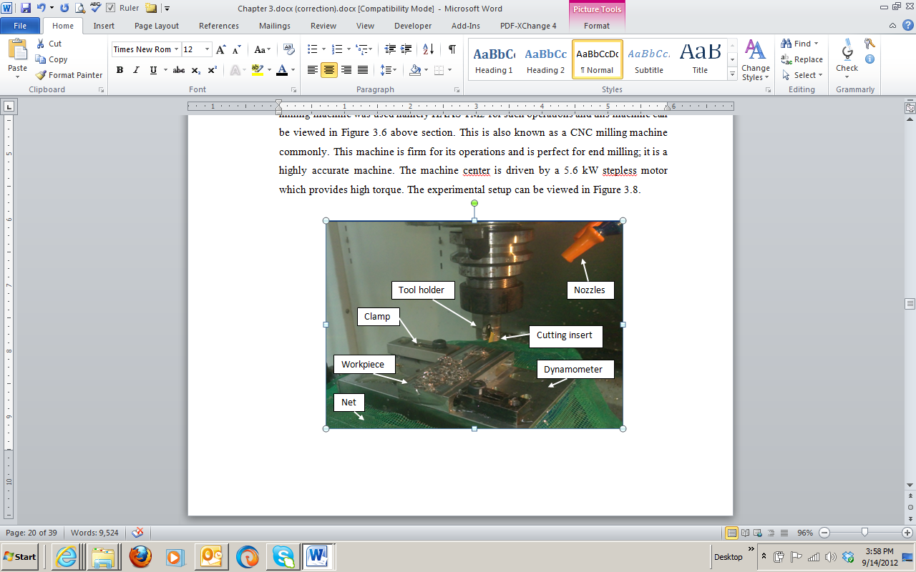 

1. (b)

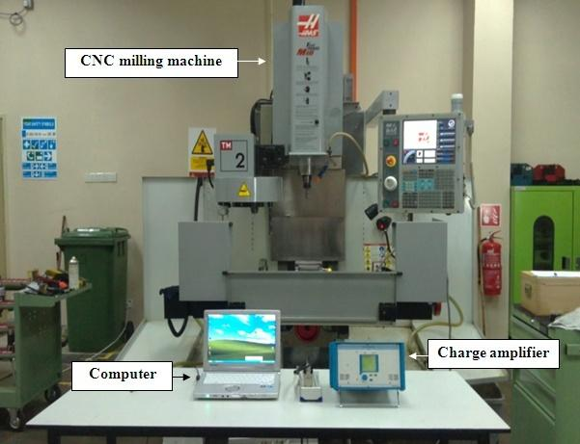

(c)

**Figure 1.** Machining set up of Hastelloy C-2000 (a) workpiece set up on CNC milling machine, (b) TiAlN tungsten coated carbide insert, (the red dotted lines indicate the cutting edge of the cutting tool).

and (c) CNC milling machine

1. **Result and Discussion**

Response surface methodology (RSM) is implemented to determine milling parameters that influence the life of the tool insert. The second order- polynomials mathematical for tool life is generated as in equation 1.

(1)

Where *Y* represents the corresponding responses, *β* is the estimator in the second order regression coefficients and *X1*, *X2*, *X3* are the input parameters. Mathematical equation for TiAlN coated and uncoated carbide inserts can be written as in Eq. 2 and 3 respectively.

For TiAlN coated carbide:

*Y”*=1.14667-0.79363*X1*-0.017475*X2*-0.02738*X3*+0.03392 *X1*2+0.01917*X*22+0.0067*X*32

+0.03325*X*1*X*2-0.03750*X*1*X*3+0.0437*X*2*X*3  (2)

For uncoated carbide:

*Y”*=0.52167-0.320750*X1*-0.104375*X2*0.007125*X3*+0.058667*X1*2+0.057917*X*22-0.033583*X*32+0.022750*X*1*X*2-0.013250*X*1*X*3-0.012500*X*2*X*3 (3)

Where *Y’*’ is the corresponding to tool life, *X1* ,*X2*and *X3* are feed rate (mm/tooth), axial depth of cut and cutting speed (m/min).

The ANOVA results have helped understand the adequacy of the second order model at a level of 95%. The *P*-value for lack of fit have been considered insignificant since they are 0.229 and 0.007 for coated and uncoated carbide cutting tool inserts which states that the model is adequate. The *P*-value of regression for coated carbide is 0.000 and uncoated carbide, 0.002 which are significant. These values are present in Table 3 and the model is fit for use. An indicator has been identified for the model effectiveness and both models are considered acceptable.

The coated and uncoated carbides have R2 of 99.40 % and 97.46 % respectively and based on the *P*-value and R2 it is clear that the second order model of RSM is much more adequate and significant in order to predict the tool life. Besides these effects, an increase in cutting speed increases the frequency of tool edge entrance into the workpiece (increasing the number of shocks per minute) and in addition the energy of the shock between the cutting edge and the workpiece. This makes cutting speed even more important to the end of tool life.

**Table 3.** Variance analysis for second order tool life for coated and uncoated carbide tools

|  |  |  |  |  |  |
| --- | --- | --- | --- | --- | --- |
| **Source** | **DOF** | **Coated carbide**  **Insert** | | **Uncoated carbide insert** | |
|  |  | **F-value** | **P-value** | **F-value** | **P-value** |
| Regression | 9 | 92.61 | 0.000 | 21.31 | 0.002 |
| Linear  Square  Interaction | 3  3  3 | 276.64  0.28  0.93 | 0.000  0.840  0.493 | 61.67  2.02  0.23 | 0.000  0.229  0.872 |
| Residual Error | 5 |  |  |  |  |
| Lack of Fit | 3 | 3.53 | 0.229 | 139.96 | 0.070 |
| Pure Error | 2 |  |  |  |  |
| Total | 14 |  |  |  |  |

High temperature is generated when the cutting speed is high and there is a long period contact between the cutting tool and the workpiece. This high temperature causes the tool life to reduce [14]. The tool life may be induced with the help of the high chemical affinity of the chemicals being used for the cutting tool materials attributes to the increases of diffusion wear [15]. Cutting tool insert always experiences the severe mechanical and thermal load and enhances the tool wear in addition to reduce the tool life [16]. When there is high cutting speed and feed rate, the inserts break which is why it is not possible to maintain a long tool life of the uncoated carbide inserts. The coating causing a high level of resistance and till the time it is still in shape, the tool wear rate is very low.

Figure 2 shows the contour plot of tool life versus feed rate, axial depth and cutting speed for coated and uncoated carbide inserts. Here, the uncoated carbide is much more superior to the coated carbide tool life. The heat that was generated by the high feed rate was able to decrease the tool life and the hardness of the cutting tool material [17]. Based on the contour plot of feed rate versus cutting speed, if the machine cutting speed is increased, the temperature increases which in return decreases the tool material hardness and leading to diffusion and abrasion [18]. In both the cases of coated and uncoated carbide inserts it is found that the tool life declines from 0.1 mm/tooth to 0.2 mm/tooth as shown in Experiment 12 and 5 respectively. If the feed rate is at minimum level then the tool life is much higher and with a high cutting speed there is tool wear and short life of the tool is experienced [19]. A low feed rate is able to provide a much longer tool life than a feed rate which is high [20].

1. (b)

(c) (d)

**Figure 2**. The tool life second order RSM contour plot vs feed rate, axial depth and cutting speed (a) coated carbide (b) uncoated carbide, (c) coated carbide and (d) uncoated carbide insert

1. **Conclusion**

It is seen that a majority of uncoated carbide inserts do not have a long tool life when exposed to high cutting speed, and feed rate leading to breakage of the inserts. The coated tool has higher tool life due to coating resistance. In terms of effect on tool life the feed rate is most influential then comes the axial depth and cutting speed. Higher cutting speed, feed rate and axial depth indicate lower tool life.

1. **References**

[1] Sigh, G. Aggrawal, V. S. Sigh, and Sigh B. B., “ Sustainable Machining of Hastelloyt C-276 enabling Minimum Quantity Lubrication of Environmentally Compatible Lubricants,” Journal of cleaner Production, vol 373 (2022) 133928.

[2] Liang J., Gao H., Xiang S., Chen, L. You Z., and Lei, Y. “Research on Tool Wear Morphology and Mechanism During Turning Nickel-Based Alloy GH4169 with PVD-TiAlN coated carbide tool,” Wear, vol.508-509 (2022), 204468.

[3] Sua ́rez, A. Veiga, F. Polvorosa, R. Artaza, Holmberg, T. . Lo ́pez de Lacalle J. L.N, A. Wretlande, Surface integrity and fatigue of non-conventional machined Alloy 718, J. Manuf. Process. 48 (2019) 44–50.

[4]  Polvorosa, R. Lo ́pez de Lacalle L.N., S ́anchez Egea A.J., Fernandez A., Esparta M., Zamakona, I. Cutting edge control by monitoring the tapping torque of new and resharpened tapping tools in Inconel 718, Int. J. Adv. Manuf. Technol. 106 (2020) 3799–3808.

[5] Sua ́rez A., Veiga, F. Lo ́pez de Lacalle, L.N. Polvorosa, R. A. Wretland, An investigation of cutting forces and tool wear in turning of Haynes 282, J. Manuf. Process. 37 (2019) 529–540.

[6] Baptista, A Silva. F., Silva J. Porteiro, J. Míguez, Pinto, G. Sputtering physical vapour deposition (PVD) coatings: a critical review on process improvement and market

[7] Zou, Z.F. He, L. Jiang, H.W. . Zhan, GJ. Wu, X. Development and analysis of a low- wear micro-groove tool for turning Inconel 718, Wear 420–421 (2019) 163–175.

[8]  Chowdhury, M. . Bose, S.I. Yamamoto, BK. Shuster, . Paiva, L.S. Fox- Rabinovich JG.S., S.C. Veldhuis, Wear performance investigation of PVD coated and uncoated carbide tools during high-speed machining of TiAl6V4 aerospace alloy, Wear 446–447 (2020), 203168.

[9] Capasso,S. Paiva,J.M. LocksJunior, E. Settineri L., Yamamoto,K. Amorim,D. Torres, Covelli, D. Veldhuis, S.C. A novel method of assessing and predicting coated cutting tool wear during Inconel DA 718 turning, Wear 432–433 (2019), 202949.

[10] Xue, C. and Chen, W.Y. Adhering layer formation and its effect on the wear of coated carbide tools during turning of a nickel-based alloy, Wear 270 (2011) 895–902.

[11] Hao,Z.P and Gao D.,Y.H.Fan,R.D.Han,Newobservationsontoolwearmechanismin dry machining Inconel718, Int. J. Mach. Tool Manufact. 51 (2011) 973–979.

[12] Sousa, V.F.C. Pinto, F.D. Baptista, G. Alexandre, A. R. Characteristics and wear mechanisms of TiAlN-based coatings for machining applications: a comprehensive review, Metals 11 (2021) 260.

[13] ISO 8688-1:1989 Tool life testing in milling part 1.

[14] Vivancos J., Luis, C. .Ortiz J. J A. and H.A. Gonzalez, 2005.Analysis of factors affecting the high speed side milling of hardened die steels. *Journal Material Processing Technology,* **162–163:** 696–701I. S. Jacobs and C. P. Bean, “Fine particles, thin films and exchange anisotropy,” in Magnetism, vol. III, G. T. Rado and H. Suhl, Eds. New York: Academic, 1963, pp. 271–350.

[15] Sharman, A. Dewes R.C,. and Aspinwall, D.K. 2001.Tool life when high speed ball nose end milling Inconel 718. *Journal of materials Processing Technology,* **118**: 29-35.

[16] Xue C., and Chen, W. 2011. Adhering layer formation and its effect on the wear of coated carbide tools during turning of a nickel-based alloy. *Wear*, **270**(11–12): 895–902.

[17] Venugopal, K. Paul, A. S. and Chattopadhyay A.B., 2007. Growth of tool wear in turning of Ti-6Al-4V alloy under cryogenic cooling. *Wear,* **262**: 1071–1078.

[18] Coromant, S. 1994. Modern metal cutting: a practical handbook. Sweden: Tofters Tryckeri.

[19] Jawaid, A. Koksal, S. and Sharif, S. 2001. Cutting performance and wear characteristics of PVD coated and uncoated carbide tools in face milling Inconel 718 aerospace alloy. *Journal Material Processing Technology*, **116**: 2–9.

[20] Che Haron C.H. 2001. Tool life and surface integrity in turning titanium alloy. *Journal of Materials Processing Technology*,**118:** 231–237.

**Acknowledgments**

This project is supported by the Research and Innovation Department of Universiti Malaysia Pahang Al-Sultan Abdullah through grant number RDU210369.