Mechanical Strength and Fire Resistance Analysis of Semiconductor Epoxy Mold Component Resin Waste Reinforced Recycled High-Density Polyethylene for SEMC-RW/R-HDPE Composite Permeable Pavement

**ORIGINAL ARTICLE**

Tan K Reen1, Noraini Marsi1,2[1]*, Hasnida Harun1, Kamarulzaki Mustafa3, Nik Normunira Mat Hassan1, Roslinda Ali1, Jamaluddin Johar4, Hock Chee Low4

|  |
| --- |
| 1Faculty of Engineering Technology, Universiti Tun Hussein Onn Malaysia, Pagoh Campus KM 1, Jln Panchor, 86400 Pagoh, Johor, MALAYSIA |
| 2Advanced Manufacturing and Material Centre (AMMC), Institute of Integrated Engineering, Universiti Tun Hussein Onn Malaysia, Parit Raja, 86400 Batu Pahat, Johor, MALAYSIA |
| 3Faculty of Applied Sciences and Technology, Universiti Tun Hussein Onn Malaysia, Pagoh Campus KM 1, Jln Panchor, 86400 Pagoh, Johor, MALAYSIA |
| 4STMicroelectronics Sdn Bhd, Industrial Area Muar, 84007 Muar, Johor, MALAYSIA |

*E-mail: mnoraini@uthm.edu.my

**Abstract**. Permeable pavement is a green infrastructure where it allows water to travel through which can prevent floods and control stormwater. Disposing of semiconductor resin waste is a major concern due to their recalcitrant nature with only 18% currently being recycled and around 12,000 Mt of plastic waste is ending up in landfills and the environment. The main objective in this study is to determine the optimum composition of Semiconductor Epoxy Mold Component Resin Waste (SEMC-RW) reinforced Recycled-High Density Polyethylene (R-HDPE) to produce a SEMC-RW/R-HDPE composite permeable pavement. The fabrication stage involved the cleaning and crushing of R-HDPE at Angkasa Kowaris Plastics Sdn. Bhd. and the grinding process of SEMC-RW provided by ST Microelectronics Sdn. Bhd. with particle size of 1.0 ± 0.05 mm to produce SEMC-RW/R-HDPE composite permeable pavement with different ratios, 10% to 80% (wt/wt%) SEMC-RW reinforced with 50% (wt/wt%) R-HDPE. The composite was heated at 160°C in a furnace for 3 hours. The results show the ratio of 50% - 50 % (wt/wt%) of SEMC-RW/R-HDPE composite permeable pavement gives higher tensile strength (ASTM-D3039) at 2.67 MPa and bending strength (ASTM D425) at 1.33 MPa. It is also producing a strong matrix reinforcement bonding through Scanning Electron Microscope (SEM) analysis (ASTM E766-14) and rate of fire resistance (ASTM E-119) at 83%. In conclusion, the 50% SEMC-RW/R-HDPE composite permeable pavement has potential to be apply on permeable pavement application.

**Keywords:** Permeable Pavement, Resin Waste, HDPE, Mechanical Strength, Fire Resistance

1. Introduction

Permeable pavement, a paving solution that is now widely acknowledged as sustainable, has a historical origin reaching back to the 18th century when it was first used in urban environments. Recently, its usage has expanded to include the management of runoff water [1]. Permeable pavement allows surface water, particularly during intense rainfall and precipitation, to seep through the entire pavement structure using permeable subbase materials, often made of coarse-grained aggregates [2]. Researchers have been investigating the use of solid waste as alternative resources in road construction and maintenance due to the issue of excessive trash generation and inadequate disposal techniques. The use of waste materials like Semiconductor Epoxy Mould Component Resin Waste (SEMC-RW) and Recycled High-Density Polyethylene (R-HDPE) in waste disposal procedures improves effectiveness and reduces the requirement for natural aggregates, leading to a significant decrease in life cycle impacts and costs [3]. The utilisation of SEMC-RW and R-HDPE has the potential to be employed as a polymer composite, which is in line with the current trends in the production of sustainable materials.

SEMC-RW is the predominant composite material used for encapsulation in the semiconductor sector, resulting in a monthly waste production of 5,000 tonnes. R-HDPE is a type of polyethylene thermoplastic that is obtained from petroleum. It is being recycled due to the projected increase in global plastic waste, which is estimated to triple in the next 20 years. Currently, only 18% of plastic trash is recycled, leading to the disposal of almost 12,000 Mt in landfills and the environment by 2050 [4]. A significant drawback of permeable pavement composites is their reduced tensile strength in comparison to conventional, impermeable pavements. Incorporating voids to enhance permeability reduces the structural integrity of the material, increasing its susceptibility to fracture when subjected to tensile stress. Permeable pavement composites frequently exhibit reduced bending strength compared to their conventional counterparts. The primary cause of this shortage is mostly due to the permeable characteristics of these materials, which can lead to the formation of vulnerable regions and points of high stress within the structure. Permeable pavements may undergo surface deformation and fracturing due to repeated loads, resulting in damage [5]. Permeable pavement composites, sometimes containing organic binders or additives, have reduced fire resistance and are susceptible to significant damage or can contribute to the spread of fire when exposed to high temperatures.

Achieving both fire resistance and preserving permeability and mechanical strength is a challenging endeavour. To improve these performances, it is possible to use additional materials like fibres and binders to create internal pore structures. This can be achieved by implementing advanced construction and maintenance techniques, leading to a minimum increase of 20% [6]. Thus, this study employed waste materials such as Semiconductor Epoxy Mould Component Resin Waste (SEMC-RW) and Recycled High-Density Polyethylene (R-HDPE). These materials are readily accessible in large quantities and have the potential to replace traditional industrial resources. In this study, different waste compositions were used to improve the mechanical and physical properties of epoxy composites. This resulted in a reduction in the density of the composite permeable pavement and an increase in its mechanical strength compared to traditional concrete pavement. Concrete pavement is typically heavier, more brittle, and less durable. Given these difficulties, employing composites made from Semiconductor Epoxy Mould Component Resin Waste Reinforced Recycled-High Density Polyethylene (SEMC-RW/R-HDPE) for permeable pavement applications offers a viable solution to solve environmental issues and promote sustainable efforts.

1. Literature Review

Epoxy moulding compounds are polymers used as encapsulation materials in electronic packaging. Over the past few years, the increased production of electronic components has led to a significant rise in the generation of epoxy moulding compounds as industrial waste during the moulding process of electronic component packages [7]. Encapsulation enables the assembly and safeguards the delicate semiconductor die, bond wires, and lead frame from external elements such as shock, moisture, and contamination. Epoxy moulding compounds are the most commonly used packing materials [8]. Epoxy resin is a specific form of resin that is renowned for its inflexible mechanical characteristics. The material possesses outstanding characteristics such as excellent filler adhesion, superior thermal stability, easy processing, resistance to chemicals, and low density, which make it very appropriate for the creation of composite materials [9]. The restricted use of epoxy is due to its properties such as brittleness resulting from cross-linking, delamination, low impact strength, and poor cracking resistance. Scientists have extensively researched methods to enhance the mechanical and physical characteristics of epoxy, such as toughness, rigidity, and strength, through the manipulation of the matrix or the incorporation of fillers. Filler or epoxy nanocomposites are widely used in engineering, anti-corrosive coatings, electronic materials, and aerospace industries [10].

Plastic is a frequently dumped trash that has had a lasting detrimental effect on species, their habitats, and humans, making it one of the most prevalent pollutants in the environment. High-Density Polyethylene (HDPE) is a thermoplastic synthetic polymer that falls within the Polyethylene (PE) macro plastic category [11]. It is commonly employed in the production of containers for milk, motor oil, shampoo and conditioner, soap, detergents, and bleaches. Polyethylene (PE) is composed of infinite hydrocarbon chains, where each carbon atom is connected to two other carbon atoms and two hydrogen atoms. HDPE, or high-density polyethylene, has a limited number of branches in its polymer chain. This results in the molecular chains of the liner packing together frequently during the process of crystallization. R-HDPE, on the other hand, refers to HDPE that has been recycled [12]. The incorporation of HDPE waste materials yielded exceptional results in several experiments, highlighting the capacity of waste materials such as HDPE to enhance pavements, whether they are permeable or conventional. HDPE is more frequently used in slope land engineering than in road engineering. The main purpose in this particular situation is to hinder the entry of water [13]. HDPE is notable for its robustness, lack of transparency, and ability to withstand changes in temperature. This material is lightweight, non-toxic, and can be easily recycled, which has led to its growing popularity as a replacement for less eco-friendly components [14].

An investigation was conducted to examine the impact of R-HDPE on the tensile strength of a polymer matrix composite material used for pavement applications [15]. This investigation utilized a combination of nylon, epoxy resin, and fibre-glass. The tensile strength reduced in samples containing a substantial amount of fibre-glass, but increased in samples reinforced solely with R-HDPE. The enhanced performance was ascribed to the superior boundary contact between nylon and epoxy resin, in contrast to the interaction between fibre-glass and epoxy resin [16]. The tensile strength of pervious concrete roads was evaluated by incorporating different levels of silica fume. The mix types SFPC1, SFPC2, SFPC3, SFPC4, and SFPC5 correspond to silica fume replacements of 0%, 4%, 8%, 12%, and 16% respectively. The study found that replacing 8% of cement with SFPC 3, a type of silica fume, resulted in a higher tensile strength of 2.08 MPa after 28 days. The effectiveness of silica fume tends to decrease with additional incorporation. The study shown that the addition of 4 to 12% silica fume resulted in an increase in the tensile strength of the composite material when compared to the control mixture [17]. The study on pervious concrete pavements utilizing recycled concrete aggregate (RCA) indicates that the bending strength is highest at 80% replacement levels of RCA, measuring 2.25 MPa.

These findings align with the results documented in the existing literature on pervious concrete made with concrete aggregate. According to the Brazilian standard, which outlines the basic requirements for the design, specification, construction, and upkeep of permeable concrete pavements, the minimum flexural strength for pervious pavement applications is 2 MPa [18]. Scanning electron microscopy (SEM) has been commonly employed to examine the structure of the fractured surface of Epoxy Asphalt resulting from a brittle fracture in liquid nitrogen. An SEM image of the Epoxy Resin (ER) and Epoxy Asphalt (EA) was analyzed. The occurrence of phase separation was noted when the composite matrix comprised of cured ER and the dispersed phase was asphalt. The outcome demonstrates a robust link and positive interaction between EA and ER. The use of Polymerized fatty acid (PFA) in the epoxy-asphalt composite system resulted in a more homogeneous dispersion of asphalt. The increase in PFA concentration enhanced the compatibility between asphalt and ER, with PFA serving as a versatile curing agent [19]. It is important to select or create permeable pavement materials that have fire-resistant characteristics, especially in regions that are susceptible to wildfires. This involves the careful selection of materials that possess high melting points, low flammability, and the ability to withstand damage caused by heat. The relationship between a material's ability to absorb heat and its thermal conductivity determines its fire resistance. Specifically, materials with lower thermal conductivity have a higher resistance to fire [20].

The study focused on the thermal conductivity of the concrete pavement that allows the passage of steel fibres [21]. The results indicate that Permeable Concrete (PC) has a higher surface temperature of 66.9 ℃, which can be attributed to its elevated thermal conditions. The maximum surface temperature of high-conductivity permeable concrete was 1 to 3 °C lower than that of regular permeability concrete. Simulation experiments conducted in an outdoor setting indicate that permeable concrete pavement generates higher heat output on sunny days compared to regular concrete pavement [22]. The literature study highlights the capacity of composite materials in sustainable infrastructure, specifically in relation to the design and construction of permeable pavements that can endure different levels of impact. This study seeks to use SEMC-RW and R-HDPE to create permeable pavement as a composite. This aligns with the broader goal of using innovative materials and methods to construct sustainable and resilient urban infrastructure.

1. Methodology

## Preparation of SEMC-RW/R-HDPE Composite Permeable Pavement

The manufacturing process of SEMC-RW reinforced R-HDPE for the production of SEMC-RW/R-HDPE composite permeable pavement involves the preparation of raw materials and samples. The raw materials used for the SEMC-RW/R-HDPE composite, as shown in Figure 1, were semiconductor epoxy mold component resin waste (SEMC-RW) and R-HDPE. These materials were utilized to improve the performance of pavements. The sample preparation involved different combinations of SEMC-RW reinforced R-HDPE, and included multiple phases of the procedure such as weighing, mixing, heating, and curing shown in Figure 2. STMicroelectronics Sdn. Bhd. supplied the SEMC-RW, which is widely available in the industry, while Angkasa Kawaris Plastic Sdn. Bhd. supplied R-HDPE plastic waste. Eight samples of SEMC-RW/R-HDPE composite permeable pavement were precisely manufactured, with varying percentages of SEMC-RW mixed with R-HDPE, as shown in Table 1. This study aims to thoroughly examine the SEMC-RW/R-HDPE composite permeable pavement, assessing its qualities and its uses within the framework of sustainable permeable pavement solutions.

Eight permeable pavement samples were created using a combination of SEMC-RW and R-HDPE materials. Each sample had different ratios of SEMC-RW reinforced R-HDPE, as shown in Figure 3. The intricate procedure unfolded in multiple crucial stages to guarantee accuracy and uniformity. The initial step entailed the weighing procedure, in which the samples of SEMC-RW/R-HDPE composite permeable pavement were carefully measured based on the stipulated component ratios. The process was performed utilizing the electronic precision balance, which is well-known for its high level of accuracy and has a readability of 0.1 mg. The precise measurement of each component in the composite was ensured through a thorough weighing process conducted at the Laboratory of Material Science, Faculty of Engineering Technology, UTHM. Following that, the mixing procedure began, during which the SEMC-RW was combined in accordance with the predetermined composition ratios. This procedure was crucial in attaining a homogeneous dispersion of the constituents within the composite, guaranteeing consistency and optimal functionality. The ultimate blend was placed onto the prepared mold using the casting technique, with a dimension of 200mm x 200mm and consistent thickness and width.

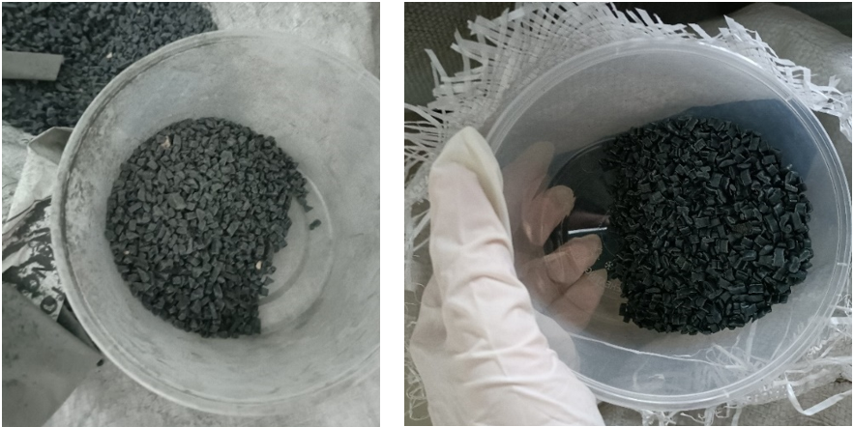

1. (b)

**Figure 1.** Raw material: (a) SEMC-RW; (b) R-HDPE

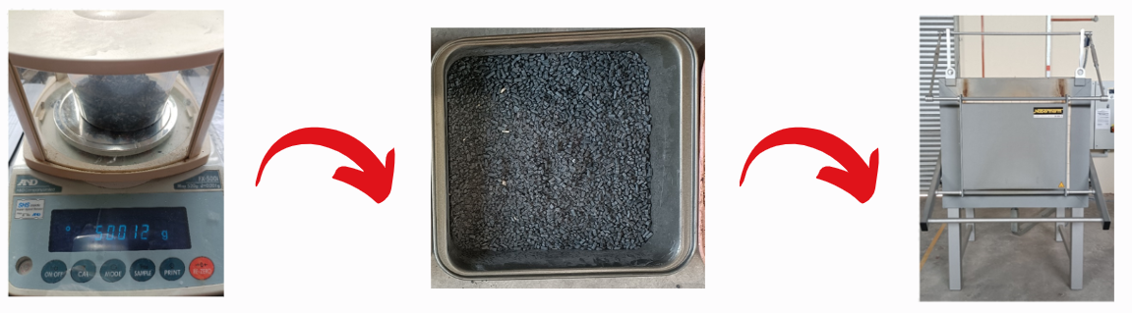

(a) (b) (c)

**Figure 2.** Manufacturing process of composite permeable pavement: (a) Weighing; (b) Mixing; (c) Heating and Curing

**Table 1.** The composition ratios of raw materials in preparing permeable pavement composite

|  |  |  |  |
| --- | --- | --- | --- |
| **Sample** | **Ratio of SEMC-RW (wt/wt%)** | **Ratio of R-HDPE (wt/wt%)** | **Thickness (mm)** |
| A | 10 | 50 | 20 |
| B | 20 | 50 | 20 |
| C | 30 | 50 | 20 |
| D | 40 | 50 | 20 |
| E | 50 | 50 | 20 |
| F | 60 | 50 | 20 |
| G | 70 | 50 | 20 |
| H | 80 | 50 | 20 |

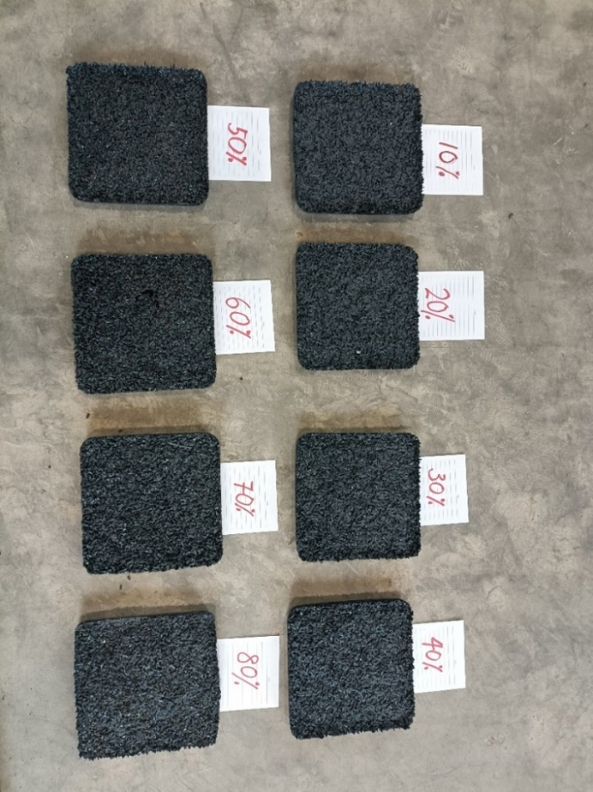

**Figure 3.** SEMC-RW/R-HDPE composite permeable pavement samples at different weight ratios

After the mixing stage, the composite was subjected to a heating process. The SEMC-RW/R-HDPE composite samples were exposed to a regulated temperature of 160°C in a furnace for a period of 3 hours. The purpose of this meticulously controlled heating procedure was to promote the fusing and bonding of the composite components, hence improving the overall structural integrity. Ultimately, the composite samples were subjected to a cooling procedure and then kept undisturbed for a duration of 24 hours at the ambient temperature. During this period, the material was exposed to ambient conditions, which helped it stabilise and prevented any thermal stresses that may potentially impact the structural qualities of the SEMC-RW/R-HDPE composite permeable pavement. The SEMC-RW/R-HDPE composite permeable pavement samples were prepared by weighing, thoroughly mixing, controlled heating, and gradually cooling methods. Every individual step played a vital role in guaranteeing the accuracy.

1. Results and Discussion

## Tensile Strength Analysis

Figure 4 illustrates the correlation between the tensile strength and the ratio of SEMC-RW/R-HDPE. The tensile strength exhibits an initial increase followed by a decrease as the SEMC-RW/R-HDPE ratio varies. Sample E has the highest tensile strength, measuring 2.67 MPa due to uniform bonding. It is followed by Sample D at 2.53 MPa, Sample C at 2.13 MPa, Sample B at 1.4 MPa, Sample A at 1.13 MPa, Sample F at 0.29 MPa, Sample G at 0.25 MPa, and Sample H at 0.2 MPa. The tensile strength exhibited an upward trend as the ratios of SEMC-RW rose, reaching a peak at 50%, and thereafter decreased drastically after reaching 60%. This is because there is a thicker layer of epoxy bonding material and more cured material are produced that cause the lack of strong bonding between the SEMC-RW and R-HDPE at the interface [23]. Tensile strength is a crucial property that determines a material's ability to withstand tensile strains without fracturing [24].

A higher tensile strength indicates increased resistance to stretching and elongation. Materials possessing a high level of tensile strength are well-suited for structural purposes that necessitate the capacity to withstand tension loads [25]. The use of bisphenol-A epoxy resin in Resin-Based Permeable Brick was studied. Resin, a robust and fragile adhesive material, was examined for its ability to withstand static pressure [26]. The findings of this experiment suggest that the most favourable proportion for the SEMC-RW/R-HDPE composite was sample E, which consisted of 50% by weight. The research shows that the HDPE and resin waste from a SEMC-RW/R-HDPE ratio of 60% to 80% do not form strong bonds, indicating that it cannot support 60% resin waste composites. In the case of a sample with a weak link, the transmission of stress at the interface of the permeable pavement is ineffective. However, incorporating 30% to 50% of SEMC-RW and R-HDPE in the composite indicated an improved resin waste-to-HDPE interface.

**Figure 4.** Tensile strength for different ratio of SEMC-RW/R-HDPE composite permeable pavement

## Bending Strength Analysis

Figure 5 illustrates that the bending strength exhibited an upward trend until reaching a ratio of 50%, after which it declined from 60% to 80%. Sample E demonstrated the highest flexural strength, measuring at 1.33 MPa. A higher bending strength indicates a superior ability to withstand bending or flexural stresses, which is crucial for structural purposes. The samples were arranged in descending order of pressure: sample D at 0.75 MPa, sample C at 0.66 MPa, sample B at 0.60 MPa, sample A at 0.55 MPa, sample F at 0.45 MPa, sample G at 0.18 MPa, and sample H at 0.05 MPa. The bending capabilities of the SEMC-RW/R-HDPE composite were compromised due to insufficient interfacial bonding between the SEMC-RW and R-HDPE [27]. The uneven dispersion of SEMC-RW in composites led to a weakened adhesion zone in the composite, hence lowering the effectiveness of stress transfer. Various factors impact the quality of interfacial bonding, such as the characteristics of the fibre and binder, the manufacturing process, mixing methods, and fibre treatment [28].

Chandrappa (2019) investigated the bending strength of pervious concrete used in pavement. The results show that the bending strength ranged between 1.5 and 3.2 MPa. It demonstrated that aggregate can be thought of as a stiff pavement slab, with large-sized faults serving as a symbol for inadequate support and low strength. However, because the crack path frequently passes through aggregate in better interlocking and smaller pore sizes, where the crack must come into contact with more aggregates before failing, the flexural strength is improved [29].

**Figure 5.** Bending strength of different ratio of SEMC-RW/R-HDPE composite permeable pavement

## SEM Microstructure Analysis

The SEM study the surface morphology and uncovered images of the bonding between the matrix and reinforcement at magnifications of 500x, 800x, and 1000x for each SEMC-RW composite ratio [30]. The most favourable result obtained is sample E, which exhibits a robust correlation between the matrix and reinforcement, as evidenced in Figure 6. The distribution of SEMC-RW and R-HDPE was more uniform throughout the composite.

A study investigated the compatibility and dispersion of phosphogypsum (PG) composites with polypropylene (PP) and polyethylene (PE) using scanning electron microscopy (SEM). The results indicate the diverse quantities of the two substances. The findings indicate that the concentration of PG varies between 20% and 70%, and there is no observable aggregation in the PP matrix. This demonstrates that PG is compatible with PP and may be effectively disseminated within it. Polyethylene glycol (PG) exhibits exceptional compatibility and dispersibility when combined with polyethylene (PE) [31]. Adeniyi (2022) was studied the microstructural properties of composites filled with kaolin and polyethylene powder. The SEM analysis result shows the micrograph demonstrates effective interaction between the polyethylene filler and polystyrene resin. This is because adding more polyethylene filler than kaolin causes the composite to become more plastic, resulting in unevenly distributed white areas on the surface. Thus, polyethylene was more noticeable in certain places in the micrograph. The scan showed a smooth surface with few cracks [32].

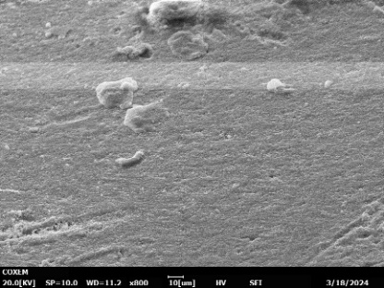 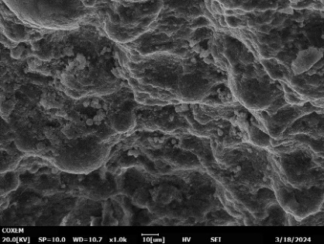 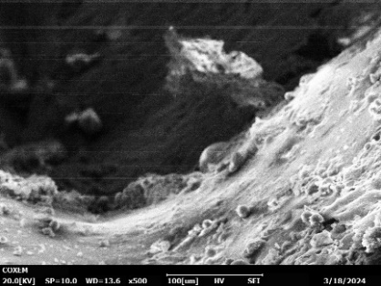

**R-HDPE**

**SEMC-RW**

**SEMC-RW**

**R-HDPE**

**R-HDPE**

**SEMC-RW**

(a) (b) (c)

**Figure 6.** SEM image for sample E: (a) 500x; (b) 800x; (c) 1000x

## Fire Resistance Analysis

Figure 7 shows the samples after undergo direct fire testing at Kim Hoe Thye Industries Sdn. Bhd. The external and internal temperatures correspond to the temperatures at which heat is absorbed and emitted during the process, as indicated in Table 2. By comparing these temperatures across various resin concentrations, we can observe the impact of each concentration on heat transfer and thermal characteristics. Differences in the temperatures of the input and output have been seen while using different concentrations of resin. For instance, in the case of sample E, the input temperature is considerably higher compared to other concentrations at 256.3 $℃$, but the output temperature remains virtually unchanged resulting the highest rate of fire resistance at 83%. This is because Sample E has a very good load-bearing capability and homogenous bonding, which improved thermal stability while impeding heat transfer [33].

Increasing the concentration of resin typically leads to a decrease in input temperatures, but it may cause an increase in output temperatures. This suggests that there may be differences in the thermal conductivity or heat absorption capacity of the resin blends [34]. The maximum temperatures vary depending on the concentration of resin, with the highest temperatures seen at a resin concentration of 50% at 440 $℃$. This indicates that the substance might exhibit greater resistance to heat or higher thermal stability at this particular dose [35]. Although there are slight variations in the output temperatures, they are rather insignificant, indicating that the material's thermal characteristics remain consistent under the specified processing conditions.

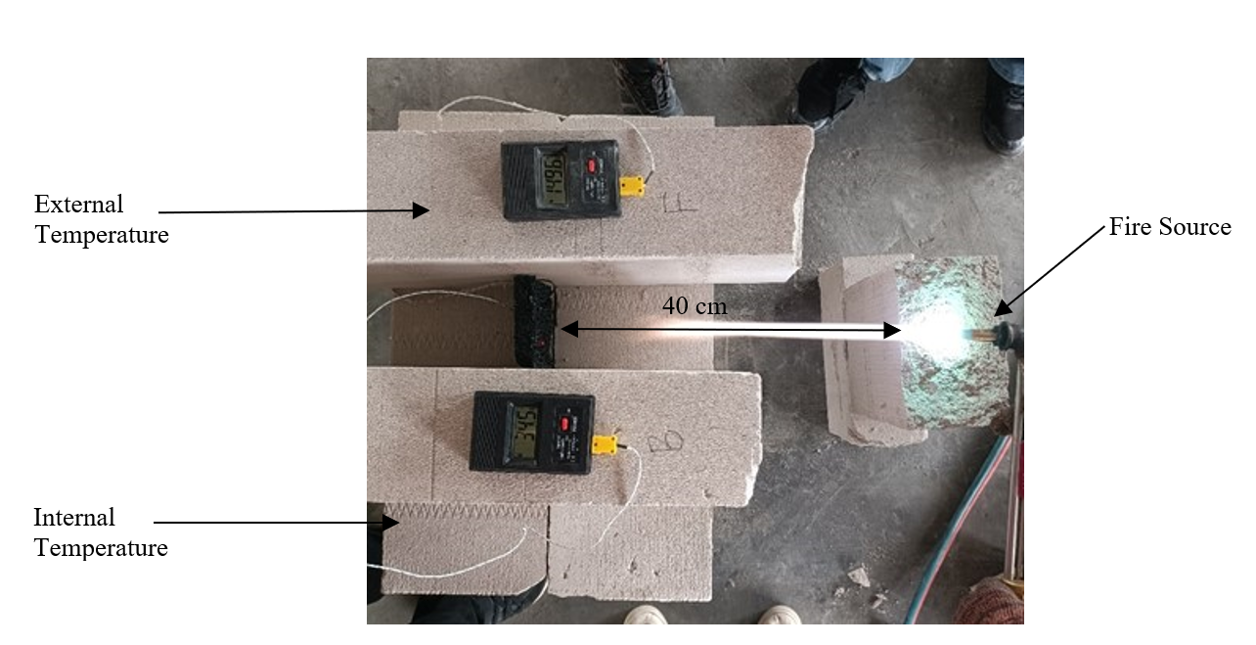

**Figure 7.** Direct fire testing at Kim Hoe Thye Industries Sdn. Bhd.

**Table 2.** Rate of fire resistance of different ratio of SEMC-RW/R-HDPE composite

permeable pavement

|  |  |  |  |  |
| --- | --- | --- | --- | --- |
| Sample | Temperature | | Rate of Fire Resistance (%) | Max Temperature (>5min) |
| **External** | **Internal** |
| A | 181.9 | 48 | 74 | 200 |
| B | 218.7 | 51.9 | 76 | 215 |
| C | 188.7 | 41.7 | 77 | 270 |
| D | 184.3 | 40.2 | 78 | 257 |
| E | 256.3 | 41.7 | 83 | 440 |
| F | 190.2 | 44.9 | 76 | 260 |
| G | 157 | 43.7 | 72 | 273 |
| H | 169.6 | 50.7 | 70 | 250 |

1. Conclusions

In conclusion, this study shows that the SEMC-RW/R-HDPE composite permeable pavement has outstanding physical and mechanical qualities, making it appropriate for permeable pavement applications. SEM study of the cracked surface morphology at a 50% SEMC-RW/R-HDPE ratio revealed a strong matrix-reinforcement relationship, as well as a more homogenous distribution of SEMC-RW and R-HDPE across the composite. This improved performance is visible in the composite's characteristics. Fire resistance tests for the 50% SEMC-RW/R-HDPE ratio revealed much higher input temperatures and an 83% rate of fire resistance, demonstrating that the material is both heat-resistant and thermally stable at this concentration. Mechanical testing also demonstrated that the 50% SEMC-RW/R-HDPE ratio excelled the other ratios, with the highest tensile strength (2.67 MPa) and bending strength (1.33 MPa). These findings show that the 50% SEMC-RW/R-HDPE ratio is the best configuration for producing resin waste-based composite permeable pavements, indicating the promise of polymer composite materials in transportation applications. Furthermore, employing resin waste as a recyclable resource encourages environmentally responsible practices by reducing landfill use and air pollution. The SEMC-RW/R-HDPE composite permeable pavement is viable for more than just permeable pavement applications, contributing to sustainable road-related manufacturing technologies.

**Acknowledgement**

The research was financially supported by the GPPS Grant Vot. Q572, Industry Grant Vot. M105, and Matching Grant, vot Q266. The author expresses gratitude to the Faculty of Engineering Technology, Universiti Tun Hussein Onn Malaysia (UTHM), STMicroelectronics Sdn Bhd, STMicroelectronics Sdn Bhd, Industrial Area Muar, and Angkasa Kowaris Plastics Sdn. Bhd., Jalan Kebun Tambahan, Seksyen 32, Shah Alam, Selangor for providing the necessary equipment and technical support. The authors express their gratitude for the productive conversations and valuable information provided by the UTHM staff during the project.

References

1. Ramovha, N., Chadyiwa, M., Ntuli, F., & Sithole, T. (2024). The Potential of Stormwater Management Strategies and Artificial Intelligence Modeling Tools to Improve Water Quality: A Review. In *Water Resources Management* (Issue 0123456789). Springer Netherlands. <https://doi.org/10.1007/s11269-024-03841-9>
2. Muttuvelu, D. V., & Kjems, E. (2021). A systematic review of permeable pavements and their unbound material properties in comparison to traditional subbase materials. *Infrastructures*, *6*(12). <https://doi.org/10.3390/infrastructures6120179>
3. Bamigboye, G. O., Bassey, D. E., Olukanni, D. O., Ngene, B. U., Adegoke, D., Odetoyan, A. O., Kareem, M. A., Enabulele, D. O., & Nworgu, A. T. (2021). Waste materials in highway applications: An overview on generation and utilization implications on sustainability. *Journal of Cleaner Production*, *283*, 124581. <https://doi.org/10.1016/j.jclepro.2020.124581>
4. Klose, L., Meyer-Heydecke, N., Wongwattanarat, S., Chow, J., Pérez García, P., Carré, C., Streit, W., Antranikian, G., Romero, A. M., & Liese, A. (2023). Towards Sustainable Recycling of Epoxy-Based Polymers: Approaches and Challenges of Epoxy Biodegradation. *Polymers*, *15*(12). <https://doi.org/10.3390/polym15122653>
5. Hung Anh, L. D., & Pásztory, Z. (2021). An overview of factors influencing thermal conductivity of building insulation materials. Journal of Building Engineering, 44. <https://doi.org/10.1016/j.jobe.2021.102604>
6. Fang, M., Wang, X., Liu, J., Xu, Z., & Chen, Y. (2022). Design, application and performance improvement of Eco-Permeable pavement materials (Eco-PPMs): A review. *Construction and Building Materials*, *360*(August), 129558. <https://doi.org/10.1016/j.conbuildmat.2022.129558>
7. Boon, W. P., & Harun, H. (2023). Waste Epoxy Moulding Compound as a Composite Gypsum Ceiling Board for a Sustainable Potential. *Progress in Engineering Application and Technology*, *4*(1), 850–858. <https://penerbit.uthm.edu.my/periodicals/index.php/peat/article/view/10298>
8. Brunnbauer, L., Zeller, V., Gajarska, Z., Larisegger, S., Schwab, S., Lohninger, H., & Limbeck, A. (2023). Classification of epoxy molding compounds by Tandem LA-ICP-MS/LIBS to enhance the reliability of electronic devices. *Spectrochimica Acta - Part B Atomic Spectroscopy*, *207*(June), 106739. <https://doi.org/10.1016/j.sab.2023.106739>
9. Tewari, U. S., Sharma, S. K., & Vasudevan, P. (2020). Polymer tribology. In *Journal of Macromolecular Science - Reviews in Macromolecular Chemistry and Physics* (Vol. C29, Issue 1). <https://doi.org/10.1533/9781782421788.1>
10. Tiwari, S., Srivastava, K., CL, G., & Srivastava, D. (2020). Epoxy/Fly ash from Thermal Power Plant/Nanofiller Nanocomposite: Studies on Mechanical and Thermal Properties: A Review. *International Journal of Waste Resources*, *10*(01), 1–16. <https://doi.org/10.35248/2252-5211.20.10.375>
11. Sulong, N., Rus, A. Z. M., Latif, N. A., Wahab, N., Omar, A., Salim, N. S. M., Hassan, N. N. M., Marsi, N., & Agustian, E. (2023). Photodegradation Mechanism of Biopolymer Blended with High Density Polyethylene (HDPE). Journal of Advanced Research in Applied Mechanics, 103(1), 1–12. <https://doi.org/10.37934/aram.103.1.112>
12. Parmar, B. H. (2007). Rheology of peroxide modified recycled high density polyethylene. *M. Tech Thesis,RMIT University*, *December*, 154.
13. Prusty, P., & Farooq, S. H. (2020). Seawater intrusion in the coastal aquifers of India - A review. *HydroResearch*, *3*, 61–74. <https://doi.org/10.1016/j.hydres.2020.06.001>
14. Moshood, T. D., Nawanir, G., Mahmud, F., Mohamad, F., Ahmad, M. H., & AbdulGhani, A. (2022). Sustainability of biodegradable plastics: New problem or solution to solve the global plastic pollution? *Current Research in Green and Sustainable Chemistry*, *5*(November 2021). <https://doi.org/10.1016/j.crgsc.2022.100273>
15. D. A. I. Malyuta, K. L. Matteson, M. P. Berry, D. Bajwa, and C. Ryan, “Experimental statistical modeling of tensile properties and flexural stiffness of recycled high-density polyethylene (rHDPE) thermoplastic using response surface methodology (RSM),” Results Mater., vol. 20, no. September, 2023. <https://doi.org/10.1016/j.rinma.2023.100472>
16. Wei, J., Mao, X., Xu, W., Xi, C., Yan, S., Sun, T., Hu, X., Wang, Y. and Chi, F. "Experimental research on the effect of fiberglass on the performance of epoxy asphalt concrete" *Sustainability* 14, no. 22 (2022): 1-20. <https://doi.org/10.1016/j.ast.2012.02.006>
17. Pradhan, S. K., & Behera, N. (2022). Materials Today : Proceedings Performance assessment of pervious concrete road on strength and permeability by using silica fume. 60, 559–568.
18. Dutra, P., Strieder, H. L., Vanessa, F., Graeff, G., Peres, W., Raul, F., & Merten, M. (2022). *Performance evaluation of pervious concrete pavements with recycled concrete aggregate ˆ*. *315*(September 2021).
19. Chen, Y., Hossiney, N., Yang, X., Wang, H., & You, Z. (2021). Application of Epoxy-Asphalt Composite in Asphalt Paving Industry: A Review with Emphasis on Physicochemical Properties and Pavement Performances. *Advances in Materials Science and Engineering*, *2021*. <https://doi.org/10.1155/2021/3454029>
20. Hung Anh, L. D., & Pásztory, Z. (2021). An overview of factors influencing thermal conductivity of building insulation materials. *Journal of Building Engineering*, *44*. <https://doi.org/10.1016/j.jobe.2021.102604>
21. N. Jafarifar, “S Hrinkage B Ehaviour of,” 2012.
22. Chen, J., Chu, R., Wang, H., Zhang, L., Chen, X., & Du, Y. (2019). Alleviating urban heat island effect using high-conductivity permeable concrete pavement. *Journal of Cleaner Production*, *237*. <https://doi.org/10.1016/j.jclepro.2019.117722>
23. J. Xu, B. Ma, W. Mao, and X. Wang, “Strength characteristics and prediction of epoxy resin pavement mixture,” Constr. Build. Mater., vol. 283, p. 122682, 2021. <https://doi.org/10.1016/j.conbuildmat.2021.122682>
24. Lin, C. Y., & Kang, J. H. (2021). Mechanical properties of compact bone defined by the stress-strain curve measured using uniaxial tensile test: A concise review and practical guide. *Materials*, *14*(15). <https://doi.org/10.3390/ma14154224>
25. Marsi, N., Subramaniam, L., Rus, A. Z. M., Sulong, N., Fodzi, M. H. M., Huzaisham, N. A., Yusuf, N. A. A. N., Mahmood, S., Shaari, M. F., & Shariff, H. H. (2020). The Mechanical Performance of Pipe Based on Fiberglass Reinforced with Plastic Waste (FRPW) Composites. *IOP Conference Series: Materials Science and Engineering*, *854*(1). <https://doi.org/10.1088/1757-899X/854/1/012001>
26. Luo, M., Zhang, X., Zhang, H., Wang, X., & Du, R. (2021). Study on compatibility optimization of resin-based permeable pavement bricks. *E3S Web of Conferences*, *237*, 1–8. <https://doi.org/10.1051/e3sconf/202123703007>
27. Hashim, M. M., Marsi, N., Letchumanan, T., Rus, A. Z. M., Jamir, M. R. M., & Hassan, N. (2021). Bending strength analysis of HDPE plastic reinforced wood waste and thermoplastic polymer to replace ceramic tile composites. Journal of Physics: Conference Series, 2051(1). <https://doi.org/10.1088/1742-6596/2051/1/012045>
28. Guo, Y., Ruan, K., Shi, X., Yang, X., & Gu, J. (2020). Factors affecting thermal conductivities of the polymers and polymer composites: A review. *Composites Science and Technology*, *193*(December 2019), 108134. <https://doi.org/10.1016/j.compscitech.2020.108134>
29. Chandrappa, A. K., & Biligiri, K. P. (2019). Investigation on flexural strength and stiffness of pervious concrete for pavement applications. Advances in Civil Engineering Materials, 7(2). <https://doi.org/10.1520/ACEM20170015>
30. Costa, U. O., Nascimento, L. F. C., Garcia, J. M., Bezerra, W. B. A., Fabio da Costa, G. F., Luz, F. S. da, Pinheiro, W. A., & Monteiro, S. N. (2020). Mechanical properties of composites with graphene oxide functionalization of either epoxy matrix or curaua fiber reinforcement. *Journal of Materials Research and Technology*, *9*(6), 13390–13401. <https://doi.org/10.1016/j.jmrt.2020.09.035>
31. Zhang, J., Wei, C., Ran, J., Li, Y., & Chen, J. (2022). Properties of polymer composite with large dosage of phosphogypsum and it’s application in pipeline. *Polymer Testing*, *116*(September), 107742. <https://doi.org/10.1016/j.polymertesting.2022.107742>
32. Adeniyi, A. G., Abdulkareem, S. A., Emenike, E. C., Abdulkareem, M. T., Iwuozor, K. O., Amoloye, M. A., Ahmed, I. I., & Awokunle, O. E. (2022). Development and characterization of microstructural and mechanical properties of hybrid polystyrene composites filled with kaolin and expanded polyethylene powder. Results in Engineering, 14(March). <https://doi.org/10.1016/j.rineng.2022.100423>
33. L. He, Y. Cao, H. Qu, Y. Zhang, and Q. Bi, “Advanced Industrial and Engineering Polymer Research Advances in fl ame retardancy of asphalt pavement : A review,” vol. 7, 2024. <https://doi.org/10.1016/j.aiepr.2024.01.001>
34. Guo, Y., Ruan, K., Shi, X., Yang, X., & Gu, J. (2020). Factors affecting thermal conductivities of the polymers and polymer composites: A review. *Composites Science and Technology*, *193*(December 2019), 108134. <https://doi.org/10.1016/j.compscitech.2020.108134>
35. Asim, M., Paridah, M. T., Chandrasekar, M., Shahroze, R. M., Jawaid, M., Nasir, M., & Siakeng, R. (2020). Thermal stability of natural fibers and their polymer composites. Iranian Polymer Journal (English Edition), 29(7), 625–648. <https://doi.org/10.1007/s13726-020-00824-6>

1. * *Corresponding author.*

   *E-mail address: mnoraini@uthm.edu.my*