Optimization of PLA-Carbon Printing Parameter on Tensile Properties of 3D Printed Polymeric Scaffolds
Z. Nooraizedfiza^{1*}, O. Norashiken¹, M.D.M Azaman¹, M. Marina¹

¹. Faculty of Mechanical Engineering & Technology, Universiti Malaysia Perlis, Kampus Pauh Putra, 02600 Arau, Perlis, Malaysia

*nooraizedfiza@unimap.edu.my
norashiken@unimap.edu.my
azaman@unimap.edu.my
marina@unimap.edu.my

Abstract. This study focuses on the optimization of printing parameters for PLA-Carbon 3D printed scaffolds to enhance their tensile properties. Utilizing Fused Filament Fabrication (FFF), the research investigates the impact of printing speed, thickness, and infill density on the mechanical strength of the scaffolds. The Taguchi experimental design was employed to identify the optimal parameters, revealing that a printing speed of 60 mm/s, thickness of 0.2 mm, and infill density of 60% yield the highest tensile strength of 10.70 N/mm². This optimization is crucial for developing biodegradable scaffolds suitable for tissue engineering applications, providing a foundation for future advancements in biomedical engineering.
Keywords: PLA-carbon, 3D printing, Tensile strength, Polymer scaffolds
- Introduction
Fused filament fabrication (FFF) is a 3D printing technology used in biomedicine to create high-resolution polymer scaffolds for tissue regeneration and studying cell responses. The effectiveness of scaffolds depends on the material, geometry, internal architecture, and surface texture. These factors influence cell response, mechanical properties, porosity, and nutrient absorption. The effectiveness of scaffolds depends on the material, manufacturing technology, geometry, internal architecture, and surface texture. These factors are crucial in scaffold production and in the potential applications of polymer scaffolds in synthetic biology and other medical fields [1]. The size, shape, orientation, and arrangement of struts in a scaffold play a crucial role in determining cell response. The scaffold's structure affects its mechanical properties, porosity, nutrient absorption, and cell response. Additionally, the arrangement of holes within the scaffold significantly impacts the osteogenic differentiation of preosteoblastic cells by mesenchymal stem cells (MSCs) [2]. This project aims to fabricate 3D printed scaffolds of PLA-Carbon with optimal mechanical strength for tissue engineering by determining and optimizing key printing parameters. FFF technologies impact the mechanical and physical properties of scaffolds. Factors like infill density, printing temperature, layer thickness, and speed are crucial for achieving desired mechanical properties [3,4,5,6]. Infill density in 3D printing refers to the volume of material used inside a printed object, typically expressed as a percentage. Higher infill density results in increased strength and weight, while lower infill density conserves material and reduces weight. In the realm of 3D bioprinting, infill density plays a significant role in shaping the mechanical properties and functionality of the printed scaffold. Printing speed in 3D printing denotes the rate at which the printer's nozzle moves during material deposition, a critical parameter that influences the quality and characteristics of the final printed object. Layer thickness, also known as layer height, in 3D printing signifies the thickness of each individual layer of material deposited by the printer to construct an object. Typically, printing speeds range from 10 to 60 mm/s depending on the material and desired resolution [3,4] and layer thicknesses are 0.1 to 0.3 mm [3,5]. While, infill density can vary widely, but typical values range from 20% to 100% [3].

Effective scaffolds must be biocompatible, biodegradable, and have appropriate mechanical strength, porosity, and pore size to support tissue growth and regeneration [7]. Both natural and synthetic polymers are used in scaffold construction, with each type offering unique benefits for tissue engineering applications [8]. Carbon-based materials are valued for their mechanical, electrical, and biological properties, making them suitable for various industrial applications, including tissue engineering [9].
- Methodology
The study uses Polylactic Acid (PLA) with Carbon Fiber (85% PLA and 15% Carbon) to develop scaffolds for 3D printing using Creality Ender 3 printer. Specific parameters like speed, temperature, and infill density affecting the mechanical strength of the printed scaffolds. ASTM D638 standard is used for tensile testing of the printed samples to evaluate their mechanical properties. Taguchi Orthogonal Array (3 factor with 3 level) [10,11] and ANOVA analysis are employed to optimize and analyse the printing parameters for maximum stress.
  - Sample fabrication
PLA-Carbon scaffold was printed referring ASTM D628 standard as in Figure 1 for tensile test at temperature of 210 ⁰C with various parameter setting as shown in Table 1. To assess the factors' contribution to the tensile properties of the scaffold, the L9 of Taguchi orthogonal array experiment was setting up according to the Table 2.

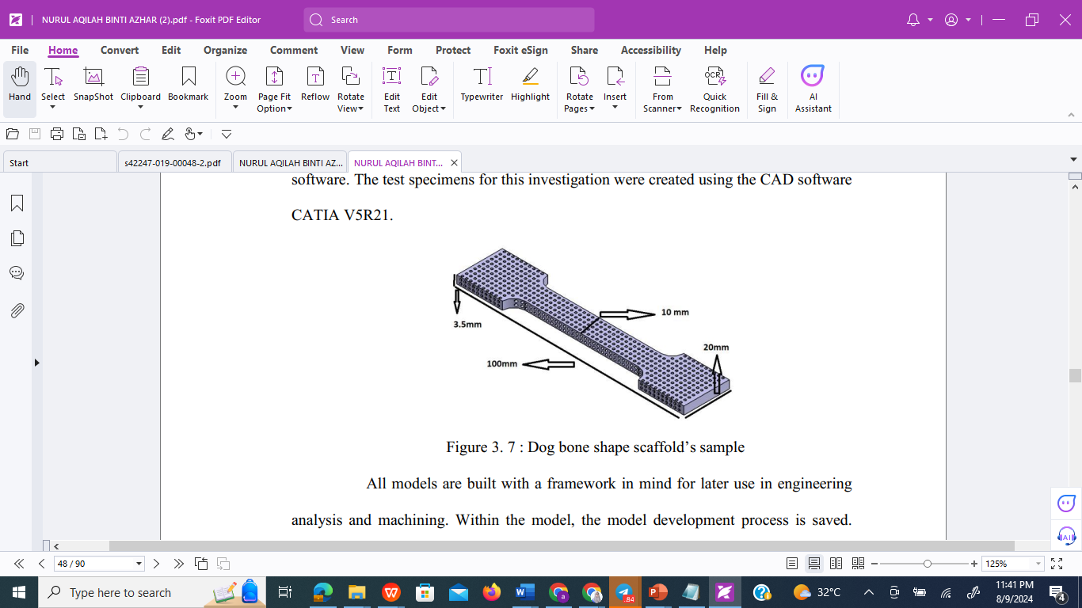
Figure 1: Sample design

Table 1: Parameter involves in sample fabrication.

Parameter Factor | Parameter Level
 | Level 1 | Level 2 | Level 3
Temperature (ºC) | 210
Printing Thickness (mm) | 0.1 | 0.2 | 0.3
Printing Speed (mm/s) | 30 | 60 | 90
Infill Density (%) | 20 | 60 | 100

Table 2: Taguchi orthogonal array experiment setting for sample fabrication

Sample No | Orthogonal Array |  |  | Control Factor
 | Factor A | Factor B | Factor C | Printing Speed (mm/s) | Printing Thickness  (mm) | Infill Density (%)
1 | 1 | 1 | 1 | 30 | 0.1 | 20
2 | 1 | 2 | 2 | 30 | 0.2 | 60
3 | 1 | 3 | 3 | 30 | 0.3 | 100
4 | 2 | 1 | 3 | 60 | 0.1 | 100
5 | 2 | 2 | 1 | 60 | 0.2 | 20
6 | 2 | 3 | 2 | 60 | 0.3 | 60
7 | 3 | 1 | 2 | 90 | 0.1 | 60
8 | 3 | 2 | 3 | 90 | 0.2 | 100
9 | 3 | 3 | 1 | 90 | 0.3 | 20

  - Tensile Test
After fabrication, the scaffolds undergo the tensile testing using Shimadzu AG-DXPlus Universal Testing Machine. Tensile stress (σ) is the force applied per unit area of the material, causing it to elongate or deform (Equation 1). Tensile strain (ϵ) on the other hand, is the resulting deformation or elongation of the material in response to the applied tensile stress (Equation 2). The relationship between tensile stress and tensile strain is often used to characterize the mechanical behaviour of materials under tension in the name of Young’s Modulus by dividing the stress to the strain (Equation 3).

$Tensile Stress, σ=\frac{Force Applied, F}{Cross-sectional are of force applied, A}$ (1)

  - ANOVA Analysis
S/N ratios with the type of higher is better since maximum tensile strength is better for the result as in Equation 4. An orthogonal array is a fractional factorial design that balances the levels of factors across the experimental runs. Through array plan, the property of multiple variables on the concern characteristics will simultaneously be predictable thus reducing the sum of the test. The S/N ratio formula for higher is better type [11, 12].

$S/N = -10 *log(Σ(1/Y2)/n)$ (2)

ANOVA (Analysis of Variance) analysis, which is used to determine the contribution of different factors to the tensile strength of 3D printed PLA-Carbon scaffolds. Degree of Freedom (DF) represents the number of independent values or quantities that can vary in the analysis. For each factor (Printing speed, Layer thickness, Infill density), the degree of freedom is 2, and the total degree of freedom is 8. Sum of Squares (SS) measures the total variation in the data. It is calculated for each factor and the error. Mean of Squares (MS) is the average variation for each factor, calculated by dividing the sum of squares by the degree of freedom. Percentage of Contribution (%) indicates how much each factor contributes to the total variation [11].

Result and discussion
Table 3 shows the maximum stress that can be hold by each printed scaffolds before breaks. The results shows that the PLA-Carbon scaffolds can holds stress range from 8.4 N/mm² to 10.4N.mm². Based on the experimental results in Table 3, it shows that the highest stress achieved from the tensile test is obtain by sample number 8 with 10.4 N/mm² which having printing speed of 90 mm/s, printing thickness 0.2 mm and infill density of 100 %. However, this result only shows the value of maximum stress that can be hold by the specimen before breaks. Furthermore, ANOVA was conducted to determine the percentage of contribution of each control factors to the printed PLA-Carbon scaffolds.

Table 3: Maximum stress for the printed PLA-carbon scaffolds
Sample No | Control Factor |  |  | Maximum stress (N/mm²)
 | Printing Speed (mm/s) | Printing Thickness  (mm) | Infill Density (%)
1 | 30 | 0.1 | 20 | 8.4
2 | 30 | 0.2 | 60 | 9.8
3 | 30 | 0.3 | 100 | 9.2
4 | 60 | 0.1 | 100 | 9.5
5 | 60 | 0.2 | 20 | 10.2
6 | 60 | 0.3 | 60 | 9.25
7 | 90 | 0.1 | 60 | 9.58
8 | 90 | 0.2 | 100 | 10.4
9 | 90 | 0.3 | 20 | 9

From ANOVA analysis, the given F value for this study is 7.09 which indicates of this result is accepting the alternative hypothesis for at least one batch mean is not equal to the others. The result confirms that there is a significant difference or relationship between variables in a study. It is the opposite of the null hypothesis, which assumes there is no effect or relationship. The study uses the alternative hypothesis to test whether the results of a study are statistically significant and to draw conclusions about the relationship between variables being studied. Similar finding also reported by Tarmizi et. al., (2022). They also rejecting null hypothesis for the study on ANOVA analysis of maximum stress on 3D printed PLA [13].

Table 4 shows the percentage of contribution if each factor studied. Layer thickness exhibit the highest contribution among the factors with 61.45%. This value indicates that with a small change in layer thickness setting during printing will result to significant changes of the maximum stress that can be hold by the sample before break. From the result, it’s also shows that the printing speed and infill density also have a contribution to the maximum stress. However, the significance of these 2 factors is not as critical to layer thickness. The error factor indicates that, there are other factors that contributed to the maximum stress of the printing samples which are not considered in this study. The value of 5.76% of the error can be considered as less significant since it less than 10%.

Table 4: ANOVA analysis result

 | Degree of Freedom | Sum of Square | Mean of Square | Percentage of contribution (%)
Printing speed | 2 | 1.58 | 0.79 | 18.62
Layer thickness | 2 | 6.8 | 3.43 | 61.45
Infill density | 2 | 3.12 | 1.56 | 14.15
error | 2 | 0.42 | 0.21 | 5.76
Total | 8 | 11.99 | 1.49

Figure 2 (a-c) shows the main effect plot of the factor that being studied and the calculated S/N ratio (as calculated using Eq. 4). Figure 2 (a) shows the highest S/N ratio is at level 2 while Figure 2 (b) shows the highest S/N ratio is at level 2 and finally Figure 2 (c) shows the highest S/N ratio is at level 3. Thus, the preferred printing condition for obtaining the highest tensile properties laid at A2B2C3 as in Table 5.

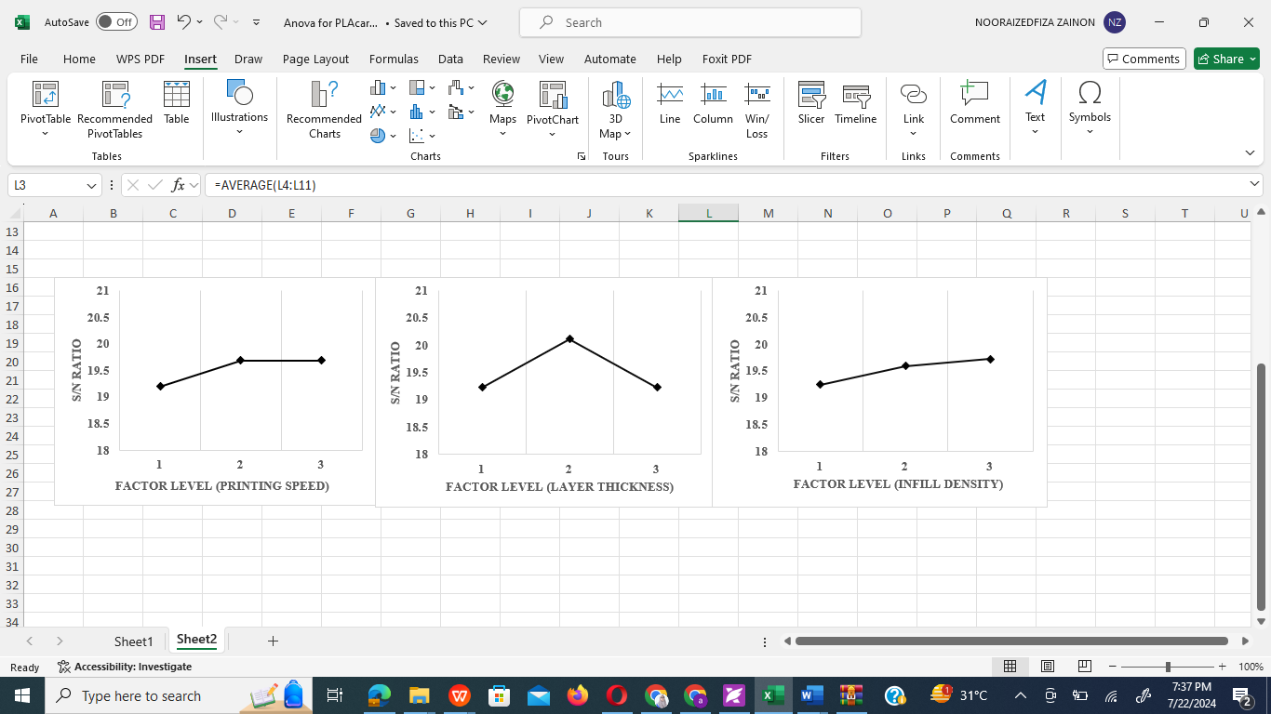

(a) (b) (c)

Figure 2: Main effect plot for the studied factor a) Printing speed (mm/s), b) Layer thickness (mm), and c) Infill density (%)

Table 5: Preferred printing parameter

Factors | Parameter | Suggestion
Factor A | Printing speed (mm/s) | 60mm/s
Factor B | Layer thickness (mm) | 0.2mm
Factor C | Infill density (%) | 100%

Table 6 shows the verification testing setting parameter that was conducted to refine the printing thickness by expanding the variation of the parameter. This experiment was conducted to find the best printing thickness that possibly gave have the higher tensile strength. Since printing thickness exhibit the highest contribution among other factors, the variation only involves the printing thickness.

Table 6: Parameter setting for verification testing

Factor | Level
 | 1 | 2 | 3 | 4 | 5
A: Printing Speed (mm/s) | 60
B: Printing thickness (mm) | 0.1 | 0.15 | 0.2 | 0.25 | 0.3
C: Infill density (%) | 100

Figure 2 shows the maximum stress that required to break the sample under tension. The highest maximum stress was achieved by specimen number 3, which fabricated by a combination of parameter 60mm/s printing speed, 0.2mm printing thickness and 100 % infill density. This result shows that 0.2mm printing thickness is still the optimum parameter for the good parameter combination. The figure also shows that the pattern of tensile strength began to decrease at the printing thickness of 0.25mm. This can be concluded that 0.2mm printing thickness is the greatest parameter that can provide a good tensile strength to combine with the appropriate printing speed and the infill density. The decline of the tensile strength that consists of the increasing of the printing thickness more than 0.2mm shows the tensile strength is reducing. When the layer thickness is increased, it can lead to improved interlayer adhesion and mechanical strength of the scaffold. However, excessively thick layers may result in reduced resolution and surface quality, potentially compromising the overall tensile properties of the scaffold [14]. On the other hand, thinner layers can enhance the surface finish and resolution but may exhibit lower tensile strength due to decreased interlayer bonding [15]. This is in line with research by Christine et al. that found low layer thickness to have the maximum tensile strength because as layer thickness increases, layer count decreases [16]. Furthermore, layer height was observed to have a major impact on tensile strength as well as the thinner layers will lead to better layer bonding with sharper edges and hence the ability to extract smaller features appropriately. Additionally, it was found that printing thickness significantly affected tensile strength. Thinner layers would link together better, have sharper edges, and may thus be effectively extracted to extract smaller features [17].

Figure 2: Maximum stress for the 3d printed sample before break.
- Conclusion
Printing thickness shows the most significant parameter on the tensile properties of 3D printed PLA-Carbon scaffolds with 61.45 % of contribution. The parameter combination was derived from Taguchi and ANOVA. From the validation experiment, the best combination of parameters for better mechanical properties of PLA-Carbon scaffold is 60 mm/s printing speed, 0.2 mm printing thickness, and 100 % of infill density.

References

[1] A. Eltom, G. Zhong, and A. Muhammad, “Scaffold Techniques and Designs in Tissue Engineering Functions and Purposes: A Review,” Adv. Mater. Sci. Eng., vol. 2019, 2019, doi: 10.1155/2019/3429527.
[2] H. Hanna, L. M. Mir, and F. M. Andre, “In vitro osteoblastic differentiation of mesenchymal stem cells generates cell layers with distinct properties,” Stem Cell Res. Ther., vol. 9, no. 1, pp. 1–11, 2018, doi: 10.1186/s13287-018-0942
[3] Bahraminasab, M. Challenges on optimization of 3D-printed bone scaffolds. BioMed Eng OnLine 19, 69 (2020). https://doi.org/10.1186/s12938-020-00810-2
[4] Zimmerling, A., Yazdanpanah, Z., Cooper, D.M.L. et al. 3D printing PCL/nHA bone scaffolds: exploring the influence of material synthesis techniques. Biomater Res 25, 3 (2021). https://doi.org/10.1186/s40824-021-00204-y
[5] Do, Q.D., Nguyen, D.K., Van Nguyen, T., Phung, L.X., Nguyen, T.K. (2023). Effect of Printing Parameters on Characteristics of PCL Scaffold Fabricated by Direct Powder Extrusion. In: Nguyen, D.C., Vu, N.P., Long, B.T., Puta, H., Sattler, KU. (eds) Advances in Engineering Research and Application. ICERA 2022. Lecture Notes in Networks and Systems, vol 602. Springer, Cham. https://doi.org/10.1007/978-3-031-22200-9_51
[6] Quang Ta, T., Kien Nguyen, T., Hoanh Truong, S., Xuan Phung, L. (2022). The Effect of Printing Parameters on the Characteristics of PCL Scaffold in Tissue Engineering Application. In: Le, AT., Pham, VS., Le, MQ., Pham, HL. (eds) The AUN/SEED-Net Joint Regional Conference in Transportation, Energy, and Mechanical Manufacturing Engineering. RCTEMME 2021. Lecture Notes in Mechanical Engineering. Springer, Singapore. https://doi.org/10.1007/978-981-19-1968-8_67
[7] Krishani, M.; Shin, W.Y.; Suhaimi, H.; Sambudi, N.S. Development of Scaffolds from Bio-Based Natural Materials for Tissue Regeneration Applications: A Review. Gels 2023, 9, 100. https:// doi.org/10.3390/gels9020100.
[8] Laldinthari Suamte, Akriti Tirkey, Jugal Barman, Punuri Jayasekhar Babu, Various manufacturing methods and ideal properties of scaffolds for tissue engineering applications, Smart Materials in Manufacturing, Volume 1, 2023, 100011, ISSN 2772-8102, https://doi.org/10.1016/j.smmf.2022.100011.
[9] Kim, CH., Lee, SY., Rhee, K.Y. et al. Carbon-based composites in biomedical applications: a comprehensive review of properties, applications, and future directions. Adv Compos Hybrid Mater 7, 55 (2024). https://doi.org/10.1007/s42114-024-00846-1.
[10] Ulrike Grömping, A unifying implementation of stratum (aka strong) orthogonal arrays, Computational Statistics & Data Analysis, Volume 183, 2023, 107739, ISSN 0167-9473, https://doi.org/10.1016/j.csda.2023.107739.
[11] Nooraizedfiza, Z., Marina, M., Zain, M. Z. M., Haziq, T. I., Khasanah, R. N. A., & Hazira, Z. (2019, July). Elucidating the influence of deposition condition on light energy absorbance of FTO/ZnO via Taguchi’s orthogonal arrays experiment. In AIP Conference Proceedings (Vol. 2129, No. 1). AIP Publishing.
[12] Gao, G.; Xu, F.; Xu, J. Parametric Optimization of FDM Process for Improving Mechanical Strengths Using Taguchi Method and Response Surface Method: A Comparative Investigation. Machines 2022, 10, 750. https://doi.org/10.3390/machines10090750.
[13] Tamizi, N. S. M., Zainon, N., Deros, M. M., & Basri, A. A. (2022). Investigation on the Effect of Printing Parameters on Flexural properties of 3D Printed Polymeric Scaffolds. In Journal of Physics: Conference Series (Vol. 2169, No. 1, p. 012027). IOP Publishing.
[14] Mohammed, Mazher & Wilson, Daniel. (2019). Effect of layer thickness and cross-section geometry on the tensile and compression properties of 3D printed ABS. Materials Today Communications. 22. 10.1016/j.mtcomm.2019.100626.
[15] Zahra Miri, Håvard Jostein Haugen, Dagnija Loca, Filippo Rossi, Giuseppe Perale, Amirhossein Moghanian, Qianli Ma, Review on the strategies to improve the mechanical strength of highly porous bone bioceramic scaffolds, Journal of the European Ceramic Society, Volume 44, Issue 1, 2024, Pages 23-42, https://doi.org/10.1016/j.jeurceramsoc.2023.09.003.
[16] R. Hashemi Sanatgar, C. Campagne, and V. Nierstrasz, “Investigation of the adhesion properties of direct 3D printing of polymers and nanocomposites on textiles: Effect of FDM printing process parameters,” Appl. Surf. Sci., vol. 403, pp. 551–563, 2017, doi: 10.1016/j.apsusc.2017.01.112.
[17] Stojković, J.R.; Turudija, R.; Vitković, N.; Górski, F.; Păcurar, A.; Pleşa, A.; Ianoşi-Andreeva-Dimitrova, A.; Păcurar, R. An Experimental Study on the Impact of Layer Height and Annealing Parameters on the Tensile Strength and Dimensional Accuracy of FDM 3D Printed Parts. Materials 2023, 16, 4574. https://doi.org/10.3390/ma16134574

Acknowledgements

Funding for this research work is kindly supported by Internal University Malaysia Perlis Research Grant under UNIPRIMA (9001-00634) and special thanks to Faculty of Mechanical Engineering and Technology, University Malaysia Perlis for the lab facilities..

