Energetic Analysis on a Russian Process for Liquefaction of Natural Gas
N H Ismail¹, M N Omar^{2,*}, M Arumugam³, Zaiazmin Y N², K A Abdul Khalid² and M Z Abdul Rahim²
¹Department of Automotive, Institut Kemahiran MARA Beseri, 02400 Kaki Bukit, Perlis, Malaysia
² Faculty of Mechanical Engineering Technology, Universiti Malaysia Perlis, 02600 Arau, Perlis, Malaysia
³ Construction & Commissioning Department (Operation), GE Gas Power Solutions Sdn Bhd, 203, Jalan Tun Sambanthan, 50470 Brickfields, Kuala Lumpur, Malaysia
*Corresponding author: nazriomar@unimap.edu.my
Abstract. With the increasing global demand for natural gas, efficient transportation methods are crucial. Liquefied natural gas (LNG) provides a practical solution for safer, cost-effective transport and enhanced storage capacities. This study investigates the Coefficient of Performance (COP) of the Russian process for LNG liquefaction using DWSIM, an open-source simulation software. Unlike traditional research relying on costly software like ASPEN, this study employs DWSIM to simulate the Russian process and evaluate its COP, resulting in a value of 0.6474. The simulation, based on preset assumptions and specifications such as the Peng-Robinson equation of state, produced P-h and T-s diagrams and power requirements for compressors. The calculated COP differed by about 0.1 from previous research using different software, demonstrating DWSIM's capability to perform complex analyses comparable to proprietary tools. This study confirms DWSIM's effectiveness and user-friendly nature, suggesting future applications for larger LNG production capacities and floating LNG systems.
- Introduction
The global use of natural gas is growing quickly. Natural gas is a fossil fuel [1]. Today, the uses of natural gas are in countless ways for industrial, commercial, residential, and transportation purposes. In addition, burning coal or oil release more potentially hazardous emissions into the air, but burning natural gas releases less of these emissions. Nevertheless, natural gas is in gas state, so when there is a substantial distance involved in transporting natural gas, liquefied natural gas (LNG) is the most suitable method of supply, it is also based on technical, economic, and geopolitical factors. Hence, to meet the global energy demand LNG is expected to play a major role, even during the last year total cost of LNG technology has decreased significantly due to improvements on the liquefaction process. Clean type fossil fuels are scarce in the world [2]. One of them is Natural Gas (NG). To liquefy the natural gas requires a large amount of energy which cost a lot of expenditures. Cascade process is a type of liquefaction process used to liquefy natural gas with use of propane, ethane and methane as a refrigerant. But propane has low physical properties streams, and low thermal properties especially heat vaporization compared to ammonia [3]. Energetic analysis is the variation of the total energy owned by the system, during a thermodynamic process involving it, which to find that variation it is sufficient to calculate the difference between the energy entering and leaving a system while the process is running. Based on the problem an energetic analysis is implemented on the Russian liquefaction process which uses ammonia as a refrigerant in order to achieve higher thermodynamic efficiency to reduce total energy consumption. On other note, most of the energy experts applied proprietary software such as Aspen Plus, Pro-Sim and others paid software’s to carry out their research analyses. This has created a boundary to the new researchers and startups that possess limited expenditure to simulate processes using expensive software [4]. The boundary also thus affects the secondary and tertiary students in learning such topic.
- Methodology
This study of the simulation is done with DWSIM software for the energetic analysis of natural gas liquefaction on a Russian process per several parameters are used for the simulation is as per Table 1.
Table 1. Parameters used for DWSIM simulation.
Specification | Ethylene (C₂H₄) | Methane (CH₄) | Ammonia (NH₃)
mass flow, ṁ (kg/s) | 1.063 | 1 | 0.493
temperature, T (K) | 306.31 | 311.3 | 273.83
pressure, P (bar) | 0.348 | 18.67 | 0.3136

- Result and Discussion
  - Process data, flowsheet and graphs results.
The DWSIM open-sourced software was used to simulate the Russian process of liquefaction. The Peng-Robinson (PR) property method was used because it is suggested for gas processing applications which turn out to successful in the previous studies. The enthalpy and entropy values for the streams are calculated and gained from the software as per Table 2-3 following the illustrated flowsheet in Figure 1. Furthermore, it is easy to calculate the values of the enthalpy and entropy with the help of the software for each stream.
Table 2. Process simulated data
Stream | Material | ṁ (kg/s) | T  (K) |  | P  (bar) |  | Molar Fraction (Phase) |  | h  (kJ/kg) |  | s  (kJ/kg K) |  | $$\dot{E}$$  (kW)
1 | NH₃ | 0.493 | 273.98 |  | 0.3136 |  | 1.00 |  | -51.37244 |  | 0.3972 |  | -25.327
2 | NH₃ | 0.493 | 420.055 |  | 1.41 |  | 1.00 |  | 265.0363 |  | 0.5961 |  | 130.66
2-1 | NH₃ | 0.493 | 323.15 |  | 1.368 |  | 1.00 |  | 48.81355 |  | 0.01833 |  | 24.065
2-3 | NH₃ | 1.173 | 323.15 |  | 1.368 |  | 1.00 |  | 48.81355 |  | 0.01833 |  | 57.258
2-4 | NH₃ | 0.68 | 246.3 |  | 1.368 |  | 1.00 |  | -112.7589 |  | -0.547447 |  | -83.476
3 | NH₃ | 0.68 | 448.3495 |  | 11.33 |  | 1.00 |  | 313.7284 |  | -0.2943445 |  | 213.335
3-1 | NH₃ | 0.68 | 323.15 |  | 10.99 |  | 1.00 |  | 18.57941 |  | -1.06074 |  | 12.634
3-2 | NH₃ | 1.463 | 301.41 |  | 10.99 |  | 1.00 |  | -31.8551 |  | -1.2250464 |  | -46.604
3-3 | NH₃ | 0.784 | 301.41 |  | 10.99 |  | 1.00 |  | -31.8551 |  | -1.2250464 |  | -24.974
4 | NH₃ | 0.784 | 361.38674 |  | 20.23 |  | 1.00 |  | 81.453854 |  | -1.144807 |  | 63.859
5 | NH₃ | 0.784 | 323.15 |  | 20.23 |  | 1.00 |  | -14.5769 |  | -1.4291659 |  | -11.428
6 | NH₃ | 0.784 | 308.8477 |  | 10.99 |  | 1.00 |  | -14.5769 |  | -1.16794 |  | -11.428
6-1 | NH₃ | 0.68 | 301.41 |  | 10.99 |  | 1.00 |  | -31.8551 |  | 1.22505 |  | -21.661
7 | NH₃ | 0.68 | 285.2025 |  | 1.368 |  | 1.00 |  | -31.8551 |  | -0.24912 |  | -21.661
Table 2. Process simulated data (continued)
Stream | Material | ṁ (kg/s) | T  (K) |  | P  (bar) |  | Molar Fraction (Phase) |  | h  (kJ/kg) |  | s  (kJ/kg K) |  | $$\dot{E}$$  (kW)
7-1 | NH₃ | 0.493 | 246.3 |  | 1.368 |  | 1.00 |  | -112.7589 |  | -0.547447 |  | -55.59
8 | NH₃ | 0.493 | 225.66 |  | 1.327 |  | 1.00 |  | -1580.036 |  | -6.52078 |  | -778.96
9 | NH₃ | 0.493 | 218.6338 |  | 0.314 |  | 1.00 |  | -1580.036 |  | -6.5171766 |  | -778.96
11 | C₂H₄ | 1.063 | 306.46 |  | 0.348 |  | 1.00 |  | 12.31228 |  | 0.3583242 |  | 13.0879
12 | C₂H₄ | 1.063 | 442.85607 |  | 2.014 |  | 1.00 |  | 256.56031 |  | 0.50289534 |  | 272.723
12-1 | C₂H₄ | 1.063 | 323.15 |  | 1.954 |  | 1.00 |  | 36.536553 |  | -0.0716018 |  | 38.838
13 | C₂H₄ | 1.4 | 292.51 |  | 1.954 |  | 1.00 |  | -11.91833 |  | -0.2310222 |  | -16.685
14 | C₂H₄ | 1.4 |  | 431.13927 |  | 11.67 |  | 1.00 |  | 223.94257 |  | -0.0877593 | 327.519
15 | C₂H₄ | 1.4 |  | 323.15 |  | 11.32 |  | 1.00 |  | 22.374099 |  | -0.6217677 | 31.324
16 | C₂H₄ | 1.4 |  | 225.15 |  | 11.32 |  | 1.00 |  | -516.5981 |  | -2.8896169 | -723.24
17 | C₂H₄ | 1.4 |  | 181.40378 |  | 1.954 |  | 1.00 |  | -516.5981 |  | -2.8079836 | -723.24
17-1 | C₂H₄ | 1.063 |  | 181.32 |  | 1.954 |  | 1.00 |  | -628.0852 |  | -3.4228685 | -667.65
17-2 | C₂H₄ | 0.336 |  | 181.32 |  | 1.954 |  | 1.00 |  | -628.0852 |  | -3.4228685 | -211.04
18 | C₂H₄ | 1.063 |  | 161.35 |  | 1.954 |  | 1.00 |  | -672.9100 |  | -3.6805747 | -715.30
19 | C₂H₄ | 1.063 |  | 153.57298 |  | 0.359 |  | 1.00 |  | -672.9100 |  | -3.6744057 | -715.30
21 | C₂H₄ | 1.063 |  | 298.15 |  | 0.359 |  | 1.00 |  | -1.666068 |  | -0.0036498 | -1.771
31 | CH₄ | 1 |  | 311.45 |  | 18.67 |  | 1.00 |  | 10.209417 |  | -1.4560105 | 10.209
32 | CH₄ | 1 |  | 217.15 |  | 18.11 |  | 1.00 |  | -210.1141 |  | -2.271354 | -210.11
33 | LNG | 1 |  | 160.35 |  | 18.11 |  | 1.00 |  | -717.9298 |  | -5.2573664 | -717.93
34 | CH₄ | 1 |  | 111.92831 |  | 1.04 |  | 1.00 |  | -717.9298 |  | -4.8982712 | -717.93
35 | LNG | 0.625 |  | 111.85 |  | 1.04 |  | 1.00 |  | -909.0943 |  | -6.6069691 | -568.18
51 | CH₄ | 0.375 |  | 111.85 |  | 1.04 |  | 1.00 |  | -909.0943 |  | -6.6069691 | -340.91
52 | CH₄ | 0.375 |  | 171.85 |  | 1.04 |  | 1.00 |  | -272.1182 |  | -1.1688819 | -102.04
53 | CH₄ | 0.375 |  | 228.75 |  | 1.04 |  | 1.00 |  | -152.2284 |  | -0.5815907 | -57.08
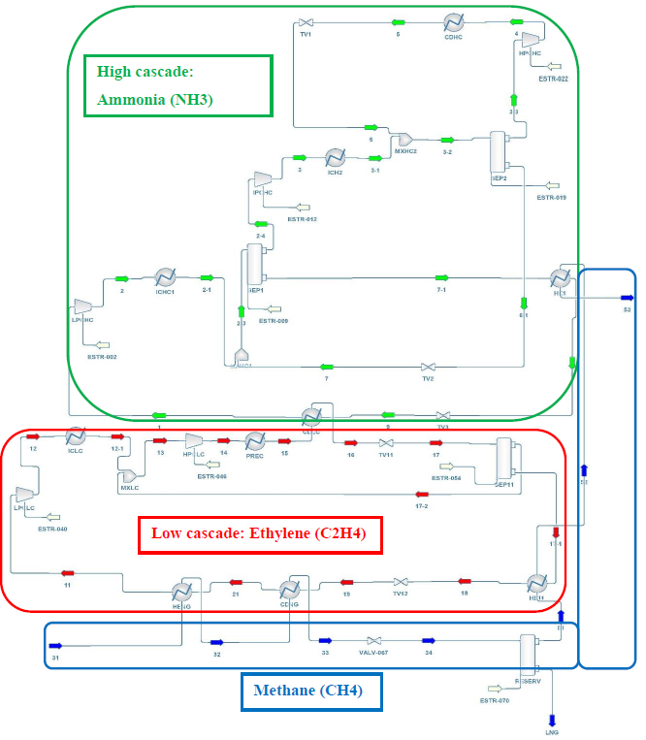 |  |  | Ammonia Power required (kW)  LPCHC 155.98952  IPCHC 290.04955  HPCHC 88.83418  Ethylene Power required (kW)  LPCLC 259.63569  HPCLC 330.20529  Table 3. Power required values from DWSIM for all the compressors
Figure 1. Process flowsheet in DWSIM (refrigerants bordered)

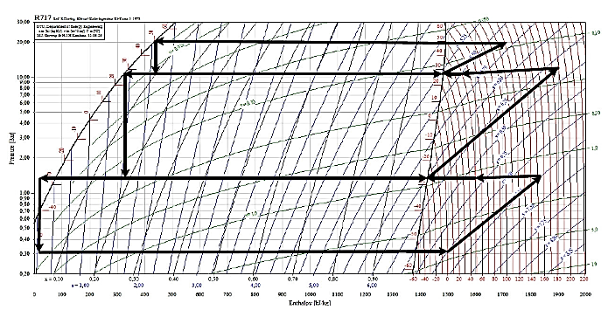  Figure 2. P-h diagram graph of Ammonia refrigerant cycle | 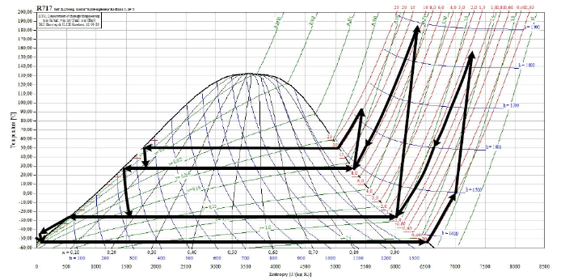  Figure 3. T-s diagram graph of Ammonia refrigerant cycle
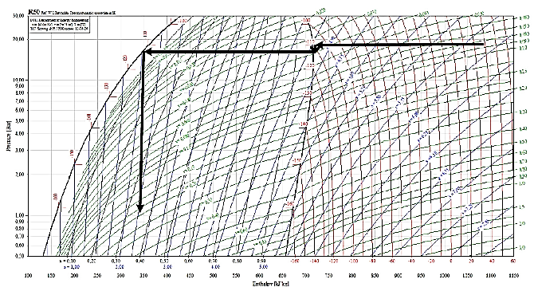  Figure 4. P-h diagram graph of Natural gas cycle (methane) | 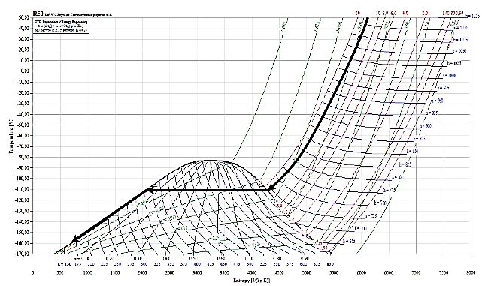  Figure 5. T-s diagram graph of Natural gas cycle (methane)
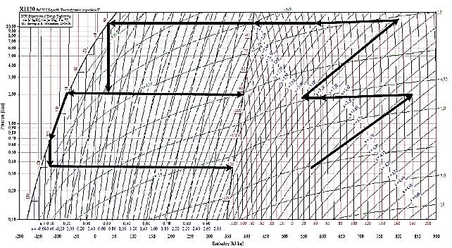  Figure 6. P-h diagram graph of Ethylene refrigerant cycle | 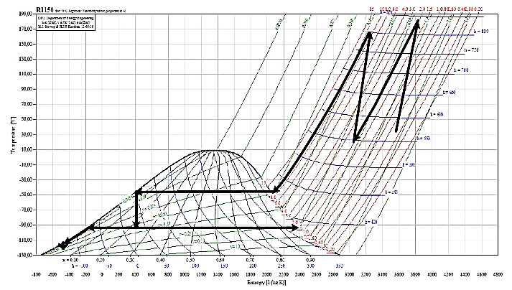  Figure 7. T-s diagram graph of Ethylene refrigerant cycle

These graphs Figure 2-7 are plotted based on the enthalpy and entropy values gain from the simulation for the refrigerants and natural gas, respectively.
  - Coefficient of Performance of Russian Process Liquefaction
The calculation of the coefficient of performance of Russian liquefaction is based on the collected results from the simulation from the DWSIM. Based on the natural gas stream results from the simulation the energy flow decreases steadily from the stream 31 till 34 but the energy flow at streams 33 and 34 remain with the same enthalpy results besides that, the energy flow for stream 35 to 53 are not consistent where the streams 35 and 51 have the same enthalpy value and stream 52 to 53 the enthalpy values decrease. Hence, stream 31 to 34 is evidenced to be productive materials compared to stream 35 to 53. Moreover, the organization of the component after the stream 35 could be diverse conferring to the condition of transportation and storage of LNG so that it could be different and adjustable which also resulting in varying pattern values of energy flow. The calculation of the Coefficient of Performance is shown below:
$COP=\frac{{\dot{H}}_{31}-{\dot{H}}_{34}}{W_{Total}}=\frac{{\dot{m}}_{31}h_{31}-{\dot{m}}_{34}h_{34}}{\sum_{1}^{5}{W_{Compressors}}}=\frac{728.139 kW}{1124.714 kW}=0.6474$ being the software energetic efficiency, and
the energetic efficiency [5] as $\frac{727 kW}{1220 kW}=0.596$. The calculation of the COP value is gain based on the data in DWSIM software. These COP values are compared with the COP value from Aspen Plus software to identify the effectiveness for the Russian process of Liquefaction with both software’s. Based on the Coefficient of performance value from the calculation, the COP value from the DWSIM software is 0.6474 which is higher compared to the value from Aspen Plus which is 0.596 [5]. Consequently, there is an improvement done on the COP from the previous work of 5%.

- Conclusion
The project has been finished by finding and completing every one of the requirements identifying with the project title. The project begins by doing research from the journals, theses, and articles to frame an idea regarding to the title. Moreover, based on the research we able to understand the essential of the title. The project also has been successfully done in the previous thesis by using other software. Hence, the DWSIM software is used to testify and prove its effectiveness on how the Russian (classic cascade process) can liquefy the natural gas and its COP.
The simulation process detail has been explained to understand how the Russian process of liquefaction works to liquefy the natural gas. By the usage of the property method of Peng-Robinson (PR) equation and with the needed assumptions and specification for the project the simulation was successfully done. The results data from the simulation flow sheet of Russian process are tabulated.
Moreover, with value of enthalpy and entropy which is gained from the simulation P-h graph and T-s graph are plotted in order to complete the Coefficient of Performance. Furthermore, from the simulation the power required values for the compressors are also tabulated in order to find the Coefficient of Performance values (COP). Based on the calculation of Coefficient of Performance, the COP value gain effectively from the DWSIM software is 0.6474.
Finally, the project research has met the objectives of the project which obtaining data with the simulation from the open-sourced software. Values of enthalpy and entropy were also obtained from the DWSIM simulation are compared with Aspen Plus simulation values nevertheless the results and pattern were considerably different for both the software’s. Consequently, there is also an improvement done on the Coefficient of Performance where 0.596 [5] from previous work by Aspen Plus to 0.6474 by DWSIM which is an improvement of 5%.
References
- Sisson, R. (2021). Natural Gas Resource Library – Encyclopedic Entry (Classroom Resources). Retrieved from https://www.nationalgeographic.org/encyclopedia/natural-gas
- US Federal Energy Regulatory Commission. (2021). How Does LNG Work. Retrieved from http://www.rigzone.com/training/insight.asp?insight_id=322
- Morosuk, T., & Tsatsaronis, G. (2012). LNG – Based Cogeneration Systems: Evaluation Using Exergy-Based Analyses. Natural Gas - Extraction to End Use. https://doi.org/10.5772/51477
- M.N.B. Omar (2015). Thermodynamic and Economic Evaluation on Existing and Prospective Processes for Liquefaction of Natural Gas in Malaysia. Ph.D Thesis, Berlin, Germany.
- Pulcinelli, D. (2012). Thermodynamics Evaluation on a Cascade Process for Liquefaction of Natural gas in the Soviet Union. Master Degree Thesis, Berlin, Germany.

Acknowledgement
The authors would like to acknowledge the support from the Fundamental Research Grant Scheme (FRGS) under a grant number of FRGS/1/2022/TK10/UNIMAP/02/25 from the Ministry of Higher Education Malaysia.

