**Predictive Linear Regression Model for Mechanical Vibrations in a 187 MW Gas-Turbine Generator Operating Under Combined Cycle**

**Ahmed I. Abed1, 2 and Loh Wei Ping2 \***

1School of Arts & Sciences, American International University, Kuwait

2School of Mechanical Engineering, Engineering Campus, Universiti Sains Malaysia, 14300 Nibong Tebal, Seberang Perai Selatan, Penang, Malaysia.

*E-mail: meloh@usm.my

**Abstract.** A power generating unit's fundamental component is a gas turbine (GT), consisting of a compressor, a turbine, and a generator to convert thermal energy into electrical energy. The rotating turbine is prone to high vibrations, potentially leading to bearing wear and fatigue failure of turbine blades. Numerous studies have reported various simulation techniques, including MATLAB, Pro-Engineering, and computational fluid dynamics (CFD) to develop mathematical models and simulators of GT components. These models typically focus on specific physical parameters such as temperature, pressure, rotational speed, and load variations. Despite extensive research, gaps remain in understanding the relationship between mechanical vibrations in GT generators and their underlying causes. This study addresses these gaps using statistical analysis and data mining techniques on a large dataset of mechanical vibrations from GT components in a thermal power unit. Data mining techniques were employed to create mechanical vibration velocity models, linking various operational parameters and conditions: vibration velocities and amplitudes on the GT power unit main components (compressor, turbine, and generator). Linear Regression algorithm in WEKA software was used to construct two linear models for the mechanical vibration velocity of the GT generator’s support bearings. The models demonstrated correlations of 99% and 92%, respectively, for the front and rear support bearings. Validation using a supplied test set of case study data confirmed an accuracy rate of 99% for both models. Ultimately, these predictive mechanical vibration models pave the way for more effective maintenance practices and improved turbine reliability in power generation.

**Keywords:** Data Mining, Gas-Turbine, Linear regression, Maintenance, Statistical analysis, Vibration.

1. **Introduction**

Gas- turbine (GT) power plant consists of three components: compressor, turbine, and generator. It is used to covert the fuel chemical energy into mechanical (and ultimately electrical) energy using compressed air and fuel [1]. The generator must spin at a constant specified speed to produce the correct voltage at a constant AC frequency. GTs are primarily configured in two ways: simple cycle (SC) and combined cycle (CC), both typically utilizing natural gas [2], In SC, ambient air enters the compressor at atmospheric pressure. The compressor increases the air pressure, and fuel is then added to the compressed air in the combustion chamber, where the pressure and temperature rise significantly. The high-pressure air is used to rotate the turbine which is mechanically linked to both the compressor and the generator. Once the turbine reaches its operating speed (steady speed) the generator produces the required electrical power, and the exhaust gases are released into the atmosphere [3].

In a CC power plant, GT works in parallel with a steam turbine to generate electrical power. The hot exhaust gases from the GT are used to heat water, producing steam that drives the steam turbine, thereby enhancing overall power output cycle. Figure 1 illustrates different types of power plants based on the generated heat rate [1].

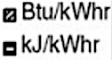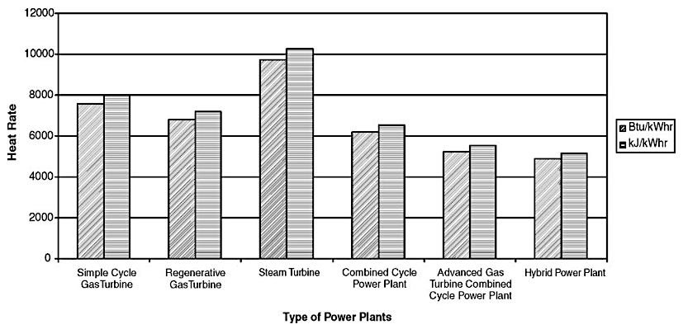

**Figure 1.** Heat rate generated for different power plants [1].

[4] Rotating machines, such as those found in GT power plants rely on bearings to support their mechanical components. Bearings are important to reduce friction and power loss during power generation and transmission [4]. Typically, GT utilizes Tilt Pad bearings; one set located for both the compressor and the turbine. Additionally, the generator is supported by four support bearings. The type of bearing used depends on the size and power output of GT power plant size.

It is widely acknowledged that mechanical vibrations in GT power plants are a primary cause of component failure [5]-[7]. High vibrations induce fatigue in turbine and compressor blades and can also cause significant damage to support bearings and their foundations due to high vibration velocity and amplitude. Furthermore, high temperature effects on GT elements such as blades, shafts, and casing, exacerbating wear and tear [8].

To address these challenges, mathematical modelling has become an essential tool in understanding and mitigating the effects of mechanical vibrations. Mathematical modelling involves the process of creating relationships between independent variables to predict outcomes. Linear models, such as simple linear regression, are used when the relationship between variables is straight forward. Meanwhile, nonlinear modelling is employed for more complex interactions. In this study, mathematical models are generally developed using two primary methods.[9]-[11]. The first method adopts System Dynamic Modelling involves linking the physical parameters of GT through an equation to determine crucial parameters, such as output power, efficiency, and exhaust temperature. The second method uses collected data on GT physical parameter to generate mathematical models for variables such as turbine speed, output power, mechanical vibration velocity, and vibration amplitude. The models are developed using a case study data from GT power plant operated under combined cycle. This study aims to develop predictive models using statistical and data mining approaches to accurately represent the mechanical vibrations in gas-turbine.

1. **Related Work**

A dynamic neural networks approach was employed to develop a mathematical model of mechanical vibrations on GT bearings [12], by comparing the GT recent vibration data with data coming from normal operation, the generated model helps in identifying GT health status. Accurately reflecting real-time vibration amplitudes across four support bearings [13]. Additionally, a fault monitoring system based on vibration and spectral analysis was implemented, demonstrating its efficacy in preventing turbine operation in vibration modes while optimizing performance. Analytical techniques, including the Rayleigh-Ritz method and Lagrangian mechanics were selected to derive a nonlinear mathematical model for gas-turbine rotating blades [14]. In research [15], a simplified dynamic model of heavy GT was developed with the validation results showing excellent alignment between the generated model and the real plant data. In other studies, the modelling of GT thermal power plant using agricultural biomass fuel has been developed using MATLAB / Simulink simulations, enabling evaluation of various operating conditions [16].

1. **Research Methodology**

The methodology involves collecting mechanical vibrations data of the gas-turbine generator from a case study conducted in thermal power production in Jordan over a duration of one month (January 2019) when GT plant is running under normal operation conditions (no-overload during winter season). Statistical analysis and data mining techniques were applied to develop predictive models on how the mechanical vibration velocities of various components affect the overall vibration velocity on the generator. The entire study flowchart is depicted in Figure 2.

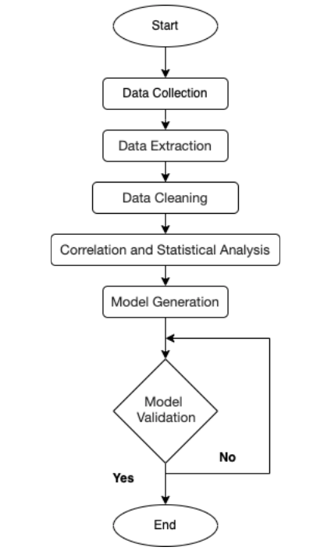

**Figure 2.** The study flowchart.

*3.1 GT Power Plant Physical Parameters*

The data collection process involves gathering a comprehensive set of parameters for each unit within the GT plant. Specifically, for the GT power plant, the selected parameters include:

* Air inlet temperature (oC).
* Air intel pressure, inlet air relative humidity (%).
* Air outlet temperature (oC).
* Air outlet pressure (bar).
* Generator current (A).
* Generator voltage (V).
* Frequency (Hz).
* Rotating speed (rpm).
* Electrical load (MW).
* Vibration velocity of each bearing (mm/s).
* Vibration on the bearing side (µm).

These quantitative and measurable study parameters are detailed in Table 1. Additionally, the schematic diagram in Figure 3 shows the physical location of these parameters, including the positions of the bearings (supports).

**Table 1.** SGT5- 2000E unit’s quantitative parameters.

|  |  |  |  |
| --- | --- | --- | --- |
| Symbol | Description | Symbol | Description |
| $${\dot{m}}_{f}$$ | fuel mass flow rate (kg/s). | *d* | Vibration displacement (mm). |
|  | Inlet air pressure (bar). | $$P_{e}$$ | Exit pressure (bar). |
| $$T_{a}$$ | Inlet air temperature (oC). |  | Exit temperature (oC). |
| F | Inlet air relative humidity (%). | $$Load$$ | The generator output power (MW). |
| $$I$$ | Generator output current (A). | $$V$$ | Generator output Voltage (V). |
| $$f$$ | Frequency (Hz). | $$v$$ | Vibration average speed (mm/s). |
| $$N$$ | Rotating speed (rpm). |  |  |

**Figure 3.** Schematic diagram of GST5-2000E with all physical parameters and main bearings.

*3.2 Data Collection*

The selected power plant is equipped with the SPPA-T3000 system, which controls the GT power unit's operation. The system collects physical parameter data every 10 minutes. It connects with external systems and controls the automation and safety procedures of boilers, auxiliary equipment, and turbines within the power unit. It manages the automation and safety procedures of boilers, auxiliary equipment, and turbines within the power unit while interfacing smoothly with external systems not included in the unit. The SPPA-T3000 unit is structured into three logical layers: Operator, Automation, and Process.

The generator component is specifically equipped with four vibration velocity measuring points located near the main bearings and its foundation. As illustrated in Figure 4, the collected data include:

* Amplitude of vibrations at two positions (GEN) on the generator.
* Velocities of vibrations at four positions (GEN 01, GEN 02, GEN 03, & GEN 04) on the generator.
* Amplitudes of vibrations on the compressor side (COMP).
* Velocities of vibrations at two positions (COMP 01 & COMP 02) on the compressor.
* Amplitudes of vibrations on the turbine side (TURB).
* Velocities of vibrations at two positions (TURB 01 & TURB 02) on the turbine.

These comprehensive data collection approach ensures all critical parameters are monitored and recorded for subsequent data analysis and development of predictive vibration modelling techniques.

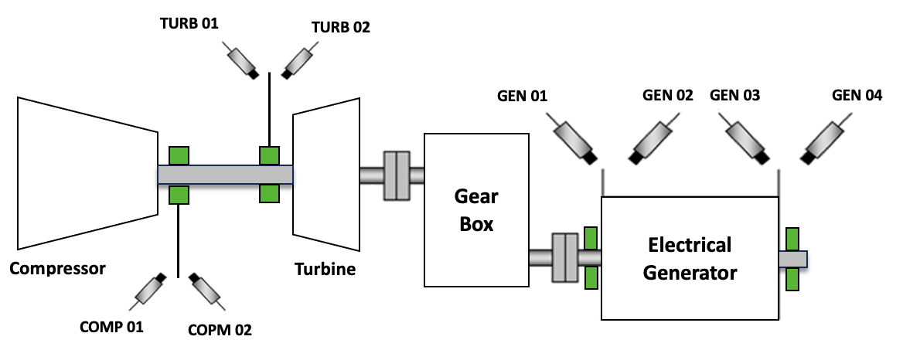

**Figure 4.** The positions of vibration measuring points on SGT5- 2000E GT unit.

Table 2 shows the breakdown of the measuring points for generator, compressor, and turbine based on the vibration’s amplitude and velocity. The collected data were systematically stored and subsequently compared with the standardized values for all unit components.

**Table 2.** The number of measuring positions of mechanical vibrations on the GT unit.

|  |  |  |  |  |
| --- | --- | --- | --- | --- |
| GT Component | # Vibration Measuring Points | | | |
| Velocity | Parameter identifier | Amplitude | Parameter identifier |
| **Generator** | 4 | VBGEN01 to VBGEN04 | 2 | VBG01 & VBG02 |
| **Compress** | 2 | VBCOMP01 & VBCOMP02 | 1 | VBCOMP |
| **Turbine** | 2 | VBTURB01 & VBTURB02 | 1 | VBTURB |
| Generator: Velocity = VBGEN0X, Amplitude: VBG0X  Compressor: Velocity = VBCOMP0X, Amplitude: VBCOMP  Turbine: Velocity = VBTURB0X, Amplitude: VBTURB | | | | |

*3.3 Data Extraction*

The gathered data were converted to Comma Separated Value (CSV) format, readable by the WEKA software, to develop linear models of the mechanical vibration velocities on the sides of the GT generator. Relevant data involving the mechanical vibrations velocity and amplitude of the GT components (compressor, turbine, and generator) will be extracted.

*3.4 Data Cleaning*

A complete dataset of 4,372 instances has been generated by using an online data collection system (SPPA-T3000) to gather measurements every 10 minutes. The dataset contains abnormal entries, such as outliers, extreme values, and zero readings recorded during shutdown periods. A systematic cleaning procedure was employed to eliminate these irregular data points. Outliers and extreme values were identified and removed based on thresholds established by Equations (1) and (2).

$$Outliers= Q_{1}±1.5* IQR \left(1\right)$$

$$Exterme Values= Q_{3}±3* IQR (2)$$

where:

*Q1*: First quartile (25% percentile).

*Q3*: Third quartile (75% percentile).

*IQR*: Interquartile range (*IQR = Q3 – Q1*).

*3.5 Correlation and Statistical Data Analysis*

Microsoft Excel was used to study the relationship between the physical parameters- Excel is a helpful point-and-click tool for data entry, analysis, and visualization- specifically the mechanical vibration velocities and amplitude of GT components. This involve calculating the correlation coefficients using equation (3) and performing single factor ANOVA analysis to identify significant relationships between two physical parameters.

$$r_{x,y}= \frac{\sum{{(x}_{i}-\overline{x}).{(y}_{i}-\overline{y})}}{\sqrt{\sum{{{(x}_{i}-\overline{x})}^{2}.\sum{{{(y}_{i}-\overline{y})}^{2}}}}} (3)$$

where:

*rx, y*: correlation coefficient between variables *x* and *y*.

*xi*: the values of variable *x* (VBGEN0X, VBG0X, VBCOMP0X, VBCOMP, VBTURB0X, and VBTURB).

*yi*: the values of variable *y* (VBGEN01 and VBGEN03).

the average values of variable *x*.

$\overline{y}:$ the average values of variable *y*.

The null hypothesis (H0) posits that there is no significant difference in the mechanical vibration velocities across the generator elements, while the alternative hypothesis (H1) suggests that there is a significant difference. The p-value estimates the likelihood of obtaining the observed outcomes under the assumption that the null hypothesis is correct. A lower p-value (< 0.05) a statistically significant result.

*3.6 Models Generation and Validation*

WEKA software was employed to generate linear models of the mechanical vibration velocity on the GT generator. The Linear Regression algorithm was deployed to construct these models, leveraging the significant parameters identified from the correlation and statistical analysis stage.

The 10-fold cross-validation method with a dataset of 1,488 instances was applied using WEKA software to verify the accuracy and reliability of the generated models at a priori. The drawbacks of 10-fold cross-validation are as follows: it cannot be used with unbalanced data sets; it requires many training data sets; and it is expensive. This technique partitions the data into 10 "folds," for training and testing, ensuring a robust evaluation of the developed models' performances. Following this, a testing set from a different period at the same GT power plant was used to further validate the models. This step ensures that the models are robust and can generalize well to “unseen” data. The performances of the generated models were assessed using key metrics: the correlation coefficient, mean absolute error (MAE), relative absolute error (RAE), and root relative squared error (RRSE).

1. **Results and Discussion**

The single factor ANOVA approach was used to examine the relationship between parameters, specifically to test the independence of vibration velocities across the generator elements. The results are listed in Tables 3 and 4. The first group consists of VBGEN01 & VBGEN02, representing the mechanical vibration velocities at positions 01 and 02 on the opposite sides of the GT generator’s front. The second group includes VBGEN03 and VBGEN04, corresponding to positions 03 & 04 on the GT generator’s back side. The results P-value between vibration velocity positions 01 and 02is close to zero (*P*-value < 0.05). Such indicates a significant relationship. Similarly for the second group, the P-values between velocities at positions 03 and 04 is below 0.05, confirming a significant relationship between these two parameters. The distribution and relationship of the vibration velocities at the specified positions are further depicted in Figure 5, which visually presents the data's spread, central tendency, and potential outliers.

**Table 3.** ANOVA results for generator side positions 01 and 02.

|  |  |  |  |  |  |  |
| --- | --- | --- | --- | --- | --- | --- |
| *Groups* | *Count* | *Sum* | *Average* | *Variance* |  |  |
| **VBGEN01** | 4455 | 9308.83 | 2.08952413 | 0.22614699 |  |  |
| **VBGEN02** | 4455 | 9816.38207 | 2.20345277 | 0.25175807 |  |  |
| **Source of Variation** | *SS* | *df* | *MS* | *F* | *P-value* | *F crit* |
| **Between Groups** | 28.9123569 | 1 | 28.9123569 | 120.996237 | *5.7915E-28 | 3.84250294 |
| **Within Groups** | 2128.58913 | 8908 | 0.23895253 |  |  |  |

\**P*-value < 0.05

**Table 4.** ANOVA results for generator side positions 03 and 04.

|  |  |  |  |  |  |  |
| --- | --- | --- | --- | --- | --- | --- |
| *Groups* | *Count* | *Sum* | *Average* | *Variance* |  |  |
| **VBGEN03** | 4455 | 4087.61492 | 0.91753421 | 0.01719297 |  |  |
| **VBGEN04** | 4455 | 3787.46954 | 0.85016151 | 0.01619765 |  |  |
| **Source of Variation** | *SS* | *df* | *MS* | *F* | *P-value* | *F crit* |
| **Between Groups** | 10.1108023 | 1 | 10.1108023 | 605.607319 | *1.976E-129 | 3.84250294 |
| **Within Groups** | 148.721827 | 8908 | 0.01669531 |  |  |  |

\**P*-value <0.05

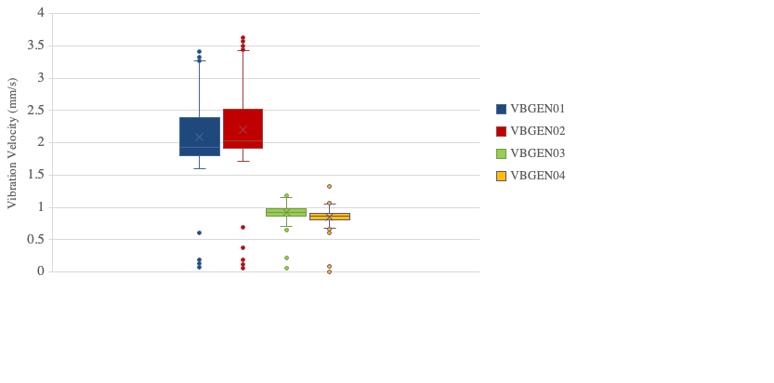

**Figure 5.** Box plot for the generator vibration velocities.

The correlation coefficients among mechanical vibrations demonstrate the interdependencies between various parameters. The correlations matrix, shown in Table 5, was generated using Microsoft Excel. The matrix utilized colour coding to reflect the strength of the relationships between the measured parameters; green indicates a strong relationship (r > 0.85), yellow moderate correlation (r = 0.5), and red signifies a weak correlation (r < 0.10). Positions 01 and 02 of the generator side exhibit a strong correlation in vibration velocity, as indicated by the green colour. This suggests a robust relationship between the vibration velocities at the positions 01 and 02 (VBGEN01 & VBGEN02). This means that the behaviour of these variables is highly similar, suggesting a predictive model based on one of these variables will suffice, given their near identical behaviour.

Similarly, positions 03 and 04 exhibit comparable behaviour in terms of mechanical vibration velocity, suggesting consistency in their vibration patterns. These positions were omitted from the final model development because they are strongly correlated with positions 01 and 03, respectively. Given their high correlation, it was determined that positions 01 and 02, and similarly positions 03 and 04, effectively represent each other. Therefore, including both positions would provide redundant information. Consequently, the analysis focused on positions 01 and 03, as they offer distinct and comprehensive insights for predictive vibration models development.

|  |  |  |  |  |  |  |  |  |  |  |  |  |  |  |  |  |  |  |  |
| --- | --- | --- | --- | --- | --- | --- | --- | --- | --- | --- | --- | --- | --- | --- | --- | --- | --- | --- | --- |
|  | VBGEN01 | | VBGEN02 | VBGEN03 | | VBGEN04 | VBG01 | VBG02 | | VBCOMP01 | VBCOMP02 | | VBCOMP | | VBTURB01 | | VBTURB02 | VBTURB | |
| VBGEN01 | 1.0000 | |  |  | |  |  |  | |  |  | |  | |  | |  |  | |
| VBGEN02 | 0.9946 | | 1.0000 |  | |  |  |  | |  |  | |  | |  | |  |  | |
| VBGEN03 | 0.1362 | | 0.1402 | 1.0000 | |  |  |  | |  |  | |  | |  | |  |  | |
| VBGEN04 | 0.1639 | | 0.1681 | 0.9743 | | 1.0000 |  |  | |  |  | |  | |  | |  |  | |
| VBG01 | 0.5114 | | 0.5162 | 0.5891 | | 0.6271 | 1.0000 |  | |  |  | |  | |  | |  |  | |
| VBG02 | 0.5221 | | 0.5288 | 0.6801 | | 0.6931 | 0.6419 | 1.0000 | |  |  | |  | |  | |  |  | |
| VBCOMP01 | 0.4859 | | 0.4880 | 0.6160 | | 0.6341 | 0.6758 | 0.6248 | | 1.0000 |  | |  | |  | |  |  | |
| VBCOMP02 | 0.5125 | | 0.5143 | 0.6263 | | 0.6446 | 0.6911 | 0.6379 | | 0.8946 | 1.0000 | |  | |  | |  |  | |
| VBCOMP | 0.3667 | | 0.3680 | 0.4110 | | 0.4260 | 0.4428 | 0.4176 | | 0.4535 | 0.4712 | | 1.0000 | |  | |  |  | |
| VBTURB01 | 0.0064 | | 0.0097 | 0.4509 | | 0.4485 | 0.2846 | 0.4179 | | 0.4838 | 0.4520 | | 0.1511 | | 1.0000 | |  |  | |
| VBTURB02 | -0.0274 | | -0.0237 | 0.4397 | | 0.4345 | 0.2611 | 0.4243 | | 0.4802 | 0.4487 | | 0.1345 | | 0.9333 | | 1.0000 |  | |
| VBTURB | 0.2192 | | 0.2204 | 0.3495 | | 0.3563 | 0.3225 | 0.3631 | | 0.2833 | 0.2965 | | 0.2513 | | 0.2925 | | 0.2781 | 1.0000 | |
| VBGEN01: Vibration velocity generator side – position 01. VBCOMP01: Vibration velocity compressor side – position 01.  VBGEN02: Vibration velocity generator side – position 02. VBCOMP02: Vibration velocity compressor side – position 02.  VBGEN03: Vibration velocity generator side – position 03. VBCOMP: Vibration amplitude compressor side.  VBGEN04: Vibration velocity generator side – position 04. VBTURB01: Vibration velocity turbine side – position 01.  VBG01: Vibration Amplitude generator side – position 01. VBTURB02: Vibration velocity turbine side – position 02.  VBG02: Vibration Amplitude generator side – position 02. VBTURB: Vibration amplitude turbine side. | | | | | | | | | | | | | | | | | | | |
|  | | High Correlation > 85% | | |  | |  | | About 50% correlation | | |  | |  | | Low Correlation < 10% | | |  |

Table 5. Correlation coefficient for the mechanical vibrations of gas-turbine (GT) components

The resulting linear regression models generated from WEKA for positions 01 and 03 are expressed in terms of other vibration parameters. Equation (4) provides a general representation of the linear models for GT vibration velocities at positions 01 and 03.

$VB_{GEN_{i}}= a * VB_{GEN01}+b*VB_{GEN02}+c * VB_{GEN03}+ d* VB_{GEN04}+ e* VB_{G01}+ f* VB_{G02}+g*VB_{COMP01}+h*VB_{COMP02}+i*VB_{COMP}+j*VB_{TURB01}+k*VB_{TURB02}+l*VB_{TURB}+m$ (4)

Where:

$VB_{GEN_{i}}=$ Vibration velocity at generator side position *i*.

$$i=01, 03$$

VBGEN01 =Vibration velocity at generator side position 01.

VBGEN02 = Vibration velocity at generator side position 02.

VBGEN03 =Vibration velocity at generator side position 03.

VBGEN04 =Vibration velocity at generator side position 04.

VBG01 =Vibration amplitude at generator side position 01.

VBG02 =Vibration amplitude at generator side position 02.

VBCOMP01 =Vibration velocity at compressor side position 01.

VBCOMP02 =Vibration velocity at compressor side position 02.

VBCOMP =Vibration amplitude at compressor side.

VBTURB01 =Vibration velocity at turbine side position 01.

VBTURB02 =Vibration velocity at turbine side position 02.

VBTURB =Vibration amplitude at turbine side.

$a, b, c, d, e, f, g, h, i, j, k, l, m=$ constant coefficients given by Table 6.

**Table 6.** The constant values for predictive $VB_{GEN_{i}}$ models developed using Equation (4)

|  |  |  |
| --- | --- | --- |
| Constant coefficient | $$i=01$$ | $$i=03$$ |
| $$a$$ | 0 | 0 |
| $$b$$ | 0.9398 | -0.0126 |
| $$c$$ | 0 | 0 |
| $$d$$ | 0.0535 | 0.9582 |
| $$e$$ | -0.0012 | -0.002 |
| $$f$$ | -0.0032 | 0.0017 |
| $$g$$ | 0 | 0 |
| *h* | 0 | 0.0121 |
| *i* | 0 | 0 |
| *j* | 0 | 0 |
| *k* | 0 | 0.0036 |
| *l* | 0 | 0 |
| *m* | 0.1495 | 0.1165 |

The model developed in Equation (4) was assessed using several key metrics: MAE, RAE and RRSE are detailed in Table 7. The correlation coefficient reflects the strength of the relationship between the predicted and actual vibrations values. MAE provides insights into the average magnitude of prediction errors, while RAE and RRSE measure the error relative to a baseline model. In the context of GT, the baseline model is a basic linear regression model with minimal predictors (VBGEN01).

The model developed relates to the mechanical vibration parameters of the GT power plant. These parameters were identified as significant in a study by Bracco [10], which underscores their importance in GT operations. Our findings align with those of Bracco [10], highlighting that mathematical model of mechanical vibration velocities on the GT, generator side, power plants are both obtained and validated based on the collected data set, the vibration predicted models show the vibration velocity on the generator sides (positions 01 and 03) in terms of the mechanical vibration parameters (velocity and amplitude of the GT’s compressor, turbine, and generator.

With reference to Table 7, the errors and the verification test results for the mechanical vibration velocity models are presented, showing an error range from 0.0229 to 0.375 for both models. The correlation coefficient (*r*) exceeds 90% for both models. Specifically, the first model (VBGEN01) exhibits a higher correlation coefficient than the second model (VBGEN03), with values above 99% for VBGEN01 and above 92% for VBGEN03.

The mean absolute error (MAE) shows the average absolute mean difference between the predicted and the measured values. The generated models demonstrate 3.9% and 2.29% relative absolute errors respectively, as shown in Table 7. The highest MAE observed is 6.51% for model VBGEN01 in the verification test. WEKA produced RAE values for the models and their verification, Model VBGEN01 has 11% RAE, while model VBGEN03 shows 36.8% RAE and an 8.17%. RAE in verification.

**Table 7.** The generated models’ error and its verification using testing dataset *(in italic).*

|  |  |  |
| --- | --- | --- |
|  | VBGEN01 | VBGEN03 |
| **Correlation Coefficient** | 0.9928 (*0.9984*) | 0.9269 *(0.9984)* |
| **MAE** | 0.0391*(0.0651)* | 0.0229 *(0.0285)* |
| **RAE** | 0.1145 *(0.1100)* | 0.368 *(0.0817)* |
| **RRSE** | 0.1197 *(0.0790)* | 0.375 *(0.0773)* |

The verification summary for both models is shown in Figure 6. The findings reveal that all error metrics are below 12%, indicating a generally low level of prediction error. Notably, model VBGEN03 demonstrates lower error metrics compared to model VBGEN01, highlighting its superior performance and accuracy in predicting mechanical vibration velocities.

**Figure 6.** Percentage predicted model errors using RAE, RRSE, and MAE metrics on supplied testing data mode.

Comparing the 10-fold cross validation errors with those findings from the supplied testing set, it was noted that the models developed exhibited consistent performance across both validation methods. Specifically, the cross-validation errors were comparable with MAE, RAE, and RRSE within to those obtained from the testing set. Such observation indicates that the models generalize well and are robust against overfitting. This consistency underscores the reliability of the models in predicting mechanical vibration velocities and supports their practical applicability for real-world scenarios in GT power plants.

1. **Conclusion**

High mechanical vibrations pose a significant challenge in rotating machines, including GT power plants, where vibration velocity and amplitude are critical parameters.

This study focused on collecting and analyzing data related to the mechanical vibration velocity and amplitude of a 187 MW GT power plant operating under CC. Specifically, measurements were taken for four generator positions (01, 02, 03, and 04) and amplitudes at positions 01 and 02 for the generator, as well as velocities at two positions (01 & 02). Additionally, amplitude measurements were taken for the turbine and compressor at one position. Correlation analysis revealed strong correlations among the measured variables, with positions 01 and 02, as well as between positions 03 and 04 showing near perfect correlation. The strong correlation observed between the measured parameters led to the selection of only positions 01 and 03 for mechanical vibration model development.

Using WEKA software, linear regression models were developed and validated through a 10-fold cross validation method along with supplied test set for unseen data. The models for mechanical vibration velocity at generator positions 01 and 03 achieved MAE, RAE and RRSE below 12%. These findings indicate that the developed models are highly accurate and reliable for predicting mechanical vibrations, which significantly advances predictive maintenance strategies and optimizes operational efficiency in GT power plants.

Future research will extend this study by developing vibration models for the compressor and turbine components in GT power plants. Using WEKA software, these models will be adopted to capture and correspond with the unique mechanical vibration characteristics of the GT power unit. Future studies will build on the present findings to gain deeper insights into the overall vibration dynamics of the system, paving the way for more effective predictive maintenance strategies and enhancing the operational reliability of GT power plant equipment.

**References**

1. Anon. *Gas Turbine Engineering Handbook*. 2006.
2. Faqihi B, Ghaith FA. A novel design of heat recovery system from exhaust stacks’ silencers in a simple cycle gas turbine. *International Communications in Heat and Mass Transfer*. 2023;148:107068.
3. Motamed MA, Genrup M, Nord LO. Part-load thermal efficiency enhancement in gas turbine combined cycles by exhaust gas recirculation. *Applied Thermal Engineering*. 2024:122716.
4. Guan H, Li J, Wei K, *et al.* Rotordynamics of a rotor radially and axially supported by active bump-type foil bearings and bump-type thrust foil bearings. *Mechanical Systems and Signal Processing*. 2024;208:110995.
5. Nan G, Yao X, Yang S, *et al.* Vibrational responses and fatigue life of dynamic blades for compressor in gas turbines. *Engineering Failure Analysis*. 2024;156:107827.
6. Feng K, Xiao Y, Li Z, *et al.* Gas turbine blade fracturing fault diagnosis based on broadband casing vibration. *Measurement*. 2023;214:112718.
7. Song C, Cheng W, Chen X, *et al.* Identification and separation of coupled vibration sources in multi-rotor gas turbines under time-varying speed conditions. *Mechanical Systems and Signal Processing*. 2023;188:110037.
8. Błachnio J, Spychała J, Zasada D. Analysis of structural changes in a gas turbine blade as a result of high temperature and stress. *Engineering Failure Analysis*. 2021;127:105554.
9. Bartnik R, Buryn Z, Hnydiuk-Stefan A. Methodology and mathematical model with the continuous time for the selection of the optimal power of the gas turbine set for the dual fuel gas-steam combined cycle in a parallel system. *Applied Thermal Engineering*. 2018;141:1161–1172.
10. Bracco S, Delfino F. A mathematical model for the dynamic simulation of low size cogeneration gas turbines within smart microgrids. *Energy*. 2017;119:710–723.
11. Marin GE, Osipov BM, Titov AV, *et al.* Simulation of the operation of a gas turbine installation of a thermal power plant with a hydrogen fuel production system. *International Journal of Hydrogen Energy*. 2023;48:4543–4550.
12. Benrahmoune M, Ahmed H, Mouloud G, *et al.* Detection and Modeling Vibrational Behavior of a Gas Turbine Based on Dynamic Neural Networks Approach. *StrojníCky ČAsopis/Journal of Mechanical Engineering*. 2018;68:143–166.
13. Djaidir B, Hafaifa A, Kouzou A. Faults detection in gas turbine rotor using vibration analysis under varying conditions. *Journal of Theoretical and Applied Mechanics/Mechanika Teoretyczna I Stosowana*. 2017:393.
14. Roy PA, Meguid SA. Analytical modeling of the coupled nonlinear free vibration response of a rotating blade in a gas turbine engine. *Acta Mechanica*. 2018;229:3355–3373.
15. Bahrami S, Ghaffari A, Sadati SH, *et al.* Identifying a simplified model for heavy duty gas turbine. *Journal of Mechanical Science and Technology*. 2014;28:2399–2408.
16. Rico-Riveros LF, Trujillo-Rodríguez CL, Díaz-Aldana NL, *et al.* Modelling of Electric Power Generation Plant Based on Gas Turbines with Agricultural Biomass Fuel. *Electronics*. 2023;12:1981.