Study on the degradation of H₂/O₂ PEMFC with a dead-end gas management during long-term operation
Panida Kanha^{1*}, Werrachai Chaiworapuek², Yong-Song Chen¹
¹ Department of Mechanical Engineering, National Chung Cheng University, Chiayi 621301, Taiwan
² Department of Mechanical Engineering, Kasetsart University, Bangkok 10900, Thailand
panida@alum.ccu.edu.tw
Abstract. The increasing environmental pollution problem has been attributed to fossil fuels, prompting a high demand for effective replacements. Proton exchange membrane fuel cells (PEMFCs) are a crucial technology for producing electric power in many applications that utilize hydrogen to generate high-efficiency and low-emission electricity. To improve the utilization of supplied gases, dead-end operations have been employed both on the cathode and anode sides of a fuel cell system; however, in dead-end operations, impurities may accumulate and cause the catalyst layer to degrade. In this study, both the anode and cathode of an H₂/O₂ PEMFC are operated in a dead-end mode. The cell is operated at 800 mA/cm² and 70°C under various cathode gas humidifying conditions. The anode is purged at selected current integral values of 5000 As and 10000 As, whereas the cathode is purged at 1400 As. The polarization curve, impedance, and morphology of the catalyst layer are investigated after long-term operation (24 and 48 hours). The results indicate that the performance of the single cell deteriorates significantly under dry cathode conditions compared to 50%RHc. The minimum degradation rates observed with humidify on the cathode side were 0.059 and 0.076 V/h, respectively, with an anode current integral of 5000 As and 10000 As. Furthermore, the thickness of the cathode catalyst layer decreased by 50% after 48 hours of operation.
Keywords: proton exchange membrane fuel cell, dead-ended, purge,
degradation, current integral.
.
- Introduction
Most of the world's energy needs are being met by fossil fuels, which have been harmful to the environment due to the human response since the Industrial Revolution, which has led to the extraction, transportation, processing, and combustion of such fuels. The main components of fossil fuels are carbon and hydrogen, and they also contain other elements, such as sulfur, as well as additives, including lead and alcohol, that are added during the refining process. When burned, these fuels release various gases (COx, SOx, NOx et al.), soot, ash, tar droplets, and other organic
compounds into the atmosphere, resulting in air pollution [1-3]. Hydrogen energy is a promising green fuel source that produces only water as a byproduct for electric
power generation. This clean, sustainable energy source can solve many environmental problems. Proton exchange membrane fuel cells (PEMFCs), a crucial technology that uses hydrogen as fuel in many applications, offer a promising solution. These fuel cells utilize dead-end operations on both the cathode and anode sides to enhance the usage of supplied gases in a fuel cell system, thereby reducing the release of unused gas from the system [4-5]. However, it is essential to consider the possibility of accumulating impurities and causing the catalyst layer's degradation when using this method. In a study, both the anode and cathode of an H₂/O₂ PEMFC were operated in a dead-end mode, analyzing the performance, the effects of various factors, and the long-term operation on the fuel cell performance. The research delves into the degradation of the catalyst through the utilization of electrochemical impedance spectroscopy (EIS) and scanning electron microscope (SEM) to observe the morphology of the catalyst layer.
- Experimental
  - Experimental setup
The experimental setup is illustrated in Fig.1. A single PEMFC was used, which included a membrane electrode assembly (MEA) with an active area of 5 × 5 cm². The MEA was placed between carbon paper (28BC, SGL, Germany), graphite plates, gold-coated copper current collectors, and aluminum alloy end plates. The anode and cathode sides of the membrane (Nafion 212, Dupont, USA) were coated with 0.1 and 0.3 mg Pt/cm², respectively. The anode and cathode of the PEMF were both in a dead-end mode. The data acquisition module (NI9219, National Instruments, USA) was used to record cell voltage, temperature, current, and gas flow rate. At the cathode outlet, a normally-closed solenoid valve (Type 6126, Burkert, Germany) was meticulously controlled by a relay (KG1010D, KYTTO, Taiwan) and a digital output module (NI 9401, National Instruments, USA), ensuring the experiment's reliability.

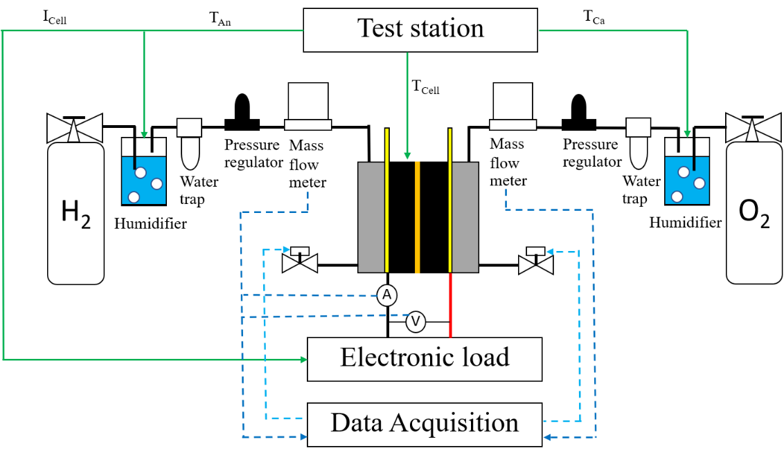
Fig. 1. A schematic of the experimental setup in this study.
  - Experimental procedure for long-term operation.
Specific conditions were maintained throughout the long-term performance experiments to accelerate the degradation rate. The cell temperatures were held at a consistent 70 ºC, while the current density was kept at a precise 800 mA/cm². Additionally, to gain a comprehensive understanding of the impact of operational humidity on performance, the relative humidity cathode sides were carefully adjusted and varied with the anode fully humidified. The current integral is used as a purging strategy, with control at the cathode side maintained at 1400 As, while that of the anode side was maintained at 5,000 As and 10,000 As, which was investigated for up to 48 hours. After long-term testing, the MEA cross-section morphology was analyzed using a scanning electron microscope (SU 8200, HITACHI, Japan).
- Result and Discussion
  - Performance degradation.
The polarization curves at the beginning and end of each test day are used to observe the fuel cell stack's performance change, proving the effect of the purging strategy and humidification Fig.2a shows that dry humidity at the cathode and longer purge duration by current integral accelerate performance degradation with degradation rates of 0.094 and 0.183 V/h with anode current integral of 5000 As and 10000 As, respectively. The degradation rate of the cathode with 50% relative humidity is lower, as shown in Fig.2b. Specifically, the degradation rates were 0.059 and 0.076 V/h, respectively, with an anode current integral of 5000 As and 10000 As. The effect of humidity is also revealed in the EIS, as shown on the Nyquist plot in Fig.3. Dry
conditions have higher resistance dominated by membrane resistance than humidified conditions, which causes low performance, as shown on the polarization curve. Fig.3(a) shows that when the current integral for the cathode with 0%RHc is increased, ohmic resistance increases. However, the chart transfer resistance of current integral 5000As decreases as water accumulates, aiding the cell in increasing oxygen reaction. An increase in chart transfer resistance over time of approximately 0.5 Ωcm² also causes a performance drop. However, in the humidified cathode 50%RHc in Fig.3(b), the ohmic resistance increases very little from the initial value of a fresh single cell during the purge in 5000As and 10000As. The chart transfer also increases that, causing performance to drop slightly over time.
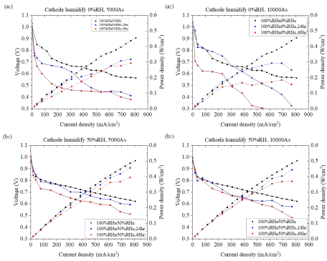
Fig. 2. The polarization curve of the single cells after the long-term test (1) Anode current integral 5000As; (2) Anode current integral 10000As with cathode humidity (a) 0%RHc and (b) 50%RHc.
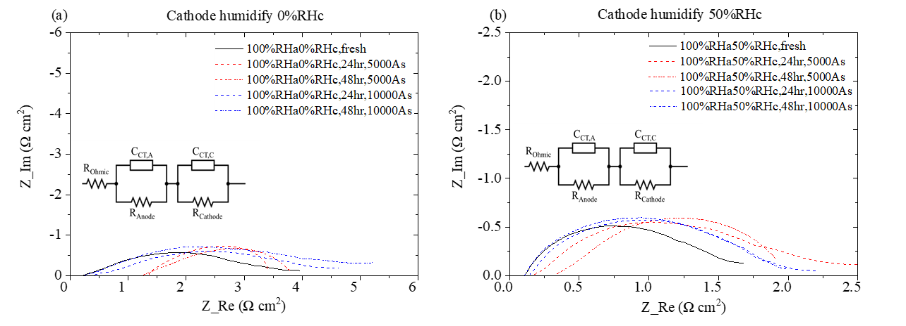
Fig. 3. The Nyquist plot of the single cells after the long-term test with cathode humidity (a) 0%RHc and (b) 50%RHc.
  - Cross-section morphology of Membrane electrode assembly (MEA)
During the dead-end mode operation, the loss of the catalyze layer may cause hydrogen starvation, resulting in carbon corrosion. According to Fig.4(a), the MEA in the fresh condition and the catalyst layer that coats the membrane are smooth and uniform. By coating with 0.1 and 0.3 mg Pt/cm2, it is found that thickness is 12.16 and 25.5 μm on the anode and cathode side, respectively. In this case of fully humidifying at the anode and 50%RHa at the cathode, after the 48 hours long-term test, the catalyzed layer decayed significantly. The thickness reduction was more than 50% of the original thickness. But in terms of integral, there is no significant difference. The loss of the catalyst layer is related to the platinum content used in the PEMFC because of its stability during the hydrogen and oxygen reactions at the anode and cathode, causing performance loss. However, the result of the current integral increase does not give the influential morphology decay of the catalyzed layer.

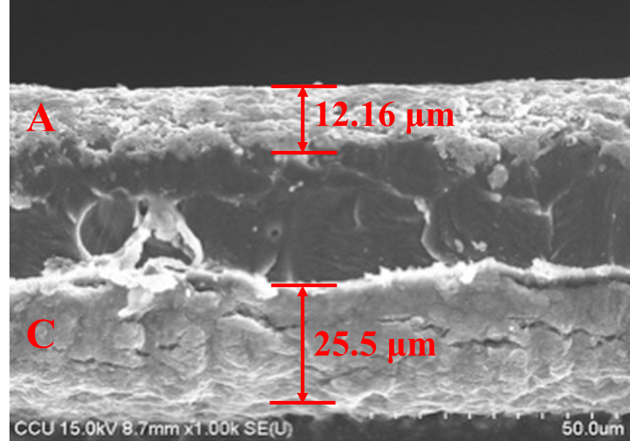 | 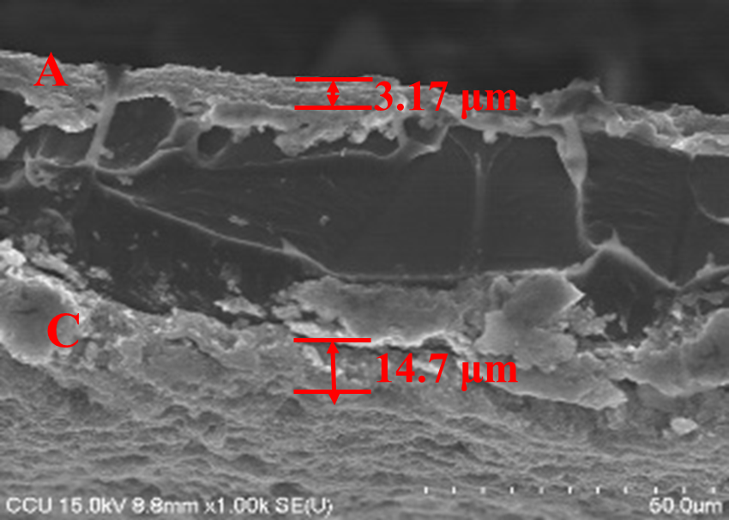 | SHAPE \* MERGEFORMAT 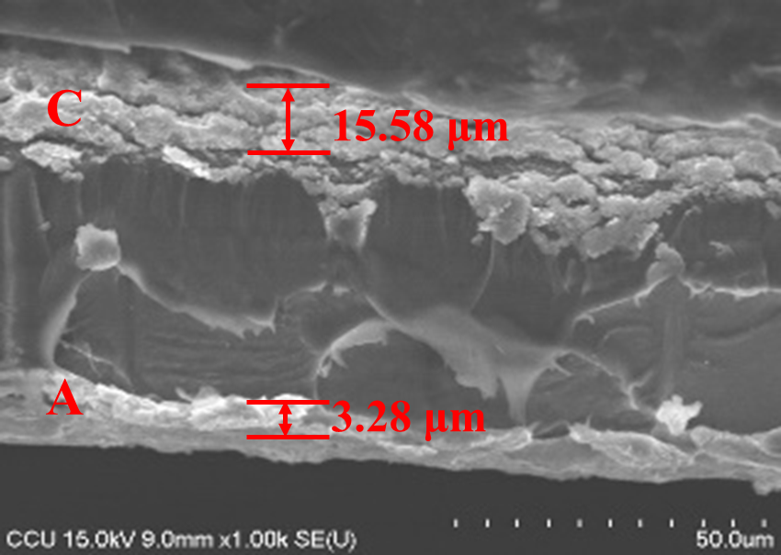
(a) | (b) | (c)
Fig. 4. The cross-section SEM on MEA investigates (a) Fresh (b) 5000As and (c) 10000As
- Conclusion
Based on the results, it has been observed that the performance of a single cell deteriorates significantly under dry cathode conditions when compared to 50%RHc. The observed minimum degradation rates with humidified 50%RHc on the cathode side were 0.059 and 0.076 V/h, with an anode current integral of 5000 As and 10000 As, respectively. The ohmic and chart transfer resistance by EIS also indicates that dry cathode results in worse performance and has a performance drop over time.
Additionally, after 48 hours of operation, the morphology of MEA lost the thickness of the cathode catalyst layer by 50%.

References
- Barbir, F., Veziroǧlu, T. N., & Plass, H. J.: Environmental damage due to fossil fuels use. International Journal of Hydrogen Energy, 15(10), 739-749 (1990).
- Solomon, C. G., Salas, R. N., Malina, D., Sacks, C. A., Hardin, C. C., Prewitt, E., Lee, T. H., & Rubin, E. J.: Fossil-Fuel Pollution and Climate Change - A New NEJM Group Series. N Engl J Med, 386(24), 2328-2329 (2022).
- Yang, J., Yu, Y., Ma, T., Zhang, C., & Wang, Q.: Evolution of energy and metal demand driven by industrial revolutions and its trend analysis, Chinese Journal of Population, Resources and Environment, 19(3), 256-264 (2021).
- Kurnia, J. C., Sasmito, A. P., & Shamim, T.: Advances in proton exchange membrane fuel cell with dead-end anode operation: A review. Applied Energy, 252 (2019).
- Fan, L., Xing, L., Tu, Z., & Hwa Chan, S.: A breakthrough hydrogen and oxygen utilization in a H₂-O₂ PEMFC stack with dead-ended anode and cathode. Energy Conversion and Management, 243 (2021).

