Experimental Study on the Effect of Electrode Configuration on the Performance of High Temperature Proton Exchange Membrane Fuel Cells

Pongsapak Treegosol and Yong-Song Chen

Department of Mechanical Engineering, National Chung Cheng University,   
Chiayi, 621301, Taiwan  
pongsapak@alum.ccu.edu.tw

**Abstract:** High–temperature proton exchange membrane fuel cells (HT–PEMFCs) are widely recognized as a feasible sustainable energy technology for usage in automotive and stationary applications. It has high CO tolerance, fast reaction kinetics, a high amount of reusable heat energy, and no humidification requirement due to the operating temperature higher than 100˚C, thus the water at the inlet and the chemical reaction’s products become the vapor phase, leading to simple water and thermal management. However, various factors influence the performance of high–temperature membrane electrode assemblies (MEAs) with phosphoric acid–doped PBI membrane, therefore determining the optimal operating parameters is one of the challenges for an HT–PEMFC. This study investigated the performance of HT–PEMFCs at various temperatures (140˚C, 160˚C, and 180˚C), air cathode stoichiometric ratio (2, 2.5, and 3), acid doping levels (360% and 460%), and gas diffusion layers (GDL340, GDS with 5% and 20% PTFE). The catalyst layer was composed of Pt/C (46.7 wt.%), PVDF binder, and DMAc as a solvent. The Pt loading on the electrode was approximately set as 0.5 and 1 mg Pt·cm–2 for the anode and the cathode, respectively. The commercial PBI membrane was utilized in this study. The results indicated that increasing the operating temperature can enhance the performance of an HT–PEMFC. However, the cell performance also increased with increasing the air stoichiometric ratio at the cathode side and the acid doping level. Moreover, the MEA with GDS310 reached the maximum power density up to 0.410 and 0.396 W·cm–2, which can be enhanced by approximately 31% and 27% under 5 and 20% PTFE, respectively.

**Keywords:** High–temperature proton exchange membrane fuel cells, Polybenzimidazole, Acid doping level, Gas diffusion layers

1. Introduction

Nowadays, the rising consumption of electrical power leads to increased combustion of fossil fuels, which is a major contributor to environmental degradation due to carbon monoxide emissions and the depletion of energy resources. Alternative and renewable energy sources are vital for a sustainable energy cycle [1]. In recent years, fuel cells have attracted a lot of attention from researchers as an environmentally friendly, clean energy, zero emissions, and high-quality power scalability [2, 3], which is an electrochemical device that directly converts chemical energy from fuel into electrical energy. Moreover, HT–PEMFCs offer significant advantages over LT–PEMFCs, including improved gas impurities [4], faster kinetics reaction [5], and simplified water and heat management [6-8], making them highly promising for automotive, stationary, and portable applications [9]. Over the last decade, further studies have focused on HT–PEMFCs using phosphoric acid–doped Polybenzimidazole (PBI) membrane and investigated the operating parameters effect to enhance the performance and durability of fuel cells. Acid doping level (ADL) in the PBI membrane can improve the ionic transfer, leading to enhanced cell performance, while it can reduce the mechanical properties of the membrane, affecting the cell's durability [10]. Ohmic loss is the major factor that can affect the performance, which can be reduced by increasing temperature [11, 12]. In addition, various operating conditions must be considered to affect the performance, including the gases stoichiometric [12], the thickness of the gas diffusion layer [13], the effect of binder on the electrode and gas diffusion layer [13-16], the gases impurity [17]. Additionally, other researchers have investigated the bipolar plate and flow field development of HT–PEMFCs by numerical studies to find an optimal design structure and the optimal operating conditions [18, 19]. However, various factors influence the performance of high–temperature membrane electrode assemblies (MEAs) with phosphoric acid–doped PBI membrane, therefore determining the optimal operating parameters is one of the challenges for HT–PEMFCs. Thus, this study investigates the performance of HT–PEMFCs under various operating parameters, including the effect of operating temperatures (140˚C, 160˚C, and 180˚C), air cathode stoichiometric ratio (2, 2.5, and 3), acid doping levels (360% and 460%), and gas diffusion layers (GDL340, GDS with 5% and 20% PTFE).

1. Experimental methods
   1. Membrane electrode assemblies (MEAs) preparation

In this study, the catalyst inks consisted of a commercial catalyst with 46.6 wt.% Pt/C (Tanaka Kikinzoku Kogyo K.K., Japan), Polyvinylidene fluoride; PVDF binder, and Dimethylacetamide; DMAc as solvent. All contents were mixed using an ultrasonic bath and planetary. The catalyst inks were sprayed onto GDL 340 and GDS 310 (CeTech Co., Ltd., Taiwan) using the ultrasonic spray coating technique. A commercial PBI membrane (hiPower Green Technology Co., Ltd., Taiwan) with an active area of 5×5 cm2 was immersed in 85 wt.% H3PO4 at 30˚C until ADL reaches the desired level.

* 1. Fuel cell test

In a single stack fuel cell, the MEAs were assembled by sandwiching the PA–doped membrane between two GDEs. In all conditions, the Pt loading on the electrode was 0.5 and 1 mg Pt·cm–2 for the anode and the cathode side. The single–stack fuel cell consisted of the endplate, current collector, gasket, bipolar plate, and MEAs. Moreover, the fuel cell test station was carried out by HEPHAS Energy Co., Ltd. The fuel cell was activated under a constant voltage of 0.6 V at the temperature of 180˚C until the current became stable. Then, the steady–state polarization curves were obtained by measuring the voltage after 2 minutes at each current point. The experimental conditions were classified as shown in Table 1 to investigate the effect of operating temperatures, air cathode stoichiometric ratio, doping levels, and gas diffusion layers on the HT–PEMFCs performance.

**Table 1.** Experimental study conditions

|  |  |  |  |  |  |
| --- | --- | --- | --- | --- | --- |
| **Configurations** | **GDE** | | **Cell Temp** | **Stoi. ratio** | **ADL** |
| **Anode** | **Cathode** |
| 1 | GDL340 | GDL340 | 140˚C | 1.2/2 | 360% |
| 2 | GDL340 | GDL340 | 160˚C | 1.2/2 | 360% |
| 3 | GDL340 | GDL340 | 180˚C | 1.2/2 | 360% |
| 4 | GDL340 | GDL340 | 160˚C | 1.2/2.5 | 360% |
| 5 | GDL340 | GDL340 | 160˚C | 1.2/3 | 360% |
| 6 | GDL340 | GDL340 | 160˚C | 1.2/2 | 460% |
| 7 | GDL340 | GDS310  (5% PTFE) | 160˚C | 1.2/2 | 360% |
| 8 | GDL340 | GDS310  (20% PTFE) | 160˚C | 1.2/2 | 360% |

1. Results and discussion
   1. The effect of the operation temperature

The performance curve under various operating temperatures (140˚C, 160˚C, and 180˚C) was illustrated in Fig. 1(a). The result showed that the cell performance tended to increase with increasing the operation temperature. When the cell voltage reached 0.6 V, the current density was 0.212, 0.256, and 0.300 A·cm–2 under the cell temperature of 140, 160, and 180˚C, respectively. Moreover, the decreasing rate of the voltage in the ohmic losses region under low temperatures was significantly higher than at high temperatures due to the ohmic resistance tends to decrease with increasing cell temperature, leading to high performance under high operation temperatures. Furthermore, the maximum power density was 0.278, 0.312, and 0.345 W·cm–2 under the cell temperature of 140, 160, and 180˚C, respectively.

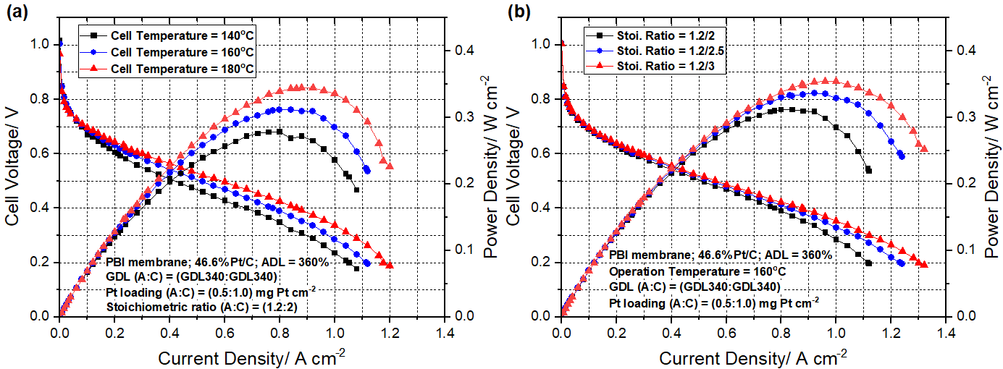

**Fig. 1** Polarization curves under various (a)cell temperatureand (b)air stoichiometric ratio

* 1. The effect of air stoichiometric ratio

The performance curves under different air cathode stoichiometric ratios (2, 2.5, and 3) were observed in Fig. 1(b). In this study, the cell was operated at 160˚C, and commercial GDL340 was employed as GDEs on both anode and cathode sides. Fig. 1(b) also showed that the cell performance tended to increase with increasing the air stoichiometric ratio, due to a high air stoichiometric ratio causing the high flowrate at the cathode side leading to the high chemical reaction inside the HT–PEMFCs when compared with the lower air stoichiometric. Moreover, when the cell voltage was observed at 0.6 V, the current densities were almost similar among these conditions, which were 0.256, 0.280, and 0.288 A·cm–2, respectively. Meanwhile, at the cell voltage of 0.4 V, the current density significantly increased with increasing air stoichiometric ratio, which was 0.766, 0.832, and 0.876 A·cm–2, respectively. Furthermore, the peak power density (PPD) was 0.312, 0.337, and 0.354 W·cm–2 under the air stoichiometric ratio of 2, 2.5, and 3, respectively.

* 1. The effect of the acid doping level

Fig. 2(a) showed the polarization curve under different acid doping levels – 360 and 460% on the MEAs, which were assembled by sandwiching the doped membrane between the GDL340 on both sides. These results also showed that at the low current density region (lower than 0.4 A·cm–2), the cell voltage under various acid doping levels was almost similar due to the effect of the chemical reaction in these study didn’t significant difference. On the contrary, at current densities higher than 0.4 A·cm–2, the cell voltage at high ADL was significantly higher than the MEAs with lower ADL. Due to the ADL increases with decreasing the ohmic resistance, leading to high performance under high acid doping levels. According to the figure, when the cell voltage reached 0.4 V, the current density was 0.776 and 0.936 A·cm–2 under the acid doping level of 360 and 460%, respectively. Moreover, the maximum power density was 0.312 and 0.378 W·cm–2 under the acid doping level of 360 and 460%, respectively.

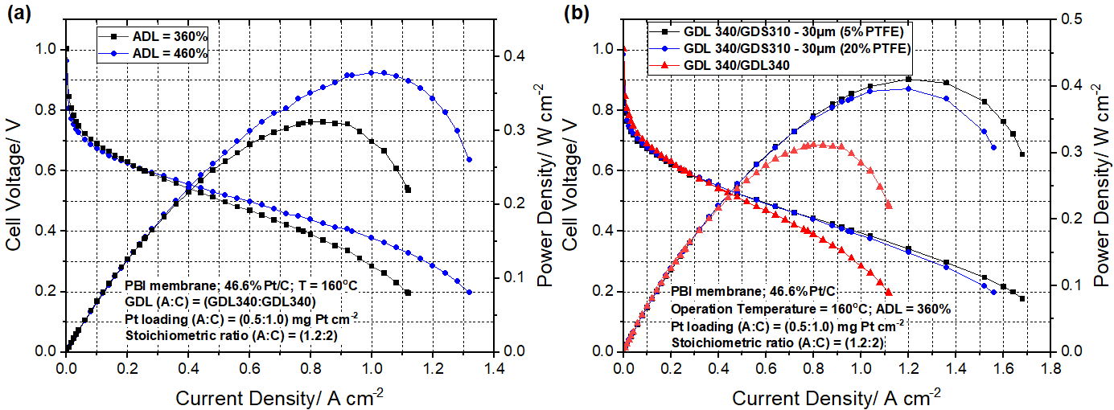

**Fig. 2** Polarization curves under various (a) acid doping levels (ADL)   
and (b) Gas diffusion electrode (GDE)

* 1. The effect of the gas diffusion layer with different PTFE content

The polarization curves under various compositions of cathode gas diffusion electrode (GDE) – GDL340, GDS310 (5% PTFE), and GDS310 (20% PTFE) were observed in Fig. 2(b). In the study, the GDL340 was used as GDE at the anode side for all case studies, and the H2 and air were supplied at the stoichiometric ratio of 1.2 and 2, respectively. The results found that when the GDS310 was used as GDE on the cathode side, the cell performance was significantly higher than GDL340. Because the MPL on GDS310 was composed of PTFE, which had a hydrophobic property and high gas permeability, resulting in the case of GDS310 with PTFE had higher performance than GDL340. Moreover, the cell performance tended to decrease with increasing the content of PTFE. When the cell voltage reached 0.4 V, the current density was 0.766, 0.960, and 0.948 A·cm–2 under three cases. Furthermore, the maximum power density under three cases was 0.312, 0.410, and 0.396 W·cm–2, respectively. Meanwhile, when compared with GDL340, the performance in the case of GDS310 can be enhanced by approximately 31% and 27% under 5 and 20% PTFE, respectively.

1. Conclusion

In this study, the HT–PEMFCs performance under various operation temperatures, the air stoichiometric ratios, the gas diffusion layer with different PTFE contents, and the acid doping levels were investigated by polarization curves. As a result, the cell performance can be enhanced by increasing the operating temperature and the acid doping level (ADL) because of decreasing the ohmic resistance and, consequently high performance. However, the cell performance of HT–PEMFCs also increased with increasing the air stoichiometric ratio. Due to higher chemical reactions inside the cell, leading to higher performance. In addition, the MEA with GDS310 reached the maximum power density up to 0.410 and 0.396 W·cm–2, which can be enhanced by approximately 31% and 27% under 5 and 20% PTFE, respectively.

References

1. Shimpalee, S., Van Zee, J.W., Numerical studies on rib & channel dimension of flow-field on PEMFC performance. International Journal of Hydrogen Energy 32(7), 842-856 (2007).
2. Prykhodko, Y., Fatyeyeva, K., Hespel, L., Marais, S., Progress in hybrid composite Nafion®-based membranes for proton exchange fuel cell application. Chemical Engineering Journal 409(1), 27329 (2021).
3. Shahgaldi, S., Ozden, A., Li, X., Hamdullahpur, F., A scaled-up proton exchange membrane fuel cell with enhanced performance and durability. Applied Energy 268, 114956 (2020).
4. Chen, C.-Y., Huang, K.-P., Experimental characterization of high-temperature proton exchange membrane fuel cells under CO- and methane-containing hydrogen-rich gases. Journal of Applied Electrochemistry 48(8), 911-921 (2018).
5. Rosli, R.E., Sulong, A.B., Daud, W.R.W., Zulkifley, M.A., Husaini, T., Rosli, M.I., Majlan, E.H., Haque, M.A., A review of high-temperature proton exchange membrane fuel cell (HT-PEMFC) system. International Journal of Hydrogen Energy 42(14), 9293-9314 (2017).
6. Aili, D., Henkensmeier, D., Martin, S., Singh, B., Hu, Y., Jensen, J.O., Cleemann, L.N., Li, Q., Polybenzimidazole-Based High-Temperature Polymer Electrolyte Membrane Fuel Cells: New Insights and Recent Progress. Electrochemical Energy Reviews 3(4), 793-845 (2020).
7. Barreras, F., Lozano, A., Roda, V., Barroso, J., Martín, J., Optimal design and operational tests of a high-temperature PEM fuel cell for a combined heat and power unit. International Journal of Hydrogen Energy 39(10), 5388-5398 (2014).
8. Wang, Y.-X., Xuan, D.-J., Kim, Y.-B., Design and experimental implementation of time delay control for air supply in a polymer electrolyte membrane fuel cell system. International Journal of Hydrogen Energy 38(30), 13381-13392 (2013).
9. Peighambardoust, S.J., Rowshanzamir, S., Amjadi, M., Review of the proton exchange membranes for fuel cell applications. International Journal of Hydrogen Energy 35(17), 9349-9384 (2010).
10. Chen, Y., Azizi, K., Zhang, W., Aili, D., Primdahl, S., Cleemann, L.N., Hjuler, H.A., Li, Q., Feasibility of using thin polybenzimidazole electrolytes in high-temperature proton exchange membrane fuel cells. International Journal of Hydrogen Energy 47(66), 28615-28625 (2022).
11. Oono, Y., Fukuda, T., Sounai, A., Hori, M., Influence of operating temperature on cell performance and endurance of high temperature proton exchange membrane fuel cells. Journal of Power Sources 195(4), 1007-1014 (2010).
12. Ryu, S.K., Vinothkannan, M., Kim, A.R., Yoo, D.J., Effect of type and stoichiometry of fuels on performance of polybenzimidazole-based proton exchange membrane fuel cells operating at the temperature range of 120–160 °C. Energy 238, 121791 (2022).
13. Sasiwimonrit, K., Chang, W.C., The influences of catalyst combination on the high temperature proton exchange membrane fuel cell. Journal of Physics: Conference Series 1198(3), 032014 (2019).
14. Martin, S., Jensen, J.O., Li, Q., Garcia-Ybarra, P.L., Castillo, J.L., Feasibility of ultra-low Pt loading electrodes for high temperature proton exchange membrane fuel cells based in phosphoric acid-doped membrane. International Journal of Hydrogen Energy 44(52), 28273-28282 (2019).
15. Tang, H., Geng, K., Aili, D., Ju, Q., Pan, J., Chao, G., Yin, X., Guo, X., Li, Q., Li, N., Low Pt loading for high-performance fuel cell electrodes enabled by hydrogen-bonding microporous polymer binders. Nature Communications 13(1), 7577 (2022).
16. Chao, G., Tang, H., Ju, Q., Li, N., Geng, K., Fluorinated polybenzimidazole as binders for high-temperature proton exchange membrane fuel cells. Journal of Power Sources 556, 232473 (2023).
17. Kang, R.-J., Chen, Y.-S., Experimental Study on the Effect of Hydrogen Sulfide on High-Temperature Proton Exchange Membrane Fuel Cells by Using Electrochemical Impedance Spectroscopy. Catalysts 8(10), (2018).
18. Liu, H., Hu, Z., Li, J., Xu, L., Shao, Y., Ouyang, M., Investigation on the optimal GDL thickness design for PEMFCs considering channel/rib geometry matching and operating conditions. Energy 282, 128780 (2023).
19. Saeidfar, A., Yesilyurt, S., Numerical investigation of the effects of catalyst layer composition and channel to rib width ratios for low platinum loaded PEMFCs. Applied Energy 339, 121040 (2023).