Readiness Analysis for Implementing Green Diesel as Sustainable Aviation Fuels in Indonesia
Jeesica Hermayanti Pratama¹, Evtriyandani², Zeni Rahmawati¹, Hamzah Fansuri¹
¹ Department of Chemistry, Faculty of Science and Data Analytics, Sepuluh Nopember Institute of Technology, Surabaya, Indonesia
² Department of Environmental Engineering, Faculty of Civil, Planning and Geo-Engineering, Sepuluh Nopember Institute of Technology, Surabaya, Indonesia
lncs@springer.com
Abstract. The expanding commercialization of the aviation industry has led to a rising demand for aviation fuel. This increasing demand for fossil fuels is concerning due to the dwindling availability of crude oil and escalating environmental impacts. As a response, alternative fuels are being developed, particularly environmentally sustainable and renewable biofuels. One promising avenue is the transformation of biodiesel into green diesel, which has an alkane chemical composition similar to fossil fuel. This conversion can improve fuel quality and address several issues associated with biodiesel, such as low energy content and incomplete combustion due to high oxygen content. Indonesia has begun implementing green diesel applications to enhance biodiesel quality, despite the policy being in place since 2013. Sustainable aviation fuels (SAF) are essential for achieving zero-carbon aviation by 2050, necessitating significant reforms to expedite their adoption. By leveraging its position as the top global palm oil producer, Indonesia has the potential to spearhead green diesel implementation as SAF in the region, through enhanced economic tools and increased inter-regional partnerships for international integration, although further initiatives are required. This paper evaluates Indonesia's readiness to adopt drop-in SAF from palm oil biodiesel.
Keywords: Green Diesel, Sustainable Aviation Fuel, Renewable Energy.
- Introduction
The escalating demand for aviation fuel is driven by the expanding commercialization of the aviation industry. As per the Global Outlook for Air Transport [1], the airline's fuel expenses in 2021 increased by approximately 30% as a result of the easing of travel restrictions and the initial recovery in global passenger demand. Aviation fuel is a significant cost for an airline, typically accounting for 20-25% of the total expenses. The proportion of overall expenses in 2022 is significantly higher than in 2021 as a result of the commencement of the Russia-Ukraine conflict, which led to a substantial surge in worldwide oil prices. As of June 2, 2022, the price of Brent crude oil stood at USD120 per barrel. An noteworthy feature of the fuel market this year is the substantial disparity in prices between crude oil and jet fuel. Presently, the increased fuel costs do not seem to be affecting individuals' inclination to travel. Nevertheless, once consumers have adjusted for their decreased travel, the diminished responsiveness of demand to price may decline in 2023, posing a challenge for airlines to manage the rise in fuel prices relative to demand in the upcoming year. Therefore, utilizing the more cost-effective aviation fuel will prove highly advantageous.
Air transportation necessitates the use of drop-in fuel that possesses a chemical structure compatible with the aircraft's built-in engine. Sustainable aviation fuel (SAF) or bio-jet fuel (bioavtur) can potentially decrease CO₂ emissions by 55% to 92%. SAF compability can substitute traditional kerosene in aircraft and fuel systems without requiring any adjustments [2]. Green diesel, classified as a second-generation biofuel, can be further processed to meet the stringent standards for aviation use, making it a potential feedstock for SAF production. Green diesel can be produced by upgrading biodiesel, the first-generation biofuel also known as fatty acid methyl ester (FAME) [3]. Green diesel can be produced by upgrading biodiesel, a first-generation biofuel commonly referred to as fatty acid methyl ester (FAME). Biodiesel, however, presents several limitations, including low thermal and oxidative stability due to its high oxygen content, reduced energy content, and the risk of carbon buildup in engines. Additionally, it is prone to degradation during storage. Converting biodiesel into green diesel enhances fuel quality and brings it closer to meeting SAF performance standards.
Extensive research has been conducted to support green diesel as an alternative biofuel, focusing on catalyst development, the use of highly variable feedstocks, and the conversion of biodiesel into green diesel. However, Indonesia's readiness to implement green diesel production technology and its application in SAF still requires further study. Therefore, this article was aimed to analyze Indonesia's readiness to implement green diesel in accordance with regulations and environmental ethics.
- Materials and Methods
This article reviews literature data acquired from the Scopus database (https://www.scopus.com/) due to its high-quality criteria of indexation inclusivity. The Scopus database is known for its comprehensive collection of interdisciplinary academic papers sourced from reputable scientific journals. The database encompasses a diverse array of scientific disciplines, positioning it as a prominent repository for citations and abstracts. To analyze the regulatory frameworks, this article summarizes published national press release, report, news, and government policy.
- Results and Discussion
  - Green Diesel Properties
Green diesel consists of a mixture of straight and branched chain-saturated hydrocarbons that typically contain 15 to 18 carbon atoms per molecule (C15 to C18). The composition resembling petroleum diesel allows the use of green diesel in compression ignition engines in pure form or as a mixture with the desired mixing ratio without the need for engine modifications. The suitability characteristics of green diesel as a fuel have met standards based on ASTM D-97, ASTMD-973, ASTM D-1298, and ASTM D4294–03, regarding flash point, energy content, cetane number, viscosity, density, and oxygen, sulfur and water content [4]. Green diesel also has good performance in reducing fuel consumption and NO_{x} emissions [5]. Green diesel has a higher cetane number above 70 compared to biodiesel so it can operate with higher thermal efficiency and lower fuel consumption. Using green diesel as a SAF has numerous benefits as it can also help to reduce the environmental impact of the aviation industry (Fig. 1). By 2050, biofuels are expected to reduce CO₂ emissions from the aviation industry by more than 50%.
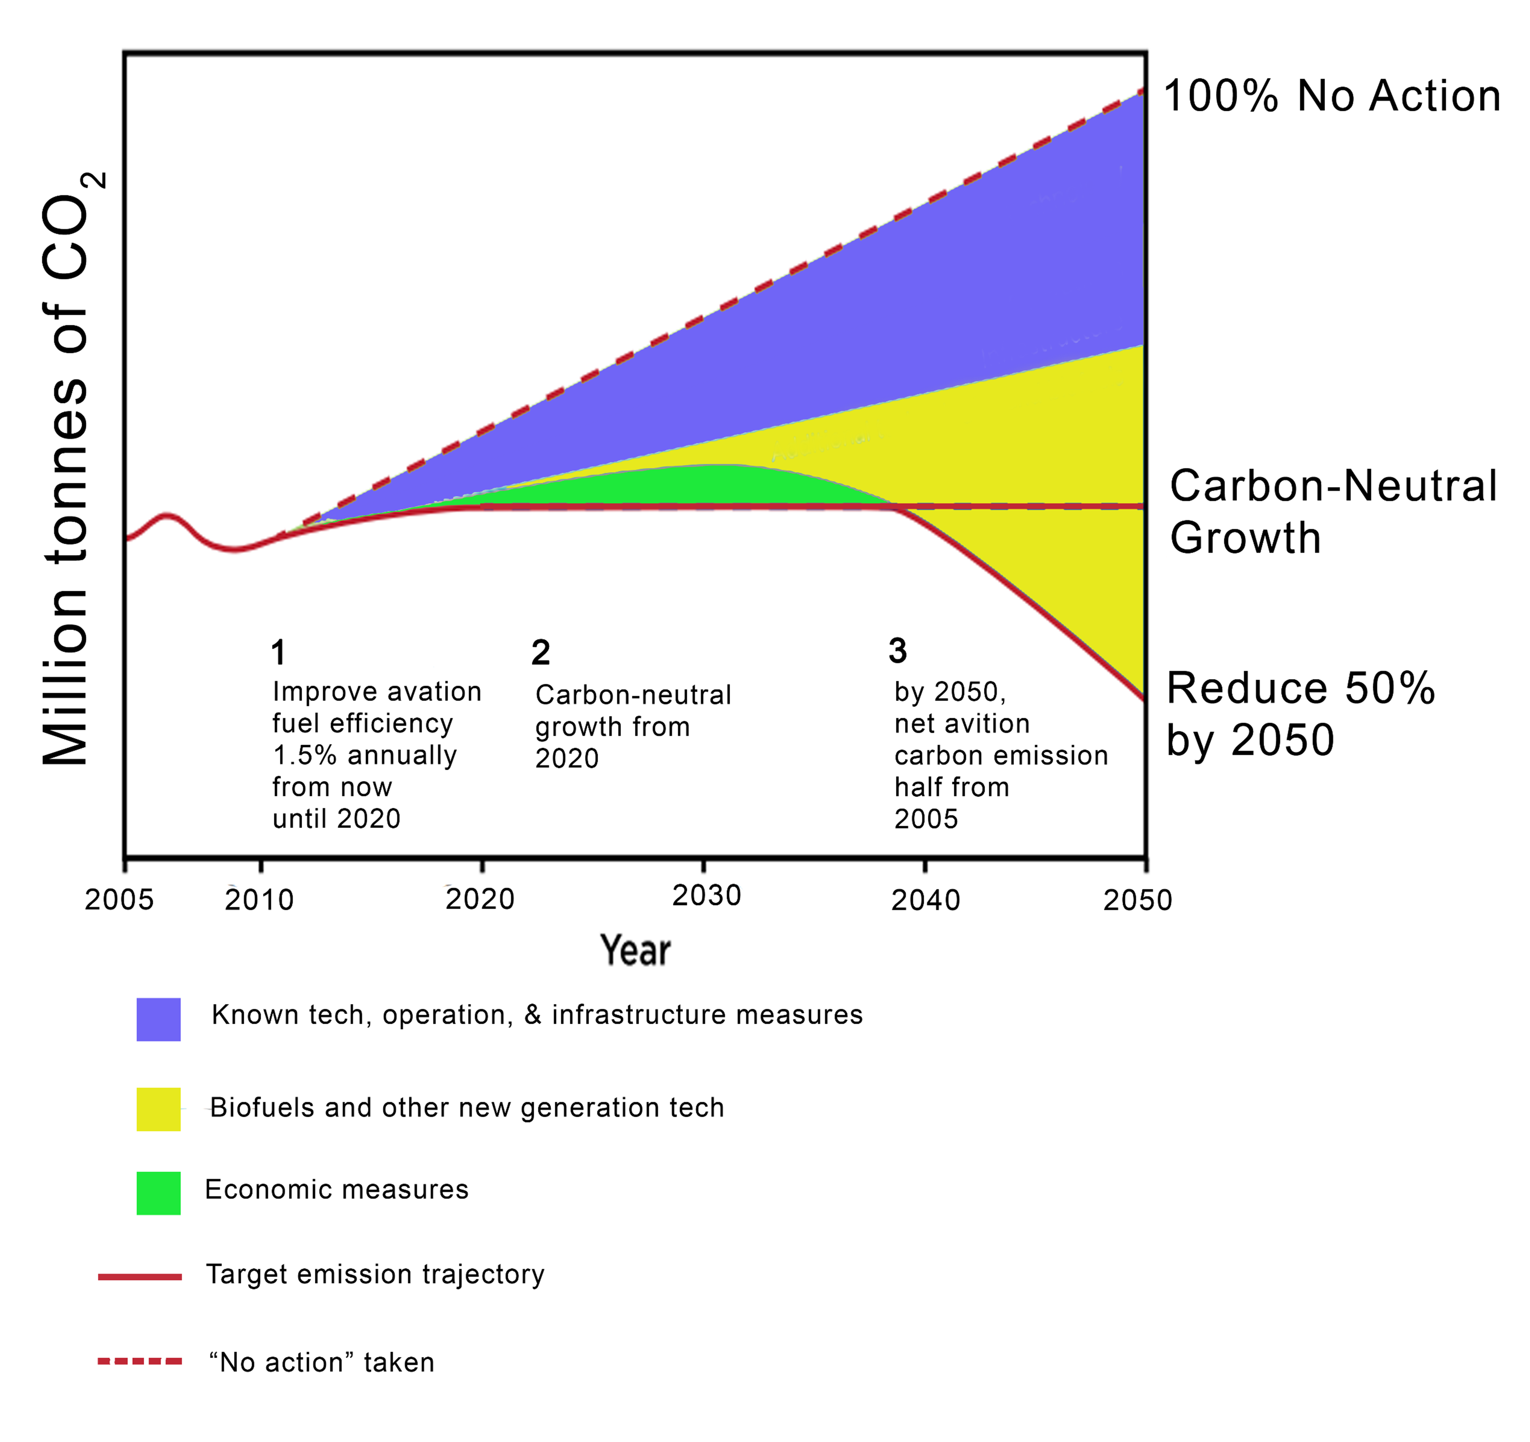
Fig. 1. CO₂ emission potential from aviation industry. Modified from Qaseem et al. [6]

  - Feedstock Availability
The physical and chemical characteristics of biodiesel can vary according to the raw materials that used. Palm oil has good oxidation stability compared to oils from other feedstocks [7]. It has almost the same amount of saturated and unsaturated fatty acids. Palm oil is composed of monoalkyl esters of long-chain fatty acids, primarily containing 17-19 carbon atoms, that can be transformed into biodiesel using a catalytic method. According to Li et al. [3], palm oil biodiesel content mainly consists of 17.42% methyl palmitate; 73.54% methyl oleate; and 7.26% methyl stearate. Palm oil biodiesel shows great potential as a viable alternative to diesel fuel.
As a major export commodity in Indonesia, palm oil ensures a stable supply of feedstock for biodiesel production. Palm oil is primarily used for food products (16.4%), oleochemicals (33.3%), biodiesel (14.1%), and exports (66.2%) in the country. Approximately 5 million tons of palm oil are available as a significant source for sustainable biodiesel production. Indonesia's production of palm oil biodiesel surged from 190 thousand kL in 2009 to nearly 8.4 million kL in 2019 [8]. Along with the government's strong commitment to creating an ecosystem climate conducive to the development of Indonesia's biodiesel industry, this has resulted in an increase in the biodiesel industry (also known as the biofuel business entity), both in terms of the number of companies and production capacity. Fig. 2 displays the mapping of biodiesel producers in Indonesia. The rise in biodiesel production aligns with the Ministry of Energy and Mineral Resources' goal for the B-35 application target [9].
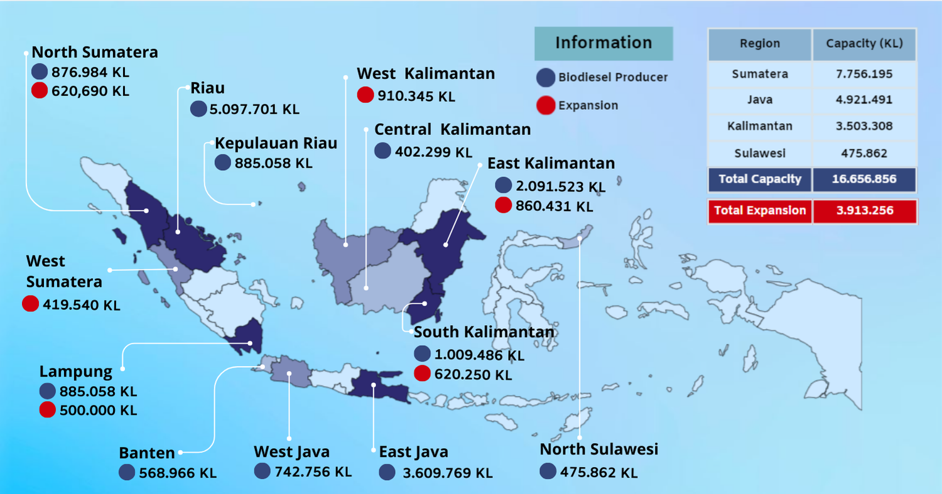
Fig. 2. Distribution capacity of biodiesel producers in Indonesia until 2022. Adapted data from APROBI (Indonesia Biofuel Producer Association)

  - Technological Feasibility and Production Process
Generally, green diesel can be produced from vegetable oil through a deoxygenation (DO) reaction using a metal catalyst. The difficulty in determining the reaction stages and conditions of the DO reaction of vegetable oils is a factor in the massive development of fatty acid and fatty acid methyl ester (biodiesel) based feedstocks for green diesel production [5]. Several reaction pathways can involve simultaneously or individually in DO reaction, including hydrodeoxygenation (HDO), decarboxylation (DCO₂), and decarbonylation (DCO) [10]. The deoxygenation reaction is a thermal process of alkane production through the removal of hydrogen, oxygen and carbon atoms from fatty biomass by releasing CO₂, CO and H₂O. The involvement of the three different pathways in a deoxygenation reaction is strongly influenced by the catalyst and reaction conditions. The DO process employs a solid phase heterogeneous catalyst, which comprises an active phase deposited on a catalytic support material. The catalytic properties are influenced by the selection of the support and active phase, as well as the chemical interactions between the catalyst and the reagents and products. Nevertheless, when choosing the catalyst type, additional factors such as the ability to regenerate, the associated costs of regeneration, and the level of toxicity are also given due consideration [11]. Srifa et al. [12] reported that Co and Ni are the most effective catalysts for producing green diesel from palm oil. The proposed mechanism for this process can be seen in Fig. 3 revealing that stearic acid, octadecanol, octadecyl stearate, and stearyl oleate are oxygenated intermediates that result from the DO reaction. The proposed reaction mechanism involves the initial hydrogenation of double bonds in unsaturated triglycerides to saturated ones, followed by hydrogenolysis to form fatty acids and propane. The fatty acid undergoes DO at the metal catalyst site through DCO and HDO reaction pathways.
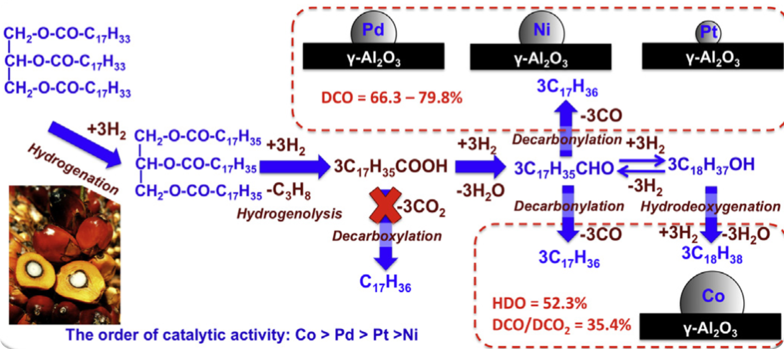
Fig. 3. Mechanism of palm oil deoxygenation reaction with Pd, Ni, Pt, or Co catalysts [12], reproduced with permission from Elsevier

Green diesel research is still ongoing, particularly to target it as a bio-jet. From 1993 to 2022, there were 4294 publications (articles, proceeding paper, and review articles) with keywords of green diesel OR deoxygenation AND catalyst AND biojet AND biofuel. The term green diesel was continuously mentioned with particular trend as illustrated in Fig. 4. The annual number of green diesel article significantly improved anually. Indonesia can pursue further advancements in acquiring sufficient biojet fuel due to the abundance of publications pertaining to green diesel research. Furthermore, the presence of abundant raw materials offers significant research opportunities for acquiring appropriate catalysts and reaction conditions when implemented on a large-scale industrial level.
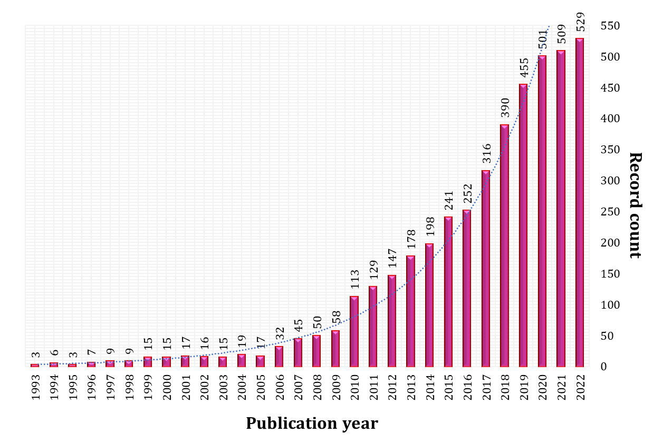
Fig. 4. Annual publications of the selected keywords from 1993 to 2022
(Source: Authors’ classification based on Scopus database)

  - Regulatory Framework and Development Progress in Indonesia
The international aviation sector, guided by the International Civil Aviation Organization (ICAO), has set ambitious goals to enhance fuel efficiency by 2% annually until 2050 and achieve carbon-neutral growth from 2020. In line with these global efforts, Indonesia is pushing for a new and renewable energy (NRE) mix target of 23% by 2025, with biofuels playing a crucial role. After the success of the B30 biodiesel program in land transportation, Indonesia has extended biofuel testing to the aviation sector.
A significant milestone was achieved in 2012 when Pertamina Research & Technology Innovation, in collaboration with the Center for Catalysis Engineering at the Bandung Institute of Technology, developed the Merah-Putih catalyst. This catalyst enabled the conversion of palm kernel oil into bioavtur feedstock. This innovation was further scaled up through a partnership with PT Kilang Pertamina Internasional, conducting industrial-scale production tests at the Cilacap Refinery. These tests successfully produced 2.4%-v bioavtur, known as J2.4, by co-processing Refined, Bleached, and Deodorized Palm Kernel Oil (RBDPKO) with kerosene using the Merah-Putih catalyst. In 2021, J2.4 bioavtur proved its superior performance in CN235-220 aircraft tests.
The Ministry of Energy and Mineral Resources Regulation No. 12 in 2015 mandates the blending of biofuels into aviation fuel, starting with 3% bioavtur by 2020, increasing to 5% by 2025. This regulation aligns with Sustainable Development Goals (SDGs) 7 and 13, which focus on ensuring access to affordable, reliable, and modern clean energy. To achieve these targets, the economic viability of J2.4 bioavtur must be supported through various government incentives, including tax benefits like super tax deductions for research and non-fiscal support. With Indonesia's estimated daily aviation fuel consumption of 14,000 kiloliters, the market potential for J2.4 bioavtur is projected to reach approximately 1.1 trillion rupiahs annually. This presents a significant opportunity for the growth of the national palm oil industry.
Indonesia has reached an important stage in the technological readiness to use green diesel as a sustainable aviation fuel. However, the success of future efforts will require the continued support of all stakeholders during the next phases of testing and commercialization. Establishing a robust aviation biofuel industry will depend on effective collaboration between the government, research institutions, bioavtur producers, and the aviation sector to bring the product to market successfully.
- Conclusions
Green diesel as a sustainable aviation fuel (SAF) presents a highly promising alternative to conventional fossil fuels in the aviation sector. The production methods, materials used, and positive environmental impact make it a viable choice for reducing greenhouse gas emissions and improving air quality. The Indonesian government plays a pivotal role in fostering the development of SAF in the country. Indonesia has implemented a command-and-control strategy by imposing a mandatory requirement for blending SAF. However, it is important to note that there are currently no commercial flights in Indonesia that utilize bio-jet fuels in their daily operations. The government demonstrates its support through initiatives such as its participation in the pilot phase of the carbon offsetting reduction scheme for international aviation and the proposed establishment of a domestic carbon market known as the archipelagic carbon scheme. The development of SAF in Indonesia is driven by ongoing government policies and global support. Apart from challenges such as the limited existing research facilities, complex certification processes, low public awareness, and the need to develop catalyst performance, Indonesia has successfully achieved initial technological readiness by obtain D-100 and J2.4. The national project continues to advance green diesel for SAF implementation, with a target of achieving J5.0 by 2025. This ongoing development underscores the critical need for continued research, collaboration, and innovation to realize the full potential of green diesel in aviation, paving the way for a sustainable future.

Acknowledgement
The first author gratefully acknowledge the Indonesian Endowment Fund for Education/Lembaga Pengelola Dana Pendidikan (LPDP), Ministry of Finance Indonesia for providing the financial support/studentship (Jeesica Hermayanti Pratama).

References
1. IATA: Global Outlook for Air Transport, https://www.iata.org/en/iata-repository/publications/economic-reports/global-outlook-for-air-transport---december-2022---presentation/, last accessed 2024/07/16.
2. Song, M., Zhang, X., Chen, Y., Zhang, Q., Chen, L., Liu, J., Ma, L.: Hydroprocessing of lipids: An effective production process for sustainable aviation fuel, (2023).
3. Li, X., Wu, Y., Wang, Q., Li, S., Ye, Y., Wang, D., Zheng, Z.: Effect of preparation method of NiMo/γ-Al₂O₃ on the FAME hydrotreatment to produce C15–C18 alkanes. Renew. Energy. 193, 1–12 (2022).
4. Zafeiropoulos, J., Petropoulos, G., Kordouli, E., Kordulis, C., Lycourghiotis, A., Bourikas, K.: Development of nickel catalysts supported on silica for green diesel production. Catal. Today. 423, 113952 (2023).
5. Mahdi, H.I., Bazargan, A., McKay, G., Azelee, N.I.W., Meili, L.: Catalytic deoxygenation of palm oil and its residue in green diesel production: A current technological review. Chem. Eng. Res. Des. 174, 158–187 (2021).
6. Qasem, N.A.A., Mourad, A., Abderrahmane, A., Said, Z., Younis, O., Guedri, K., Kolsi, L.: A recent review of aviation fuels and sustainable aviation fuels. J. Therm. Anal. Calorim. (2024).
7. Sakthivel, R., Ramesh, K., Purnachandran, R., Mohamed Shameer, P.: A review on the properties, performance and emission aspects of the third generation biodiesels. Renew. Sustain. Energy Rev. 82, 2970–2992 (2018).
8. Farobie, O., Hartulistiyoso, E.: Palm Oil Biodiesel as a Renewable Energy Resource in Indonesia: Current Status and Challenges. BioEnergy Res. 15, 93–111 (2022).
9. Sipayung, T.: Biodiesel Indonesia: Produksi, Konsumsi dan Ekspor (2023), https://palmoilina.asia/sawit-hub/biodiesel-indonesia/, last acessed 2024/07/30.
10. Rahmawati, Z., Santoso, L., McCue, A., Azua Jamari, N.L., Ninglasari, S.Y., Gunawan, T., Fansuri, H.: Selectivity of reaction pathways for green diesel production towards biojet fuel applications, (2023).
11. Hafriz, R.S.R.M., Nor Shafizah, I., Arifin, N.A., Maisarah, A.H., Salmiaton, A., Shamsuddin, A.H.: Comparative, reusability and regeneration study of potassium oxide-based catalyst in deoxygenation reaction of WCO. Energy Convers. Manag. X. 13, (2022).
12. Srifa, A., Faungnawakij, K., Itthibenchapong, V., Assabumrungrat, S.: Roles of monometallic catalysts in hydrodeoxygenation of palm oil to green diesel. Chem. Eng. J. 278, 249–258 (2015).

