**Functional Groups Analysis and Optical Properties of Oyster Mushroom’s Mycelium Using Sorghum Media with FTIR Spectrophotometer**

Nazopatul Patonah Har1, Lusia Anita Br. Sagala1, Irzaman1

*1Department of Physics, Faculty of Mathematics and Natural Sciences, IPB University, Bogor, Indonesia*

**ABSTRACT**

The successful establishment of oyster mushroom seeds depends on Potato Dextrose Agar (PDA). In this study,the sterilization level of media varied from level 1 to 3. For each sterilization level, PDA were steamed at 102 0C for 60 minutes. The best result was found at the third level which was shown by growing of mycelium. All of spread seeds (F1) produced were good and not contaminated. The result of growing spread seeds by using sorghum media were not contaminated. The characterization result of FTIR mycelium from pure culture (F0), spread seeds (F1), and planting seeds (F2) indicated the stretching vibration. Stretching vibration showed of several functional groups. They were C-O, C-N, C=O, C-H, O-H, and β-D-glukan. These results suggest that the energy required for mycelium growth in the spread seedling culture media is smaller than that required for planting seedling culture media. This is following the relationship between photon energy which is directly proportional to the wave number.

**Keywords:** FTIR, functional groups, mycelium, sorghum media, Optical properties

1. **INTRODUCTION**

The low purchasing power of the Indonesian people has caused a lack of consumption of high-protein animal foods. So that the need for vegetable protein becomes an alternative choice to meet the body's protein needs. One alternative to replace high-protein food sources is oyster mushrooms (*Pleorotus ostreatus*) [1]. The protein content in oyster mushrooms is quite high, which is around 10.5-30.4% per 100 grams of oyster mushroom weight [2]. The protein content in mushrooms is higher than other foods that also come from plants, namely mushroom protein which has twice the amount of protein than asparagus and potatoes, four times higher than carrots and tomatoes and six times higher than oranges [3]. In addition to containing protein, oyster mushrooms also contain the minerals K, P, Ca, Na, Mg, and Cu.

The nutritional content of oyster mushrooms provides potential for farmers to start oyster mushroom cultivation businesses. The prospects for developing oyster mushroom cultivation in Indonesia are very potential, because the climate and weather in Indonesia are suitable for the growth of oyster mushrooms. Although the climate and weather are suitable, farmers still experience many problems in producing good mushroom lips that are free from contamination. Perseverance and sterile conditions are needed in making good oyster mushroom seeds, and this is considered difficult by farmers, so many farmers prefer to buy seeds at the market rather than making them themselves. This is an obstacle for small farmers, because the price of seeds sold in the market is in the expensive category and adds to their spending budget.

Good oyster mushroom seeds are oyster mushroom seeds produced from pure tissue culture and are free from environmental contamination. Sterilization of Potato Dextrose Agar (PDA) culture media for 60 minutes with three levels of sterilization in this study is expected to minimize contamination in tissue culture media. Sorghum as a growing medium for scattered seeds and planted seeds is used to see the difference in the growth process of mushroom seeds with other growing media. FTIR characterization was carried out to see the content of functional groups and molecular bonds in the mycelium of pure seeds (F0), scattered seeds (F1), and planted seeds (F2). This study aims to observe the effect of sterilization levels in the manufacture of Potato Dextrose Agar (PDA) media, to study the functional groups and optical properties of samples based on the transversal optic (TO) and longitudinal optic (LO) values ​​obtained from the results of the analysis using FTIR.

1. **EXPERIMENTAL METHOD**

The main materials used in this study were white oyster mushrooms, potatoes, agar, dextrose, cloran penicolt, distilled water, sorghum, bran, agricultural lime, and sawdust. The stages of this study include the stages of making white oyster mushroom seeds and FTIR characterization of mycelium molecular bonds.

* 1. **Making Oyster Mushroom Seeds**

The stages of making oyster mushroom seeds begin with making Potato Dextrose Agar (PDA) with 200 grams of potatoes, 20 grams of white sugar (dextrose), white agar, phenicolt capsules and distilled water. Clean potatoes are cut into pieces and boiled with distilled water for 15 minutes and left to stand until yellowish boiled water is obtained. The water is filtered and distilled water is added to the volume of 1 liter. Dextrose and agar are added to the boiled water until dissolved, then phenicolt capsules are also added to the boiled solution and stirred until evenly distributed. The solution is put into an Erlenmeyer flask and left for 1 hour (sterilization is carried out with 3 levels of variation). PDA is left for 2 days in a sterilization box. The next stage is isolation with tissue culture. This process begins with preparing healthy and good mushroom fruit bodies, preparing the mother mushroom aseptically. The mushroom fruit body is taken using sterilized tweezers, then planted in a test tube containing media that has been left for two days. All treatments are carried out near a fire from a burning bunsen. Incubate the media that has been planted with mushrooms for 4 days. The incubation results are considered successful if white mushroom mycelium grows around the explant and will be evenly distributed after two weeks. Pure cultures are ready to be used to make parent seeds.

The next stage is making spread seeds, this stage is formed from 1 kg of sorghum, 40 grams of dextrose, and 100 grams of sawdust. All ingredients are mixed and put into a bottle. Furthermore, the material is sterilized by steaming for 1 hour at a temperature of 100-1200C. The next is the inoculation process with mushroom subculture. Inoculation is considered successful if the mushroom seeds grow within 2-3 weeks.

The last stage is making planting seeds, which consist of sawdust, bran, corn flour, agricultural lime, dextrose and clean water. All the ingredients are mixed in a plastic container and composted for 24 hours. After that, the ingredients are inoculated with scattered seeds and incubated for 3-4 weeks at room temperature.

* 1. **Characterization using Fourier Transform Infrared Spectroscopy (FTIR)**

The FTIR characterization results provide information on the phenomenon of symmetrical stretching vibration (stretching harmonic vibration) and asymmetrical stretching vibration (stretching anharmonic vibration). These phenomena include the values ​​of vibration wave numbers, anharmonic constants and molecular bond force constants. The characterized mushroom mycelium comes from mycelium in pure culture media (F0), spread seeds (F1), and planted seeds (F2). In addition, based on FTIR data, the optical properties of the sauce can also be studied. These optical properties consist of Longitudinal Optical (LO) and Transversal Optical (TO) values ​​obtained by several processes [4-6]:

The data obtained from measurements using FTIR are in the form of wavelength and transmittance values.

1. The transmittance value is converted to the reflectance value R using the following equation:

|  |
| --- |
| $A (ω) = 2 – log[T(ω)\%]$ (1) |
| $R (ω) = 100 – [T(ω) + A(ω)]$ (2) |

1. Next, the wavelength and reflectance value data are processed using ms. Excel.
2. The reflectance value R is used to obtain the refractive index value which consists of the real refractive index and imaginary refractive index using the equation (3) and (4).

$n\left(ω\right)=\frac{1-R(ω)}{1+R\left(ω\right)-2cosφ(ω)\sqrt{R(ω)}}$ (3)

$k\left(ω\right)=\frac{2sinφ(ω)\sqrt{R(ω)}}{1+R\left(ω\right)-2cosφ(ω)\sqrt{R(ω)}}$ (4)

1. Before obtaining the refractive index value, the equation in step 4 is divided as in the following image. This aims to make data processing easier using Excel

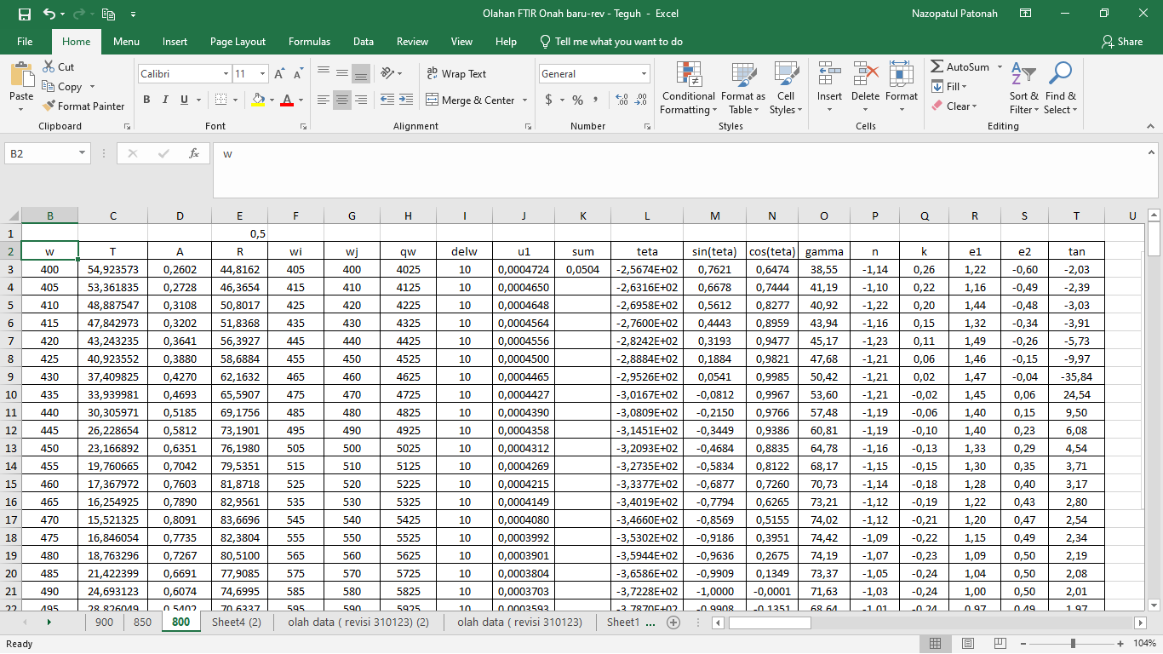

1. The most important part of processing this data is that it is necessary to input part of the wave number series and divide it into two, namely column F is the wave number column with an odd series order and column G is the even wave number series column.
2. The next step to obtain the refractive index values n and k requires the value φ(ω). This value is calculated using the following equation which is called the simplified KK relation equation (5)

|  |  |
| --- | --- |
| $$φ\left(ω_{j}\right)= -\frac{{4ω}_{j}}{π}∆ω \sum_{i}{\frac{\ln{(\sqrt{R(ω)}}}{ω_{i}^{2}- ω_{j}^{2}}}$$ | (5) |

where $∆ω=ω_{i+1}-ω_{i}$, and if *j* is an odd number then *i =* 2, 4, 6, …, *j – 1, j+1*,… whereas if *j* is an even number *i* = 1, 3, 5, …, *j – 1, j+1*,…

1. Furthermore, from the value of φ(ω) the values of n and k will be obtained.
2. **RESULT AND DISCUSSIONS**
3. **Potato Dextrose Agar (PDA)**

The success of oyster mushroom cultivation is highly dependent on the seeds used. In producing pure cultures (F0), good, nutritious, and contamination-free growing media are needed. The media used as a place for the growth of pure cultures is Potato Dextrose Agar (PDA). In this study, variations in sterilization levels were carried out to produce good PDA media, namely sterilization level 1, level 2, and level 3. Sterilization level 1, PDA is steamed in a steamer for 60 minutes and PDA is ready to use. While level 2, PDA is steamed in a steamer for 60 minutes after being left for 24 hours in a sterilization box. Sterilization level 3, PDA that has been steamed for the second time is left again for 24 hours, then steamed again. The measured temperature of each sterilization level is the same, which is at a temperature of 102 0C. The measured temperature of the three sterilization level treatments is 102 0C as shown in Table 1.

**Table 1.** Sterilization Level Treatment of PDA

|  |  |  |  |  |
| --- | --- | --- | --- | --- |
| Boiling time of potatoes | Sterilization level | | | Temperature (oC) |
| Level1 | Level 2 | Level 3 |
| 15 minutes | 60 | 60 | 60 | 102 |
| - | 60 | 60 | 102 |
| - | - | 60 | 102 |

1. **Pure Breed (F0)**

Pure tissue culture from fresh white mushroom fruit bodies was planted on PDA media that had been successfully formed. Pure tissue culture was carried out with the same treatment for all PDAs. Table 2 shows that oyster mushroom tissue culture was not all successful. Five repetitions have been carried out for each level of sterilization. Sterilization level 3 successfully produced good white oyster mushroom mycelium as indicated by the presence of mycelium threads that filled the test tube. Sterilization level 3 successfully produced the best pure culture because the PDA was sterilized three times (3 levels) for 60 minutes which killed the microbes in the PDA due to the influence of long steaming (heating). The longer the level of sterilization (heating), the greater the amount of heat received. According to Black's principle, the greater the amount of heat received will be directly proportional to the large temperature change. The higher the temperature, the more microbes will die, thus minimizing the failure of pure culture. Sterilization levels 2 and 1 are less than optimal sterilization due to the short sterilization time so that there are still microbes contained in the PDA. The presence of microbes contained in PDA supports microbial growth during inoculation of pure cultures, making it less successful in producing good pure cultures.

**Table 2.** Isolation Success Data (Tissue Culture) for Pure Culture (F0)

|  |  |  |  |
| --- | --- | --- | --- |
| Repetition of- | Sterilization level | | |
| Level1 | Level 2 | Level 3 |
| 1 |  |  |  |
| 2 |  |  |  |
| 3 |  |  |  |
| 4 | - | - |  |
| 5 | - | - | - |

Description:

* : isolation successful
* : isolation contaminated

After isolation, the tube containing mycelium is stored in a container with an optimum temperature for mycelium growth, which is around room temperature (25-29 0C) [7]. The higher the temperature of the container used, the greater the heat distributed by the container to the tubes containing mycelium. If the temperature used exceeds the room temperature range, the mycelium will be damaged, while if the temperature used is less than the room temperature range, the mycelium will not grow perfectly.

1. **Spread Culture (F1)**

The mycelium that has grown in the tube is cultured again into its second medium, namely sorghum media with a mixture of dextrose and sawdust. The results of this culture are called spread seedlings (F1). Mycelium in one test tube can produce seedlings for 3 three bottles of spread seedlings. F1 is declared successful if after about 3 weeks or 4 weeks, the bottle has been fully covered with fine threads or white mycelium. In this study, three repetitions were carried out for each level of sterilization with a total of nine repetitions, and all were successful as shown in Table 3. This is indicated by the absence of contaminated mycelium. The success of all spread seedlings is due to the length of sterilization and the steaming temperature of the media (sorghum) when sterilization using the optimum temperature, namely 102 0C. In addition, it is also supported by the growth medium, namely sorghum. Sorghum as a growth medium has the nutritional content needed for mycelium growth. Similar to the success of F0, the success of F1 is also influenced by temperature. The temperature used for mycelium growth is the optimum temperature, which is around 25-29 0C and is also supported by a sterile and clean storage area.

**Table 3.** Seedling Success Rate (F1)

|  |  |  |  |
| --- | --- | --- | --- |
| Sterilization level | Repetition | | |
| 1 | 2 | 3 |
| 1 |  |  |  |
| 2 |  |  |  |
| 3 |  |  |  |

Description:

* : isolation successful
* : isolation contaminated

1. **Planting Seeds (F2)**

After the mycelium in F1 has grown perfectly, it is continued by culturing it into the planting seed media (F2). The F2 media is a mixture of bran, sawdust, and water. One bottle of F1 can produce 15 bottles of F2 seeds. This F2 media will be used for cultivating white oyster mushrooms. The success rate of F2 is indicated by the growth of fine white threads for about 3 to 4 weeks. In this study, not all of the F2 produced were successful as shown in table 4. However, the success rate is quite high. This is because the temperature used in the F2 storage area is the optimum temperature for its growth (25-29 0C), and the planting seed media also resembles the media for cultivation.

**Table 4.** Success Rate of Planting Seedlings (F2)

|  |  |  |
| --- | --- | --- |
| Sterilization level | Repetition | Result |
| 1 | 1 |  |
| 2 |  |
| 3 |  |
| 4 |  |
| 5 |  |
| 6 |  |
| 7 |  |
| 8 |  |
| 9 |  |
| 10 |  |
| 11 |  |
| 12 |  |
| 13 |  |
| 14 |  |
| 2 | 1 |  |
| 2 |  |
| 3 |  |
| 4 |  |
| 5 |  |
| 6 |  |
| 7 |  |

Description:

* : isolation successful
* : isolation contaminated

1. **Mycelium Characterization using FTIR Method**

If infrared radiation is applied to an organic compound sample, several frequencies can be absorbed by the compound. The number of frequencies that pass through the compound is measured as transmittance [8]. The magnitude of the transmittance intensity (%T) of the infrared spectrum absorption band at each wave number is equivalent to the number of functional groups in a sample tested by FTIR [9] When the transmittance reaches its maximum value, it does not indicate any vibration. Vibration occurs when a sample experiences maximum absorbance. Maximum absorbance indicates the large number of rays absorbed so that many molecules interact with each other and cause vibrations between molecules [10]. When the mycelium of each seed experiences maximum absorbance, stretching vibrations of C-O, C-N, C=O, C-H, and O-H are detected.

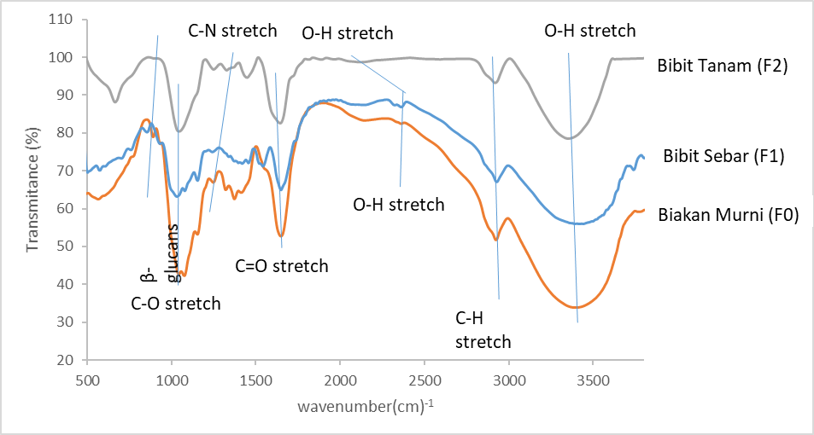

**Figure 1**. FTIR Characterization Results of F0, F1, and F2

Based on the FTIR characterization results shown in Figure 1, the absorption bands formed from the mycelium of each seedling depict the same dominant absorption band pattern, only differing in the absorbance value. This shows that each seedling mycelium contains the same functional group. The difference lies in the β-glucan bond and the wave number value. The 1,3-β-D-glucan bond appears in pure culture, while in the scattered seeds and planted seeds the absorption band that appears is the 1,4-β-D-glucan bond. The difference in β-glucan bonds in each seedling is thought to occur due to changes in the structure of functional groups from pure culture to scattered seeds, or from scattered seeds to planted seeds. This is because the seeds are no longer purely from mushrooms, but have been mixed with sorghum and sawdust, so that in the scattered seeds and planted seeds the 1,3-β-D-glucan peak does not appear, but what appears is the 1,4-β-D-glucan peak. The 1,3-β-D-glucan bond in F0 mycelium for each sterilization level is indicated by the presence of absorption bands at wave numbers 856 cm-1, 856 cm-1, 895 cm-1, 894 cm-1, and 894 cm-1. According to the literature, the presence of a 1,3-β-D-glucan bond is indicated by the absorption band at 895 cm-1 [11]. The type of beta glucan from the mycelium of the spread and planted seedlings is indicated by the appearance of an absorption band of the 1,4-β-D-glucan bond at wave numbers 933 cm-1 and 1034 cm-1 for the spread seedlings, and 925 cm-1 for the planted seedlings. According to the literature, the presence of a 1,4-β-D-glucan bond is indicated by the absorption band at 930-1025 cm-1 [12]. Based on the above data, pure culture mycelium, seedling, and planted seedlings showed the presence of beta-glucan. Beta-glucan is the main component of polysaccharides found in the cell walls of white oyster mushrooms which contain substances that can stimulate the immune system and are anti-cytotoxid, anti-mutagenic, and anti-tumorogenic compounds [13]. Infrared energy is unable to transition electrons but is only able to cause molecules to vibrate at certain vibration levels. This vibration phenomenon is used to detect functional groups (stretching vibrations) and to identify compounds and analyze mixtures (bending vibrations). In diatomic molecules, there is only one type of vibration, namely stretching vibrations. However, if there are many atoms in one molecule, there will be many bonds, which means many types of vibrations. The mycelium characterized by FTIR is modeled as a diatomic molecule, so that only stretching vibrations are analyzed in this study. The results of FTIR characterization provide information that mycelium contains C-O, C-N, C=O, C-H, and O-H functional groups. Mycelium contains protein indicated by the appearance of aromatic amine functional groups, namely C-N bond functional groups. Mycelium still contains a fairly high water content indicated by the presence of O-H functional groups. Mycelium contains carbohydrates indicated by the appearance of C-O, C=O, and C-H functional groups.

1. **Optical properties of mycelium**

The optical properties of the sample can be studied from the characterization results using FTIR by utilizing the Kramer-Kronig relation method. Based on the transmittance value and wave number, the refractive index value can be derived, namely the real refractive index (n) and the imaginary refractive index (k). The intersection graph between the n and k values ​​at shorter wave numbers is called the Transversal Optics (TO). While the intersection of the n and k values ​​at longer wave numbers is called the Longitudinal Optics (LO).

TO

LO

**Figure 2.** Results of LO and TO values ​​of sample F1

LO

TO

**Figure 3.** Results of LO and TO values ​​of sample F2

Based on Figure 2 and Figure 3, it shows the LO and TO values ​​for mycelium in the spread seedling media culture (F1) and planting seedling media (F2). The difference in media culture shows that the LO and TO values ​​in the spread seedling culture to the planting seedling culture shift towards a larger wave number. The LO value is at wave numbers 590 and 905 cm-1 for each sample F0 and F1. While the TO value is at wave numbers 577 and 850 for each sample F0 and F1. Based on these results, it indicates that the energy required for mycelium growth in the spread seedling culture media is smaller than the planting seedling culture media. This is in accordance with the relationship between photon energy which is directly proportional to the wave number.

1. **CONCLUSION**

Initial success in cultivating white oyster mushrooms is highly dependent on the seeds used. In producing good pure cultures (F0), a culture medium is needed, namely Potato Dextrose Agar (PDA) which is good, nutritious, and free from contamination. A good PDA for growing oyster mushroom seeds is PDA that is sterilized at the third sterilization level. All the spread seeds (F1) produced were good and none were contaminated. Based on the results of FTIR characterization, the mycelium experienced stretching vibrations of C-O, C=O, C-H, and O-H. This shows that the mycelium of white oyster mushrooms for pure cultures, spread seeds, and planted seeds contains the functional groups C-O, C-N, C=O, C-H, and O-H. The absorption area of ​​maximum absorbance at wave numbers 3402 cm-1, 3425 cm-1, 3448 cm-1, 3386 cm-1, 3394 cm-1, 3456 cm-1, and 3333 cm-1 indicates the presence of O-H functional groups (carboxylic acid). Mycelium contains carbohydrates indicated by the presence of C-O, C=O, and C-H functional groups. Mycelium contains protein indicated by C-N functional groups. The LO value is at wave numbers 590 cm-1 and 905 cm-1for each sample F0 and F1. While the TO value is at wave numbers 577 cm-1 and 850 cm-1 for each sample F0 and F1.

**REFERENCE**

1. Ginting, Alan Randallet al. Studi Pertumbuhan dan Produksi Jamur Tiram Putih (Pleorotus ostreatus) pada Media Tumbuh *Gergaji* Kayu Sengon dan Bagas Tebu. Jurnal Produksi Tanaman. 2013;1(2).
2. Sumarmi. Botani dan Tinjauan Gizi Jamur Tiram Putih. Jurnal Inovasi Pertanian. 2006; 4(2): 124-130.
3. Saat Egra, Irawan Wijaya Kusuma, Enos Tangke arung, and Harlinda Kuspradini. The potential of white-oyster mushroom (Pleurotus ostreatus) as antimicrobial and natural antioxidant. Journal of Natural Product Biochemistry. 2019 17 (1).
4. Irzaman, Syahrul, Nazopatul Patonah Har, Teguh Puja Negara, Irmansyah, and Husin Alatas. Effects of Iron Doped LiTaO3 Films on Transverse Optic (TO) and Longitudinal Optic (LO) Values Using Kramers-Kronig Method. International Journal of Nanoelectronics and Materials. 16 (Special issue) (2023): 1-8
5. Reza Zamiri, Hossein Mahmoudi Chenari, H. F. Moafi, Mehdi Shabani, S. A. Salehizadeh f, Avito Rebelo, J. Suresh Kumar, M. P. F. Graça, M. J. Soares , & J. M. F. Ferreira. Ceramics International. vol 42, Issue 11 (2016), pp. 12860-12867.
6. Dahlang Tahir, Sultan Ilyas, Roni Rahmat, Heryanto Heryanto, Ahmad Nurul Fahri, Mufti Hatur Rahmi, Bualkar Abdullah, Chol Chae Hong, & Hee Jae Kang. ACS Omega. vol 6, (2021) pp. 28334-28346.
7. Linda Agun, Norhayati Ahmad, Norizah Redzuan, Nor Azyan Syahirah Idirs, Shazwin Mat Taib, Zarita Zakaria, Raja Kamarulzaman Raja Ibrahim. Sterilization of oyster mushroom crop residue substrate by using cold plasma technology. Materialstpday proceedings. 2021. 39 (2) : 903-906.
8. Daminur dan Sukarsono. Karakterisasi Struktur Molekul Butiran Gel dan Kernel Oksida Uranium dengan Spektroskopi Fourier Transform Infra Merah. Prosiding PPI-PDIPTN. Puslitbang Teknologi Maju BATAN. 2005.
9. William, D.H and Fleming. Spectronic Methods Inorganic Chemistry. United Kingdom: Mc.Craw Hill Book Company. 1980.
10. Nachiket Kotwaliwale, Pramod Bakane, and Ajay Verma. Changes in textural and optical properties of oyster mushroom during hot air drying. Journal of Food Engineering. 2007. 78 (4) : 1207-1211.
11. Liu, et al. Immunomudulation and Anti-cancer Activity of Polysaccharide-protein Complexes. Current Medical Chemistry. 2000; (7) 715-729.
12. Piyathida Jantaramanant, Decha Sermwittayawong, Kusumarn Noipha, Nongporn Hutadilok-Towatana, Rapepun Wititsuwannakul. Β-glucan-containing Polysaccharide Extract from The Grey Oyster Mushroom [Pleorotus sajor-caju (Fr.) Sing.] Stimulates Glucose Uptake by the L6 Myotubes. International Food Research Journal. 2014; 21(2):779-784.
13. Widyastuti Netty, Teguh Baruji, Reni Giarna, Henky Isnawan, Priyo Wahyudi, Donowati. Analisa Kandungan Beta-Glukan Larut Air dan Larut Alkali dari Tubuh Buah Jamur Tiram (Pleurotus ostreatus) dan Shitake (Lentinus odedes). Jurnal Sains dan Teknologi. 2011; 13(3): 182-191.