Glass Wastes-reinforced Brake Pad Composite to Increase Friction Stability

Sutikno Madnasri1.a *. M. Nuzaihan M.N.2.b and Heru Saputra 3.a

a Composite Materials Laboratory. Study Field of Physics. Faculty of Mathematics and Natural Sciences. Universitas Negeri Semarang. Sekaran 50229. Semarang. Indonesia

bInstitue of Nano Electronic Engineering. Universiti Malaysia Perlis. 01000 Kangar. Perlis. Malaysia  
* Corresponding author. Tel.: +62-858-6565-6282; e-mail: sutiknomadnasri@mail.unnes.ac.id

Received XXX 2023. Revised XXX 2023. Accepted XXX 2023

ABSTRACT

This project examines the effect of using glass-waste powder as a reinforcement material in brake pads composite. The specimens were prepared using hot isostatic pressing at 250 0C within 2 hours. Fabrication of brake pad specimens was carried out by varying the volume fraction of glass powder (9.9 %vol – 29.9 %vol). Characterization of material carried out included hardness. wear. density. thermal resistance. and surface structure. The results of characterization showed that the maximum value of the specimen with the ingredient of glass powder was 29.9 %vol with hardness value of 80 HRB. wear value of 0.63 x 10-4 mm2/kg. density 2 g/cm3 and thermal resistance until 500°C. The improvement of brake pad material characteristics confirms the increase in friction coefficient due to the increase in the amount of glass powder during the simulation.

**Keywords:** Brake pad. Composite. Glass Powder. Reinforcement-material. Waste

# INTRODUCTION

The rapid development of industry is not accompanied by adequate waste management. resulting in accumulation and even environmental pollution [1]. One of the largest wastes is glass. which is an amorphous solid and is composed of various chemical compositions of natural materials connected by oxygen bridges [2]. Overall. total glass production in the world reached 77 million tons in 2014 [3]. The large use of glass materials is due to its good characteristics such as optical transparency. chemical moisture. high intrinsic strength and low gas permeability [4]. Although with a very large amount of glass waste. it has the potential to be managed properly considering that the raw material for the glass industry is glass waste itself. logically any amount of glass waste can be recycled into new valuable products [3].

One of the uses of recycled glass waste is as a brake pad reinforcement material [5]. Glass fiber is chosen because it can increase surface hardness and increase the wear resistance of brake pads at temperatures below the glass transition temperature [6]. In addition. glass fiber can also increase the overall strength of the composite structure [7]. The presence of glass fiber in the composite can increase the modulus of elasticity so that resistance to crack propagation also increases [8].

However. the use of glass fiber in composites causes a decrease in the overall flexural strength of the composite [9]. This is because glass fiber has a low strain modulus [10]. Another material that has the same material properties as glass fiber is glass powder because glass powder is the main ingredient in making glass fiber [11]. The addition of glass powder in polymer composites can increase the hardness value. especially with smaller sizes [12].

# MATERIALS AND METHOD

The specimen manufacturing refers to the brake pad design according to SNI (National Standard of Indonesia) SNI 09-0143-1987. through the hot isostatic pressing technique. at 250 0C and 6 metric-tons for 2 hours.

The friction coefficient test was conducted on a laboratory scale for safety reasons by utilizing the high-speed brake disc loading method. with a 933 wats motor power and a 9.5 cm radius of metal disc brake. The loads used were 5 kg. 7 kg. 9 kg. 11 kg. and 13 kg in a perpendicular direction. Several other tests were added to see the characteristics of the material.

The specimen was successfully processed and looks like golden-gray color with evenly distributed yellow spots of brass waste. having a mass of 18 g - 20 g and 0.6 cm - 0.7 cm thickness. The characteristics of the material are described including hardness. wear. density. thermal resistance. and surface morphology.

## Rockwell Ball Hardness Test

Rockwell hardness testing shows that brake pads containing 29.9% vol glass powder have a higher hardness value than those containing 9.9% vol. The increase in hardness value is directly proportional to the increase in glass powder content in the brake pad composite composition. The increase in hardness value forms a positive exponential line. ranging from 75 HRB for a 9.9% vol glass powder content to 89.5 HRB for a 29.9% vol glass powder content. The increase in hardness occurs because the material becomes denser and is dominated by the properties of the glass powder. which accounts for almost 30% volume.

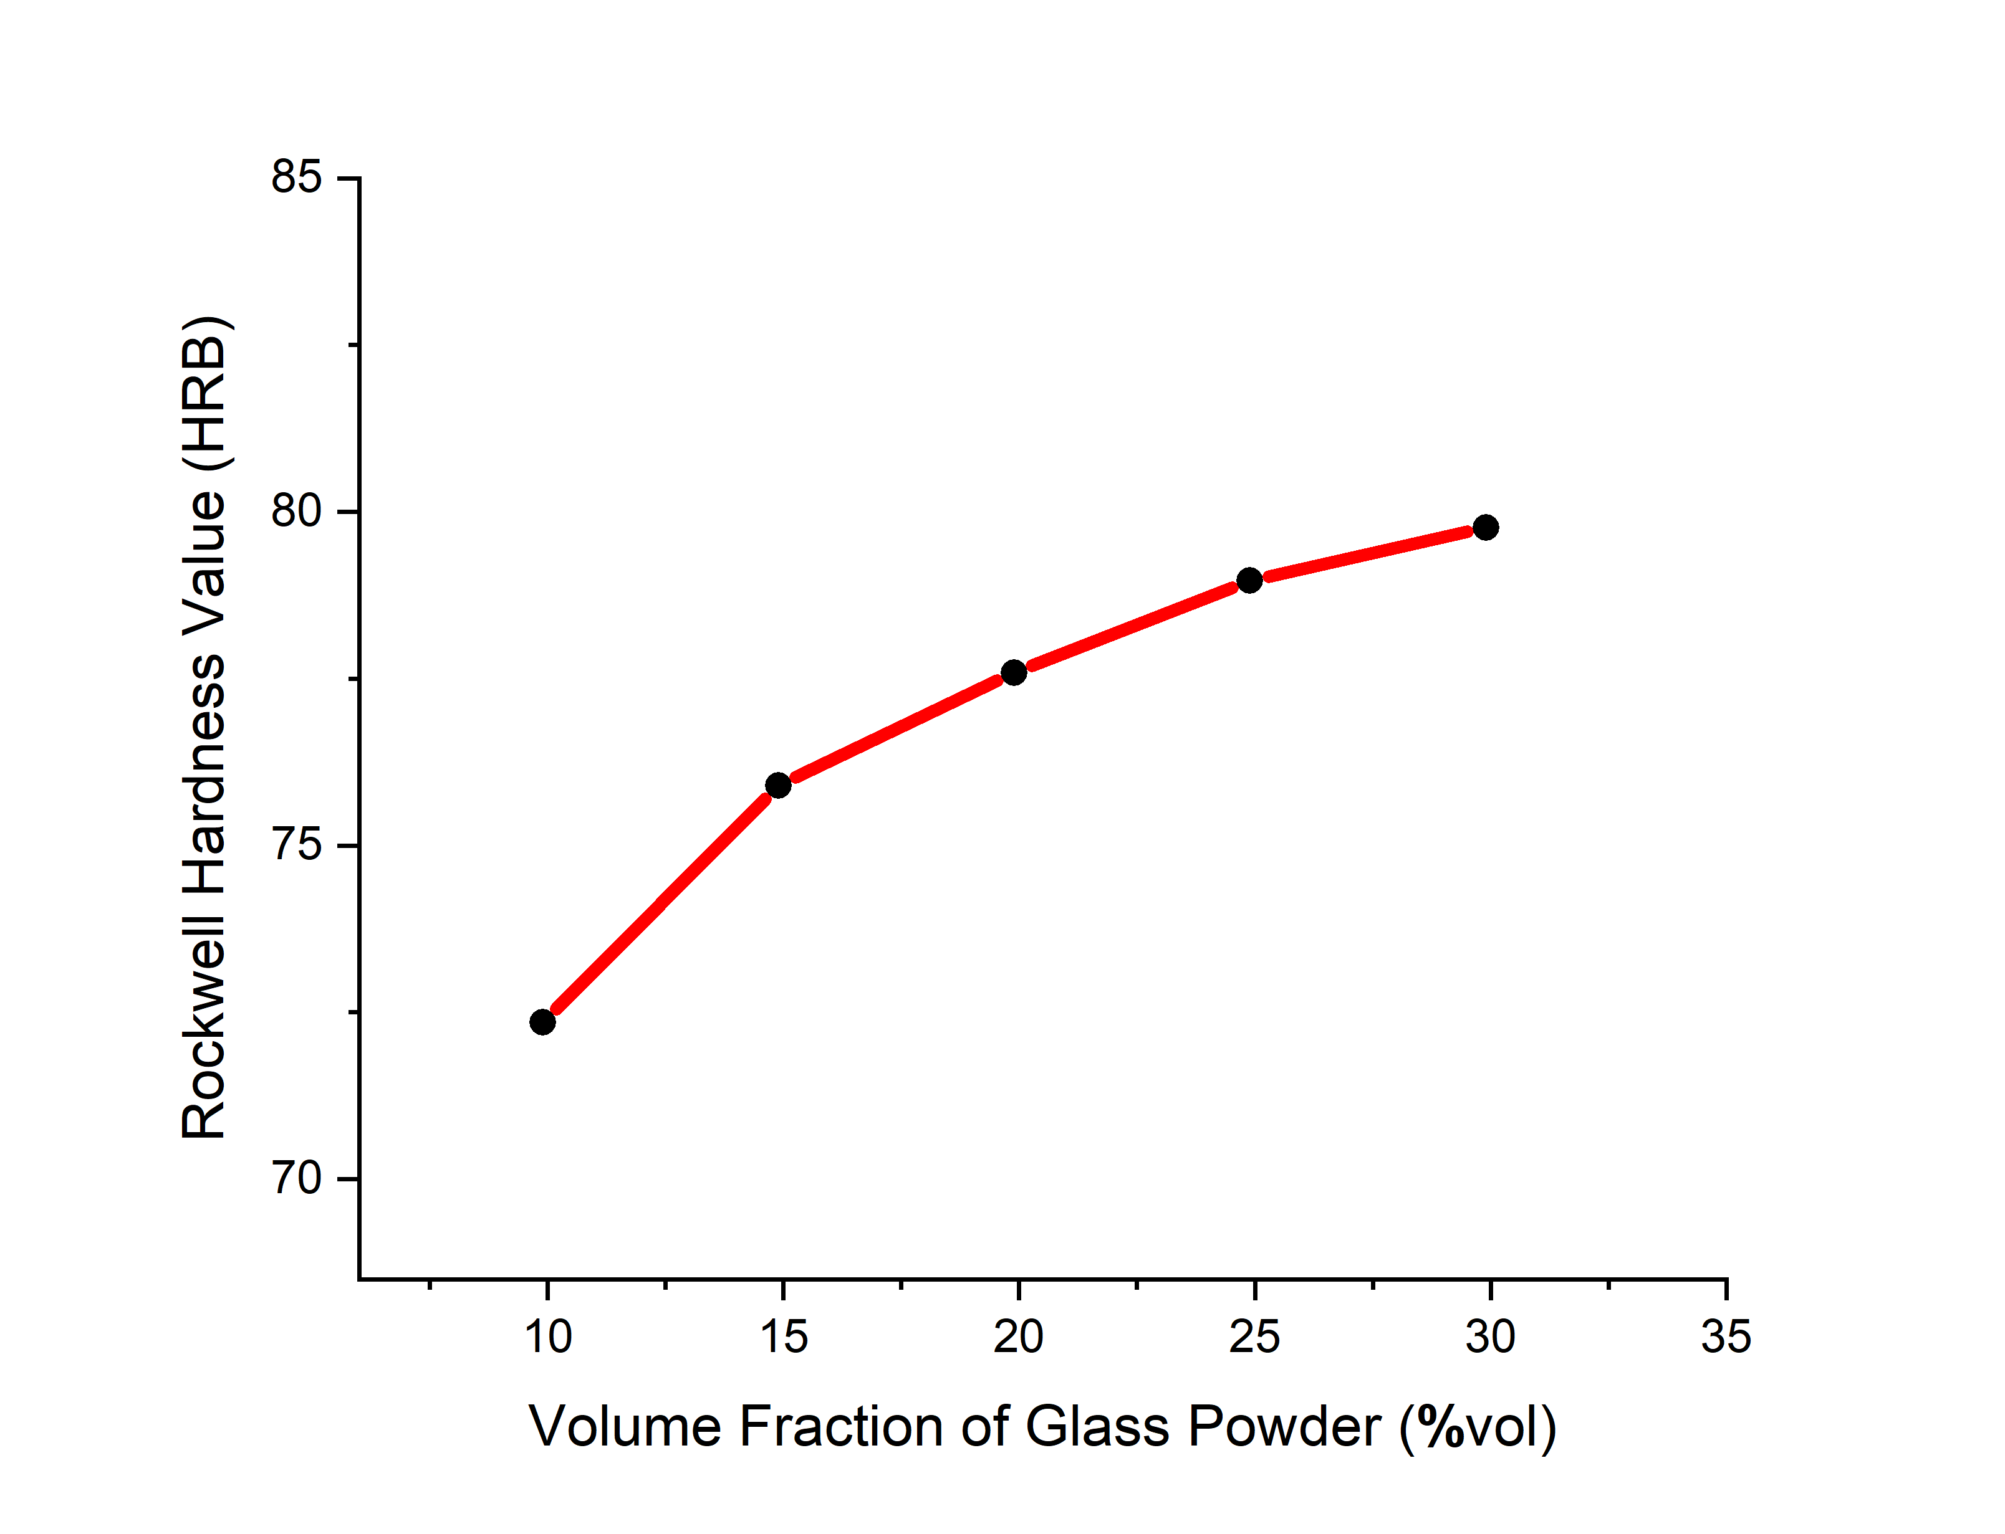

Figure 1. Effect of increasing the volume fraction of glass powder on the Rockwell Hardness.

The glass powder naturally has a high level of hardness. making the composite material harder [13]. The difference in hardness is caused by the deformation process between the constituent materials during the formation of the brake pad composite material. Differences in the inherent properties of each constituent material cause differences in the deformation process. In addition to the inherent properties of the constituent material. the size of the material also affects the properties of the particles. especially for reinforcing materials. By using fine reinforcing materials. the particle density will increase because the micro cavities will be closed with fine particles. Metal powders on the market only have the smallest size of ≤100 mesh (149 µm). so they require additional materials that have smaller size. namely glass powder which has a size of up to ≤200 mesh (74 µm) so that it is more effective in closing micro cavities [14].

## Wear Ogoshi Test

The results of wear testing are shown in Figure 2. where the brake pad composite with has a wear value of 4.22x10-4 mm2/Kg - 0.63 x10-4 mm2/kg. The addition of glass powder volume fraction in the ingredient causes an increase in wear resistance. The increase occurs because the gaps between the constituent material particles will be filled by glass powder particles so that the material can maintain inter-particle bonds during friction. Because the volume of glass powder in the ingredient is increased. the inter-particle bonds will be stronger [15]. The presence of glass powder contributes to the densification process of the material so that the specimen is harder and more resistant to wear.

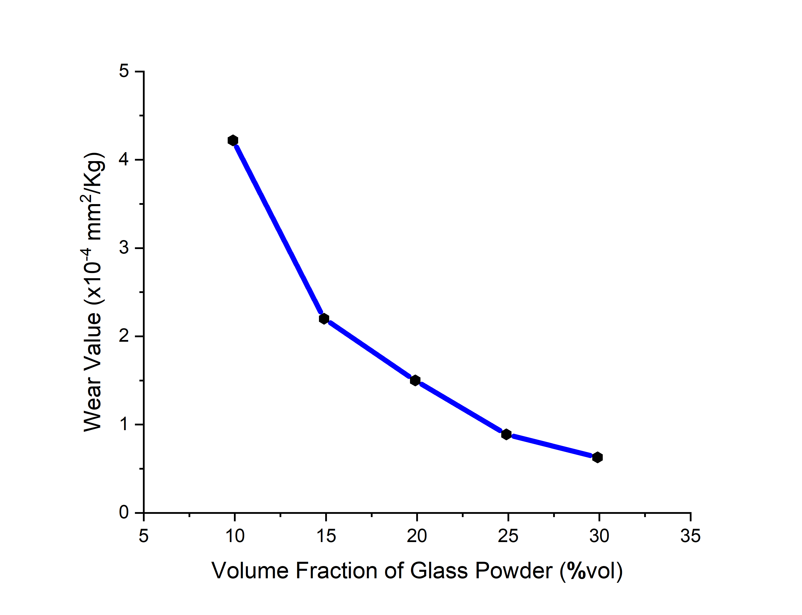

Figure 2. Effect of increasing the volume fraction of glass powder on the Wear value

The wear is inversely proportional to the hardness. This is because the higher the hardness of a material. the higher the wear resistance of the material. Similar to hardness testing. the wear value will be greatly influenced by the adhesion force between particles. However. unlike the hardness test. which is oriented perpendicularly. the wear test is oriented parallel so that the particle erosion process will take place gradually. The material will tend to maintain interparticle bonds during the erosion process [16].

## Density Test

The results of the density test were obtained on the specimen with glass powder ingredient 29.9 %vol. the density of the brake pad composite has the smallest density of 2.0 g/cm2. In contrast to the specimen with glass powder ingredient 9.9 %vol which has a density of 2.4 g/cm2.

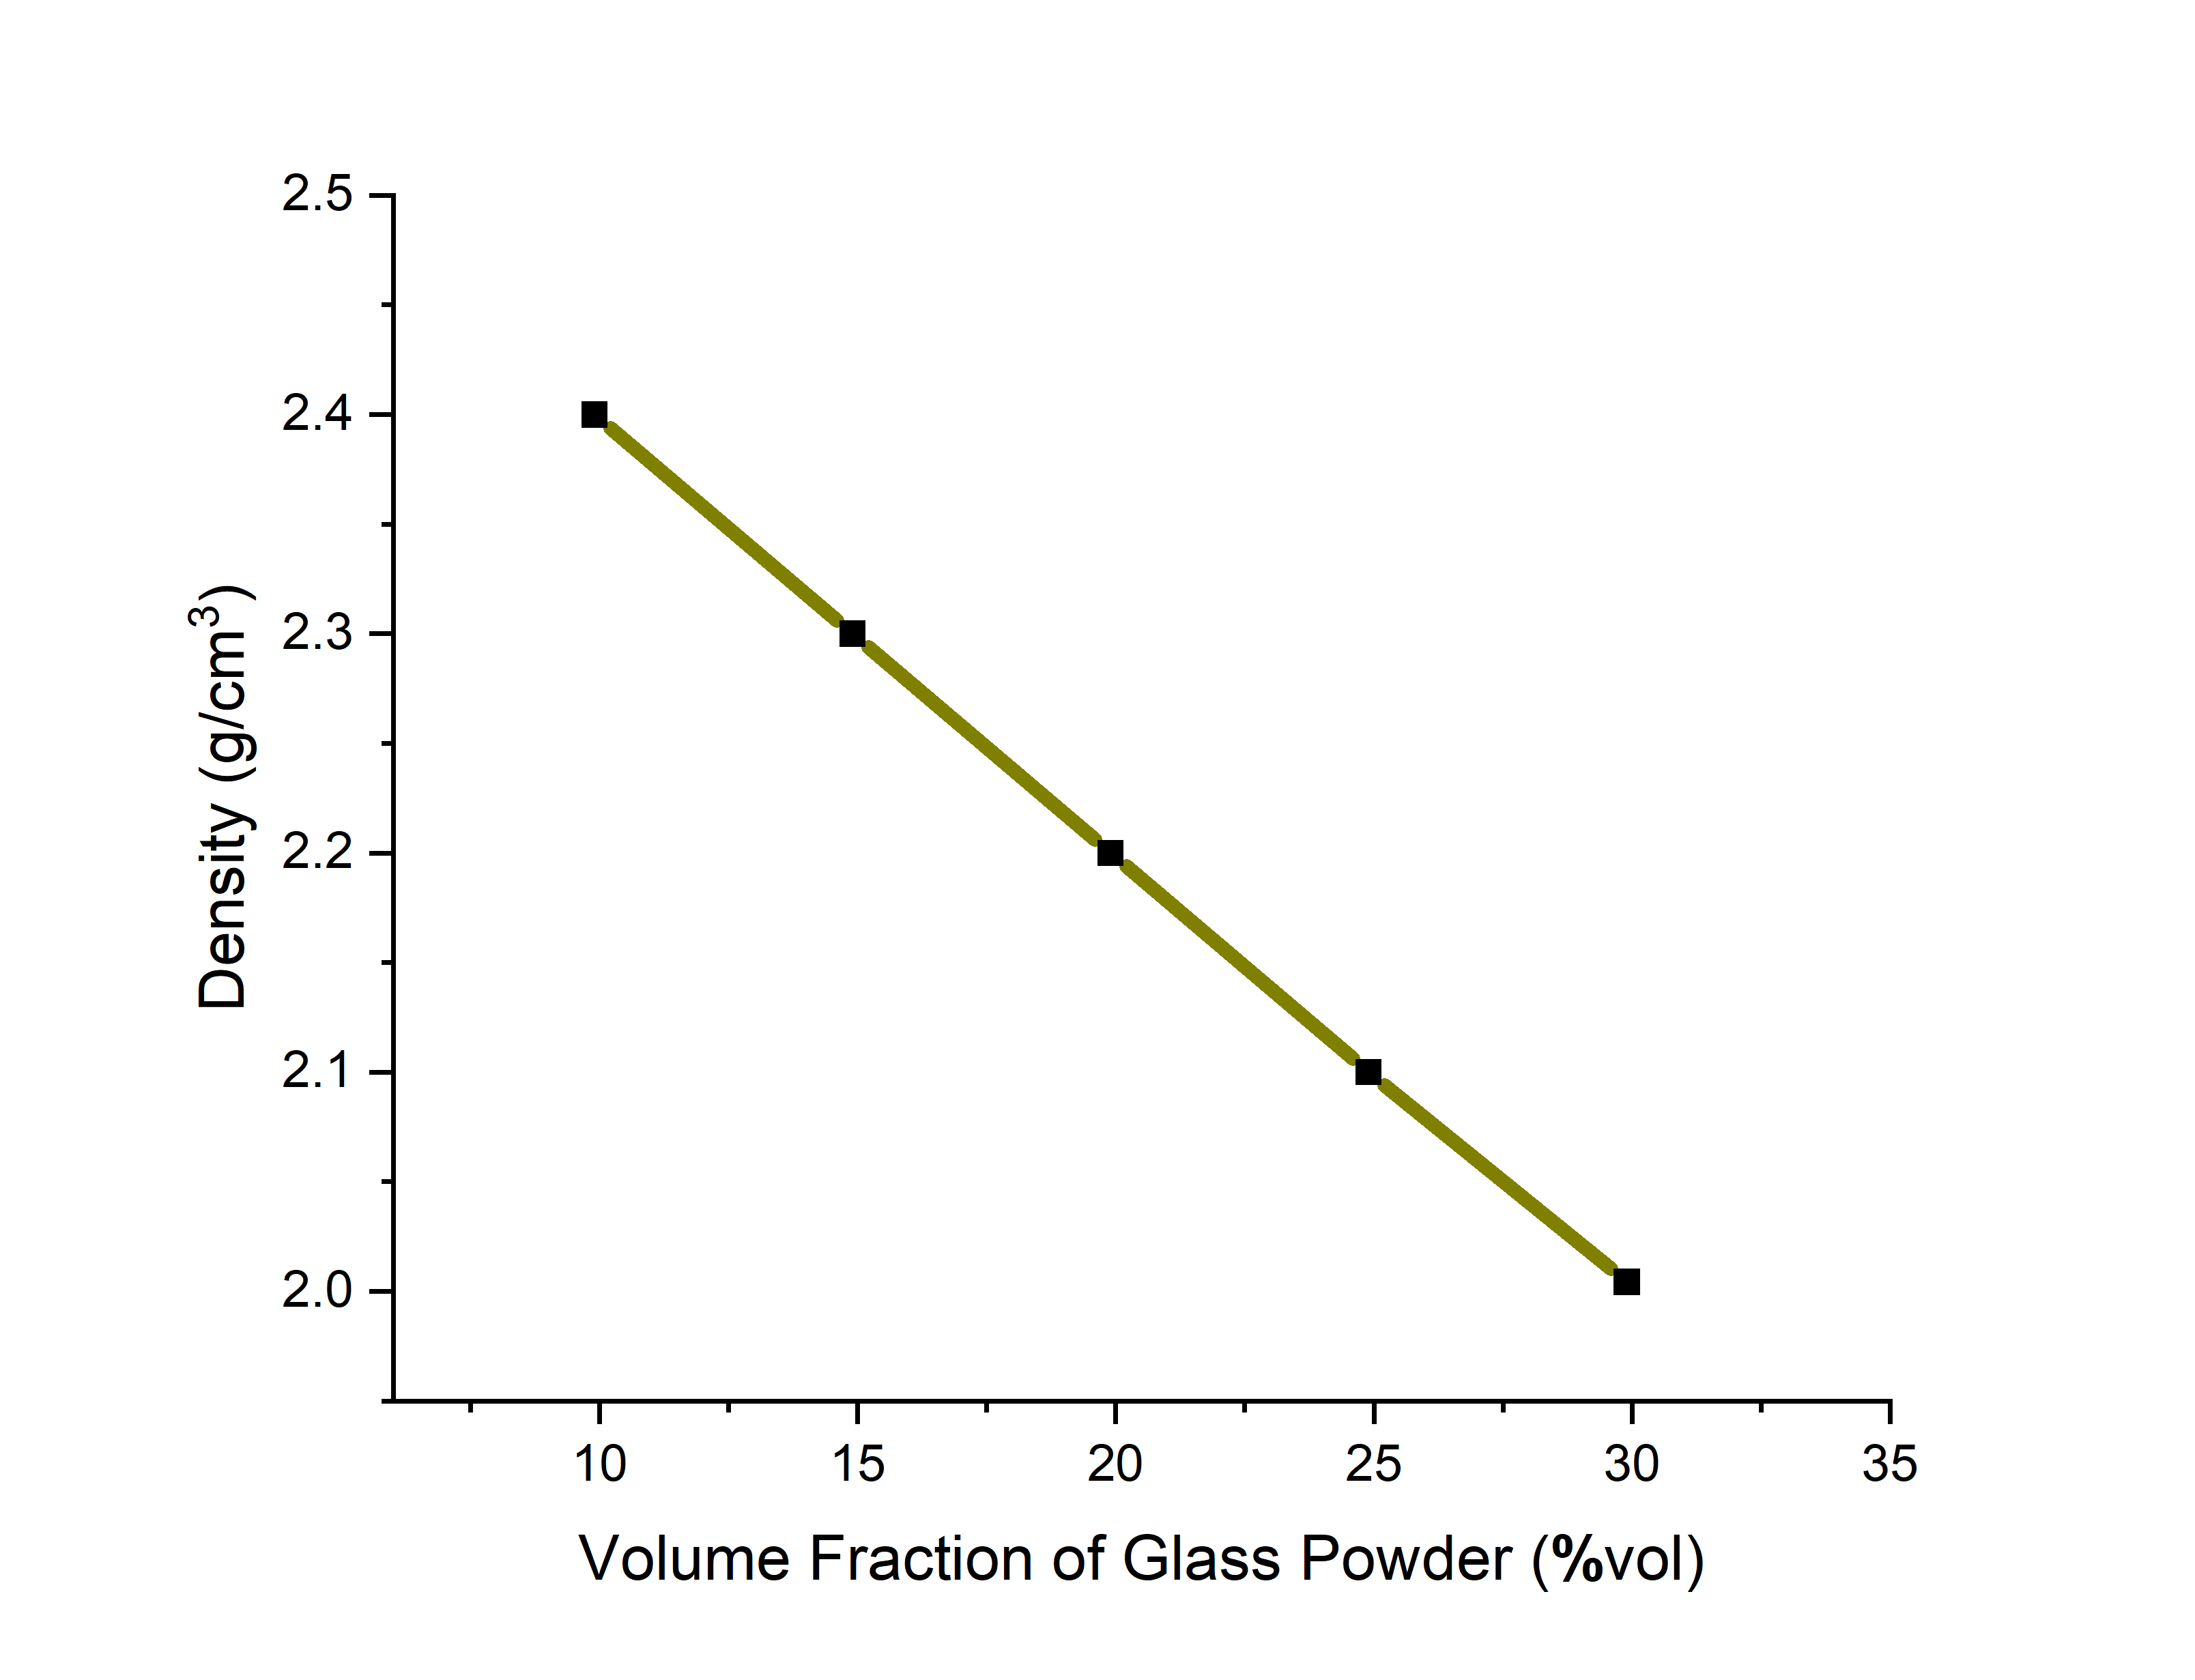

Figure 3. Effect of increasing the volume fraction of glass powder on the Density value

The density of composite materials is greatly influenced by the density of the constituent materials. The greater the density of the constituent materials. the greater the density of the composite material. The constituent materials that have a percentage of content in the ingredients have a stronger influence on the properties of the composite material including density. Metal powder has a density of 1.21 g/cm2 while glass powder has a density of 0.65 g/cm2. So. the specimen that uses more glass powder by reducing metal powder. the density decreases [17].

## Thermal Resistance Test (DTA-TGA)

From the DTA/TGA test results. it was found that the specimen experienced exothermic at two peak points. namely at temperatures of 336 °C and 444 °C as shown in Figure 6. The exothermic curve indicates a chemical reaction. After a temperature of 444 °C. the specimen began to experience an endothermic phase until it reached a peak at a temperature of 522 °C due to the decomposition of organic materials such as carbon and oxygen. The endothermic curve tends to widen. indicating a dehydration reaction. During the heating process from a temperature of 218 °C - 507 °C. the specimen has lost up to 8% weight from its initial weight. The loss of some material is caused by the softening and oxidation processes during heating. This indicates that the specimen is still quite good at withstanding heat up to a temperature of 500 °C [18].

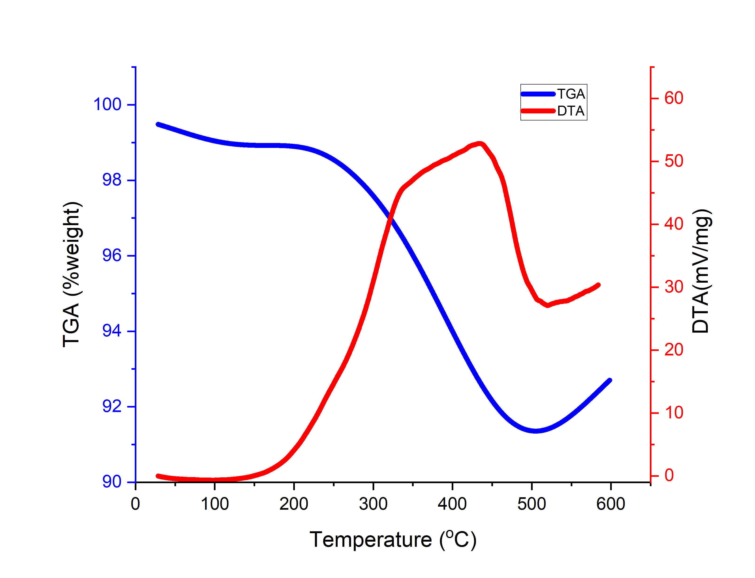

Figure 4. DTA and TGA test results for composite brake pads reinforced with 29.9%vol glass powder

## Microstructure Characterization

Observation of the brake pad microstructure was carried out using a Scanning Electron Microscope with a magnification of 5000 times. In Figure 7. the surface relief of the brake pad composite forms solid grains with various sizes. The difference in grain size is caused by the size of each component material [19]. However. at some points there are objects with an oval shape. The oval object is a material that has undergone elastic deformation so that it changes shape [20]. The image also shows a fluorescent object. At the bottom of Figure 7. there are fewer fluorescent objects than at the top of the image. indicating that the material mixing is uneven. The height of the material surface tends to be flat because there is no visible dark and light pattern and no hole area [21].

The microstructure is shown during Energy Dispersive X-Ray Spectroscopy (EDX) testing. The test results. Figure 8.



Figure 5. Surface appearance of brake pad composite reinforced with 29.9%vol glass powder with 5000x magnification

show that the concentration of Si compounds has the highest peak with a fairly large interval with other compounds. This is because the glass powder material. which is predominantly composed of Si compounds. has the highest ingredient of almost 30%vol. In addition to coming from glass powder material. Si compounds also come from coal fly ash material [22]. The second most abundant material is compound O which functions as a natural binder of Si compounds by forming SiO2. The compounds contained quite a lot in the brake pad composite are metal groups such as Fe. Al. and Cu which come from metal powder materials.

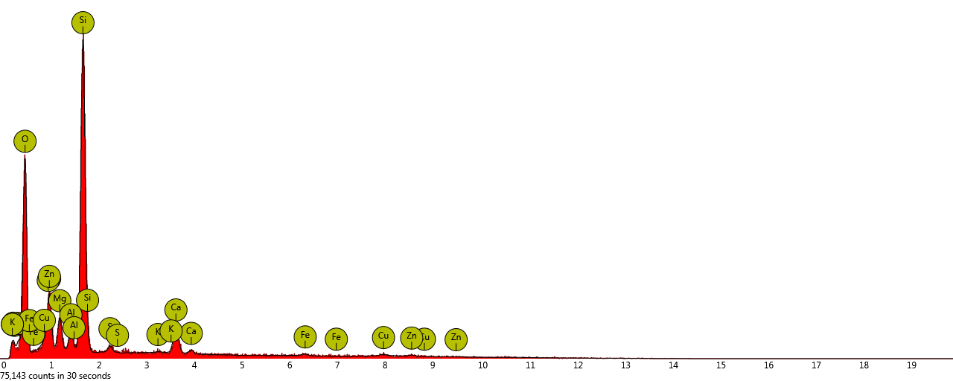

Figure 6. Curve of material content of glass powder reinforced brake pad composite 29.9 %vol

# RESULTS AND DISCUSSION

Friction stability is described through the friction coefficient that was obtained during the simulation. The simulation was carried out on a laboratory scale for safety reasons. During the simulation. the environment was attempted to be as similar as possible to the real event during the braking process.

Tabel 7. Friction coefficient values ​​at all braking load levels

|  |  |  |  |  |  |
| --- | --- | --- | --- | --- | --- |
| Glass Powder (%vol) | Load (Kg) | | | | |
| 5 | 7 | 9 | 11 | 13 |
| 9.9 | 0.66 | 0.49 | 0.39 | 0.33 | 0.29 |
| 14.9 | 0.70 | 0.52 | 0.42 | 0.37 | 0.33 |
| 19.9 | 0.75 | 0.57 | 0.47 | 0.39 | 0.36 |
| 24.9 | 0.82 | 0.61 | 0.50 | 0.44 | 0.38 |
| 29.9 | 0.89 | 0.69 | 0.56 | 0.48 | 0.44 |

The friction test results show that the greater the load is used to press. the smaller the friction coefficient created. The amount of pressure on the brake pad composite increases the braking load so that the process of particle release from the material is greater due to hard friction [23].

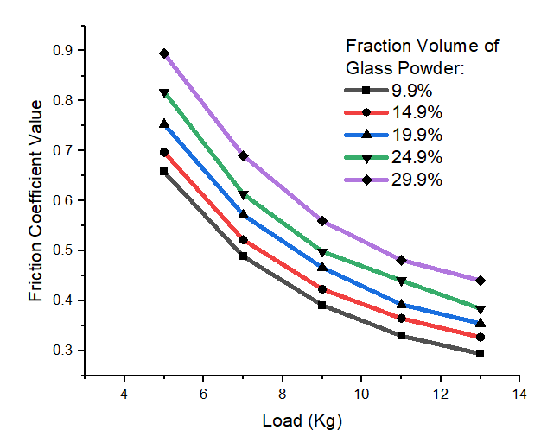

Figure 8. Friction Coefficient of brake pad composite against increasing braking load

In addition to being influenced by the test load. The friction coefficient is also influenced by the material of the brake pads. Materials that have high adhesion are more resistant to abrasion due to friction with other objects. Therefore. A composite brake pad material must consist of components that physically support each other. From Figure 5. It can be

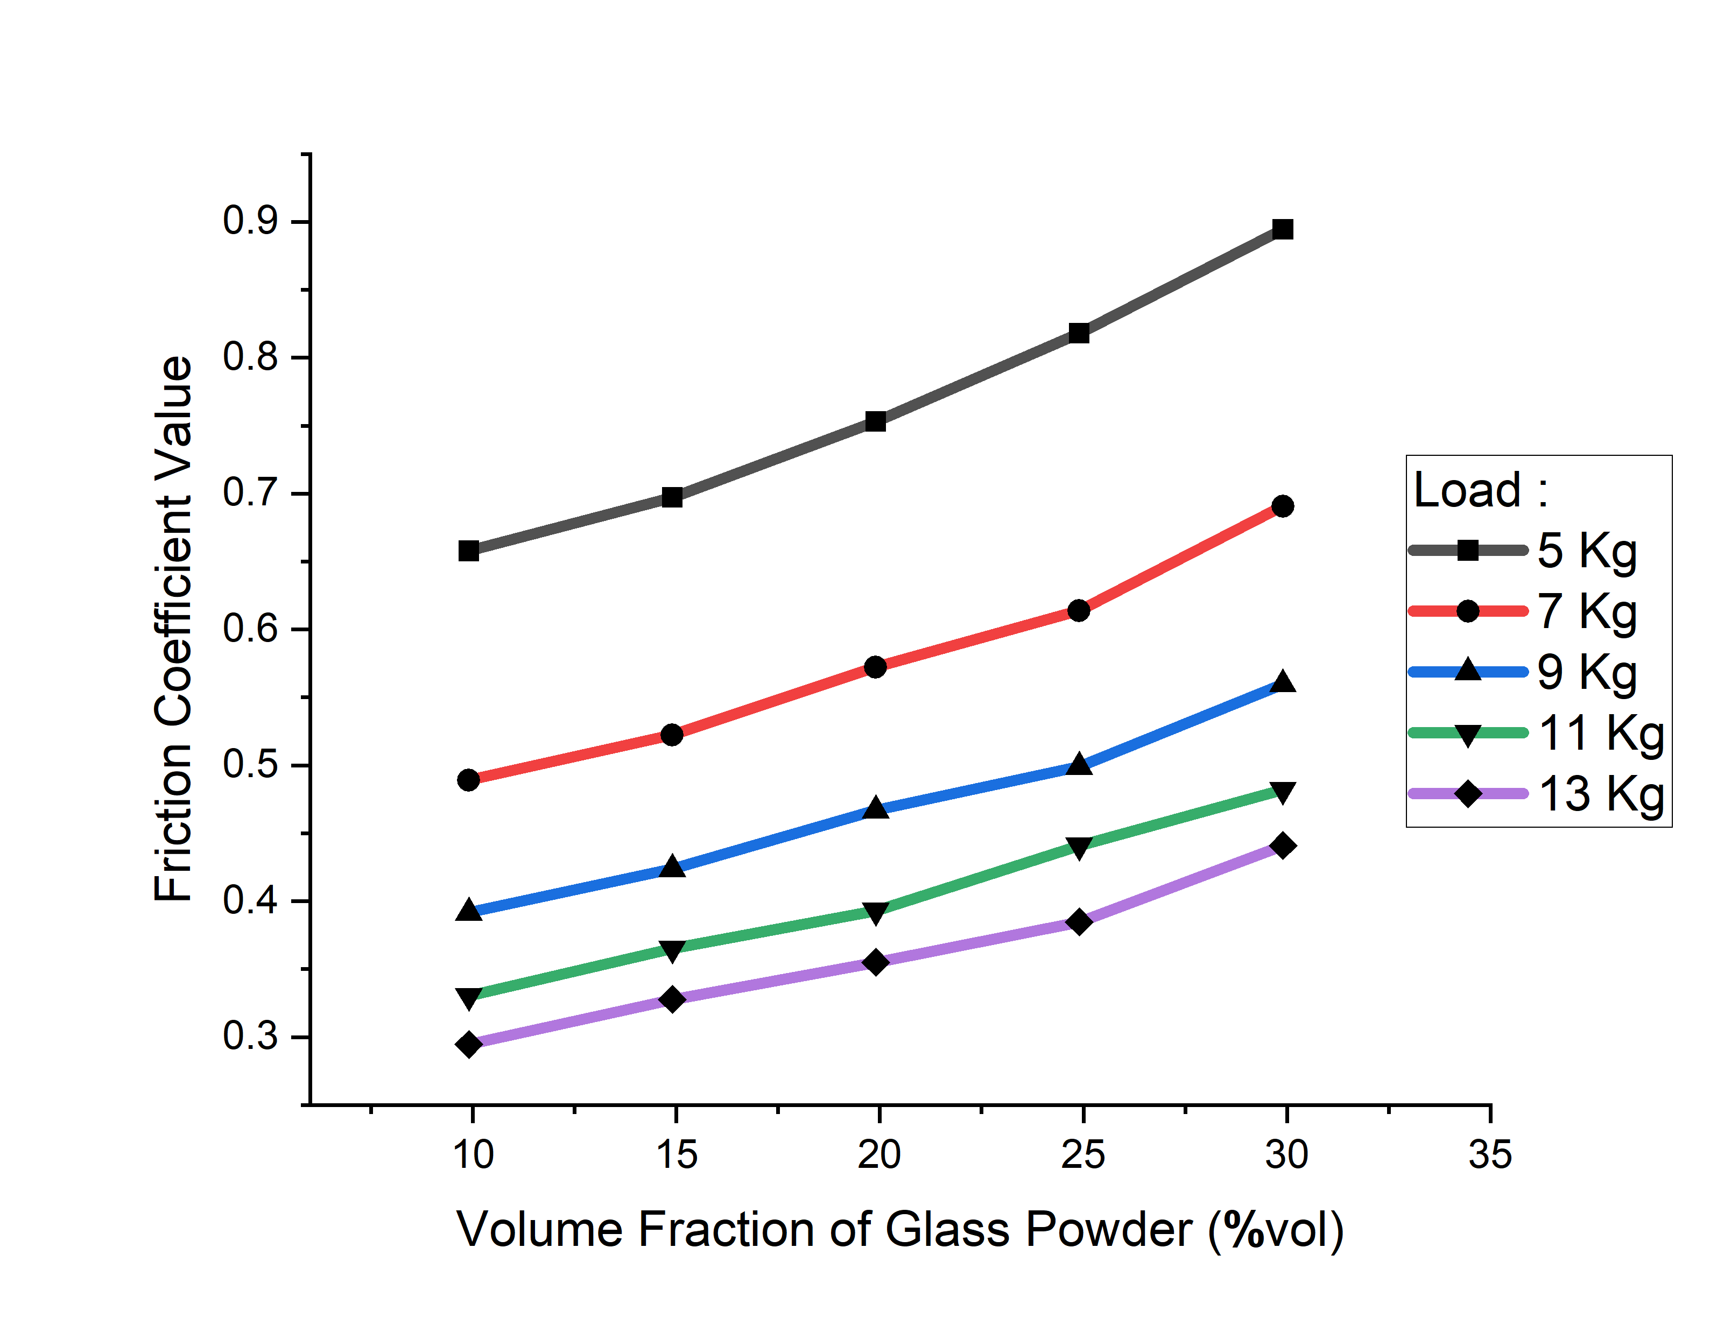

Figure 8. Friction Coefficient of brake pad composite against increasing volume fraction of glass powder

seen that the more glass powder ingredients. the higher the friction coefficient. The effect of particle bonding is the same as the effect of particle bonding on wear testing where the particle adhesion force is directly proportional to the wear resistance of a particle [24].

Due to limited facilities. The friction coefficient test does not include the evaluation of the effect of temperature during the braking process. The increase in temperature affects the erosion of the material during friction with the disc plate. Therefore. Further investigation is needed in the next development stage.

# Conclusion

The addition of glass powder in the composition of brake pad material has been proven to have a positive effect on the characterization and friction coefficient value. The results of all tests obtained values ​​​​close to the standards set by SNI 9370:2025. Although the evaluation of the effect of temperature increases during braking has not been carried out. The results of thermal resistance tests (DTA-TGA) show that the material has quite good resistance in high temperature environments up to 500 0C.

ACKNOWLEDGMENTS

We thank the Rector of Universitas Negeri Semarang who has provided full support for this research, and we would thank all academicians in the Faculty of Mathematics and Natural Sciences. Universitas Negeri Semarang who contributed indirectly to this research.

REFERENCES

1. Awuchi. C.G.. & Igwe. V.S. 2017. Industrial Waste Management: Brief Survey and Advice to Cottage. Small and Medium Scale Industries in Uganda. *International Journal of Advanced Academic Research.* Vol. 3(1):26-43.
2. Testa. M.. Malandrino. O.. Sessa. M.R.. Supino. S.. Sica D. 2017. Long-Term Sustainability from the Perspective of Cullet Recycling in the Container Glass Industry: Evidence from Italy. *Sustainability.* Vol. 9 (1752).
3. Butler. J.H.. & Hooper. P.D. 2019. Glass Waste. Waste: A Handbook for Management. Second Edition. Ch.15: 307-322.
4. Lu. J.X.. & Poon. C.S. 2019. Recycling of Waste Glass in Construction Materials. *New Trends in Eco-Efficient and Recycled Concrete.* Chapter 6:153-167.
5. Xiao. X.. Yin. Y.. Bao. J.. Lu. L.. & Feng. X. 2016. Review on the Friction and Wear of Brake Materials. *Advances in Mechanical Engineering*. Vol. 8(5):1–10.
6. Kim. S.H.. & Jang. Ha. 2013. Friction and Vibration of Brake Friction Materials Reinforced with Chopped Glass Fibers. *Tribology Letters.* Vol. 52:341-349.
7. Natarajan. M.P.. Rajmohan. B.. & Devarajulu. S. 2012. Effect of Ingredients on Mechanical and Tribological Characteristics of Different Brake Liner Materials. *International Journal of Mechanical Engineering and Robotics Research*. Vol. 1(2):135-157.
8. Aramide. F.O.. Atanda. P.O.. & Olorunniwo. O.O. 2012. Mechanical Properties of a Polyester Fibre Glass Composite. *International Journal of Composite Materials*. Vol. 2(6):147-151.
9. Kiran. M.D.. Govindaraju. H.K.. & Jayaraju. T. 2018. Evaluation of Mechanical Properties of Glass Fiber Reinforced Epoxy Polymer Composites with Alumina. Titanium dioxide and Silicon Carbide Fillers. *Materials Today.* Proceedings 5:22355–22361.
10. Shukla. M.J.. Kumar. D.S.. Mahato. K.K.. Rathore. D.K.. Prusty. R.K.. & Ray. B.C. 2015. A Comparative Study of the Mechanical Performance of Glass and Glass/Carbon Hybrid Polymer Composites at Different Temperature Environments. *IOP Conference Series: Materials Science and Engineering.* Vol. 75(012002).
11. Quadrini. F.. Bellisario. D.. & Santo. L. 2015. Molding Articles Made of 100% Recycled Fiberglass. *Journal of Composite Materials.* Vol. 50(21):2959-2969.
12. Sonsakul. K.. & Boongsood. W. 2017. Effects of Glass Scraps Powder and Glass Fiber on Mechanical Properties of Polyester Composites. *IOP Conference Series: Materials Science and Engineering.* Vol. 273(012006).
13. Hemanth. R.D.. Kumar. M.S.. Gopinath. A.. & Natrayan. L. 2017. Evaluation of Mechanical Properties of E-Glass and Coconut Fiber Reinforced with Polyester and Epoxy Resin Matrices. International Journal of Mechanical and Production Engineering Research and Development. Vol. 7 (5): 13-20.
14. Khalidi. F.R.A.. & Rajab. M.A. 2018. Hardness and Wear Resistance of Composite Materials Supported by Graphite and Silica Particles and Reinforced by Cuffler Fiber. *American Journal of Engineering Research*. Vol. 7 (11): 317 322.
15. Wang. J.. GangaRao. H.. Liang. R.. Zhou. D.. Liu. W.. & Fang. Y. 2015. Durability of Glass Fiber-Reinforced Polymer Composites Under The Combined Effects of Moisture and Sustained Loads. *Journal of Reinforced Plastics and Composites*. Vol. 34(21): 1739–1754.
16. Oladele. I.O.. Ayanleye. O.T.. Adediran. A.A.. Makinde-Isola. B.A.. Taiwo. A.S.. & Akinlabi. E.T. 2020. Characterization of Wear and Physical Properties of Pawpaw–Glass Fiber Hybrid Reinforced Epoxy Composites for Structural Application. *Fibers 2020. 8. 44.* MDPI Publisher.
17. Elanchezhian. C.. Ramnath. B.V.. & Hemalatha. J. 2014. Mechanical Behaviour of Glass and Carbon Fibre Reinforced Composites at Varying Strain Rates and Temperatures. *Procedia Materials Science*. Vol. 6: 1405 – 1418.
18. Saidova. Z.. Grakhov. V.. Yakovlev. G.. Gordina. A.. & Zakharov. A. 2017. Thermal Analysis of Glass-Fiber Reinforced Polymer Rebars. *Engineering Structures and Technologies.* Vol. 9(3): 142-147.
19. Mukherjee. A.. & Arwikar. S.J. 2005. Performance of Glass Fiber Reinforced Polymer Reinforcing Bars in Tropical Environments - Part II: Microstructural Tests. *ACI Structural Journal.* Title Number: 102-S82.
20. Adekomaya. O.. Adediran. A.A.. & adama. K. 2018. Characterization and Morphological Properties of Glass Fiber Reinforced Epoxy Composites Fabricated Under Varying Degrees of Hand Lay-Up. *Techniques. Journal of Applied Sciences and Environmental Management*. Vol. 22 (1): 110-114.
21. Talib. R.J.. Muchtar. A.. & Azhari. C.H. 2003. Microstructural Characteristics on the Surface and Subsurface of Semimetallic Automotive Friction Materials During Braking Process. *Journal of Materials Processing Technology.* Vol.140: 694–699.
22. Miricioiu. M.G.. & Niculescu. V. 2020. Fly Ash. from Recycling to Potential Raw Material for Mesoporous Silica Synthesis. *Nanomaterials 2020. 10. 474.* MDPI Publisher.
23. Srinivasan. V.. Asaitambhi. B.. Ganesan. G.. Karthikeyan. R.. & Palanikumar. K. 2009. Wear Mechanism of Glass Fiber Reinforced Epoxy Composites Under Dry Sliding Using Fuzzy Clustering Technique. *Journal of Reinforced Plastics and Composites.* Vol. 28(11): 1349-1358.
24. Mehoub. G. 2013. Adhesive Wear and Frictional Behaviour of Glass Fibre Reinforced Thermoset Composites. *A Master Dissertation.* Faculty of Engineering and Surveying - University of Southern Queensland.