Characterization of SnO₂ nanoparticles via *Morinda citrifolia* leaf extract

Irmaizatussyehdany Buniyamina,*, Mohd Yusri Idorusb, Muhamad Faizal Abd Halima, Salifairus Mohammad Jafara, Zahidah Othmana,c, Nur Fairuz Rostana,c, Kevin Alvin Eswara,d, Mohd Khairil Adzhar Mahmoode, Maryam Mohammada,f, Mohamad Azri Tukimong, Hanis Mohd Yusoffh,i, A. F. M. Motiur Rahmanj, Mohamad Rusop Mahmoodk, Mohd Firdaus Maleka,c

aNANO-SciTech Laboratory, Centre for Functional Materials and Nanotechnology (FMN), Institute of Science, Universiti Teknologi MARA (UiTM), Shah Alam, Selangor 40450, Malaysia  
bInstitute for Biodiversity and Sustainable Development, Universiti Teknologi MARA (UiTM), Shah Alam, Selangor 40450, Malaysia  
cFaculty of Applied Sciences, Universiti Teknologi MARA (UiTM), Shah Alam, Selangor 40450, Malaysia  
dFaculty of Applied Sciences, Universiti Teknologi MARA (UiTM), Sabah Branch Tawau Campus, Tawau, Sabah 91032, Malaysia   
eMicrowave Research Institute, Universiti Teknologi MARA (UiTM), Shah Alam, Selangor 40450, Malaysia

fDepartment of Physics,Faculty of Applied Sciences, Universiti Teknologi MARA (UiTM), Perak Branch Tapah Campus, Tapah Road, Perak 35400, Malaysia

gPusat Pengurusan Makmal Alami & Fizikal UKM (ALAF-UKM), Aras 2, Kompleks Penyelidikan, Universiti Kebangsaan Malaysia, Bangi, Selangor 43600, Malaysia

hFaculty of Science and Marine Environment, Universiti Malaysia Terengganu, Kuala Nerus, Terengganu 21030, Malaysia  
iAdvanced Nano Materials (ANoMa) Research Group, Faculty of Science and Marine Environment, Universiti Malaysia Terengganu, Kuala Nerus, Terengganu 21030, Malaysia

jCollege of Pharmacy, King Saud University, Riyadh 11451, Kingdom of Saudi Arabia

kNANO-ElecTronic Centre, Faculty of Electrical Engineering, Universiti Teknologi MARA (UiTM), Shah Alam, Selangor 40450, Malaysia  
  
* Corresponding author. Tel.: +60355444853; e-mail:syehdany@uitm.edu.my

Received XXX 2023, Revised XXX 2023, Accepted XXX 2023

ABSTRACT

This study presents a green synthesis approach for fabricating tin oxide nanoparticles (SnO₂ NPs) using *Morinda citrifolia* leaf extract as a reducing and capping agent. The influence of varying extract concentrations (ratios 1:1, 1:3, 1:5, 1:7 and 1:10) on the structural, optical and compositional properties of SnO₂ NPs was systematically investigated. Characterization was performed using XRD, FTIR, UV-DRS and XPS techniques. XRD analysis revealed rutile tetragonal crystalline structure with varying degrees of crystallinity, highest at the 1:3 extract ratio while. Meanwhile, FTIR confirmed the formation of Sn-O-Sn and Sn-OH functional groups. UV-DRS analysis indicated tunable optical properties, with the energy band gap ranging from 3.17 to 3.71 eV depending on extract concentration. XPS characterization of the optimal low-band-gap sample (1:10) confirmed the presence of Sn⁴⁺ and lattice oxygen. The study demonstrates that extract concentration significantly affects properties of SnO₂ NPs, highlighting the potential of *M. citrifolia* for eco-friendly nanoparticle synthesis.

**Keywords:** Crystallinity, energy band gap, extract concentrations, Morinda citrifolia, tin oxide nanoparticles

# INTRODUCTION

In recent years, nanotechnology has gained significant prominence as a multidisciplinary research domain across various scientific and industrial sectors [1][2]. This rapid development is primarily driven by engineering advancements that allow precise and efficient manipulation of nanomaterials [3]. Due to their distinctive properties, including high physicochemical stability and an extensive surface area, nanoparticles have been extensively employed in numerous applications such as catalysis [4] , biomedical sciences [5], energy [6] and optoelectronic devices [7], often offering superior performance compared to their bulk counterparts. Among the broad range of nanomaterials, metal oxide nanoparticles particularly ZnO, TiO₂, CuO, Ag₂O and SnO₂ which have received substantial attention owing to their high surface-to-volume ratios, tunable electronic band gaps and excellent optical properties [8].

Among various metal oxide nanomaterials, tin oxide nanoparticles (SnO₂ NPs) stand out due to their wide band gap, typically ranging between 3.6 and 4.0 eV, and their classification as n-type semiconductors [9]. These nanoparticles exhibit high carrier concentrations up to 6 x 1020 cm-3, attributed to oxygen vacancies that enhance electron density, thus making them suitable for a broad range of advanced applications [10]. SnO₂ NPs also offer additional advantages such as low cost, non-toxicity, high electron mobility (100 to 200 cm²V-1s-1), notable photosensitivity and excellent stability with high optical transmittance in the visible region [11][12]. Owing to these features, they are widely applied in solar energy conversion [13], chemical sensors [14], lithium-ion batteries[15], light-emitting diodes (LEDs) [15], supercapacitors [16] and photocatalytic systems [17]. The efficiency of these applications is said to be strongly influenced by the structural uniformity and adjustable morphology of SnO₂ NPs, leading to a growing body of research focused on tailoring these characteristics to improve their sensitivity, selectivity and response speed [18].

There have been numerous approaches adopted in the synthesis of SnO₂ nanoparticles, such as sol-gel process [19][20], laser ablation [21], chemical vapor deposition [22] and microwave [23]. Although these methods are easy to implement, most present high production costs, require toxic chemicals and are difficult to scale up. This is why alternative methods, such as green synthesis, are currently widely used [24]. Green chemistry is a way of synthesizing new materials through methods that are approachable to living organisms. In this case, metal salt precursors are reduced to nanoparticles through plant extracts whereby phytochemicals such as flavonoids, phenolics, terpenoids and alkaloids act as capping-reducing agents to reduce metal ions and as capping agents [25]. In this case, electrons donated by phytochemicals reduce Sn⁴⁺ ions from the precursor salts, leading to the formation of SnO₂ NPs. Subsequently, the remaining phytochemicals bind to the nanoparticle surfaces, whereby the functional groups present in these phytochemicals stabilize the nanoparticles by preventing direct contact between nuclei. This action prevents agglomeration and fusion of the nanoparticles, thus helping to control their size [26]. Using natural extracts reduces the inherent environmental impacts of chemical processes, making them safe, biocompatible and eco-friendly [27]. For the record, diverse research on SnO2 NPs green synthesis using plant extracts has been reported in the literature such as using *Stevia rebaudiana* [28], Piper betle [29], *Chromaena odorata* [30], *Daphne alpina* [31], *Aloe barbadensis* [32], *Aquilaria malaccensis* [33], *Tradescantia spathacea* [34], *Pandanus amaryllifolius* [35], *Vernonia amygdalina* [36] and many more.

In this present study, the authors report the most economical and easiest green synthesizes protocol to prepare SnO2 NPs using *Morinda citrifolia* leaf extract as a capping-reducing agent toward tin chloride (precursor salt), which contains hydroxyl-rich flavonoids [37][38]. This research aims to investigate the influence of extract concentration on their functional, crystalline, optical and compositional properties that have not been previously explored using this plant. Different extract concentrations can affect the reduction rate, particle size, morphology, and stability of the synthesized nanoparticles [39][40]. By optimizing the extract concentration, it is possible to enhance the quality and functional properties of the SnO₂ NPs. The extract concentration varied to five variations; 1:1, 1:3, 1:5, 1:7 and 1:10, whereby the precursor salt solution was maintained at constant concentration. The characterizations involve the utilization of several instruments; X-ray diffraction (XRD), Fourier transform infrared (FTIR), UV-Vis diffuse reflectance (UV-DRS) and X-ray photoelectron spectroscopy (XPS).

# Methodology

**a. Synthesis of SnO2 NPs**

The methodology employed in this study was adapted from a previously reported procedure, with modifications in the precursor-to-extract ratios which were extended to 1:7 and 1:10 [41]. *M. citrifolia* leaf extract was added dropwise into a continuously stirred solution of tin chloride (Sigma-Aldrich with 98% purity) at a 1:1 volume-to-volume ratio. The mixture was stirred at room temperature for three hours to promote the reaction. The resulting colloidal solution was then centrifuged to isolate the gelatinous precipitate, which was subsequently dried within 12 hours at 50 °C. The dried material was subsequently calcined at 800 °C for three hours. This procedure was repeated using varying precursor-to-extract ratios of 1:3, 1:5, 1:7 and 1:10. The resulting products were then subjected to comprehensive characterization analyses.

**b. Characterization**

Crystallographic characterization was conducted using an X’Pert PRO PANalytical X-ray diffractometer employing CuKα radiation (λ = 0.154 nm), operated at an accelerating voltage of 45 kV and a current of 40 mA. The diffraction patterns were recorded over a 2θ range of 5°–90°, with a scanning rate of 0.417782°/s. Crystallite sizes were estimated utilizing the Debye–Scherrer equation based on the full width at half maximum (FWHM) of the predominant diffraction peaks. The identification of functional groups was performed using a PerkinElmer Spectrum 400 Fourier-transform infrared (FTIR) spectrometer equipped with an attenuated total reflectance (ATR) accessory. Spectral data were acquired in the wavenumber range of 4000–400 cm⁻¹ to elucidate the presence of Sn–O–Sn and Sn–OH bonding vibrations, indicative of the SnO₂ framework. Optical properties were examined via UV–Visible diffuse reflectance spectroscopy (UV–DRS) using a Varian Cary 5000 spectrophotometer. The optical band gap energies were calculated by applying the Kubelka–Munk function to the reflectance data. Compositional and chemical state analysis of tin and oxygen was performed using X-ray photoelectron spectroscopy (XPS) on a Shimadzu/Kratos AXIS Ultra DLD system, with survey spectra acquired at a resolution of 1.0 eV and high-resolution spectra at 0.1 eV, averaged over three sweeps.

# Results and Discussion

## X-Ray Diffraction (XRD) Analysis

The X-ray diffraction (XRD) patterns of SnO₂ NPs synthesized with varying precursor salt-to-extract ratios, as illustrated in Figure 1a, exhibit distinct crystalline peaks corresponding to the rutile tetragonal structure of SnO₂. These peaks align well with the standard reference data provided by JCPDS card no. 01-077-0452, confirming the successful formation of the desired crystalline phase. The prominent diffraction peaks are observed at approximately 27.08°, 34.35°, 38.39°, 52.29°, 55.21°, 58.41°, 62.40°, 65.23°, 66.37°, 71.85° and 79.83°, corresponding to the (110), (101), (200), (211), (220), (002), (310), (112), (301), (202) and (321) planes, respectively. These findings are consistent with previous literature, further validating the structural integrity of the synthesized SnO₂ NPs [42][43].

The most prominent diffraction peaks were associated with the (110), (101) and (211) planes. The presence of all characteristic diffraction peaks across samples synthesized with varying precursor salt-to-extract ratios demonstrates

|  |
| --- |
| **(a)** |
| **(b)** |
| **(c)** |
| **Figure 1.** (a) XRD Diffraction patterns of SnO₂ NPs synthesized with varying precursor salt-to-extract ratios; (b) Magnified view of the (110) diffraction peaks; (c) Intensity of the (110) diffraction peaks at approximately 27.08° |

a well-ordered atomic arrangement on the crystal surfaces, confirming the successful formation of the SnO₂ crystalline framework. The absence of additional peaks attributable to impurities further substantiates the synthesis of pure, single-phase SnO₂ NPs. Notably, the sample synthesized at a 1:3 precursor salt-to-extract ratio exhibited the highest intensity diffraction peak, suggesting enhanced crystallinity under these conditions. This is attributed to the optimal amount of hydroxyl groups acting synergistically as dispersing agents [44]. As a result, the nanoparticles are better dispersed with minimal aggregation, enhancing their stability. Consequently, the (110) plane displays a sharp and prominent peak, indicating a more stable SnO₂ NPs structure compared to the other planes. The crystallite size (D) of the SnO₂ NPs was determined using the Debye-Scherrer equation (Equation 1). The crystallite size (D) and FWHM were analyzed based on the (110) plane orientation due to its high atomic density, which is frequently cited in SnO₂ NPs studies [45]. In addition, other structural parameters such as interplanar spacing (*d*), dislocation density (δ), and lattice strain (ε) were calculated using Equations (2–4) [46][47]. The computed XRD parameters are summarized in Table 1.

|  |
| --- |
| $D=\frac{k}{β Cos }$ (1) |
| $d= \frac{}{2\sin{}}$ (2) |
| $δ=\frac{1}{D^{2}}$ (3) |
| $=\frac{β}{4\tan{}}$ (4) |

The highest peak intensity is recorded for the sample with a 1:3 ratio as shown in Figure 1b, which also exhibited the largest crystallite size among all samples measured at 33.43 nm. Meanwhile Figure 1c presents an enlarged view of the relative shift and intensity of the (110) diffraction peaks. As the extract concentration increases beyond the 1:1 ratio, a noticeable shift in the diffraction peaks toward lower 2θ angles is observed for ratios ranging from 1:3 to 1:10. However, this shift does not significantly affect the crystalline structure or phase purity of the synthesized SnO₂ NPs. This behavior may be associated with variations in the lattice constant, influenced by stress within the crystal grains [48], as detailed in Table 1. When chelation between OH groups and Sn⁴⁺ ions is complete, the magnitude of the chelation bonding might differ from individual concentration. At higher extract levels, competition among OH groups for capping may lead to a disordered chelation environment, leaving some Sn⁴⁺ ions uncapped. During calcination, thermal energy induces random atomic motion, which can cause fluctuations in interatomic distances [49].

Based on the results, the crystallite size and FWHM did not exhibit a consistent dependency on the extract concentration used during synthesis. This finding does not align with the reported results using *Lycopersicon esculentum* [50] and *Camellia sinensis* [51], where increasing the extract’s concentration was found to reduce crystallinity and introduce noise into the signal. On this subject, this variability is reflected in the values of dislocation density and lattice distortion, which are directly influenced by these parameters. As the extract concentration increased, both FWHM and crystallite size fluctuated, suggesting a degree of disorder in the crystalline structure across the different extract ratios. This disorder may also affect the grain boundaries, potentially due to structural irregularities at the interfaces [52][53]. Furthermore, the variation in extract concentration may cause uneven capping of Sn⁴⁺ ions by hydroxyl groups, resulting in uneven bonding or steric hindrance. Such effects could contribute to inconsistent crystallite growth and irregular lattice dislocation and strain.

**Table 1.** XRD Parameters of SnO₂ NPs synthesized with different precursor salt-to-extract ratios

|  |  |  |  |  |  |
| --- | --- | --- | --- | --- | --- |
| **Parameter** | **Precursor salt: Extract** | | | | |
| **1:1** | **1:3** | **1:5** | **1:7** | **1:10** |
| Crystallite size D (nm) | 12.62 | 33.43 | 11.33 | 27.92 | 10.16 |
| FWHM (o) | 0.67 | 0.25 | 0.75 | 0.30 | 0.84 |
| Lattice spacing (*d*) | 0.3285 | 0.3289 | 0.3298 | 0.3292 | 0.3289 |
| Dislocation density (δ) | 0.0063 | 0.0009 | 0.0078 | 0.0013 | 0.0097 |
| Lattice distortion (ε) | 0.2379 | 0.0899 | 0.2660 | 0.1078 | 0.2959 |

## Fourier Transform Infrared (FTIR) Analysis

The results reveal two main sets of absorption peaks in all five SnO₂ NPs samples synthesized using varying precursor salt-to-extract ratios (Figure 2). The Sn-O-Sn anti-symmetric vibrations is observed in the range of 529 to 748 cm⁻¹, while the stretching vibration of the Sn-OH group appears between 921 and 1132 cm⁻¹ [54][55]. These findings confirm the presence of key functional groups across all samples and validate the formation of the SnO₂ framework. Notably, the peaks corresponding to Sn-O-Sn groups is most intense at the 1:3 ratio, suggesting that this ratio yields the highest production of SnO₂ NPs. This enhancement may be attributed to an optimal capping effect from hydroxyl-rich flavonoids, which effectively stabilize Sn⁴⁺ ions during synthesis. In contrast, other ratios may result in weaker or inconsistent capping due to either an insufficient or excessive amount of hydroxyl groups.

**Figure 2**. The FTIR spectra showing Sn-O-Sn anti-symmetric and stretching vibration of the Sn-OH groups

## Analysis of UV-Vis Diffuse Reflectance (UV-DRS)

The reflectance edges for all SnO₂ samples fall within the visible region, 450 to 480 nm as shown in Figure 3a. The employment of higher extract concentration induces a slight excitonic transition within the SnO₂ phase, resulting in a minor extension of the reflectance edge toward hypsochromic shift with variation of reflectance [56]. This reflects the previous analysis XRD and FTIR that contain variation in the parameter. It was observed that the highest reflectance percentages were recorded as 62 % for ratio 1:1 and the lowest with 39 % using ratio 1: 7. This trend suggests that higher extract concentrations, the reflectance might be reduced due to increased light absorption or more irregular surfaces.

The reflectance data were subsequently employed to determine the energy band gaps, where the Kubelka-Munk method was employed by plotting the square of the Kubelka-Munk function against photon energy. The optical band gap was estimated by extrapolating the linear portion of the resulting plot to the energy axis [57]. From the result, the band gap initially increases at 1:3, reaching a peak of 3.71 eV, then steadily decreases with higher extract concentrations (Figure 3b). The lowest band gap which is 3.17 eV is observed at a 1:10 ratio and the highest is at 3.71 eV using ratio 1:3 (Table 2). The observed variations in optical band gap values are reflected in the corresponding shifts of the linear plots. The decrease in band gap is attributed to crystal defects creating new energy levels and to transitions between Sn4+ ion d-shell electrons in the valence and conduction bands [58][59]. In contrary, the observed increase in band gap may be attributed to the quantum confinement effect [60].

**Table 2.** Reflectance and energy band gap values of SnO₂ NPs synthesized with varying extract concentrations

|  |  |  |  |  |  |
| --- | --- | --- | --- | --- | --- |
| **Parameter** | **Precursor salt: Extract** | | | | |
| **1:1** | **1:3** | **1:5** | **1:7** | **1:10** |
| Reflectance (%) | 62 | 51 | 46 | 39 | 47 |
| Energy band gap (eV) | 3.61 | 3.71 | 3.27 | 3.33 | 3.17 |

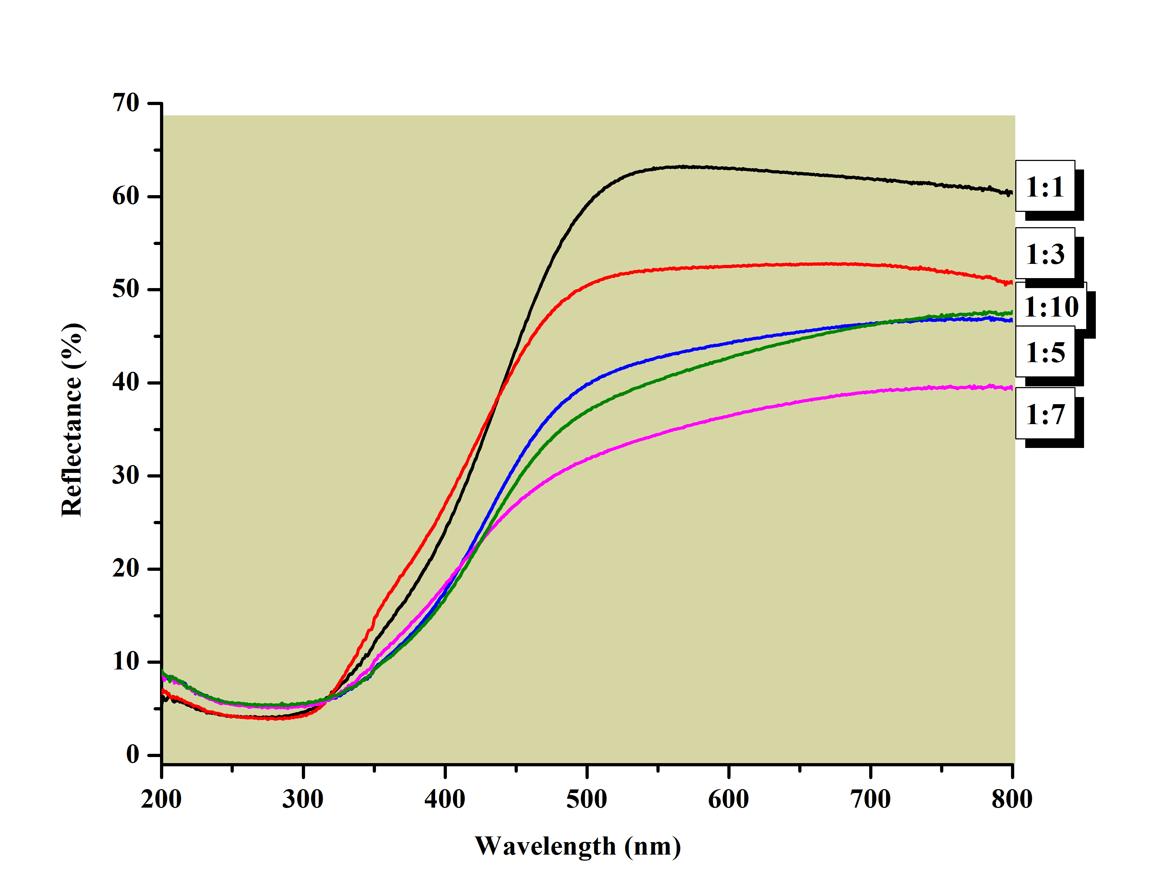

**(a)**

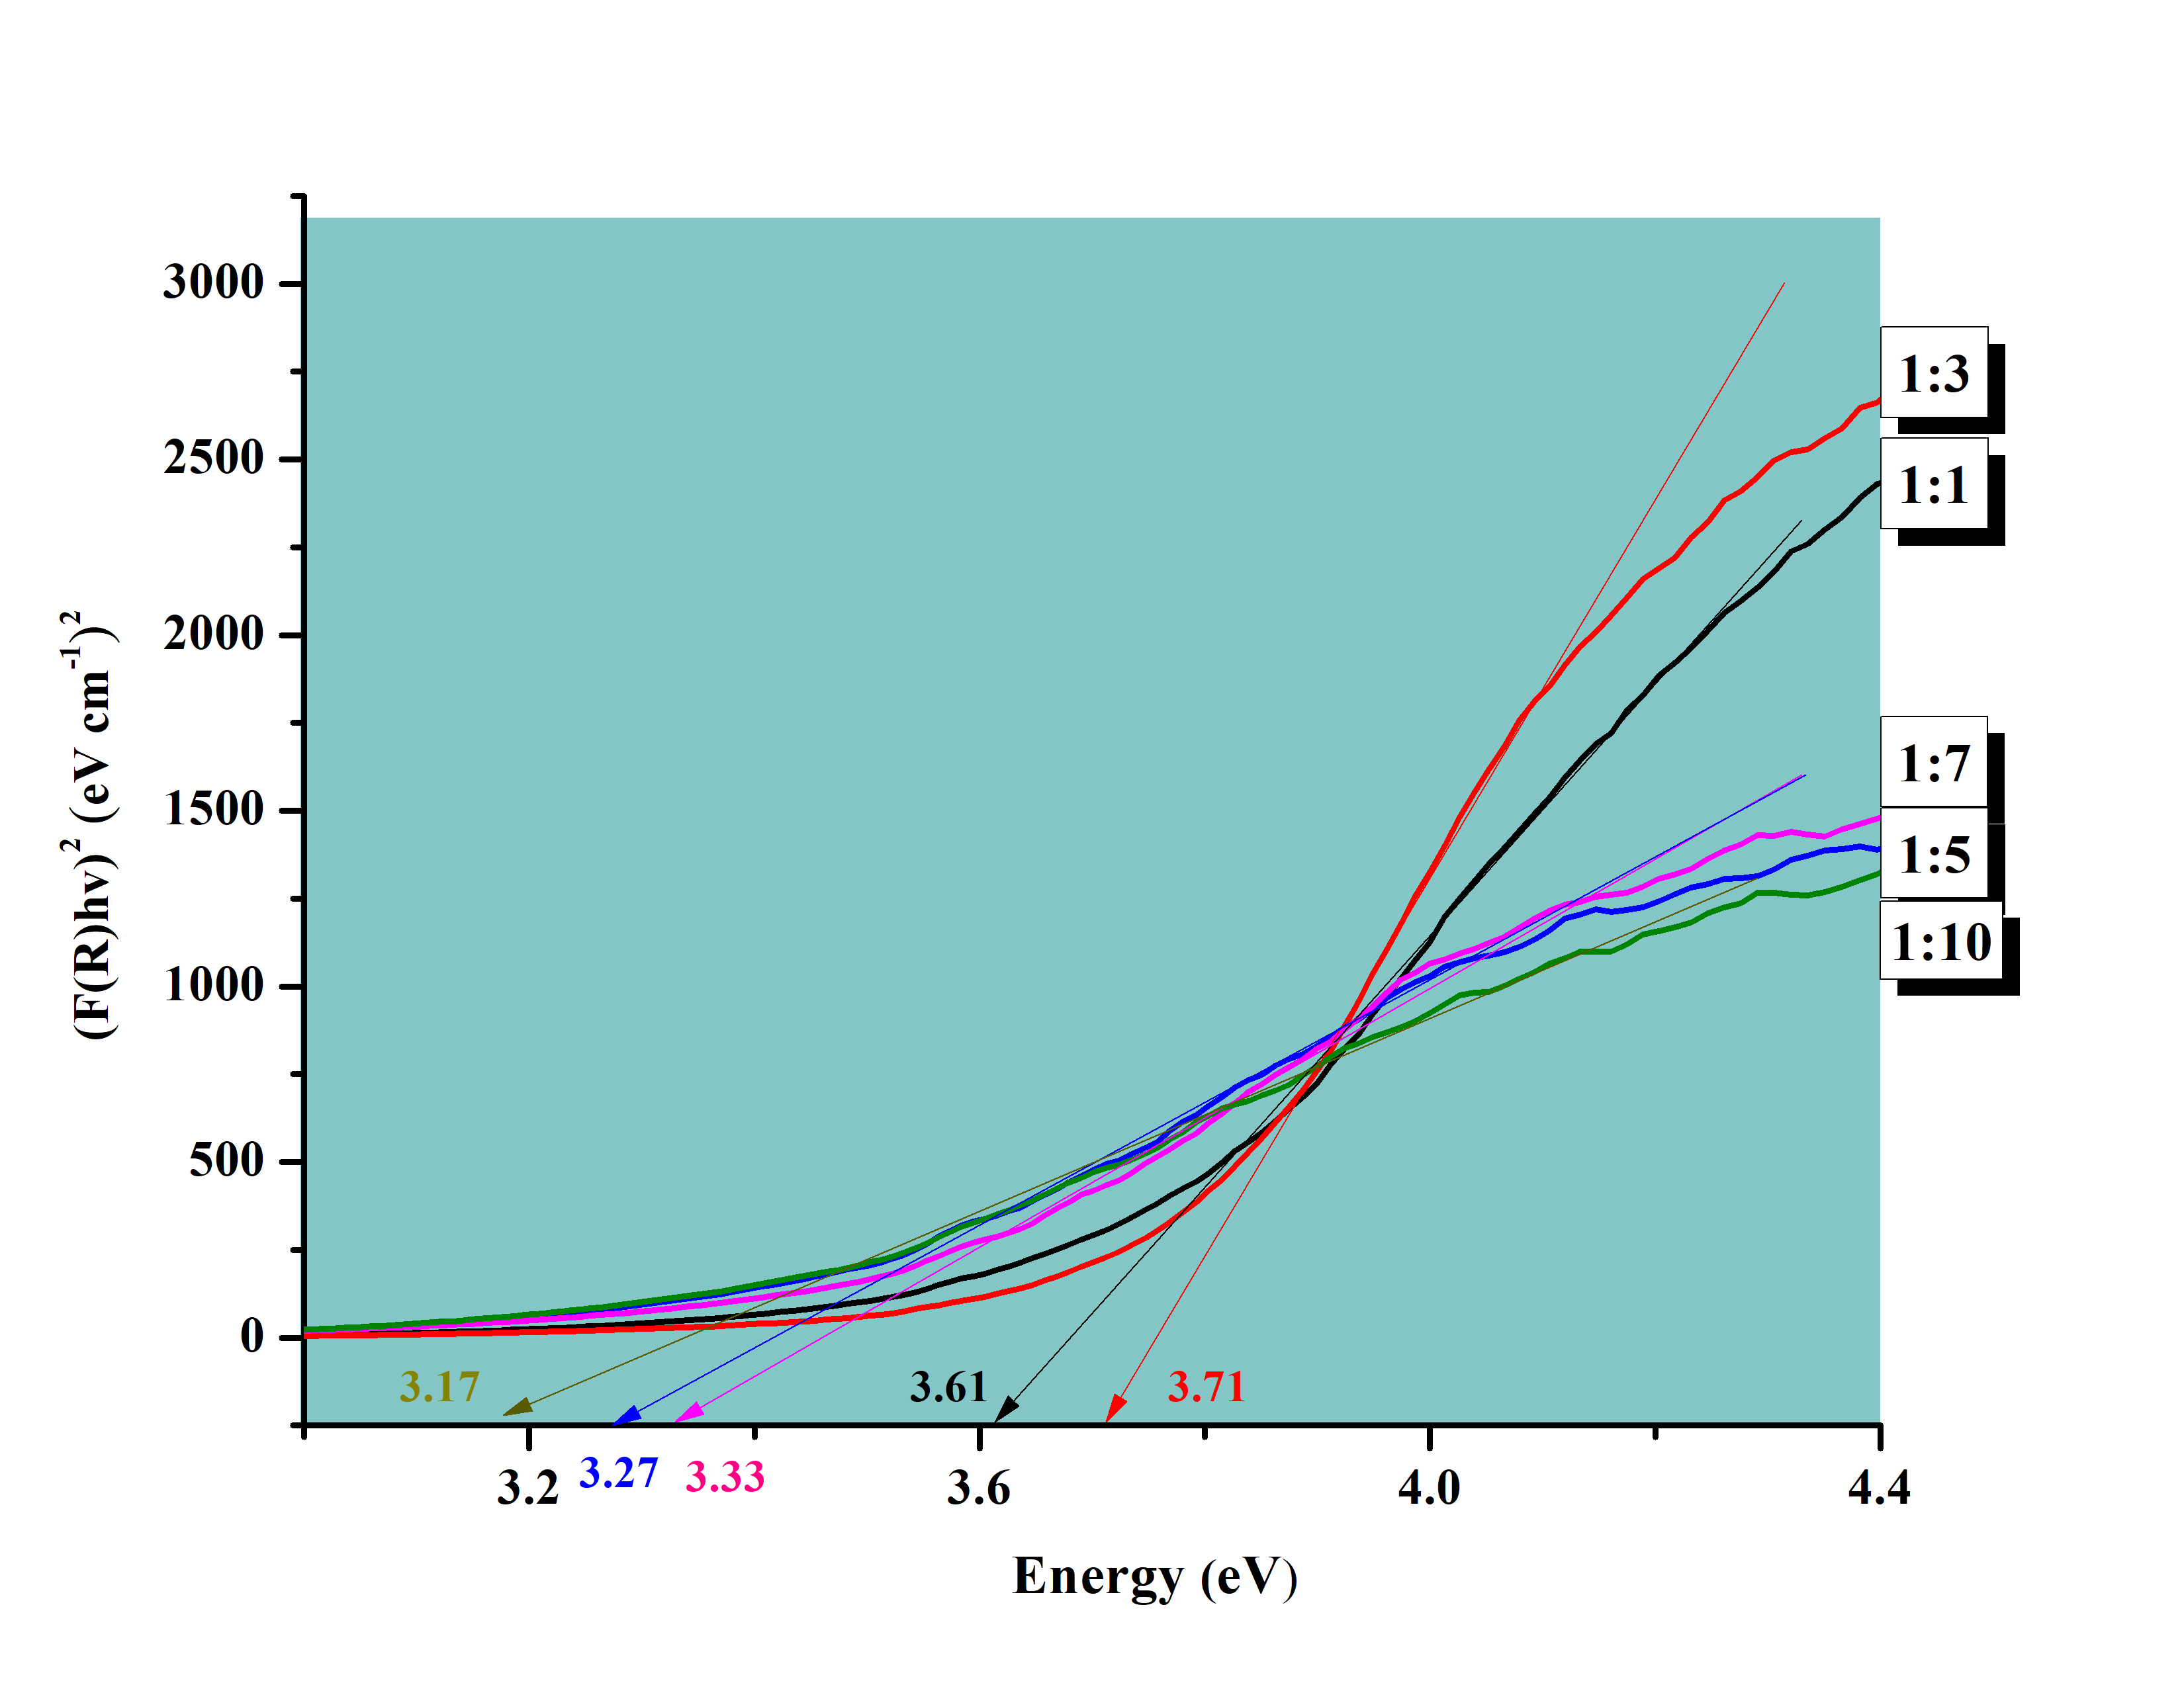

**(b)**

**Figure 3**. (a) Reflectance spectra and (b) Tauc plot of SnO₂ NPs using various extract concentrations

## X-ray photoelectron spectroscopy (XPS)

Lower energy band gap values require less energy to excite electrons from the valence band to the conduction band. Therefore, the SnO₂ composition with a ratio of 1:10, which exhibited the lowest band gap value of 3.17 eV, was selected for further investigation. The phase composition and chemical states of Sn and O elements was analyzed and the results are illustrated in the Figure 4a-c. The presence of Sn, O and C elements is confirmed by the survey spectra (Figure 4a). Meanwhile, doublet peaks corresponding to Sn 3d₅/₂ and Sn 3d₃/₂, with binding energies of 487.5 eV and 495.9 eV, providing further characterization of the tin oxidation state (Figure 4b). Moreover, the O 1s XPS spectrum of SnO₂ NPs reveals a well-defined singlet peak at a binding energy of 531.4 eV, attributed to lattice oxygen and its interaction with O₂ ions within the tetragonal structure associated with Sn²⁺ ions. (Figure 4c). The synthesized SnO₂ NPs exhibited atomic concentrations of 49.66% for O 1s and 22.91% for Sn 3d. These findings are consistent with values reported in earlier studies [61][62].

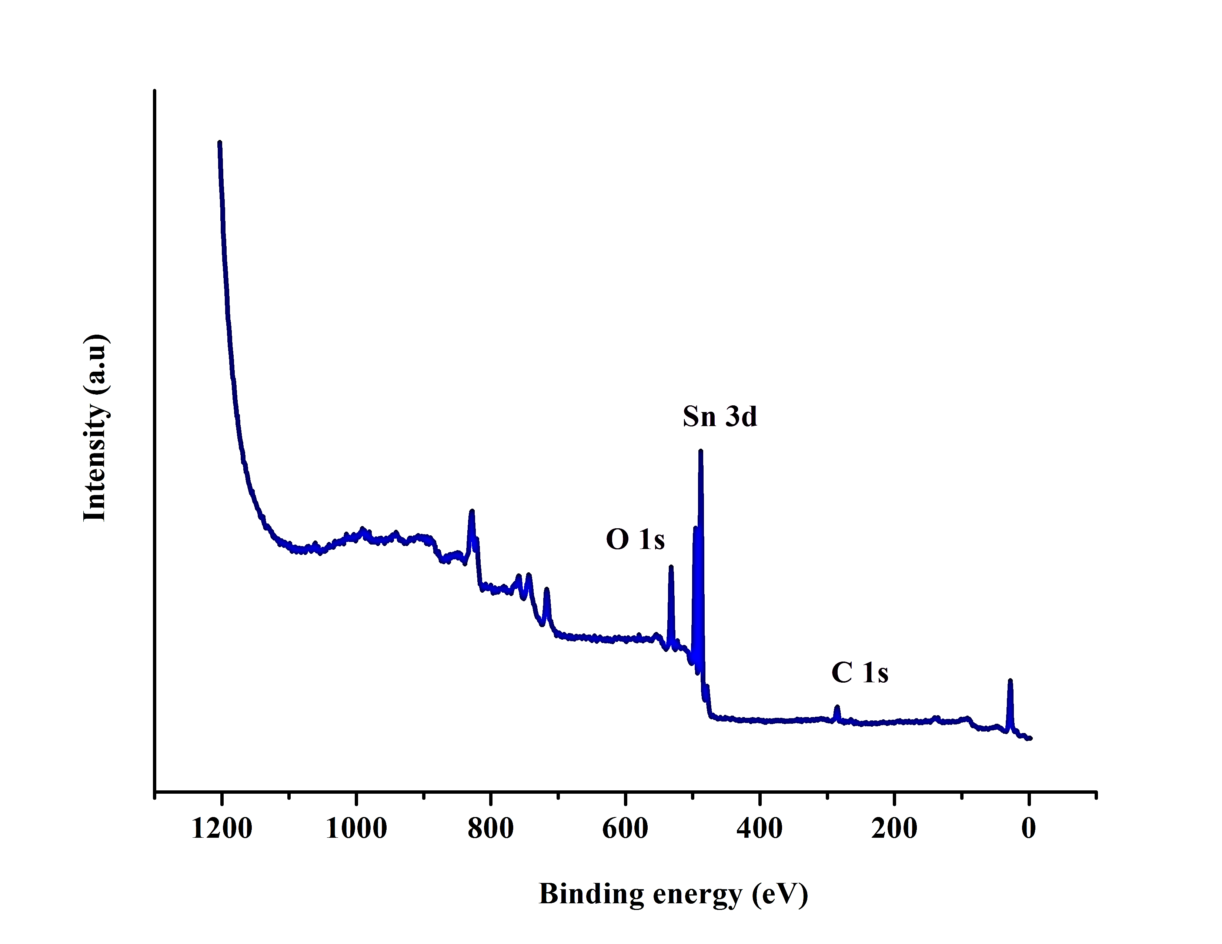

**(a)**

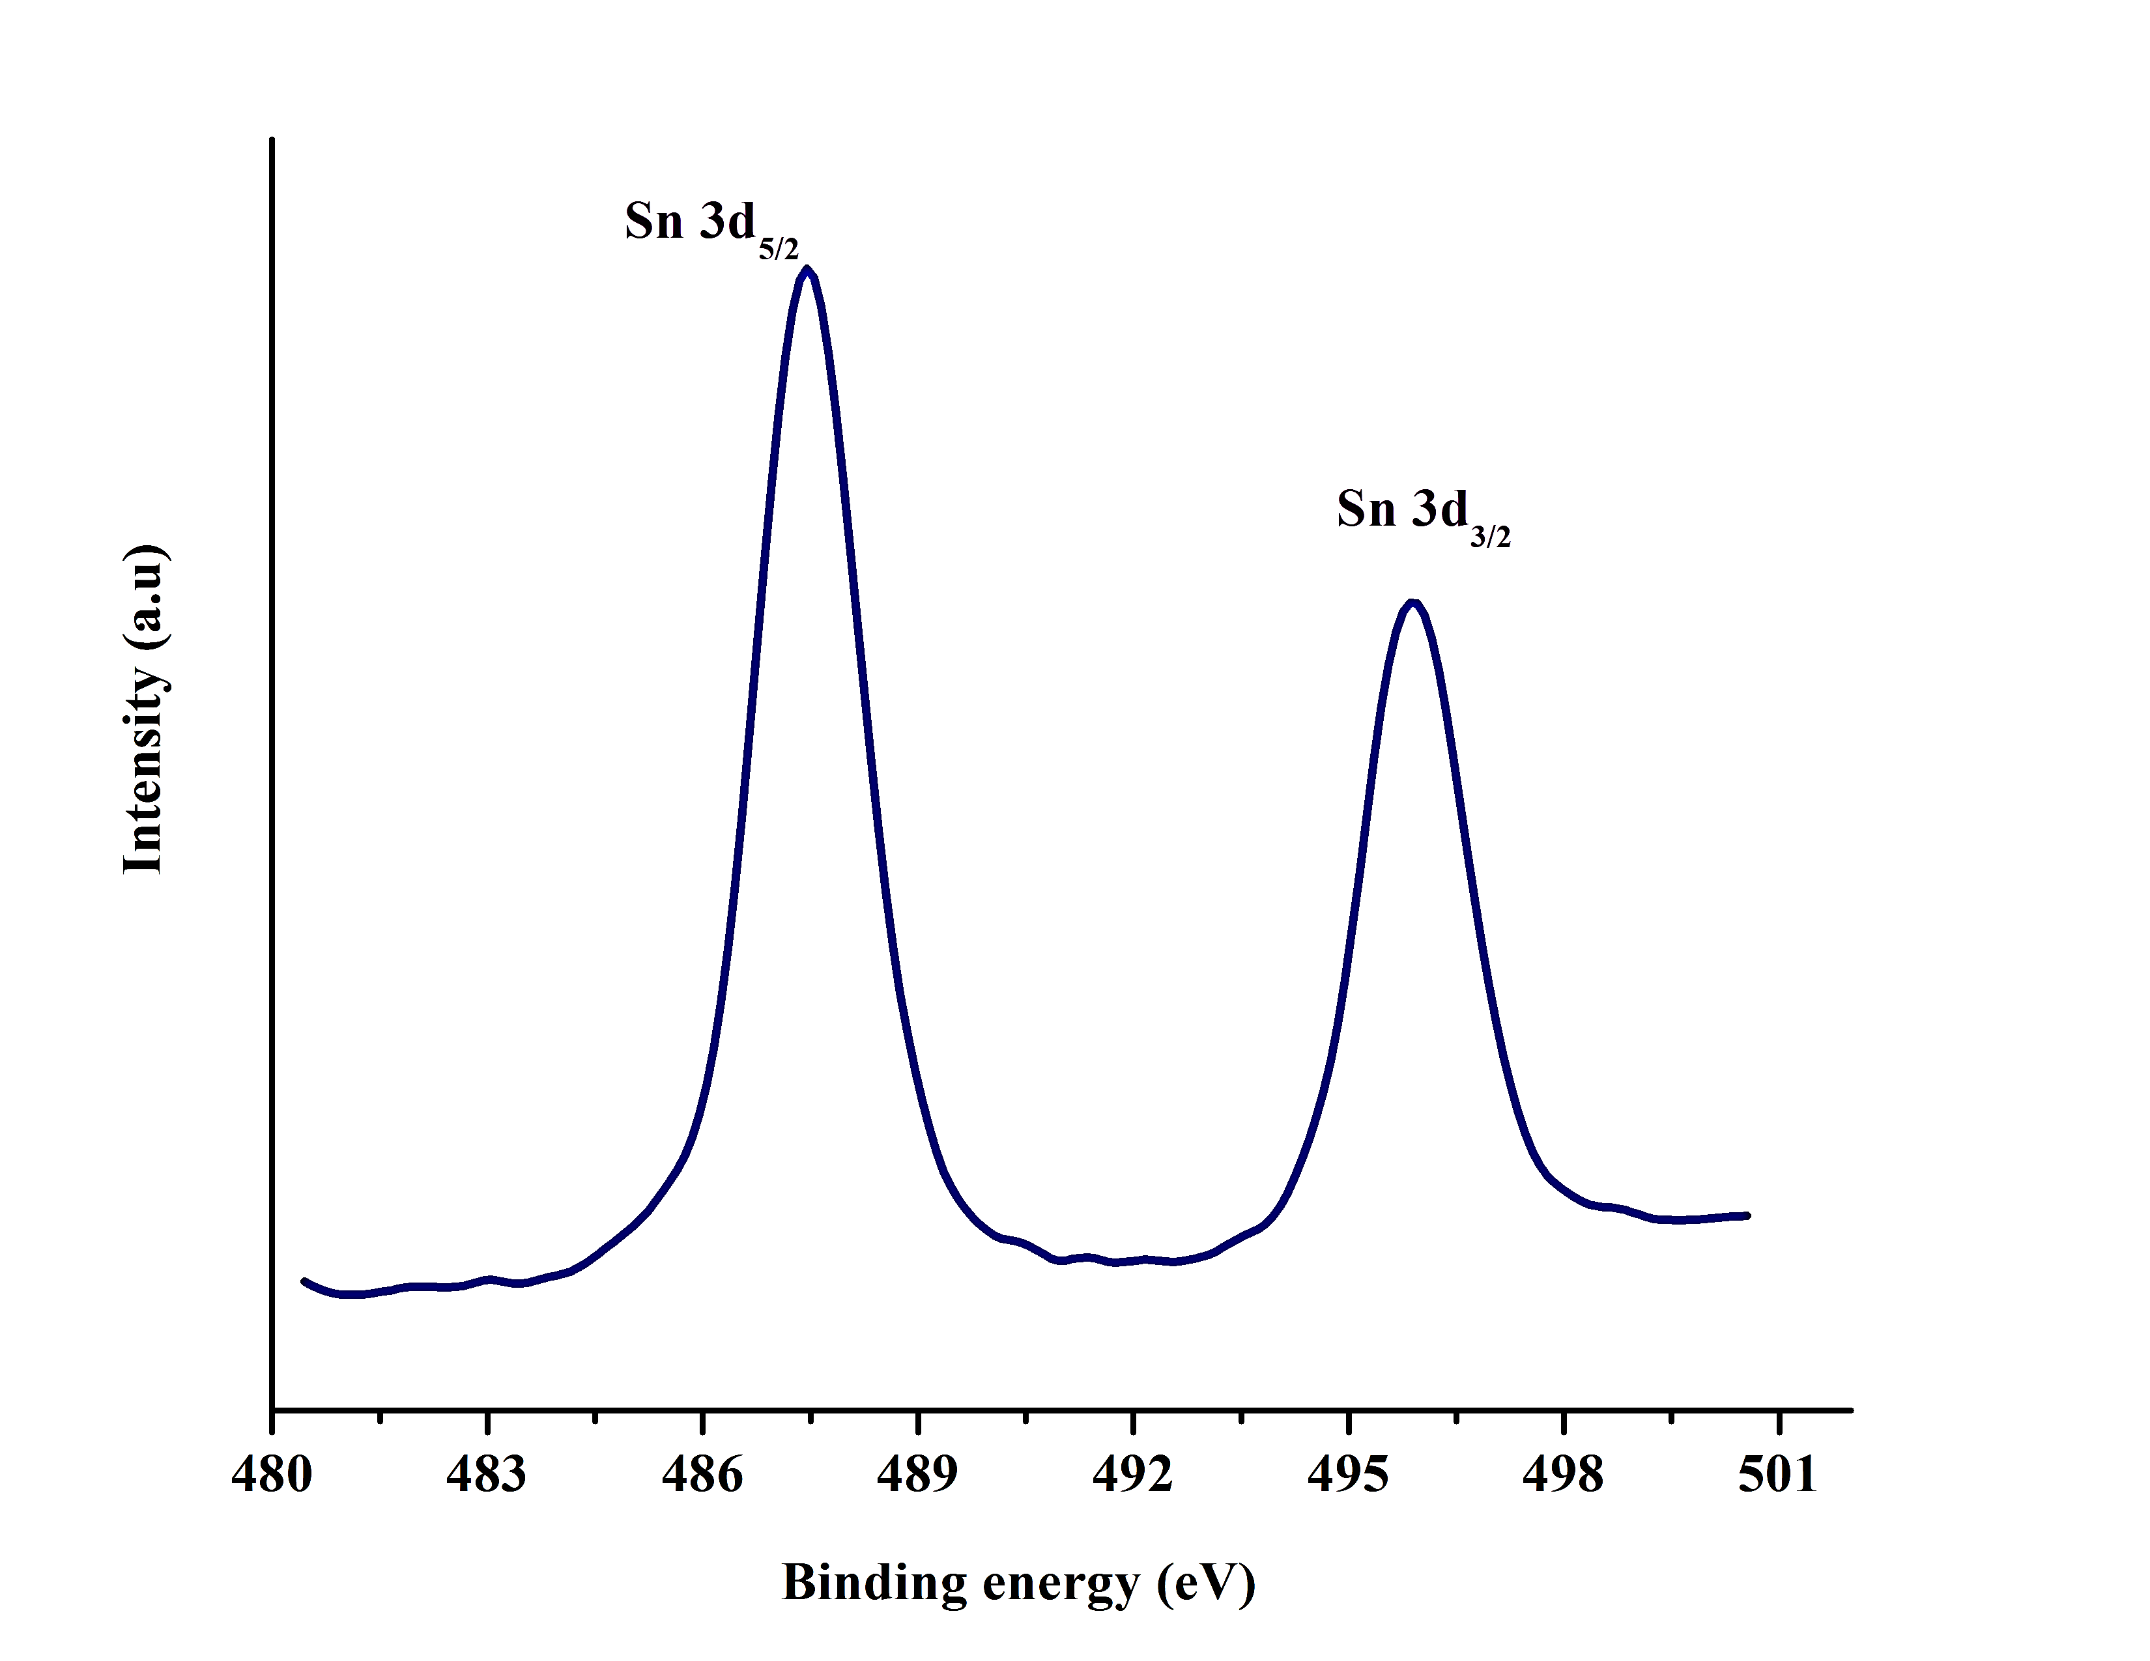

**(b)**

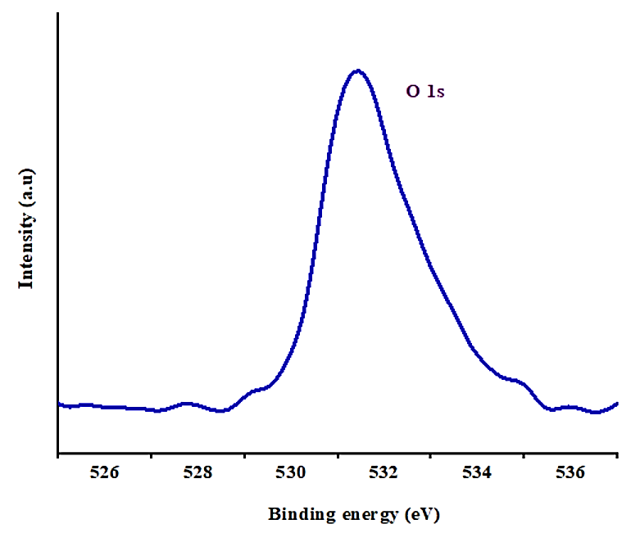

**(c)**

**Figure 4**. XPS spectra of SnO2 NPs; (a) XPS spectra, (b) Sn 3d peak and (c) O 1s peak of SnO₂ NPs synthesized using a 1:10 extract ratio

# Conclusion

The green synthesis of SnO₂ NPs using *Morinda citrifolia* leaf extract was successfully achieved, with extract concentration playing a significant role in modulating the nanoparticles' characteristics. The 1:3 precursor-to-extract ratio produced SnO₂ NPs with superior crystallinity, optimal Sn-O bonding and the highest energy band gap (3.71 eV), indicating strong quantum confinement and minimal structural defects. Conversely, the 1:10 ratio showed a significant band gap reduction (3.17 eV), likely due to increased lattice disorder and oxygen vacancies. XRD, FTIR, UV-DRS and XPS analyses consistently validated the formation of high-purity SnO₂ NPs with tunable optical and structural properties. These results highlight the potential of *M. citrifolia* as an effective and sustainable resource for the eco-friendly fabrication of SnO₂ NPs with tailored functionalities suitable for applications in optoelectronics, sensors and photocatalysis.

ACKNOWLEDGMENTS

Authors acknowledge the Universiti Teknologi MARA for funding under the Geran Insentif Penyelidikan Skim Q (GPQ) (600-RMC 5/3/GPQ (001/2023)).

REFERENCES

1. S. A. Ahire, A. A. Bachhav, T. B. Pawar, B. S. Jagdale, A. V. Patil, and P. B. Koli, "The augmentation of nanotechnology era: A concise review on fundamental concepts of nanotechnology and applications in material science and technology," *Results Chem*, vol. 4, pp. 100633, 2022.
2. S. Jadoun, R. Arif, and N. K. Jangid, "Green synthesis of nanoparticles using plant extracts: a review," *Environ. Chem. Lett*, vol. 19, pp. 355–374, 2021.
3. V. Harish, M. M. Ansari, D. Tewari, A. B. Yadav, N. Sharma, S. Bawarig, M.-L. García-Betancourt, A. Karatutlu, M. Bechelany, and A. Barhoum, "Cutting-edge advances in tailoring size, shape, and functionality of nanoparticles and nanostructures: A review," *J. Taiwan Inst. Chem. Eng*, vol. 149, pp. 105010, 2023.
4. Y. Han, J. Li, X. Zhang, and F. Xia, "Reversible down-regulation and up-regulation of catalytic activity of poly(N-isopropylacrylamide)-anchored gold nanoparticles," *Nanotechnology*, vol. 33, no. 16, pp. 165601, 2022.
5. I. Buniyamin, R. Md Akhir, N. A. Asli, Z. Khusaimi, and M. F. Malek, "Nanotechnology applications in biomedical systems," *Curr. Nanomater*, vol. 17, pp. 167–180, 2022.
6. H. S. Hussein, “The state of the art of nanomaterials and its applications in energy saving,” *Bull. Natl. Res. Cent*, vol. 47, pp. 7, 2023.
7. P. and P. Payal, “Role of nanotechnology in electronics: A review of recent developments and patents,” *Recent Pat. Nanotechnol*, vol. 16, no. 1, pp. 45–66, 2022.
8. W. Sadik, A. M. El-Demerdash, A. W. Nashed, A. A. Mostafa, and E. Lamie, “Synthesis and investigation of optical properties and enhancement photocatalytic activity of TiO2-SnO2 semiconductor for degradation of organic compounds,” *Sci. Rep*, vol. 14, no. 27846, pp. 1-24, 2024.
9. M. A. Dheyab, A. A. Aziz, M. S. Jameel, and N. Oladzadabbasabadi, “Recent advances in synthesis, modification, and potential application of tin oxide nanoparticles,” *Surfaces and Interfaces*, vol. 28, pp. 101677, 2022.
10. A. S. Yusuf, A. A. Abubakar, I. K. Mohammed, U. Ahmadu, and K. U. Isah, “A review of coating tin oxide electron transport layer for optimizing the performance of perovskite solar cells,” *Chem. Inorg. Mater*, vol. 6, pp. 100100, 2025.
11. M. S. G. K. Dalapati, H. Sharma, A. Guchhait, N. Chakrabarty, P. Bamola, Q. Liu, G. Saianand, A. M. S. Krishna, S. Mukhopadhyay, A. Dey, T. K. S. Wong, S. Zhuk, S. Ghosh, and S. Cha, "Tin oxide for optoelectronic, photovoltaic and energy storage devices: a review," J. Mater. Chem. A, vol. 9, pp. 16621, 2021.
12. H. Sun, C. Yang, J. Xu, M. Cui, Y. Ren, W. Zhang, J. Zhao, and B. Liang, "Recent intensification strategies of SnO₂-based photocatalysts: A review," Chem. Eng. J, vol. 427, pp. 131564, 2022.
13. J. Ye, Y. Li, A. A. Medjahed, S. Pouget, D. Aldakov, and Y. Liu, "Perovskite solar cells: Doped bilayer tin(IV) oxide electron transport layer for high open-circuit voltage planar perovskite solar cells with reduced hysteresis," Small, vol. 17, no. 5, pp. 2170020, 2021.
14. E. Pargoletti, U. H. Hossain, I. D. Bernardo, H. Chen, T. Tran-Phu, G. L. Chiarello, J. Lipton-Duffin, V. Pifferi, and A. Tricoli, "Engineering of SnO₂-graphene oxide nanoheterojunctions for selective room-temperature chemical sensing and optoelectronic devices," ACS Appl. Mater. Interfaces, vol. 12, no. 35, pp. 39549–39560, 2020.
15. F. Zoller, D. Böhm, T. Bein, and D. Fattakhova-Rohlfing, "Tin oxide-based nanomaterials and their application as anodes in lithium-ion batteries and beyond," ChemSusChem, vol. 12, pp. 4140–4159, 2019.
16. S. Deepa, A. M. Philip, K. A. S. George, and Prasannakumari, "Microstructural, optical and dielectric variations in SnO₂ nanoparticles synthesized via surfactant-assisted sol–gel route," J. Mater. Sci.: Mater. Electron., vol. 44, pp. 283, 2021.
17. I. Buniyamin, M. R. Mahmood, and Z. Khusaimi, "Utilization of tin oxide nanoparticles synthesized through plant-mediated methods and their application in photocatalysis: A brief review," Int. J. Chem. Biochem. Sci, vol. 24, pp. 116–123, 2023.
18. Yu, Y. Dou, J. Zhao, S. Zhu, and K. Zhang, "A review of metal oxide semiconductors: Progress in solution-processed photovoltaic technologies," J. Alloys Compd, vol. 1024, pp. 180207, 2025.
19. G. H. Patel, S. Chaki, R. Kannaujiya, Z. Parekh, A. B. Hirpara, and A. J. Khimani, "Sol-gel synthesis and thermal characterization of SnO₂ nanoparticles," Phys. B Condens. Matter, vol. 613, pp. 412987, 2021.
20. L. E. Ahmadabad, F. S. Kalantari, H. Liu, A. Hasan, N. A. Gamasaee, Z. Edis, F. Attar, M. Ale-Ebrahim, F. Rouhollah, M. M. N. Babadaei, M. Sharifi, K. Shahpasand, K. Akhtari, M. Falahati, Y. Cai, "Hydrothermal method-based synthesized tin oxide nanoparticles: Albumin binding and antiproliferative activity against K562 cells," Mater. Sci. Eng. C, vol. 119, pp. 111649, 2021.
21. U. M. Nayef, A. J. Hadi, S. K. Abdulridha, F. A.-H. Mutlak, and A. F. Ahmed, "Tin dioxide nanoparticles synthesized via laser ablation in various liquids medium," *J. Opt*, vol. 52, pp. 441–448, 2023.
22. M. Gurgula, R. Zazpe, J. Rodriguez-Pereira, L. Hromadko, and J. M. Macak, "Improving photoelectrochemical performance of SnO₂ nanocones through TiOx shell via atomic layer deposition*," Electrochim. Acta*, vol. 519, pp. 145854, 2025.
23. R. A. Tayeb, A. Alsafrani, and A. Khan, "Microwave-assisted synthesis and photoluminescence characterization of tetragonal rutile phase of SnO₂," *Semiconductors*, vol. 59, no. 4, pp. 318–327, 2025.

1. N. Rani, P. Singh, S. Kumar, P. Kumar, and V. Bhankar, "Plant-mediated synthesis of nanoparticles and their applications: A review," *Mater. Res. Bull*, vol. 163, pp. 112233, 2023.
2. I. Buniyamin, M. F. A. Halim, K. A. Eswar, K. J. Jalani, S. A. I. A. Syed Abd Kadir, M. Mohammad, M. Y. Idorus, N. A. Asli, and M. R. Mahmood, "Natural biomolecules in leaves and fruit extracts mediate the biosynthesis of SnO₂ nanoparticles: A mini review," Int. J. *Pharm. Nutraceut. Cosmet. Sci*, vol. 6, no. 2, pp. 24–40, 2023.
3. S. Sagadevan, J. A. Lett, I. Fatimah, Y. Lokanathan, M. M. H., and M. R. J. W. C. Oh, "Current trends in the green syntheses of tin oxide nanoparticles and their biomedical applications," *Mater. Res. Express*, vol. 8, pp. 082001, 2021.
4. V. Soni, P. Raizada, P. Singh, H. N. Cuong, R. S., A. Saini, R. V. Saini, Q. V. Le, A. K. Nadda, and T.-T. Le, "Sustainable and green trends in using plant extracts for the synthesis of biogenic metal nanoparticles toward environmental and pharmaceutical advances: A review," *Environ. Res*, vol. 202, pp. 111622, 2021.
5. M. G. T. Nathan and P. Myvizhi, "Green Synthesis and Characterization of Tin Oxide Nanoparticles Using Plant Extract," *Int. J. Pure Appl. Math*, vol. 119, pp. 6439–6448, 2018.
6. Singha, N. Kaura, P. Kaur, S. Kaur, P. Kukkar, V. Kumar, and D. Kukkar, "Piper betle leaves mediated synthesis of biogenic SnO₂ nanoparticles for photocatalytic degradation of reactive yellow 186 dye under direct sunlight," *Environ. Nanotechnol. Monit. Manag*, vol. 10, pp. 1–9, 2018.
7. I. Buniyamin, N. A. Asli, K. A. Eswar, S. A. I. A. Syed Abd Kadir, A. Saiman, M. Y. Idorus, M. R. Mahmood, and Z. Khusaimi, "Biosynthesis of tin(IV) oxide nanoparticles (SnO₂ NPs) via *Chromolaena Odorata* leaves: The Influence of heat on the extraction procedure," *J. Sci. Math. Lett*, vol. 12, no. 2, pp. 142–150, 2024.
8. S. Haq, W. Rehman, M. Waseem, M. Shahid, K. H. S., and M. Nawaz, "Adsorption of Cd²⁺ ions on plant mediated SnO₂ nanoparticles," *Mater. Res. Express*, vol. 3, pp. 105019, 2016.
9. A. Ayeshamariam, T. M. Begam, J. M. Jayachandran, P. K. G. Praveen Kumar, and M. Bououdina, "Green synthesis of nanostructured materials for antibacterial and antifungal activities," *Int. J. Bioassays*, vol. 2, no. 1, pp. 304–311, 2013.
10. I. Buniyamin, N. A. Asli, F. S. Husairi, K. A. Eswar, M. Mohammad, M. Rusop, and Z. Khusaimi, "The photocatalytic characteristics of tin oxide nanoparticles synthesized through Aquilaria malaccensis," *Int. J. Chem. Biochem*. Sci, vol. 24, no. 7, pp. 63–73, 2023.
11. S. N. Matussin, M. H. Harunsani, A. L. Tan, A. Mohammad, M. H. Cho, and M. M. Khan, "Photoantioxidant studies of SnO₂ nanoparticles fabricated using aqueous leaf extract of *Tradescantia spathacea*," *Solid State Sci*, vol. 105, pp. 106279, 2020.
12. I. Buniyamin, R. M. Akhir, M. Z. Nurfazianawatie, H. Omar, N. S. A. Malek, N. F. Rostan, K. A. Eswar, N. F. Rosman, M. A. Abdullah, N. A. Asli, Z. Khusaimi, and M. Rusop, "*Aquilaria malaccensis* and *Pandanus amaryllifolius* mediated synthesis of tin oxide nanoparticles: The effect of the thermal calcination temperature," *Mater. Today Proc*, vol. 75, pp. 23–30, 2023.
13. N. Awoke, D. Pandey, and A. B. Habtemariam, "Synthesis of tin(IV) oxide nanoparticles using plant leaf extracts of *Vernonia amygdalina* and *Mentha spicata*," *Regen. Eng. Transl. Med*, vol. 8, pp. 407–412, 2021.
14. S. Sang, X. Cheng, N. Zhu, R. E. Stark, V. Badmaev, G. Ghai, and R. T. R. and C.-T. H., "Flavonol glycosides and novel iridoid glycoside from the leaves of *Morinda citrifolia*," *J. Agric. Food Chem*, vol. 49, pp. 4478–4481, 2001.
15. H. Setyani and H. Setyowati, "Phytochemical investigation of noni (*Morinda citrifolia L*.) leaves extract applicated for sunscreen product," *Malaysian J. Fundam. Appl. Sci*, pp. 164–167, 2018.
16. I. V. Makarov, A. J. Love, O. V. Sinitsyna, S. S. Makarova, N. O. Kalinina, and M. E. Taliansky, "‘Green’ nanotechnologies: Synthesis of metal nanoparticles using plants," *Acta Naturae*, vol. 6, no. 1, pp. 35–44, 2014.
17. Y. V. S. Oliveira, M. M. R. Azevedo, C. A. Felsemburgh, J. de Souza, A. K. O. Lima, H. C. Braga, D. B. Tada, K. Gul, G. Nakazato, and P. S. Taube, "Green synthesis of silver nanoparticles from cumaru (*Dipteryx odorata*) leaf extract," *Discover Applied Sciences*, vol. 7, pp. 227, 2025.
18. I. Buniyamin, N. A. Asli, R. Md Akhir, S. M. Jafar, K. A. Eswar, M. K. A. Mahmood, M. Y. Idorus, M. S. Shamsudin, A. F. M. M. Rahman, M. R. Mahmood, and Z. Khusaimi, "Biofabricated SnO2 nanoparticles derived from leaves extract of *Morinda citrifolia* and *Pandanus amaryllifolius* for photocatalytic degradation," *J. Clust. Sci*, vol. 36, pp. 3, 2025.
19. F. Is, G. Purwiandono, M. H. Jauhari, A. A. A. P. Maharani, S. Sagadevan, W.-C. Oh, and R.-A. Doong, "Synthesis and control of the morphology of SnO2 nanoparticles via various concentrations of *Tinospora cordifolia* stem extract and reduction methods," *Arab. J. Chem*, vol. 15, pp. 103738, 2022.
20. G. Ramanathan and K. R. Murali, "Photocatalytic activity of SnO2 nanoparticles," *J. Appl. Electrochem*, vol. 52, pp. 849–859, 2022.
21. N. Bahari, N. Hashim, K. Abdan, A. Md Akim, and B. M. Al-Shdifat, "Role of honey as a bifunctional reducing and capping/stabilizing agent: Application for silver and zinc oxide nanoparticles," *Nanomaterials*, vol. 13, pp. 1244, 2023.
22. J. T. Wang, X. L. Shi, W. W. Liu, X. H. Zhong, J. N. Wang, L. Pyrah, K. D. Sanderson, P. M. Ramsey, and M. Hirata, "Influence of preferred orientation on the electrical conductivity of fluorine-doped tin oxide films," *Sci. Rep*, vol. 4, pp. 3679, 2014.
23. N. F. H. Zambri, E. Yusrianto, N. Marsi, and I. A. Manaf, "Phase formation and microstructure properties of autoclaved aerated concrete (AAC) based on ceramic and gypsum waste (CGW) as raw material addition," *J. Adv. Res. Micro Nano Eng*, vol. 30, no. 1, pp. 10–21, 2024.
24. H. Köse, Ş. Karaal, A. O. Aydin, and H. Akbulut, "Structural properties of size-controlled SnO₂ nanopowders produced by sol-gel method," *Materials Science in Semiconductor Processing*, vol. 38, pp. 404–412, 2015.
25. N. Motloung, S. V. Tsega, M. Dejene, H. C. Swart, H. M. Om, L. F. Koao, and T. E. Motaung, "Effect of annealing temperature on structural and optical properties of ZnAl2O4: 1.5% Pb2+ nanocrystals synthesized via sol-gel reaction*," J. Alloy Compd*, vol. 677, pp. 72–79, 2016.
26. M. K. Hussen and F. B. Dejene, "Influence of annealing temperature on material properties of red emitting ZnGa₂O₄:Cr³⁺ nanostructures*," J. Sol-Gel Sci. Technol,* vol. 88, pp. 454–464, 2018.
27. H. E. Garrafa-Galvez, O. Nava, C. A. Soto-Robles, A. R. Vilchis-Nestor, A. Castro-Beltrán, and P. A. Luque, "Green synthesis of SnO₂ nanoparticle using *Lycopersicon esculentum* peel extract," *J. Mol. Struct*, vol. 1197, pp. 354-360, 2019.
28. M. P. A. Luque, M. J. Chinchillas-Chinchillas, O. Nava, E. Lugo-Medina, L. E. Martínez-Rosas, A. Carrillo-Castillo, A. R. Vilchis-Nestor, H. E. Garrafa-Galvez, and E. Madrigal-Muñoz, "Green synthesis of tin dioxide nanoparticles using *Camellia sinensis* and its application in photocatalytic degradation of textile dyes," *Int. J. Light Electron Opt*, vol. 229, pp. 166259, 2021.
29. S. Manir, "Size-strain distribution analysis from XRD peak profile of (Mg, Fe) co-doped SnO2 nanoparticles fabricated using chemical co-precipitation route," *Ceram. Int*, vol. 50, no. 21, pp. 44038–44055, 2024.
30. R. Verma, A. Chauhan, Neha, K. M. Batoo, R. Kumar, M. Hadhi, and E. H. Raslan, "Effect of calcination temperature on structural and morphological properties of bismuth ferrite nanoparticles," *Ceram. Int*, vol. 47, pp. 3680–3691, 2021.
31. H. E. Quintero González, E. L. Medina, R. V. Quevedo Robles, H. E. Garrafa Gálvez, Y. A. Baez Lopez, E. V. Viveros, F. A. Molina, A. R. Vilchis Nestor, and P. A. Luque Moral, "A study of the optical and structural properties of SnO₂ nanoparticles synthesized with *Tilia cordata* applied in methylene blue degradation," *Symmetry*, vol. 14, pp. 2231, 2022.
32. G.-B. Hong and C.-J. Jiang, "Synthesis of SnO2 nanoparticles using extracts from Litsea cubeba fruits," *Mater. Lett*, vol. 194, pp. 164–167, 2017.
33. T. S. Suresh Sagadevan, J. Anita Lett, S. F. Alshahateet, I. Fatimah, G. K. Weldegebrieal, M.-V. Le, S. Paiman, and E. Leonard, "Photocatalytic degradation of methylene blue dye under direct sunlight irradiation using SnO₂ nanoparticles," *Inorg. Chem. Commun*, vol. 141, pp. 109547, 2022.
34. I. Buniyamin, Z. Khusaimi, N. A. Asli, K. A. Eswar, M. R. Mahmood, S. A. I. A. S. A. Kadir, A. Saiman, M. Y. Idorus, and A. R. A. Razak, "The application of pandan and soybean extracts on the biosynthesis of tin oxide nanoparticles," *J. Sci. Math. Lett*, vol. 12, no. 2, pp. 83–92, 2024.
35. N. M. Al-Hada, H. M. Kamari, A. A. Baqer, A. H. Shaari, and E. Saion, "Thermal calcination-based production of SnO₂ nanopowder: an analysis of SnO₂ nanoparticle characteristics and antibacterial activities," *Nanomaterials*, vol. 8, pp. 250, 2018.
36. B. P. Narasaiah, P. Banoth, A. Sohan, B. K. Mandal, A. G. Bustamante Dominguez, L. D. L. S. Valladares, and P. Kollu, "Green biosynthesis of tin oxide nanomaterials mediated by agro-waste cotton boll peel extracts for the remediation of environmental pollutant dyes," *ACS Omega*, vol. 7, pp. 15423–15438, 2022.
37. G. Kiruthiga, K. S. Rajni, N. Geethanjali, T. Raguram, E. Nandhakumar, and N. Senthilkumar, "SnO₂: Investigation of optical, structural, and electrical properties of transparent conductive oxide thin films prepared by nebulized spray pyrolysis for photovoltaic applications," *Inorg. Chem. Commun*, vol. 145, pp. 109968, 2022.
38. Y. Etafa, T. K. Sarma, and T. K. Sahu, "Phytosynthesis and characterization of tin‑oxide nanoparticles (SnO₂‑NPs) from *Croton macrostachyu*s leaf extract and its application under visible light photocatalytic activities," *Sci. Rep*, vol. 14, pp. 10780, 2024.
39. A. Phukan, R. P. Bhattacharjee, and D. K. Dutta, "Stabilization of SnO₂ nanoparticles into the nanopores of modified Montmorillonite and their antibacterial activity," *Adv. Powder Technol*, vol. 28, pp. 139–145, 2017.