Comparative Analysis of Bovine Serum Albumin Detection Using Cuvettes, Biofunctionalized and Non-Biofunctionalized Tapered Optical Fiber

Nur Nadia Bachoka, Norhafizah Burhamb, Ahmad Razi Othmanc, Nurul Huda Abd Karimd, Ahmad Ashrif A Bakara Retna Apsarie and Norhana Arsada *

aPhotonics Technology Laboratory, Department of Electrical, Electronic and Systems Engineering, Faculty of Engineering and Built Environment, Universiti Kebangsaan Malaysia, 43600 UKM Bangi, Selangor, Malaysia  
b Integrated Microelectronics System and Applications (IMSaA), School of Electrical Engineering, College of Engineering, Universiti Teknologi MARA, 40450 Shah Alam, Selangor, Malaysia  
cDepartment of Chemical and Process Engineering, Faculty of Engineering and Built Environment, Universiti Kebangsaan Malaysia, 43600 UKM Bangi, Selangor, Malaysia  
 dDepartment of Chemical Science, Faculty of Science and Technology, Universiti Kebangsaan Malaysia, 43600 UKM Bangi, Selangor, Malaysia  
eDepartment of Engineering, Faculty of Advanced Technology and Multidiscipline, Universitas Airlangga, Jl. Mulyorejo, Surabaya 60115, Indonesia  
* Corresponding author. Tel.: 03-8911-8363; e-mail: noa@ukm.edu.my

Received XXX 2023, Revised XXX 2023, Accepted XXX 2023

ABSTRACT

Advances in optical sensor technologies have been substantial in recent years, especially in the detection of biomolecules like Bovine Serum Albumin (BSA), driven by the need for more sensitive and precise diagnostic tools. The detection of BSA plays a critical role, particularly in the early diagnostic tools for chronic kidney disease. This work aims to investigate the performance of three different BSA detection methods: biofunctionalized and non-biofunctionalized tapered optical fiber sensors, and conventional cuvettes. This study conducted an experimental investigation, utilizing 3.5 ml cuvette and tapered optical fibers with design parameters including upper and lower taper lengths of 10 mm, a waist length of 10 mm, and a waist diameter of 10 µm. The sensors were fabricated using the Vytran GPX 3400 machine. Measurements of time response, intensity, and absorbance were carried out using a Deuterium-Tungsten DT-2-GS light source and an Ocean Optics Flame spectrometer. The biofunctionalization of the sensing area involved three sequential steps: hydroxylation with a 0.1M sodium hydroxide solution, salinization with a 2% (3-aminopropyl) triethoxysilane solution, and aldehyde activation using a 2% glutaraldehyde solution. The experiment used 120 ml of BSA solutions at concentrations of 31.25 mg/dL, 62.5 mg/dL, and 125 mg/dL. Each method exhibits a unique spectral response across the ultraviolet, visible, and near-infrared, regions. Both intensity and absorbance assessments reveal a significant reduction in sensitivity when transitioning from the cuvette to the tapered optical fiber. Notably, the sensitivity decreases by 99.96% for intensity measurements and by 97.76% for absorbance. Nonetheless, after biofunctionalization, the tapered optical fiber's sensitivity increased, showing a 207.1% increase in absorbance and a 1494.72% increase in intensity measurements compared to the non-bio functionalized tapered optical fiber.

**Keywords:** Spectrometer, bovine serum albumin, intensity, absorbance, tapered optical fiber, biofunctionalized, biosensor

# INTRODUCTION

Optical technologies have significantly impacted us in various sectors, including security [1], [2], communication, [3], [4], imaging [5], [6], and healthcare [7], [8]. The ongoing advancements in optical sensor applications hold great promise for further innovations. The creation of temperature [9], vibration [10], humidity [11], and gas [12] sensors are notable examples of research in this area. Each of these sensors improves accuracy and productivity in its own sector. Research has consistently demonstrated the significant potential of various bio-optical sensors, including D-Fiber, U-Fiber, Fiber Bragg Gratings (FBG), Mach-Zehnder interferometers, and Surface Plasmon Resonance (SPR) sensors [13], [14]. Evidence from several experimental studies has established that bio-optical sensors offer high sensitivity and can be quantified This exciting development creates new opportunities to investigate its possible uses in the biosensors industry.

The rising incidence of kidney-related diseases is a growing concern [15]. For many decades albuminuria has served as a marker for kidney issues. However, in a study conducted by Teeuw et.al (2021) and Mejia et al. (2022), it was shown that current detection methods using urine dipsticks perform poorly[16], [17]. Furthermore, Thakur (2021) stresses that paper-based urine dipstick indicates albumin presence through color changes that lead to semi quantitative and lack of sensitivity, particularly for concentrations below 300 mg/dL [18]. Taken together, these studies support the notion of finding new alternatives to detect and quantify albumin. The increasing body of literature reflects a commitment to exploring innovative sensor technologies that enhance detection capabilities and broaden applications in biomedical fields.

There is a vast literature on several light sources for element detection are used through sensors, including ultraviolet (UV)[19], visible (VIS)[20] and near-infrared (NIR)[21]. Each type of light possesses unique properties that impact the detection mechanism differently. The distinct characteristics of each light source play a critical role in optimizing sensor performance and enhancing detection capabilities. Furthermore, improvements in the optical substrate’s properties can be realized either through surface modifications or by promoting interactions with targeted materials, resulting in notable enhancements in optical performance. These advancements play a critical role in increasing the sensor's precision and effectiveness across various applications. ~~Despite the substantial research conducted on optical sensors, there remains a gap in the literature—no study to date has systematically compared the performance of identical light sources across different optical substrates and the modifications. The diversity of these studies complicates the assessment of sensor performance, necessitating a comprehensive analysis to accurately determine their efficacy in various applications. Another promising optical sensor worth further exploration is the tapered fiber optic sensor, which offers several notable advantages. Its high sensitivity and straightforward fabrication process make it a compelling candidate for a broad range of applications in sensing technology, particularly in scenarios requiring precise detection of concentration changes. The simplicity of its design, coupled with its enhanced sensitivity, positions tapered fiber optics as an essential tool for future advancements in the field.~~ Despite these advances, the current literature lacks a comprehensive comparison of BSA detection performance across multiple sensing modalities using a unified light source and detection system. Specifically, there is limited analysis that concurrently evaluates time response, light intensity, and absorbance across cuvette-based, non-biofunctionalized, and biofunctionalized tapered optical fiber methods.

This paper experimentally demonstrates the optical properties of various concentrations of Bovine Serum Albumin (BSA) using three different mediums: cuvettes, non-bio functionalized tapered optical fiber sensors, and bio-functionalized tapered optical fiber sensors. While cuvettes are commonly employed in the biochemical field, this comparison aims to evaluate the performance of non-biofunctionalized and biofunctionalized tapered optical fiber sensors against the standard cuvette method. By analyzing the data from these sensors, we highlight their effectiveness in BSA detection.

# THEORETICAL BACKGROUND

## Electromagnetic Waves

~~Electromagnetic waves are waves made up of two fields: the electric field and the magnetic field. These fields move together through space, and they are always at right angles to each other, as well as to the direction the wave is traveling.~~ Electromagnetic waves are characterized by the presence of two orthogonal fields: the electric field and the magnetic field. These fields propagate simultaneously through space, maintaining perpendicular orientations relative to each other and to the direction of wave propagation.

## Maxwell's Equations and Wave Equation

~~Maxwell's equations describe how electric and magnetic fields interact. In a simple material (non-ferromagnetic, with no charges or currents), these equations combine into what's called the "wave equation." The wave equation helps describe how the electric field (E) changes in space and time:~~The interaction between electric and magnetic fields is governed by Maxwell’s equations. In a homogeneous, non-ferromagnetic medium devoid of free charges and currents, these equations can be simplified and combined to yield the wave equation. This equation describes the spatial and temporal evolution of the electric field

$\frac{∂^{2}}{∂x^{2}}E\left(x,t\right)=\frac{1}{εc^{2}}\frac{∂^{2}}{{∂t}^{2}}E\left(x,t\right)$ (1)

where

$E\left(x,t\right)$ is the electric field at position x and time t;

$ε$ is the dielectric constant;

$c$ is the speed of light in a vacuum.

## Evanescent Wave

The evanescent wave (EW) plays an important role in enhancing the sensor's sensitivity. It appears in the near-surface electromagnetic field when light experiences total internal reflection at the interface between two media with different refractive indexes, such as core and cladding. In a standard optical fiber, this wave is not able to interact with the analyte significantly because it decays exponentially in the cladding. EW intensity *I(z)* decays can be described by :

$I(z)=I_{0}e^{-αz}$ (2)

where

$I_{0}$ is the initial intensity of the EW at the surface

α is the decay constant

Exponentially decaying waves can penetrate the medium, and the penetration depth $d_{p}$ can be explained by:

$d_{p}=\frac{λ}{2π{\left(n_{co}^{2}{\sin{θ}}^{2}-n_{cl}^{2}\right)}^{\frac{1}{2}}}$ (3)

where

*λ* is wavelength of incident light

θ is incident angle at core-medium interface

The sensor was tapered to enhance the strength of the EW in the cladding area. Its diameter was reduced to less than its core diameter, allowing light to pass through the analyte at the sensing area. In the tapered region, Point Z represents the location between the core and cladding layers where the incident angle is produced, as illustrated in Figure 1. Incident angle $θ_{i}\left(z\right)$ is given by :

$θ_{i}\left(z\right)=\frac{π}{2}-β_{T}-α_{z}$ (4)

where $β_{T}$ and $α_{z}$ correspond to the taper and launch angle respectively. The taper angle ($β_{T}$) can be explained as follows:

$β_{T}= \tan^{-1}\left(\frac{R_{0}-R_{L}}{L}\right)$ (5)

where $R_{0},R_{L}$ and *L* are the initial radius, final taper radius, and tapered region length, respectively.

The taper profile influences the launch angle $α_{z}$ for a tapered structure. In the specific case of a linear taper geometry, the relationship between these parameters can be described by the following equation:

$α_{z}=\sin^{-1}\left[\frac{\sin{α_{0}}}{z\left({R_{L}/R}_{0}-1\right)/L+1}\right]$ (6)

Here, $z$ represents the height and spans the range from ${ R}_{L}$ to $R_{0}$, while $α_{0}$ denotes the initial angle of the guided ray at the fiber's input end. However, for a parabolic profile, the relationship varies. The $α_{z}$ is characterized as follows:

$α_{z}=\sin^{-1}\left[\frac{\sin{α_{0}}}{z\left({R_{L}/R}_{0}-1\right)/L+1}\right]$ (7)

For an exponential tapered fiber, the relationship is described as follows:

$α_{z}=\sin^{-1}\left[\frac{\sin{α_{0}}}{z\left(1-{R_{L}/R}_{0}\right)\left[exp\left(-z/L\right)-\left(\frac{z}{L}\right)exp⁡(-1)\right]+R_{L}/R_{0}}\right]$ (8)

The equations indicate that the angle $α_{z}$ in the taper geometry impacts the penetration depth of the evanescent waves, which subsequently influences the sensitivity of the sensor.

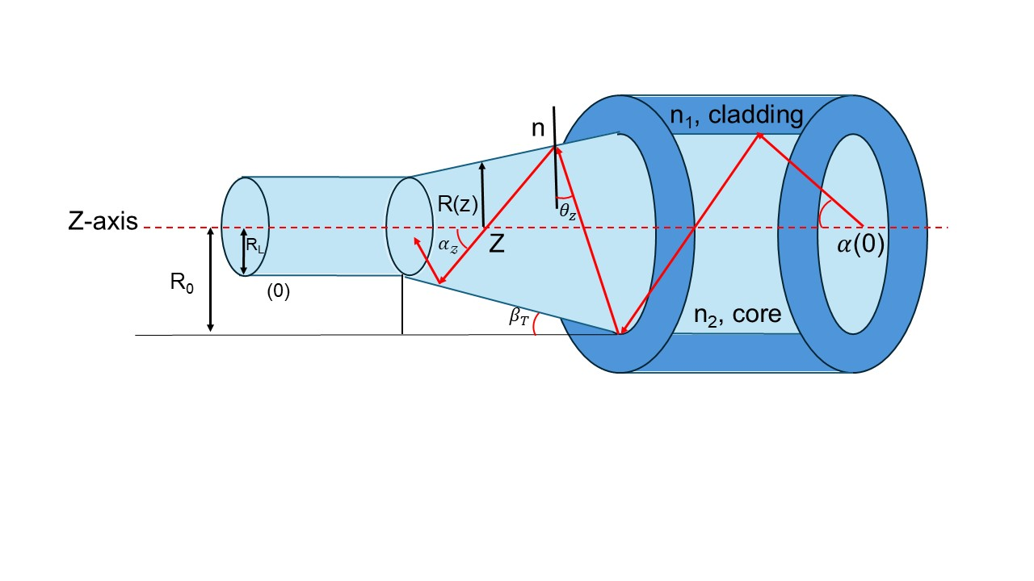

**Figure 1**. Light transmission in tapered optical fiber BSA measurement experimental setup using cuvette

# METHODOLOGY

In this study, three experimental setups were employed for investigation: a cuvette, a non-bio-functionalized tapered optical fiber, and a bio-functionalized tapered optical fiber.

## Sample Preparation

### BSA Solution Preparation

In this investigation, BSA solutions were prepared at concentrations ranging from 125 mg/dL to 31.25 mg/dL. A precise mass of 62.5 mg of BSA pellets was measured using an analytical balance. Approximately 40-45 mL of deionized (DI) water was added to a beaker, into which the BSA pellets were gradually introduced. The mixture was gently stirred until complete dissolution of the BSA pellets in the DI water was achieved. The resulting BSA solution was then transferred to a volumetric flask, and the beaker was rinsed with additional DI water to ensure complete transfer of the solution. DI water was added to the volumetric flask until the final volume reached 50 mL. The volumetric flask was then inverted multiple times to ensure thorough mixing of the solution.

### Sodium Hydroxide Solution Preparation

Sodium hydroxide supplied by R&M Chemical company is utilized for the hydroxylation process on the sensing surface. Precisely 0.4 g of NaOH was measured with a weighing scale and dissolved in 100 mL of deionized water.

### 3-aminopropyltriethoxysilane (APTES) Solution Preparation

A 2% (v/v) solution of 98% pure 3-aminopropyltriethoxysilane (APTES) was prepared for experimental purposes. The APTES reagent, obtained from Sigma-Aldrich, was measured using a micropipette, transferring 1.02 mL of the 98% solution into a beaker. Deionized water was then added to the beaker to achieve a final volume of 50 mL. The mixture was continuously stirred to ensure that the APTES was uniformly diluted to the target 2% concentration.

### Glutaraldehyde Solution Preparation

A 2 mL aliquot of 50% glutaraldehyde solution (Sigma-Aldrich) was accurately measured with a micropipette, transferred to a beaker, and diluted with deionized water to a final volume of 50 mL. All safety precautions were observed, and the mixture was thoroughly stirred for homogenization.

### Tapered Optical Fiber Fabrication

The heat-pull technique has been used to fabricate tapered fiber optic sensors using a Vytran machine (GPX-3400). This method was employed due to its capability to fabricate tapered fibers with uniformity and precision [22]. The parameters employed for this sensor are derived from an optimized design, carefully refined through extensive experimental validation by previous researchers [23]. Initially, the cladding layer in the central portion of the optical fiber was stripped away. The prepared fiber was then positioned in the filament zone of the machine, with both ends secured in the fiber holders. During the heating process, driven by a motor, the fiber holders created two tapered sections on either side of a thinner central region. This central region serves as the sensing area of the tapered optical fiber sensor.

## Experimental Set Up

### Conventional Cuvette Method

The experimental setup, as illustrated in Figure 2, comprised a DT-2-GS light source linked to the cuvette holder through the SMA 905 multimode optical fiber cable, with another component connected to the Flame Ocean Optic spectrometer via another SMA 905 multimode optical fiber cable. A 3.5 mL quartz cuvette was utilized throughout the experiment. Three BSA solutions, with concentrations varying from 125 mg/dL to 31.25 mg/dL, were prepared and subsequently measured using the cuvette.

**Figure 2**. BSA measurement experimental setup using cuvette

### Non-Bio Functionalized Tapered Optical Fiber

In the second experimental setup, illustrated in Figure 3, the configuration was the same as the initial setup, except that the cuvette and cuvette holder were replaced with non-bio functionalized tapered fiber sensors and a sensor holder. The tapered optical fiber used in this setup featured a waist length of 10 mm, a waist diameter of 10 µm, an upper taper length of 10 mm, and a lower taper length of 10 mm. The process involved using the Dip-Coat technique to apply BSA solutions to the sensor area until the submerged section of the sensor was completely immersed in the solution.

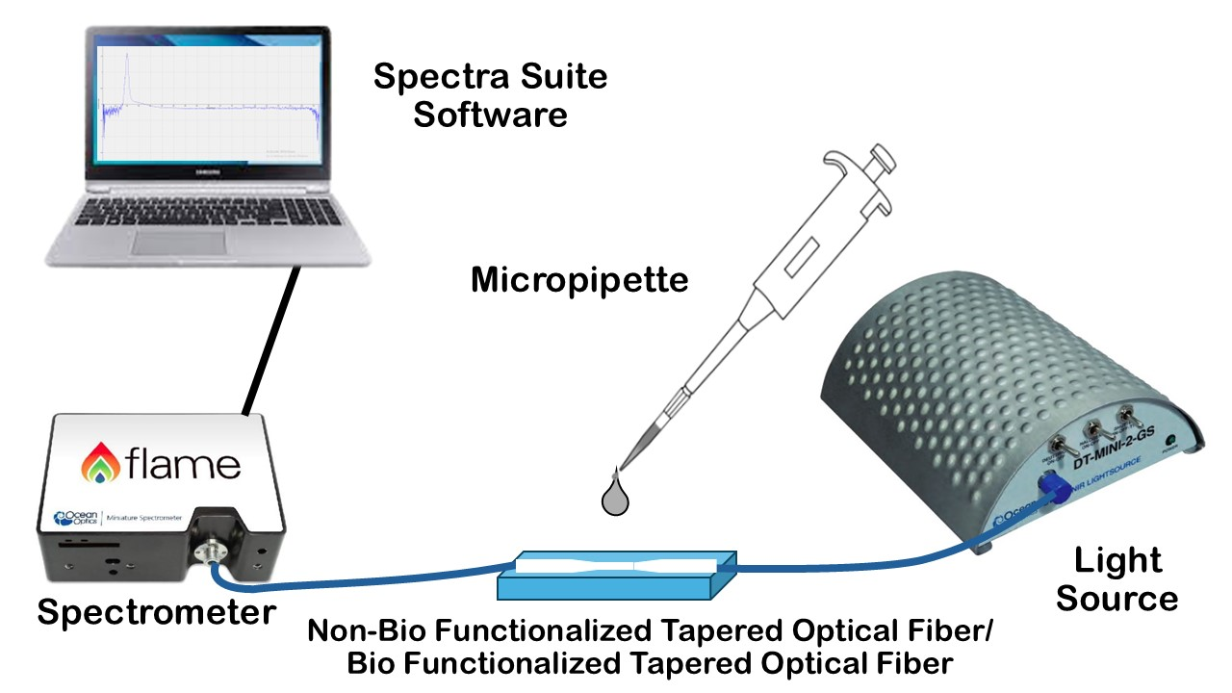

**Figure 3**. BSA measurement experimental setup using non-bio functionalized tapered optical fiber/biofunctionalized tapered optical fiber

### Biofunctionalized Tapered Optical Fiber

The biofunctionalization of the sensor was implemented to enhance the adhesion of organic analytes to the sensing surface, comprising three main steps: hydroxylation, salinization, and aldehyde treatment. The experimental procedures and material formulations utilized in this study are based on methodologies established in prior research [24]. The hydroxylation process aimed to increase the density of hydroxyl (–OH) groups on the sensor's surface. To achieve this, 120 µL of 0.1 M sodium hydroxide (NaOH) was applied to the optical fiber sensor, which was then left to soak for one hour.

Subsequently, the salinization process was conducted to convert the hydroxyl groups into aminopropyl groups. This involved immersing the sensor in a 2% (v/v) solution of 3-aminopropyltriethoxysilane (APTES) for one hour. The final step, aldehyde treatment, served as a bifunctional linker to facilitate the attachment of BSA to the sensor. During this phase, aldehyde molecules bonded to the free amino groups on the silane-treated sensor, forming covalent amide bonds, while other aldehyde groups interacted with the amine groups present in BSA.

The effectiveness of each functionalization step was monitored by measuring the optical absorption rate with a spectrometer. After completing the biofunctionalization process, the sensor was rinsed three times with deionized water and allowed to dry at room temperature. The sensor was then set up as in Figure 2. The experiment utilized the Dip Coating method, where a BSA solution was carefully applied to the detection region. The sensing region was then allowed to air dry for three hours to ensure proper binding and stability of the BSA molecules.

# DATA COLLECTION AND ANALYSIS

## Time Responses

In this study, response times for three methods were systematically recorded for comparative analysis across various methods as shown in Figure 4. As depicted in Figure 4 (a), the response time of absorption measurements using a cuvette showed an initial spike to 3.5 optical density (OD) within the first 70 seconds, likely reflecting instability due to the introduction of the BSA sample. The system subsequently stabilized at 140 seconds, reaching an OD value of 0.68.

Further graph, Figure 4(b) shows that during the initial 100 seconds, absorption rose gradually, peaking at 0.28 OD over the next 50 seconds, followed by a decline to 0.041 OD with subsequent fluctuations. Stabilization occurred at approximately 330 seconds, with a final absorption value of 0.036 OD. The early spikes observed in both the cuvette and optical fiber sensor methods are attributed to interactions between the BSA molecules and the detection medium.

The initial spikes observed in Figures 4(a) and 4(b) during the early phase of absorbance measurements are likely attributable to several transient phenomena. These include initial mixing effects, wherein the BSA molecules may not be uniformly distributed within the medium, resulting in temporary concentration gradients that influence light absorption. Additionally, the formation of microbubbles or trapped air during sample loading can introduce localized scattering and refractive index changes, thereby distorting the optical signal. Solution settling may further contribute, as protein molecules require time to stabilize within the detection volume, leading to fluctuations in absorbance as the system transitions toward equilibrium. Moreover, early-phase interactions between BSA molecules and the detection surface whether the inner cuvette wall or the tapered optical fiber interface can induce temporary refractive index shifts or incomplete binding states, affecting the evanescent field or direct light path. Collectively, these factors produce short-lived perturbations in the absorbance signal prior to achieving steady-state conditions.

Additionally, Figure 4(c) illustrates a sharp decrease in absorption to -0.038 OD within the first 40 seconds, followed by a gradual deceleration up to 800 seconds. This initial decline is ascribed to the interaction of BSA molecules with the functionalized surface, which involved energy release, resulting in negative absorption values.

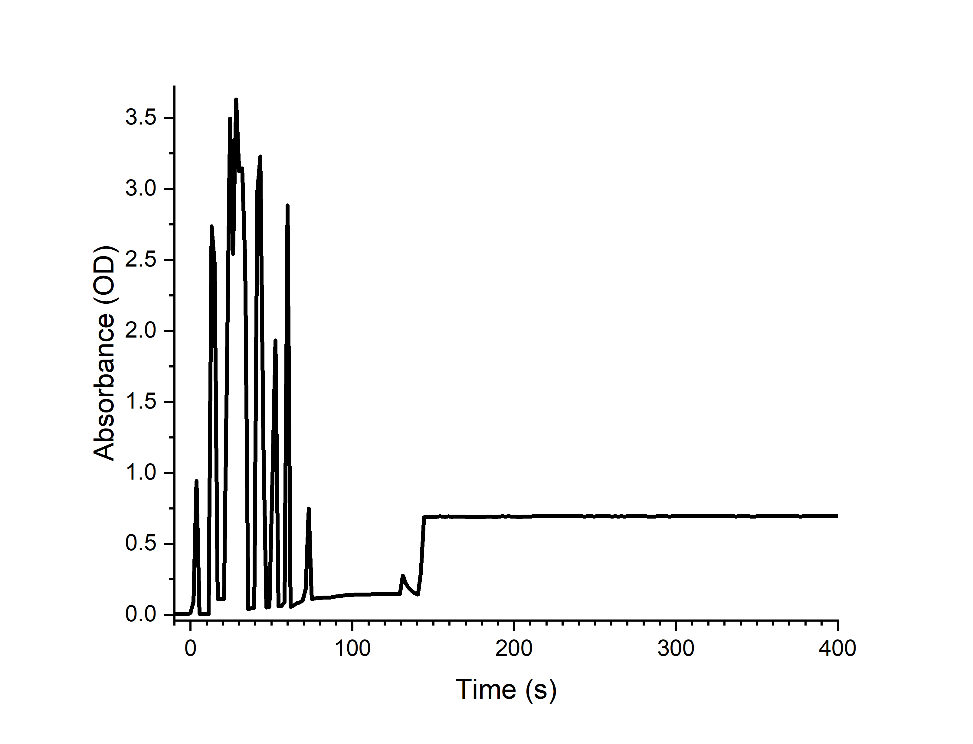(a)

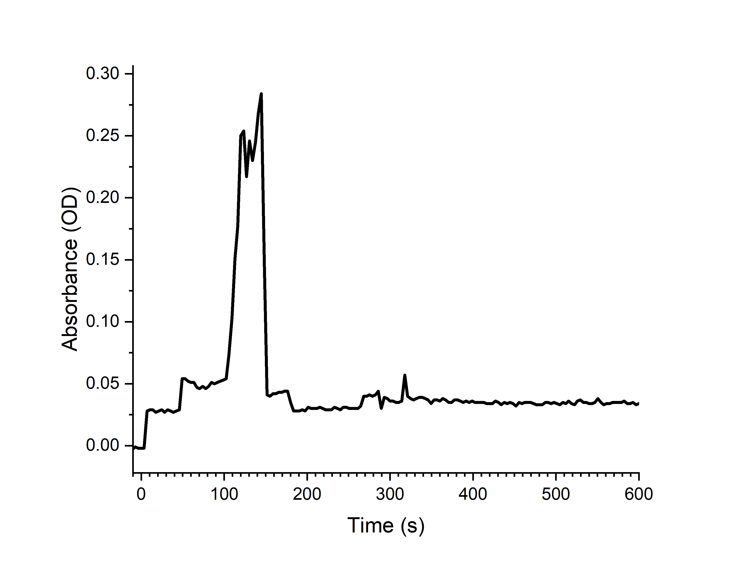 (b)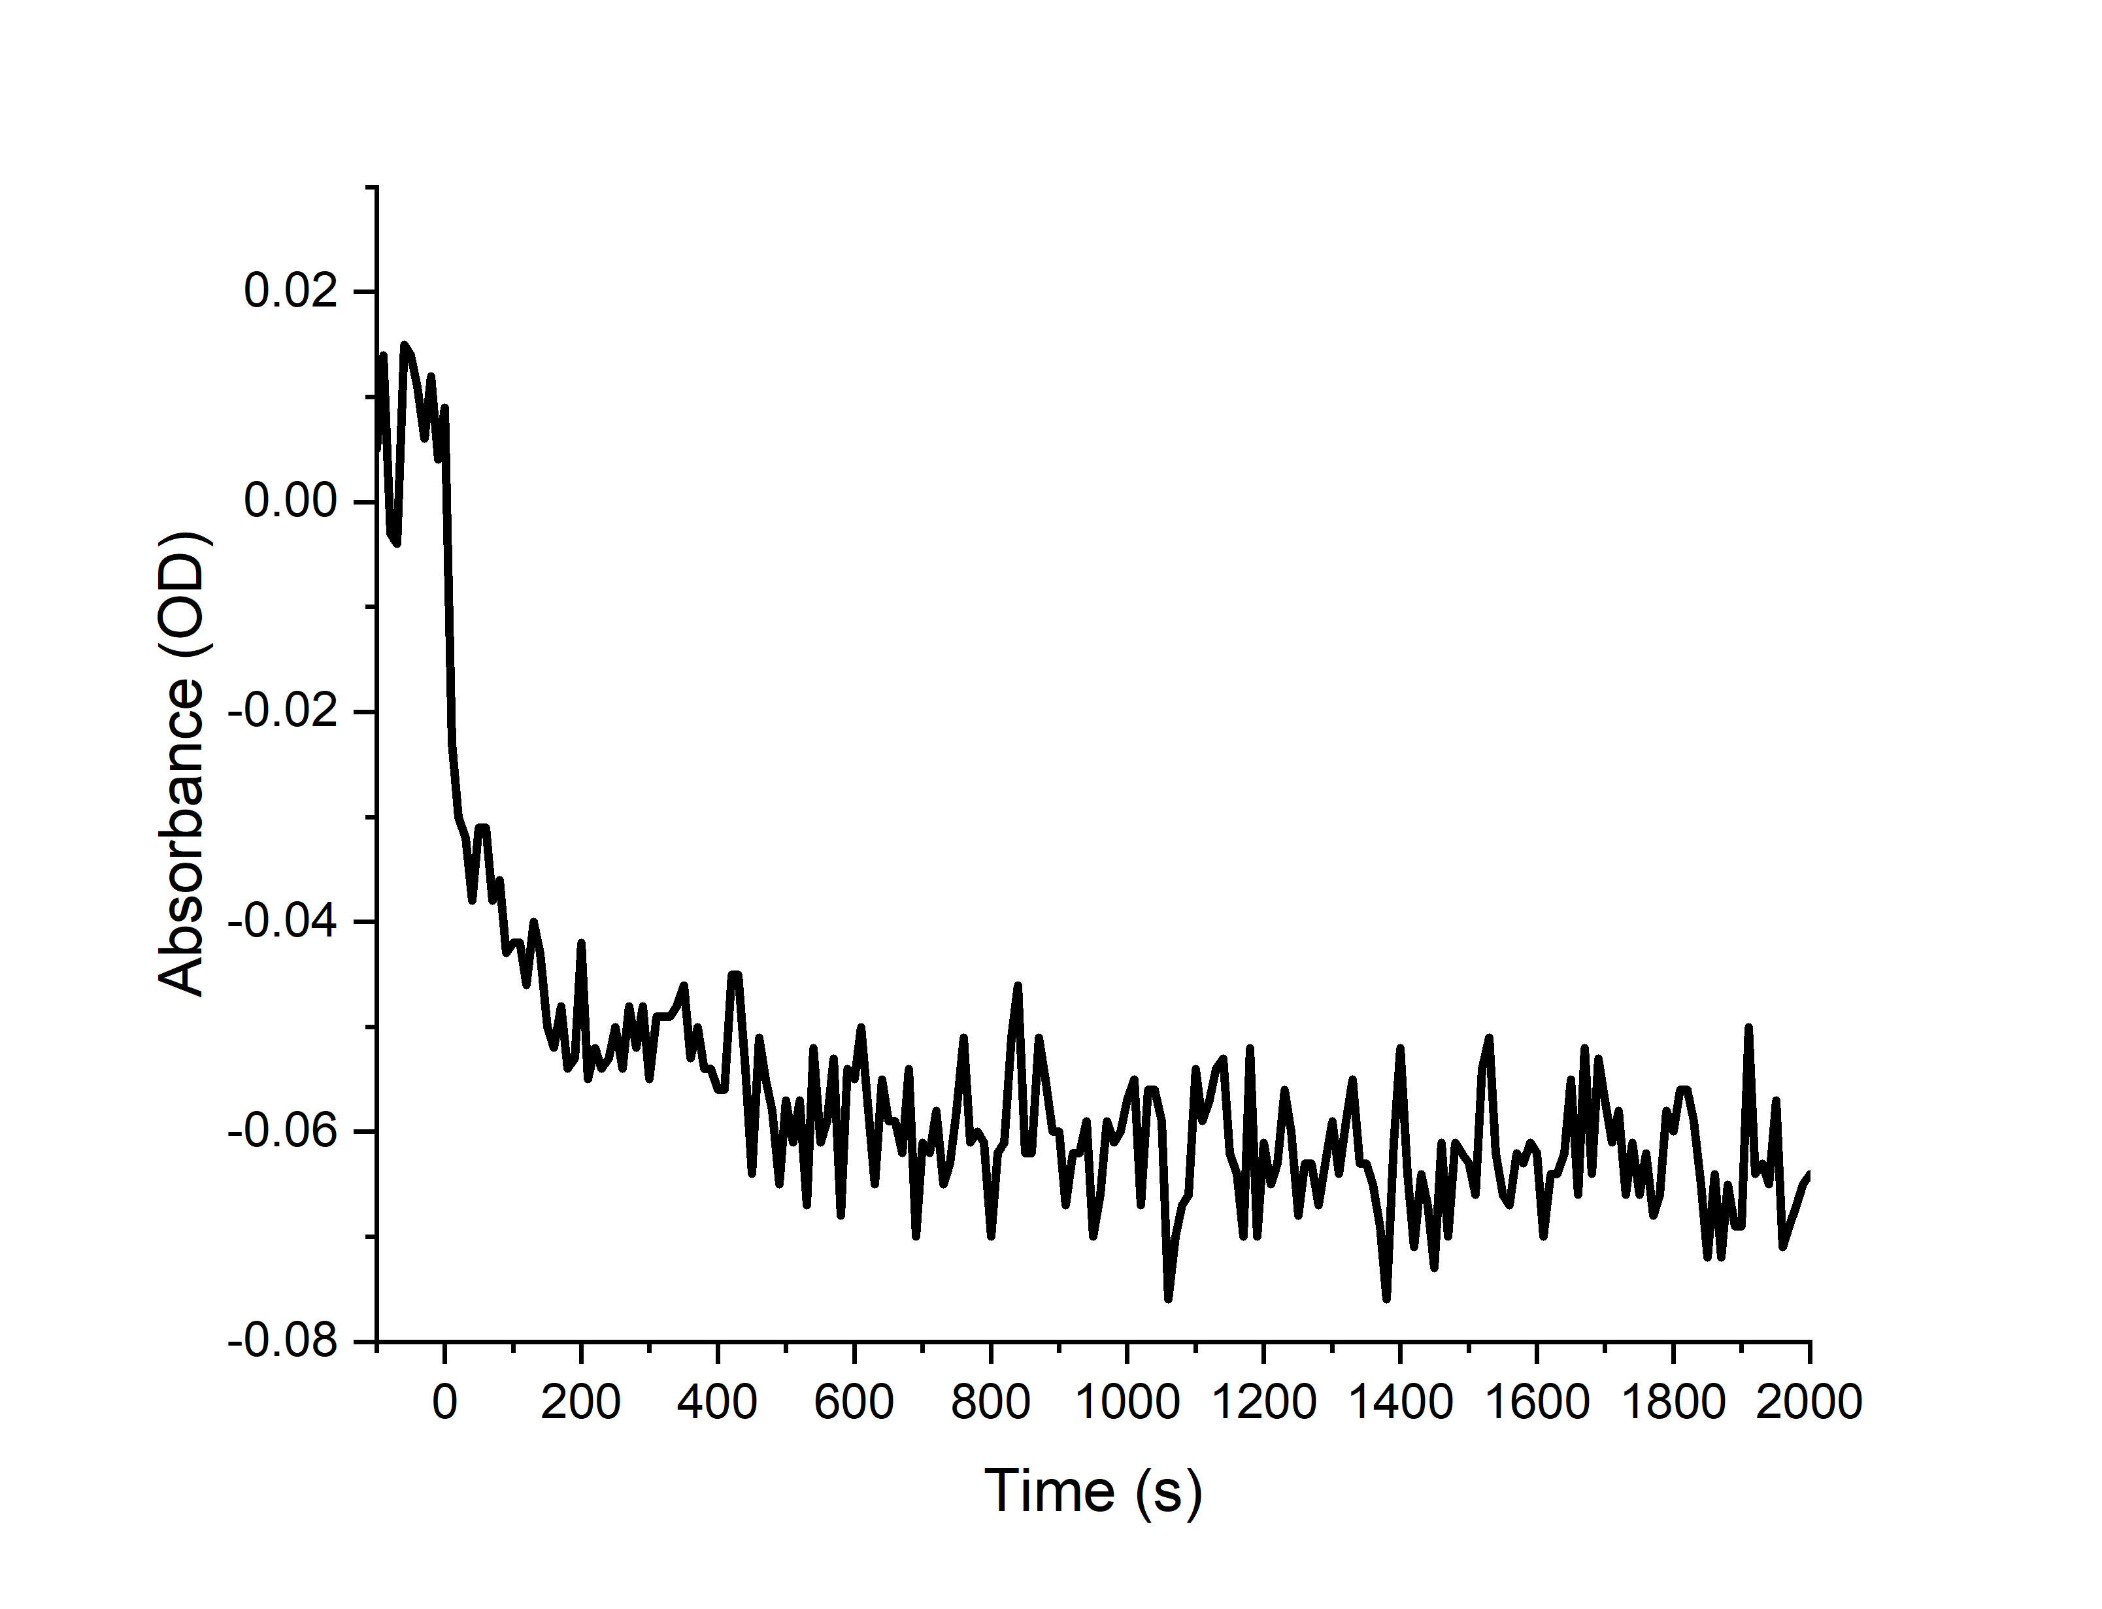(c)

**Figure 4**. Time responses for BSA absorbance level using (a) cuvette; (b) tapered optical fiber and (c) biofunctionalized tapered optical fiber

## Intensity Analysis

The subsequent analysis addresses light intensity measurements, expressed in counts, which indicate the amount of light detected by the spectrometer at specific wavelengths. Figure 5 (a) illustrates the penetration of light through BSA in a cuvette at three different concentrations. The data reveal significant peaks at 320 nm, 500 nm, and 585 nm wavelengths, with intensity values ranging from 2,500 to 45,000 counts. At 320 nm, the highest concentration of BSA (125 mg/dL) demonstrates the lowest intensity, suggesting a higher light absorption at this concentration.

A pronounced variation in light intensity among the three concentrations is observed between 275 nm and 285 nm, a range situated within the UV spectrum. This variation is likely due to the increased interaction between light and BSA molecules at higher concentrations, particularly involving aromatic amino acids such as tryptophan, tyrosine, and phenylalanine, which have strong absorption properties in the UV range. Consequently, the higher the absorption by these amino acids, the less light is transmitted through the solution. Outside this wavelength range, the differences among the concentrations are less significant.

In contrast, when light intensity is measured using a tapered optical fiber biosensor, a distinct spectrum emerges, with intensity values ranging from 2,500 to 14,000 counts as shown in Figure 5 (b). The deployment of tapered optical fibers as biosensors results in a reduced light intensity detected by the spectrometer. This reduction occurs as light traverses the tapered fiber, where a portion exits the core and cladding to interact with the sensor surface, while the remaining light continues to propagate within the core to the spectrometer. The spectrum displays a primary peak at approximately 582 nm, followed by a secondary peak at 603 nm. Consistent with the cuvette measurements, higher concentrations of BSA correlate with lower light intensity readings.

Figure 5(c) further depicts the change in light intensity before and after BSA application on the sensor surface. Within the wavelength range of 362 nm to 725 nm, a significant difference in light intensity is observed for higher BSA concentrations compared to lower concentrations. This difference is attributed to the light exiting the core and cladding, which initially interacts with the bio-functionalized optical surface and subsequently with the BSA molecules attached to the bio-functionalized tapered optical fiber sensor surface. As a result, the quantity of light interacting with the surface increases compared to the initial state. Beyond this wavelength range, while differences in light intensity among the BSA concentrations persist, they are less pronounced.

## Absorbance Analysis

The next analysis is an absorbance analysis. The absorbance spectra of BSA solutions at varying concentrations, as shown in Figure 6(a), reveal distinct peaks at 229 nm and 277 nm. The peak at 229 nm corresponds to the π-π* transition in the peptide backbone, while the 277 nm peak is linked to the absorption by aromatic amino acids such as tryptophan, tyrosine, and phenylalanine [25]. Notably, the spectra do not exhibit significant absorbance in the visible and NIR regions.

Figure 6(b) highlights the differential absorbance characteristics when utilizing a non-bio functionalized tapered fiber optic sensor compared to traditional cuvettes, showing less than 5% absorbance. This reduction is attributed to lower light capture efficiency in the fiber optic system as only a portion of the guided light is allowed to interact via the EW. Unlike conventional cuvettes, where the full optical path interacts directly with the sample non-bio functionalized tapered optical fiber rely on the evanescent field. An exponentially decaying electromagnetic field that extends into the surrounding medium beyond the fiber cladding. This field enables partial interaction between light and analyte molecules at the surface. According to the Beer–Lambert law, absorbance (A) is directly proportional to the concentration (C), path length ($l$), and the molar extinction coefficient (ε), expressed as

$$A=εCl$$

In the context of non-bio functionalized tapered optical fibers, the effective path length is governed by the penetration depth of the evanescent wave, which is influenced by the wavelength, refractive index contrast, and taper geometry. As a result, absorbance is modulated by the evanescent wave intensity, which decays exponentially from the fiber surface. A weaker EW intensity or shorter penetration depth leads to reduced effective absorbance values, as observed in this figure.

The observed absorbance peak around 340 nm, predominantly due to lysine's charge transfer transitions, extends beyond this wavelength[26]. The declining absorbance trend at longer wavelengths is consistent with a decrease in the molar extinction coefficient. Nevertheless, there is an increase in absorbance between 647 nm and 750 nm which may indicate weak vibrational overtone interactions.

Figure 6 (c) illustrates that the highest BSA concentration shows the greatest absorbance across almost all spectra below 915 nm, suggesting successful immobilization on the functionalized surface. The interaction between the evanescent field and immobilized BSA molecules on the sensor surface is enhanced due to improved surface binding. In the visible spectrum (400-700 nm), absorbance remains relatively constant, indicating the sensor's stability and reliability in detecting BSA. The NIR region (650-1000 nm) also shows a minor increase in absorbance, likely due to BSA's vibrational overtones and combination bands. This behavior reaffirms that the enhanced evanescent field interactions improved surface functionalization directly increase the effective optical path length and lead to higher absorbance responses, thereby validating the Beer–Lambert relationship in the context of evanescent wave-based sensing.

The observed discrepancy between the insignificant intensity variation across BSA concentrations in Figure 5(b) and the clear absorbance increase in Figure 6(b) can be attributed to the inherent limitations in light coupling efficiency and mode confinement within the tapered optical fiber sensor. Although the Beer–Lambert law predicts an inverse relationship between absorbance and transmitted light intensity, this relationship assumes a uniform and well-defined optical path length through the sample. In tapered optical fibers, only a fraction of the guided light propagates as an evanescent wave that interacts with the external medium, while the remaining light continues to travel through the fiber core with minimal interaction. As a result, the detected intensity differences may appear negligible due to the small portion of light affected by the analyte.

Additionally, factors such as modal dispersion, fiber bending losses, and imperfect alignment during dip-coating may introduce variability and suppress measurable changes in raw intensity values. In contrast, the absorbance spectrum shown in Figure 6(b) is derived from processed data that accounts for baseline corrections and spectral integration, making it more sensitive to subtle changes in molecular interaction and concentration. Therefore, while raw intensity variations may not appear significant in Figure 5(b), the absorbance calculation effectively reveals concentration-dependent trends consistent with the expected optical behavior.

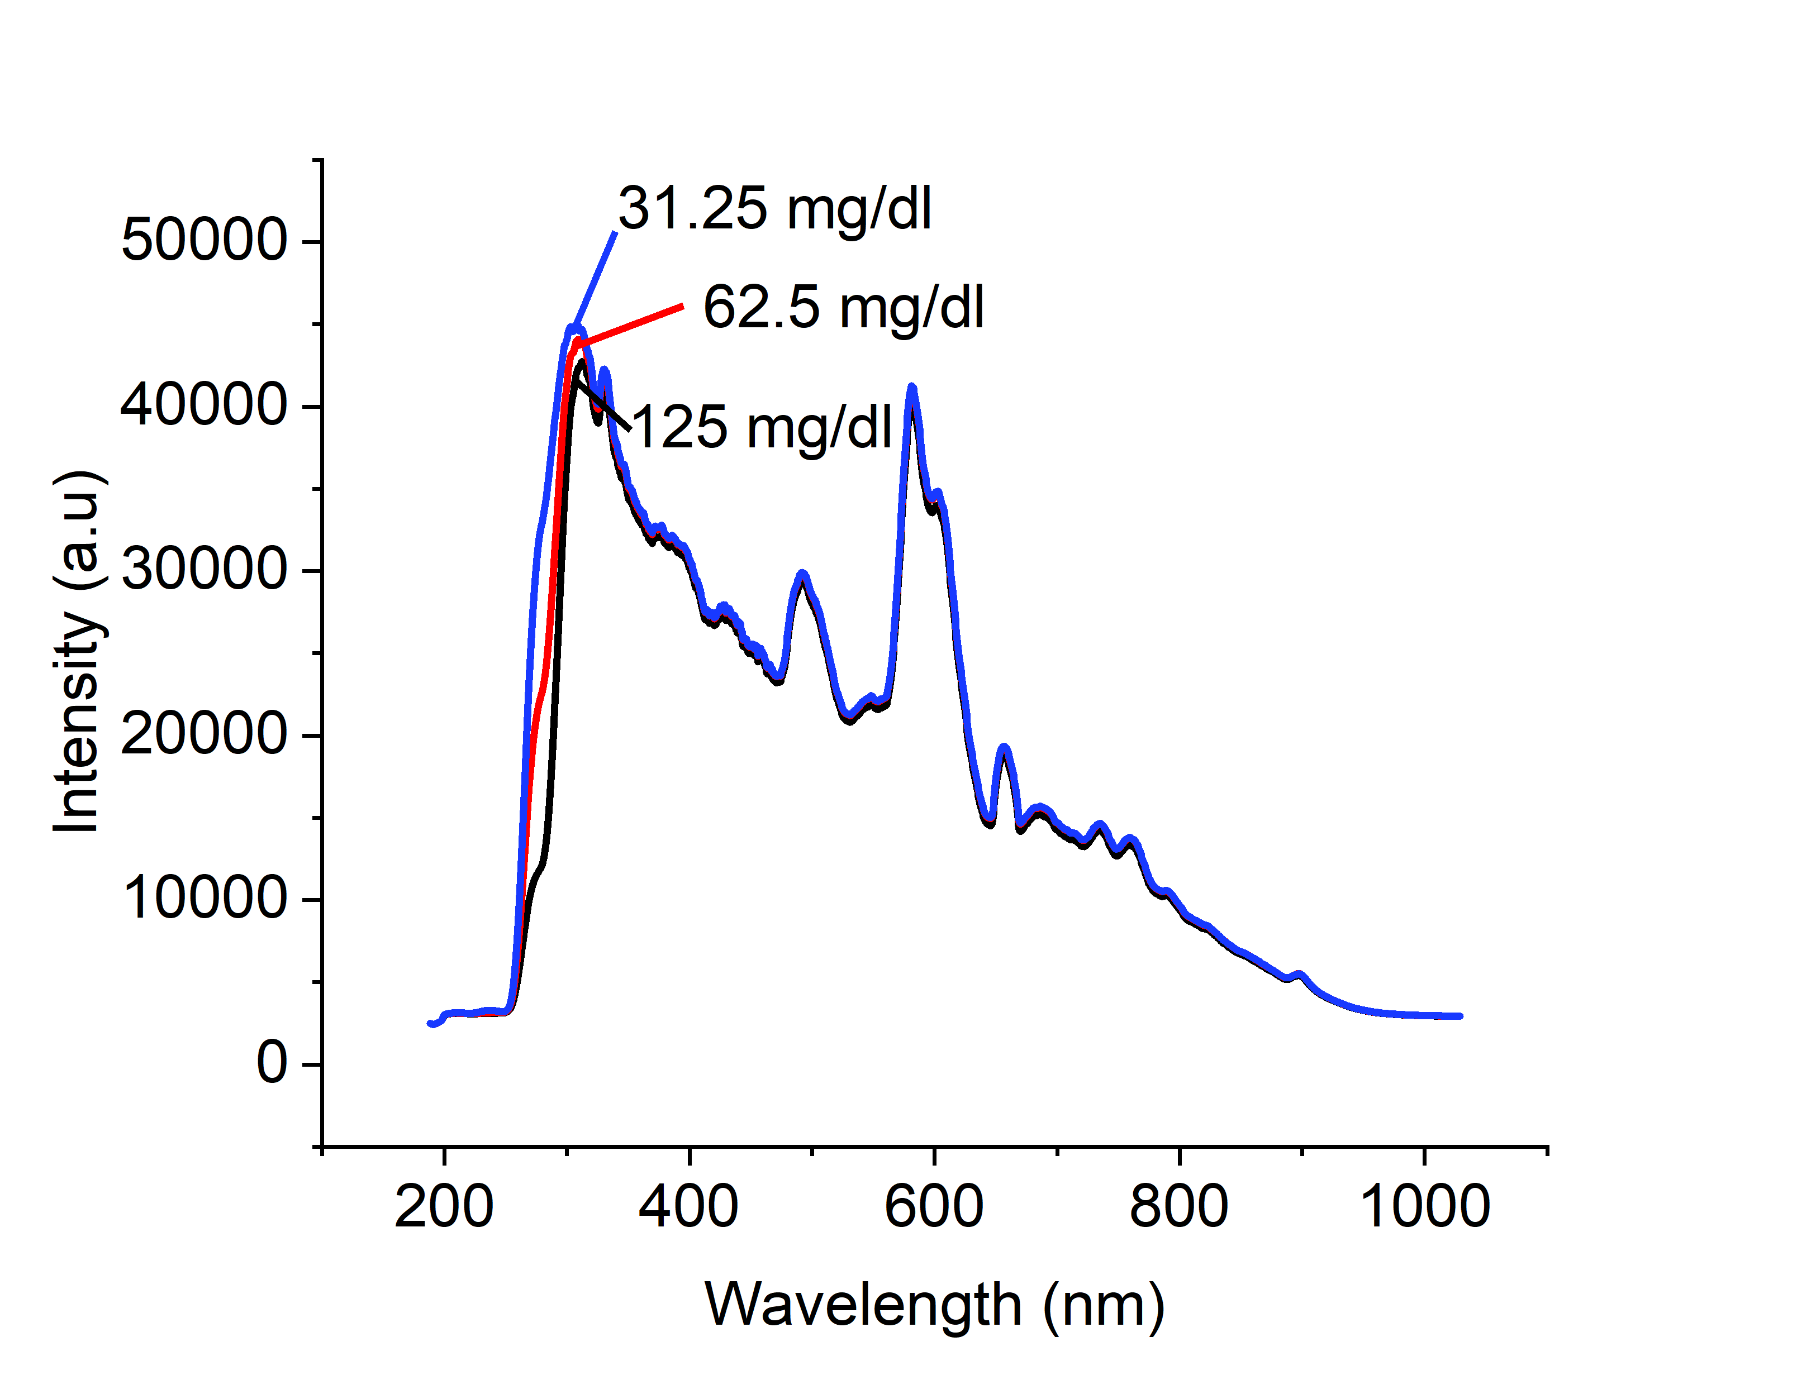(a)

(b)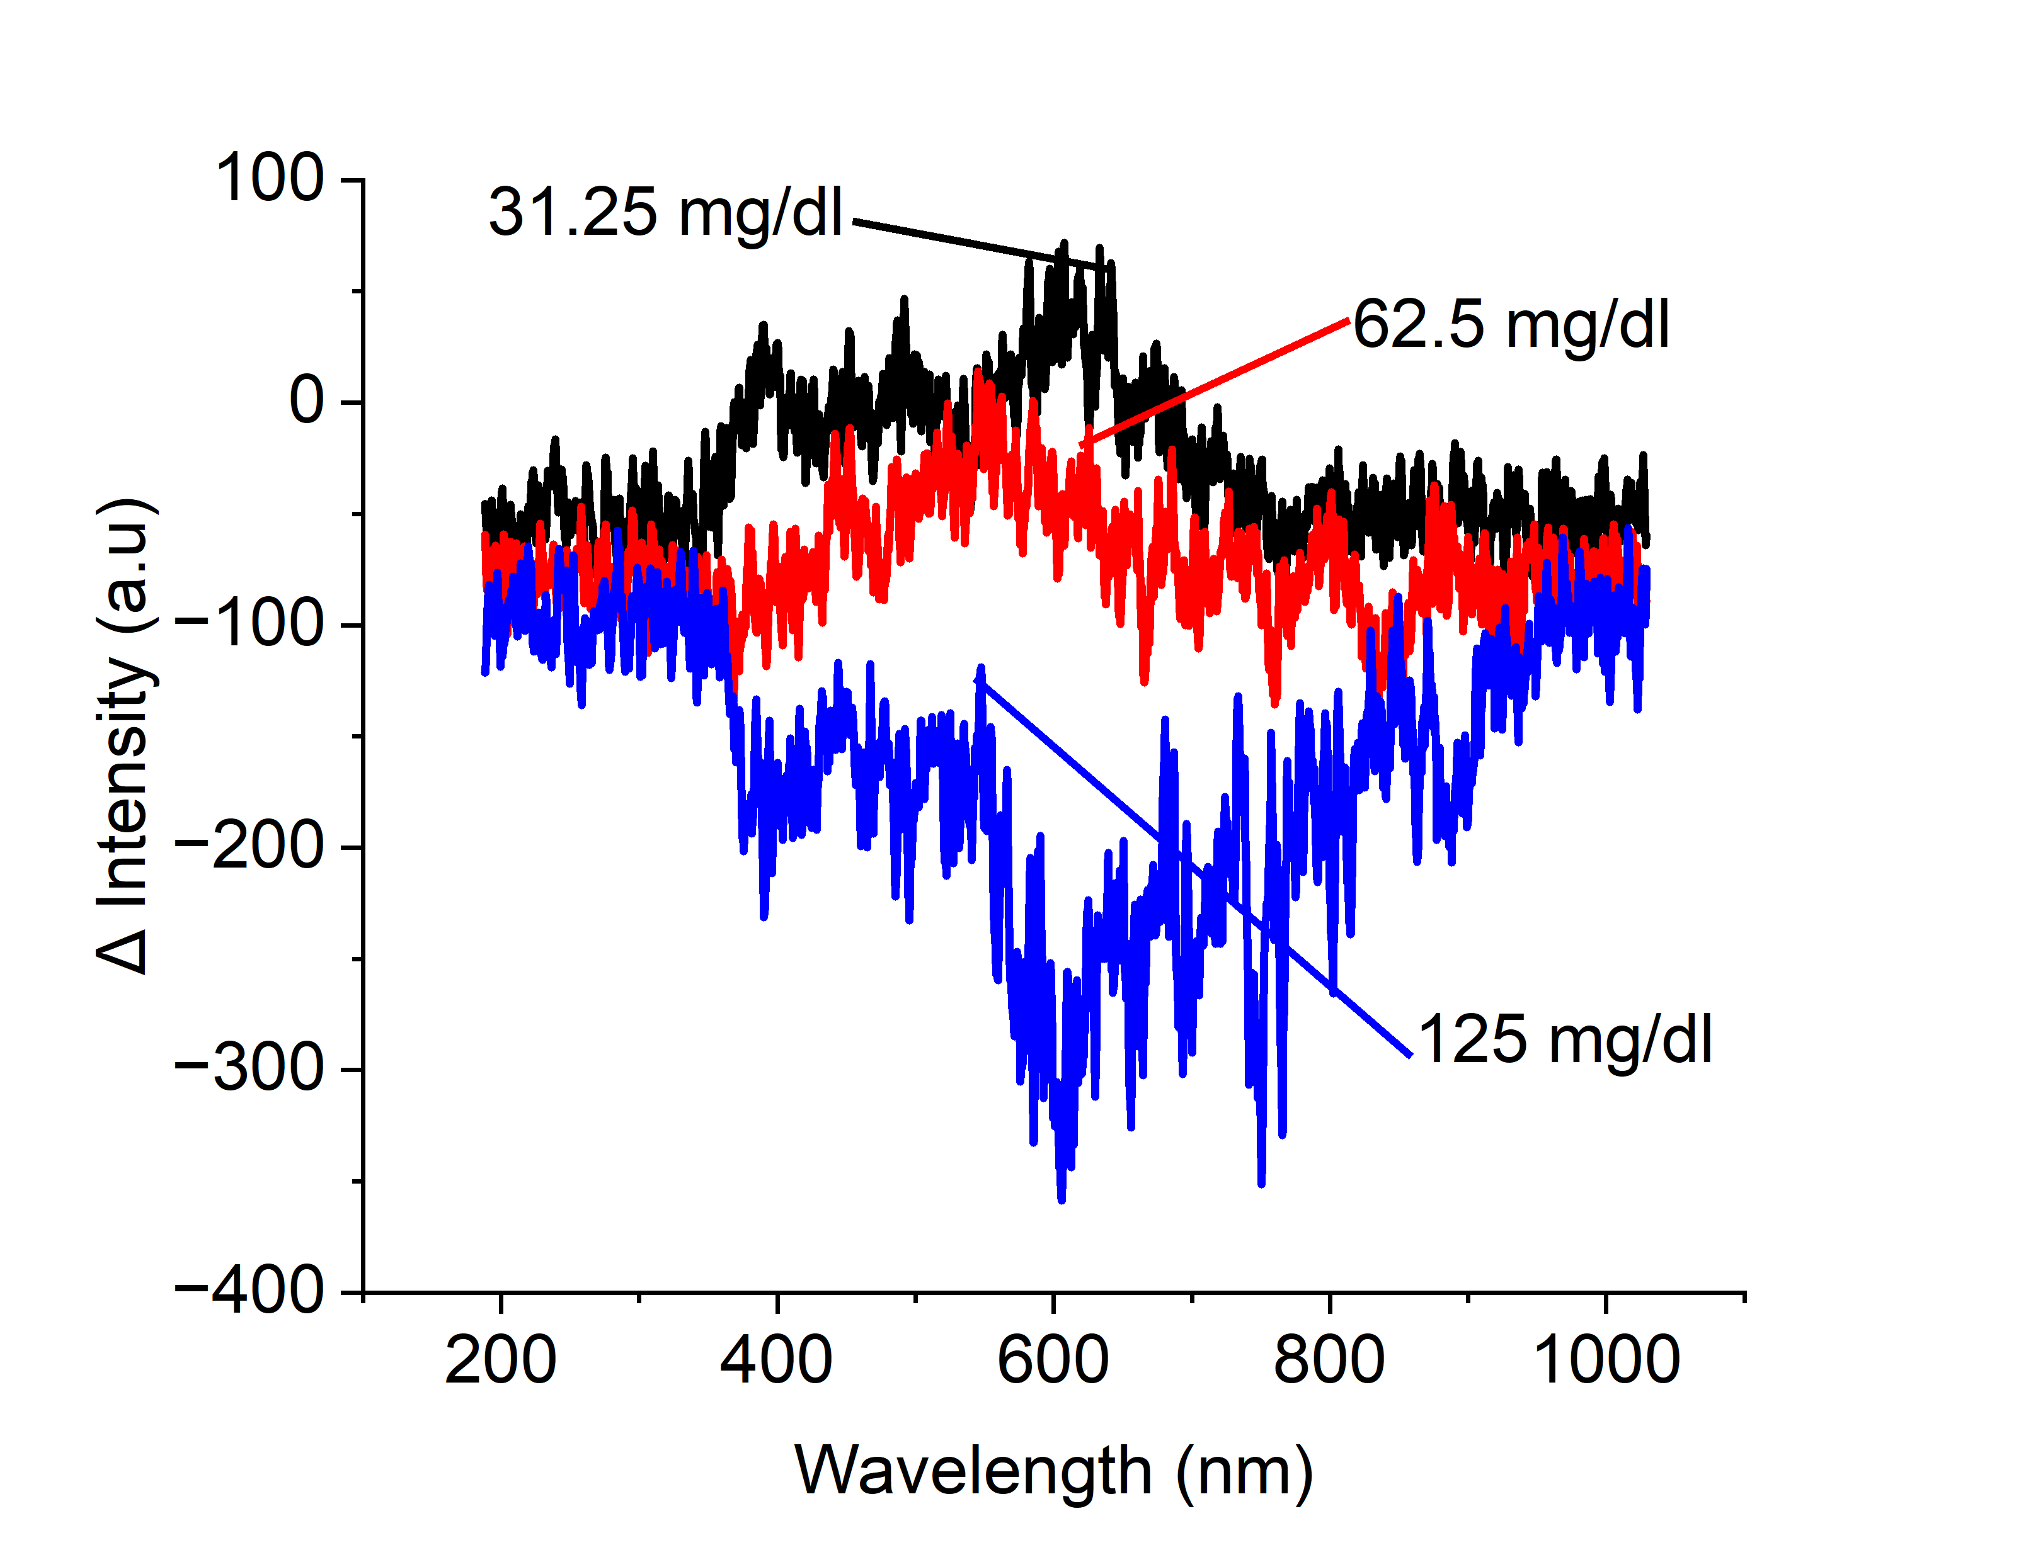(c)

**Figure 5**. Light intensity value for UV-VIS-NIR wavelength using (a) cuvette; (b) tapered optical fiber and (c) changes in light intensity value for UV-VIS-NIR wavelength using biofunctionalized tapered optical fiber

(a)

(b)

(c)

**Figure 6**. Absorbance value for UV-VIS-NIR wavelength using (a) cuvette; (b) non-bio functionalized tapered optical fiber and (c) bio functionalized tapered optical fiber

# DISCUSSION AND RESULTS

## Comparative Analysis of Various BSA Detection

Table 1 provides a concise summary of the key findings in spectrum intensity and absorbance, offering a clear overview of the critical data points that underpin this study's analysis.

**Table 1** Comparative Analysis of Various BSA Detection

|  |  |  |  |
| --- | --- | --- | --- |
| **RANGE** | **CUVETTE** | **NON-BIO FUCTIONALIZEDTAPERED OPTICAL FIBER** | **BIO FUNCTIONALIZED TAPERED OPTICAL FIBER** |
| Intensity | | | | |
| UV 189-380 nm | * Low intensity * Highest peak: 236 nn | * 189-220nm: rapid increment * 220-340 nm: Rises gradually | * Noise * Highest concentrations = lowest intensity |
| Visible  (380– 750 nm) | * 350-750 nm: gradually decreases * Highest peak: 582 nm | * 380-750 nm: rises steadily * Highest peak:   582 nm and-603 nm | * Distinct profile spectrum * Changes are greatest at the highest concentration. |
| NIR  (750 -1029 nm) | * 750 – 1029 nm: gradually decreases | 750 – 1029 nm: gradually decreases | * Lower concentration: maintained * Higher concentration: progressive climb |
| Absorbance | | | | |
| UV  (189 nm – 380 nm) | * High absorbance: 229 and 277 nm | * High absorbance: 340 nm * Inverse relationship between absorbance and concentration * An inverse relationship between absorbance and concentration below wavelength 340 nm. * High noise. | * Highest concentration: low gap * Lowest concentration: high gap * High noise. |
| Visible  (380 nm – 750 nm) | No absorbance detected | * 380-647 nm: absorbance spectrum decrease. * 648-750 nm: absorbance spectrum increase. * High noise. | * Higher gap absorbance between 125 mg/dL and 62.5 mg/dL concentration. * Low gap absorbance between 62.5 mg/dL and 31.25 mg/dL concentration. |
| NIR  (750 nm -1029 nm) | No absorbance detected | * The absorbance increased towards the longer wavelength. * An inverse relationship with concentration. * High noise | * The highest absorbance is 62.5 mg/dL concentration, followed by 125 mg/dL and 31.25 mg/dL concentrations. * High noise |

## Calibration Curve

The magnitude of light intensity and the absorption spectrum data are significant for detecting an analyte. This study utilized a comparison of the calibration curve in the UV band to assess the sensitivity. Figure 7 (a)(i)-(iii) displays the calibration curve for the total light intensity of the cuvette medium, non-bio functionalized tapered optical fiber, and bio functionalized tapered optical fiber. The sensitivity value in this experiment is negative because the decrease in light observed by the spectrometer is directly proportional to the increase in BSA content. The cuvettes demonstrated superior sensitivity values, followed by bio functionalized tapered optical fiber and non-bio functionalized tapered optical fiber. The sensitivity of non-bio functionalized tapered optical fiber was 99.96% lower than that of cuvette medium. The functionalized version, on the other hand, has demonstrated a 207.1% improvement in sensitivity, with values rising from -0.64962 to -1.99477. This enhancement was quantified by calculating the relative increase in sensitivity of BFTOF over NBTOF.

$$Sensitivity Increase \left(\%\right)=\left(\frac{-1.9947-\left(-0.64962\right)}{\left|-0.64962\right|}\right) ×100$$

$$\left(\frac{-1.34508}{-0.64962}\right) ×100 ≈207.1$$

The bio functionalized tapered sensitivity value is merely 0.962% of the sensitivity seen on the cuvette because of a significant disparity in the intensity levels employed in the two scenarios.

$$Relative Sensitivity \left(\%\right)= \left(\frac{-1.9947}{-207.26403}\right)×100≈0.962$$

The calibration curve in Figure 7 (b)(i)-(iii) for absorbance mirrors the sensitivity pattern observed in the intensity calibration curve, highlighting critical differences in detection efficacy. Notably, the cuvette achieves the highest sensitivity at 0.00546, substantially outperforming the biofunctionalized and non-biofunctionalized tapered optical fibers, which demonstrate sensitivities of 0.00195 and 1.2228e-4, respectively. The non-bio functionalized tapered optical fiber sensitivity has dropped 97.76 percent from 0.00546 to 1.22286e-4 compared to the cuvette medium, which is comparable to the trend in light intensity. Remarkably, biofunctionalization enhances the sensitivity of the tapered optical fiber by an impressive 1494.72%. This significant improvement underscores the potential of biofunctionalized tapered fibers in precision sensing applications, positioning them as a compelling alternative in the field. This is based on the relative increase of BFTOF over NBTOF, calculated using:

$$Sensitivity Increase \left(\%\right)= \left(\frac{0.00195-0.000122286}{0.000122286}\right) ×100 ≈1494.72$$

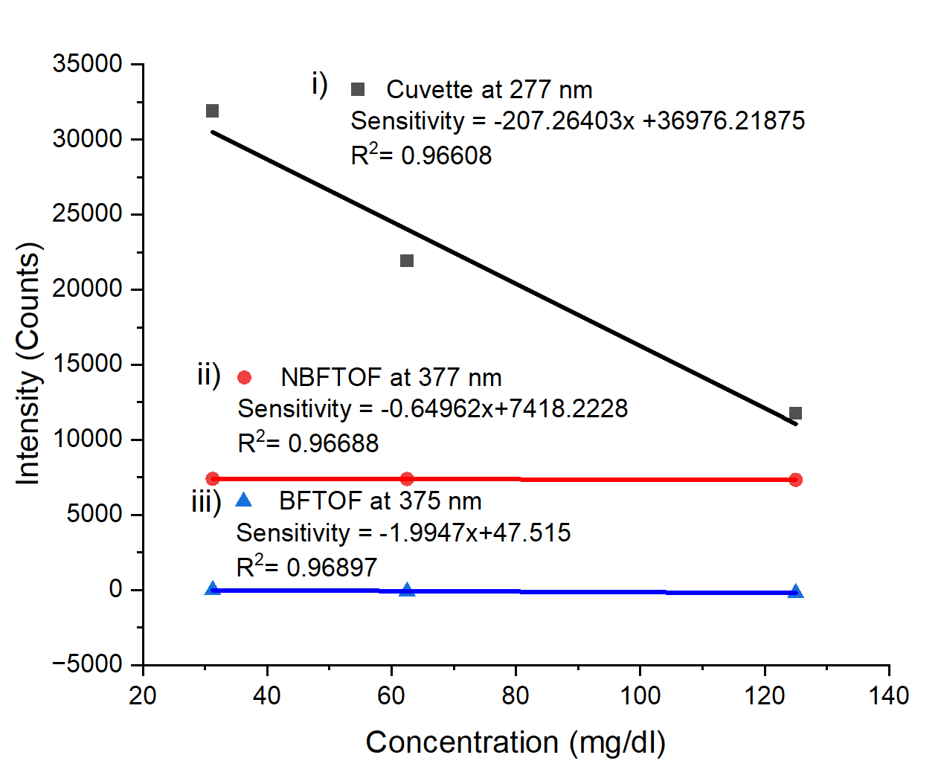

(a)

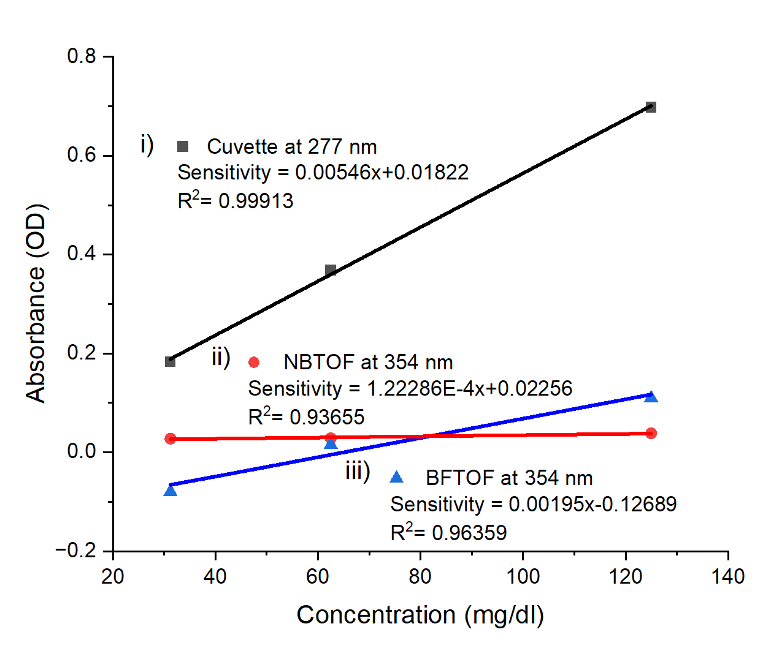

(b)

**Figure 7**. Calibration curve for cuvette, tapered optical fiber and biofunctionalized tapered optical fiber using (a) intensity and (b) absorbance measurement

Table 2 presents a comparison of BSA detection across four previous studies using optical methods. Although the photothermal lens technique demonstrates superior sensitivity compared to this study, it requires a significantly larger analyte volume of 1.4 mL. In contrast, this study successfully detects BSA with only 120 µL of analyte using a bio-functionalized tapered optical fiber sensor.

**Table 2** The reported BSA detection by optical sensor

|  |  |  |  |  |  |
| --- | --- | --- | --- | --- | --- |
| **No** | **Optical Substrate** | **Detection Method** | **Detection Range** | **Sensitivity** | **Ref** |
| 1 | Hollow−core micro-structured optical waveguides | Transmission | 1000, 2000, 4000, 6000 mg/dl | 6.44  mL/mg | [27] |
| 2 | quartz semi-microcell | Photothermal lens signal | 0.05-7.5 mg/dl | 0.0212 a.u./(μg/ml) | [28] |
| 3 | Cuvette | Absorbance | 1,2,3,4,5,7.5, 10, 12.5, 15, 20, 25 and 50 nM | -0.11835 (OD/nm) | [29] |
| 4 | Micro-taped-long-period fiber grating | Wavelength shift | 40, 80, 120, 160, 200 mg/dl | 0.043 mg/mL | [30] |
| 5 | Bio functionalized tapered optical fiber | Intensity | 125 mg/dl, 62.5 mg/dl & 31.25 mg/dl | -1.9947 a.u/(mg/dl) | This work |
| 6 | Absorbance | 125 mg/dl, 62.5 mg/dl & 31.25 mg/dl | 0.00195 a.u/(mg/dl) |

# CONCLUSION

In conclusion, this study provides a comprehensive evaluation of BSA detection using various sensing modalities, highlighting each approach's distinct advantages and limitations. The results demonstrate that while cuvettes offer superior sensitivity with high volume for analyte usage, the biofunctionalization significantly enhances the performance of tapered optical fibers, achieving a remarkable 1494% increase in sensitivity by using absorbance value and 206% by using intensity value. This improvement, although still lower than that of cuvettes, underscores the transformative potential of biofunctionalized tapered fibers in precision sensing applications. The time response analysis reveals critical insights into the interaction dynamics between BSA molecules and the sensing surfaces, with biofunctionalized fibers showing promise in achieving more stable and reliable measurements over time. The intensity and absorbance analyses further validate the effectiveness of these fibers in detecting BSA, particularly in the UV and visible spectra, where traditional cuvettes may fall short. Collectively, these findings position biofunctionalized tapered optical fibers as a compelling alternative in biosensing, with the potential to revolutionize detection methodologies in biomedical and environmental applications. The significant enhancements in sensitivity and stability contribute to the growing body of knowledge and pave the way for future innovations in fiber optic sensor design.

# ACKNOWLEDGEMENTS

This research was funded by Universiti Kebangsaan Malaysia through INISIATIF BELANJAWAN 2025 : AI ENHANCEMENT, Malaysia, under the grant WARISAN-2025-023.

# REFERENCES

[1] M. Ruzicka, L. Jabloncik, P. Dejdar, A. Tomasov, V. Spurny, and P. Munster, “Classification of Events Violating the Safety of Physical Layers in Fiber-Optic Network Infrastructures,” *Sensors*, vol. 22, no. 23, 2022, doi: 10.3390/s22239515.

[2] X. Guo *et al.*, “A High-Precision Transfer of Time and RF Frequency via the Fiber-Optic Link Based on Secure Encryption,” *Appl. Sci.*, vol. 12, no. 13, 2022, doi: 10.3390/app12136643.

[3] L. Liu, Y. Liu, and X. Gao, “Flexible Ultra-Wide Electro-Optic Frequency Combs for a High-Capacity Tunable 5G+ Millimeter-Wave Frequency Synthesizer Li,” *Appl. Sci.*, vol. 22, no. 11, p. 10742, 2021.

[4] D. Venu, A. V. R. Mayuri, S. Neelakandan, G. L. N. Murthy, N. Arulkumar, and N. Shelke, “An efficient low complexity compression based optimal homomorphic encryption for secure fiber optic communication,” *Optik (Stuttg).*, vol. 252, no. December 2021, p. 168545, 2022, doi: 10.1016/j.ijleo.2021.168545.

[5] J. Zhou *et al.*, “Miniature non-contact photoacoustic probe based on fiber-optic photoacoustic remote sensing microscopy,” *Opt. Lett.*, vol. 46, no. 22, p. 5767, 2021, doi: 10.1364/ol.444889.

[6] H. Liu *et al.*, “Uav-borne hyperspectral imaging remote sensing system based on acousto-optic tunable filter for water quality monitoring,” *Remote Sens.*, vol. 13, no. 20, 2021, doi: 10.3390/rs13204069.

[7] Y. Kitahama, M. Egawa, P. K. Dwivedi, W. Yang, and K. Goda, “An emerging tool in healthcare: wearable surface-enhanced Raman Spectroscopy,” *JPhys Photonics*, vol. 6, no. 2, pp. 0–16, 2024, doi: 10.1088/2515-7647/ad38f6.

[8] W. Lyu, S. Chen, F. Tan, and C. Yu, “Vital Signs Monitoring Based on Interferometric Fiber Optic Sensors,” *Photonics*, vol. 9, no. 2, 2022, doi: 10.3390/photonics9020050.

[9] Z. Zhu, L. Liu, Z. Liu, Y. Zhang, and Y. Zhang, “Surface-plasmon-resonance-based optical-fiber temperature sensor with high sensitivity and high figure of merit,” *Opt. Lett.*, vol. 42, no. 15, pp. 2948–2951, Aug. 2017, doi: 10.1364/OL.42.002948.

[10] H. Liu *et al.*, “High-Temperature Fiber-Optic Fabry–Perot Vibration Sensor Based on Single-Crystal Sapphire,” *Sensors*, vol. 23, no. 10, 2023, doi: 10.3390/s23104952.

[11] S. K. Al-Hayali, A. M. Salman, and A. Hadi Al-Janabi, “Effect of hygroscopic polymer-coatings on the performance of relative humidity sensor based on macro-bend single-mode fiber,” *Opt. Fiber Technol.*, vol. 62, no. February, p. 102460, 2021, doi: 10.1016/j.yofte.2021.102460.

[12] Y. Deng *et al.*, “Fiber optic coupled surface plasmon resonance sensor based Ag-TiO2 films for hydrogen detection,” *Opt. Fiber Technol.*, vol. 65, no. February, 2021, doi: 10.1016/j.yofte.2021.102616.

[13] J. L. C. Perez *et al.*, “Fiber optic sensors: A review for glucose measurement,” *Biosensors*, vol. 11, no. 3, 2021, doi: 10.3390/bios11030061.

[14] G. Besselink *et al.*, “Asymmetric Mach–Zehnder Interferometric Biosensing for Quantitative and Sensitive Multiplex Detection of Anti-SARS-CoV-2 Antibodies in Human Plasma,” *Biosensors*, vol. 12, no. 8, 2022, doi: 10.3390/bios12080553.

[15] M. Sahay *et al.*, “Aetiology, practice patterns and burden of end-stage kidney disease in South Asia and South-East Asia: A questionnaire-based survey.,” *Nephrology (Carlton).*, vol. 26, no. 2, pp. 142–152, Feb. 2021, doi: 10.1111/nep.13825.

[16] H. M. Teeuw, H. B. Amoakoh, C. A. Ellis, K. Lindsley, and J. L. Browne, “Diagnostic accuracy of urine dipstick tests for proteinuria in pregnant women suspected of preeclampsia: A systematic review and meta-analysis,” *Pregnancy Hypertens.*, vol. 27, no. December 2021, pp. 123–130, 2022, doi: 10.1016/j.preghy.2021.12.015.

[17] J. R. Mejia *et al.*, “Diagnostic accuracy of urine dipstick testing for albumin-to-creatinine ratio and albuminuria: A systematic review and meta-analysis,” *Heliyon*, vol. 7, no. 11, 2021, doi: 10.1016/j.heliyon.2021.e08253.

[18] R. Thakur, P. Maheshwari, S. K. Datta, S. K. Dubey, and C. Shakher, “Machine Learning-Based Rapid Diagnostic-Test Reader for Albuminuria Using Smartphone,” *IEEE Sens. J.*, vol. 21, no. 13, pp. 14011–14026, 2021, doi: 10.1109/JSEN.2020.3034904.

[19] B. D. Frank, M. Antonietti, P. Giusto, and L. Zeininger, “Photocharging of Carbon Nitride Thin Films for Controllable Manipulation of Droplet Force Gradient Sensors,” *J. Am. Chem. Soc.*, pp. 0–5, 2023, doi: 10.1021/jacs.3c09084.

[20] G. Wang, X. Xu, J. Ren, P. Xie, and R. Li, “Sensing performance enhancement of plasmonic waveguide sensor using a bimodal strategy with digital Gaussian filter,” *Chemom. Intell. Lab. Syst.*, vol. 245, no. October 2023, p. 105069, 2024, doi: 10.1016/j.chemolab.2024.105069.

[21] Y. Zhao, C. Li, Z. T. Lin, Y. Wang, R. Tong, and L. Cai, “Plug-and-Play Fabry-Perot interferometric biosensor with Vernier effect for label-free detection of bovine serum albumin,” *Sensors Actuators B Chem.*, vol. 416, no. January, p. 135999, 2024, doi: 10.1016/j.snb.2024.135999.

[22] N. Burham *et al.*, “Effect of Coated Tungsten Disulfide (WS2) on Tapered Optical Fibre for Urea Detection,” *J. Adv. Res. Appl. Sci. Eng. Technol.*, vol. 39, no. 2, pp. 181–190, 2024, doi: 10.37934/araset.39.2.181190.

[23] M. A. Mustapa, M. H. Abu Bakar, Y. Mustapha Kamil, A. Syahir, and M. A. Mahdi, “Bio-Functionalized Tapered Multimode Fiber Coated with Dengue Virus NS1 Glycoprotein for Label Free Detection of Anti-Dengue Virus NS1 IgG Antibody,” *IEEE Sens. J.*, vol. 18, no. 10, pp. 4066–4072, 2018, doi: 10.1109/JSEN.2018.2813385.

[24] N. H. Zainuddin *et al.*, “Enhanced detection sensitivity of Leptospira DNA using a post-deposition annealed carbon quantum dots integrated tapered optical fiber biosensor,” *Opt. Mater. (Amst).*, vol. 141, no. March, p. 113926, 2023, doi: 10.1016/j.optmat.2023.113926.

[25] X. Zhao, R. Liu, Z. Chi, Y. Teng, and P. Qin, “New insights into the behavior of bovine serum albumin adsorbed onto carbon nanotubes: Comprehensive spectroscopic studies,” *J. Phys. Chem. B*, vol. 114, no. 16, pp. 5625–5631, 2010, doi: 10.1021/jp100903x.

[26] S. Prasad *et al.*, “Near UV-Visible electronic absorption originating from charged amino acids in a monomeric protein,” *Chem. Sci.*, vol. 8, no. 8, pp. 5416–5433, 2017, doi: 10.1039/c7sc00880e.

[27] A. Merdalimova *et al.*, “Two-in-one sensor of refractive index and Raman scattering using hollow−core microstructured optical waveguides for colloid characterization,” *Colloids Surfaces B Biointerfaces*, vol. 234, no. December 2023, p. 113705, 2024, doi: 10.1016/j.colsurfb.2023.113705.

[28] N. A. Behnaz Abbasgholi, N. Shokoufi, and S. Nouri Hajibaba, “Bovine serum albumin determination based on methylene blue detection by photothermal lens spectroscopy,” *Anal. Biochem.*, vol. 594, no. January, p. 113621, 2020, doi: 10.1016/j.ab.2020.113621.

[29] M. Beyer, C. Hladun, and F. Bou-Abdallah, “Detection of proteins with ascorbic acid-capped gold nanoparticles: a simple and highly sensitive colorimetric assay,” *Anal. Methods*, vol. 16, no. 31, 2024, doi: 10.1039/d4ay01146e.

[30] R. Wang, H. Wu, M. Qi, J. Han, and Z. Ren, “Bovine Serum Albumin Detection by Graphene Oxide Coated Long-Period Fiber Grating,” *Photonic Sensors*, vol. 12, no. 3, pp. 1–10, 2022, doi: 10.1007/s13320-022-0649-6.

~~{Bibliography~~