Enhancing Electron Transport in Silicon Self-Switching Devices: A Study on Triangular Barrier-Induced Ballistic Effects
Yi Liang Tan ª, Nor Farhani Zakaria ^{a,b,c,*}, Shahrir Rizal Kasjoo ^{a,c}, Mohd Fairus Ahmad ^{a,b}, Zarimawaty Zailan ª, Mohd Natashah Norizan ^{a,d}, Ili Salwani Mohamad ^{a,d}, Banu A Poobalan ª, Faradilla Azizª, and Arun Kumar Singh ^{e}
ª Faculty of Electronic Engineering Technology, Universiti Malaysia Perlis (UniMAP), Arau 02600, Perlis, Malaysia;
^{b} Advanced Communication Engineering, Centre of Excellence (ACE), Universiti Malaysia Perlis (UniMAP), Kangar 01000, Perlis, Malaysia
^{c} Institute of Nano Electronic Engineering, Universiti Malaysia Perlis, Lot 106, 108 & 110, Blok A, Taman Pertiwi Indah, Jalan Kangar-Alor Setar, Seriab 01000 Kangar, Perlis, Malaysia
^{d} Center of Excellence, Geopolymer and Green Technology, School of Materials Engineering, Universiti Malaysia Perlis, Kompleks Pusat Pengajian Jejawi 2, Taman Muhibbah, 02600, Jejawi, Perlis
^{e}Department of Electronics and Communication Engineering, Punjab Engineering College (Deemed to be 11 University), Sector-12, Chandigarh 160012, India
* Corresponding author. Tel.: +604-9885509; fax: +604-9885510; e-mail: norfarhani@unimap.edu.my
Received XXX 2023, Revised XXX 2023, Accepted XXX 2023
ABSTRACT
With the increasing demand for high-frequency applications due to congestion in lower frequency bands, the need for high-performance diode detectors has become critical. Achieving fast and efficient high-frequency response requires diodes with strong rectification capability and sharp nonlinearity. These electrical characteristics, particularly the I–V behavior of the device, strongly influence key performance metrics such as the curvature coefficient and current responsivity. Derived from the I–V curve shape, these metrics reflect the device’s nonlinear behavior. This study investigates how geometrical modifications influence ballistic transport and electrical performance in silicon-based self-switching devices (SSDs). A triangular potential barrier is introduced within the channel to promote ballistic-like electron transport, especially when the channel dimensions are comparable to or smaller than the mean free path (MFP) of charge carriers. Device structures are designed using Silvaco Devedit 3D and simulated in ATLAS. I–V characteristics, hole velocity, electric field and hole velocity are extracted from Tonyplot. Among the simulated structures, both the fully triangular and the integrated trench designs are more significantly exhibited substantially higher hole velocities and localized electric fields. Furthermore, the SSD with integrated planar and triangular trenches achieved a significantly enhanced forward current which is pointing toward stronger ballistic-like behavior. This geometry is considered the most promising within the scope of the simulations, with its narrow trench width and short channel length suggesting the possibility of quasi-ballistic or ballistic-like transport. Results further indicate that both the size and shape of the triangular barrier critically affect electrical characteristics, showing their importance for future SSD optimization.
Keywords: rectification performance. curvature coefficient, ballistic transport, current response, triangular barrier

INTRODUCTION
Diodes is an electronic device that enables the asymmetric current flow by allowing forward current under forward bias while drastically restricting it under reverse bias [1]. The functionality that primarily achieved is using semiconductor p-n junctions, which take advantage of inherent electric fields and carrier diffusion processes between two different charge carriers. However, the miniaturization of conventional p-n diodes is a significant challenge, such as complex production at the atomic level, tunneling-induced leakage currents, and performance restrictions imposed by doping control and material interfaces [2]. Therefore, this research is carried out to explore alternative ways of rectification processes, particularly those that use quantum and ballistic transport phenomena to produce high rectification performance diodes. Geometric diodes offer a paradigm shift, as they only manipulate the movement of the carrier charges that exploit the ballistic transport or quasi ballistic transport in confined, asymmetrically shaped pathways [3]. In addition, they operate the same as conventional diode that produces asymmetric I-V characteristics by engineering the asymmetric device shape functioning in certain transport regime rather than depending on the doping of p-type and n-type materials to create charge carrier imbalance [4].
The relationship between the device's geometrical shape dimensions and the Mean Free Path length (MFP) of charge carriers in the material is crucial for geometrical diodes functionally [5]. The MFP is the average distance of a charge carrier, either electron or hole travels between scattering events. When the geometrical shape dimensions of a conductive channel length or channel width are comparable to or smaller than the MFP, ballistic transport takes precedence. Under ballistic conditions, charge carriers are injected from a narrow channel to a wider channel. As they enter the wide region, they can separate freely which results in high conductance (like forward bias in a normal diode). In contrast, charge carriers injected from the wide channel into the small channel will experience constriction. Many carriers collide with the tapering walls and are reflected or scattered before reaching the narrow neck, resulting in much decreased conductance (like reverse bias). An asymmetric structure will aid the rectification by influencing directional transmission, but the device still requires certain type of doping to control channel conduction. Doping plays the key factor in opening and closing the channel, enabling switching behavior that geometric design alone cannot achieve, especially under non-ideal or non-ballistic transport conditions where scattering becomes significant.
Several diode devices have been introduced using the concept of ballistic transport such Self-Switching Diode (SSD) [6, 7], geometrical diode, Planar Barrier Diode (PBD) [8] and hybrid of PBD and SSD [9]. In addition, both SSD and PBD have been implemented in many applications such as frequency detector [10, 11], full-wave bridge rectifier [12 - 14], thermoelectric rectifier [15] and microwave rectifier [8, 16].
This research focuses on the self-switching diode (SSD) and introduces a novel trench geometry utilizing a triangular shape. In addition to analyzing the original rectangular trench structure, the study incorporates a triangular trench configuration to assess its influence on carrier transport. By comparing these two distinct geometrical trench designs, the objective is to evaluate the presence of ballistic-like behavior in the devices through analysis of hole-related electrical properties. It is anticipated that inducing ballistic transport within the channel can enhance carrier mobility and contribute to improved electrical performance, including better current response and rectification efficiency.

MATERIALS AND METHODOLOGY
Prior to the proposed structural modification of the SSD, the baseline parameters were adapted from the work of Yi Liang et. al. (2022), as shown in Figure 1. This reference structure featured a channel length, L, channel width, W, and channel trench, W_{t}, of 1.30 µm, 0.23 µm and 0.10 µm, respectively. This geometry was implemented in the Silvaco Devedit 3D and subsequently simulated using ATLAS Silvaco. The SSD was constructed SSD on a p-type silicon substrate with a doping concentration of 2.45 × 10¹⁶ cm⁻³, with interface charge density of 3.16 × 10¹¹ cm⁻² applied along the channel. To accurately model and imitate the electron transfer mechanism of the real device, physical models such as Klaassen’s uniﬁed low-ﬁeld mobility model, the Watt model, Auger recombination, and the energy balance transport model were incorporated [7, 11, 17]. In this study, we employed advanced physical models, including the energy balance transport model, to examine the potential for ballistic or quasi-ballistic transport in SSD structures. Although the exact transport behavior in the fabricated device is not fully characterized, the use of these models enables us to explore and predict carrier dynamics under conditions where ballistic transport is likely to occur. This approach provides valuable insight into the design and optimization of nanoscale device geometries that aim to enhance current response through reduced scattering.
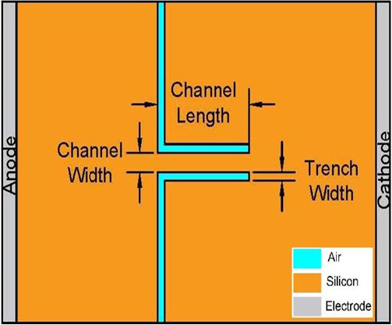
Figure 1 The structure of SSD has been selected for different geometrical shape changes.

Different structure of geometrical diode
In this section, two additional geometrical modifications to the SSD structure are proposed, both incorporating triangular-shaped insulating regions to introduce engineered potential barriers within the channel. As illustrated in Figure 2(a), the first design integrates a combination of planar and triangular trench geometries, aiming to leverage the benefits of both gradual carrier injection and localized electric field enhancement. The second design, shown in Figure 2(b) features a fully triangular trench structure, intended to maximize field concentration and carrier acceleration through a sharp constriction.
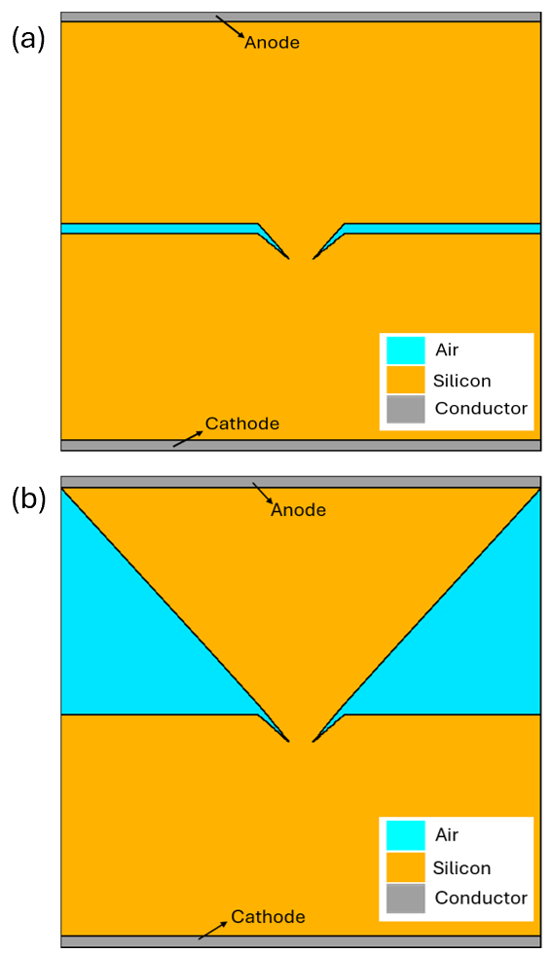
Figure 2 SSD (a) with integration of planar and triangular trench, and (b) with fully triangular barrier structure.
These modifications are introduced to investigate their effects on carrier transport characteristics and to assess the potential for promoting ballistic-like behavior in the channel.

results and discussion

Planar trench
Two planar trench SSD structures with different channel lengths were designed to investigate the impact of channel scaling on device performance. The current–voltage (I–V) characteristics were analyzed by applying a positive bias to the anode and a negative bias to the cathode. The results as shown in Figure 3 (a) shows that the device with a shorter channel length exhibits a notable improvement in forward current, indicating enhanced carrier transport due to reduced scattering and resistance. However, this improvement comes at the cost of increased leakage current under reverse bias conditions, likely due to weaker electrostatic control and enhanced tunnelling or thermionic emission effects across the shortened channel. Curvature coefficient analysis is also carried out and plotted in Figure 3 (b). This analysis shown that channel length of 0.55 µm cannot reached the minimal requirement of the curvature coefficients, 3.5 V⁻¹ to efficiently rectify the current [18].
The hole velocity, hole temperature, and electric field profiles for the two planar trench SSDs are further analyzed with different channel lengths to gain deeper insight into carrier transport behavior. These results are illustrated in Figures 4 – 6. As shown in Figures 4 and 5, the hole velocity is initially low at the channel entrance but increases significantly near the channel exit, indicating acceleration along the transport path [19, 20]. This trend correlates with the electric field distribution observed in Figure 6, where stronger electric fields near the channel exit region correspond to regions of higher hole velocity, confirming field-driven acceleration [21, 22]. Notably, in the shorter channel device, holes exit the channel more rapidly, suggesting reduced scattering and shorter transit time. In contrast, holes traveling through the longer channel experience more frequent interactions, requiring a larger number of carriers to transfer momentum and accelerate. This resulting in a decrease of hole temperatures, as can be seen in Figure 5 [23]. These observations collectively suggest that ballistic or quasi-ballistic transport is more prominent in the shorter channel device, though evidence of such transport mechanisms can also be seen in the longer channel under high field conditions.
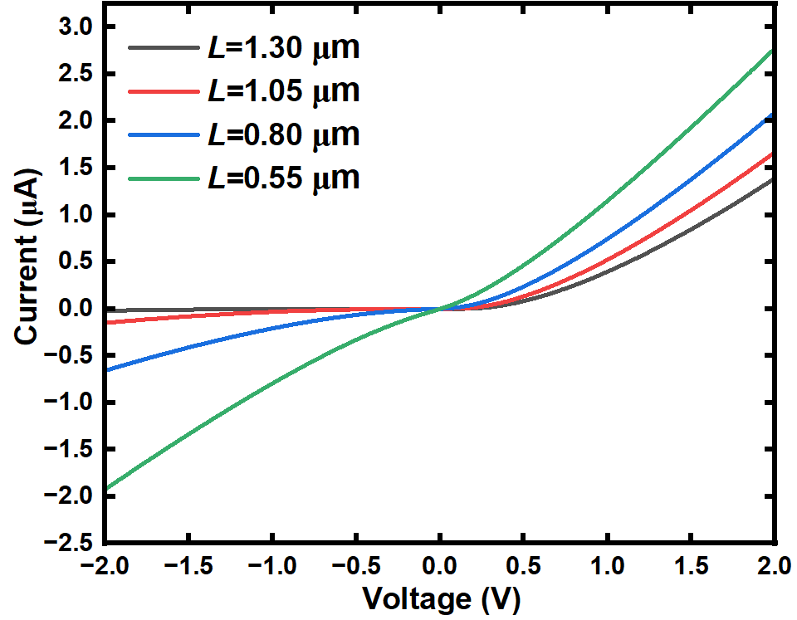
(a)
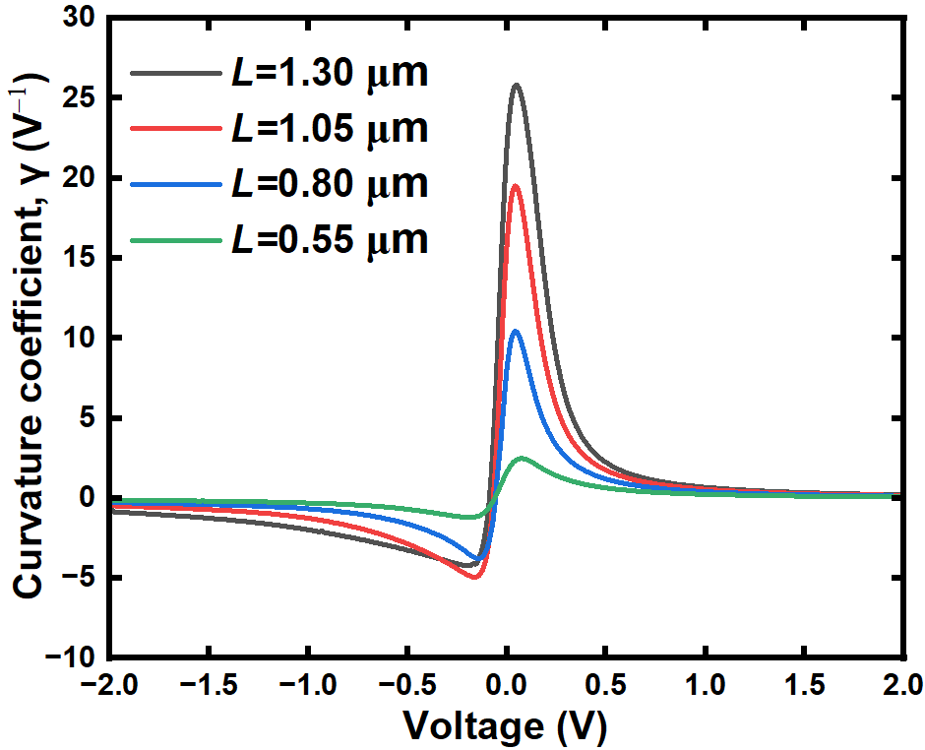
(b)
Figure 3 (a) I-V characteristic (b) curvature coefficient, γ of channel length, L from 0.55 µm to 1.3 µm.

  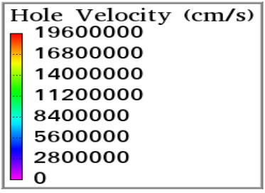  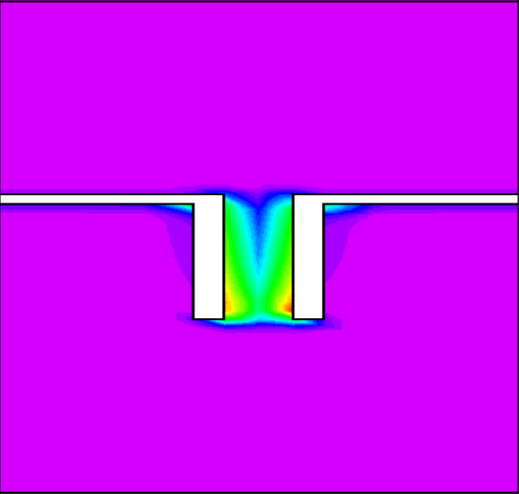 | 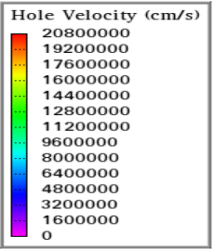  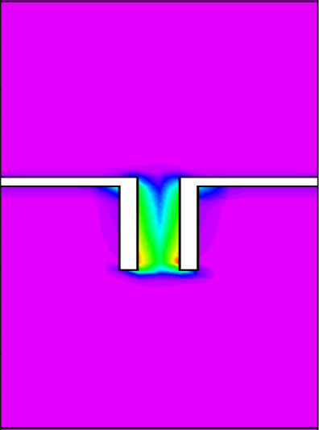
(a) | (b)
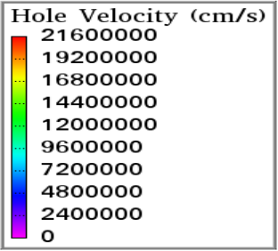  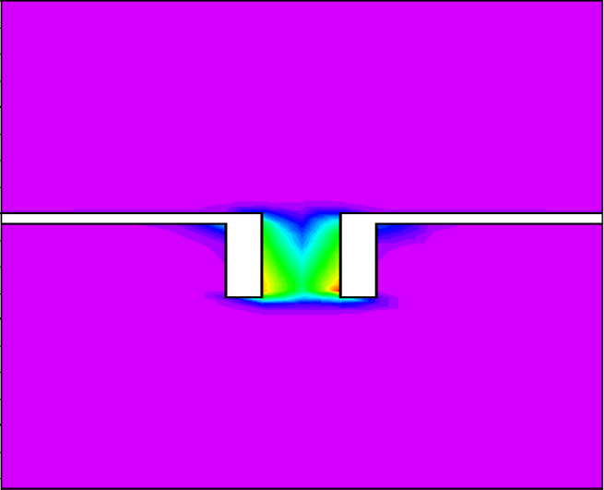 | 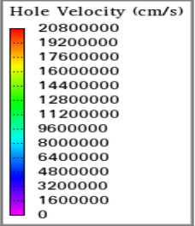  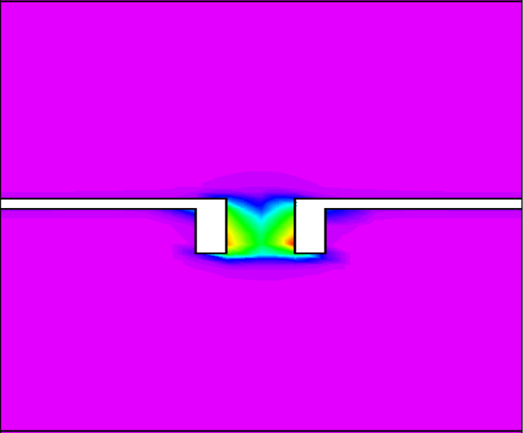
(c) | (d)
Figure 4 Hole velocity of the SSD with channel length, L (a) 1.3 µm, (b) 1.05 µm, (c) 0.80 µm, (d) 0.55 µm.
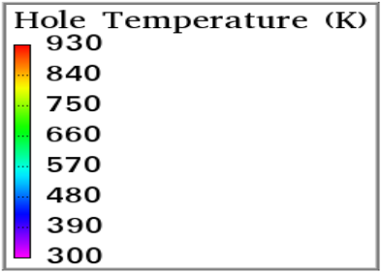  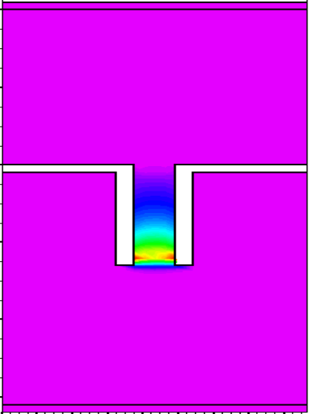 | 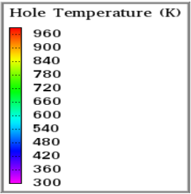  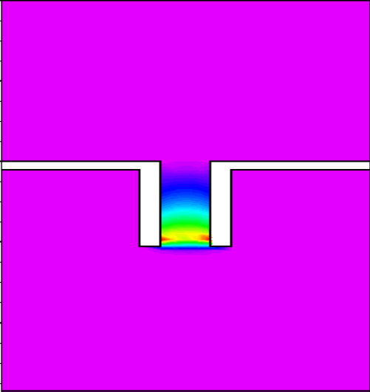
(a) | (b)
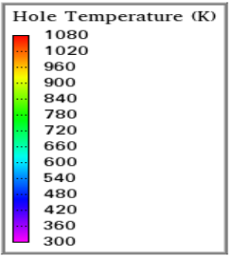  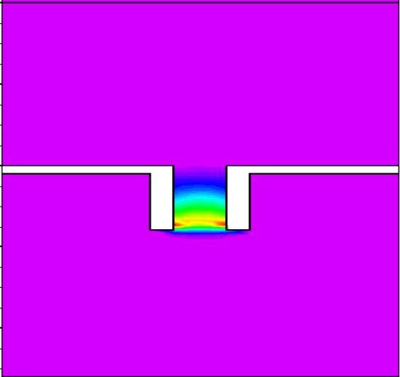 | 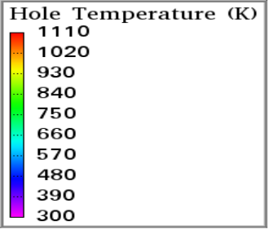  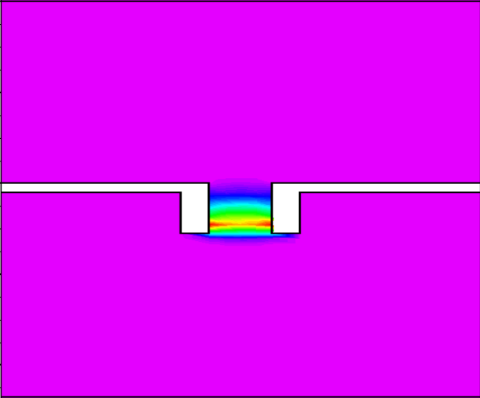
(c) | (d)
Figure 5 Hole temperature of the SSD with channel length, L (a) 1.3 µm, (b) 1.05 µm, (c) 0.80 µm, (d) 0.55 µm.
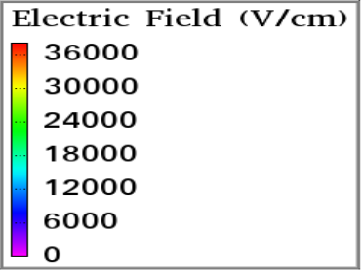  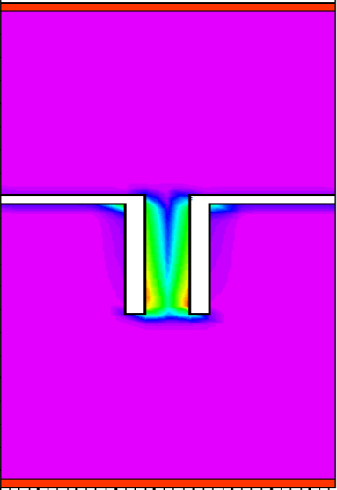 | 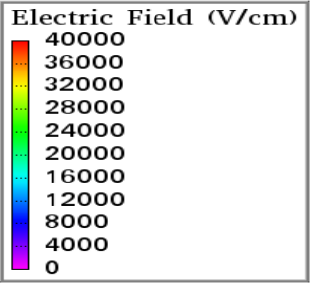  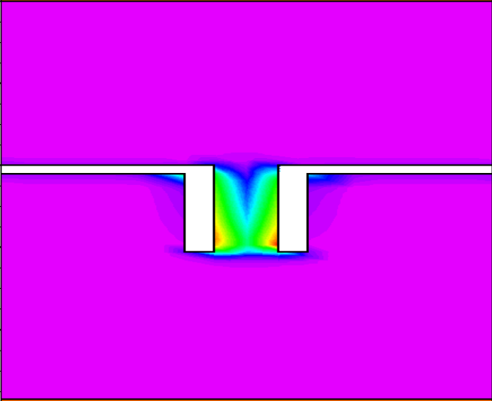
(a) | (b)
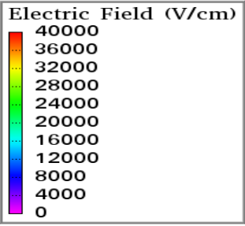  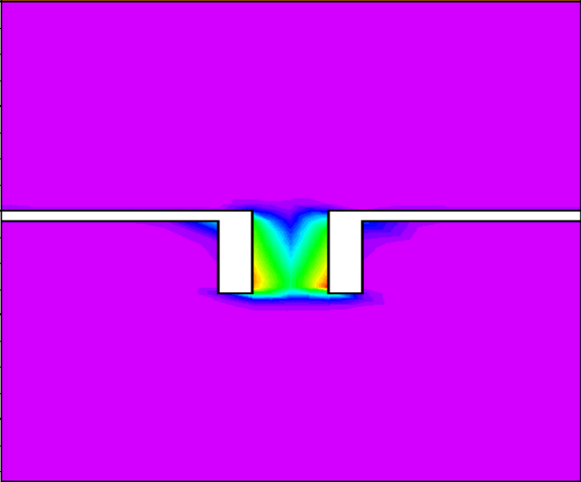 | 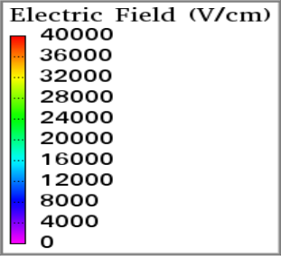  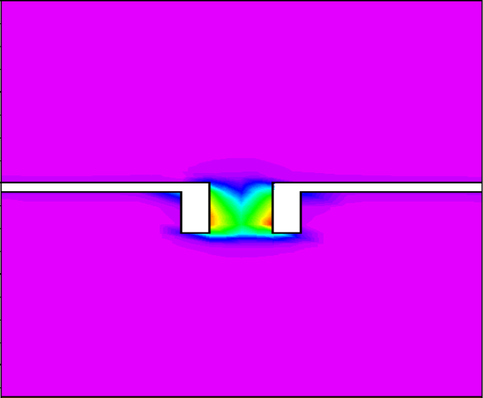
(c) | (d)
Figure 6 Electric field distribution of the SSD with channel length, L (a) 1.3 µm, (b) 1.05 µm, (c) 0.80 µm, (d) 0.55 µm.

Fully triangular barrier structure
Figure 7 (a) shows the I–V characteristics of the fully triangular barrier structure. The results indicate a significantly improved forward current compared to the planar trench design, suggesting enhanced carrier transport efficiency. The minimal curvature coefficient of this structure has been observed above 3.5 V⁻¹ as shown in Figure 7 (b) which motivated us to conduct a detailed electrical property analysis of the fully triangular structure. As shown in Figure 8(a), the hole velocity in the triangular barrier structure is markedly higher than that of the planar trench, attributed to the presence of a substantially stronger localized electric field within the triangular geometry, as illustrated in Figure 8(b). This strong electric field accelerates the carriers rapidly, resulting in high velocities. Consequently, the increased carrier energy leads to more frequent hole–hole interactions, manifesting as elevated hole temperatures near the channel exit, as seen in Figure 8(c). Furthermore, the observed reduction in hole density within the active channel, particularly near the narrow triangular region, supports the hypothesis of ballistic-like transport. In this regime, carriers traverse the confined channel with minimal scattering, maintaining high velocity and energy. This behavior aligns with the purposefully engineered triangular barrier, which was designed to facilitate rapid, low-scattering carrier transport through the channel.

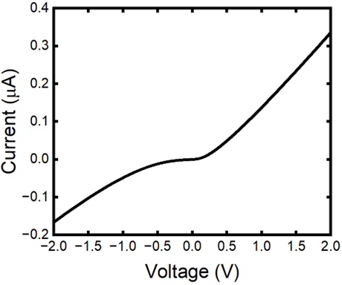 | 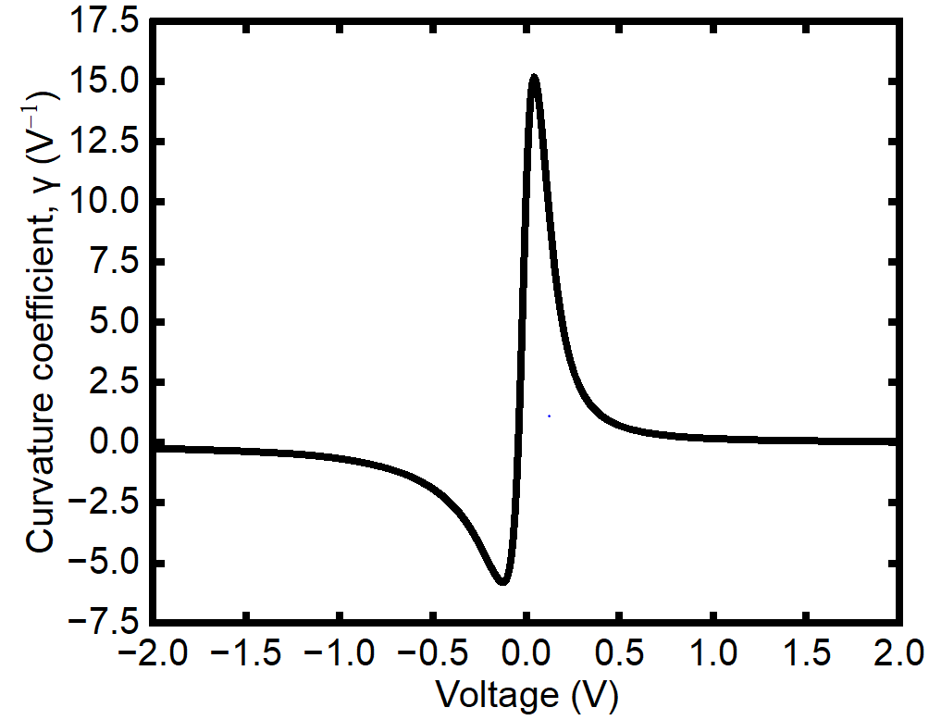
(a) | (b)
Figure 7 (a) I-V characteristics (b) curvature coefficient of a fully triangular barrier structure.

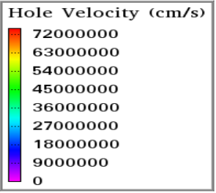  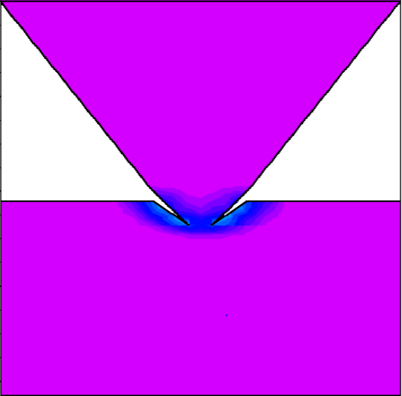 | 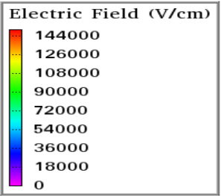  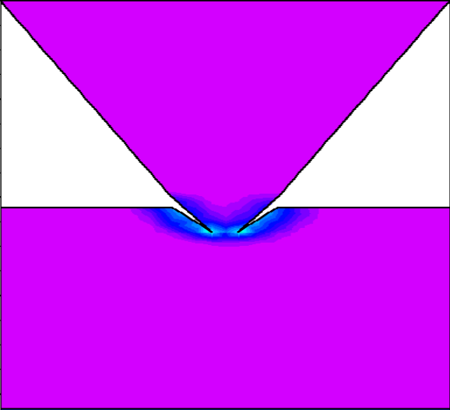
(a) | (b)
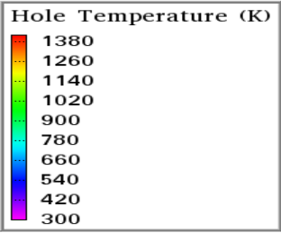
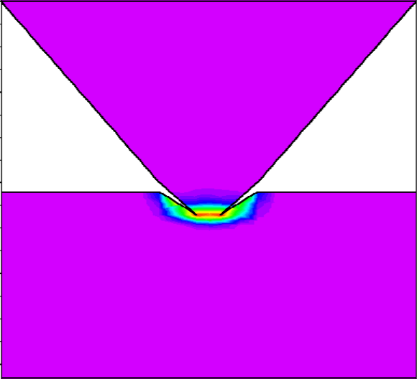
(c)
Figure 8 Electrical properties of fully triangular barrier SSD structure: (a) hole velocity (b) electric field, and (c) hole temperature

Integration of planar and triangular trench
Figure 9 presents the I–V characteristics and its respective curvature coefficient for the structure integrating both planar and triangular trenches. The results show only minor differences with slightly better performances in forward currents, reverse currents and curvature coefficient compared to the fully triangular barrier structure shown in Figure 7. Although the variation in I–V characteristics is modest, we further investigate of its internal electrical properties to understand the cause. As shown in Figure 10(a), the integrated structure demonstrates a significantly higher hole velocity compared to both the fully triangular and planar trench structures. This enhancement is attributed to a stronger localized electric field in the hybrid geometry, particularly where the planar and triangular regions converge, as illustrated in Figure 10(b). The high velocity increases the probability of hole–hole collisions, especially due to carriers approaching from varying angles, which leads to elevated hole temperatures near the channel exit, as shown in Figure 10(c). When examining the carrier concentration, we observe that the integrated structure shows an even lower hole density in the active channel compared to the fully triangular design. This suggests that the angled collisions and enhanced field dynamics promote conditions favorable for ballistic-like transport, where holes maintain high velocity and energy while experiencing minimal scattering. This behavior aligns well with the design goal of combining planar stability and triangular acceleration to facilitate efficient, low-scattering carrier transport.

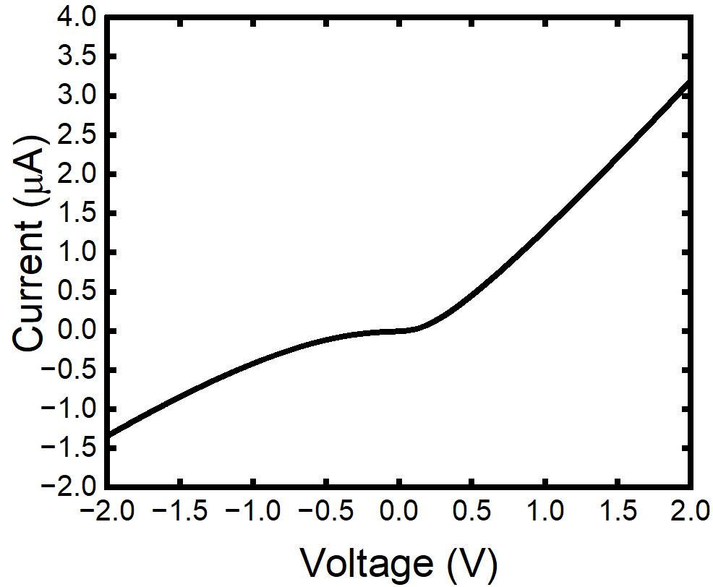 | 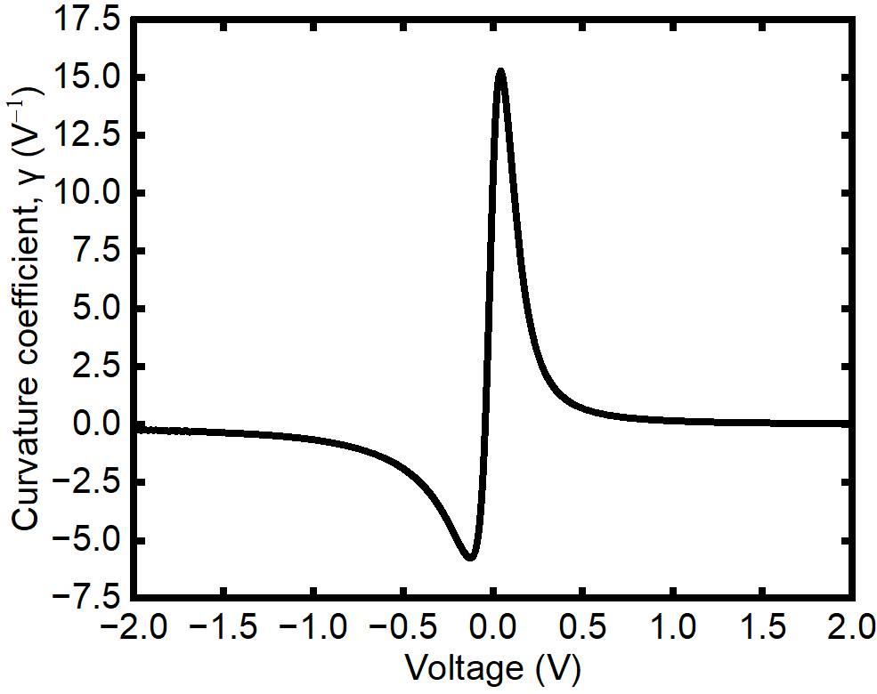
(a) | (b)
Figure 9 (a) I-V characteristics (b) curvature coefficient of an integrating both planar and triangular trenches barrier structure.

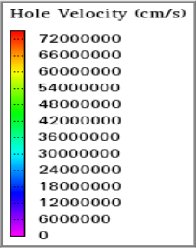  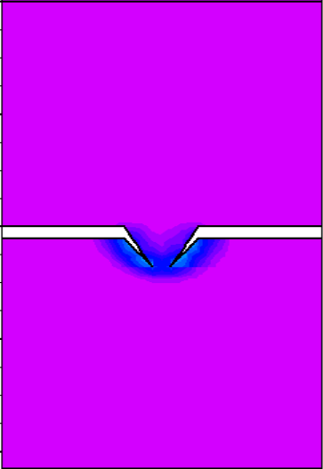 | 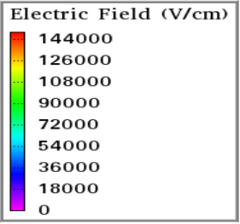  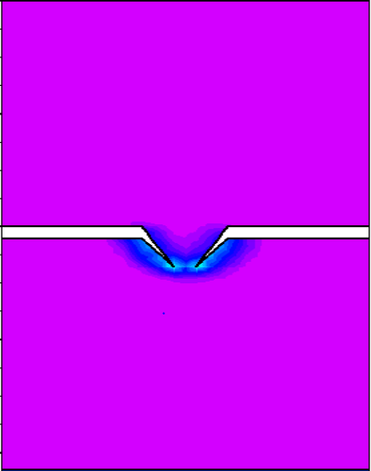
(a) | (b)
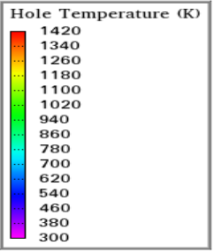
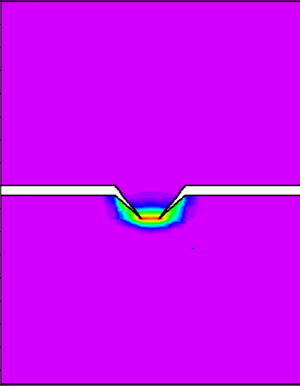
(c)
Figure 10 Electrical properties of integrated planar and triangular SSD trench: (a) hole velocity, (b) electric field, and (c) hole temperature

conclusion
In conclusion, various SSD structures including a rectangular trench, a fully triangular barrier, and an integrated planar–triangular trench were simulated to investigate their influence on carrier transport behavior, with particular focus on ballistic or quasi-ballistic effects. The results indicate that shortening the channel length in the rectangular trench enhances hole velocity due to reduced scattering, suggesting improved transport efficiency. More significantly, both the fully triangular and the integrated trench designs exhibited substantially higher hole velocities and localized electric fields, pointing toward stronger ballistic-like behavior. Among the three, the integrated structure demonstrated the highest forward current and hole velocity, likely due to the combined effect of smooth carrier injection from the planar region and rapid acceleration induced by the triangular barrier.
To assess the potential for ballistic transport, advanced physical models including the energy balance transport model were implemented in ATLAS Silvaco. These models were chosen to capture non-equilibrium effects and short-channel dynamics, which are not adequately represented by conventional drift-diffusion models. Although the exact transport mechanisms in fabricated devices remain uncertain, using such models allows us to explore and predict behaviors associated with ballistic transport in engineered nanoscale geometries. It is important to note that in real devices, multiple transport mechanisms including ballistic, diffusive, and thermionic likely coexist and interact. This complex interplay may lead to even higher current levels than those observed in simulation. Nonetheless, the findings of this work strongly suggest that triangular barrier engineering, particularly when combined with planar features can effectively promote high-velocity, low-scattering carrier transport, offering a promising route for enhancing the performance of self-switching devices.

ACKNOWLEDGMENTS
The author would like to acknowledge the support from the Fundamental Research Grant Scheme (FRGS) under a grant number of FRGS/1/2023/STG07/UNIMAP/02/2 (FRGS 9003-00981) from the Ministry of Higher Education Malaysia.

REFERENCES
[1] M. Kong, “New Electronic Devices for Power Converters,” in Power Electronics, Radio Frequency and Microwave Engineering [Working Title], IntechOpen, 2023. doi: 10.5772/intechopen.108467.
[2] D. J. Frank, R. H. Dennard, E. Nowak, P. M. Solomon, Y. Taur, and Hon-Sum Philip Wong, “Device scaling limits of Si MOSFETs and their application dependencies,” Proceedings of the IEEE, vol. 89, no. 3, pp. 259–288, Mar. 2001, doi: 10.1109/5.915374.
[3] Z. Zhu, S. Joshi, S. Grover, and G. Moddel, “Graphene geometric diodes for terahertz rectennas,” J Phys D Appl Phys, vol. 46, no. 18, May 2013, doi: 10.1088/0022-3727/46/18/185101.
[4] V. H. Nguyen et al., “Optimum design for the ballistic diode based on graphene field-effect transistors,” NPJ 2D Mater Appl, vol. 5, no. 1, p. 89, Dec. 2021, doi: 10.1038/s41699-021-00269-2.
[5] J. Stearns and G. Moddel, “Simulation of Z-Shaped Graphene Geometric Diodes Using Particle-in-Cell Monte Carlo Method in the Quasi-Ballistic Regime,” Nanomaterials, vol. 11, no. 9, p. 2361, Sep. 2021, doi: 10.3390/nano11092361.
[6] A. M. Song, M. Missous, P. Omling, A. R. Peaker, L. Samuelson, and W. Seifert, “Unidirectional electron flow in a nanometer-scale semiconductor channel: A self-switching device,” Appl Phys Lett, vol. 83, no. 9, pp. 1881–1883, Sep. 2003, doi: 10.1063/1.1606881.
[7] G. Farhi, E. Saracco, J. Beerens, D. Morris, S. A. Charlebois, and J.-P. Raskin, “Electrical characteristics and simulations of self-switching-diodes in SOI technology,” Solid State Electron, vol. 51, no. 9, pp. 1245–1249, Sep. 2007, doi: 10.1016/j.sse.2007.07.013.
[8] N. F. Zakaria, S. R. Kasjoo, Z. Zailan, M. M. Isa, M. K. M. Arshad, and S. Taking, “InGaAs-based planar barrier diode as microwave rectifier,” Jpn J Appl Phys, vol. 57, no. 6, p. 064101, Jun. 2018, doi: 10.7567/JJAP.57.064101.
[9] N. F. Zakaria, S. R. Kasjoo, M. M. Isa, Z. Zailan, M. K. Md Arshad, and A. Song, “Improved Rectification Performance and Terahertz Detection in Hybrid Structure of Self-Switching Device (SSD) and Planar Barrier Diode (PBD) Using Two-Dimensional Device Simulation,” Solid State Phenomena, vol. 301, pp. 111–117, Mar. 2020, doi: 10.4028/www.scientific.net/SSP.301.111.
[10] A. Westlund et al., “Graphene self-switching diodes as zero-bias microwave detectors,” Appl Phys Lett, vol. 106, no. 9, pp. 1–6, Mar. 2015, doi: 10.1063/1.4914356.
[11] T. Yi Liang et al., “Hybrid Statistical and Numerical Analysis in Structural Optimization of Silicon-Based RF Detector in 5G Network,” Mathematics, vol. 10, no. 3, p. 326, Jan. 2022, doi: 10.3390/math10030326.
[12] J. Brownless, J. Zhang, and A. Song, “A Graphene Self-Switching Diode Bridge Rectifier,” International Conference on Infrared, Millimeter, and Terahertz Waves, IRMMW-THz, vol. 2019-Septe, pp. 1–2, 2019, doi: 10.1109/IRMMW-THz.2019.8873697.
[13] J. Zhang, J. Brownless, and A. Song, “Graphene bridge rectifier based on self-switching diode arrays,” Nanotechnology, vol. 30, no. 36, p. 364004, Sep. 2019, doi: 10.1088/1361-6528/ab25fd.
[14] S. Garg et al., “InGaAs self-switching diode-based THz bridge rectifier,” Semicond Sci Technol, vol. 36, no. 7, p. 075017, Jul. 2021, doi: 10.1088/1361-6641/abffe0.
[15] B. Kaushal et al., “Graphene self‐switching diode‐based thermoelectric rectifier,” Electron Lett, vol. 56, no. 20, pp. 1069–1072, Sep. 2020, doi: 10.1049/el.2020.1996.
[16] Z. Zailan, N. F. Zakaria, M. M. Isa, S. Taking, M. K. M. Arshad, and S. R. Kasjoo, “Characterization of self-switching diodes as microwave rectifiers using ATLAS simulator,” in 2016 5th International Symposium on Next-Generation Electronics (ISNE), IEEE, May 2016, pp. 1–2. doi: 10.1109/ISNE.2016.7543286.
[17] G. Farhi, D. Morris, S. A. Charlebois, and J.-P. Raskin, “The impact of etched trenches geometry and dielectric material on the electrical behaviour of silicon-on-insulator self-switching diodes,” Nanotechnology, vol. 22, no. 43, p. 435203, Oct. 2011, doi: 10.1088/0957-4484/22/43/435203.
[18] N. F. Zakaria, S. R. Kasjoo, M. M. Isa, Z. Zailan, M. Khairuddin Md Arshad, and S. Taking, “Self-switching diodes as RF rectifiers: evaluation methods and current progress,” Bulletin of Electrical Engineering and Informatics, vol. 8, no. 2, pp. 396–404, Jun. 2019, doi: 10.11591/eei.v8i2.1413.
[19] I. Iniguez-de-la-Torre, T. Gonzalez, H. Rodilla, B. G., and J. Mateos, “Monte Carlo Simulation of Room Temperature Ballistic Nanodevices,” in Applications of Monte Carlo Method in Science and Engineering, InTech, 2011. doi: 10.5772/15863.
[20] J. Mateos, A. M. Song, B. G. Vasallo, D. Pardo, and T. Gonzalez, “THz operation of self-switching nano-diodes and nano-transistors,” in Nanotechnology II, P. Lugli, L. B. Kish, and J. Mateos, Eds., Jun. 2005, p. 145. doi: 10.1117/12.609126.
[21] Z. Chen, Z. Zheng, K. Xu, and G. Wang, “Ballistic transport in nanoscale self-switching devices,” Chinese Science Bulletin, vol. 56, no. 21, pp. 2206–2209, Jul. 2011, doi: 10.1007/s11434-011-4557-1.
[22] Y. Heng and K. Y. Xu, “The Monte Carlo Method Used in Self-Switching Device,” Adv Mat Res, vol. 760–762, pp. 607–611, Sep. 2013, doi: 10.4028/www.scientific.net/AMR.760-762.607.
[23] J. P. Custer et al., “Ratcheting quasi-ballistic electrons in silicon geometric diodes at room temperature,” Science (1979), vol. 368, no. 6487, pp. 177–180, Apr. 2020, doi: 10.1126/science.aay8663.

